CuriousLab Tutorials · O-Level Physics 6091
Tutorial 5
Light
Reflection · Refraction · Total internal reflection · Thin converging lenses
“All these fifty years of conscious brooding have brought me no nearer to the answer to the question, ‘What are light quanta?”
— Albert Einstein, letter to Michele Besso, 1951

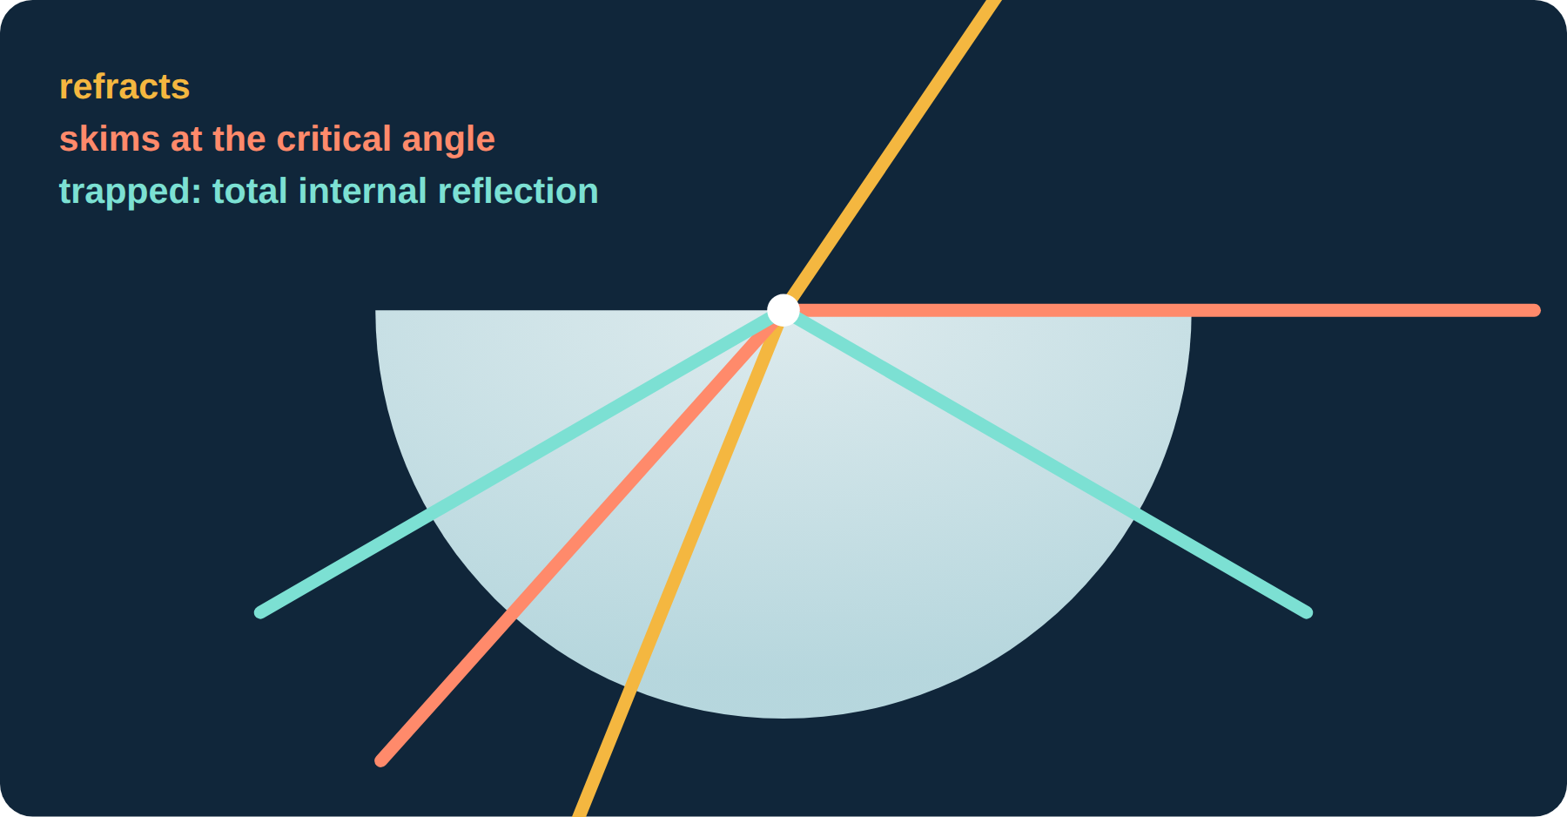
[ Infographic placeholder · drop the NotebookLM infographic here ]

Concept summary
Reflection  - Angles are measured from the normal (at 90° to the surface).  - Law: i = r; incident ray, reflected ray and normal lie in one plane.  - Plane mirror image: virtual, upright, same size, laterally inverted, as far behind the mirror as the object is in front. | Refraction  - Bending of light when it changes speed passing from one medium to another.  - Into a denser medium (slower): bends towards the normal. Out of it: away.  - Along the normal: no bending, but speed still changes.
Refractive index  - n = sin i / sin r (i in air, r in the medium). Snell’s law: the ratio is constant.  - n = c / v, c = 3.0 × 10⁸ m/s. n has no unit and is always > 1.  - Glass 1.5, water 1.33, diamond 2.42. | Total internal reflection  - Needs dense → less dense AND i > c.  - sin c = 1 / n. Glass c = 41.8°, water c = 48.8°.  - Optical fibres: core has higher n than cladding. Uses: telecom, endoscopes. More data, less loss, no electrical interference, secure.
Thin converging lens  - Focal length f: optical centre to principal focus F.  - Rays: parallel → through F; through C → straight; through near F → parallel.  - Beyond 2F: real, inverted, diminished (camera). At 2F: same size. F–2F: magnified (projector). Inside F: virtual, upright, magnified (magnifying glass). | Exam pitfalls  - Angle given from the surface? Use 90° − angle.  - n < 1 or a Math ERROR means a fraction is upside down.  - Ray diagrams: ruler, arrows, virtual lines dashed, image labelled.  - Real/virtual, upright/inverted, magnified/diminished: give all three.

CuriousLab Tutorials · O-Level Physics 6091
Tutorial 5 · Light
Paper 1 · Multiple Choice
30 minutes · 20 marks
Name
Class
Register number

READ THESE INSTRUCTIONS FIRST
- Write your name, class and register number in the spaces above.
- There are twenty questions in this paper. Answer all questions.
- For each question there are four possible answers, A, B, C and D. Choose the one you consider correct and write its letter in the brackets provided.
- Each correct answer scores one mark. A mark is not deducted for a wrong answer.
- Any rough working should be done in this booklet. The use of an approved scientific calculator is expected, where appropriate.
- Take the speed of light in a vacuum as 3.0 × 10⁸ m/s.

1 A ray of light strikes a plane mirror, making an angle of 30° with the surface of the mirror. What is the angle of incidence? ( )
A 60° | B 30°
C 90° | D 120°

2 The angle of incidence of a ray on a plane mirror is 35°. What is the angle between the incident ray and the reflected ray? ( )
A 35° | B 70° | C 110° | D 145°

3 Which statement describes the image of an object formed by a plane mirror? ( )
A It is real, upright and the same size as the object.
B It is virtual, inverted and the same size as the object.
C It is virtual, upright, the same size and laterally inverted.
D It is real, inverted and smaller than the object.

4 Which statements about refraction are correct? ( )
I Light bends because its speed changes at the boundary between two media.
II A ray entering a glass block along the normal does not change direction.
III Light speeds up when it passes from air into glass.
A I only | B II only
C II and III only | D I and II only

5 The refractive index of a type of glass is 1.6. What is the speed of light in this glass? (Speed of light in a vacuum = 3.0 × 10⁸ m/s.) ( )
A 1.9 × 10⁸ m/s | B 3.0 × 10⁸ m/s
C 4.8 × 10⁸ m/s | D 5.3 × 10⁷ m/s

6 Light enters four different materials from air, each time at an angle of incidence of 40°. The angles of refraction are shown. Which material has the greatest refractive index? ( )
 | angle of incidence | angle of refraction
A | 40° | 30°
B | 40° | 25°
C | 40° | 35°
D | 40° | 38°

7 A ray of light in air strikes a block at an angle of incidence of 45°. The angle of refraction is 28°. What is the refractive index of the block? ( )
A 0.66 | B 1.33
C 1.51 | D 1.61

8 A ray of light passes from water into air. The angle of incidence is less than the critical angle. What happens to the ray at the surface? ( )
A It bends towards the normal and speeds up.
B It bends towards the normal and slows down.
C It bends away from the normal and slows down.
D It bends away from the normal and speeds up.

9 A material has a refractive index of 1.25. What is its critical angle? ( )
A 53° | B 37° | C 39° | D 51°

10 Which conditions are needed for total internal reflection? ( )
I Light travels from an optically denser medium towards a less dense medium.
II The angle of incidence is greater than the critical angle.
III The light must be of one colour only.
A I only | B I and II only
C II and III only | D I, II and III

11 Why is the cladding of an optical fibre made of glass with a lower refractive index than the core? ( )
A So that it absorbs any light escaping from the core.
B So that the fibre is flexible enough to bend.
C So that light striking the core–cladding boundary at large angles is totally internally reflected.
D So that light refracts into the cladding and travels faster.

12 The critical angle of a glass is 42°. A ray inside the glass strikes the glass–air surface at an angle of incidence of 50°. What happens to the ray? ( )
A It refracts out, bending towards the normal. | B It travels along the surface.
C It passes straight through. | D It is totally internally reflected.

13 What is an advantage of using optical fibres rather than copper cables for telecommunication? ( )
A They carry much more information with less signal loss.
B They are easier to repair when broken.
C They can carry electric current as well as light.
D They can be bent at sharp right angles without losing any light.

14 The focal length of a converging lens is the distance between ( )
A the lens and the image. | B the optical centre and the principal focus.
C the object and the image. | D the principal focus and 2F.

15 Which row correctly describes the image formed by a thin converging lens? ( )
 | object position | nature of image
A | beyond 2F | virtual, upright, diminished
B | at 2F | real, inverted, magnified
C | between F and 2F | real, inverted, magnified
D | between F and the lens | real, upright, magnified

16 An object is placed 10 cm from a converging lens of focal length 10 cm. Where is the image formed? ( )
A 10 cm | B 20 cm | C 5 cm | D at infinity

17 A converging lens is used as a magnifying glass. What type of image does it form? ( )
A virtual, upright and magnified
B real, inverted and magnified
C virtual, inverted and diminished
D real, upright and the same size

18 Which statements about a real image are correct? ( )
I It can be formed on a screen.
II It is formed where rays of light actually meet.
III It is always upright.
A I only | B I and II only
C II and III only | D I, II and III

19 An object is placed 20 cm from a converging lens of focal length 10 cm. How far from the lens is the image? ( )
A 10 cm | B 15 cm
C 20 cm | D 40 cm

20 In a slide projector, where is the slide placed relative to the converging lens? ( )
A beyond 2F | B at 2F
C at F | D between F and 2F

END OF PAPER 1

CuriousLab Tutorials · O-Level Physics 6091
Tutorial 5 · Light
Paper 2 · Structured Questions
45 minutes · 40 marks
Name
Class
Register number

READ THESE INSTRUCTIONS FIRST
- Write your name, class and register number in the spaces above.
- Section A: answer all questions in the spaces provided.
- Section B: answer one question in the spaces provided.
- Show your working. Omission of essential working will result in loss of marks.
- The number of marks is given in brackets [ ] at the end of each question or part question.
- Take the speed of light in a vacuum as 3.0 × 10⁸ m/s.

For examiner’s use
Section A · Q1 | / 5
Section A · Q2 | / 7
Section A · Q3 | / 6
Section A · Q4 | / 8
Section A · Q5 | / 6
Section B | / 8
Total | / 40

Section A · Answer all questions.
1 This question is about reflection and refractive index.
(a) State the two laws of reflection. [2]
..............................................................................................................
..............................................................................................................
..............................................................................................................
(b) Define the refractive index of a medium in terms of the speed of light. [1]
..............................................................................................................
..............................................................................................................
(c) Light travels at 2.25 × 10⁸ m/s in water. Calculate the refractive index of water. [2]
..............................................................................................................
..............................................................................................................
refractive index = ...........................
[Total: 5]
2 A ray of light in air strikes the surface of a rectangular glass block at an angle of incidence of 40°. The refractive index of the glass is 1.52.
(a) Calculate the angle of refraction. [2]
..............................................................................................................
..............................................................................................................
angle of refraction = ........................... °
(b) Calculate the speed of light in the glass. [2]
..............................................................................................................
..............................................................................................................
speed = ........................... m/s
(c) The ray leaves through the opposite, parallel face of the block. State and explain the direction of the emergent ray compared with the incident ray. [2]
..............................................................................................................
..............................................................................................................
..............................................................................................................
(d) Explain why a ray that strikes the block along the normal does not bend. [1]
..............................................................................................................
..............................................................................................................
[Total: 7]
3 An endoscope uses optical fibres made of glass of refractive index 1.48.
(a) Define critical angle. [1]
..............................................................................................................
..............................................................................................................
(b) Calculate the critical angle of the glass. [2]
..............................................................................................................
..............................................................................................................
critical angle = ........................... °
(c) Explain how light travels along a curved optical fibre. [2]
..............................................................................................................
..............................................................................................................
..............................................................................................................
(d) State one advantage of using an endoscope instead of surgery to examine a patient’s stomach. [1]
..............................................................................................................
..............................................................................................................
[Total: 6]
4 An object 2.0 cm tall is placed 8.0 cm from a thin converging lens of focal length 5.0 cm. The grid is drawn to scale: 1 square represents 1 cm.
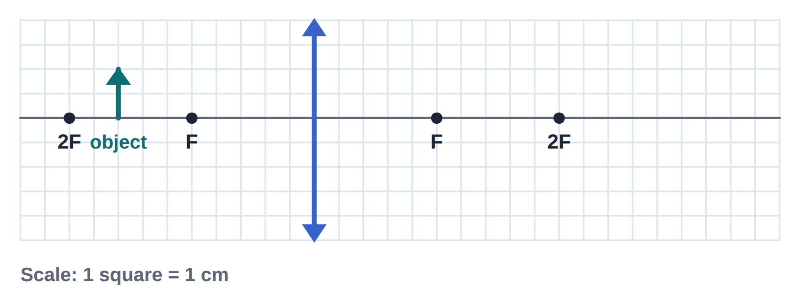
(a) Complete the ray diagram to locate the image. Label the image. [3]
(b) Measure the distance of the image from the lens. [1]
..............................................................................................................
..............................................................................................................
image distance = ........................... cm
(c) Measure the height of the image. [1]
..............................................................................................................
..............................................................................................................
height = ........................... cm
(d) State three characteristics of the image. [2]
..............................................................................................................
..............................................................................................................
(e) Name one optical device that uses this arrangement. [1]
..............................................................................................................
[Total: 8]
5 A small lamp is fixed to the bottom of a swimming pool. The refractive index of water is 1.33.
(a) Calculate the critical angle for water. [2]
..............................................................................................................
..............................................................................................................
critical angle = ........................... °
(b) A ray from the lamp strikes the water surface at an angle of incidence of 30°. Calculate the angle the ray makes with the normal in the air. [2]
..............................................................................................................
..............................................................................................................
angle = ........................... °
(c) Another ray strikes the surface at an angle of incidence of 60°. Describe and explain what happens to this ray. [2]
..............................................................................................................
..............................................................................................................
..............................................................................................................
[Total: 6]

Section B · Answer one question.
6 A student uses a converging lens of focal length 8.0 cm as a magnifying glass to look at a stamp.
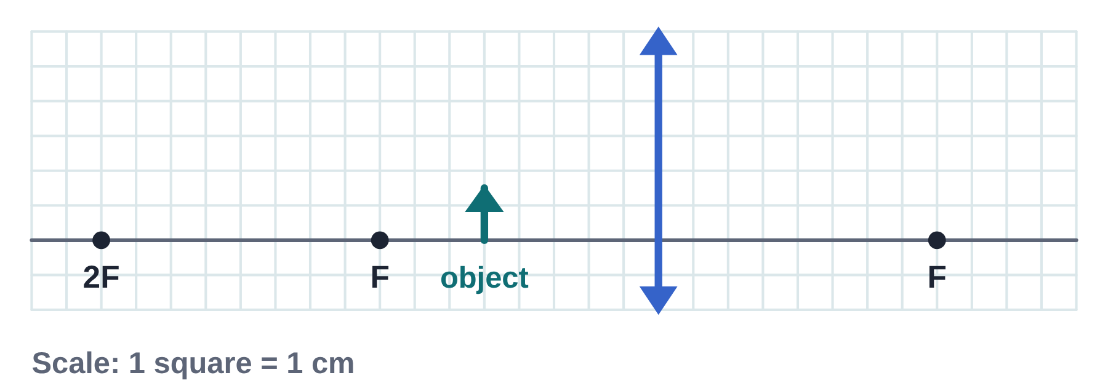
(a) Define principal focus. [1]
..............................................................................................................
..............................................................................................................
(b) The stamp detail, 1.5 cm tall, is 5.0 cm from the lens. On the grid (1 square = 1 cm), complete a ray diagram to find the image. Label the image. [3]
(c) State the distance of the image from the lens and its height. [2]
..............................................................................................................
..............................................................................................................
(d) The student moves the lens so that the stamp is 12 cm from it. Describe the image now formed. [2]
..............................................................................................................
..............................................................................................................
[Total: 8]
7 A student investigates refraction using a ray box and a rectangular glass block. For five angles of incidence i, she measures the angle of refraction r.
i / ° | r / ° | sin i | sin r
20 | 13.2 | 0.342 | 0.228
30 | 19.5 | 0.500 | 0.334
40 | 25.4
50 | 30.7 | 0.766 | 0.511
60 | 35.3
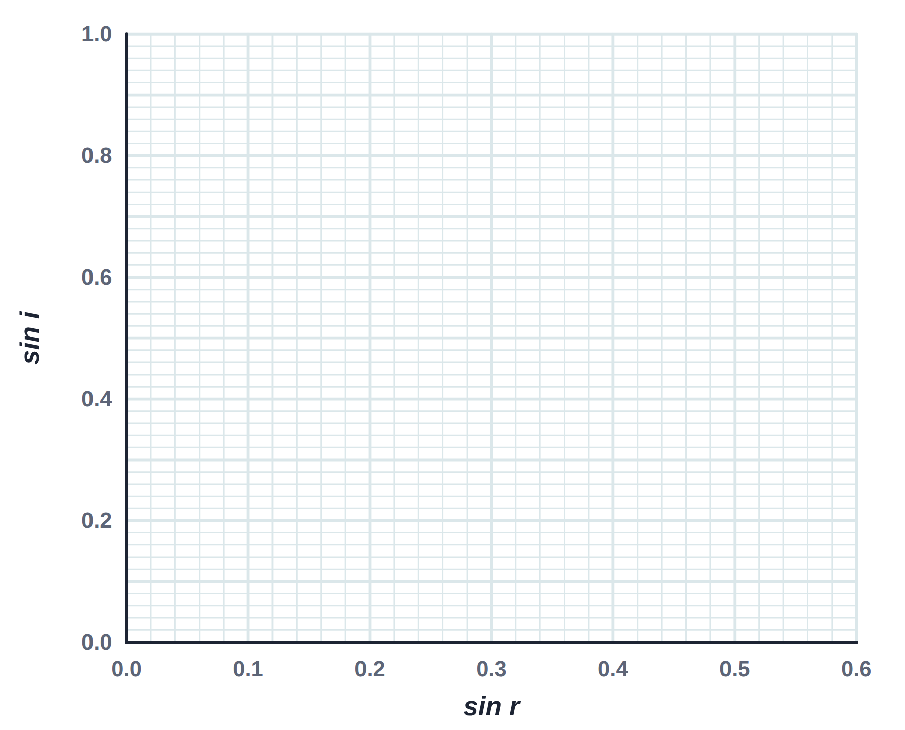
(a) Describe how she can mark the path of the ray inside the block to measure r. [2]
..............................................................................................................
..............................................................................................................
..............................................................................................................
(b) Complete the table. [2]
(c) Plot sin i against sin r on the grid and draw the best-fit line. Use it to find the refractive index of the glass. [3]
..............................................................................................................
..............................................................................................................
refractive index = ...........................
(d) State one precaution to improve the accuracy of her measurements. [1]
..............................................................................................................
..............................................................................................................
[Total: 8]
END OF PAPER 2

Answer key
Paper 1 · Multiple choice
Q | Answer | Why
1 | A | Angles are measured from the normal: 90° − 30° = 60°.
2 | B | i + r = 35° + 35° = 70°.
3 | C | A plane mirror image cannot be caught on a screen, is upright, same size and left–right reversed.
4 | D | III is false: light slows down in glass.
5 | A | v = c / n = 3.0 × 10⁸ / 1.6 = 1.9 × 10⁸ m/s.
6 | B | Same i, so the smallest r means the greatest bending and the largest n.
7 | C | n = sin 45° / sin 28° = 0.707 / 0.469 = 1.51.
8 | D | Light speeds up entering air (less dense), so it bends away from the normal.
9 | A | sin c = 1 / 1.25 = 0.80, so c = 53°.
10 | B | Colour is irrelevant to whether TIR occurs.
11 | C | TIR can only happen going from higher n (core) to lower n (cladding).
12 | D | 50° > 42°, so total internal reflection occurs.
13 | A | High data capacity and low loss are the key advantages.
14 | B | By definition.
15 | C | At 2F the image is the same size; inside F it is virtual; beyond 2F it is real and diminished.
16 | D | An object at F gives parallel rays: no image is formed (at infinity).
17 | A | Object inside F: virtual, upright, magnified.
18 | B | Real images from a single converging lens are inverted.
19 | C | The object is at 2F, so the image is at 2F: 20 cm.
20 | D | Between F and 2F gives a real, inverted, magnified image on the screen.

Paper 2 · Question 1 [5]
(a) [2]
The angle of incidence equals the angle of reflection. The incident ray, the reflected ray and the normal lie in the same plane.
(b) [1]
Refractive index = speed of light in a vacuum ÷ speed of light in the medium.
(c) [2]
Use n = c / v.
n = 3.0 × 10⁸ / 2.25 × 10⁸ = 1.33

Paper 2 · Question 2 [7]
(a) [2]
Rearrange n = sin i / sin r.
sin r = sin 40° / 1.52 = 0.643 / 1.52 = 0.423
Inverse sine.
r = 25.0°
(b) [2]
Use v = c / n.
v = 3.0 × 10⁸ / 1.52 = 1.97 × 10⁸ m/s
(c) [2]
It is parallel to the incident ray (displaced sideways). The ray meets the second face at 25.0°, so by reversibility it leaves at 40° to the normal.
(d) [1]
Its angle of incidence is 0°, so sin r = 0 and r = 0°: it slows down but does not change direction.

Paper 2 · Question 3 [6]
(a) [1]
The angle of incidence in the optically denser medium for which the angle of refraction is 90°.
(b) [2]
Use sin c = 1 / n.
sin c = 1 / 1.48 = 0.676, so c = 42.5°
(c) [2]
Light strikes the core–cladding boundary at an angle of incidence greater than the critical angle, so it is totally internally reflected. This repeats all along the fibre, even round bends.
(d) [1]
Only a small opening (or none) is needed, so less pain, lower risk of infection and faster recovery.

Paper 2 · Question 4 [8]
(a) [3]
Ray parallel to the axis refracts through F; ray through C is undeviated; they cross at the image tip.
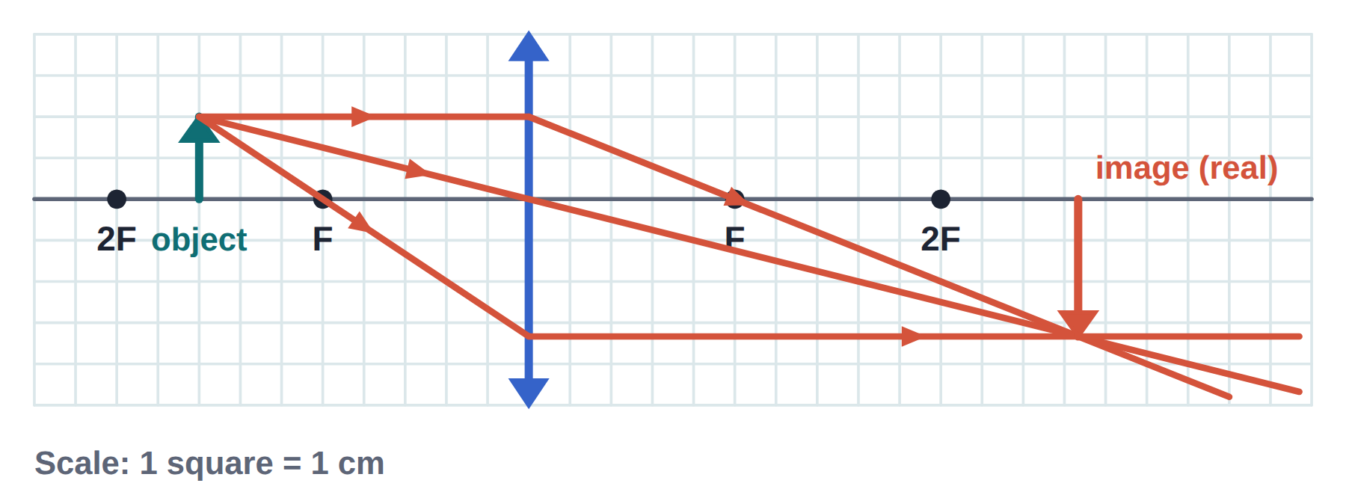
(b) [1]
13.3 cm (accept 12.5–14.0 cm)
(c) [1]
3.3 cm (accept 3.0–3.6 cm)
(d) [2]
Real, inverted, magnified. (3 correct: 2 marks; 2 correct: 1 mark)
(e) [1]
A projector.

Paper 2 · Question 5 [6]
(a) [2]
Use sin c = 1 / n.
sin c = 1 / 1.33 = 0.752, so c = 48.8°
(b) [2]
The larger angle is in air.
sin θ = 1.33 × sin 30° = 0.665
Inverse sine.
θ = 41.7°
(c) [2]
It is totally internally reflected back into the water, because 60° is greater than the critical angle of 48.8° and the light is going from water to air.

Paper 2 · Question 6 [8]
(a) [1]
The point on the principal axis where rays parallel to the axis converge after passing through the lens.
(b) [3]
Draw the parallel ray through F and the ray through C; they diverge, so extend both back with dashed lines until they meet.
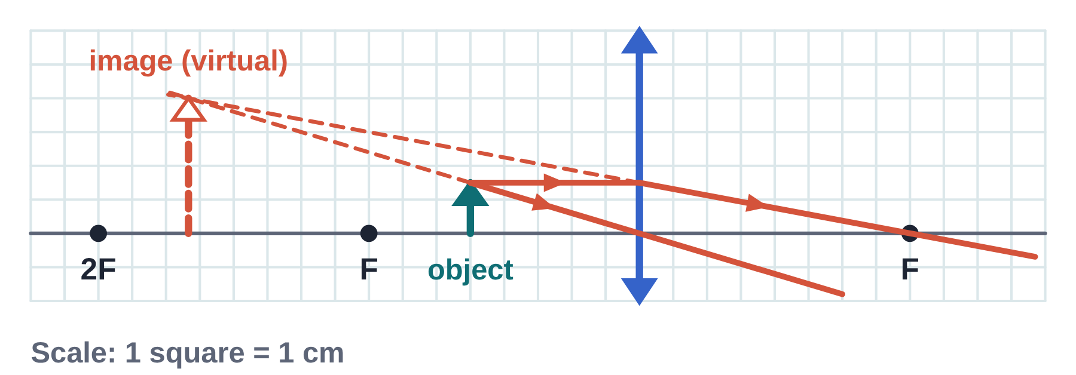
(c) [2]
13.3 cm from the lens, on the same side as the stamp (accept 12.5–14.0 cm); height 4.0 cm (accept 3.7–4.3 cm).
(d) [2]
The stamp is now between F and 2F, so the image is real, inverted and magnified, on the opposite side of the lens (beyond 2F).

Paper 2 · Question 7 [8]
(a) [2]
Mark the incident and emergent rays with crosses (or pins) far apart, remove the block, join the entry and exit points with a straight line, then draw the normal and measure r with a protractor.
(b) [2]
i = 40°: sin i = 0.643, sin r = 0.429. i = 60°: sin i = 0.866, sin r = 0.578.
(c) [3]
Points lie on a straight line through the origin, so sin i / sin r is constant (Snell’s law).
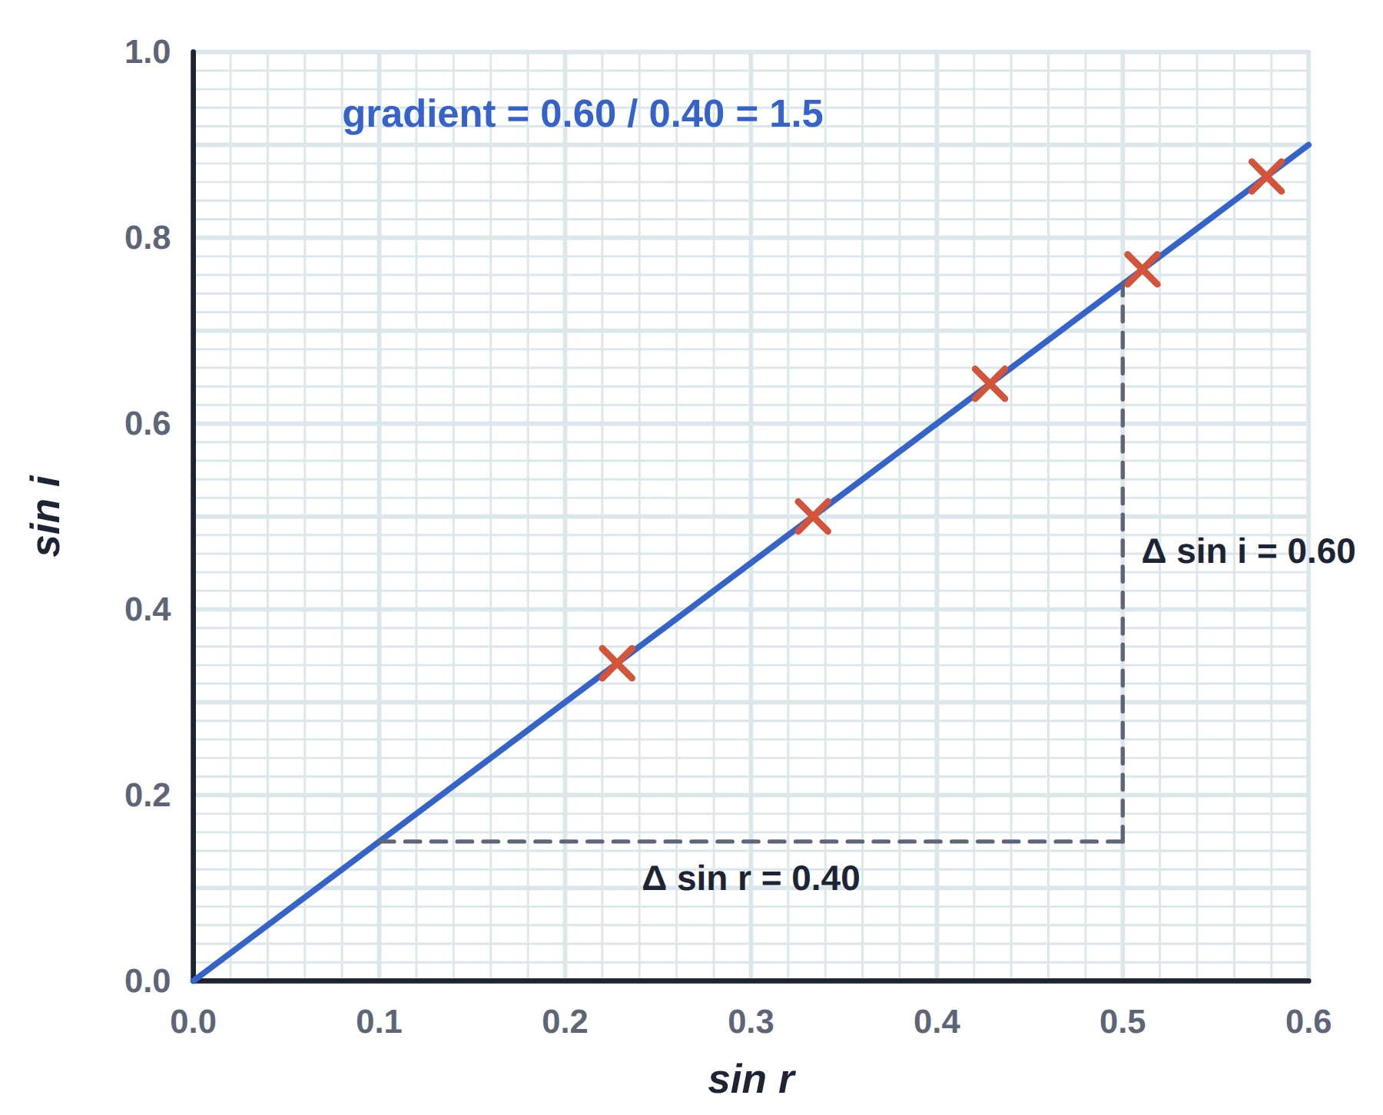
Gradient from a large triangle.
n = 0.60 / 0.40 = 1.5
(d) [1]
Use a narrow ray; read the protractor with the eye directly above; mark the ray at points far apart; repeat and average.

