Predicting Solar Eclipses:
Part IB Computing Prize Problem
Leonhard Markert ‧ lm510
20 March 2012

Task
Numerically integrate the orbits of celestial bodies in order to predict when solar eclipses will occur. Given are the positions, velocities, masses, and radii of the Moon, Earth, and Sun at midnight on the beginning of 7 January, 2008.

Implementation
The source code of this project is laid out as follows:
src/
|-- libtwilight/
| |-- date.cc
| |-- date.hh
| |-- geometry.cc
| |-- geometry.hh
| |-- libtwilight.hh
| |-- numerics.cc
| |-- numerics.hh
| |-- physics.cc
| `-- physics.hh
`-- twilightbin/
|-- main.cc
|-- utils.cc
`-- utils.hh
Of these files, physics.cc, numerics.cc and geometry.cc are the most important ones and will be discussed in the following sections. date.cc contains an implementation of a minimal Date class used to output the dates at which solar eclipses occur. main.cc and utils.cc parse the command line options and contain the program’s main loop.

Physics
The physics of the problem is modelled as a system (class System) containing a list of bodies (of type struct Body) as well as their current positions and velocities. Body is just a collection of properties: It has fields mass, radius, and name.
The physical simulation is done in the System.pulse method. It advances the state of the system by one time step, recalculating all the bodies’ positions and velocities by calling the appropriate numerical integration method. These, in turn, make use of System.gravitate, which calculates the gravitational accelerations acting on each body in the system due to all other bodies.

Numerics
numerics.cc consists of five functions, each corresponding to one method of numerical integration: Euler, Heun (also known as Predictor-Corrector), Gauss (Gaussian Quadrature using five points), Fourth Order Runge-Kutta (RK4), or Runge-Kutta-Fehlberg (RKF).

Geometry
Checking whether the centres of Earth and Moon are within a constant angle as seen from the Sun proved not to be a very reliable method of predicting solar eclipses. Instead, the program checks the actual geometry of the constellation to see if there is an eclipse.
Firstly, the coordinates of the three bodies are projected onto a plane. Then, the tangents from the Sun to Moon and Earth are found (see Figure 1). If the Moon is between the Sun–Earth tangents, there is a solar eclipse (see Figure 2).

Data Types
Initially, I wrote my own Vector3D class to deal with the positions of the bodies in 3D space. The System class contained a vector<Vector3D> for the positions and one for the velocities of its bodies.
After a bit of research, I discovered the Eigen linear algebra C++ library. It is very fast and easy to use and reduced the amount of boilerplate code I had to write for each batch of vector calculation enormously. Now, the positions and velocities are stored in an Array3Xd each. An Array3Xd is a matrix with three rows and a variable number of columns where each component has double precision (hence the d). The individual position and velocity vectors of the bodies are the columns of the respective matrices.

Usage
twilight -h shows the list of options and their defaults:
Options:
-h [ --help ] print help message
-n [ --days ] arg (=3650) set duration of simulation (days)
-d [ --dt ] arg (=0.002) set time step (days)
-m [ --method ] arg (=rkf) set integration method: 'euler',
'heun', 'gauss', 'rk4', or 'rkf'
Example: To run the simulation using the start data given on the exercise web page (saved in system.in) for twenty years (from 7 January, 2008) using the Fourth Order Runge-Kutta method and a time step of 0.003 days, use twilight -n 7300 -d 0.003 -m rk4 < system.in > /dev/null. This will discard the calculated positions (via stdout) to /dev/null and print the dates at which it predicts solar eclipses to the screen (via stderr).

Results
After many test runs, I compiled a spreadsheet that compares the actual solar eclipse dates from Wikipedia to one set of output data for each numerical integration method.
It shows that the errors of the algorithms really have different orders of magnitude. This difference is especially apparent when one compares the column computed using the Euler method and a time step of 0.0001 days and the column computed using the Heun method and a time step of 0.002 days – the computation for Euler used 50 times as many steps, but predicts solar eclipses accurately for only one year (2008) whilst the Heun data is accurate up to and including 2012. That is the difference between O(dt) – Euler – and O(dt²) – Heun.
The spreadsheet also shows that Gaussian Quadrature is either a very bad integration method (using three times as many function evaluations than Heun but less accurate) or my implementation of it is faulty; I believe that the latter is the case.

Conclusions
The computed data and the runtime of the program to obtain it using the different algorithms (see spreadsheets) shows that an awareness of the complexity and expected error of the methods of numerical integration that are available is important.

Libraries
I made use of the following open source C++ libraries in my program:
Eigen, a linear algebra library used by a number of scientific projects, amongst them the European Space Agency’s Space Trajectory Analysis, and Boost.ProgramOptions, a command line options parsing library.

Tools
Whilst writing the code, I made use of the following tools:
Vim, my text editor of choice; Git, a distributed version control system, to manage the code; Premake and GNU Make to simplify and speed up the compilation process; GeoGebra to sketch diagrams of possible constellations of Sun, Earth and Moon as well as to find ways to construct tangents; Python to analyse and compare data using two scripts (list_eclipses.py and csv_merge.py); show_sim (which I copied from the Department server) to visualise the movement of Sun, Earth and Moon, particularly in the early stages of the project.

Appendix
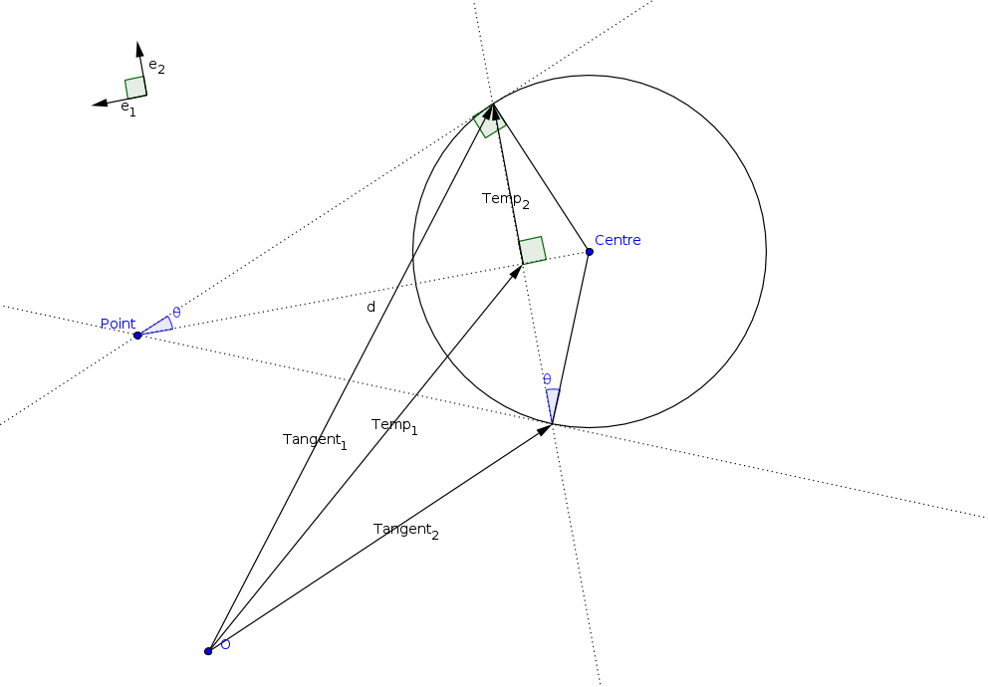Figure 1: Finding the tangents to a circle
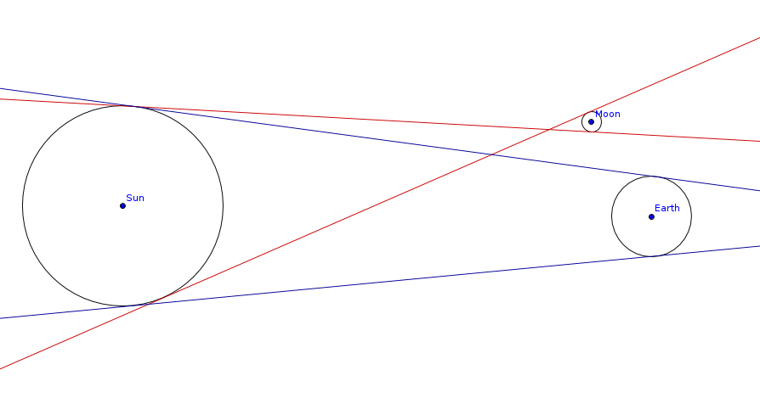Figure 2: The Moon is not between the Sun–Earth tangents: No solar eclipse

