**PROBLEM 1**

A binary geothermal power station is operated with geothermal fluid extracted at 90oC and re-injected at 30oC. Propane (C3) is used as working fluid in the Rankine cycle to produce power (WT) in a turbine. After condensation, propane is driven to a heat exchanger and the cycle continues. The mass flow rate of propane is 10 kg/s and the heat capacity (CP) of the geothermal fluid (A-B) is 3565.5 J.(kg.K)-1.

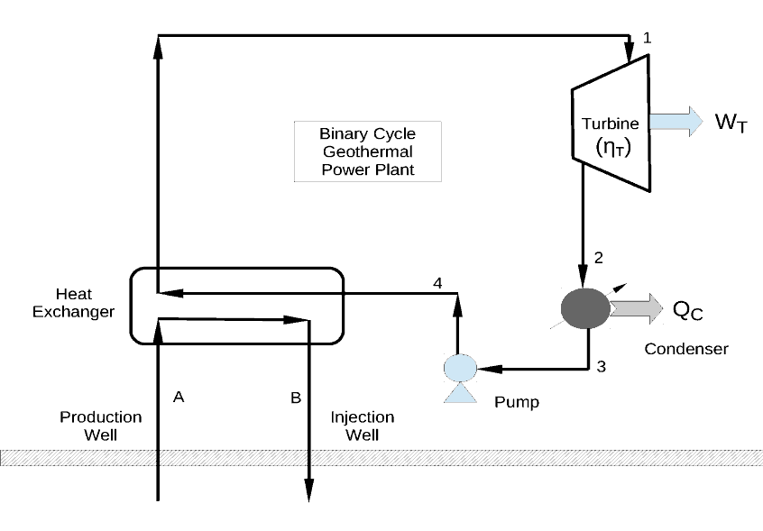

Geothermal

fluid

Conditions for propaneand geothermal fluid flows are described in the table below.

|  |  |  |  |  |  |
| --- | --- | --- | --- | --- | --- |
| **Stage** | **P (bar)** | **T(oC)** | **State** | **h (kJ/kg)** | **s (kJ/(kg.K))** |
| **1** | 20 | 80 | **(i)** | **-** | **-** |
| **2** | 0.50 | - | Wet vapour | **(ii)** | **(iii)** |
| **3** | 0.50 | - | Saturated Liquid | **-** | - |
| **4** | 16 | - | - | **(iv)** | - |
| **A** | - | 90 | - | - | - |
| **B** | - | 60 | - | - | - |

1. Determine (i)-(iv) from the table above. **[4 Marks]**
2. Calculate the power produced by the turbine (WT) and the heat released in the condenser, in *MW*. **[2 Mark]**
3. Propane is returned to the saturated liquid state in the condenser using water (Cp,w=4.1813 kJ/(kg.K)) as a cooling fluid. The water enters the condenser at 15 oC (Twin) with a mass flow rate of 5 kg/s. Calculate the temperature of the water leaving the condenser (Twout). Assume that there is no heat losses to the environment **[3 Mark]**
4. Calculate the mass flow rate of geothermal fluid (A-B), assuming that the heat exchanger operates with 100% efficiency. **[3 Marks]**
5. What are the main environmental impacts on binary geothermal power plant? Discuss. **[4 Marks]**
6. Temperature gradient between upper and deep layers of rocks (i.e., near the surface and at large depths) can lead to geothermal circulation. Define thermal buoyancy and its links to thermal convection. **[3 Marks]**
7. What are the main heat transfer mechanisms in subsurface geothermal systems? Explain how these mechanisms are connected.  **[6 Marks]**

To solve this problem, you should assume that the saturated liquid streams are incompressible, and therefore *dh = vdP* (where *h*, *v* and P are specific enthalpy, specific volume and pressure, respectively). Quality of the vapour stream is expressed as,

$$x_{j}=\frac{ψ_{i}-ψ_{f}}{ψ_{g}-ψ_{f}}\text{ with }ψ=h,s$$

where *s* is the specific entropy.

**SOLUTION:**

*In order to fill the Table we need to calculate the thermodynamic properties for each*

*stage of the cycle:*

**Stage 1:** *At P1 = 20 bar, T1 = 80oC > Tsat (P1) = 57.27 oC. Therefore the fluid is*

**[1/4]** *at* **(i)** **superheated state**. *From the superheated table for C3 at P1 and T1, we*

*can obtain:*

h1 = 578.8 kJ.kg-1 *and*

s1 = 1.867 kJ.(kg.K)-1 .

**Stage 2:** *At P2 = 0.50 bar, the fluid is wet vapour after the isentropic expansion*

**[1/4]*****(iii)****(****s2****=s1=***1.867 kJ.(kg.K)-1***). We should first calculate the quality of the vapour (using values of entropy/enthapy obtained from the saturated C3 table at P2)*

now to calculate the enthalpy,

**[1/4] $x_{2 }= 0.9980= \frac{h_{2 } - h_{f}}{h_{g}- h_{f}}= \frac{h_{2 }–(-37.6)}{402.9-(-37.6) } \overset{⇔}{} h_{2}=402.02 \frac{kJ}{kg}$** **(ii)**

**Stage 3**: *At P3 = P2 = 0.5 bar, the fluid leaving the condenser towards the pump is*

*saturated liquid, and the enthalpy and specific volume are the same of the liquid*

*phase obtained from the saturated table:*

$h_{3 }= h_{f} \left(P=0.5 bar\right)= -37.6 kJ .{kg}^{-1}$

$v_{3}= v_{f} \left(P=0.5 bar\right)= 1.672 × {10}^{-3} m^{3} .{kg}^{-1}$

**Stage 4**: *The fluid leaving the pump is* sub-cooled liquid. As there is no heat loss

*in the pump, we can assume dH =V dP, therefore*

**[1/4] *(iv)***

$$h_{4}= h_{3 }+ { v}_{3} \left(P_{4}- P_{3}\right)=-37.6 \frac{kJ}{kg}+ 1.672 ×{10}^{-3} \frac{m^{3}}{kg} \left(20-0.5\right)bar=-34.34\frac{kJ}{kg}$$

**Turbine:**

**[1/2] $W_{T }= {\dot{m}}_{C3} \left(h_{2}- h_{1 }\right)= 10\frac{kg}{s}×\left(402.02-578.8\right)\frac{kJ}{kg}=-1767.8\frac{kJ}{s}=1.77MW$**

**Condenser**

**[1/2]**



$$Q_{C }= {\dot{m}}_{C3} \left(h_{3}- h_{2 }\right)= 10\frac{kg}{s}×\left(-37.6-402.02\right)\frac{kJ}{kg}=-4396.2\frac{kJ}{s}=4.40MW$$

*The heat extracted from the condenser is transferred to the cooling water stream, assuming no heat loss:*

**[3/3] ${-Q}_{C }= {\dot{m}}_{w}C_{p,w} \left(T_{w,out}- T_{w,in }\right)= 5\frac{kg}{s}×4.1813\frac{kJ}{kg.K}\left(T_{w,out}-15\right)$**

***Tw,out = 225.27oC***



*Energy balance in the heat exchanger assuming that there is no heat losses.*

**[3/3]**

$${\dot{m}}_{C3}\left(h_{1}- h_{4 }\right)= {\dot{m}}_{geot}C_{p,geot} \left(T_{geot,out}- T_{geot,in }\right)$$

***mgeot = 28.66 kg/s***



**[4/4]**

*Any 3 of:*

* *Temperature of the geothermal fluid re-injected is too high. It will need to be cooled and all (concentrated) minerals (and heavy metals, e.g., Ar, Se etc) will need to be removed before re-injection and properly discarded.*
* *Also, non-condensable gasses (e.g., H2S) will need to be removed;*
* *Heat removal from the condenser: if the wasted heat is used elsewhere the environmental impact is kept minimum otherwise the heat transferred to the cooling water will be released to the environment;*
* *Although the propane cycle is closed, there are losses in the long term (due to plant maintenance or hydrocarbon decomposition/degradation).*



**[3/3]**

*Let's consider a geothermal reservoir with dimension $\underline{X }(=x,y,z)$*  *with* imposed

temperature gradient $(∇T=\frac{∂T}{∂z})$*and saturated with fluid with density*

$ρ=ρ(T,ρ,\underline{X}, salinity, etc)$.

*Under static* *conditions, pressure can be expressed as $p=ρgz$. Algebraic expressions,*

*known as* equations of state (EOS), are designed to correlate density, temperature,

pressure and any other thermodynamic potential. *The pressure can be obtained by integrating the above equation through the depth,*

$$p\left(z\right)=\int_{0}^{z}{ρ\left(z\right)gdz}$$

*Thermal buoyancy is a physical phenomenon in which cold and denser fluid at low depth $(z→0)$ displaces warm and lighter fluid at larger depth pushing the warmer fluid upwards.*



**[2/6]** There are 3 main heat transfer mechanisms in geo-fluid flows in the subsurface:

* Thermal conduction;
* Convection (or interphase heat transfer) and;
* Thermal radiation from the Earth’s core to rock formations at (relatively) low depth.

**[2/6]**

Conduction mechanisms occur within the same phase and depend on surface contact between materials (i.e., rocks of distinct geological nature) and are proportional to the temperature gradient,

$$q_{cond}=-κ∇T$$

Thus heat from geothermal rock formations at large depth is transported through surface contact between rocks to low depth rocks (geological formation). The heat transported from this depth leads to high rock temperature (Ts) at the interface with rock saturated with fluids. As the temperature of such saturated rocks (Trs) is smaller than Ts, heat is transferred from the interfacial layer to the saturated rock. Thermal conduction may also occur in the upper region of the strata as conductive heat loss.

**[2/6]**

The difference in temperature between the interface rock and the rock saturated with geothermal fluids leads to forced convective heat transfer. Here assuming that the system rock saturated with fluids is at uniform temperature, the convective heat transfer between the interface-layered rocks and the fluids is

$$q_{conv}=h∆T$$

As the fluids are heated up (and partially/fully vaporised), they become less dense and moved upward by sinking ‘cold’ (and denser) geothermal fluids. This thermally-driven fluid circulation is called natural convection and is due to thermal buoyancy.