**PROBLEM 1**

An engineer decided to use a geothermal source from the yard to keep her Scottish house warm during the winter. The designed heat pump extracts water from the well at 15oC and discharges at 8oC. As working fluid, she decided to use propane (C3) - see Figure below, that will transfer heat into a constant stream of cold air (mair = 2 kg/s, Cp,air = 1.004 kJ/(kg.K)) at 12oC.

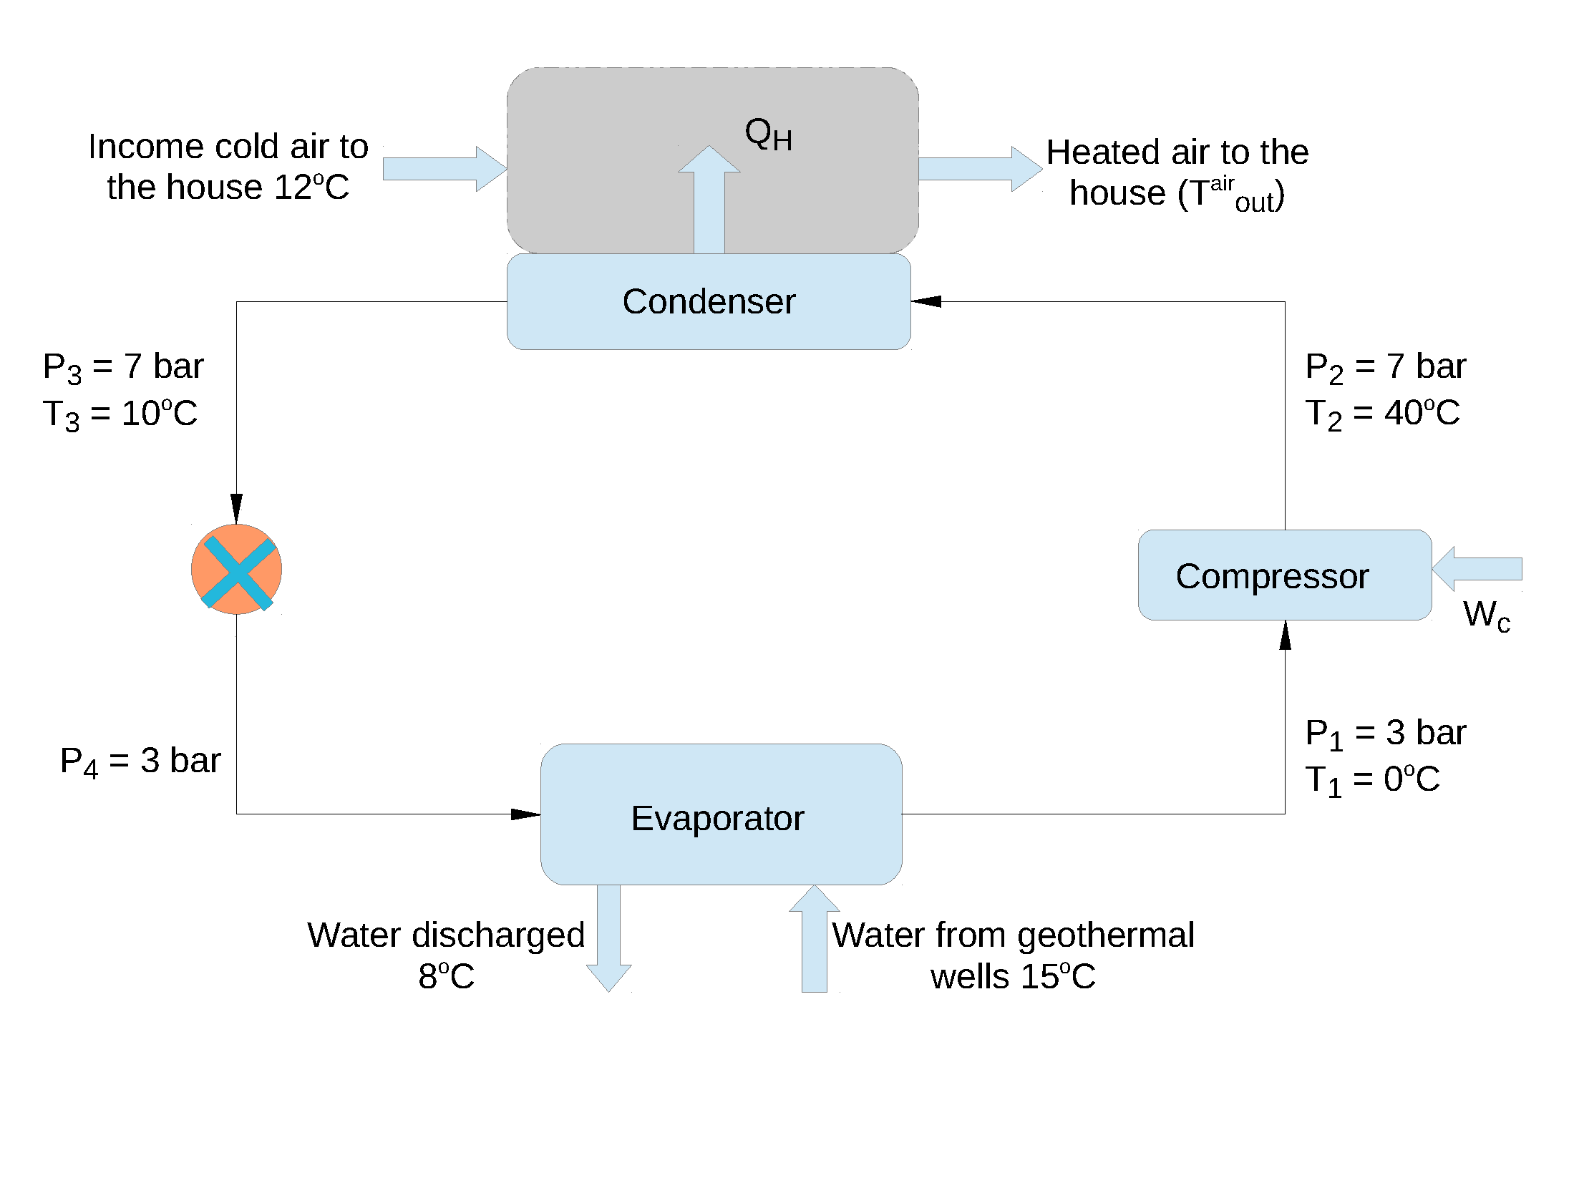

Expansion valve

1. Calculate enthalpies and entropies of streams 1-4. **[8 Marks]**
2. For a mass flow rate of C3 (mC3) of 0.1 kg/s, calculate the required water flow rate (mW). The heat capacity (CP) of water is 4.1813 kJ/(kg.K). **[2 Marks]**
3. Assuming that all heat extracted in the condenser is transferred to the air stream (mair = 2 kg/s), calculate the temperature of this heated stream $\left(T_{\text{out}}^{\text{air}}\right)$. **[5 Marks]**
4. Nearby the engineer’s house, a geothermal reservoir was mapped and the following data was gathered,

|  |  |  |  |  |  |  |
| --- | --- | --- | --- | --- | --- | --- |
| **Temperature (oC)** | 25 | 40 | 63 | 100 | 155 | 245 |
| **Depth (m)** | 0 | 200 | 400 | 600 | 800 | 1000 |

* 1. Calculate the temperature gradient of this reservoir. **[2 Marks]**
  2. Binary cycle geothermal power plants operate at a temperature above 100oC. Assuming there is no heat losses in the production well, what is the ideal depth for a source geothermal fluid of 143oC?

**[3 Marks]**

* 1. Describe how binary cycle geothermal power plants operate. **[5 Marks]**

To solve this problem, you should assume that the saturated liquid streams are incompressible, and therefore *dh = vdP* (where h, v and P are specific enthalpy, specific volume and pressure, respectively). Quality of the vapour stream is expressed as,

$$x_{j}=\frac{ψ_{i}-ψ_{f}}{ψ_{g}-ψ_{f}}\text{ with }ψ=h,s$$

where s is the specific entropy.

**Solution: (a)**

**Stage 1:** is at $P_{1}=3 bar and T_{1}=0℃\underset{⇒}{}T_{sat}=-14.16℃<T_{1}, thus C_{3}$*is at*

[1/8]  *superheated state (SHF). Thus, from SHF table*, $h_{1}=477.1 kJ.{kg}^{-1}and$

[1/8] $s_{1}=1.851kJ.{(kg.K)}^{-1}$

**Stage 2: $At P_{2}=7 bar and T_{2}=40℃\overset{⇒}{}T_{sat}=13.41℃<T_{2 }, thus C_{3}$** is at

[1/8] superheated state (SHF). Thus, from SHF table $h_{2}=534.8 kJ.{kg}^{-1}$ and

[1/8] $s_{2}=1.901kJ.{(kg.K)}^{-1.}$

**Stage 3: $At P_{3}=7 bar and T_{3}=10℃\overset{⇒}{}T_{sat}=13.41℃>T_{2 }, thus C_{3}$** is

[1/8] a sub-cooled fluid. Thus, from saturated table, $h_{3}=129.6 kJ.{kg}^{-1}$ and

[1/8] $s_{2}$**=0.495 kJ ${(kg.K)}^{-1}.$**

[1/8] **Stage 4:** At $P_{4}=3 bar \overset{⇒}{} Isenthalpic expansion, thus h_{4}=h_{3}=129.6 kJ.{kg}^{-1}$.

In order to calculate the entropy, we first need to calculate the quality of the fluid,

$$x_{4}=\frac{h_{4}-h_{f}}{h_{g}- h_{f}}=\frac{129.6-60.3}{453.6-60.3}=0.1762$$

$$x_{4}=0.1762=\frac{s_{4}-s_{f}}{s_{g}-s_{f}}=\frac{S_{4}-0.244}{1.762-0.244}\overset{⇒}{}s_{4}=0.5115\frac{kJ}{kg.K}$$

[1/8]

**Solution: (b)**

*The heat exchange in the evaporator can be expressed as:*

$${\dot{-m}}_{C3}{(h}_{1}-h_{4})={(h}_{w}^{out}-h_{w}^{in})={\dot{m}}_{w}C_{p,w}\left(T_{w}^{out}-T_{w}^{in}\right)$$

$$-{10}^{-1}\left(477.1-129.6\right)={\dot{m}}_{w}×4.1813×\left(8-15\right)\overset{⇒}{}{\dot{m}}_{w}=1.1873 \frac{kg}{s}$$

[2/2]

**Solution: (c)**

*The heat exchange in the condenser is expressed as*

$$Q_{H}={\dot{m}}_{C3}{(h}_{2}-h_{3})=40.52\frac{kJ}{kg}$$

[2/5] *Assuming that there is no heat loss,*

$$Q_{4}=40.52={\dot{m}}_{air}C_{p,air}\left(T_{out}^{air}-T_{in}^{air}\right)=2×1.004×\left(T_{out}^{air}-12\right){\overset{⇒}{} T}_{out}^{air}=32.18℃$$

[3/5]

**Solution: (d - i)**

$$∇T=\frac{∂T}{∂z}=\frac{T_{n}-T_{1}}{z_{n}-z_{1}}=\frac{245-25}{1000-0}=0.22\frac{℃}{m}$$

[2/2]

**Solution: ( d – ii)**

The depth can be obtained via linear interpolation at $100≤T≤155℃.At 143℃$ the [3/3] depth is **756.36m**

**Solution: (d – iii)**

* Binary cycle geothermal power plants are often operated between $107≤T≤182℃$;

[1/5]

* The produced hot brine vaporises the working fluid and is isentropically expanded in the turbine;

[2/5]

* Working fluids often used in geothermal plants are organic chemical species with low boiling temperature.

[2/5]