trapezoid_box.py
Build Validation Manual
v0.20 — From first Python run to first cut

This document covers:
Phase 0 Prerequisites and material checklist
Phase 1 Proof scripts — 7 pass/fail gates before any cutting
Phase 2 Generate and inspect SVG output
Phase 3 Test strip cut and kerf calibration loop
Phase 4 Full panel cut and dry-fit assembly
Phase 5 Instrument mode additions (soundboard, kerfing)
Appendix Error codes, troubleshooting, material reference

Phase 0 — Prerequisites

0.1 Software checklist
Install and verify each item before proceeding. All are free.

Item | How to verify
Python 3.9+ | python3 --version → 3.9 or higher
No extra libraries needed | Scripts use stdlib only (math, sys, os)
Inkscape 1.0+ | inkscape --version → opens and renders SVG
Your laser cutter software | Can import SVG and set cut vs engrave layers
trapezoid_box_proofs/ folder | Contains 01_trapezoid_geometry.py through 07_assembly_simulation.py

0.2 Material checklist — dulcimer preset (reference dimensions)
These quantities are for the reference dulcimer preset: long=180mm, short=120mm, length=380mm, depth=90mm, thickness=3mm. If you change any dimension, re-run the tool with --estimate-material to get updated quantities.

Material | Quantity
3mm laser-grade plywood or MDF | 1 sheet 600 × 400 mm (box mode, no soundboard) — 600×600 is NOT needed
3mm laser-grade plywood or MDF | 2 sheets 600 × 400 mm (instrument mode with soundboard)
Wood glue (PVA) | Small bottle — finger joints need very little
Clamps or rubber bands | 4–6 corner clamps or heavy rubber bands for glue-up
Calipers (0.01mm resolution) | Essential for measuring test strip fingers
Scrap material (same sheet) | ~60 × 340mm offcut of 3mm ply/MDF — the TEST_STRIP (60×270mm) plus a small mating slot strip (60×60mm). Any workshop scrap works. You do NOT need a full sheet for test cuts.

NOTE Sheet size note: the 180×380mm BASE panel is the largest single piece. Your laser bed must accommodate at least 400×400mm. Standard 600×400mm laser bed is comfortable. If your bed is smaller, adjust long/short/length dimensions and re-run.

0.3 Material quantities — detailed breakdown
Panel bounding boxes for the dulcimer preset (actual panel areas are less due to trapezoid shape and finger joints):

Panel | Bounding box (mm) | Count
BASE | 180 × 380 | 1
SOUNDBOARD (instrument mode) | 180 × 380 | 1
WALL_LONG | 180 × 90 | 1
WALL_SHORT | 120 × 90 | 1
WALL_LEG_LEFT / RIGHT | 381 × 90 each | 2
NECK_BLOCK / TAIL_BLOCK | 25 × 90, 15 × 90 | 1 each
TEST_STRIP | 60 × 270 | 1
KERF_STRIP (instrument mode) | 374 × 12 each | ~8
NECK_SLOT_PLUG (if neck slot) | 42 × 15 each | 1 or 2
Total (box mode, no soundboard) | ~130,000 mm² | ≈ 0.13 m²
Total (instrument mode) | ~257,000 mm² | ≈ 0.26 m²

Phase 1 — Proof Scripts
Run all seven scripts in order. Each script is independent — no installation required beyond Python 3.9+. A script either exits with ALL PASS or prints the failing check with expected vs actual values.
Purpose: these scripts verify that the geometry spec is arithmetically correct before any code is written or material is cut. They are not unit tests for an implementation — they are proofs of the specification itself.

1.1 Script 01 — Trapezoid geometry derivation
Step 1. Run the script: — cd trapezoid_box_proofs && python3 01_trapezoid_geometry.py
Checks: mode A (length given), mode B (leg given), DimMode.INNER expansion, boundary conditions, square-box degenerate case.
PASS All 27 checks pass. Output ends: ALL PASS — trapezoid geometry derivation is correct.
FAIL Any FAIL line: note the label and delta. The label maps to a formula in spec Section 6. Most likely cause: leg_angle_deg or long/short_end_angle formula error.

1.2 Script 02 — Corner arc geometry
Step 2. Run: — python3 02_corner_arcs.py
Checks: tangent distances, arc centre offsets, bisector directions for all four BASE corners, proves wrong bisector formula gives wrong answer.
PASS All 30 checks pass. Key values confirmed: tang long-end = 8.317mm, tang short-end = 9.739mm.
FAIL centre_TR dist to arc_start fails: bisector formula is wrong. Correct formula: normalise(-edge_a_dir + edge_b_dir). The old wrong formula normalise(-edge_a_dir + -edge_b_dir) gives a centre 8.35mm from arc_start instead of 9.00mm — arc will not be tangent.

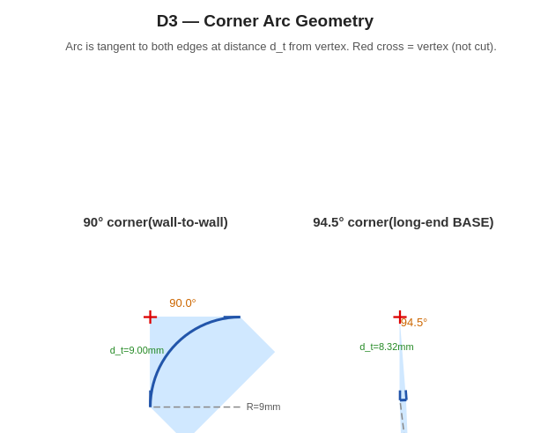
D3 — Corner arc geometry. Red cross marks the vertex. Arc is tangent to both edges at the tangent-distance points. Centre is on the inward bisector.

1.3 Script 03 — Finger joint geometry
Step 3. Run: — python3 03_finger_joints.py
Checks: auto finger width, D_eff and W_over corrections, structural safety, BASE finger counts, BASE-as-master spatial offset, burn compensation, sliding lid width formula, groove angle limit.
PASS All 33 checks pass. Confirmed: n_long=17, n_short=11, n_leg=39. Sliding lid width = 107.8mm. W_struct = 8.66mm (well above minimum 1.5mm).
FAIL sliding lid width check fails: formula must be short_inner - 2*(T+tol), not short_outer + 2*(T+tol). The wrong formula gives 126.2mm which is 18.4mm wider than the groove span and will not fit.
NOTE BASE-as-master: the test confirms WALL_LONG finger zone starts 0.739mm laterally offset from BASE if computed independently. That is 7x the 0.1mm assembly tolerance. Wall panels must inherit finger positions from BASE, not recompute them.

1.4 Script 04 — Panel alignment simulation
Step 4. Run: — python3 04_panel_alignment.py
Simulates assembling each wall panel against BASE in global coordinates. Verifies every tab/slot pair is spatially aligned and has opposite polarity.
PASS All 10 checks pass. All 4 mating pairs aligned: WALL_LONG (17 fingers), WALL_SHORT (11 fingers), WALL_LEG_LEFT (39 fingers), WALL_LEG_RIGHT (39 fingers). Max offset: 0.000mm.
FAIL Any polarity fail (both tabs / both slots): the wall panel bottom edge polarity assignment is inverted — first finger of BASE bottom is a TAB, so the mating wall edge must start with a SLOT.

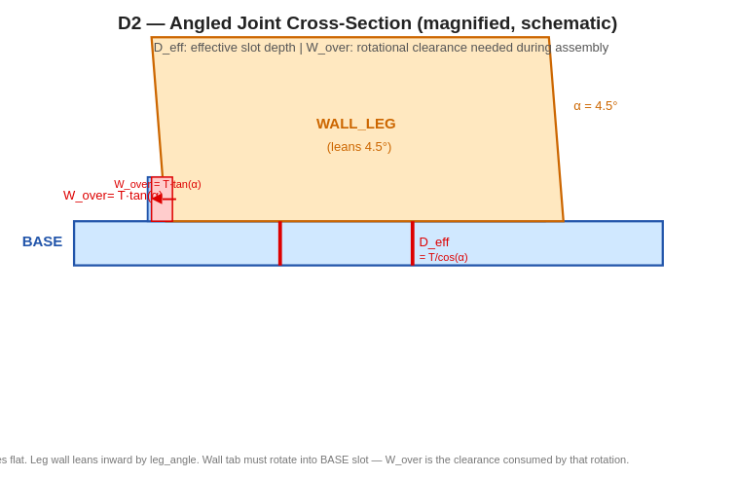
D2 — Angled joint cross-section. D_eff = T/cos(α) is the effective slot depth. W_over = T·tan(α) is consumed by the rotation during assembly. For dulcimer preset these are 3.009mm and 0.237mm respectively — small but non-negligible in the SVG path generation.

1.5 Script 05 — Helmholtz solver
Step 5. Run: — python3 05_helmholtz.py
Checks: solver convergence, round-trip accuracy, volume sensitivity, neck slot volume correction (full through-body and partial), triskele equivalent diameter.
PASS All 23 checks pass. Converges in <30 iterations. Round-trip frequency error < 0.0001Hz. Full through-body neck correction: 5.2% volume displaced, corrected diameter 21.883mm vs uncorrected 22.938mm.
FAIL round-trip frequency fails tolerance: the iterative solver is not converging. Check the L_eff formula: L_eff = T_top + 0.85 * diameter (end correction for a flanged circular aperture).
NOTE Neck slot correction is only needed for --neck-slot-both-ends (full through-body). One-end-only with tenon length under 100mm shifts frequency by less than 1Hz — within the spec 5% acceptance band.

1.6 Script 06 — SVG primitives (visual check)
Step 6. Run: — python3 06_svg_primitives.py
Generates four SVG files in the same directory. Open each in Inkscape or a browser.

File | What to look for
06a_corner_arcs.svg | All four BASE corners. Arcs smooth, no kinks. Red cross at vertex. No gap between arc end and edge start.
06b_finger_strip.svg | BASE long_bottom finger profile. Fingers regular width, centred in available space. Plain-line gaps at each end.
06c_full_base.svg | Complete BASE panel. Correct trapezoid shape. Arcs at all four corners. Fingers on short and long edges only (legs are plain line in this render).
06d_lid_width.svg | Cross-section: green lid fits inside the groove span with visible clearance. Groove notches visible in grey walls.
PASS All four SVGs open and look geometrically correct as described above.
FAIL 06a: arc has a kink or gap at the joint with the edge line — arc_start/end point calculation is wrong. 06c: panel looks rectangular, not trapezoidal — leg_inset is zero or geometry derivation is wrong.

1.7 Script 07 — Full assembly simulation (the integration test)
Step 7. Run: — python3 07_assembly_simulation.py
Three phases: individual geometry checks, full assembly simulation across all four mating pairs, validation rule checks, edge cases. 48 checks total.
PASS Output ends: ALL PASS — geometry is consistent and assembly-ready. 48 passed, 0 failed, 0 warnings.
FAIL Any failure in Phase 2 (assembly simulation): the BASE-as-master finger inheritance rule is not implemented correctly. The spatial positions of all finger centres must be identical between BASE and mating wall panels.
If all seven scripts pass: the geometry is verified. Proceed to Phase 2. The remaining risk is the physical cut — material thickness variance, actual kerf width, and assembly fit. These are addressed in Phase 3.

Phase 2 — Generate and Inspect SVG

2.1 Generate your first SVG
Once implementation exists, generate the box SVG with the reference preset:

python3 trapezoid_box.py --long 180 --short 120 --length 380 --depth 90 --thickness 3.0 --output my_box.svg

Expected stdout output (reference preset):
trapezoid_box v0.20
long=180 short=120 length=380 depth=90 thickness=3.0 R=9.0 fw=9.0
leg_angle=4.514 deg leg_length=381.182mm
BASE: long=17 fingers short=11 fingers legs=39 fingers
air_volume=4,523,904 mm3 (no sound hole — Helmholtz not computed)
sheets: 1 of 1 written: my_box.svg

PASS File my_box.svg written, no ERR_ lines in output, finger counts match 17/11/39.
FAIL Any ERR_ line: look up the error code in the Appendix. Most common at this stage: ERR_VALIDATION_GEOMETRY_LONG_TOO_SMALL (long must be > short) or ERR_VALIDATION_RADIUS_TOO_LARGE (R must be <= short/4).

2.2 Inspect SVG in Inkscape — panel-by-panel checklist
Open my_box.svg in Inkscape. All panels are on a single sheet. Use Edit > Find to select panels by label. Zoom to 100% actual size to check dimensions.

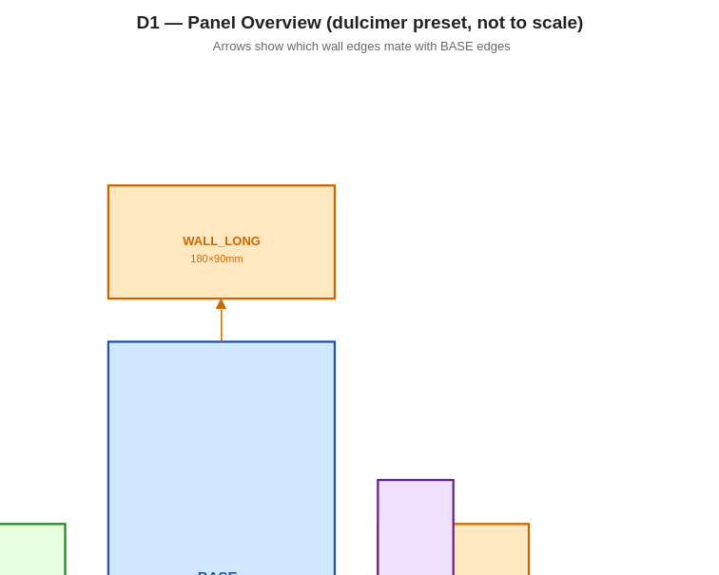
D1 — Panel overview. Arrows show which edges mate. Blue = BASE. Orange = wall panels. Green = leg walls. Purple = test strip.

Checklist — run through each item before cutting
Check | Expected
BASE shape | Trapezoid: long bottom edge wider than short top edge. Four rounded corners.
BASE finger count long edge | 17 fingers, alternating tabs/slots, regular spacing.
BASE finger count short edge | 11 fingers. Plain-line gaps at each end before first finger.
BASE finger count leg edges | 39 fingers each.
WALL_LONG width | Equals long_outer = 180mm (measure in Inkscape with ruler).
WALL_LONG height | Equals depth_outer = 90mm.
WALL_SHORT finger count | 11 fingers — must match BASE short edge.
WALL_LEG width | ~381mm (diagonal length). Parallelogram shape, not rectangle.
Corner arcs | All eight wall corners have smooth arcs. No sharp right-angle cuts.
TEST_STRIP present | 60 × 270mm panel on the sheet. One long edge has finger profile.
Labels | Each panel has a laser-engraved label: BASE, WALL_LONG, etc. plus assembly number.
Sheet fits bed | Entire sheet outline fits within your laser bed dimensions.

PASS All 13 items confirmed. Proceed to Phase 3 (test strip cut).
FAIL Any item wrong: do not cut. Identify the failing panel and cross-reference with the proof script that covers that geometry. Fix the implementation, re-generate, re-check.

Phase 3 — Test Strip Cut and Kerf Calibration
This phase consumes only a small piece of scrap material. It is the most important physical gate. A 30-minute test cut here saves you from a full-sheet failure.

3.1 What the test strip tells you
The TEST_STRIP panel has one edge matching the WALL_LONG bottom finger profile (which inherits from BASE long_bottom). Cutting and testing this single strip validates your kerf compensation setting for all box joints. If the test strip fits correctly into a BASE slot, all joints will fit.

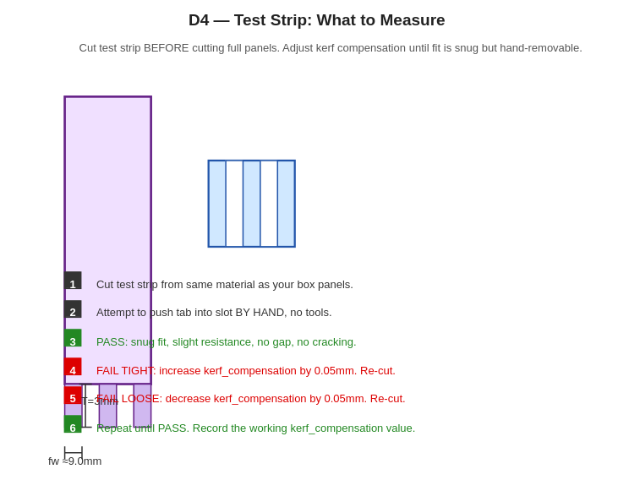
D4 — Test strip measurement guide. Only a 60×340mm offcut of your box material is needed — essentially free scrap. Do NOT buy a full sheet just for this.

3.2 Kerf calibration loop
Step 1. Export TEST_STRIP and one BASE long_bottom strip to your laser software. — Use same cut settings you will use for full panels.
Step 2. Cut both pieces from a 60×340mm offcut of the same material and thickness as your planned box panels. This is the only material consumed in Phase 3 — you do not need a full sheet.
Step 3. Measure the actual cut finger width with calipers. — Should be approximately 9.4mm for dulcimer preset. Note the delta from nominal.
Step 4. Attempt to push the TEST_STRIP tab into the BASE slot by hand. No tools.

Result | Action
Snug: slight resistance, no gap, no cracking, removable by hand | PASS — record kerf_compensation. Proceed to Phase 4.
Too tight: cannot push in without force, or material cracks | Increase kerf_compensation by 0.05mm. Re-cut. Repeat from Step 1.
Too loose: tabs rattle in slots, visible gap | Decrease kerf_compensation by 0.05mm. Re-cut. Repeat from Step 1.
Tabs shear off during insertion | Check material grain direction. Leg wall tabs on angled edges are vulnerable — ensure grain runs along the long axis of the wall panel.

NOTE Typical starting kerf_compensation for a 40W CO2 laser on 3mm ply: 0.05 to 0.15mm. MDF cuts slightly wider than ply. Birch ply and poplar ply often differ by 0.05mm. Always re-calibrate when changing material or laser settings.
Step 5. Record your working kerf_compensation value and add it to your standard laser profile for this material.
PASS Test strip fits snugly by hand. Tab is flush with slot face. No gap visible.
FAIL Fit does not converge after 3–4 iterations: check actual material thickness with calipers. If it is not 3.0mm, re-run trapezoid_box.py with --thickness set to the actual measured value.

Phase 4 — Full Panel Cut and Dry-Fit Assembly

4.1 Cut sequence
Send the full SVG to your laser software. Cut order matters — cut interior features (finger joints, sound holes) before outer profiles. Raster-engrave labels first.

Order | Layer / operation
1st | Raster engrave — panel labels and assembly numbers (low power)
2nd | Vector cut — sound holes, neck slot, all interior cuts
3rd | Vector cut — panel outer profiles (last, so panels do not shift)

PASS All panels fall free cleanly. No charring on finger surfaces. Kerf is consistent with test strip calibration.
FAIL Panel does not fall free: increase power or decrease speed by 5%. Re-cut. Do not force panels out — tearing damages finger tabs.
NOTE Leg walls (WALL_LEG_LEFT, WALL_LEG_RIGHT) are parallelograms, not rectangles. Verify in Inkscape before cutting — they should be visibly angled, not square.

4.2 Dry-fit assembly — go/no-go gates
Dry-fit means: assemble the entire box with no glue. All joints must fit by hand. This is your last gate before committing to glue.

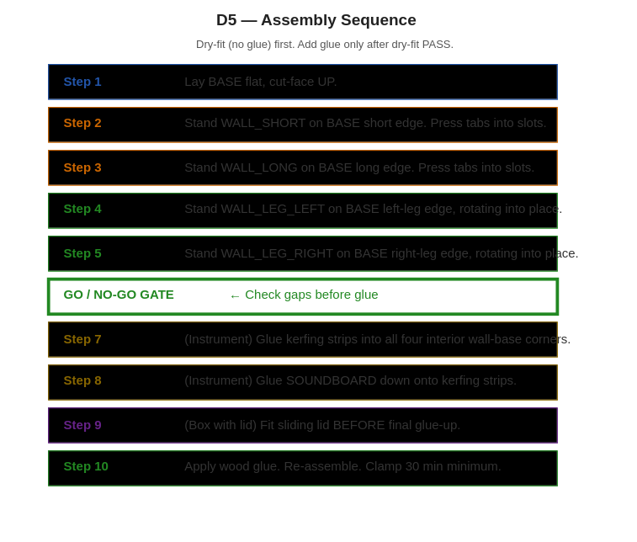
D5 — Assembly sequence. Follow numbered order. Rotate leg walls into position — do not force straight down.

Step 1. Lay BASE flat on a clean surface, cut-face UP.
Step 2. Stand WALL_SHORT on the BASE short (top) edge. — Press tabs gently into slots. Should engage by hand with light pressure.
Step 3. Stand WALL_LONG on the BASE long (bottom) edge. — Same as above.
Step 4. Stand WALL_LEG_LEFT on the BASE left-leg edge. — The wall leans inward 4.5 degrees. Rotate it into position — approach from outside, rotate inward. Tabs engage BASE and the two adjacent walls simultaneously.
Step 5. Repeat for WALL_LEG_RIGHT.
Step 6. Inspect all joints. Go/no-go gate — see table below.

Joint location | PASS | FAIL / action
BASE to WALL_LONG | Tabs fully seated, flush face | Gap at joint: kerf too tight, re-cut with higher compensation
BASE to WALL_SHORT | Tabs fully seated, flush face | Tabs shear: check grain direction on WALL_SHORT
BASE to WALL_LEG | Tabs seat on rotation, no force | Tabs miss slots: BASE-as-master rule not implemented — finger zones misaligned
WALL_LONG to WALL_SHORT corner | Flush, no gap | Corner gap: depth-edge finger count wrong
Overall squareness | Box stands square on flat surface | Diagonal measurement: both diagonals equal within 1mm
All four walls | No panel proud of adjacent panel face | Proud panel: one edge too long — check outer profile path

PASS All joints seat by hand. Box stands square. No gaps > 0.5mm. Proceed to glue-up.
FAIL Any BASE-to-leg-wall joint misses slots entirely: stop. This is the finger alignment blocker. BASE-as-master rule is not correctly implemented. Wall panels are computing their own finger positions instead of inheriting from BASE.

4.3 Glue-up
Step 1. Disassemble the dry-fit box. Keep panels in order.
Step 2. Apply PVA wood glue to finger tabs with a small brush or toothpick. — Thin coat — thick glue swells the tab and prevents seating.
Step 3. Re-assemble in the same sequence as dry-fit (Steps 1–5 above).
Step 4. Clamp all joints. Rubber bands work well for the angled leg joints.
Step 5. Check squareness again with diagonal measurement. Adjust before glue sets.
Step 6. Leave clamped for minimum 30 minutes. Full cure: 24 hours.
PASS Box is square, all joints tight, no squeeze-out gaps. The box is structurally complete.

Phase 5 — Instrument Mode Additions
Skip this phase if you are building a plain box. Instrument mode adds: soundboard with sound hole, kerfing strips, optional neck slot with kerfing plugs, and Helmholtz-tuned sound hole diameter.

5.1 Soundboard and Helmholtz sound hole
Step 1. Add sound hole flag to your command:
python3 trapezoid_box.py --long 180 --short 120 --length 380 --depth 90 --thickness 3.0 --soundhole-type round --soundhole-hz 110 --output my_instrument.svg

The tool computes the sound hole diameter needed to tune the air cavity to 110Hz (default). Check stdout:
helmholtz_target=110.0 Hz solved_diameter=22.94mm achieved=110.00 Hz error=0.00%

PASS achieved frequency within 5% of target. Diameter between 10mm and short_inner/2 (57mm). Proceed.
FAIL error > 5%: the solver did not converge or V_air is wrong. Re-run script 05 to verify Helmholtz independently.
NOTE If --neck-slot-both-ends is active: the solver automatically uses corrected air volume (subtracts neck shaft displacement). Verify stdout shows: neck_correction_applied=yes V_corrected=4,288,284 mm3.

5.2 Kerfing strips
Kerfing strips are thin triangular fillets glued into the interior corners between the BASE and each wall, giving the SOUNDBOARD a gluing surface. They are essential for an air-tight acoustic body.
Step 1. Cut KERF_STRIP panels from the SVG. Typically 8 strips (two per corner, mirrored).
Step 2. Glue-up the box walls to BASE as in Phase 4. Do not attach SOUNDBOARD yet.
Step 3. Glue kerfing strips into all four BASE-to-wall interior corners. Clamp 20 minutes.
Step 4. Fit SOUNDBOARD dry first — tabs should engage kerfing strip surfaces smoothly.
Step 5. Glue SOUNDBOARD. Weight or clamp flat for 30 minutes.
PASS Soundboard lies flat, no gaps between soundboard face and kerfing strips. Body is air-tight (test by pressing gently on soundboard — no hiss from joints).
FAIL Soundboard does not lie flat: kerfing strips not flush with wall top face. Plane or sand until flush before gluing soundboard.

5.3 Neck slot and kerfing plugs
Neck slot (--neck-slot or --neck-slot-both-ends) cuts a rectangular notch at the top of WALL_SHORT (and WALL_LONG for through-body). The slot must be sealed with kerfing plugs to keep the body air-tight.
Step 1. Cut NECK_SLOT_PLUG panels (42 × 15mm by default, generated on the final sheet).
Step 2. Before fitting the neck, glue one plug into each slot opening from inside the body. — Grain direction: across the 42mm width. Glue face: the 3mm cut edge.
Step 3. Clamp or tape flush. Let cure 20 minutes.
Step 4. Test air-tightness as above.
Step 5. Fit neck through plug (plug has a matching hole sized to neck tenon width).
PASS Neck seats correctly. Body is air-tight with neck in place. No rattles.
FAIL Plug cracks on neck insertion: plug hole is too small. Re-cut plug with +0.2mm kerf_compensation on the neck hole only.

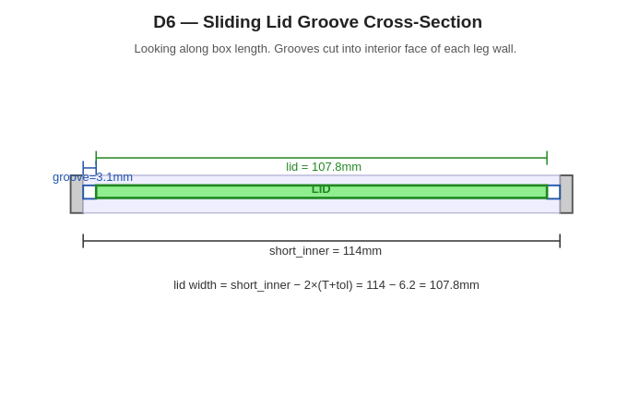
D6 — Sliding lid groove cross-section (if lid=sliding). Green lid must be cut to short_inner - 2*(T+tol) = 107.8mm for dulcimer preset. Wrong formula (short_outer + 2*(T+tol) = 126.2mm) will not fit.

Appendix — Error Codes and Troubleshooting

A.1 Error code reference
Error code | Cause | Fix
ERR_VALIDATION_LONG_NOT_GT_SHORT | long <= short | long must be strictly greater than short
ERR_VALIDATION_RADIUS_TOO_LARGE | R > short/4 or R > depth/4 | Reduce corner_radius. Default is 3*thickness; lower if depth or short is small
ERR_VALIDATION_FINGER_WIDTH_TOO_SMALL | fw < T | Increase finger_width. Must be at least wall thickness
ERR_VALIDATION_STRUCTURAL_TAB | W_struct < T/2 at leg angle | Reduce leg angle (make long and short closer in size) or increase finger_width
ERR_VALIDATION_GROOVE_ANGLE_TOO_STEEP | Sliding lid + angle > 14.6 deg | Use lift-off lid, or reduce leg angle below 14.6 degrees
ERR_VALIDATION_NECK_SLOT_TOO_WIDE | Neck slot >= short - 4*T | Reduce --neck-slot-width
ERR_VALIDATION_NECK_SLOT_TOO_DEEP | Neck slot >= depth/2 | Reduce --neck-slot-depth
ERR_VALIDATION_SLIDING_LID_NECK_SLOT_CONFLICT | --neck-slot-both-ends + sliding lid | Use lid=none or lid=lift_off with through-body neck
ERR_LID_NOT_IMPLEMENTED | lid=hinged or lid=flap | Use lid=none, lid=lift_off, or lid=sliding

A.2 Common physical failures and fixes
Symptom | Most likely cause | Fix
Tabs too tight, joint will not seat | Kerf compensation too low | Increase kerf_compensation by 0.05mm per iteration
Tabs too loose, joint rattles | Kerf compensation too high | Decrease kerf_compensation by 0.05mm per iteration
Leg wall tabs miss BASE slots entirely | BASE-as-master rule not implemented | Wall finger zone must inherit from BASE, not recompute
Corner arcs have kink at edge junction | Arc tangent point wrong | Check bisector formula: normalise(-edge_a_dir + edge_b_dir)
Panels slightly proud after assembly | Burn on finger faces | Sand finger faces lightly before glue-up, or reduce laser power
Soundboard not flat | Kerfing strips not flush | Plane kerfing strip top faces flush before fitting soundboard
Body not air-tight | Neck slot not plugged | Glue NECK_SLOT_PLUG into each slot before fitting neck
Helmholtz frequency off by >5% | Neck volume not corrected | Ensure --neck-slot-both-ends triggers V_correction in solver
Sliding lid too wide to insert | Wrong lid width formula | Lid width = short_inner - 2*(T+tol), not short_outer + 2*(T+tol)

A.3 Proof script quick reference
Script | Checks | Key value confirmed
01_trapezoid_geometry.py | 27 | leg_angle=4.514 deg, air_volume=4,523,904 mm3
02_corner_arcs.py | 30 | tang long-end=8.317mm, tang short-end=9.739mm
03_finger_joints.py | 33 | n_long=17, n_short=11, n_leg=39, lid_w=107.8mm
04_panel_alignment.py | 10 | All 4 mating pairs aligned, max_offset=0.000mm
05_helmholtz.py | 23 | D=22.938mm for 110Hz, corrected D=21.883mm with neck
06_svg_primitives.py | Visual | 4 SVG files: arcs, finger strip, BASE outline, lid diagram
07_assembly_simulation.py | 48 | ALL PASS — geometry consistent and assembly-ready

A.4 Plywood sheet size guide
Use case | Recommended sheet
Box mode (no soundboard), dulcimer preset | 1 × 600 × 400mm, 3mm ply
Instrument mode (with soundboard + kerfing) | 2 × 600 × 400mm, 3mm ply
Minimum laser bed size (dulcimer preset) | 400 × 400mm (largest panel: 180×380mm BASE)
If building multiple boxes from one sheet | 1200 × 600mm sheet fits 3–4 full box sets
Material choice | 3mm birch ply preferred. MDF is heavier but cheaper. Both work.
Grain direction | Long axis of BASE and SOUNDBOARD aligned with sheet grain for best strength

End of Build Validation Manual
trapezoid_box.py v0.20 — spec believed correct, unproven by physical cut

