trapezoid_box.py
Kerf Calibration: Test Strip Guide
v0.20 — standalone procedure
docs/trapezoid_box_test_strip_guide.docx

Purpose
Find the kerf_compensation value for your laser and material before cutting any full box panels.
Material cost: one ~120 × 270 mm offcut. Time: ~30 minutes including iteration.

Contents
3.1 What you are testing and why
3.2 The kerf_compensation direction table
3.3 What to cut — two identical TEST_STRIP pieces
3.4 Material and scrap required
3.5 Step-by-step: cut the test strips
3.6 Step-by-step: evaluate the fit
3.7 Interpreting results and iteration table
3.8 What this test covers and does not cover
3.9 Record and proceed to Phase 4

3.1 What you are testing and why
Every laser cutter burns a path slightly wider than the vector line in the SVG. This width is the kerf. Because the laser removes material symmetrically on both sides of the path, finger joint tabs come out narrower than drawn and slots come out wider than drawn. If uncorrected, the joints either cannot assemble (too tight) or are structurally useless (too loose).

The trapezoid_box tool has a kerf_compensation parameter. It offsets tab edges outward in the SVG — making tabs wider on paper — and slot edges inward — making slots narrower on paper — so that after the laser removes its kerf, the physical dimensions come out at the designed nominal values.

The correct kerf_compensation value cannot be calculated from first principles. It depends on your specific machine, its focus quality, the power and speed settings you use, and the particular material and batch. It must be found physically by cutting and testing.

NOTE This calibration must be done once per material type. If you change from birch ply to poplar ply, or change laser settings, repeat from scratch. Results do not transfer between materials.

3.2 The kerf_compensation direction table
Read this table before touching the laser. Internalise it. Every iteration decision in this procedure follows from it.

Parameter | Higher kerf_compensation | Lower kerf_compensation
SVG tab width (drawn) | Wider — edges pushed outward more | Narrower — edges pushed outward less
Physical tab after laser cut | Wider | Narrower
SVG slot width (drawn) | Narrower — edges pushed inward more | Wider — edges pushed inward less
Physical slot after laser cut | Narrower | Wider
Net effect on fit | Tighter joint | Looser joint

Memory rule: Higher kerf_compensation = wider tabs = tighter fit. Too tight → go lower. Too loose → go higher. This is the only rule you need for every iteration decision in this procedure.

3.3 What to cut — two identical TEST_STRIP pieces
You need exactly two copies of the TEST_STRIP panel. It is generated by the tool and appears labelled on the SVG output sheet. It is 60 mm wide × 270 mm long and has an alternating tab/slot finger profile on one long edge.

There is no separate "slot strip" or "JOINT_TEST" panel. The TEST_STRIP already contains both tabs and slots in alternating sequence. Two identical strips, offset by one finger width when mated, interlock perfectly: every tab on Strip A sits in a slot on Strip B and vice versa. This is a complete joint test.

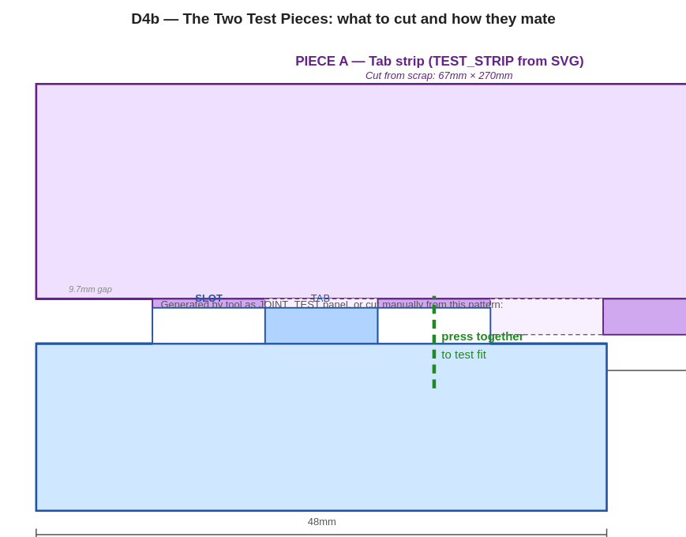
D4b — Both test pieces are TEST_STRIP. Strip A (top, purple) is offset one finger width to the right of Strip B (bottom, blue). Tabs on A sit in slots on B. Press A straight down into B to test fit.

Do not cut a slice off the BASE panel for this test. BASE has different tang geometry from WALL panels. Testing BASE slots against WALL tabs gives false results.

3.4 Material and scrap required
Two TEST_STRIP pieces: 60 mm × 270 mm each. Total scrap needed: approximately 120 × 270 mm — a narrow offcut.

Requirement | Detail
Material | Same sheet you will use for the full box. Same material type, same batch, same thickness.
Thickness | Must match --thickness parameter (default 3.0 mm). Measure actual thickness with calipers before starting.
Sheet requirement | A 120 × 270 mm offcut is sufficient. No full sheet needed. Any workshop scrap works if it is the same material.
Starting kerf value | If unknown: start at 0.10 mm. Typical CO2 laser range on 3 mm ply or MDF: 0.05–0.15 mm. Always calibrate — never assume.

NOTE Measure your actual material thickness with calipers before cutting. If it differs from 3.0 mm by more than 0.2 mm, re-run trapezoid_box.py with --thickness set to the measured value before generating the test SVG.

3.5 Step-by-step: cut the test strips
Step 1. Measure your actual material thickness with calipers.
Write the value down. If it is not within 0.2 mm of 3.0 mm, use the measured value in Step 2.

Step 2. Re-generate the SVG with your starting kerf_compensation value.
First attempt: use 0.10 mm.
Subsequent attempts: use the value from your iteration tally (Section 3.7).
python3 trapezoid_box.py --long 180 --short 120 --length 380 --depth 90 --thickness 3.0 --kerf-compensation 0.10 --output test_strip.svg
Note: exact CLI flag name (--kerf-compensation) is illustrative — verify against your implementation.

Step 3. Load test_strip.svg in your laser software. Place the TEST_STRIP panel twice on the work area.
In your laser software: import the SVG, then copy-paste the TEST_STRIP panel to get two copies side by side.
Do not duplicate the whole SVG file — duplicate only the TEST_STRIP panel within the laser software.
Nest the two copies close together to minimise scrap used.

Step 4. Set laser settings to exactly match your planned full-box cut.
Same power, speed, and focal length. Do not use a quick draft setting.
Kerf width changes with power and speed. You are calibrating for the real settings.
Suggested starting point for 3 mm birch ply on a 40 W CO2 laser: power 75%, speed 20 mm/s.

Step 5. Place scrap material flat on the laser bed.
Check for warping — press all four corners down. Warped material varies in height above the focal point, producing inconsistent kerf width across the piece.

Step 6. Cut: finger profile first, then outer rectangle — for each strip.
Interior cuts before outer profile is standard practice. The outer cut frees the piece from the surrounding sheet. If outer is cut first, the piece shifts and all interior cuts are misaligned.
Cut both strips in one job to guarantee identical settings.
Let the machine complete its full cycle. Do not open the lid while the machine is still moving.

Step 7. Wait 30 seconds after the machine stops before opening the lid.
Let the extraction fan clear smoke. Laser-cut edges retain heat briefly. Thin 3 mm tabs can crack if handled immediately after cutting.

Step 8. Remove both strips. Inspect visually before attempting fit test.
Piece A: are all tab tips intact? No tips charred through, no cracks, no partial cuts?
Piece B: are slot walls clean? No fused or re-solidified material bridging across a slot?
Light char on edges is normal. Burned-through tips or fused slots indicate a laser setting problem, not a kerf problem.

PASS Both strips: tab tips intact, slot walls clean, light char only. Proceed to fit test.
FAIL Tabs snapped during cutting, or slot walls fused shut: this is a heat problem, not a kerf problem. Reduce power by 10% or increase speed by 10%. Re-cut from Step 5. Do not adjust kerf_compensation for this failure.

3.6 Step-by-step: evaluate the fit
Step 9. Label one strip "A" and one strip "B" in pencil on the back face.

Step 10. Place Strip B flat on a firm table surface. Finger-profile edge facing UP.
The finger-profile edge is the long edge (270 mm), not the short edge (60 mm).
Keep it flat on the table for the test — do not hold it in the air. The table prevents Strip B from flexing under pressure.

Step 11. Hold Strip A above Strip B. Finger-profile edge facing DOWN. Offset Strip A by one finger width to the left or right.
One finger width for the dulcimer preset = 9.44 mm.
Why offset? Both strips have the same pattern starting with a tab: TAB, slot, TAB, slot...
Without the offset, tab sits above tab — it will never fit regardless of kerf.
With a one-finger-width offset: every tab on A aligns exactly above a slot on B, and every slot on A sits above a tab on B, for the full length.
Direction (left or right) does not matter — the pattern is symmetric.

Strip A is offset one finger width. Tabs on A (solid rectangles) align above slots on B (open rectangles). Every tab-slot pair along the full length is aligned before pressing.

Step 12. Press Strip A straight down into Strip B. Thumb pressure only. No tools. No hammering.
Push gradually over 3 to 5 seconds. Do not slam.
A correctly fitting joint requires noticeable thumb pressure to seat — you should feel resistance — but should not require force or gripping.
Stop immediately if you feel material cracking. Do not continue pressing.

3.7 Interpreting results and the iteration table

Result table
What you feel / see | Diagnosis | Correct action
Seats with thumb pressure. Tabs sit flush with Strip B face. Pieces sit flat. Can pull apart by hand. | PASS. kerf_compensation is correct. | Record the value. Proceed to Phase 4 — Full Panel Cut.
Will not go together even with firm thumb pressure. Or tabs bend or crack on insertion. | Too tight. Tabs physically too wide. kerf_compensation is too HIGH. | DECREASE kerf_compensation by 0.05 mm. Return to Step 2.
Slides together with no resistance. Visible gap between tab and slot wall. Rattles when shaken. | Too loose. Tabs physically too narrow. kerf_compensation is too LOW. | INCREASE kerf_compensation by 0.05 mm. Return to Step 2.
Goes together but tab tips sit slightly raised above the Strip B face surface (proud). | Close. Tabs fractionally too wide. kerf_compensation slightly too HIGH. | DECREASE kerf_compensation by 0.02 mm only. Return to Step 2.
Tab tips snap off during insertion attempt. | Too tight and too much force applied, or grain direction wrong. | First: verify grain runs along the 270 mm length (not across). Second: thumb pressure only — no gripping or tools. Third: if grain correct and still snapping, DECREASE kerf_compensation 0.05 mm. Return to Step 2.

Reminder: Higher kerf_compensation = wider tabs = tighter fit. Too tight → DECREASE. Too loose → INCREASE.

Iteration tally — fill in as you go
One row per cut. Stop at PASS. Do not proceed to Phase 4 until you have a PASS.

# | kerf_compensation | Result | Next value | Notes
1 | 0.10 mm (start)
2
3
4
PASS value: | __________ mm | Material: |  | Date:

NOTE If no PASS after 4 cuts: stop cutting. (1) Confirm actual material thickness is within 0.2 mm of 3.0 mm — re-measure with calipers. (2) Confirm laser is in focus at the material surface — re-run autofocus. (3) If thickness is wrong, re-run trapezoid_box.py with the correct --thickness and restart the tally.

3.8 What this test covers and does not cover
Joint type | Covered by this test? | Notes
BASE ↔ WALL_LONG (17 fingers) | YES — directly | TEST_STRIP profile matches this joint exactly
BASE ↔ WALL_SHORT (11 fingers) | YES — same kerf_compensation applies | Verify during Phase 4 dry-fit
BASE ↔ WALL_LEG_LEFT/RIGHT (39 fingers, angled) | INDIRECTLY — same kerf, different technique | Leg walls rotate in at 4.5°. Technique note below.
Wall corner joints (wall-to-wall) | NO — not tested here | Checked visually during Phase 4 dry-fit

NOTE Leg-wall joints: the same kerf_compensation value applies, but the insertion technique is different. Leg walls must be rotated inward at 4.5 degrees rather than pressed straight down. If orthogonal joints pass but leg-wall joints feel tight during Phase 4 dry-fit, first try the correct rotation technique before concluding it is a kerf issue. Only adjust kerf_compensation for leg walls (by 0.02 mm decrease) if the joint is still tight after correct rotation technique.

3.9 Record and proceed
Step 13. Write the confirmed kerf_compensation value on a label and stick it to your remaining scrap sheet.
Step 14. Save the value in your laser software as a named material profile for this material and these settings.
Step 15. Proceed to Phase 4 — Full Panel Cut.

PASS kerf_compensation confirmed. Two TEST_STRIP pieces fit snugly by thumb pressure. Tabs sit flush with Strip B face. No gap visible. Removable by hand without force. Phase 3 complete.
FAIL Do not proceed to Phase 4 until Phase 3 passes. Cutting full panels with wrong kerf_compensation wastes a full sheet of material (~7–8 EUR) and requires a complete re-cut.

— end of test strip guide —
trapezoid_box/docs/trapezoid_box_test_strip_guide.docx | v0.20

