

**Department of Computer Science**

**MSc – Data Science**

**NAME: DEEPTHI NAGARAJ**

**REGISTER NUMBER.: 2148035**

**DATE: 27th JULY 2022**

**TOPIC: Log File analysis.**

**INTRODUCTION**: Log analysis is the process of reviewing, interpreting and understand computer-generated records called logs. Logs are generated by a range of programmable technologies, including networking devices, operating systems, applications, and more.

**DATA:** the server log dataset of RUET OJsharing the server log dataset of RUET OJ

**STEPS :**

1. Search of a log file with correct format (.log) extension. and download the file.
2. Download log analyzer tools
3. Install and Start the log analyzer tool
4. Upload the log file
5. Analyze your log file data
6. Later explore the measures and dimensions.

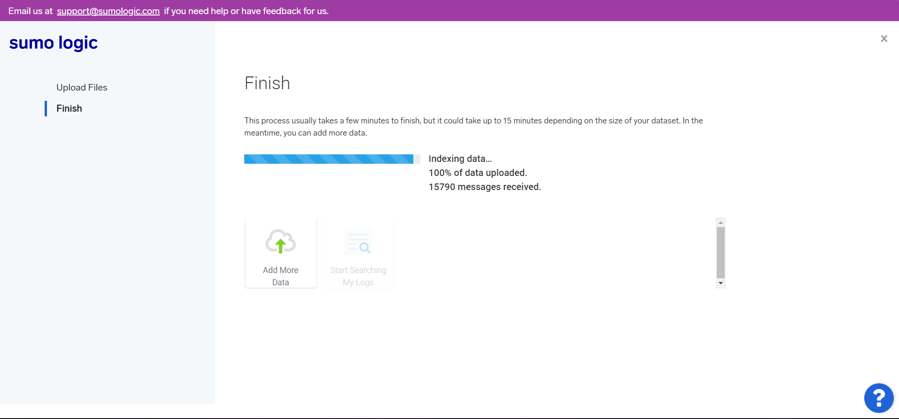

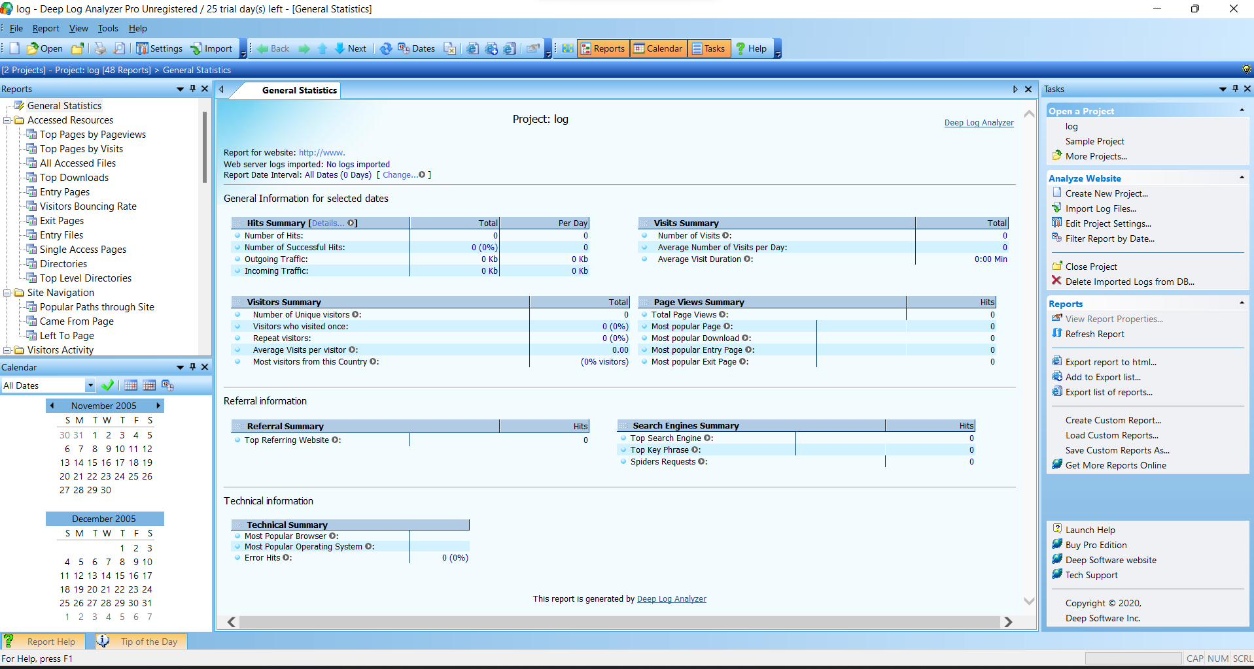

**UPLODING THE LOG FILE TO LOG ANALYSER TOOL:**

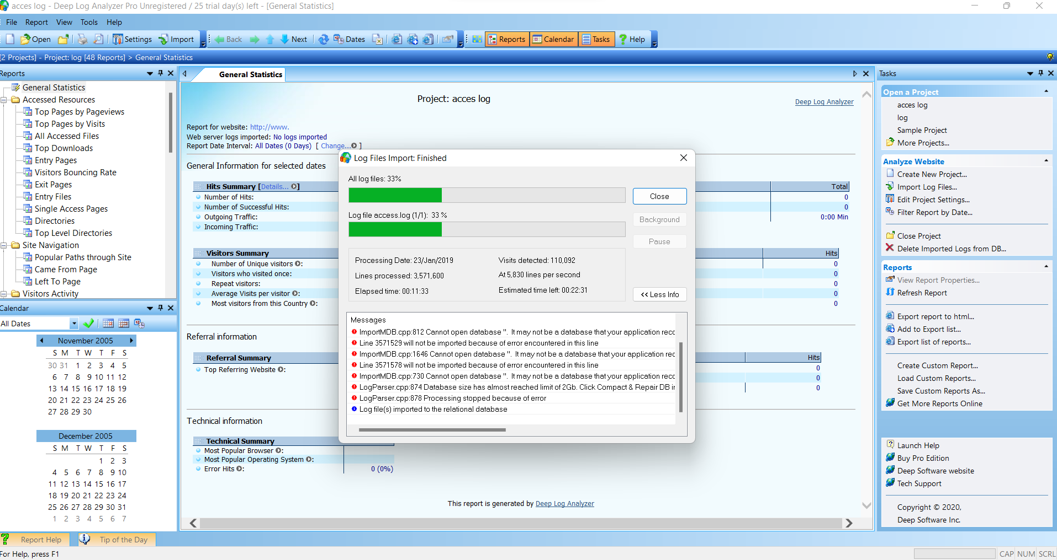

**GENERAL STATISTICS:**

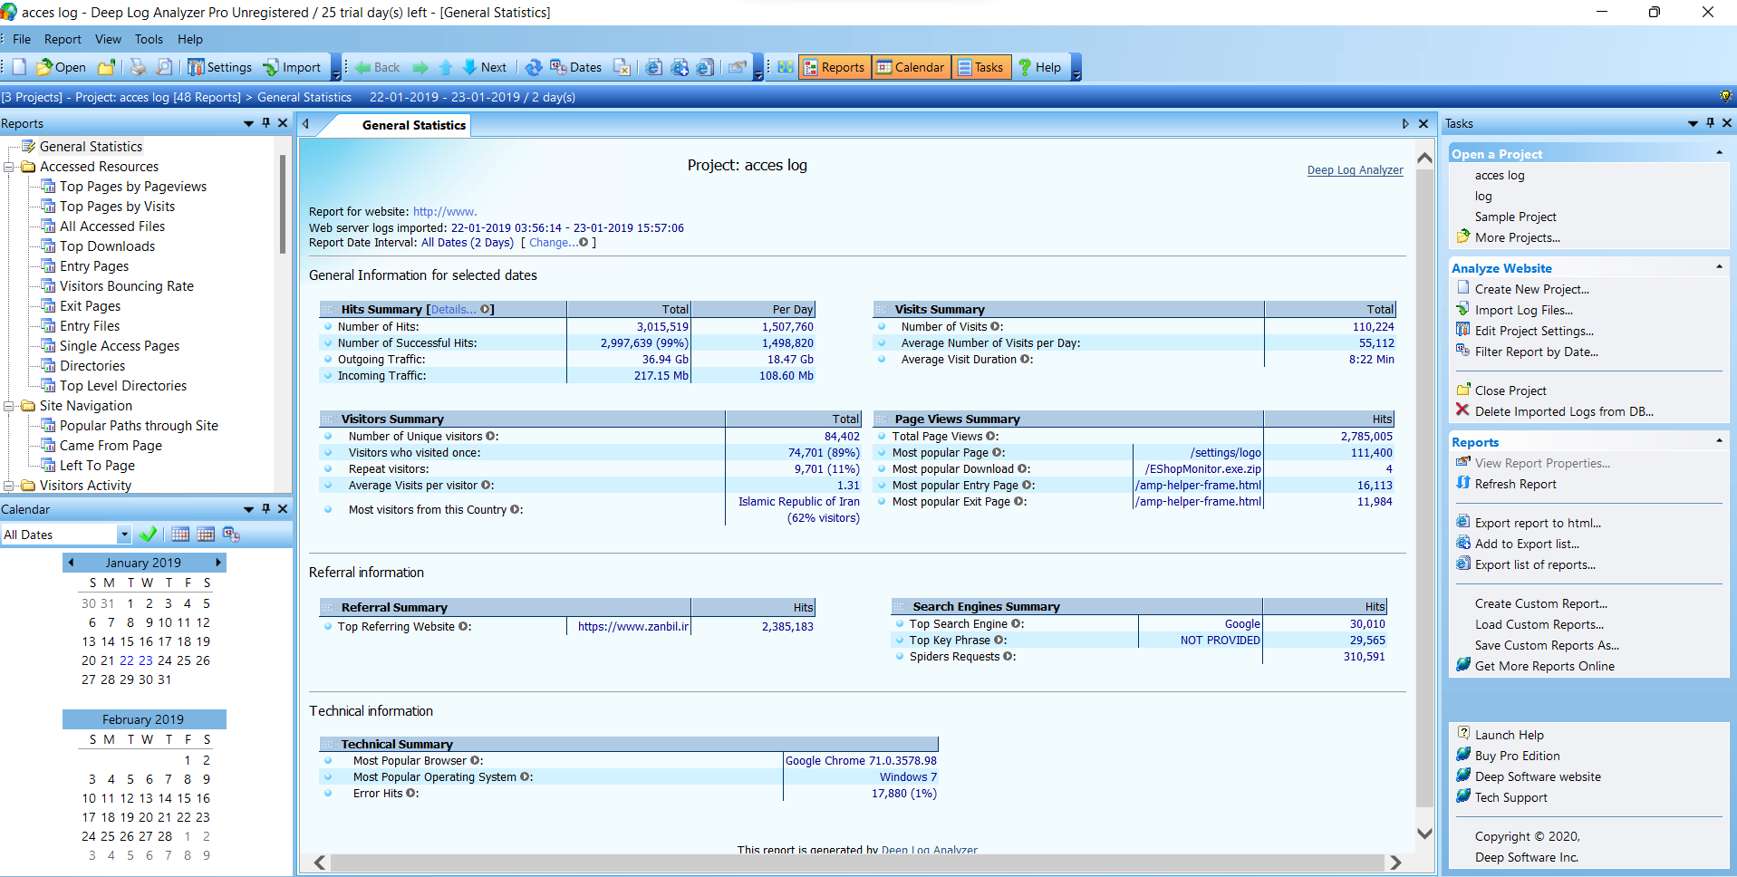

**TOP PAGES BY PAGEVIEWS:**

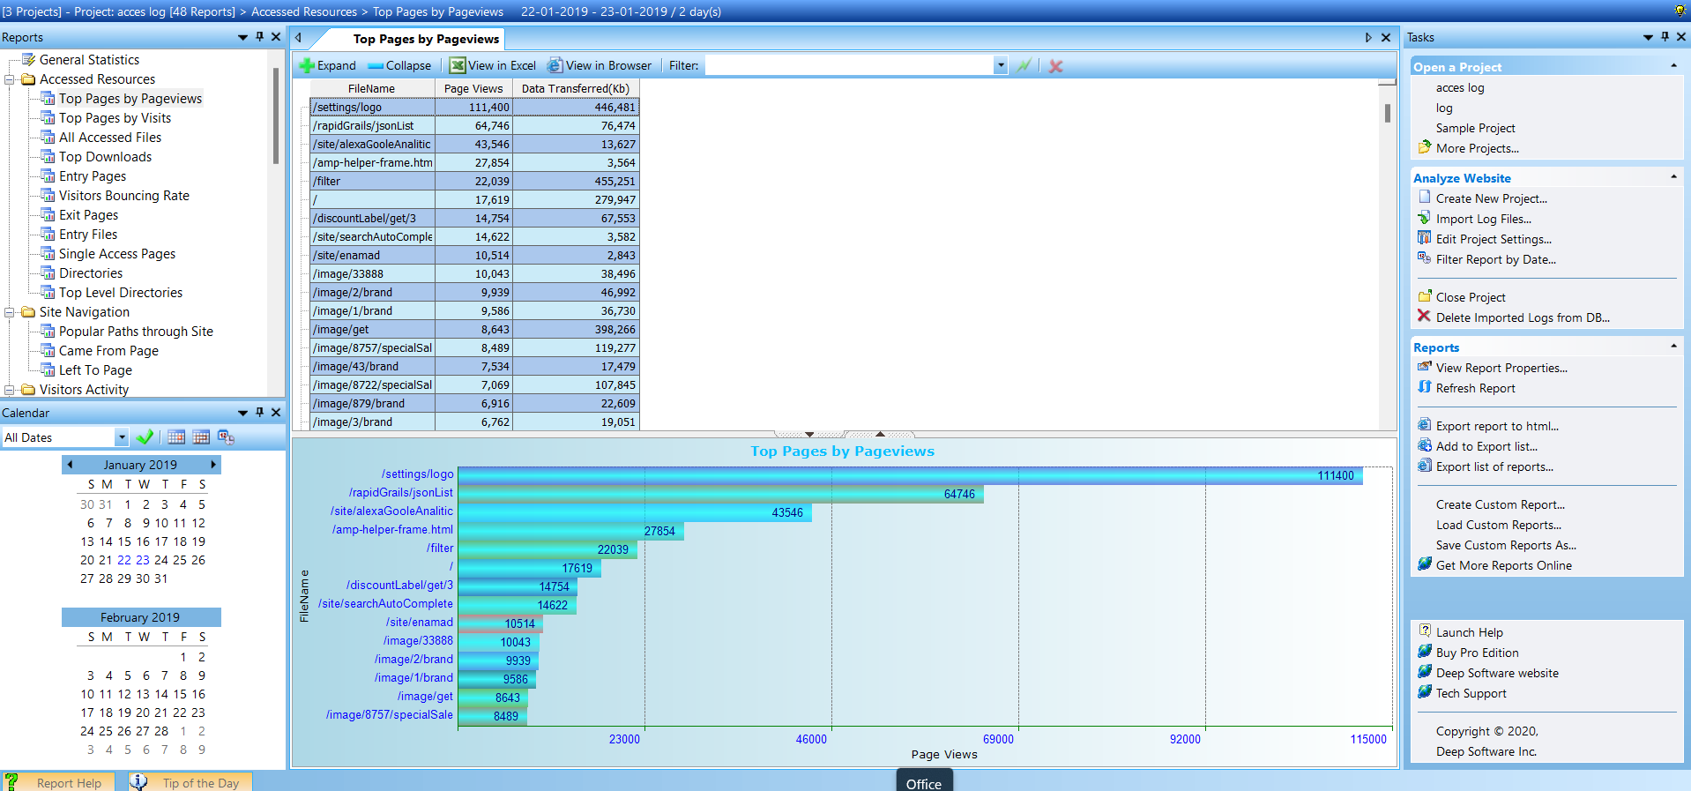

**TOP PAGES BY VISTORS:**

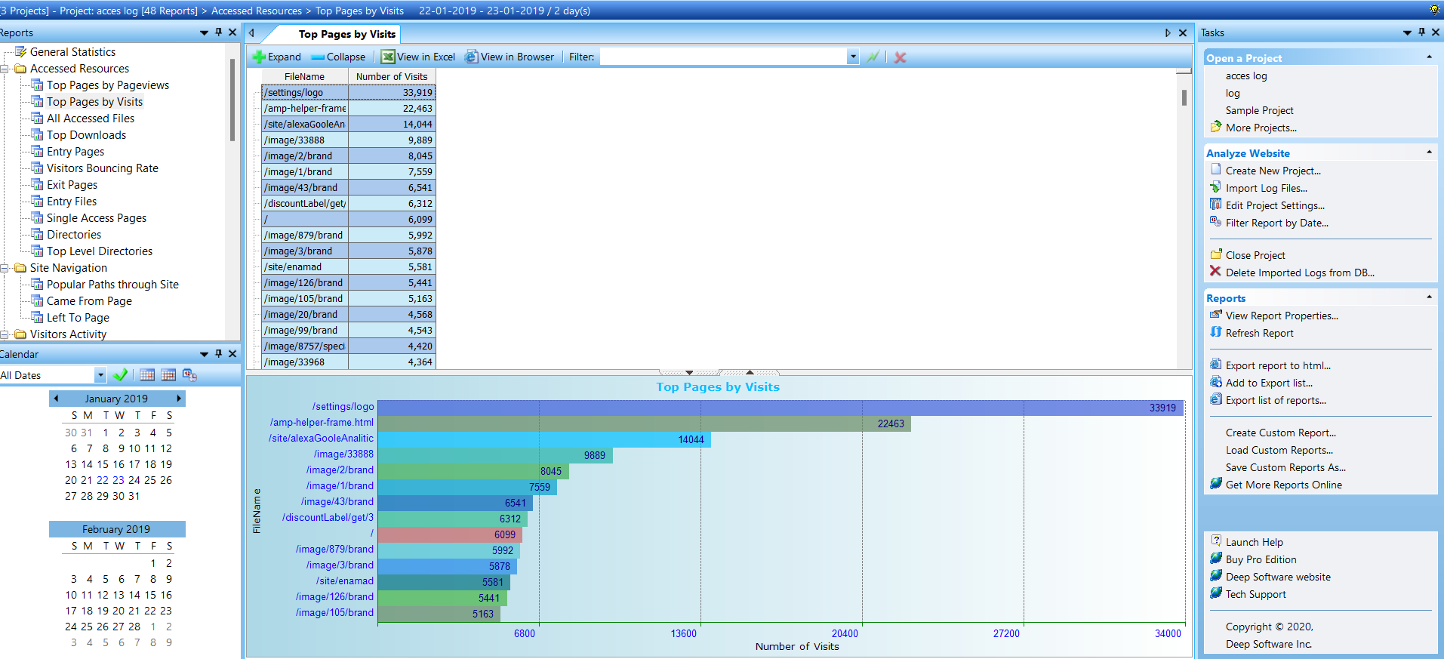

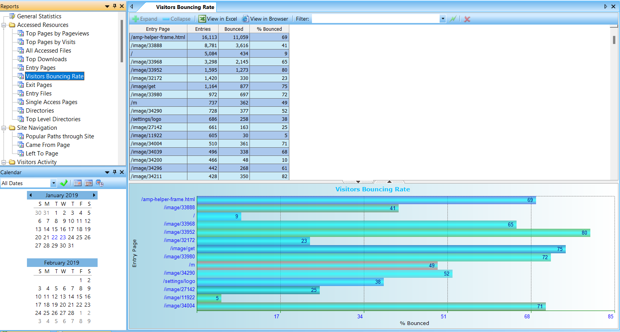**VISITORS BOUNCING RATE:**

**EXIT PAGES:**

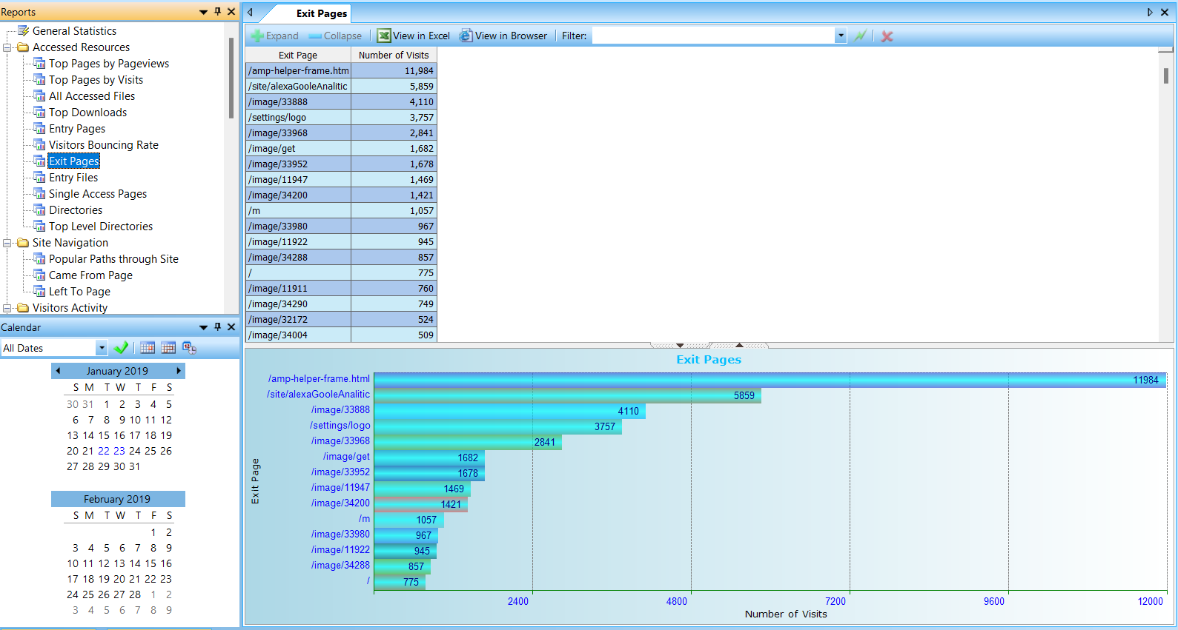

**REFERRING PAGES:**

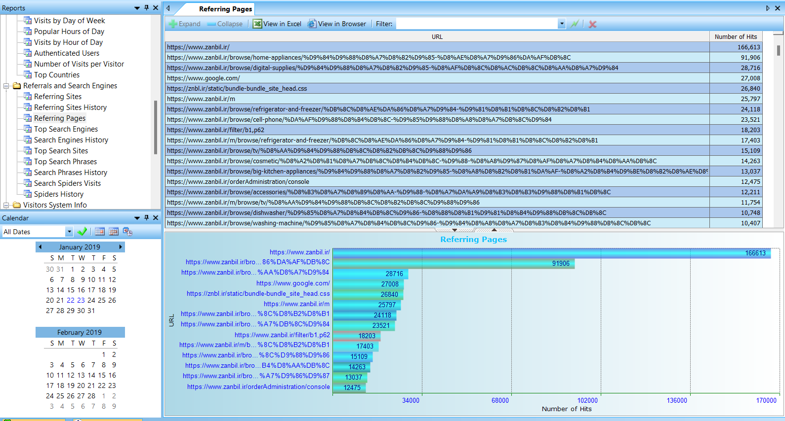

**POPULAR HOURS OF DAY:**

