CREATION OF EVENTS

IN OUR ACCOUNTS

TWO METHODS : GA4

METHOD 1

Step 1 : open google analysis

Step 2 : click configed > events > create view

Step 3: add_payment_info > add parameters

Step 4: click create

Step 5: give event name - it is case sensitive

Step 6: parameter is event_name (i.e page view, page_title)

Eg

Parameter - page_title

Operator - contains

Value - cart

This is how we will be creating the goal

* We can also modify the event
* Custom definitions; -
* Conversions - we can do analysis total vist = 1000 , first view = 500 so conversions rate =50%

METHOD 2: TAG MANAGER

STEP1: Open tag manager

STEP2: CLECK new tag

STEP3: CLICK TAG CONFIG

STEP 4: CLICK Google Analytics: GA4 Event

STEP5 : FILL THE FORM SUCH AS EVENT NAME , USER PROPERTIES ETC

STEP 5: LATER ADD TIGGER

EVENT PARA,

We use tigger whenever the button is used.

3.) TAKE ANY 5 EVENTS, LATER USE DEMO ACC , CHOOSE VALID PARAMETERS N VALUES N CHECK THE DIFFERENCES GIVE INSIGHTS. ATLEAST 2 SHOULD BE CUSTOM EVENTS.

ANS:

1.

## level_up

This event signifies that a player has leveled up. Use it to gauge the level distribution of your userbase and identify levels that are difficult to complete.

### Parameters

| **Name** | **Type** | **Required** | **Example value** | **Description** |
| --- | --- | --- | --- | --- |
| level | number | No | 5 | The level of the character. |

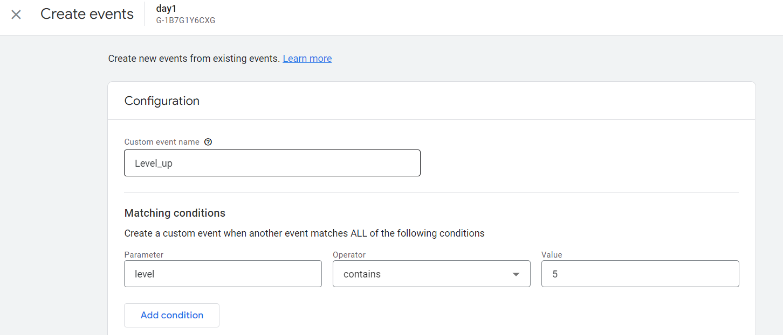

2. **join_group**

Log this event when a user joins a group such as a guild, team, or family. Use this event to analyze how popular certain groups or social features are.

### Parameters

| **Name** | **Type** | **Required** | **Example value** | **Description** |
| --- | --- | --- | --- | --- |
| group_id | string | No | G_12345 | The ID of the group. |

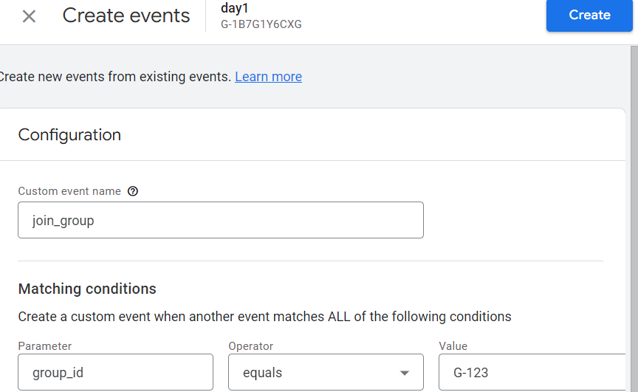

3**. begin_checkout**

This event signifies that a user has begun a checkout.

**Parameters**

**Name Type Required Example value Description**

currency string Yes* USD Currency of the items associated with the event, in 3-letter ISO 4217 format.

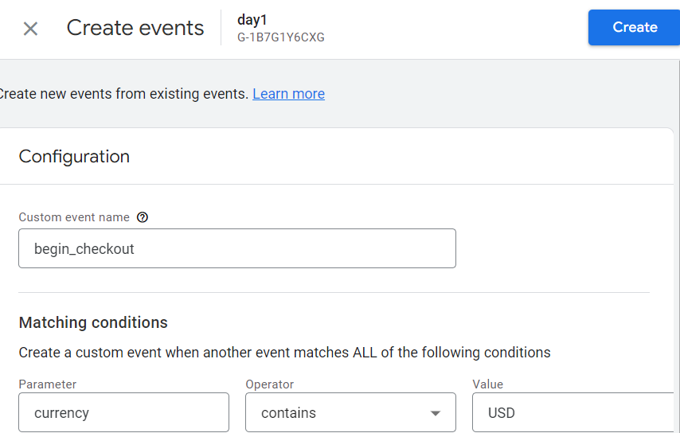

**CODE:**

gtag("event", "begin_checkout", {

currency: "USD",

value: 7.77})

4.**login**

Send this event to signify that a user has logged in.

### Parameters

| **Name** | **Type** | **Required** | **Example value** | **Description** |
| --- | --- | --- | --- | --- |
| method | string | No | Google | The method used to login. |

### Example

gtag("event", "login", {

method: "Google"

});

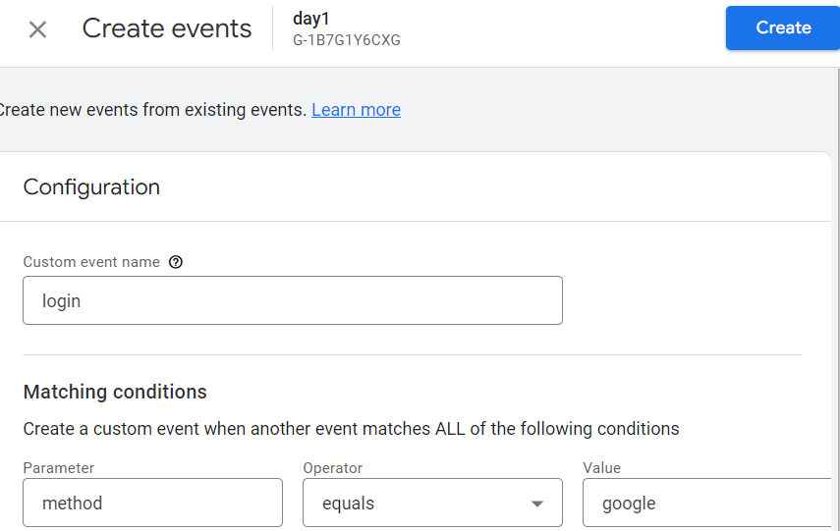

**5. search**

Use this event to contextualize search operations. This event can help you identify the most popular content in your app.

**Parameters**

**Name Type Required Example value Description**

search_term string Yes t-shirts The term that was searched for.

**Example**

gtag("event", "search", {

search_term: "t-shirts"

});

