

**Department of Data Science**

**Web Analytics - MDS372B**

**LAB 2**

**NAME:** DEEPTHI NAGARAJ

**REGISTER NUMBER.:** 2148035

**DATE:** 27th JULY 2022

**TOPIC: Exploring Metrics and Dimensions.**

**INTRODUCTION**:

Every report in Analytics is made up of dimensions and metrics.

Dimensions are attributes of your data. For example, the dimension *City* indicates the city, for example, "Paris" or "New York", from which a session originates. The dimension *Page* indicates the URL of a page that is viewed.

Metrics are quantitative measurements. The metric *Sessions* is the total number of sessions. The metric *Pages/Session* is the average number of pages viewed per session.

The tables in most Analytics reports organize dimension values into rows, and metrics into columns. For example, this table shows one dimension (*City*) and two metrics (*Sessions* and *Pages/Session*).

|  |  |  |
| --- | --- | --- |
| **DIMENSION** | **METRIC** | **METRIC** |
| **City** | **Sessions** | **Pages/Session** |
| San Francisco | 5,000 | 3.74 |
| Berlin | 4,000 | 4.55 |

In most Analytics reports, you can [change the dimension](https://support.google.com/analytics/answer/1289845) and/or [add a secondary dimension](https://support.google.com/analytics/answer/6175970).

**DATA:** the server log dataset of RUET OJsharing the server log dataset of RUET OJ

**STEPS :**

1. Search of a log file with correct format (.log) extension. and download the file.
2. Download log analyzer tools
3. Install and Start the log analyzer tool
4. Upload the log file
5. Analyze your log file data
6. Later explore the measures and dimensions.

1. ACQUISITION

* Acquisition overview:

Before comparisons After adding comparisons : page_location & page_title

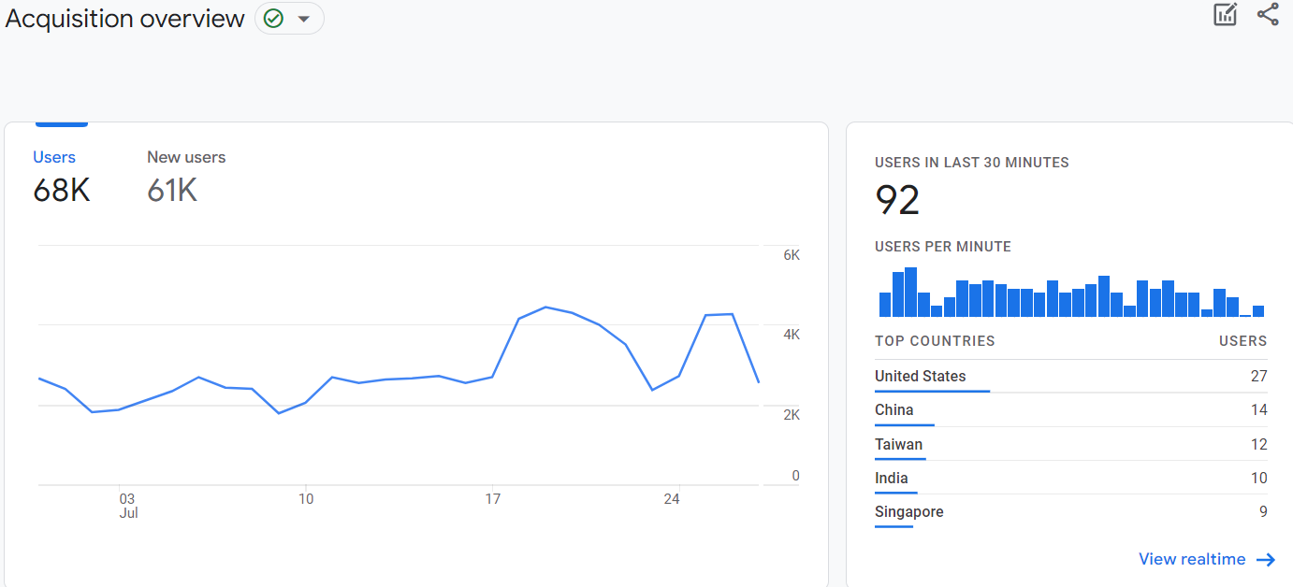 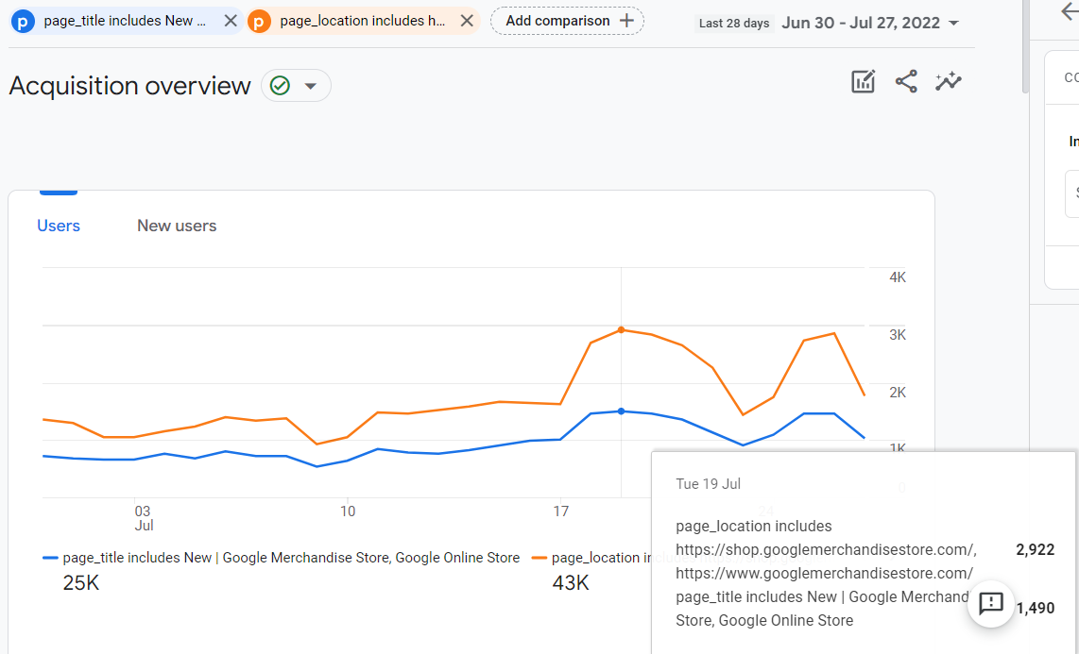

* User acquisition: First user medium

Before comparisons After adding comparisons : page_location & page_title

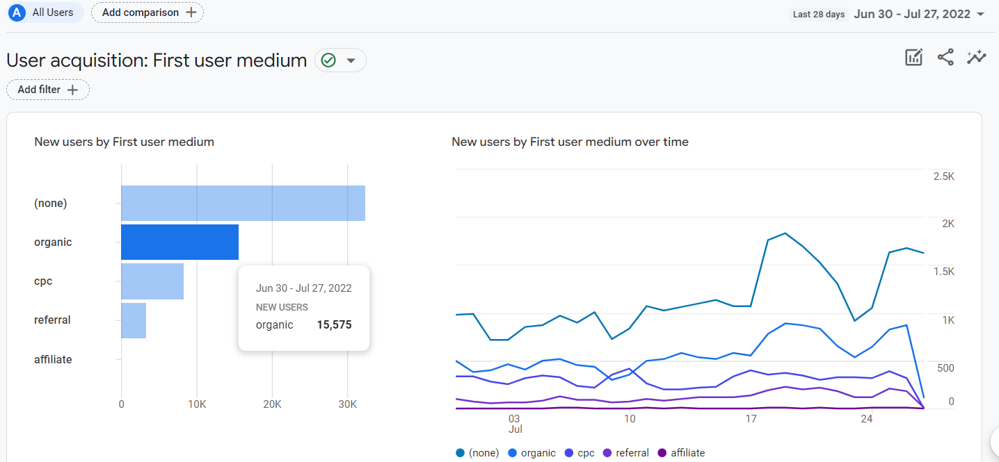 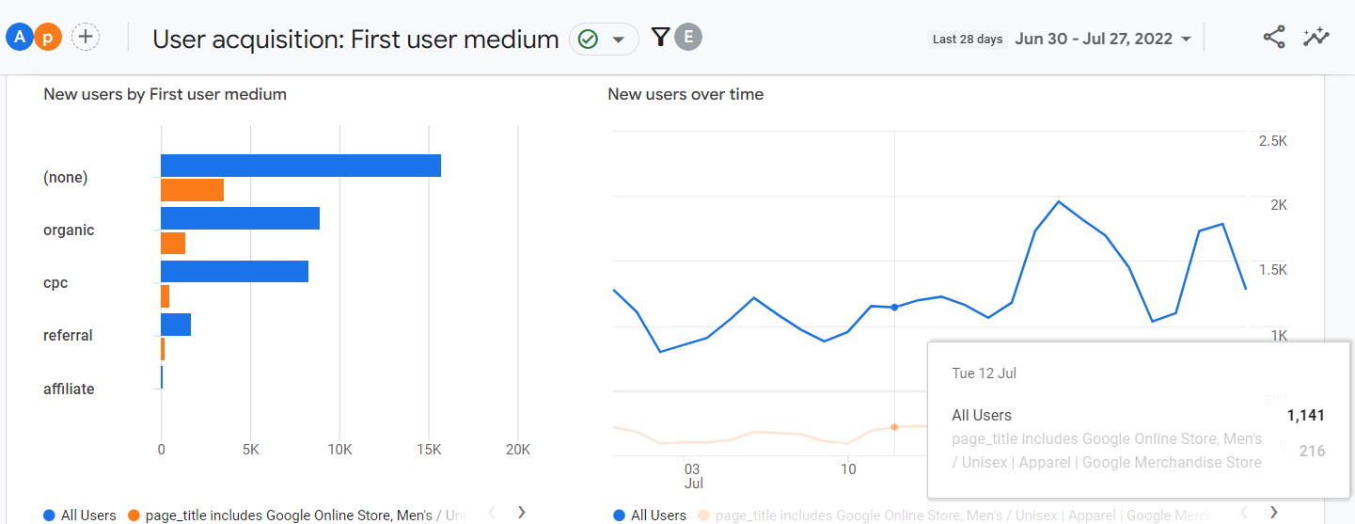

# User acquisition:

Before comparisons After adding comparisons : All user,page_location, shipping_tier& page_title

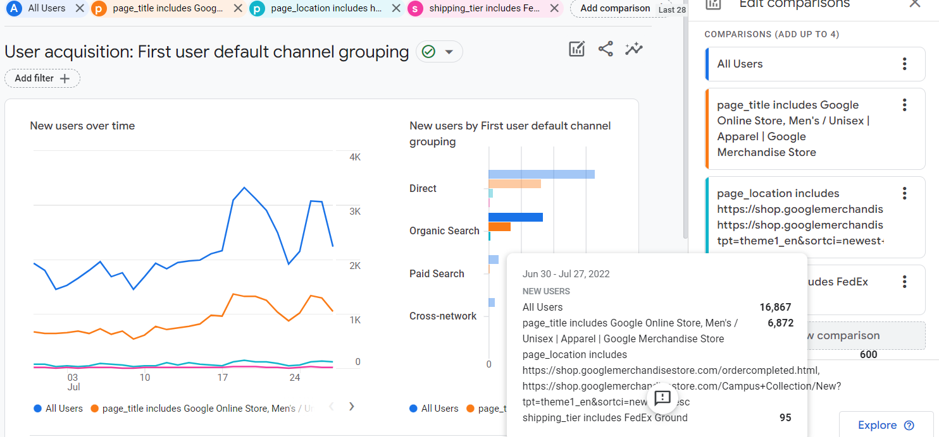

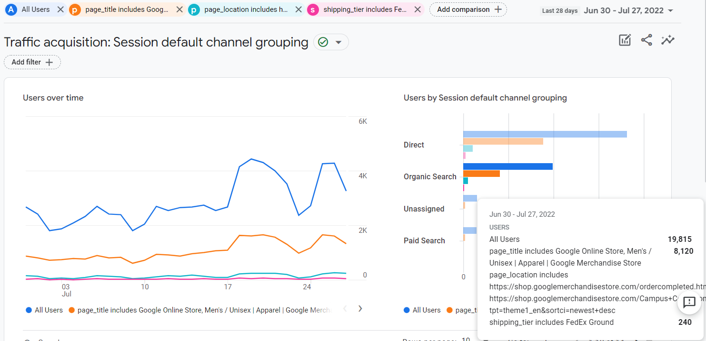

1. **ENAGEMENT:**

* **OVERVIEW**

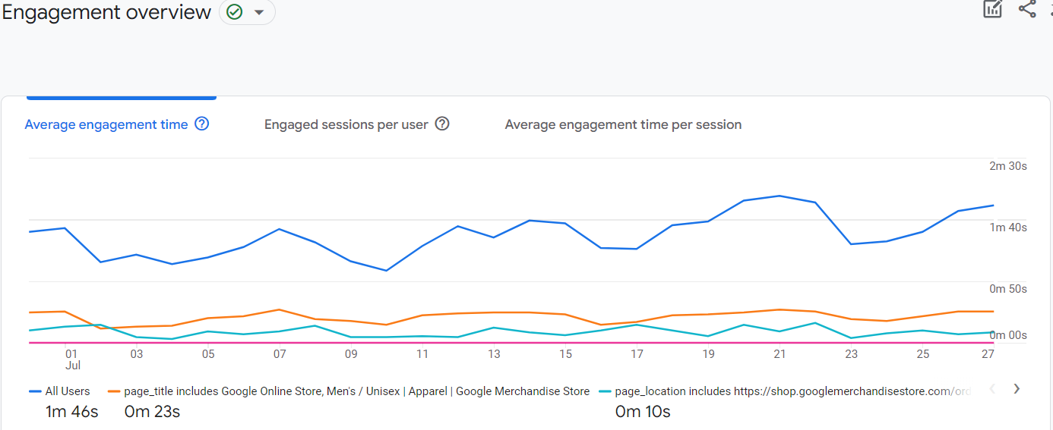

# Events: Event name

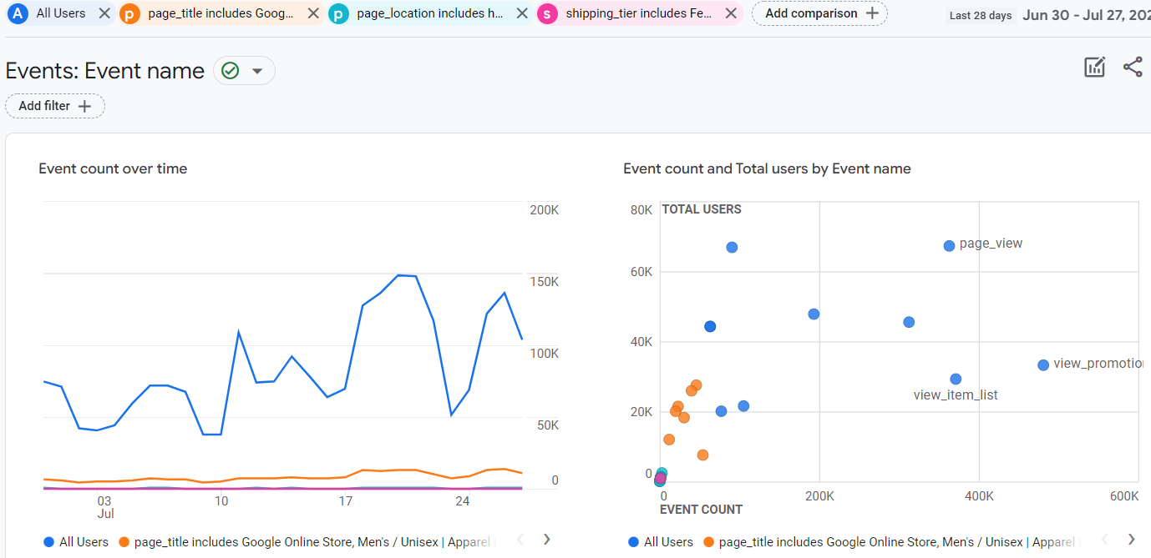

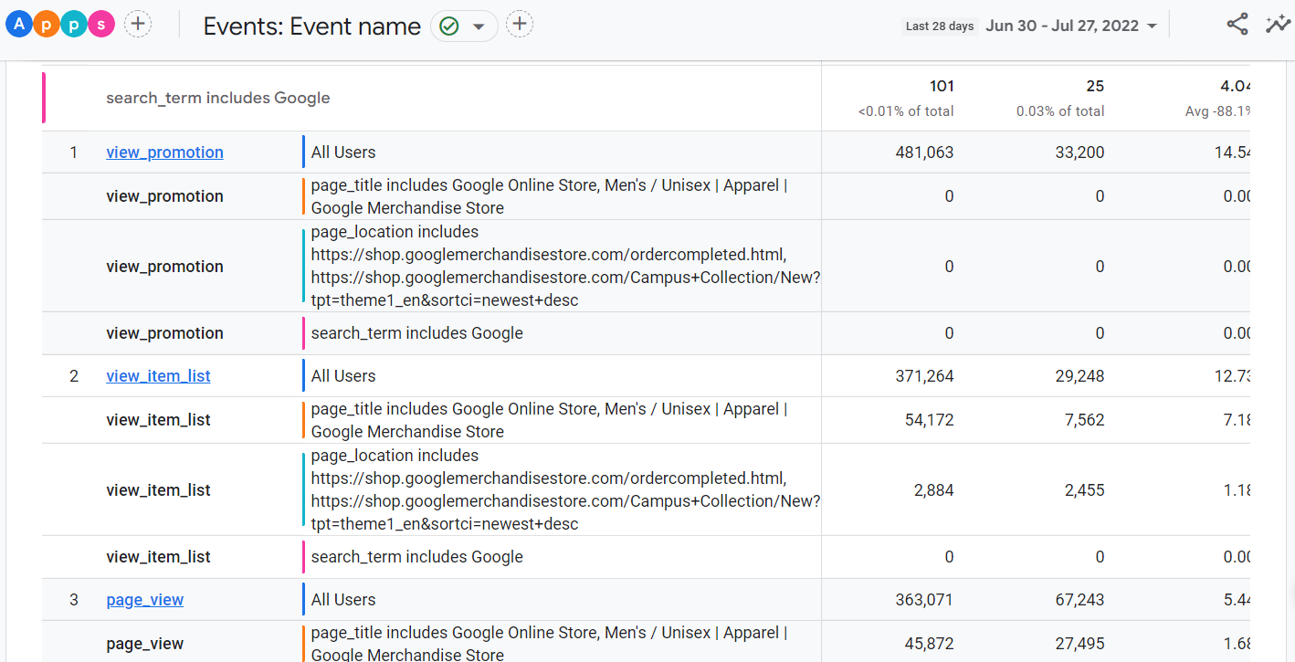

# Conversions: Event name

After adding comparisons : All user,page_location: 2 links, shipping_tier: 2 links & page_title:google onine store(men/unisex) , Search_items: google

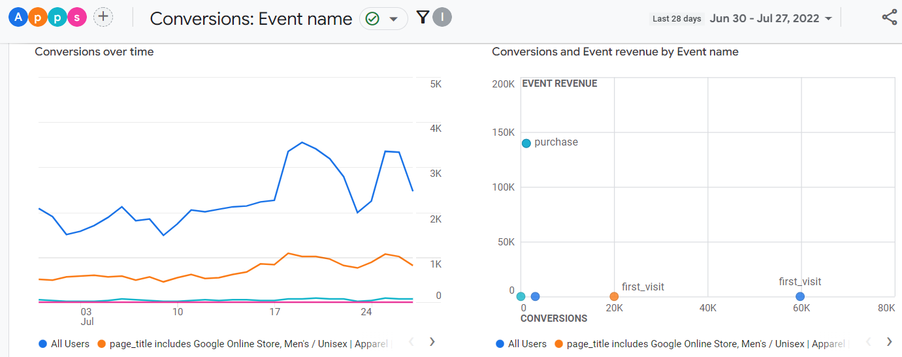

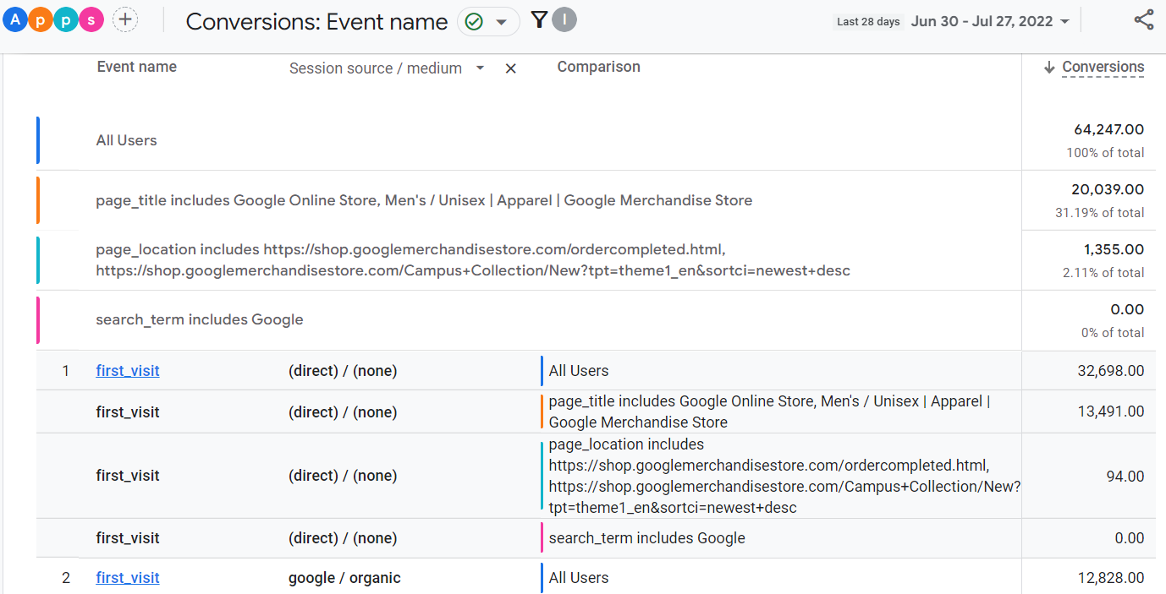

# Pages and screens:

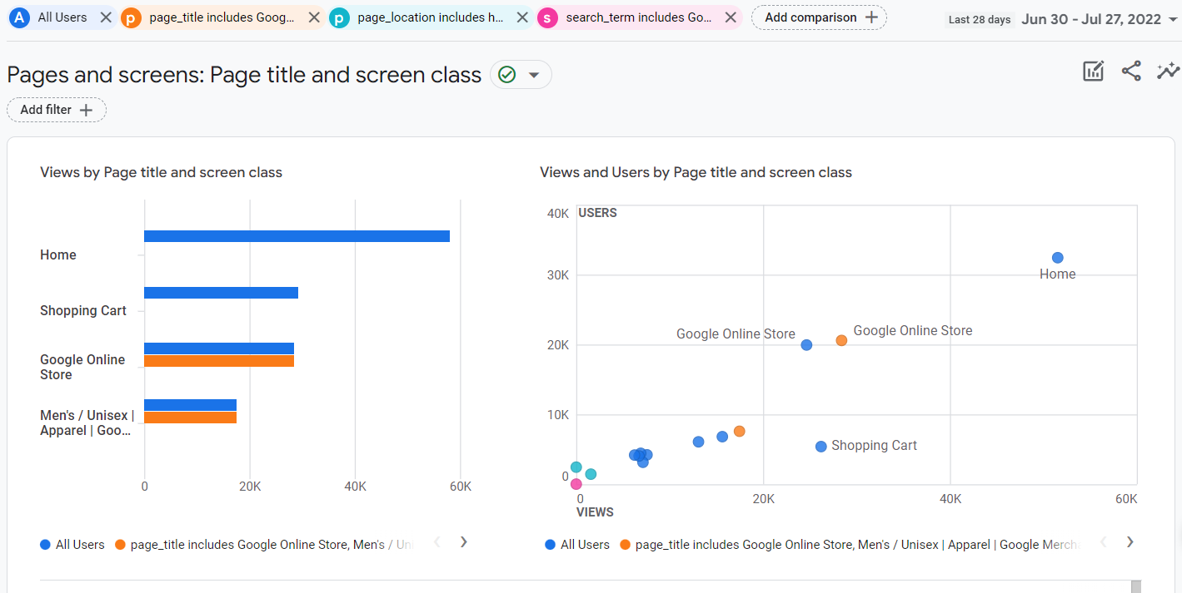

1. **MONETIZATION:**

* Overview

Before comparisons: 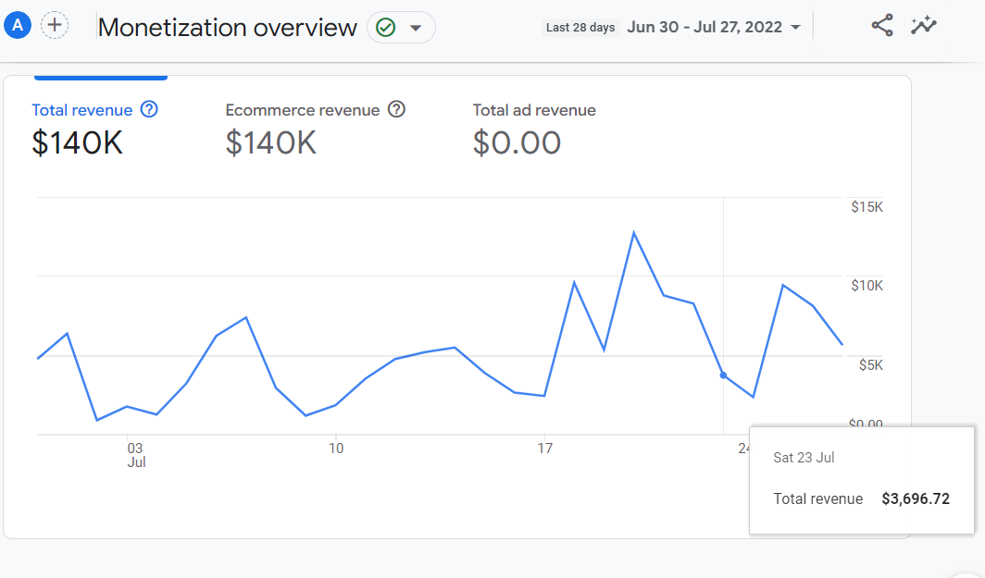

After:

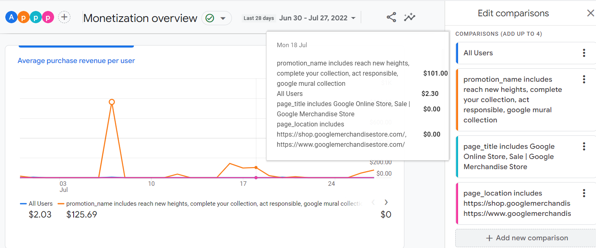

# Ecommerce purchases

# 

# In-app Purchases

# Publishers Ads

# Retention

# 

# 

# 

1. **USER:**

* Demographics
* tech