**Requirements**

These assignments has been tested and developed using the following libraries:

- python==3.6.4

- numpy==1.13.3

- scipy==1.0.0

- matplotlib==2.1.2

- jupyter==1.0.0

- jupyter_client==5.0.1

We recommend using at least these versions of the required libraries or later. Python 2 is not supported.

**Python Installation**

We highly recommend using anaconda for installing python. [Click here](https://www.anaconda.com/download/) to go to Anaconda's download page. Make sure to download the Python 3.6 version. If you are on a windows machine:

* Open the executable after download is complete and follow instructions.
* Once installation is complete, open the Anaconda prompt from the start menu. This will open a terminal with python enabled.

If you are on a linux machine:

* Open a terminal and navigate to the directory where Anaconda was downloaded.
* Change the permission to the downloaded file so that it can be executed. So if the downloaded file name is Anaconda3-5.1.0-Linux-x86_64.sh, then use the following command:  
  chmod a+x Anaconda3-5.1.0-Linux-x86_64.sh
* Now, run the installation script using ./Anaconda3-5.1.0-Linux-x86_64.sh, and follow installation instructions in the terminal.

Once you have installed python, create a new python environment will all the requirements using the following command:

https://conda.io/projects/conda/en/latest/user-guide/tasks/manage-environments.html#activating-an-environment

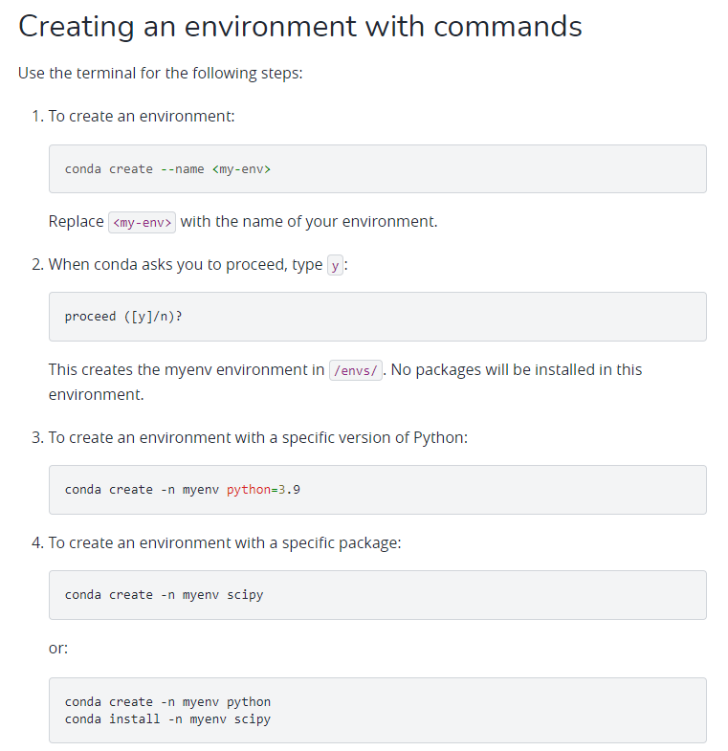

After the new environment is setup, activate it using (windows)

activate machine_learning

or if you are on a linux machine

source activate machine_learning

To deactivate the environment:

conda deactivate machine_learning

Install necessary libraries in the requirements sections by using :

conda install library_name (conda install numpy)

After that you can open jupyter notebook by:

jupyter notebook

It will open the jupyter notebook that you can start to work on your assignment