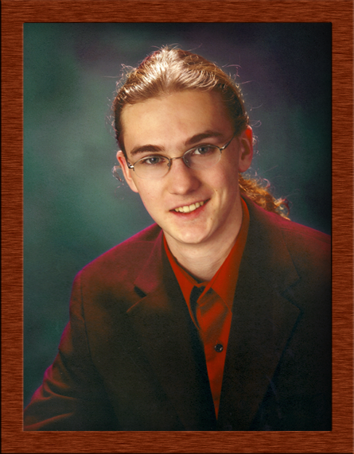
Curran Kelleher
10 Brooks Road
Paxton, MA 01612
phone 508 340 0357
e-mail: curran.kelleher@gmail.com

OBJECTIVE | To obtain a position as a research assistant in bioinformatics,  information visualization, computer graphics, or related fields.
SKILLS | Very strong Java development, particularly for interactive graphical applications. For samples of my programming, go to http://www.curransoft.com/curran/javaprojects_web  Strong C# development, rudimentary abilities with C, C++, Perl, Python, Jython  Graphic design with Adobe Photoshop, GIMP, Adobe InDesign  Web development, live sound, multitrack music recording, advanced jazz guitar  Fundamental knowledge of biology
EDUCATION | Pursuit of Bachelors Degree in Computer Science with Bioinformatics Option  University of Massachusetts Lowell Lowell, MA (anticipated graduation) 2009  - Participant in the University of Massachusetts Lowell Honors Program.  - Dean's List student spring semester 2006.  - Undergraduate representative of the Bioinformatics program.  - Cumulative GPA 3.456
Intensive Course in Dynamics of Complex Systems
Massachusetts Institute of Technology Cambridge, MA January 2006
- One week intensive course taught by Yaneer Bar-Yam, founder of the New England Complex Systems Institute. This course focused on the core concepts and methods of complex systems, and their applications in physical, biological and social systems.
PUBLICATION | Howard Goodell, Chih-Hung Chiang, Curran Kelleher, Alex Baumann, Georges Grinstein, "Collecting and Harnessing Rich Session Histories," iv, pp. 117-123, Tenth International Conference on Information Visualisation (IV'06), 2006.
PROFESSIONAL EXPERIENCE | Research Assistant  University of Massachusetts Lowell Lowell, MA June 2005 - March 2007  At the Center for Biomolecular & Medical Informatics, director Dr. Georges Grinstein.  Worked in groups:  - preprocessing text data to be released as part of the 2007 IEEE Visual Analytics Science and Technology (VAST) contest, using named entity recognition tools in collaboration with Mitre Corporation  - implementing a state based session history framework in the Universal Visualization Platform (UVP), a versatile information visualization and data mining platform, developed by the group (in Java).
Software Engineer
N. E. C. S. I. Cambridge, MA January - June 2006
- New England Complex Systems Institute headed by Dr. Yaneer Bar-Yam.
- Worked with a small group of researchers to develop a model for simulating large-scale socioeconomic dynamics. Developed software (in Java) to visualize existing global data as well as the output of the model.
Research Assistant
Univ. of Massachusetts Medical School Worcester, MA June 2004 - June 2005
- Research assistant for Dr. William Theurkauf, assisting graduate students with experiments in fruit flies. Investigated the role of RNAi (RNA Interference, a method of gene silencing) components in embryonic axis specification and related phenomena.
Software
- Developed software for easily visualizing 2D, 3D, and 4D (time-dependent 3D) mathematical functions.
- Physics simulation of particles interacting with various forces
- Developed a pure-Java 3D rendering engine
- Visualizations of fractals and cellular automata
PERSONAL INTERESTS | Music  - Studied privately guitar technique and music theory from July 2003 to June 2006  - Attended master classes with Pat Metheny, Bucky Pizzareli, Pat Martino, Jody Fisher  - Played guitar in many small and large jazz ensembles in the Worcester area  - Taught private guitar and music theory lessons to six students from 10 to 16 years old  - Studied viola and bass, played those instruments in several groups  - Much experience with live sound as well as studio recording  German  - Independent study of German from July 2006 to February 2007  - Private tutoring with exchange student James Kurz, from Frankfurt University  - Two semesters of college level German language and culture courses

