Daniel Bretthauer

August 31, 2020

Foundations of Programming: Python

Assignment 08

# **Assignment 08**

# Introduction.

This document describes the steps taken to perform Assignment 08, which requires a modification of a program that utilizes classes and objects to interact with a simple database of products/prices.

# Steps Taken for Assignment 08.

1. Created a new project for Assignment 08 inside of PyCharm. Downloaded Assignment 08 starter.
2. Watched the getting started video for Assignment 08.
3. Modified the assignment header.
4. Modified the data section of the program to create a class of objects called Product; specify variables; create a constructor; and override the default __str__() method for the Product class of objects, so that I could easily print() useful information. See Figure 1.

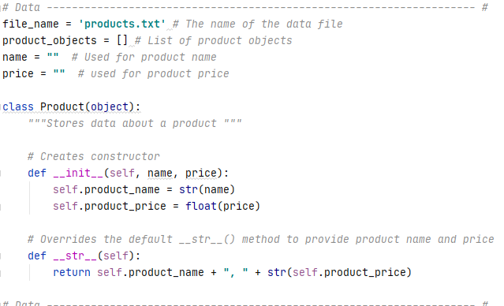

***Figure 1***

1. Modified the processing section of the program to include a FileProcessor class that reads objects from a txt file and save objects to a data file. I also experimented with the format function to round the price values to two decimals, because that is how our currency system works. See Figure 2.

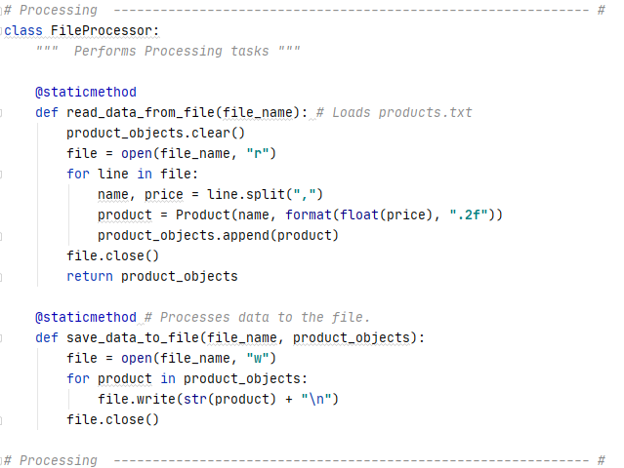

***Figure 2***

1. Modified the presentation section of the program, which includes a I/O class. This includes functions for displaying a menu with three options, a user input, the current list of products in the database, input for a new product/price, a pause before continuing step, and a yes/no option. These were all similar to prior homework. However, I once again attempted to format the user’s inputted price to a float with two decimals. See Figure 3 on next page.

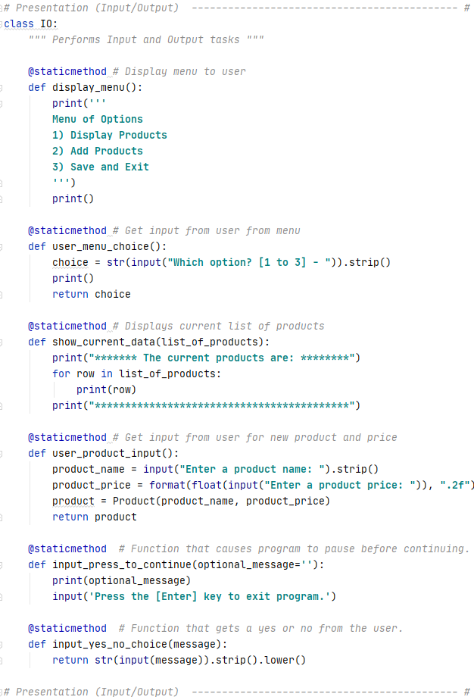

***Figure 3***

1. Next, I created the main body of the script. The script starts by loading the existing .txt file into memory. Then, the script displays the display_menu() function, which gives users three options to choose from. If the user chooses option 1, then the IO.show_current_data() function displays the existing data. If the user chooses option 2, then the IO.user_product_input() function is used to collect a new product and price from the user and the list of product objects is appended with this new information. If the user chooses option 3, then the script asks the user if they want to save and exit. If the user responds with “y”, then it saves the data and lets the user know that the save succeeded. If the user respond with a “n”, then it tells the user the save is cancelled and continues back to the menu. See Figure 4.

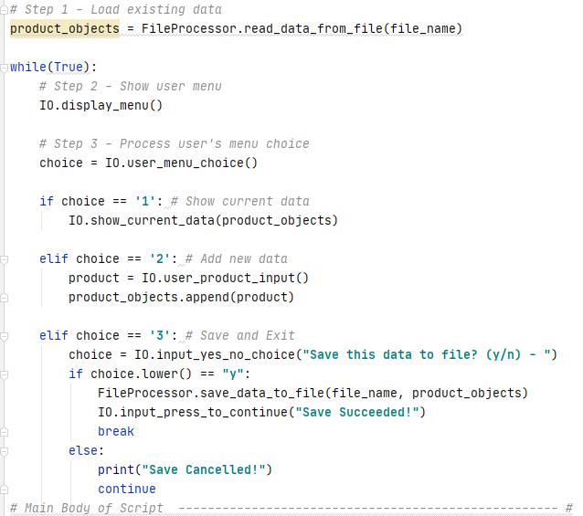

***Figure 4***

1. I then tested the program. One annoyance I had is that the formatting method I used did not convert a single decimal point to two decimals. I could not figure out how to fix that easily. Otherwise, the program worked as expected. See Figure 5.

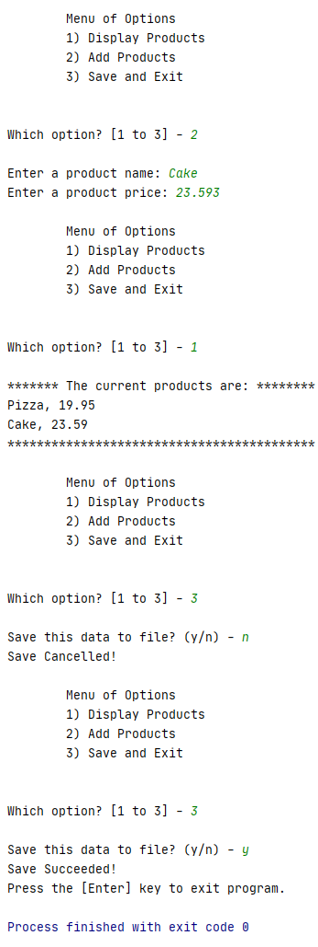

***Figure 5***

1. I then downloaded github desktop from <https://desktop.github.com/>.
2. I installed github desktop and logged in.
3. I created a github repository named “"IntroToProg-Python-Mod08”. See Figure 6.

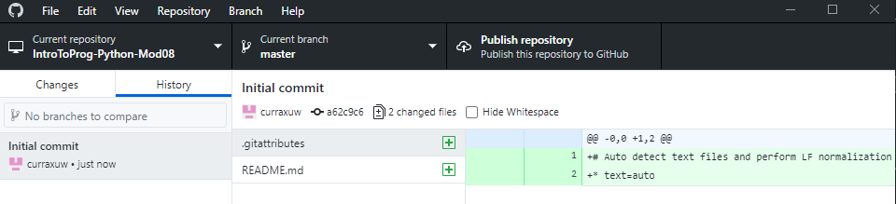

***Figure 6***

1. I then copied my Assignment08.py and Assignment08.docx into the repository folder for upload.
2. I then added a title and description of the change within github desktop.
3. Here is a link to the repository: <https://github.com/curraxuw/IntroToProg-Python-Mod08>

# Summary.

Assignment 08 called for modification of a program that uses objects.