对男生身高用皮尔逊卡方检验法检验（α=0.05）假设：



其中

因为男生身高均值176，方差40.48197，标准差6.362544，所以正态分布N(176.0738， 6.362544)。

> for(i in 1:9)

+ {b=160+3*i

+ c=160+3*(i-1)

+ p[i]<-(pnorm((b-176)/6.36)- pnorm((c-176)/6.36))

+ print(p[i])}

[1] 0.01453611

[1] 0.03746183

[1] 0.07759173

[1] 0.1291681

[1] 0.1728336

[1] 0.1858855

[1] 0.1606979

[1] 0.1116649

[1] 0.06236642

（1）说明用书上3.3.1四种的哪一种效果都不好。

male_height<-c(185, 173, 175, 182, 173, 181, 184, 179, 181, 187, 169, 178,

183, 168, 181, 175, 175, 186, 186, 182, 178, 177, 172, 168,

173.5, 184, 183, 175, 168, 174, 181, 170, 166, 178, 177, 181,

163, 172, 160, 173, 185, 172, 183, 180, 175, 178, 169, 175,

165, 169, 170, 183, 184, 174, 170, 173, 170, 182, 178, 170,

179)

hist(male_height, breaks=160+(0:7)*4,

xlim=c(min(male_height),max(male_height)), col='lightblue')

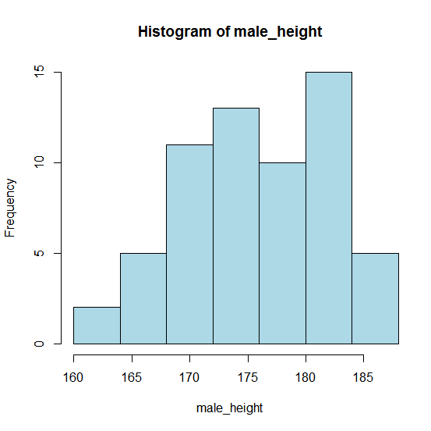

（2）用QQ图

qqnorm(male_height,

main="Normality Check via QQ Plot")

qqline(male_height, col='red')

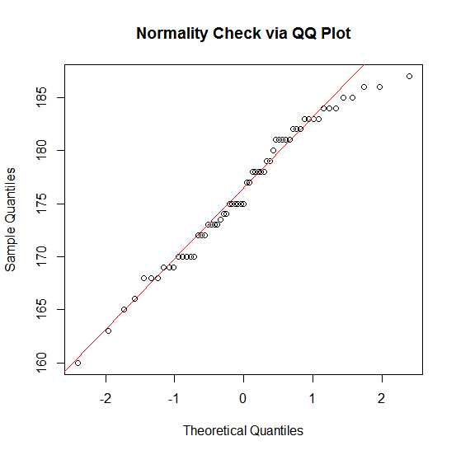

1. 与正态函数比较

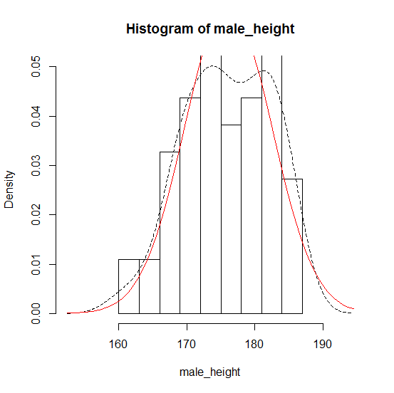

1. 使用经验分布函数

x <- sort(male_height)

n <- length(x)

y <- (1:n)/n

m <- mean(male_height)

s <- sd(male_height)

plot(x,y, type='s', main="empirical cdf of ")

curve(pnorm(x,m,s),col='red', lwd=2, add=T)

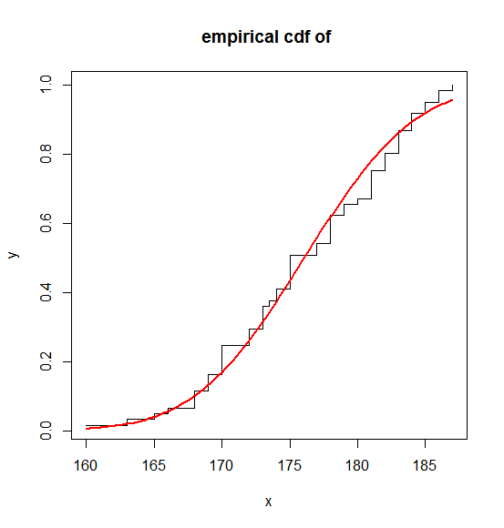

1. 参数假设检验

1.方差未知时检验均值

male_height<-c(185, 173, 175, 182, 173, 181, 184, 179, 181, 187, 169, 178,

183, 168, 181, 175, 175, 186, 186, 182, 178, 177, 172, 168,

173.5, 184, 183, 175, 168, 174, 181, 170, 166, 178, 177, 181,

163, 172, 160, 173, 185, 172, 183, 180, 175, 178, 169, 175,

165, 169, 170, 183, 184, 174, 170, 173, 170, 182, 178, 170,

179)

t.test(male_height, mu=176.0738)

One Sample t-test

data: male_height

t = -3.6222e-05, df = 60, p-value = 1

alternative hypothesis: true mean is not equal to 176.0738

95 percent confidence interval:

174.4442 177.7033

sample estimates:

mean of x

176.0738

结论：结论: 因为p值=1大于α=0:05, 故接收原假设, 认为该包装机正常.

1. 均值未知时检验方差

chisq.var.test <- function (x,var,alpha,alternative="two.sided"){

options(digits=4)

result<-list( )

n<-length(x)

v<-var(x)

result$var<-v

chi2<-(n-1)*v/var

result$chi2<-chi2

p<-pchisq(chi2,n-1)

if(alternative == "less"|alternative=="greater"){

result$p.value<-p

} else if (alternative=="two.sided") {

if(p>.5)

p<-1-p

p<-2*p

result$p.value<-p

} else return("your input is wrong")

result$conf.int<-c(

(n-1)*v/qchisq(alpha/2, df=n-1, lower.tail=F),

(n-1)*v/qchisq(alpha/2, df=n-1, lower.tail=T))

result

}

male_height<-c(185, 173, 175, 182, 173, 181, 184, 179, 181, 187, 169, 178,

183, 168, 181, 175, 175, 186, 186, 182, 178, 177, 172, 168,

173.5, 184, 183, 175, 168, 174, 181, 170, 166, 178, 177, 181,

163, 172, 160, 173, 185, 172, 183, 180, 175, 178, 169, 175,

165, 169, 170, 183, 184, 174, 170, 173, 170, 182, 178, 170,

179)

chisq.var.test(male_height, 40.48, 0.05)

$var

[1] 40.48

$chi2

[1] 60

$p.value

[1] 0.9512

$conf.int

[1] 29.16 60.00

因为p值=0.9512>0:α05, 故接收原假设, 认为熔化时间方差不超

过80.