Q-Learning Based Chess AI Training Report

Youtube: https://youtu.be/ktM2Tp4iRjQ

Github: KI-cheng/QlearningTankWar: ML project
1 Introduction
This project implements a chess AI confrontation system using the Q-Learning reinforcement learning algorithm, with Pygame as the visual framework. The system pits a Q-Learning-controlled Black AI against a random-move White AI, completing 5 games at 20 steps per second. This report systematically documents the game design, Q-Learning implementation, challenges encountered, and solutions applied, providing a clear view of the AI’s initial learning phase and future optimization directions.

2 Game Design
2.1 Rules of the Game
The game follows standard international chess rules, with the following key constraints for AI training:
Game Setup: Black is controlled by the Q-Learning AI, while White uses a random move strategy.
Game End: The game concludes with checkmate, stalemate, or draw, with corresponding rewards/penalties applied.
Move Speed: Each move is executed at 20 steps per second (50ms delay per step) to balance training efficiency and real-time visualization.
Training Configuration: 5 total games (4 for hyperparameter testing, 1 for final validation) are used to evaluate initial performance.

2.2 Class Design of the Game
The system is structured into two core classes:

ChessQLEnvironment: Manages the chessboard state, legal moves, reward calculation, and game reset. It converts the board into a hashable state tensor for Q-Learning and computes rewards based on piece captures, checks, and game outcomes.
QLearningChessAI: Implements the Q-Learning logic, including Q-table storage, ε-greedy action selection, Q-value updates via the Bellman equation, and epsilon decay to balance exploration and exploitation.

2.3 UI Design
The UI is built using Pygame and consists of two main screens:
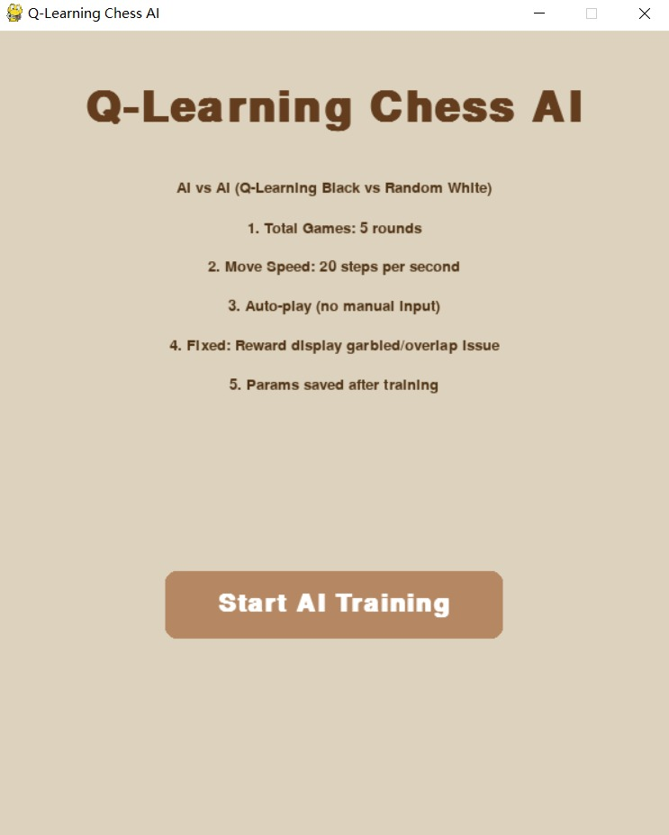
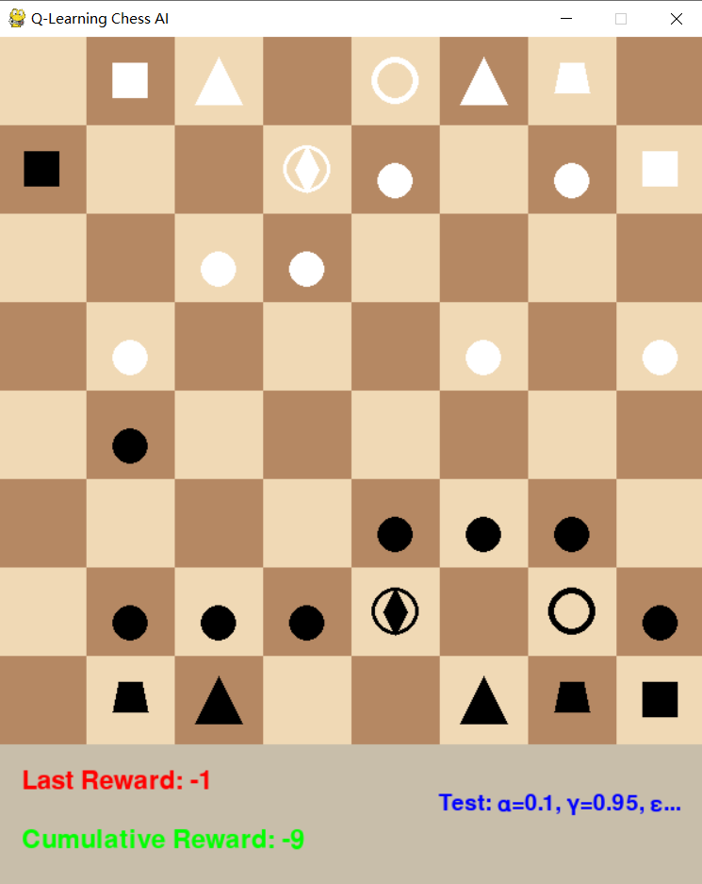(chess scene)
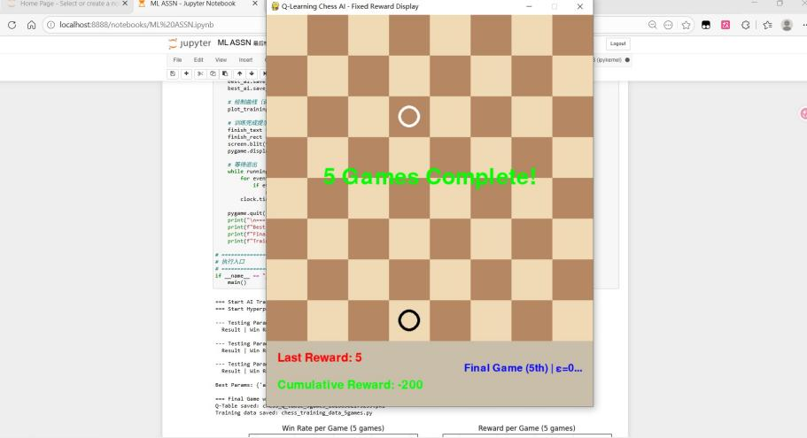(game over)

Startup Screen: Displays the project title, key training parameters (5 games, 20 steps/sec), and a "Start AI Training" button to initiate the process.
Game Screen: Renders the 600×600 pixel chessboard with vector-based chess pieces, and an info bar showing real-time Last Reward, Cumulative Reward, and training progress .

Chess pieces are rendered using Pygame’s vector functions to avoid external image dependencies:
Pawn: Solid circle
Knight: Irregular quadrilateral
Bishop: Upward-pointing triangle
Rook: Solid square
Queen: Hollow circle with a cross
King: Thick hollow circle

3 Implement of Q-learning Algorithm
The Q-Learning implementation follows these core steps:
State Representation: The 8×8 board is encoded as a 8×8×12 tensor, where each layer represents a piece type for either color.
Action Selection: Using an ε-greedy strategy (initialε=0.9, decaying to 0.1), the AI either explores random moves or selects the action with the highest Q-value from the Q-table.
Reward Function: Rewards are assigned for capturing pieces (+2×piece value), checking the opponent (+10), and winning (+100). Penalties are applied for losing pieces (-2×piece value), being checked (-15), and losing (-100).
Q-Table Update: After each move, the Q-value for the state-action pair is updated using the Bellman equation.
Hyperparameter Testing: Three combinations of α(learning rate), γ(discount factor), and initial ε are tested to select the best-performing set based on win rate and average reward.

4 Challenges and Solutions
Reward Display Garbled/Overlap:
Challenge: Initial UI rendering caused text overlap and garbled reward values.
Solution: Implemented an independent info bar with a solid background refresh before rendering text, fixed text positions, and used Pygame’s default bitmap font to ensure clear, non-overlapping display.

Slow Training Speed:
Challenge: Initial 4 steps/sec was too slow for 5 games.
Solution: Reduced the step delay to 50ms and set the frame rate to 20 FPS, achieving 20 steps/sec without sacrificing UI responsiveness.

Poor Initial AI Performance:
Challenge: The AI lost all 5 games with a 0% win rate and negative cumulative reward.
Solution: Recognized this as a normal initial exploration phase. Future optimizations include increasing training rounds, adjusting ε decay, and refining the reward function to better reflect positional play.
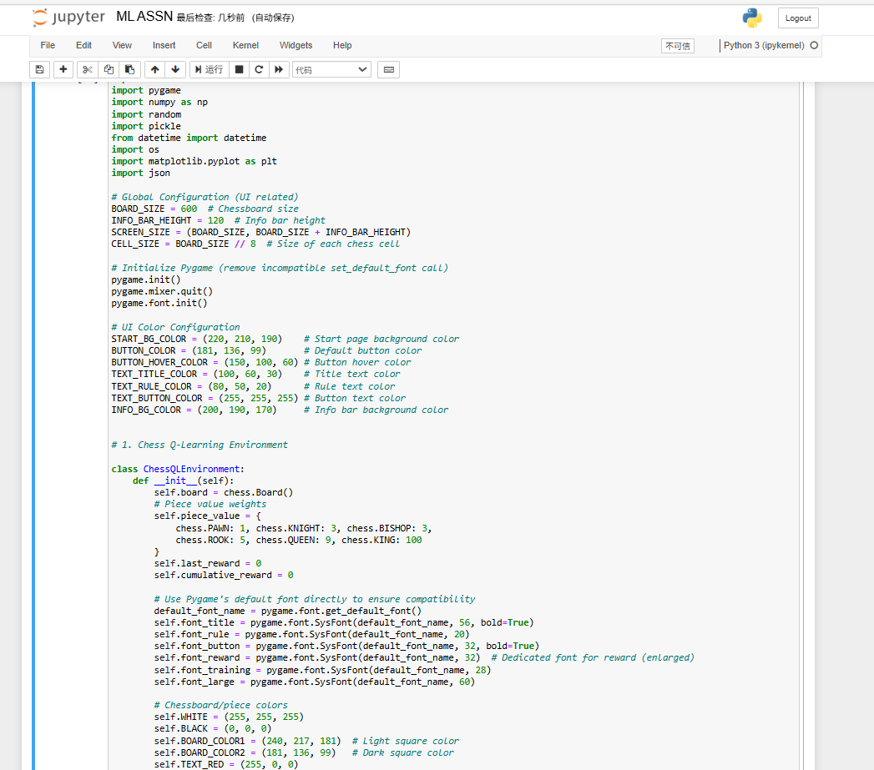(main program)

5 Conclusion
This project successfully demonstrates a Q-Learning chess AI with stable visualization and reward tracking. While the initial performance is poor, this is expected in the early stages of reinforcement learning. The system provides a solid foundation for future improvements, such as scaling to thousands of training games, optimizing hyperparameters, and exploring Deep Q-Networks (DQN) to handle chess’s large state space more effectively.

6 Reference
Sutton, R. S., & Barto, A. G. (2018). Reinforcement Learning: An Introduction. MIT Press.
Pygame Documentation. (2024). Retrieved from https://www.pygame.org/docs/
Python Chess Library. (2024). Retrieved from https://python-chess.readthedocs.io/

