Untitled

# titulo2

## subtitulo

### subsubtitulo

texto **negrito** *italico*.

* item 1
* item 2
* item 3

1. numero
   1. itens
   2. numero
2. numero
3. numero

$$e^{iπ}=−1$$

## R Markdown

This is an R Markdown document. Markdown is a simple formatting syntax for authoring HTML, PDF, and MS Word documents. For more details on using R Markdown see <http://rmarkdown.rstudio.com>.

When you click the **Knit** button a document will be generated that includes both content as well as the output of any embedded R code chunks within the document. You can embed an R code chunk like this:

## Including Plots

Como você pode ver na Figura 1, temperatura e pressão são relacionadas.

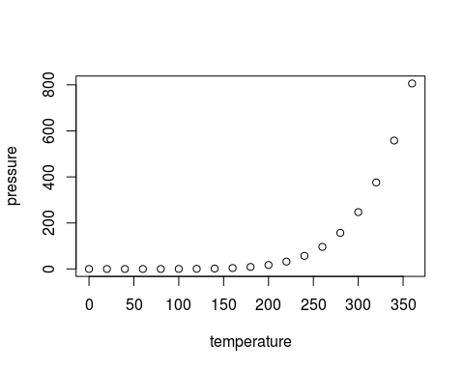

Figure 1: Descrição da minha figura

Table 1: Descrição

|  |  |
| --- | --- |
| temperature | pressure |
| 0 | 0.0002 |
| 20 | 0.0012 |
| 40 | 0.0060 |
| 60 | 0.0300 |
| 80 | 0.0900 |
| 100 | 0.2700 |
| 120 | 0.7500 |
| 140 | 1.8500 |
| 160 | 4.2000 |
| 180 | 8.8000 |
| 200 | 17.3000 |
| 220 | 32.1000 |
| 240 | 57.0000 |
| 260 | 96.0000 |
| 280 | 157.0000 |
| 300 | 247.0000 |
| 320 | 376.0000 |
| 340 | 558.0000 |
| 360 | 806.0000 |





gatinho

Note that the echo = FALSE parameter was added to the code chunk to prevent printing of the R code that generated the plot.