Untitled

bia

7/22/2021

## titulo 2

* Carregar os pacotes

ggplot(mtcars) +  
 geom_point(aes(x = wt, y = mpg))

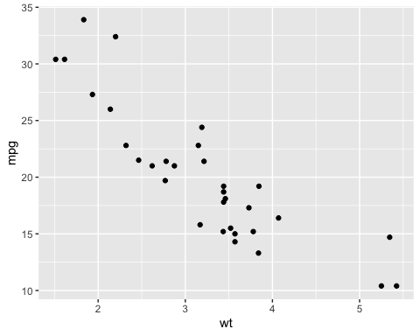

ggplot(mtcars) +  
 geom_point(aes(x = wt, y = mpg))

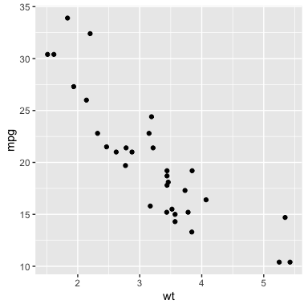

Gráfico da base mtcars

ggplot(mtcars) +  
 geom_point(aes(x = wt, y = mpg))

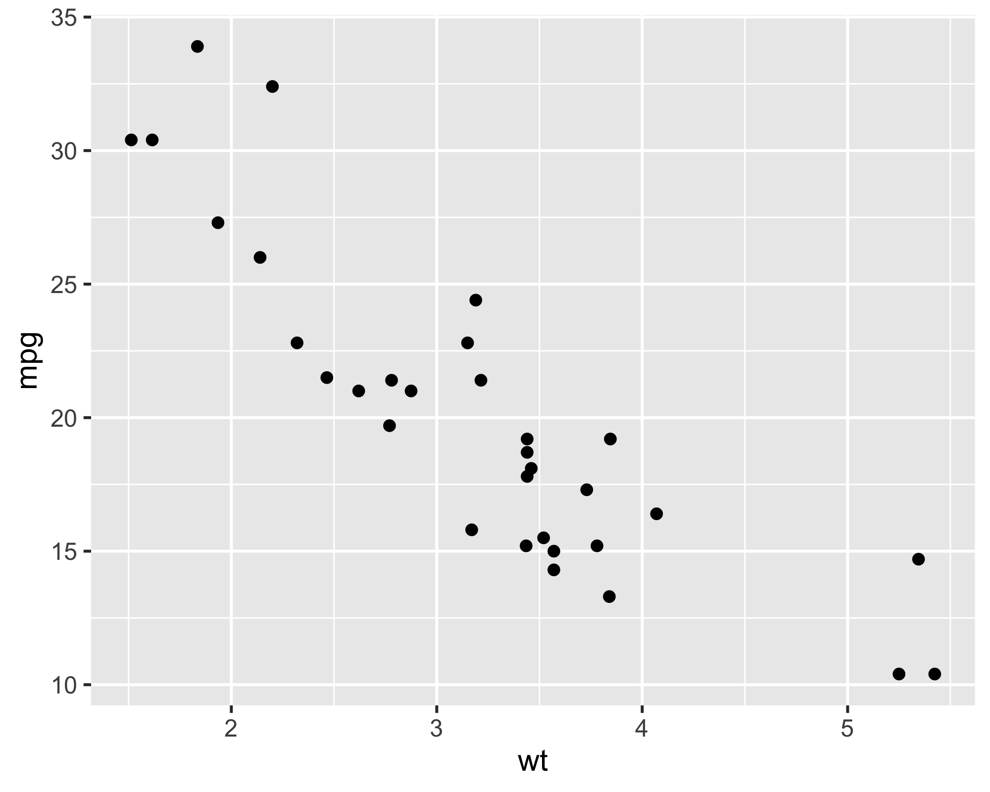

|  |  |  |  |  |  |  |  |  |  |  |  |
| --- | --- | --- | --- | --- | --- | --- | --- | --- | --- | --- | --- |
|  | mpg | cyl | disp | hp | drat | wt | qsec | vs | am | gear | carb |
| Mazda RX4 | 21.0 | 6 | 160 | 110 | 3.90 | 2.620 | 16.46 | 0 | 1 | 4 | 4 |
| Mazda RX4 Wag | 21.0 | 6 | 160 | 110 | 3.90 | 2.875 | 17.02 | 0 | 1 | 4 | 4 |
| Datsun 710 | 22.8 | 4 | 108 | 93 | 3.85 | 2.320 | 18.61 | 1 | 1 | 4 | 1 |
| Hornet 4 Drive | 21.4 | 6 | 258 | 110 | 3.08 | 3.215 | 19.44 | 1 | 0 | 3 | 1 |
| Hornet Sportabout | 18.7 | 8 | 360 | 175 | 3.15 | 3.440 | 17.02 | 0 | 0 | 3 | 2 |

o resultado é 2. O mpg do carro Mazda é 21.

## Importação

## [1] "/Users/beatrizmilz/Documents/Curso-R/cursos/visualizacao-relatorios/202107-visualizacao/exemplos_de_aula/01-rmarkdown"

## Rows: 3,713  
## Columns: 15  
## $ titulo <chr> "Avatar", "Pirates of the Caribbean: At World's End", "…  
## $ ano <int> 2009, 2007, 2012, 2012, 2007, 2010, 2015, 2016, 2006, 2…  
## $ diretor <chr> "James Cameron", "Gore Verbinski", "Christopher Nolan",…  
## $ duracao <int> 178, 169, 164, 132, 156, 100, 141, 183, 169, 151, 150, …  
## $ cor <chr> "Color", "Color", "Color", "Color", "Color", "Color", "…  
## $ generos <chr> "Action|Adventure|Fantasy|Sci-Fi", "Action|Adventure|Fa…  
## $ pais <chr> "USA", "USA", "USA", "USA", "USA", "USA", "USA", "USA",…  
## $ classificacao <chr> "A partir de 13 anos", "A partir de 13 anos", "A partir…  
## $ orcamento <int> 237000000, 300000000, 250000000, 263700000, 258000000, …  
## $ receita <int> 760505847, 309404152, 448130642, 73058679, 336530303, 2…  
## $ nota_imdb <dbl> 7.9, 7.1, 8.5, 6.6, 6.2, 7.8, 7.5, 6.9, 6.1, 7.3, 6.5, …  
## $ likes_facebook <int> 33000, 0, 164000, 24000, 0, 29000, 118000, 197000, 0, 5…  
## $ ator_1 <chr> "CCH Pounder", "Johnny Depp", "Tom Hardy", "Daryl Sabar…  
## $ ator_2 <chr> "Joel David Moore", "Orlando Bloom", "Christian Bale", …  
## $ ator_3 <chr> "Wes Studi", "Jack Davenport", "Joseph Gordon-Levitt", …