Exemplo da aula

Beatriz

2022-11-01

## R Markdown

This is an **R Markdown document**. Markdown is *a simple formatting* syntax for authoring HTML, PDF, and MS Word documents. For more details on using R Markdown see <http://rmarkdown.rstudio.com>.

### Titulo de nivel 3

1. [Beatriz](https://beamilz.com)
2. Andressa
3. Vitor
4. Gabriel
5. Daniel

[](https://curso-r.github.io/main-relatorios/slides/)

getwd()

## [1] "/Users/beatrizmilz/Desktop/material-curso-relatorios/praticas"

llalalalla

🤣

CTRL ALT I

sample(1:100, 5)

## [1] 36 42 90 48 100

# use comentários!

sample(1:100, 5)

Legenda

| Col1 | Col2 | Col3 |
| --- | --- | --- |
|  |  |  |
|  |  |  |
|  |  |  |

When you click the **Knit** button a document will be generated that includes both content as well as the output of any embedded R code chunks within the document. You can embed an R code chunk like this:

summary(cars)

## speed dist   
## Min. : 4.0 Min. : 2.00   
## 1st Qu.:12.0 1st Qu.: 26.00   
## Median :15.0 Median : 36.00   
## Mean :15.4 Mean : 42.98   
## 3rd Qu.:19.0 3rd Qu.: 56.00   
## Max. :25.0 Max. :120.00

## Including Plots

You can also embed plots, for example:

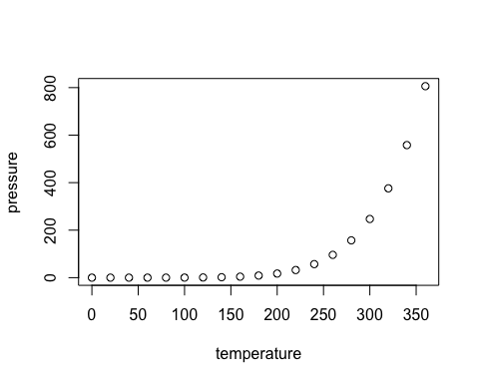

Note that the echo = FALSE parameter was added to the code chunk to prevent printing of the R code that generated the plot.