VOICE INTEGRATED USER INTERFACE FOR GEOSPATIAL MAP BASED WEB-APPLICATIONS.

Mr. Aryan Abhijit Bamane, Mr. Atharva Arun Khamkar, Mr. Abhishek Sambhaji Patil, Ms. Hrutuja Sambhaji Desai

Undergraduate Student, Computer Science & Engineering, D Y Patil Technical Campus Talsande, Kolhapur, Maharashtra, India
Undergraduate Student, Computer Science & Engineering, D Y Patil Technical Campus Talsande, Kolhapur, Maharashtra, India
Undergraduate Student, Computer Science & Engineering, D Y Patil Technical Campus Talsande, Kolhapur, Maharashtra, India
Undergraduate Student, Computer Science & Engineering, D Y Patil Technical Campus Talsande, Kolhapur, Maharashtra, India

ABSTRACT
This research explores the integration of voice assistants in geospatial web platforms, aiming to enhance human–computer interaction through natural language commands. We introduce a voice-enabled interface within the BStreams platform, employing tools such as the Web Speech API, Leaflet, and Mapbox geocoding to enable dynamic geospatial data visualization. A structured, mixed-methods approach guided the study, beginning with the identification of commonly used geospatial commands through a survey of 66 participants. These results were compared with language model predictions from ChatGPT, revealing a strong correlation (r = 0.81, p < 0.01) between model-suggested terms and user-reported terminology. Building upon this, we developed a specialized geospatial discourse framework and implemented a working prototype to validate its effectiveness. Usability testing confirmed the system's potential for intuitive map interaction via voice, though challenges remain in domain-specific language interpretation. Additionally, the study highlights the significance of user profiles and contextual language understanding in designing accessible and efficient voice user interfaces for GIS applications. All data and the open-source codebase are provided to support future research and development in this domain.

Keyword: voiceGIS, geovoice, offlinespeech, LeafletVoice, OpenLayersVoice, mapinteraction, ondevicevoice, GPUVUI, NLPGIS, webGIS.
1. INTRODUCTION
The project, “A Voice Enabled User Interface Geospatial Map-based Web-Applications,” cover many scenarios and much content, related advanced services are lacking in the field of geographic orientation, despite it being an environment of early technology adoption. For instance, methods of user–computer interaction underwent a revolution related to the introduction of graphical user interfaces (GUIs) and their popularization by the Apple Macintosh in the early 1980s. Geographic information systems (GISs) adopted them at an early stage for logical reasons . Now, even Appl. Sci. 2023,13, 2083. https://doi.org/10.3390/app13042083 https://www.mdpi.com/journal/applsci Appl. Sci. 2023, 13, 2083 2 of 16 with the help of the GUIs, GISs are inherently complex, and their interactions are often complicated [4]. Therefore, interest has been sustained over recent decades in creating new interaction models, including voice control . However, this has not directly translated into practice. Appl. Sci. 2023, 13, x FOR PEER REVIEW 2 of 17 popularization by the Apple Macintosh in the early 1980s. Geographic information systems (GISs) adopted them at an early stage for logical reasons (Now, even with the help of the GUIs, GISs are inherently complex, and their interactions are often complicated. Therefore, interest has been sustained over recent decades in creating new interaction models, including voice control . However, this has not directly translated into practice.

1.1 Voice and GIS Convergence
Voice-enabled user interfaces (VUIs) are revolutionizing how users interact with technology, offering an intuitive, hands-free approach for controlling digital systems. This project focuses on the development of a lightweight, scalable VUI specifically designed for geospatial map-based web applications. The goal is to enhance map interaction by allowing users to issue natural language voice commands that are interpreted and executed in real time. While many existing solutions rely heavily on cloud-based APIs, this system explores the possibility of on-device voice recognition using GPU/NPU acceleration to ensure minimal latency and increased privacy. The application leverages open-source GIS libraries such as Leaflet and OpenLayers to perform common geospatial actions like zooming, panning, and toggling layers. This not only improves accessibility for non-technical users but also addresses the challenges of making GIS tools more responsive, adaptive, and user-centric.

1.2 Research Context and Challenges
Despite advances in NLP, the application of voice control in GIS remains limited. Existing solutions often rely on cloud services and lack personalization for domain-specific tasks. This project proposes a lightweight, web-based, voice-controlled GIS interface using on-device recognition tools for improved performance and privacy.

2. RELATED WORK & PROBLEM DEFINITION
Several works including Mahmoudi et al. (2023) and Blanco et al. (2023) emphasize the growing importance of integrating VUI in spatial platforms. Our project extends these findings with a real-time prototype focusing on Hindi- and English-speaking users, testing domain-specific commands and refining responses based on survey feedback.
2.1 Problem Statement
To develop a voice-enabled geospatial map-based web application that supports natural user interaction using voice commands, improving accessibility and usability of GIS tools.
2.2 Scope
- Real-time voice commands for zoom, pan, query
- Integration with mapping APIs
- NLP for command recognition
- Accessible interface for diverse user groups

3. METHODOLOGY AND IMPLEMENTATION
3.1 System Architecture
The system consists of four modules:
- UI Module – built using Leaflet.js
- Voice Recognition – powered by TensorFlow.js and Web Speech API
- Geospatial Data Manager – handles GeoJSON
- Backend API – Node.js for processing.
Following is the Designed Architecture of the system:

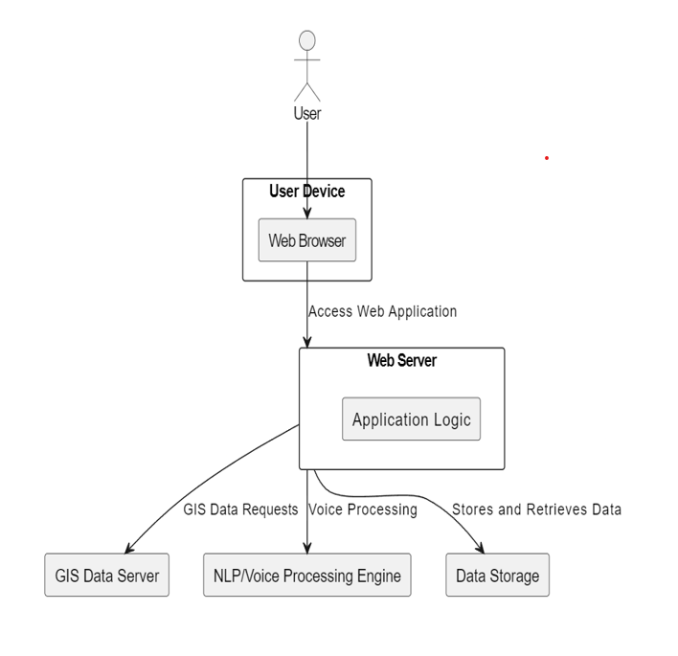

3.2 Survey & NLP Comparison
Survey of 66 users identified frequent voice commands. These were compared with ChatGPT predictions. Commands like "show," "zoom," "locate" were commonly used. High correlation (r = 0.81) confirmed validity.
3.3 Usability Testing
10 participants tested the system using real voice queries. Tasks included location search, zoom control, and layer switching. Results showed high satisfaction, though some complexity remained in command variation handling.

Following is the image that represents basic implementation and usability testing:
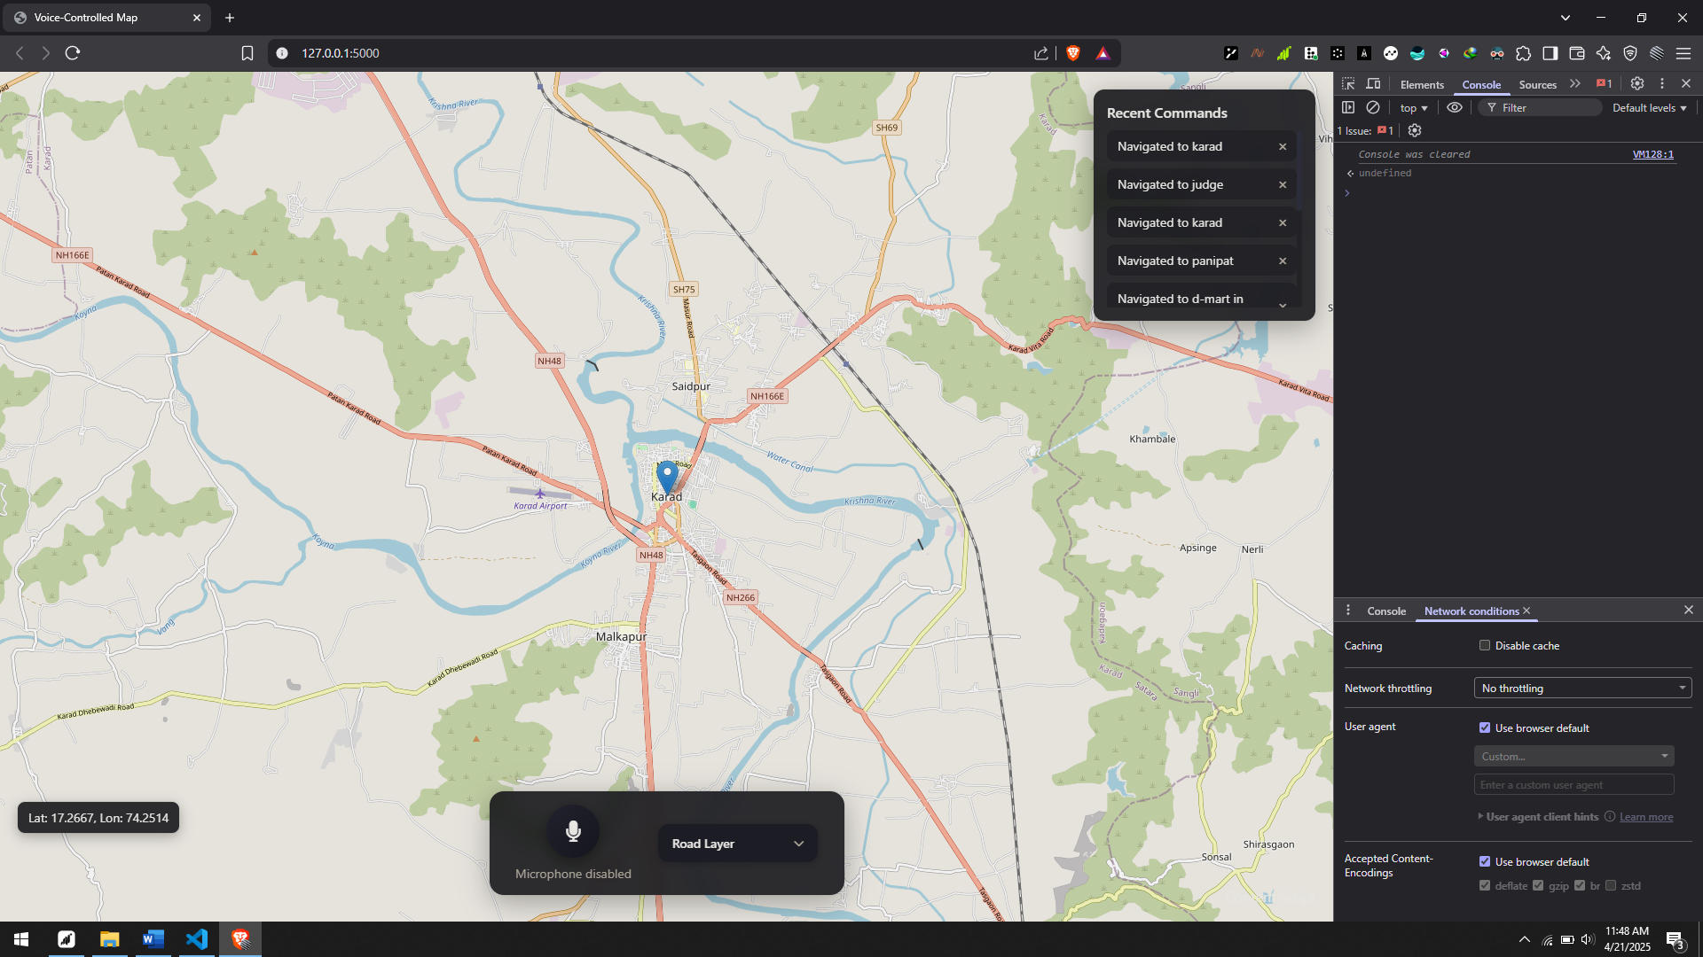

4. CONCLUSIONS
In conclusion, the Voice-Enabled Geospatial Map-Based Web Application represents a voice-based navigation approach to geospatial technology. By embracing voice interaction and modular design, the project not only addresses current challenges in GIS usability but also sets the stage for innovative solutions that can evolve with technological advancements and user needs. The successful implementation of this project has the potential to revolutionize the way users interact with geospatial information, making it more accessible, intuitive, and engaging for a diverse range of audiences.

5. ACKNOWLEDGEMENT

6. REFERENCES
[1] Gartner. 5 Trends Emerge in Gartner Hype Cycle for Emerging Technologies. 2018. Available online: https://www.gartner.com/ smarterwithgartner/5-trends-emerge-in-gartner-hype-cycle-for-emerging-technologies-2018 (accessed on 6 July 2022)
[2] Freepik-Flaticon. Gamer Icons. Flaticon. Available online: https://www.flaticon.com/free-icons/gamer (accessed on 30 December 2022)
[3] Freepik-Flaticon. Maps and Location Icons. Flaticon. Available online: https://www.flaticon.com/free-icons/maps-and-location (accessed on 30 December 2022).
[4] Hayat, S.; Rextin, A.; Bilal, A. Understanding the usability issues in contact management of illiterate and semi-literate users. PLoS ONE 2021, 16, e0259719. [CrossRef] [PubMed].
[5] Blanco, T.; Martín-Segura, S.; de Larrinzar, J.L.; Béjar, R.; Zarazaga-Soria, F.J. First Steps toward Voice User Interfaces for Web-Based Navigation of Geographic Information: A Spanish Terms Study. Appl. Sci. 2023, 13, 2083. [CrossRef]

BIOGRAPHIES (Not Essential)

Author Photo-1 | Description about the author1  (in 5-6 lines)
Author Photo-2 | Description about the author2  (in 5-6 lines)
Author Photo-3 | Description about the author3  (in 5-6 lines)
Author Photo-4 | Description about the author3  (in 5-6 lines)

