Readme:
- Master do file: sets all globals and runs analysis do file
- Run the master do file if you want all of the analyses to run
- Main outcomes we focus on based on preregistration:
  - intention1: intends to vaccinate no/yes = 0/100
  - vaccinated: vaccinated within 30 days no/yes = 0/100
- Main specification drops people who based on exclusion criteria:
  - Had already vaccinated at the time of the survey (already_vacced == 0)
  - Did not reach the question in the survey on intentions (intention1 == . )
  - Age < 18 or age >50
- The main controls are defined in the corresponding global and are exactly coded and included as pre-registered

  - Data sets:
    - data_analysis: main data set with the RCT data
    - suppl_data_1: including people who participated in the trial multiple times
    - suppl_data_2: including people who could not be matched to register data, only intentions
    - suppl_data_3: share of people vaccinated by treatment in days relative to the survey
    - suppl_data_4: extended data set to plot the pooled nudge condition alongside the other conditions
    - suppl_data_5: raw difference in vaccination uptake between treatment and control by treatment
    - suppl_data_6: raw difference in vaccination intentions between treatment and control by treatment
    - suppl_data_7: expert predictions
    - suppl_data_8: including people who already vaccinated
    - suppl_data_9: including people who did not complete the survey

  - Software: STATA 17

  - Labels of Figures 2 and 3 were made nicer in Adobe Acrobat Pro

- Considering people who participated multiple times (as indicated by their social security number), we use the following algorithm:
  - We drop people who participated more than twice
  - We keep the observation from people who participated twice if the other observation consists of a survey attempt where the participant did not reach the treatment stage
  - For remaining cases, we do the following:
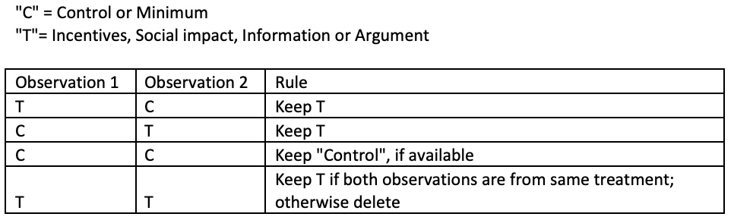
    - If the participant was once in a treatment condition and once in a control condition (actual control condition or minimum condition), we keep the treatment condition observation.
    - In case the participant was once in the control and once in the minimum (=no-reminders) condition, we keep the observation from the control condition.
    - In case the participant was twice in control, we keep the first observation based on the date.
    - We drop the remaining observations.

