Analysis

Problem:

Young people looking to play poker often have a lot of roadblocks and hurdles getting in their way. Whether this is a lack of interest from their friends, or more recently lockdown, meaning they can’t physically sit down and play with people or online solutions requiring they are above a certain age or having predatory monetisation schemes designed to take advantage of young people and designed to addict people using subconscious techniques. This leaves a giant gap in the market for accessible and non-predatory solutions that allow young people to practice and play poker in a safe environment.

How I can help by using computing:

The most obvious solution to not being able to sit down and do something is to use the internet to find a way. Without a custom solution such as mine it is impossible to play poker online as you need to play using one deck of cards and passing chips between each other. However, by using a computer and the internet you can easily have people sending data between each other with negligible delay, this is almost impossible with any other solution. Therefor we need to use computers and the internet so that data can be sent. Furthermore, due to the wide availability of the internet and the ability to store data on a central server people can log in from anywhere and pick up where they left off and see all of their data at any time without needing to bring any physical media with them. This is another task that is impossible for human’s as they would need to physically bring some method of recording data and the physical data with them to wherever they are playing from.

In addition to this the storing and tracking of data is another difficult task for people to do manually as they have to remember how and what they have done and manually plot graphs and make calculations. This wastes time that people want to be playing the game. On the other hand, this task is extremely well suited to a computer as they are designed to be able to handle data as they can easily take inputs then store, process data and display data automatically all the while unimportant information like how these numbers are generated is abstracted away to create a better user experience and save time.

Furthermore, by creating my own solution from the ground up using computational methods I can control the monetisation and the safety of the environment to ensure that no one is being taken advantage of and the game is more appropriate for all ages. This can be done by limiting the interactions between players to purely gameplay based or, if a game chat is included, to ensure it censors inappropriate messages. This isn’t possible if you are playing with strangers in real life as you can’t predict or control their behaviour or how they communicate however computers can easily parse messages and check for and violations before they are transmitted.

Stakeholders and the target demographic:

The product is targeted at anyone who wants to play poker online in a safe environment, but primarily under 18s who are unable to access many other due to restrictions in place or just because their parents/carers are worried about the dodge monetisation methods of some commercially available solutions. Despite this being the target demographic it will be accessible and appropriate for anyone from ages 12 and up to use to practice their skills without real currency on the line. It is aimed at new and experienced players alike as it will have information on how to play and what the rules are accessible if someone wants that information. It will also be aimed at both casual and competitive players, the open table format opposed to a tournament format targets it at casual players however the extensive statistic and data analysis features means more serious players still have a reason to use the platform. Because of this I will be interviewing and testing the product on a range of people under the age 18 with varying levels of experience with poker.

Interviews:

Conclusions from interviews:

Research into pre-existing solutions:

The official world series of poker game:

Cons:

* Game is “aimed at people over 21”
* A very busy and obnoxious user interface
* Focussed around the in-game store where you have ability to pay real money for their virtual currency.
* In game store offers an advantage to some players who have spent money.

Pros:

* In-depth tutorials and rule information
* 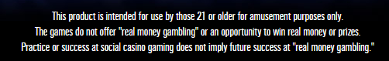Very in depth, if hard to find, statistics such as stats on when the player commonly folds.

Overall:

Not a bad solution with high production value and the ability to log on with several options as seen above. Overall though they clearly state they have different stakeholders for the product and are very heavily focused on monetisation. This is not something I am interested in as it will put off younger users and/or their parents. I will certainly use the statistics from this solution as an inspiration for my own statistics model and what to include. I will also aim to make a more simplistic user interface as I found this one hard to navigate and very claustrophobic.

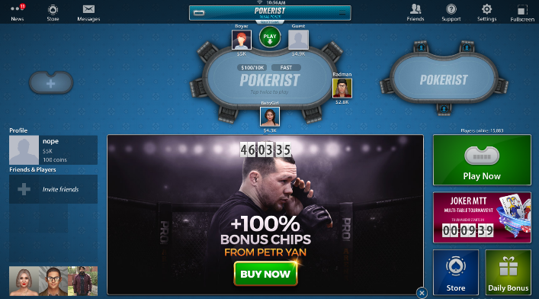Pokerist:

Cons:

* As seen here the user interface puts a large focus on promoting in-game purchases
* Limited statistics, only game played and biggest win
* Use of overly sexualised characters showing a clear target demographic
* Due to being web based a long loading process before getting to the menu
* Hard to select the right number of chips
* Strategies designed to addict such as daily bonuses to encourage people playing every day
* The fold call and check button are relatively far from each other causing a sub optimal ux.

Pros:

* Once you close the ads it reveals a very clear and useful server list displaying relevant information such as players blinds and buy ins
* Intuitive hints that show when you have a hand which can be disabled in settings
* Use of accounts so information can be accessed from anywhere
* An in-game history so you can see the result of the previous hand
* Can preselect your next action in advance so it will complete automatically

Overall:

A better solution than the wsop but not without its flaws. The user interface was, other than the large advertisements covering up useful features, very clear and much less claustrophobic than than the wsop game. This is likely due to its use of clear tiles and the ability to see the plain background behind it. The game also has a lot of social features which I found unnecessary as it detracted from the game itself.

247 free poker

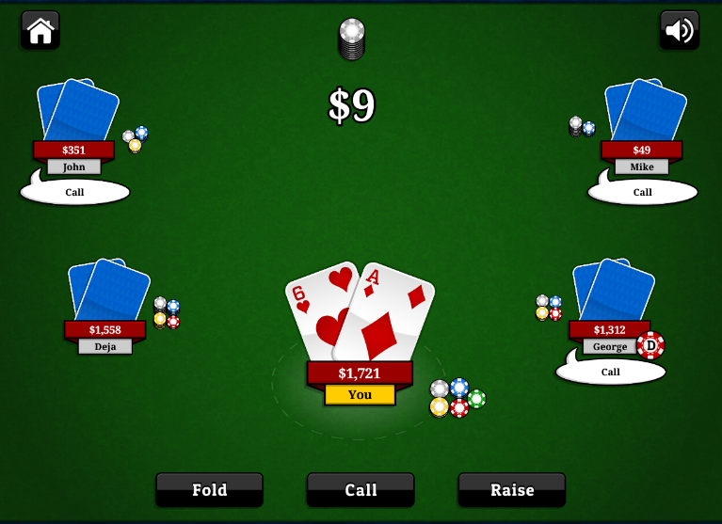Cons:

* No online component, purely against ai
* Almost no statistics at all (only largest win)
* No settings/preferences
* All data stored in cookies, can’t access from another device
* Doesn’t say if you have had a hand, no assists
* Could be clearer about rules
* Doesn’t say how much you are calling

Pros:

* No monetisation or adverts at all
* Complex/competent ai with a consistent play style you can learn so the game retains depth despite lack of real people
* Very simple ui no visual clutter at all
* Appears to have similar stakeholders to my game in objectives just without the online component
* Clearly made just for people to enjoy/practice no ulterior motives

Overall:

This is probably the closest to what I want to create, very simple no nonsense design. Clearly designed for similar stakeholders to mine. Obviously, the lack of an online component and statistics hurts it, but I believe in terms of the basic user experience this is a realistic and good target for my product

Observations of research

* Free poker games that aren’t focussed around real world money and gambling appear to web based in the browser or mobile(very few downloadable executables), while my lack of CSS/js knowledge will prohibit me from breaking into the in browser market, a mobile port of my game may not be too hard and is certainly something to consider
* These games are very focussed around getting money, whether by promoting an in-game store or external betting platforms
* There is much differentiation between the casual open tables and the organised tournament games
* The in-game user interfaces are all designed to look like a poker table
* Simplicity is key, most of the depth in poker comes from the players not the platform that people are playing on

Key features observed

* Assists to show hands
* Statistics
* Online play
* A clear and simple ui
* A good server browser with options/information about the game your joining
* A login system so information can be accessed from anywhere

Proposal

Due to the fact that none of these solutions (or any other that I found but did not write up) met all the requirements I had, and my stakeholders outlined. I propose creating an online (but not web based) poker game based around an artificial currency with no links to real world money at all. The solution will have a server browser where people can connect to a game of their choosing so they can play how they choose. The game will also have extensive statistics and analysis features, such as past games overall bankroll and other useful and relevant statistics, so that people can look at their game and learn from the experience, this is important as a large portion of stakeholders are people wanting to learn, improve and understand more about the game and what they are doing right and wrong. Another important aspect I will include is a secure login system so people can assess the game from any device. Having an online system means password security is more important than ever and not having proper password security could put me in breach of the data protection act. I will also try to include a decent tutorial or, at the very least, assists that show the information about your hand and what you have. For example, highlighting and pointing out pairs and straights etc. I also have some aspirational targets for if I have the time and ability to add such as organised more competitive tournament games that people can put their skills to the test in as well as interactive replays.

Software limitations

Due to the cost of actual server space I will have to find a more cost-effective solution to hosting my logon/game server. This will likely be in the form of a raspberry pi which will limit my space and memory meaning I won’t be able to have the large number of users that would be expected from a larger commercial competitor. I will also endeavour not to have to use this server for routing all game information which requires either getting users to port forward, which is a very ugly solution, or figuring out UDP hole punching. Other software limitations are the very server/host side nature of the processing that is necessary to coordinate all aspects of the game, therefor the hosts pc will be slower and have to constantly be sending and receiving packets, which is not a fast process. It would be nice to integrate this into a webapp however I do not have the knowledge or ability to do this with the time limitations of this project as I would have to learn it from scratch an integrate some form of cross platform support. On the other hand, I may be able to have a mobile version as there are many tools for packaging pyqt5 applications for android and all I’d have to change is any operating system file directories used. However, even if I did port it for mobile, I still would not put it on any app stores as this requires licensing and is especially difficult around gambling games. This makes it unfeasible for the time and economic constraints of the project.

Hardware limitations

The game should not have any serious performance issues running on most devices due to the simple nature of the game and design, this could still be optimised with threading if lower powered devices appear to struggle. Furthermore almost all actual processing being done by the host pc as long as they have a strong pc almost anyone should be able to play. The reliance on networking means that people who don’t have an internet connection cant access anything, not even their statistics as they would need to log on, which uses the internet, and access the data itself, which is stored on a server and so needs the internet. Due to using low level sockets I will also need to send raw data across the network rather than images or pre calculated graphs. This will take up more memory on the user’s system when looking at statistics but should not affect the actual gameplay itself. Any dedicated server hosting options cost over £40 a month which is above budget for this project, therefor for testing I will use my desktop pc as a server and will migrate it to a lower running cost low power draw raspberry pi or similar solution.

Software choices/evaluations

For this task I chose to use python for several reasons. Python is one of the most versatile languages currently on the market allowing you to combine object oriented programming and procedural programming in one file this allows me writhe my code with very few external restrictions allowing me to rapidly prototype and test different solutions without having to commit a lot of time to the codes format and style early on.

Python also has a wide range of third-party libraries I will be making use of. Such as the socket module which provides an easy to use low level networking interface built off of WINSOCK. This means the networking features are widely supported and used even outside of python applications allowing me to find information and support from a wider variety of sources. I will also be using the pyqt5 library to create my user interface, this is great as it is built off of the widely used qt platform so includes support for the qt designer, a great tool that allows you to create and edit the user interface while seeing the result in real time unlike something like tkinter or CSS where changes are made in code and it has to be run to see what it looks like.