GUIDANCE · DRAFT FOR REVIEW
Applying and Reconciling Part Note Codes for Traceable Parts
How the codes work together, how they combine on one item, and the steps that keep the parts list and the build records in agreement
This guidance is a companion to Section 6, Part Note Codes for Traceable Parts and Product-Unit Records Requiring Configuration Status Accounting Reconciliation. Section 6 governs. This guidance adds no requirement. Where the two appear to differ, follow Section 6.
Every note text in this guidance is copied from Section 6 word for word.

Audience | Design engineers, configuration management specialists, manufacturing and production, quality, materials and processes, supply chain, contracts, and program management.
Applies to | Every parts list that calls out an item with a serialization, lot/batch, traceability, item unique identification, life limit, special handling, or criticality requirement. It also applies to every parent of those items, up to the end item.
Related documents | Section 6 · Critical Part Type Register · EIA-649-1A · GEIA-HB-649
Status | Draft guidance. Not yet adopted.

Contents

1. Purpose 3
1.1 The problem in one example 3
1.2 What this document does 3
1.3 Terms used in this document 3
1.4 How this document is organized 4
2. The situation 4
2.1 Eight codes, three jobs 4
2.2 The requirement source chooses the identity code 6
2.3 A worked example: the main landing gear 7
3. Why this matters 8
3.1 A serial number says which unit. Only the chain says where. 8
3.2 Many authorities, one parts list line 9
3.3 Common misreads 9
3.4 Cost rises at each stage 10
4. Principles 11
5. Who owns each requirement source 13
6. Choosing the codes for one item 14
6.1 Four questions 14
6.2 Airworthiness Limitation Items 15
6.3 Choosing the LL note text 16
6.4 Note texts 17
7. Worked combinations 17
7.1 Example A. Main landing gear 19
7.2 Example B. Oxygen cylinder with a calendar limit 19
7.3 Example C. Two damage-tolerant PSE entries 19
7.4 Example D. Premium selected material fitting 19
7.5 Example E. Critical Safety Item on a DoD contract 20
7.6 Example F. Fracture-critical parts on a military aircraft 20
7.7 Example G. Capacitor under a counterfeit avoidance clause 21
7.8 Example H. Fire extinguisher cartridge 21
7.9 Example I. Critical casting with a casting factor of 1.0 22
7.10 Example J. Safety-Critical Item with no other source 22
7.11 Example K. End item on an IUID contract 22
8. Reconciliation 22
8.1 What reconciliation compares 22
8.2 Two kinds of gap 24
8.3 When to reconcile 24
9. Steps by lifecycle stage 24
9.1 Contract review 25
9.2 Design definition 25
9.3 Design release 26
9.4 Change 27
9.5 Build 27
9.6 Delivery 28
9.7 In service 28
10. Roles and responsibilities 28
11. Implementation options 29
11.1 Codes as parts list attributes 29
11.2 The cascade as a rule 29
11.3 Recommended approach 30
12. Limits and open decisions 30
Appendix A. Glossary 31
Appendix B. Note text reference 34
Appendix C. References 35

1. Purpose

1.1 The problem in one example
A brake hose on a main landing gear has a shelf life. The hose is lot/batch recorded. Its parts list line is correct.
The hose goes into a brake line assembly. The brake line assembly has no requirement of its own. Its parts list line carries no code.
Two years after delivery, the hose supplier reports a cure defect in one lot. The fleet team asks a simple question. Which airplanes have hoses from that lot?
The records cannot answer. They show which lot reached the factory. They stop at a brake line assembly with no serial number. Every airplane in the effectivity range now needs an inspection.
Part 2.3 walks through this example in detail.

1.2 What this document does
Section 6 states which part note codes to apply. It is precise. It is also dense. It defines more than twenty requirement sources across eight codes.
This document explains why each code exists. It shows how the codes combine on one item and up the product tree. It sets out the steps that apply the codes at design release and reconcile them against the build records.
It does not change Section 6. Where this document summarizes Section 6, Section 6 governs.

1.3 Terms used in this document
Ten terms carry this document. Each term keeps one meaning throughout. Appendix A gives the full glossary. It includes the standard definitions of the configuration management terms used here.
Term | Definition
Part note code | A short code on a parts list line. It tells the build environment what record to create, or it identifies a condition that applies to the item. Section 6 defines eight.
Note text | The fixed words that go with a part note code. Section 6 sets each note text. Copy it exactly. Fill only the bracketed fields.
Requirement source | The regulation, contract clause, standard, or engineering basis that creates a traceability requirement for an item. Examples are 14 CFR 45.15(c), DFARS 252.211-7003, and MIL-STD-1530D.
Identity code | SER, LOT, or IUID. A code that gives an item a recorded identity.
Link code | TR. The code that links recorded identities into parent-child records.
Condition code | LL, SH, CSI, or FC. A code that identifies a condition. It creates no record on its own.
Traceable item | An item that carries SER or LOT.
Cascade | The rule in Section 6.4.1 that maintains serialization and traceability records from every traceable item up the product tree to the end item.
End item | The top-level asset or system under contract. It is typically the complete aircraft tail number or the missile system. (Section 6.4.1)
Reconciliation | The configuration management comparison of the part note codes on the released design with the traceability documentation and product-unit records captured in the build environment.

1.4 How this document is organized
This document calls its own divisions Parts. "Section 6" always means the governing text.
Part | What it covers
2 | The situation. The eight codes, the requirement sources, and the worked example.
3 | Why it matters. What each record answers, the many authorities, common misreads, and rising cost.
4 | Nine principles. Every later step follows from them.
5 | Who owns each requirement source, and where configuration management fits.
6 | How to choose the codes for one item.
7 | Worked combinations. Eleven examples that cover every code.
8 | Reconciliation. How configuration management compares the design with the build records.
9 | Steps for each lifecycle stage.
10 | Roles and responsibilities.
11 | Ways to implement the practice in parts list and production systems.
12 | Limits and open decisions.

2. The situation

2.1 Eight codes, three jobs
Start with one parts list line. A shock strut on a main landing gear carries three codes: SER, LL, and TR. Each code does a different job.
SER gives the strut its own identity. LL says the strut has a life limit. TR says the strut has traceable children, and the records must link them to it.
Every part note code in Section 6 does one of three jobs. Figure 1 shows them.
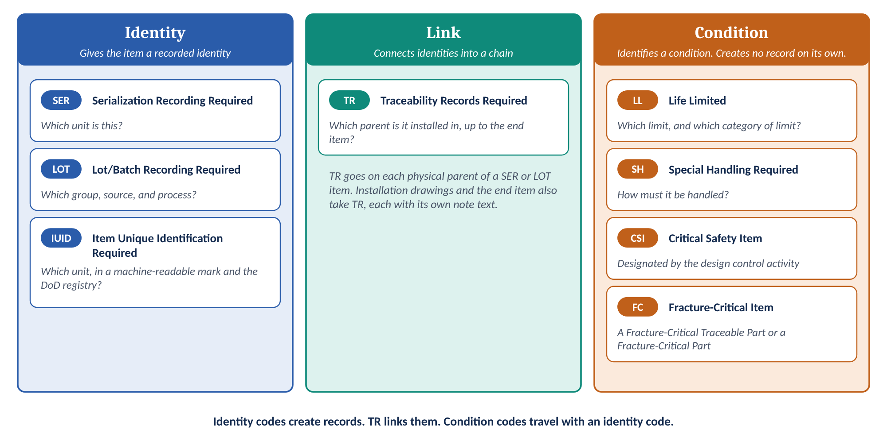
Figure 1. Eight codes, three jobs. Identity codes create records. TR links them. Condition codes travel with an identity code.
Job | Codes | What the build environment does
Identity | SER, LOT, IUID | Records a serial number, a lot/batch number, or a unique item identifier. Applies the identifier when the item has none.
Link | TR | Records which next-higher parent each traceable item is installed in.
Condition | LL, SH, CSI, FC | Nothing on its own. The code tells people how to treat the item. The records come from the identity code that goes with it.

Section 6.1 says it plainly. "SER, LOT, and IUID establish identity. TR links those identities into parent-child records. LL, SH, CSI, and FC identify a condition. They do not create records on their own."
EIA-649-1A draws the same line. It names two kinds of identifier that matter here. SER and IUID record a unit identifier. LOT records a group identifier.
Term | Definition | Source
Unit identifier | A sequentially issued identifier used to designate a specific instance of a product among like products. Examples: Item Unique Identification (IUID), serial number, Vehicle Identification Number (VIN). | EIA-649-1A
Group identifier | Uniquely identifies a group of like units of the same product manufactured under uniform conditions. Examples: lot number/batch number. | EIA-649-1A
Serial number | A unique number identifying individual units within a series of like items. The serial number does not establish the PN or PIN but tracks the number of items that were produced under the PN or PIN. Serial numbers should be assigned to all items requiring tracking. | EIA-649-1A

EIA-649-1A also states when each one applies. Principle CI-5: "Individual units of a product are assigned a unique product unit identifier when there is a need to distinguish one unit of the product from another." Principle CI-7: "A series of like units of a product is assigned a unique product group identifier when it is unnecessary or impractical to identify individual units, but necessary to correlate units to a process, date, event, or test."

2.2 The requirement source chooses the identity code
An item does not get SER because it is important. It gets SER because a requirement source says so.
Section 6.2.1 lists the sources that drive serialization. Section 6.3.1 lists the sources that drive lot/batch recording. Some sources drive SER. Some drive LOT. Three drive both. Figure 2 sorts them.
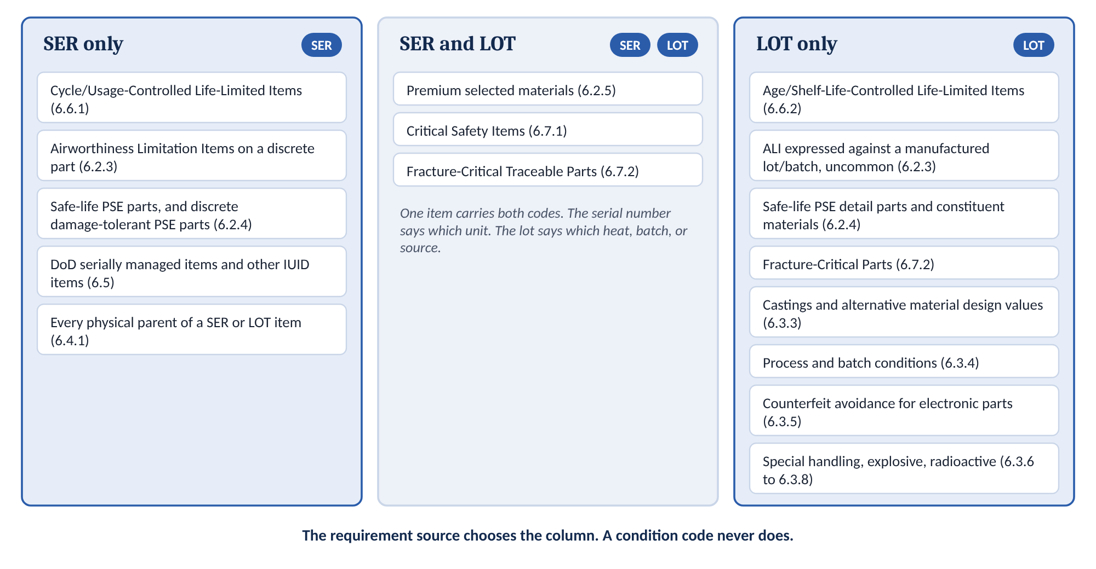
Figure 2. Requirement sources sorted by the identity code they drive. Section numbers refer to Section 6.
Two points follow from the figure.
The condition code never picks the identity code. A life limit does not decide between SER and LOT. The requirement source does. A calendar-limited Airworthiness Limitation Item (ALI) on a discrete part is still serialized. Part 3.3 returns to this point.
One item can hold several sources. A capacitor can be under a counterfeit avoidance clause and a shelf-life limit at the same time. One LOT code satisfies both. The reasons differ. The lot records are the same records.
The Critical Part Type Register is the companion reference. It catalogs the designation types and their governing sources. It is broader than Section 6 by design. Use the register to confirm which authority drives a requirement. Use Section 6 to decide what goes on the parts list.

2.3 A worked example: the main landing gear
A main landing gear sits on a commercial transport airplane. Nine lines in its product tree matter here. Figure 3 shows them as an indented tree, the way a parts list reads.
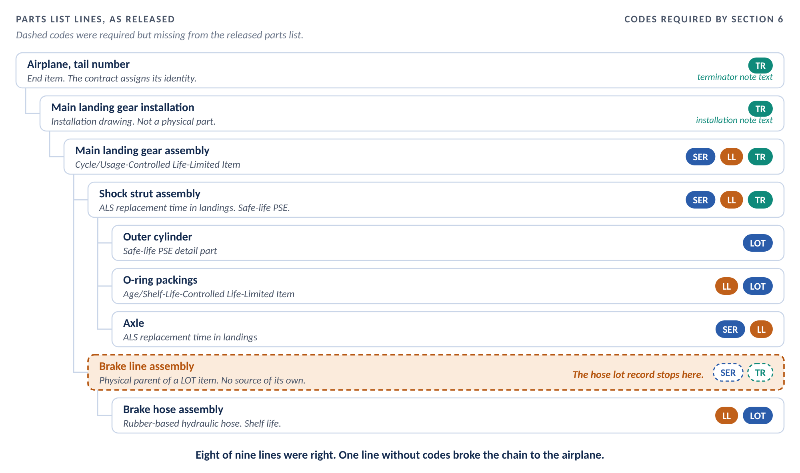
Figure 3. The worked example. Eight lines carried the right codes. The brake line assembly carried none, and the chain to the airplane broke there.
Item | Requirement source | Codes required by Section 6 | As released
Airplane | End item. The contract assigns the tail number. | TR, terminator note text | Correct
Main landing gear installation | Installation drawing between traceable items and the end item | TR, installation note text | Correct
Main landing gear assembly | Cycle/Usage-Controlled Life-Limited Item | SER, LL, TR | Correct
Shock strut assembly | ALS replacement time in landings. Safe-life PSE. | SER, LL, TR | Correct
Outer cylinder | Safe-life PSE detail part. Raw material heat and lot. | LOT | Correct
O-ring packings | Age/Shelf-Life-Controlled Life-Limited Item | LL, LOT | Correct
Axle | ALS replacement time in landings | SER, LL | Correct
Brake line assembly | Physical parent of a LOT item | SER, TR | No code
Brake hose assembly | Age/Shelf-Life-Controlled Life-Limited Item. Rubber-based hydraulic hose. | LL, LOT | Correct

Eight of the nine lines were right. The ninth line was the brake line assembly. It holds no requirement source of its own. So the designer gave it no code.
Section 6 requires SER and TR on it anyway. It is the physical parent of a lot/batch recorded item. Section 6.3.2 gives the reason. "A lot number alone does not establish location. The parent of a Lot/Batch Recording Required item is therefore serialized, so that the lot can be traced to an identified unit."
Nobody made an error about the hose. The hose line was right. The gap was one level up, on a part that looked like it needed nothing.

3. Why this matters

3.1 A serial number says which unit. Only the chain says where.
Return to the hose. Each record in the chain answers one question. Figure 4 shows the chain once the brake line assembly carries its codes.
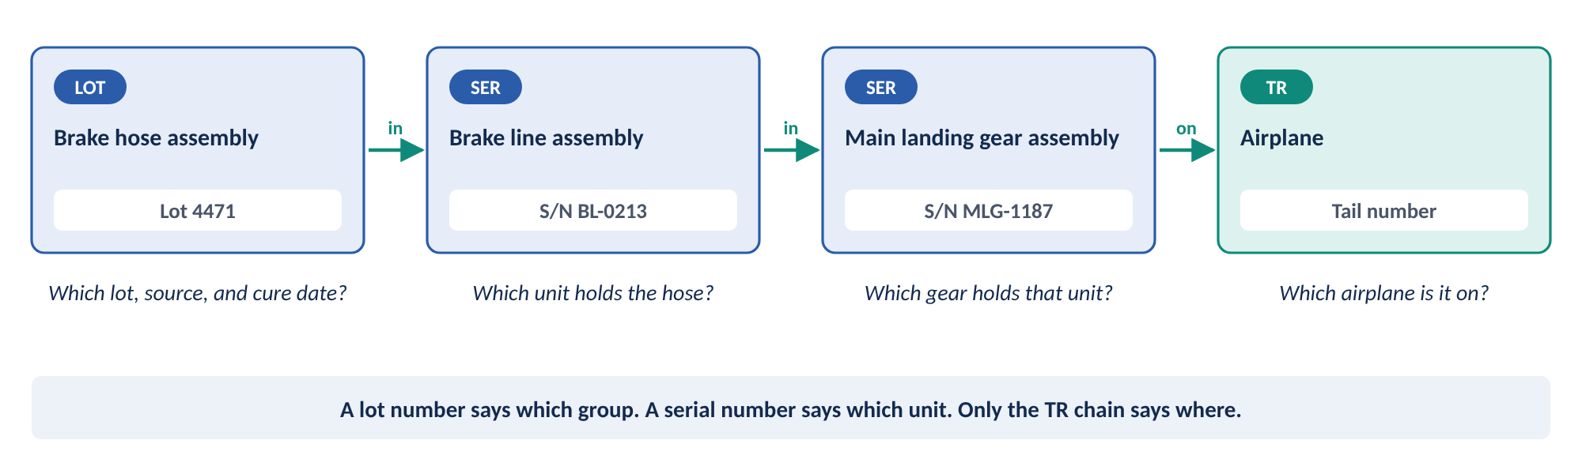
Figure 4. What each record answers. Remove any link and the last question goes unanswered.
- The lot number says which group the hose came from. It names the supplier, the batch, and the cure date.
- The brake line assembly serial number says which unit holds the hose.
- The main landing gear serial number says which gear holds that unit.
- The tail number says which airplane carries the gear.
A fleet team does not ask "which lot?" It asks "which airplanes?" Only the full chain answers that question.
That is why the cascade has no threshold. Section 6.4.1 applies it to every item carrying SER or LOT, whatever the requirement source. "There is no threshold and no shorter scope."
EIA-649-1A makes the same demand of the configuration status accounting system. Section 3.4.1(3)j requires it to "Record and report all product data inherited from Sub-tier suppliers, to include vendor part numbers and serial numbers, and provide clear traceability from these components to their respective next higher assemblies." TR is the code that produces that traceability.

3.2 Many authorities, one parts list line
The requirement sources come from different authorities. The authorities do not coordinate with one another. The parts list line is where they meet.
Authority | Requirement sources | Codes driven
FAA certification rules | 14 CFR 45.15(c) for ALS parts. 14 CFR 25.571(c) for safe-life structure. 14 CFR 25.613(e) and (f) for material design values. 14 CFR 25.621 for castings. 14 CFR 43.10 for life-limited parts. | SER, LOT, LL
DoD contract clauses | DFARS 252.211-7003 for IUID. DFARS 252.209-7010 for Critical Safety Items. DFARS 252.246-7007 and 252.246-7008 for counterfeit avoidance. | IUID, SER, LOT, CSI
Military standards | MIL-STD-1530D with Change 1 for fracture-critical parts. MIL-STD-130 for marking. MIL-STD-882E for Safety-Critical Items. | FC, SER, LOT. No code for Safety-Critical Items.
Company engineering and safety | The cascade directive in Section 6.4.1. Process and batch conditions in Section 6.3.4. Special handling direction from Materials and Processes and Radiation Health Protection. | SER, TR, LOT, SH

Each authority looks at the item from its own angle. The FAA asks about continued airworthiness. The DoD contract asks about supply chain and fleet management. The military standard asks about structural integrity. None of them looks at the parts list as a whole.
So the codes stack. An ALI part may also be a Critical Safety Item, a Fracture-Critical Traceable Part, or a premium selected material part. Section 6.2.3 states the rule. "The codes stack. Apply every code that each source drives."

3.3 Common misreads
Section 6 settles several points that are often misread. Each misread produces a wrong code. The table collects them.
The misread | The correct reading | Section 6
A calendar limit makes the item a lot/batch item. | A calendar-limited ALI on a discrete part is still serialized. 14 CFR 45.15(c) does not care how the limit is expressed. Calendar time changes the LL note text only. | 6.2.3, 6.6.2
An inspection interval adds LL. | Only a mandatory replacement limit adds LL. An inspection interval or a related procedure alone does not. | 6.2.3
A part too small to mark can be lot recorded instead. | 14 CFR 45.15(d) lets the required information go on the part or its container. The part still carries a unique serial number. | 6.2.3
The Limit of Validity is a replacement time. | The LOV bounds the engineering data that supports the structural maintenance program. It applies to the airplane. It is not a part replacement time. | 6.2.4
Counterfeit avoidance requires serialization. | It requires lot/batch recording with a source chain. Serialization records which unit. Counterfeit avoidance records which source and which lot. | 6.3.5
A Safety-Critical Item is a Critical Safety Item. | MIL-STD-882E states that the two definitions are independent. A Safety-Critical Item drives no code on its own. | 6.7.3
A Fracture-Critical Traceable Part is a kind of Fracture-Critical Part. | The two definitions exclude each other. A Fracture-Critical Part takes FC and LOT. It does not take SER on this basis. | 6.7.2
IUID flows up the tree, like SER. | IUID goes only on items that hold an IUID requirement and on the parent items the contract identifies. SER and TR flow up the tree. | 6.5.4
Lot/batch recording can stand in for a UII. | It cannot. Every UII carries a serial number. Lot/batch recording alone does not satisfy IUID. | 6.5, 6.5.3
The end item takes SER. | The contract assigns the end item’s identity. The end item takes TR with the terminator note text, and IUID when the contract requires it. | 6.4.2
Specialized metallic fasteners are life-limited. | They have no shelf life. They carry heat and lot traceability under process and batch conditions. | 6.6.2, 6.3.4
Beryllium is an explosive material. | Beryllium and beryllium alloys are toxic hazardous materials. Treat them as special handling items under factor f, Hazardous Material. | 6.3.7

Section 6.2.3 names the first misread as the one most often made. Part 6.2 shows why it happens.

3.4 Cost rises at each stage
A missing code is cheap to fix on the day of release. It gets more expensive every day after.
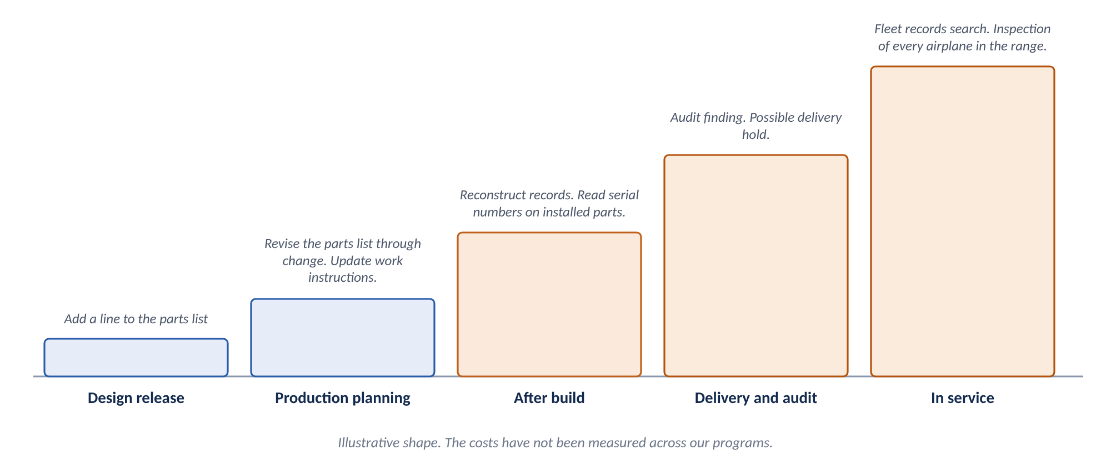
Figure 5. The cost to fix a missing code rises at each stage. The shape is illustrative.
When the gap is found | What happens | Typical cost
Design release | The checker adds the codes before release. | Minutes
Production planning | The parts list is revised through change. Work instructions are updated. | Hours to days
After build | Records are reconstructed. Serial numbers are read off installed parts, sometimes with panels removed. | Days to weeks per airplane
Delivery and audit | An audit or a customer inspection finds the gap. Delivery may be held. | Weeks. Schedule exposure.
In service | A lot or serial question arrives from the field. Every airplane in the effectivity range is searched or inspected. | Fleet action

These figures show the shape of the curve. They are illustrative. We have not measured them across our programs.
The cheapest point to apply a code is design release. In the worked example, the fix would have been two codes on one line.

4. Principles
Nine principles govern the rest of this document. When a later step is unclear, apply the principle.
- The source chooses the identity code. A requirement source decides SER, LOT, or both. A condition code never decides it.
- Answer every question. The codes stack. One item can hold several sources. Apply every code each source drives. Do not stop at the first source you find.
- Every traceable item cascades. Serialization and traceability records run from every SER or LOT item up to the end item. There is no threshold.
- A lot number does not locate. The parent of a LOT item is serialized. Otherwise the lot cannot be traced to an identified unit.
- Condition codes stay with the item. LL, SH, CSI, and FC apply where their source applies. They do not flow up the tree. IUID goes only where the contract says.
- Copy the note text exactly. Section 6 fixes the note texts. Fill only the bracketed fields. A paraphrased note text is a wrong note text.
- Installation drawings link. They are not serialized. An installation drawing takes TR with the installation note text. It is not consumed as a physical part.
- The contract names the end item. The end item ends the chain. It takes TR with the terminator note text. The contract assigns its identity.
- Design Engineering imposes. Configuration Management reconciles. Design Engineering puts the codes on the parts list. Configuration Management compares them with the build records. Section 6.1 assigns both duties.
Principles 3 and 4 produce most of the codes on a parts list. They are also where the worked example went wrong. Figure 6 shows the cascade.
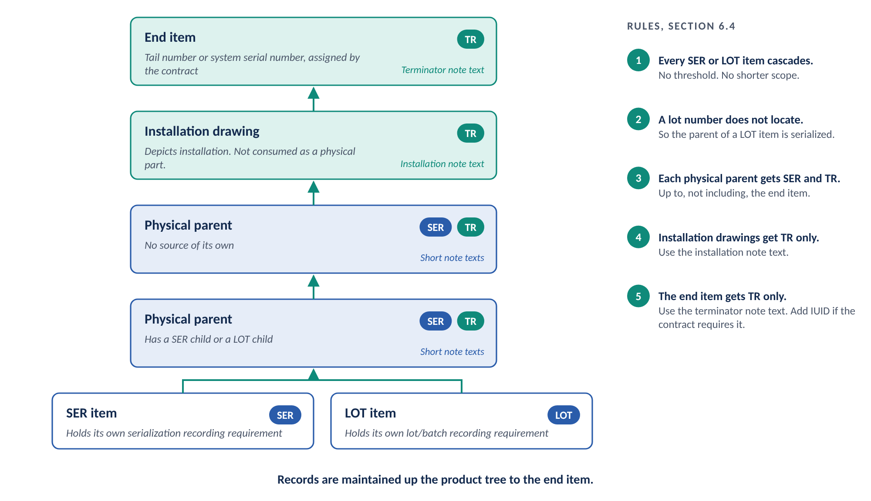
Figure 6. The cascade to the end item. Each physical parent takes SER and TR. Installation drawings and the end item take TR with their own note texts.
Principle 5 keeps the cascade from spreading the wrong codes. Figure 7 shows what flows up the tree and what stays.
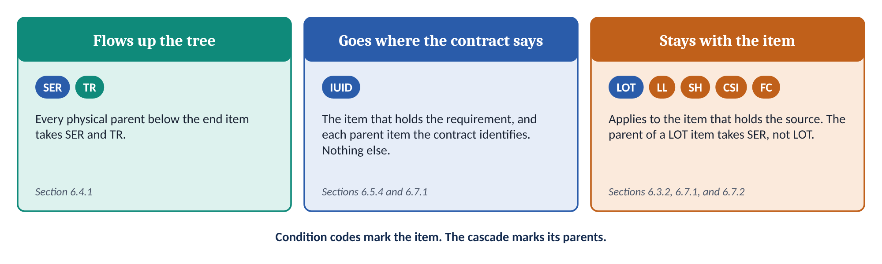
Figure 7. What flows up the tree and what stays with the item.

5. Who owns each requirement source
Go back to the worked example. The strut’s life limit came from the Airworthiness Limitations Section. The outer cylinder’s lot requirement came from the safe-life analysis. The hose’s shelf life came from the material specification. The brake line assembly’s requirement came from Section 6 itself.
Four lines. Four owners. One parts list.
Source owner | What the owner supplies | Codes affected
Airworthiness and Certification | ALS entries, with the part, the limit, and the task. Too-small-to-mark findings under 14 CFR 45.15(d). | SER, LL, LOT (uncommon)
Structures | Safe-life and damage-tolerant PSE lists. Fracture-critical part lists from the Durability and Damage Tolerance Control Plan. Premium selection decisions. | SER, LOT, LL, FC
Materials and Processes | Castings, alternative design values, process and batch conditions, and shelf-life and cure-date limits. Coordination of explosive material. | LOT, LL, SH
Contracts | IUID, Critical Safety Item, and counterfeit avoidance clauses. The parent item level. The end item identity. | IUID, CSI, SER, LOT
Design control activity (customer) | Critical Safety Item designation. | CSI
System Safety | Safety-Critical Item analysis. Inputs to Critical Safety Item designation. | None on the Safety-Critical Item basis
Radiation Health Protection | Identification of radioactive material, with the isotope and the amount. | SH, LOT
Supply Chain | Flowdown of DFARS clauses to suppliers. Supplier lot, heat, and serial data. | LOT, SER, IUID
Design Engineering | The parts list. The final code set on each line. | All

Configuration Management reconciles. It does not choose the codes.
Design Engineering imposes the part note codes on the parts list. Configuration Management reconciles those codes with the traceability documentation and product-unit records captured in the build environment. Section 6.1 assigns both duties.
A gap that reconciliation finds in the design goes back to Design Engineering. It is corrected through the change process.

Four configuration management terms place reconciliation inside configuration status accounting. This document uses them exactly as EIA-649-1A defines them.
Term | Definition | Source
Configuration status accounting (CSA) | The CM function that formalizes the recording and reporting of the established product configuration information (including historical information), the status of proposed changes, and the implementation of approved changes and changes occurring to product units due to operation and maintenance. CSA implementation includes assurances that the information is current, accurate, and retrievable. | EIA-649-1A
As-designed configuration | The configuration of an item as documented by the design activity. | EIA-649-1A
As-built configuration | The configuration of an item as actually produced. The as-built configuration consists of the as-designed configuration at the time of production as modified with approved engineering changes and variances. In addition, if the as-designed configuration consists of design alternatives, the as-built configuration reflects the actual produced item. | EIA-649-1A
Product structure | Product structuring is the hierarchical decomposition of a product. Product structures show component relationships, enable visualization of a product in relation to its higher, and lower level components, from any level. When effectively done, product structuring facilitates the “where used” requirement needed for both traceability and impact analysis. | EIA-649-1A

The parts list codes belong to the as-designed configuration. The build records belong to the as-built configuration. Reconciliation compares the two. The product structure carries the parent-child links that TR creates.

6. Choosing the codes for one item

6.1 Four questions
Take the brake hose. Which sources apply? A shelf life on a rubber-based hose. Which identity code does that source drive? LOT. Which condition codes apply? LL, with the age/shelf-life note text. Where does the hose sit? Under the brake line assembly. So the brake line assembly takes SER and TR.
Four questions set the codes for any line. Figure 8 shows them.
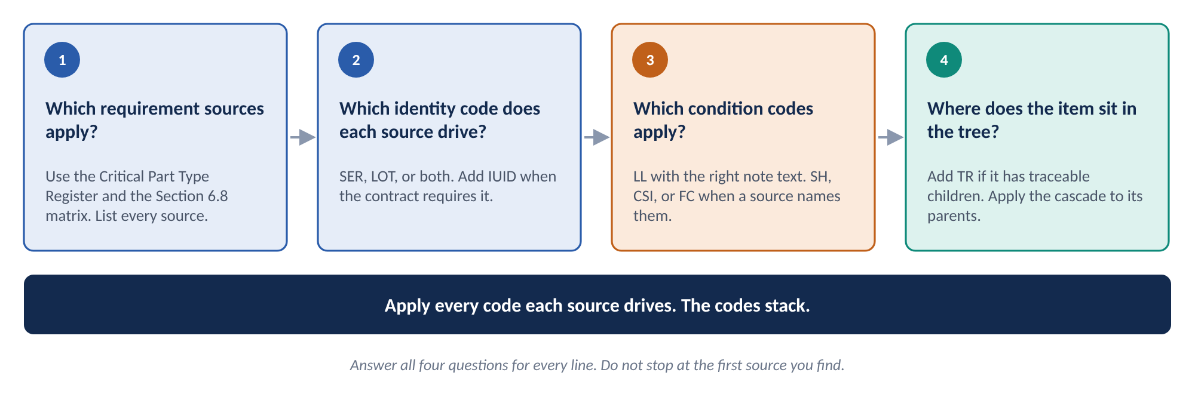
Figure 8. Four questions set the codes for every parts list line.
Question | How to answer it | Section 6
1. Which requirement sources apply? | Start with the application matrix in Section 6.8. Confirm the authority in the Critical Part Type Register. Check the contract for IUID, Critical Safety Item, and counterfeit avoidance clauses. | 6.2.1, 6.3.1, 6.8
2. Which identity code does each source drive? | Read the section for each source. Some drive SER. Some drive LOT. Some drive both. Add IUID and SER when the contract requires IUID. | 6.2 to 6.5
3. Which condition codes apply? | Add LL when a mandatory replacement limit exists, with the note text for its category. Add SH, CSI, or FC when a source names them. | 6.3.6 to 6.3.8, 6.6, 6.7
4. Where does the item sit in the tree? | Add TR when the item has SER or LOT children. Give each physical parent SER and TR. Give installation drawings and the end item their TR note texts. | 6.4

Answer all four for every line. Then walk up the tree and apply the cascade to every parent.

6.2 Airworthiness Limitation Items
ALIs raise the most questions. Section 6.2.3 answers them with three questions. The questions are independent. Answer all three. Figure 9 lays them out.
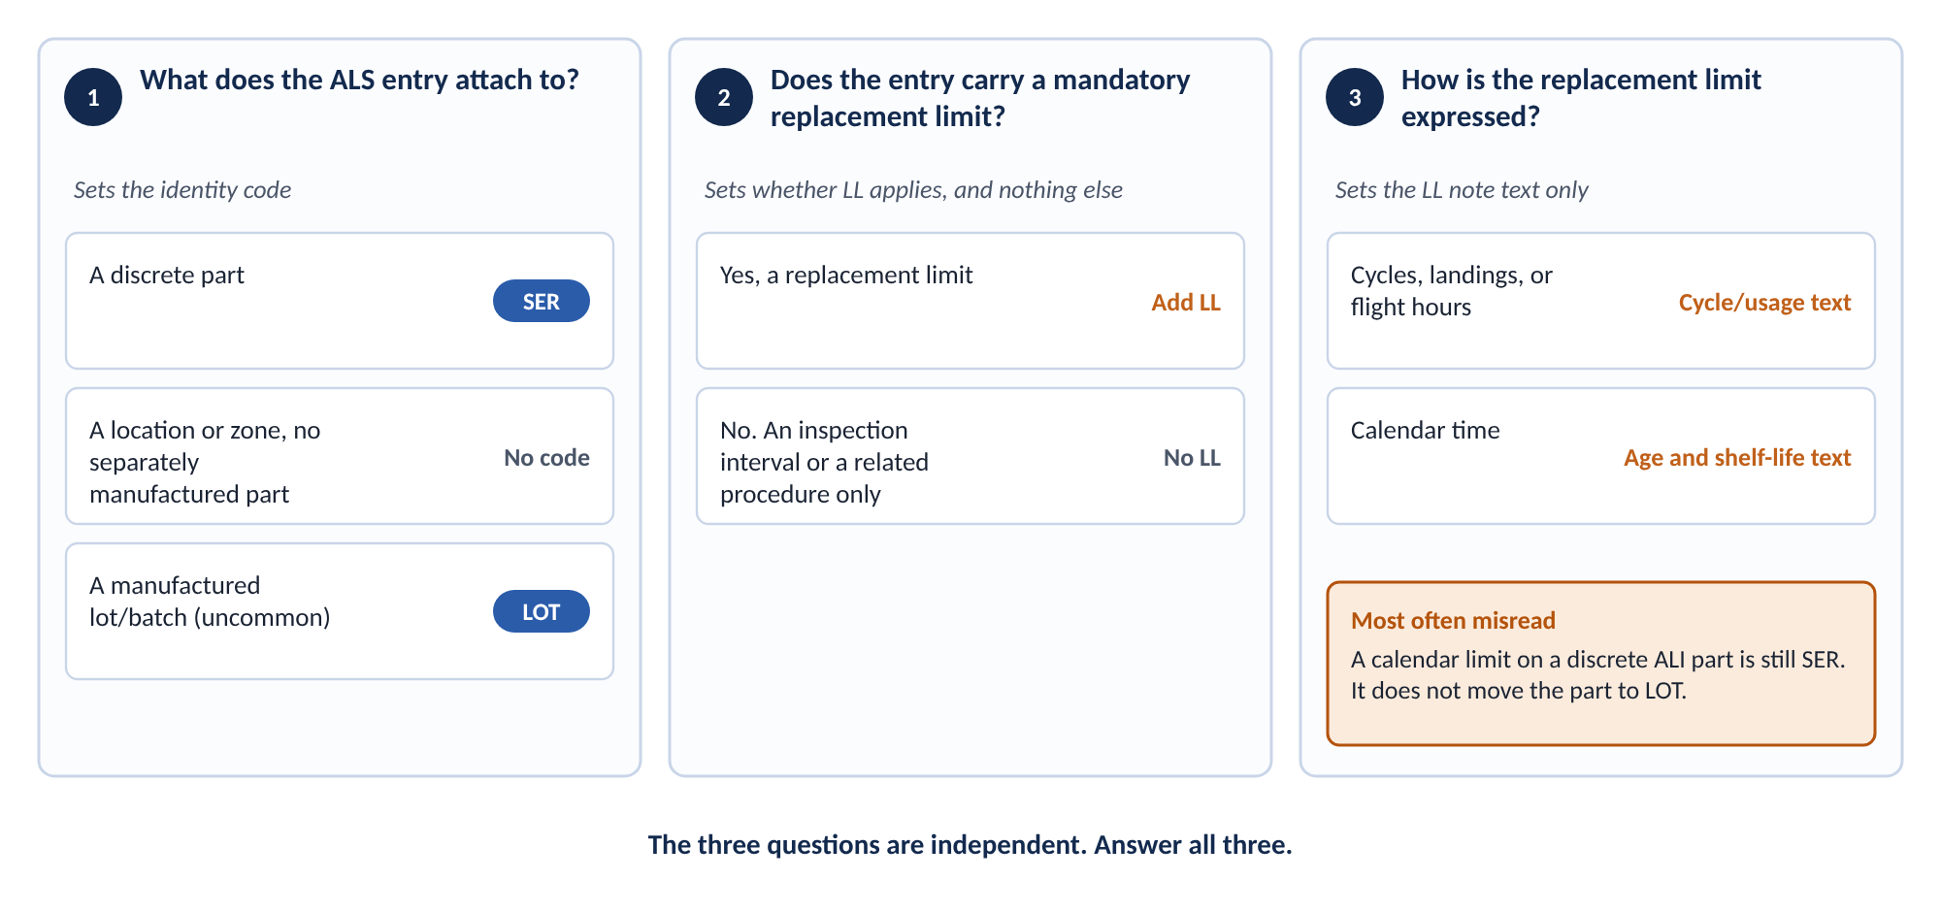
Figure 9. Airworthiness Limitation Items. Three independent questions set the identity code, the LL code, and the LL note text.
The first question sets the identity code. The second sets whether LL applies, and nothing else. The third sets which LL note text to use. It does not change the identity code.
The third question is the one most often misread. An oxygen cylinder with a 5 year replacement limit carries a serial number. Calendar time changes the LL note text. It does not move the part to lot/batch recording.
A part often carries both a replacement limit and an inspection interval. Inspect every 5,000 cycles, replace at 30,000 cycles, for example. Use the replacement limit. The inspection interval adds no code of its own.

6.3 Choosing the LL note text
LL has two note texts. The note text states which category the limit belongs to. It does not set the identity code. The requirement source sets the identity code.
14 CFR 43.10 defines the term. A life-limited part is "any part for which a mandatory replacement limit is specified in the type design, the Instructions for Continued Airworthiness, or the maintenance manual." Section 6.6 adds a boundary. "A shelf life, cure date, or storage age limit on material held in storage is not, by itself, a 14 CFR 43.10 mandatory replacement limit."
Category | Definition (Section 6) | Usual identity code
Cycle/Usage-Controlled Life-Limited Item | An item life-limited by cycles or operating hours. | SER. Remaining life is a per-unit quantity.
Age/Shelf-Life-Controlled Life-Limited Item | An item life-limited by shelf life, cure date, or storage age. | LOT. The limit attaches to the manufacturing lot/batch. SER instead when the item is a discrete part with an ALS entry.

CYCLE/USAGE NOTE TEXT
LL – LIFE LIMITED PART. THIS PART IS CYCLE/USAGE-CONTROLLED AND IS LIMITED TO A SPECIFIC NUMBER OF USAGES. [NUMBER OF FLIGHTS, CYCLE LIMIT, ETC.].

AGE/SHELF-LIFE NOTE TEXT
LL – LIFE LIMITED PART. THIS PART IS AGE/SHELF-LIFE-CONTROLLED IRRESPECTIVE OF HOW MANY TIMES IT IS USED. [SHELF LIFE, CURE DATE LIMIT, OR STORAGE AGE LIMIT].

6.4 Note texts
Section 6 fixes every note text. Appendix B collects them in one place. Three rules apply.
- Copy the note text exactly, including the dash after the code.
- Fill each bracketed field with the actual value. Remove the brackets. Leave nothing generic.
- Use the long SER and LOT note texts for an item that holds its own requirement. Use the short SER and TR note texts for a parent with no requirement of its own. Use the short LOT note text for a raw material callout.
Compare the two SER note texts. The first goes on an item that holds its own serialization recording requirement.
ITEM WITH ITS OWN REQUIREMENT
SER – SERIALIZATION RECORDING REQUIRED. THIS ITEM IS SERIALIZED AND TRACEABILITY MUST BE MAINTAINED BETWEEN THIS ITEM AND ALL HIGHER-LEVEL PHYSICAL ITEMS UP TO THE END ITEM.

The second pair goes on each physical parent that does not hold its own serialization recording requirement.
PHYSICAL PARENT WITH NO REQUIREMENT OF ITS OWN
SER – SERIALIZATION RECORDING REQUIRED.
TR – TRACEABILITY RECORDS REQUIRED.

7. Worked combinations
Part 2.3 walked through one tree. This part adds ten more examples. Together they cover every code and the combinations that raise the most questions. Figure 10 summarizes the code stacks.
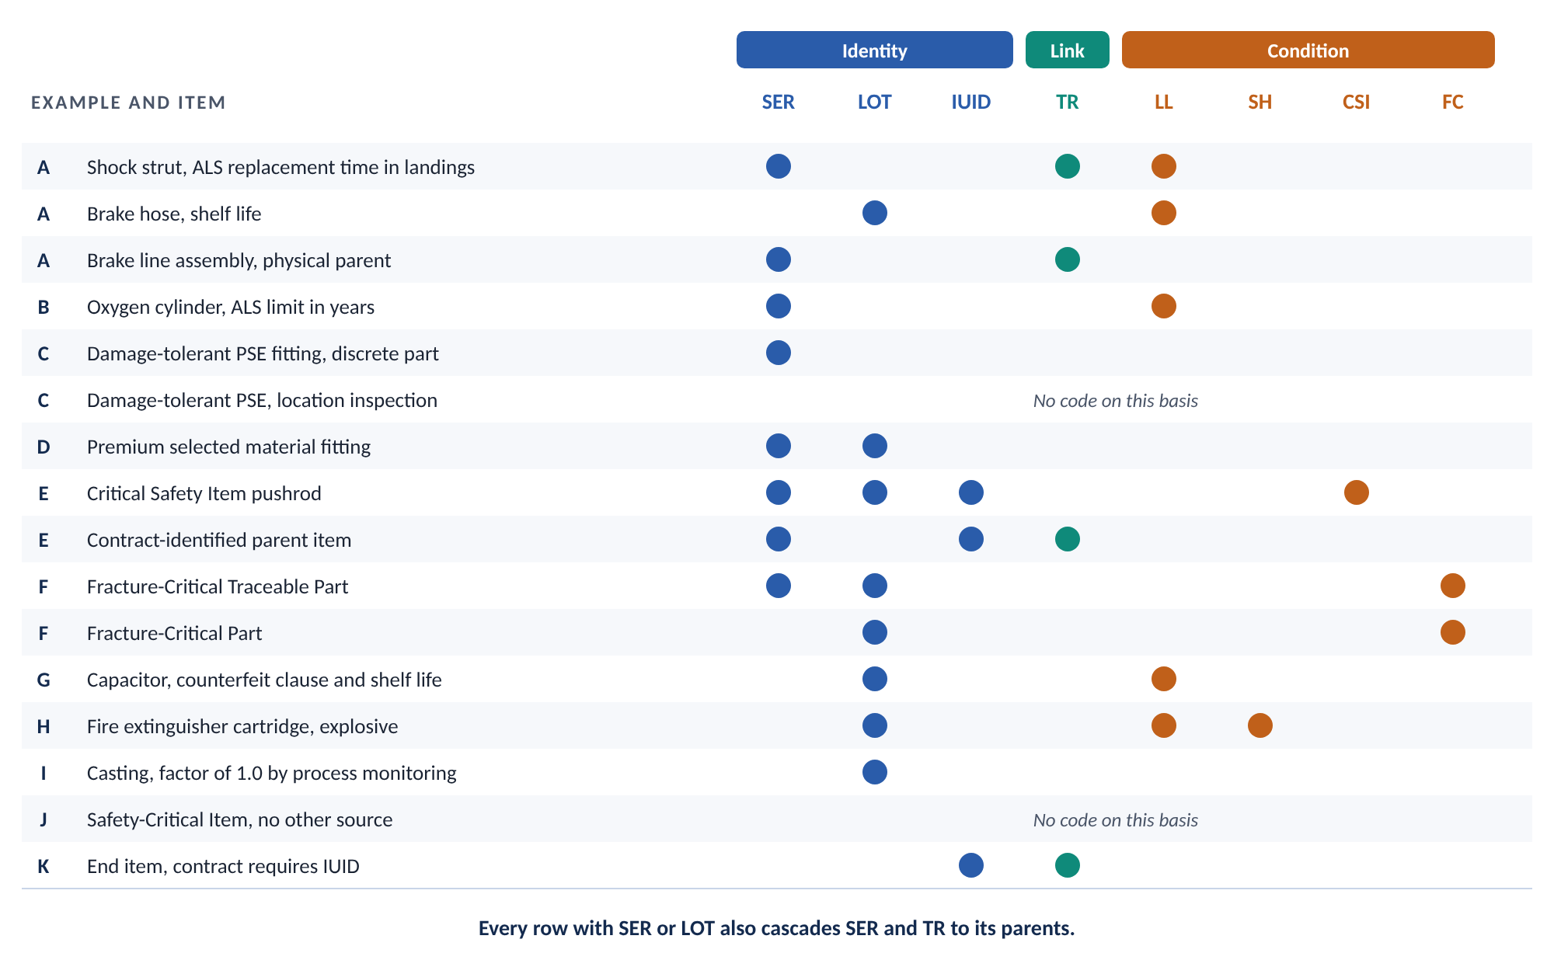
Figure 10. Code stacks in the worked combinations. Letters match the examples in this part.
Each example gives the item, the sources, the codes, and the point it teaches. Every example with SER or LOT also cascades to the end item under Section 6.4.1. The examples mention the cascade only where it teaches something.
Example | Item | Sources | Codes
A | Main landing gear | Cycle and shelf-life limits, safe-life PSE, the cascade | SER, LOT, LL, TR
B | Oxygen cylinder | ALS replacement limit in calendar time | SER, LL
C | Damage-tolerant PSE entries | ALS inspection on a discrete part, and on a location | SER, or none
D | Premium selected material fitting | 14 CFR 25.613(e) | SER, LOT
E | Critical Safety Item pushrod | DFARS 252.209-7010 and 252.211-7003 | CSI, SER, LOT, IUID
F | Fracture-critical parts | MIL-STD-1530D with Change 1 | FC, SER, LOT, or FC, LOT
G | Capacitor on a circuit card | DFARS 252.246-7007 and shelf life | LL, LOT
H | Fire extinguisher cartridge | Shelf life, explosive material, special handling | LL, LOT, SH
I | Critical casting | 14 CFR 25.621, process monitoring | LOT
J | Safety-Critical Item | MIL-STD-882E, no other source | None
K | End item on an IUID contract | DFARS 252.211-7003, Section 6.4.2 | TR, IUID

7.1 Example A. Main landing gear
Part 2.3 covers this example. It shows SER and LL on cycle-limited parts. It shows LL and LOT on shelf-life parts. It shows LOT on a safe-life detail part. It shows SER and TR on a parent with no source of its own.
Point it teaches. A part with no source of its own still takes codes when it holds a traceable child.

7.2 Example B. Oxygen cylinder with a calendar limit
A crew oxygen cylinder carries an ALS entry. The entry sets a replacement limit of 5 years. Answer the three questions in Part 6.2.
- What does the entry attach to? A discrete part. SER.
- Does the entry carry a mandatory replacement limit? Yes. Add LL.
- How is the limit expressed? In calendar time. Use the age/shelf-life note text.
CODES FOR THE CYLINDER
LL – LIFE LIMITED PART. THIS PART IS AGE/SHELF-LIFE-CONTROLLED IRRESPECTIVE OF HOW MANY TIMES IT IS USED. [SHELF LIFE, CURE DATE LIMIT, OR STORAGE AGE LIMIT].
SER – SERIALIZATION RECORDING REQUIRED. THIS ITEM IS SERIALIZED AND TRACEABILITY MUST BE MAINTAINED BETWEEN THIS ITEM AND ALL HIGHER-LEVEL PHYSICAL ITEMS UP TO THE END ITEM.

Point it teaches. Calendar time changes the LL note text. It does not move the part to lot/batch recording. 14 CFR 45.15(c) requires the serial number however the limit is expressed.

7.3 Example C. Two damage-tolerant PSE entries
An ALS lists two damage-tolerant structural inspections.
The first is a separately manufactured wing-to-body attach fitting. The ALS gives an inspection interval for the fitting. The fitting is a discrete part. It takes SER. It takes no LL, because the entry carries no replacement limit.
The second is a lower wing skin splice at a stated wing station. No separately manufactured part carries the entry. The inspection is tracked by airplane and structural location. It takes no code.
Point it teaches. One ALS can produce SER on one entry and no code on the next. The question is what the entry attaches to.

7.4 Example D. Premium selected material fitting
A machined fitting uses greater material design values under 14 CFR 25.613(e). A specimen of each fitting is tested before use.
Each test result must tie to one fitting, from specimen through acceptance to installation. So each fitting needs its own identifier. It takes SER. Each specimen must also tie to its heat and lot. It takes LOT.
Point it teaches. Neither 14 CFR 25.613(e) nor AC 25.613-1 names serialization. Serialization is required in practice, because each result must tie to one part instance.

7.5 Example E. Critical Safety Item on a DoD contract
A military derivative aircraft is delivered under a contract that includes DFARS 252.211-7003 and DFARS 252.209-7010. The design control activity designates an elevator control pushrod as a Critical Safety Item.
The pushrod takes four codes. Serialization reaches it through IUID, because Critical Safety Items are DoD serially managed items. Lot/batch recording applies too, with traceability to an approved source.
CODES FOR THE PUSHROD
CSI – CRITICAL SAFETY ITEM.
SER – SERIALIZATION RECORDING REQUIRED. THIS ITEM IS SERIALIZED AND TRACEABILITY MUST BE MAINTAINED BETWEEN THIS ITEM AND ALL HIGHER-LEVEL PHYSICAL ITEMS UP TO THE END ITEM.
LOT – LOT/BATCH RECORDING REQUIRED. THIS ITEM REQUIRES LOT/BATCH TRACEABILITY AND TRACEABILITY MUST BE MAINTAINED BETWEEN THIS ITEM AND ALL HIGHER-LEVEL PHYSICAL ITEMS UP TO THE END ITEM.
IUID – ITEM UNIQUE IDENTIFICATION REQUIRED. MARK THIS ITEM WITH A UNIQUE ITEM IDENTIFIER (UII) IN ACCORDANCE WITH MIL-STD-130 AND REPORT THE UII IN ACCORDANCE WITH DFARS 252.211-7003.

The contract identifies the elevator control assembly as the parent item. The assembly takes IUID with the parent note text. A parent item holds its own serialization requirement, because every UII carries a serial number. So it takes the long SER note text. It also takes TR, because it holds a traceable child.
CODES FOR THE CONTRACT-IDENTIFIED PARENT ITEM
IUID – ITEM UNIQUE IDENTIFICATION REQUIRED. THIS ITEM IS A PARENT ITEM. MARK THIS ITEM WITH A UNIQUE ITEM IDENTIFIER (UII) IN ACCORDANCE WITH MIL-STD-130 AND REPORT THE UIIS OF ITS EMBEDDED ITEMS IN ACCORDANCE WITH DFARS 252.211-7003.
SER – SERIALIZATION RECORDING REQUIRED. THIS ITEM IS SERIALIZED AND TRACEABILITY MUST BE MAINTAINED BETWEEN THIS ITEM AND ALL HIGHER-LEVEL PHYSICAL ITEMS UP TO THE END ITEM.
TR – TRACEABILITY RECORDS REQUIRED.

The assemblies above the parent item take SER and TR under the cascade. They take IUID only if the contract identifies them.
Point it teaches. CSI does not flow up the tree. IUID goes only where the contract says. SER and TR flow up. Coordinate the parent item level with the contracting activity.

7.6 Example F. Fracture-critical parts on a military aircraft
The Durability and Damage Tolerance Control Plan lists two parts.
The first is a single-load-path wing attach lug. It is a Fracture-Critical Traceable Part. It takes FC, SER, and LOT.
The second is a structural fitting that is not single load path and is not sized by durability or damage tolerance requirements. It needs special emphasis because of its criticality. It is a Fracture-Critical Part. It takes FC and LOT.
Point it teaches. The two categories exclude each other. Only the Fracture-Critical Traceable Part takes SER on this basis. Both take LOT, because fracture control relies on material properties and process condition. Fracture Critical Category I and Category II Parts are different again. They go through Critical Safety Item or Safety-Critical Item screening.

7.7 Example G. Capacitor under a counterfeit avoidance clause
A circuit card assembly goes into a line replaceable unit on a DoD contract. The contract includes DFARS 252.246-7007. A ceramic capacitor on the card is an electronic part under that clause. Capacitors also appear on the shelf-life list in Section 6.6.2.
Two sources. One identity code. The capacitor takes LL and LOT. The one LOT code serves both the counterfeit clause and the shelf life. The bare printed wiring board takes LOT under process and batch conditions.
The circuit card assembly takes SER and TR, because it holds LOT children. The line replaceable unit above it takes SER and TR. So does each parent up to the end item.
Point it teaches. Counterfeit avoidance records which source and which lot. It is not a serialization requirement. DFARS 252.246-7007 defines an electronic part broadly, so it reaches ordinary passive components.

7.8 Example H. Fire extinguisher cartridge
An engine fire extinguisher bottle uses an explosive cartridge to release the agent. Three sources apply. The cartridge has a shelf life. It is explosive material. Explosive material requires special handling.
CODES FOR THE CARTRIDGE
LL – LIFE LIMITED PART. THIS PART IS AGE/SHELF-LIFE-CONTROLLED IRRESPECTIVE OF HOW MANY TIMES IT IS USED. [SHELF LIFE, CURE DATE LIMIT, OR STORAGE AGE LIMIT].
LOT – LOT/BATCH RECORDING REQUIRED. THIS ITEM REQUIRES LOT/BATCH TRACEABILITY AND TRACEABILITY MUST BE MAINTAINED BETWEEN THIS ITEM AND ALL HIGHER-LEVEL PHYSICAL ITEMS UP TO THE END ITEM.
SH – EXPLOSIVE MATERIAL – SPECIAL HANDLING REQUIRED – [INCLUDE A DESCRIPTION OF THE METHOD FOR HANDLING EXPLOSIVE MATERIAL AND THE SAFETY PRECAUTIONS TO BE OBSERVED].

Two more steps apply. Coordinate the material with Materials and Processes before releasing any data. Put the Explosive Material part note text, or a reference to it, on the drawing picture sheet and on all higher-level drawings.
Point it teaches. Several sources can share one LOT code. Each source still adds its own condition code and its own steps.

7.9 Example I. Critical casting with a casting factor of 1.0
A critical casting uses process monitoring to support a casting factor of 1.0 under 14 CFR 25.621(c)(1) and 14 CFR 25.621(d)(1). Coupons cut from the prolongations of each casting are tested. Records must tie each coupon to its casting or pour.
The casting takes LOT.
Point it teaches. This source drives lot/batch records. If another source also applies, such as an ALS entry, add that source’s codes too.

7.10 Example J. Safety-Critical Item with no other source
System Safety analysis identifies a hydraulic shutoff valve as a Safety-Critical Item under MIL-STD-882E. The valve has no life limit. No other traceability source applies.
The valve takes no code on this basis. System Safety outputs drive design and process controls for the valve. They do not drive item marking. No part note code identifies Safety-Critical Items.
Point it teaches. The designation alone adds nothing to the parts list. If the valve later gains a life limit or another source, apply that source’s codes.

7.11 Example K. End item on an IUID contract
A DoD contract with DFARS 252.211-7003 requires IUID for the delivered aircraft. The aircraft is the end item.
The aircraft takes TR with the terminator note text. It also takes IUID. Choose the IUID note text under Section 6.5.4. Use the parent item note text when the contract identifies the aircraft as a parent item. The aircraft does not take SER. The contract assigns its identity.
TERMINATOR NOTE TEXT FOR THE END ITEM
TR – TRACEABILITY BEYOND THIS LEVEL IS NOT REQUIRED.

Point it teaches. The end item ends the chain. Its identity comes from the contract, not from a SER code.

8. Reconciliation

8.1 What reconciliation compares
Take the brake hose again, with the gap fixed. The released parts list says LL and LOT. The build record shows lot 4471. It shows that lot 4471 went into brake line assembly S/N BL-0213. That record names a serialized parent. The chain continues.
Reconciliation is that comparison, made for every line. Section 6.1 assigns it to Configuration Management. Figure 11 shows six checks.
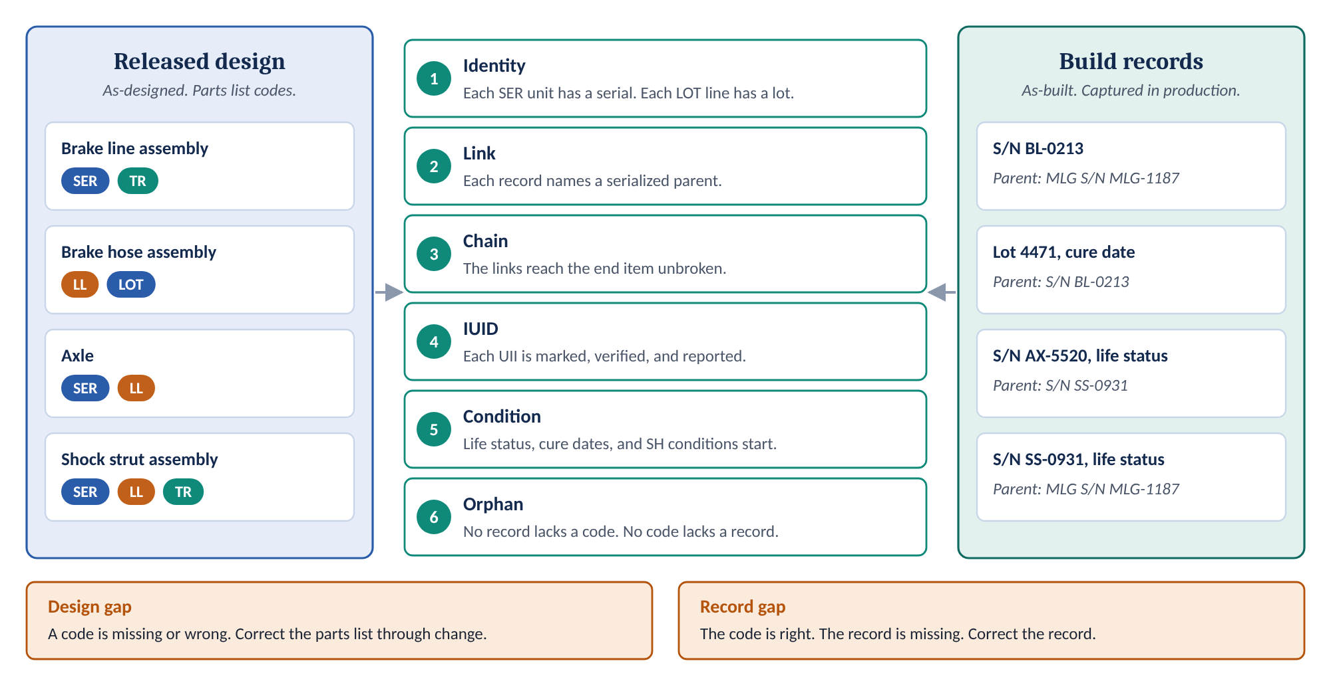
Figure 11. Reconciliation compares the released design with the build records. Six checks. Two kinds of gap.
Check | Question | Typical evidence
1. Identity | Does every SER item have a serial number recorded for each unit? Does every LOT item have a lot/batch number recorded? | Build records, receiving records, supplier certifications
2. Link | Does every recorded item name its next-higher parent? Does that parent have a serial number? | Installation records, as-built product structure
3. Chain | Do the links reach the end item without a break? Does the chain pass through installation drawings without a serial number? | As-built product structure to the tail number
4. IUID | Is each UII marked and verified? Is it reported? Is each embedded item reported with the UII of its parent item? | Mark verification records, WAWF and IUID Registry submissions
5. Condition | Does each LL item have the data to start its life status? Is each SH condition recorded with its lot? | Life status records, cure dates, handling records
6. Orphan | Is there a record for every code? Is there a code for every record? | Comparison of the parts list with the records

The worked example fails the link check. The hose lot record names a parent with no serial number.
An orphan in either direction is a finding. A code with no record means the build missed something. A record with no code may mean the design missed something.

8.2 Two kinds of gap
Gap | What it means | Correction | Owner
Design gap | The parts list is missing a code, or carries the wrong code or note text. | Revise the parts list through the change process. Then decide what to do about units already built. | Design Engineering, with Configuration Management
Record gap | The code is right. The build environment did not capture the record. | Capture the record. Correct the process that missed it. | Manufacturing and Quality, with Configuration Management

Do not close a design gap by correcting records alone. The next unit will have the same gap. Do not close a record gap by changing the design. The code was right.

8.3 When to reconcile
- At design release. Check the parts list against Section 6 before any record depends on it.
- During build. Compare records with codes as units are recorded.
- Before delivery. Complete the as-built record to the end item. Support any physical configuration audit.
- After a change that adds a source, removes a source, or moves an item to a new parent.
Two limits
Coverage. Reconciliation checks codes against records. It cannot find a source that nobody identified. That check belongs at design definition, in Part 9.2.
Supplier data. Reconciliation depends on supplier lot, heat, and serial data. Supply Chain must flow the requirement down. The data must arrive with the part.

9. Steps by lifecycle stage
Requirement sources do not arrive all at once. Contract clauses arrive first. Certification and engineering sources arrive with the design. Records start at build. Figure 12 shows the order.
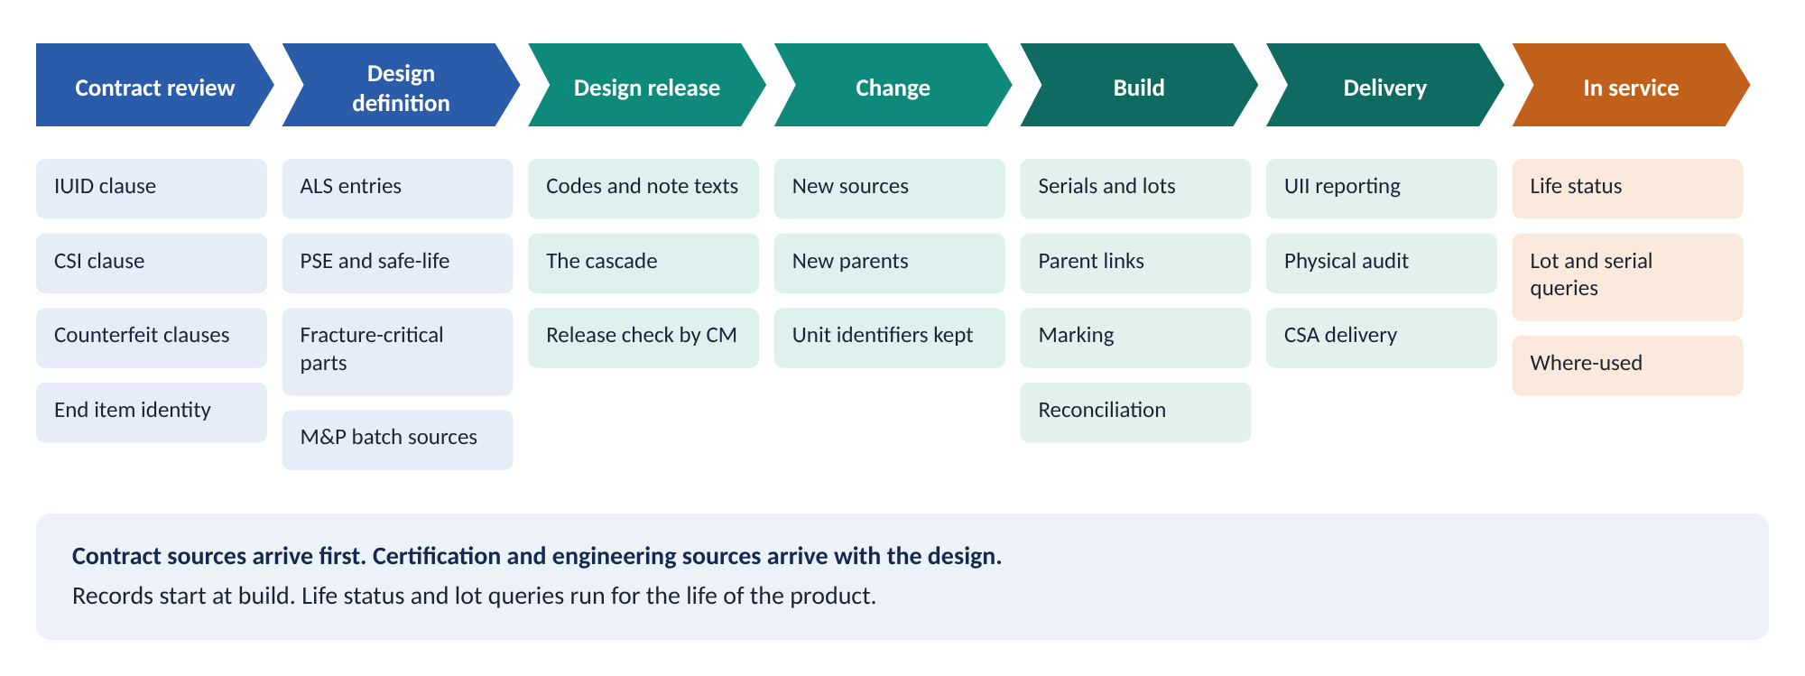
Figure 12. When each requirement source becomes known, and what happens at each stage.
Each stage below lists the actions and their owners.

9.1 Contract review
The contract decides several sources before any design exists. It also decides the end item.
Action | Owner
Identify DFARS 252.211-7003, DFARS 252.209-7010, DFARS 252.246-7007, and DFARS 252.246-7008 in the contract. Record which apply. | Contracts
Identify the end item and how the contract assigns its identity. | Contracts, Configuration Management
Identify the items the contract requires IUID for. Include the embedded items listed in the attachment called out by DFARS 252.211-7003(c)(1)(iii). | Contracts, Configuration Management
Coordinate the parent item level with the contracting activity. | Program Management, Contracts
Flow the clauses down to suppliers, including commercial suppliers where the clause requires it. | Supply Chain
Confirm whether the product is delivered only under FAA certification. If so, IUID applies only when the contract requires it. Critical Safety Item identification applies only when the United States Air Force Engineering Support Activity requires it. | Contracts, Certification

A clause missed here becomes a code missed on every parts list.

9.2 Design definition
Certification and engineering sources appear as the design matures. Each one has an owner outside Design Engineering.
Action | Owner
Identify every ALS entry. Record what each entry attaches to, whether it carries a replacement limit, and how the limit is expressed. | Airworthiness and Certification
Identify safe-life and damage-tolerant PSEs. Separate discrete parts from location-based inspections. | Structures
Identify Fracture-Critical Traceable Parts and Fracture-Critical Parts from the Durability and Damage Tolerance Control Plan. | Structures
Identify premium selection, castings, alternative design values, and process and batch conditions. | Materials and Processes, Structures
Identify shelf-life, cure-date, and storage-age limits. | Materials and Processes
Identify explosive, radioactive, and other special handling material. Coordinate explosive material before releasing any data. | Materials and Processes, Radiation Health Protection
Obtain Critical Safety Item designations from the design control activity. Provide System Safety inputs to that designation. | Program Management, System Safety
Confirm the authority for each source in the Critical Part Type Register. | Design Engineering

9.3 Design release
This is the cheapest point to get the codes right. It is also the last point before records depend on them.
Action | Owner
Answer the four questions in Part 6.1 for every line. | Design Engineering
Apply every code each source drives, with the exact note text. Fill every bracketed field. | Design Engineering
Apply the cascade. Give each physical parent SER and TR. Give installation drawings and the end item their TR note texts. | Design Engineering
Put the Explosive Material part note text, or a reference to it, on the drawing picture sheet and on all higher-level drawings. | Design Engineering
Put the radioactive material part note on the lowest-level drawing that calls for radioactive material. Add it to higher-level drawings when Radiation Health Protection requests it. | Design Engineering
Check the parts list against Section 6 before release. Check every parent of a SER or LOT item for SER and TR. | Configuration Management

If a program adopts only one step from this part, adopt the parent check. It is the gap in the worked example.

9.4 Change
A change can add a source, remove a source, or move an item to a new parent. Each one changes the codes.
Action | Owner
Answer the four questions again for each line the change touches. | Design Engineering
When an item moves to a new parent, apply the cascade to the new parent and every parent above it. | Design Engineering
When a change adds SER or LOT to an item already built, decide how to capture records for the built units. | Configuration Management, Manufacturing
When a modification changes the part number, keep the original unit identifier. | Manufacturing, Configuration Management
Check the change for codes a change board would not see, such as a parent with no source of its own. | Configuration Management

EIA-649-1A Principle CI-6 governs the unit identifier. "When a product is modified, it retains its original product unit identifier, even though its part identifying number is altered to reflect a new configuration."

9.5 Build
Action | Owner
Record serial numbers and lot/batch numbers. Apply them where the item has none. | Manufacturing
Mark ALS parts under 14 CFR 45.15(c). When the FAA finds a part too small to mark, attach the information to the part or its container under 14 CFR 45.15(d). | Manufacturing
Mark IUID items with a two-dimensional data matrix symbol under MIL-STD-130. Verify each mark. | Manufacturing, Quality
Record each installation against its next-higher serialized parent. | Manufacturing
Follow special handling, packaging, and environmental controls. Record the conditions as a lot. | Manufacturing
Record the starting data for each life-limited item, such as the cure date or the cycles at installation. | Manufacturing, Quality
Reconcile codes against records as units are built. Raise design gaps and record gaps. | Configuration Management

A record captured on the day of installation costs minutes. A record reconstructed later costs days.

9.6 Delivery
Action | Owner
Report each UII at delivery, as part of the Material Inspection and Receiving Report, through WAWF. Report each embedded item with the UII of its parent item. | Contracts, Configuration Management
Reconcile the IUID codes on the design with the UIIs reported. | Configuration Management
Complete reconciliation of the as-built record to the end item. | Configuration Management
Support any physical configuration audit with the as-built record. | Configuration Management, Quality
Deliver configuration status accounting information as the contract requires. | Configuration Management

9.7 In service
The records now serve the fleet. Every query from here on depends on the chain built at release and at build.
Action | Owner
Support life status tracking for each life-limited part. Removed life-limited parts are controlled under 14 CFR 43.10. | Product Support, operators
Answer lot and serial queries with where-used reports from the as-built record. | Configuration Management
Record changes to product units due to operation and maintenance, where the contract assigns that duty. | Configuration Management, Product Support
Send field findings back to the source owner. A recurring lot problem may show a missing source. | Quality, Product Support

The worked example ends here. A complete chain answers the fleet question in an afternoon. A broken chain turns it into a fleet inspection.

10. Roles and responsibilities
Section 6.1 assigns two duties. Design Engineering imposes the codes. Configuration Management reconciles them. Many other functions supply the sources. The table assigns each duty once.
Role | Responsibility
Design Engineering (imposes) | Owns the parts list. Answers the four questions for every line. Applies the codes, the note texts, and the cascade. Corrects design gaps through change.
Configuration Management (reconciles) | Checks parts lists against Section 6 at release. Reconciles codes against build records. Reconciles IUID codes against reported UIIs. Maintains the as-built record. Answers where-used queries.
Airworthiness and Certification | Supplies ALS entries and too-small-to-mark findings.
Structures | Supplies PSE, safe-life, damage-tolerant, and fracture-critical part lists. Supplies premium selection decisions.
Materials and Processes | Supplies casting, batch, shelf-life, and special handling sources. Coordinates explosive material.
System Safety | Performs Safety-Critical Item analysis. Provides inputs to Critical Safety Item designation.
Radiation Health Protection | Identifies radioactive material. Requests the part note on higher-level drawings when needed.
Contracts | Identifies the DFARS clauses, the end item identity, and the items that require IUID. Reports UIIs at delivery.
Supply Chain | Flows clauses and record requirements to suppliers. Obtains supplier lot, heat, and serial data.
Manufacturing and Production | Captures serial, lot, and installation records. Marks items. Follows special handling controls.
Quality | Verifies marks and records. Raises record gaps.
Program Management | Coordinates the parent item level with the contracting activity. Funds reconciliation. Holds the release criterion.

11. Implementation options

11.1 Codes as parts list attributes
Most parts list systems can hold a part note code as a structured attribute, not only as text. A rule can check a structured code. A rule cannot check free text.
Hold the code and its note text together. Hold each bracketed field as a separate value. Then a report can list every LL item with its limit, or every SH item with its control.

11.2 The cascade as a rule
The cascade is a rule a computer can check. For every line with SER or LOT, walk up the product tree. Each physical parent must carry SER and TR. Each installation drawing must carry TR with the installation note text. The walk must end at an end item with the terminator note text.
What the rule adds | What to watch
A release check that finds the worked example’s gap in seconds. | The rule needs the product tree to mark installation drawings and the end item. Without those marks it raises false gaps.
A reconciliation query that compares parts list codes with build records, by lot and serial number. | The query is only as good as the build records. Supplier data must arrive in a usable form.
Where-used reports by lot or serial number. | Effectivity must be correct, or the report misses units.
A consistent check across every program. | The rule checks consistency. It cannot find a source that nobody identified.

11.3 Recommended approach
- Start with a manual release check against the Section 6.8 matrix and the cascade.
- Add the cascade rule when the parts list system can hold structured codes.
- Run reconciliation from the build records, by lot and serial number.
- Keep Section 6 as the authority. The rule implements Section 6. It does not replace it.

12. Limits and open decisions
This guidance has limits. Some decisions remain open. The table lists both.
Item | Status
Standards basis | Section 6 governs. This guidance adds no requirement. The cascade to the end item is a company directive. It is broader than any single regulation.
Safety-Critical Items | No part note code identifies Safety-Critical Items. Whether to add one is open.
Parent item level | The contract governs. Coordinate with the contracting activity on each program.
Critical Part Type Register | The register is broader than Section 6 by design. It carries designations that do not apply to this company. Use it to confirm authority, not to choose codes.
Supplier records | Reconciliation depends on supplier lot, heat, and serial data. Flowdown must require the data and its format.
Units built before a code change | Section 6 does not say how to capture records for units built before a code was added. Decide on purpose, for each change.
Reconciliation frequency | Open. This guidance recommends release, build, delivery, and change. Each program sets the interval.
Fracture Critical Category I and II Parts | These go through Critical Safety Item or Safety-Critical Item screening. That screening decides whether part traceability applies. They are not Fracture-Critical Traceable Parts.
BDS-517 | Section 6.3.4 points to BDS-517 for more on lot/batch items. This guidance does not restate it.

Appendix A. Glossary
Terms defined by a standard, a regulation, or Section 6 keep their source wording. Terms defined for this guidance are marked "This document."
Term | Definition | Source
Age/Shelf-Life-Controlled Life-Limited Item | An item life-limited by shelf life, cure date, or storage age. | Section 6.6.2
Airworthiness Limitation Item (ALI) | An item holding a mandatory replacement time, structural inspection interval, or related procedure approved as part of the type design and published in the Airworthiness Limitations Section (ALS) of the Instructions for Continued Airworthiness (ICA). | Section 6.2.3
As-built configuration | The configuration of an item as actually produced. The as-built configuration consists of the as-designed configuration at the time of production as modified with approved engineering changes and variances. In addition, if the as-designed configuration consists of design alternatives, the as-built configuration reflects the actual produced item. | EIA-649-1A
As-designed configuration | The configuration of an item as documented by the design activity. | EIA-649-1A
Aviation critical safety item | A part, an assembly, installation equipment, launch equipment, recovery equipment, or support equipment for an aircraft or aviation weapon system if the part, assembly, or equipment contains a characteristic any failure, malfunction, or absence of which could cause any of the following: (1) A catastrophic or critical failure resulting in the loss of or serious damage to the aircraft or weapon system; (2) An unacceptable risk of personal injury or loss of life; or (3) An uncommanded engine shutdown that jeopardizes safety. | DFARS 209.270-2, as cited in Section 6.7.1
Cascade | The rule in Section 6.4.1 that maintains serialization and traceability records from every traceable item up the product tree to the end item. | This document
Condition code | LL, SH, CSI, or FC. A code that identifies a condition. It creates no record on its own. | This document
Configuration Item (CI) | A product or an aggregation of products (hardware, software, firmware, or documentation) that accomplishes an end-use function, is under separate configuration control and is designated for configuration management control. | EIA-649-1A
Configuration status accounting (CSA) | The CM function that formalizes the recording and reporting of the established product configuration information (including historical information), the status of proposed changes, and the implementation of approved changes and changes occurring to product units due to operation and maintenance. CSA implementation includes assurances that the information is current, accurate, and retrievable. | EIA-649-1A
Cycle/Usage-Controlled Life-Limited Item | An item life-limited by cycles or operating hours. | Section 6.6.1
Effectivity | A designation, defining the product range e.g., serial numbers, block numbers, batch numbers, lot numbers, model, dates or event, at which a specific product configuration applies, a change is to be or has been affected, or to which a variance applies. | EIA-649-1A, adopted from EIA-649
End item | The top-level asset or system under contract. It is typically the complete aircraft tail number or the missile system. | Section 6.4.1
Fracture-Critical Part | A safety-of-flight structural component that is not single load path and is not sized by durability or damage tolerance requirements, but that requires special emphasis due to the criticality. | MIL-STD-1530, as cited in Section 6.7.2
Fracture-Critical Traceable Part | A safety-of-flight structural component that is either single load path or sized by durability or damage tolerance requirements. | MIL-STD-1530D with Change 1, as cited in Section 6.7.2
Group identifier | Uniquely identifies a group of like units of the same product manufactured under uniform conditions. Examples: lot number/batch number. | EIA-649-1A
Identity code | SER, LOT, or IUID. A code that gives an item a recorded identity. | This document
Life-limited part | Any part for which a mandatory replacement limit is specified in the type design, the Instructions for Continued Airworthiness, or the maintenance manual. | 14 CFR 43.10
Life status | The accumulated cycles, hours, or any other mandatory replacement limit of a life-limited part. | 14 CFR 43.10
Link code | TR. The code that links recorded identities into parent-child records. | This document
Note text | The fixed words that go with a part note code. Section 6 sets each note text. | This document
Parent item | The item assembly, intermediate component, or subassembly that has an embedded item with a unique item identifier or DoD recognized unique identification equivalent. | DFARS 252.211-7003
Part note code | A short code on a parts list line. It tells the build environment what record to create, or it identifies a condition that applies to the item. | This document
Physical configuration audit (PCA) | A formal examination of the actual (as-built) configuration of an item compared to its product configuration documentation. The PCA verifies the product configuration documentation is a clear, complete, and accurate representation of the configuration item and is necessary to establish the product baseline. | EIA-649-1A
Product structure | Product structuring is the hierarchical decomposition of a product. Product structures show component relationships, enable visualization of a product in relation to its higher, and lower level components, from any level. When effectively done, product structuring facilitates the “where used” requirement needed for both traceability and impact analysis. | EIA-649-1A
Reconciliation | The configuration management comparison of the part note codes on the released design with the traceability documentation and product-unit records captured in the build environment. | This document
Requirement source | The regulation, contract clause, standard, or engineering basis that creates a traceability requirement for an item. | This document
Safe-Life Principal Structural Element (PSE) | A PSE for which the applicant establishes that compliance with the damage-tolerance requirements is impractical. | Section 6.2.4
Safety-Critical Item (SCI) | A hardware or software item that has been determined through analysis to potentially contribute to a hazard with Catastrophic or Critical mishap potential, or that may be implemented to mitigate a hazard with Catastrophic or Critical mishap potential. | MIL-STD-882E
Serial number | A unique number identifying individual units within a series of like items. The serial number does not establish the PN or PIN but tracks the number of items that were produced under the PN or PIN. Serial numbers should be assigned to all items requiring tracking. | EIA-649-1A
Traceable item | An item that carries SER or LOT. | This document
Unique item identifier (UII) | A set of data elements marked on items that is globally unique and unambiguous. The term includes a concatenated unique item identifier or a DoD recognized unique identification equivalent. | DFARS 252.211-7003
Unit identifier | A sequentially issued identifier used to designate a specific instance of a product among like products. Examples: Item Unique Identification (IUID), serial number, Vehicle Identification Number (VIN). | EIA-649-1A

Appendix B. Note text reference
Every note text below is copied from Section 6. Copy it exactly. Fill only the bracketed fields. Section 6 governs where any copy differs.
Code | Use it on | Note text | Section 6
SER | An item that holds its own serialization recording requirement | SER – SERIALIZATION RECORDING REQUIRED. THIS ITEM IS SERIALIZED AND TRACEABILITY MUST BE MAINTAINED BETWEEN THIS ITEM AND ALL HIGHER-LEVEL PHYSICAL ITEMS UP TO THE END ITEM. | 6.2.2
SER | A physical parent with no serialization recording requirement of its own | SER – SERIALIZATION RECORDING REQUIRED. | 6.2.2, 6.4.1
LOT | A raw material callout, such as bar stock, sheet, plate, or bulk sealant | LOT – LOT/BATCH RECORDING REQUIRED. | 6.3.2
LOT | A detail part or vendor part that holds a lot/batch recording requirement | LOT – LOT/BATCH RECORDING REQUIRED. THIS ITEM REQUIRES LOT/BATCH TRACEABILITY AND TRACEABILITY MUST BE MAINTAINED BETWEEN THIS ITEM AND ALL HIGHER-LEVEL PHYSICAL ITEMS UP TO THE END ITEM. | 6.3.2
TR | An item with SER or LOT children, and each physical parent below the end item | TR – TRACEABILITY RECORDS REQUIRED. | 6.2.2, 6.4.1
TR | An installation drawing between a traceable item and the end item | TR – TRACEABILITY RECORDS REQUIRED. THIS INSTALLATION DRAWING DEPICTS TRACEABLE PARTS WHOSE SERIAL NUMBERS MUST BE TRACED TO ALL HIGHER-LEVEL PHYSICAL ITEMS UP TO THE END ITEM. | 6.4.2
TR | The end item | TR – TRACEABILITY BEYOND THIS LEVEL IS NOT REQUIRED. | 6.4.2
IUID | An item that holds an IUID requirement | IUID – ITEM UNIQUE IDENTIFICATION REQUIRED. MARK THIS ITEM WITH A UNIQUE ITEM IDENTIFIER (UII) IN ACCORDANCE WITH MIL-STD-130 AND REPORT THE UII IN ACCORDANCE WITH DFARS 252.211-7003. | 6.5.4
IUID | A parent item that contains an embedded item carrying a UII | IUID – ITEM UNIQUE IDENTIFICATION REQUIRED. THIS ITEM IS A PARENT ITEM. MARK THIS ITEM WITH A UNIQUE ITEM IDENTIFIER (UII) IN ACCORDANCE WITH MIL-STD-130 AND REPORT THE UIIS OF ITS EMBEDDED ITEMS IN ACCORDANCE WITH DFARS 252.211-7003. | 6.5.4
LL | A Cycle/Usage-Controlled Life-Limited Item | LL – LIFE LIMITED PART. THIS PART IS CYCLE/USAGE-CONTROLLED AND IS LIMITED TO A SPECIFIC NUMBER OF USAGES. [NUMBER OF FLIGHTS, CYCLE LIMIT, ETC.]. | 6.6.1
LL | An Age/Shelf-Life-Controlled Life-Limited Item, or a calendar limit on a discrete ALS part | LL – LIFE LIMITED PART. THIS PART IS AGE/SHELF-LIFE-CONTROLLED IRRESPECTIVE OF HOW MANY TIMES IT IS USED. [SHELF LIFE, CURE DATE LIMIT, OR STORAGE AGE LIMIT]. | 6.6.2
SH | An item requiring special handling | SH – SPECIAL HANDLING REQUIRED – [ENTER THE SPECIAL HANDLING, PACKAGING, OR ENVIRONMENTAL CONTROL REQUIRED, OR REFERENCE THE SPECIFICATION THAT CONTAINS THAT INFORMATION]. | 6.3.6
SH | Explosive material | SH – EXPLOSIVE MATERIAL – SPECIAL HANDLING REQUIRED – [INCLUDE A DESCRIPTION OF THE METHOD FOR HANDLING EXPLOSIVE MATERIAL AND THE SAFETY PRECAUTIONS TO BE OBSERVED]. | 6.3.7
SH | Radioactive material | SH – RADIOACTIVE MATERIAL – SPECIAL HANDLING REQUIRED – WARNING: RADIOACTIVE MATERIAL [IDENTIFY THE ISOTOPE], [NUMBER OF CURIES]. CONTACT RADIATION HEALTH PROTECTION FOR SPECIAL HANDLING. | 6.3.8
CSI | A Critical Safety Item | CSI – CRITICAL SAFETY ITEM. | 6.7.1
FC | A Fracture-Critical Traceable Part or a Fracture-Critical Part | FC – FRACTURE-CRITICAL ITEM. | 6.7.2

Appendix C. References
- Section 6, Part Note Codes for Traceable Parts and Product-Unit Records Requiring Configuration Status Accounting Reconciliation. The governing text.
- Critical Part Type Register. Companion catalog of designation types, governing sources, and record structures.
- EIA-649-1A, Configuration Management Requirements for Defense Contracts. Definitions of configuration management terms. Configuration status accounting requirements.
- GEIA-HB-649, Configuration Management Handbook. Supporting guidance.
- 14 CFR 25.571, 25.613, 25.621, 25.1529, and Appendix H to Part 25. 14 CFR 43.10. 14 CFR 45.15.
- FAA AC 25.613-1 and FAA AC 25.621-1.
- DFARS 209.270, DFARS PGI 209.270, DFARS 211.274-2, DFARS 252.209-7010, DFARS 252.211-7003, DFARS 252.246-7007, and DFARS 252.246-7008.
- DoDI 8320.04.
- MIL-STD-129, MIL-STD-130, MIL-STD-882E, MIL-STD-1530D with Change 1, MIL-STD-1686, and DOD-HDBK-263.
- SAE AS5553 and SAE AS6081. ISO/IEC 16022. BDS-517.
- Guidance Diagram Editor. Holds the editable source of every figure in this document, under "Part note codes guidance."

