MEMORANDUM
TO: XXXXX
FROM: XXXXX
DATE: XXXXX
SUBJECT: The Relationship Between Configuration Status Accounting and Configuration Verification and Audit

Summary
A Physical Configuration Audit (PCA) team opens the Configuration Status Accounting (CSA) report on the first day. The report lists every approved change against the Configuration Item (CI). The team picks a few changes and checks them against the drawings and the hardware. The samples match. The team trusts the report and moves on. If the samples do not match, the audit grows.
That is the relationship in one example. CSA keeps the record. Configuration verification and audit test the record against the product.
CSA and configuration verification and audit are separate CM functions under EIA-649-1A. Each one depends on the other.
- CSA feeds the audit. It supplies change status, baselines, and open action items.
- The audit feeds CSA. It returns findings, dispositions, and the verified baseline.
Accurate CSA lets the audit sample. Weak CSA forces the audit to reverify everything. This memo recommends that the program treat CSA accuracy as audit readiness and keep the two functions separate.

Definitions
Each term keeps one meaning throughout this memo. The definitions below follow EIA-649-1A, section 2.3, unless noted.
Term | Definition | Source
Configuration Status Accounting (CSA) | The CM function that formalizes the recording and reporting of established product configuration information, including historical information; the status of proposed changes; and the implementation of approved changes and of changes to product units from operation and maintenance. CSA includes assurance that the information is current, accurate, and retrievable. | EIA-649-1A 2.3
Configuration verification | The ongoing process by which the supplier verifies the design solution. Its functional aspect covers the analyses, inspections, tests, and demonstrations that show the item meets its performance specification. Its physical aspect establishes that the as-built configuration conforms to the as-designed configuration. | GEIA-HB-649A 10.1, 10.2
Configuration audit | A review of processes, product definition information, documented verification of compliance with requirements, and an inspection of products, to confirm that products have achieved their required attributes and conform to released product configuration definition information. | EIA-649-1A 2.3
Functional Configuration Audit (FCA) | The formal examination of the functional characteristics of a CI to verify that it met the requirements in its functional and allocated configuration documentation. | EIA-649-1A 2.3
Physical Configuration Audit (PCA) | A formal examination of the actual (as-built) configuration of an item against its product configuration documentation. The PCA verifies that the documentation is a clear, complete, and accurate representation of the CI. At PCA conclusion, the final product baseline is established, and all later changes require formal engineering change action. | EIA-649-1A 2.3
As-built configuration | The configuration of an item as actually produced: the as-designed configuration at the time of production, as modified by approved engineering changes and variances. | EIA-649-1A 2.3

Editor's note: SAE restricts reproduction of these standards. The definitions above are close paraphrases. Insert the verbatim text from the licensed copy before release.

What CSA Gives Verification and Audit
Every audit starts with CSA data. GEIA-HB-649A 10.3 lists configuration, status, and schedule information from status accounting as the first input to verification and audit.
The audit team does not rebuild that information. The audit team asks CSA for it. EIA-649-1A names each request.
What the audit needs | What CSA supplies | Clause
Current list of ECPs, RFVs, SCNs, and NORs against the CI, requested or approved | Status of proposed and approved changes and variances | EIA-649-1A 3.5.1(1)(h); 3.4.1(3)(e)
For FCA: an account of ECPs incorporated and tested, and ECPs proposed | Implementation status of approved changes | EIA-649-1A 3.5.2.1(2)(c); 3.4.1(3)(f)
For PCA: approved and outstanding changes against the CI | Change status by CI | EIA-649-1A 3.5.3.1(1)(a)(2)
For PCA: engineering drawing index with revision letters | Current approved configuration by CI identifier | EIA-649-1A 3.5.3.1(1)(a)(5); 3.4.1(3)(a)
For PCA: changes made during test, and required changes not yet completed | Change history and implementation status | EIA-649-1A 3.5.3.1(1)(a)(19), (20)
For PCA: records of configuration baselines to compare with the change control and release system | Current and historical configuration information | EIA-649-1A 3.5.3.1(2)(c); 3.4.1(3)(b)
Action items open from earlier and lower-level audits | Audit planning, results, and discrepancy status | EIA-649-1A 3.4.1(3)(h); GEIA-HB-649A 10.3(e)
Sub-tier part and serial numbers traced to the next higher assembly | Sub-tier supplier data | EIA-649-1A 3.4.1(3)(j)

Change incorporation is checked through CSA. GEIA-HB-649A 10.2 describes the method. The audit team reviews the CSA report of approved changes, affected end items, and dispositions. The team may sample product data to confirm the report. The audit does not verify every change one by one. The review runs with the as-designed to as-built reconciliation. Any delta between the CSA report and the product data is reconciled and corrected as part of the audit.

What Verification and Audit Give Back to CSA
The audit does not end when the meeting ends. Every result goes back into CSA. Otherwise the next audit starts blind.
What the audit produces | What CSA records | Clause
Audit plan and schedule | Planning of configuration audits | EIA-649-1A 3.4.1(3)(h)
FCA and PCA non-compliances | Status and final disposition of each discrepancy | EIA-649-1A 3.4.1(3)(h); 3.5.2(3); 3.5.3(4)
Action items and residual tasks | Owner, approving agency, target date, suspense date, and actual closeout date for each action item | EIA-649-1A 3.5.1(1)(m); GEIA-HB-649A 9.2.11
Verification that engineering changes and variance corrective actions were implemented | Verification date and type of verification for each change | EIA-649-1A 3.5.1(1)(n); GEIA-HB-649A 9.2, Table 39
Established baseline (the PCA establishes the final product baseline) | The new approved baseline of record | EIA-649-1A 2.3 (PCA); 3.5.1(2)
Configuration Audit Summary Report | Audit results and closure | EIA-649-1A 3.5.5; DI-SESS-81022

The audit also tests CSA itself. GEIA-HB-649A 10.2 calls for the team to correct any delta between CSA reports and actual product data. EIA-649-1A 3.4.2(1) requires the supplier to evaluate CSA corrective actions. The supplier confirms that each problem is resolved and that no new problem was introduced.

How the Two Functions Connect
The two functions form a loop. CSA sends the record forward. The audit checks it against the product and sends results back.
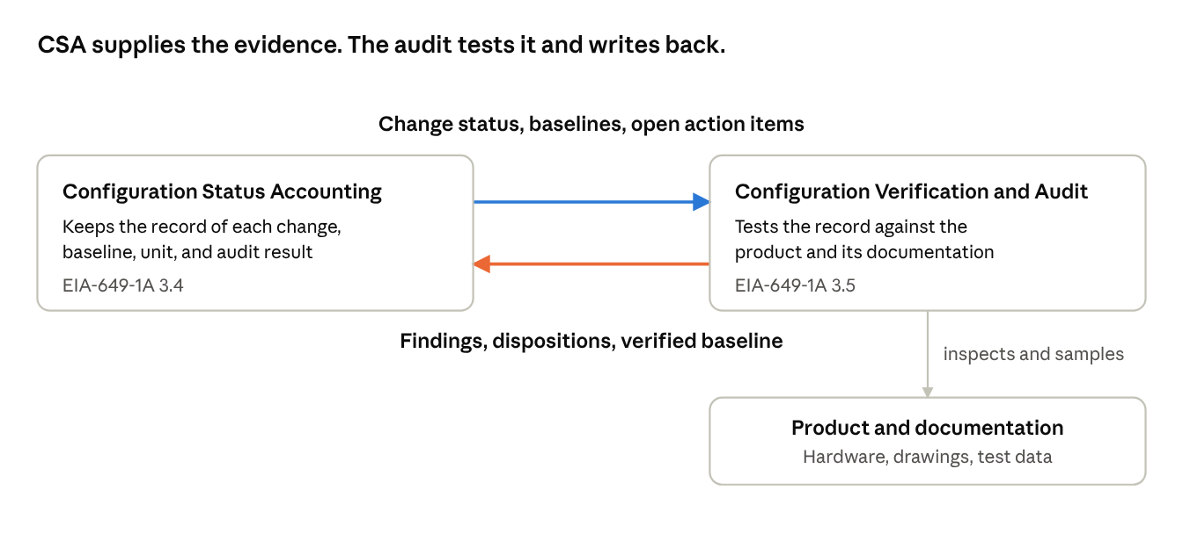
Figure 1. CSA and audit loop
The audit inspects and samples the product. It does not replace CSA as the record. Its findings become CSA entries.

Why the Separation Matters
GEIA-HB-649A describes CSA as the communication function of CM. It describes verification and audit as the feedback function that checks the integrity of CM processes and information. One carries the record. The other checks it.
CSA should not audit itself. An error in the record stays hidden when the record is its own only check. The audit brings a second look at the product and the documentation.
The audit should not keep its own records. An audit team that tracks findings in a separate spreadsheet creates a second version of the truth. CSA then shows a configuration the audit has already disproved. EIA-649-1A 3.4.1(3)(h) puts audit planning, results, and discrepancy status inside CSA for this reason.
Verification never stops. The audit is a checkpoint. GEIA-HB-649A 10.1 states that verification is ongoing. The more confidence the customer has in the supplier's verification process, the easier the audit becomes. EIA-649-1A treats configuration audits as the summation of the verification process at key points in the life cycle.
Continuous verification and accurate CSA turn the audit into confirmation. Weak CSA turns the audit into discovery. Discovery at PCA is expensive. The final product baseline waits until every delta closes.
This memo builds on the earlier memo on EBOM, MBOM, and ABOM reconciliation. GEIA-HB-649A 10.2 ties the audit's change review to the as-designed to as-built reconciliation. The reconciliation CM performs on each unit is the same evidence the PCA samples.
CSA keeps the record. The audit proves the record is true.

Requested Action
Treat CSA accuracy as audit readiness. Keep the two functions separate.
- Name the CSA system as the single source for every audit data package. Retire separate audit spreadsheets.
- Record every audit discrepancy and action item in CSA. Include owner, suspense date, disposition, and closeout date.
- Record verification of each approved change in CSA. Include the verification date and the type of verification.
- Complete the as-designed to as-built reconciliation, and a CSA data check, before FCA and PCA entry.
- Load each audit's results and the established baseline into CSA before the audit closes.
- Write these rules into the program CM Plan.

References
- SAE EIA-649-1A, Configuration Management Requirements for Defense Contracts (revised 2020-08): 2.3 Definitions; 3.4 Configuration Status Accounting; 3.4.1(3)(a), (b), (e), (f), (h), (j); 3.4.2(1); 3.5 Configuration Verification and Audits; 3.5.1(1)(h), (m), (n); 3.5.1(2); 3.5.2; 3.5.2.1(2)(c); 3.5.3; 3.5.3.1; 3.5.5
- SAE GEIA-HB-649A, Configuration Management Standard Implementation Guide (revised 2016): 9.2 and Table 39; 9.2.11; 10.1; 10.2; 10.3; Appendix AA, items E and F
- DI-SESS-81253, Configuration Status Accounting Information
- DI-SESS-81646, Configuration Audit Plan
- DI-SESS-81022, Configuration Audit Summary Report
- Companion memo: Roles in EBOM-MBOM-ABOM Reconciliation
Enterprise CM floor items served: F07 and F14 (changes recorded in CSA); F24 through F28 and F32 (CSA legitimacy and content); F29 through F31 and F34 (PCA); F42 through F44 (FCA). See the CM Floor Register.

