MEMORANDUM
TO: XXXXX
FROM: XXXXX
DATE: XXXXX
SUBJECT: Roles in EBOM-MBOM-ABOM Reconciliation: Manufacturing Engineering and Configuration Management

Summary
Manufacturing Engineering (ME) and Configuration Management (CM) both reconcile Bills of Materials (BOMs). The work looks redundant. It is not.
ME and CM reconcile different BOM pairs. They do the work at different times. They answer different questions.
- ME reconciles the Engineering BOM (EBOM) to the Manufacturing BOM (MBOM). ME asks: can we build what engineering released?
- CM reconciles the EBOM to the As-Built BOM (ABOM). CM asks: did we build what engineering released and approved, on this unit?

Each reconciliation also serves as a check on the other. No function should be the only check on its own work. This memo recommends that the program retain both reconciliations.

Definitions
This memo uses the following terms. Each term keeps one meaning throughout.
Term | Definition
Engineering Bill of Materials (EBOM) | The released, engineering-controlled list of parts, assemblies, and materials that defines a product, structured according to the design breakdown.
Manufacturing Bill of Materials (MBOM) | The list of parts, assemblies, and materials structured in the sequence and grouping used to build the product. The MBOM is derived from the EBOM and may add manufacturing items not shown in the EBOM, such as consumables and process materials.
As-Built Bill of Materials (ABOM) | The record of the parts, assemblies, and materials actually installed in a specific product unit, including serial, lot, or batch numbers, as recorded during production.
Configuration Status Accounting (CSA) | The configuration management function that captures and maintains the product configuration information needed to account for the configuration of a product throughout its life cycle.
Variance | An authorized temporary departure from approved configuration documentation for a specific number of units, that does not revise the approved documentation. A variance granted before manufacture is a deviation. A variance granted after manufacture is a waiver (EIA-649-1A 2.3, paraphrased).
Effectivity | The designation of the product units, by serial number, tail number, or lot, to which a configuration or change applies.

Editor's note: these are working definitions. Replace each with the verbatim definition from the program CM Plan or governing standard where one exists.

Division of Responsibilities
The two reconciliations differ in question, timing, and unit of analysis.
Dimension | Manufacturing Engineering (ME) | Configuration Management (CM)
Question answered | Can we build what engineering released? | Did we build what engineering released and approved, on this unit?
Reconciliation point | EBOM to MBOM | EBOM to ABOM
Timing | Before and during build planning | After build, for each unit
Unit of analysis | Part number and effectivity | Serial number, lot number, or tail number
Primary focus | Execution and producibility | Configuration integrity and compliance
Core objective | Build the product efficiently, safely, and repeatedly. | Verify that each unit's as-built record matches the as-designed record and its approved changes.
Primary drivers | DFARS 252.242-7004 (MMAS); AS9100D 8.5.1 | EIA-649-1; AS9100D 8.1.2 and 8.5.2; program airworthiness authority
Core deliverables | Routings; work instructions; ME EBOM-MBOM Metric (PE-0400) | CSA reports and views, including the As-Designed to As-Built Reconciliation Report

Neither function inspects hardware. Quality Assurance inspects the physical product, including First Article Inspection under AS9102. ME and CM reconcile data.

Manufacturing Engineering: Building What Was Designed
The EBOM calls for a bracket. No MBOM operation installs the bracket. The unit reaches final inspection without it. ME reconciliation catches that gap before the build starts.
ME turns the released design into shop-floor instructions. ME reconciles the EBOM to the MBOM so that nothing falls out along the way.
Parts consumption mapping. ME breaks the EBOM design structure into build sequences in the MBOM. The reconciliation runs in both directions. Every EBOM item must appear in the MBOM at the correct effectivity. Every MBOM item must trace to the EBOM or to an approved manufacturing addition, such as a consumable or process material.
Material management and cost accounting. Contracts that include DFARS 252.242-7004 require a Material Management and Accounting System (MMAS). The MMAS must base material costs charged to a contract on valid time-phased requirements. The clause sets a goal of 98 percent bill of material accuracy. A contractor below that goal must show that the lower accuracy causes no material harm to the Government. An MBOM that does not match the EBOM drives wrong orders, wrong inventory records, and wrong cost allocations. ME reconciliation protects BOM accuracy at the source.
Scope of work status. Each open EBOM-to-MBOM discrepancy is ME work not yet done. The PE-0400 metric tracks those discrepancies to zero. PE-0400 serves as a burndown of outstanding ME work.

Configuration Management: Verifying What Was Built
A part fails in the field. The program must find every unit that carries that part. CM reconciliation answers that question, unit by unit.
CM reconciles the EBOM to the ABOM. CM verifies records. CM confirms that each unit's as-built record matches the as-designed record. The as-designed record includes approved changes and approved variances.
Configuration traceability. EIA-649-1 requires configuration status accounting across the product life cycle. AS9100D 8.5.2 requires the organization to identify differences between the actual configuration and the required configuration. CM reconciliation meets that requirement. It shows which design revision each installed part conforms to, by serial number or tail number. The program uses this record to find the affected units after a field failure or an airworthiness directive.
Change embodiment status. CM reports which approved changes each unit has embodied and which it has not. Embodied means installed on that unit. Units also change after delivery, through operation and maintenance. CM tracks those changes too. That as-maintained configuration is outside the scope of this memo.
Product unit identification. CM verifies two things. First, CM verifies that serial, lot, and batch number recording requirements flowed to production. Second, CM verifies that production recorded those numbers as required. CM performs this check independently of production.

How the Two Reconciliations Connect
The MBOM feeds the build. The build produces the ABOM. A gap that ME misses in the MBOM becomes a mismatch that CM finds in the ABOM.
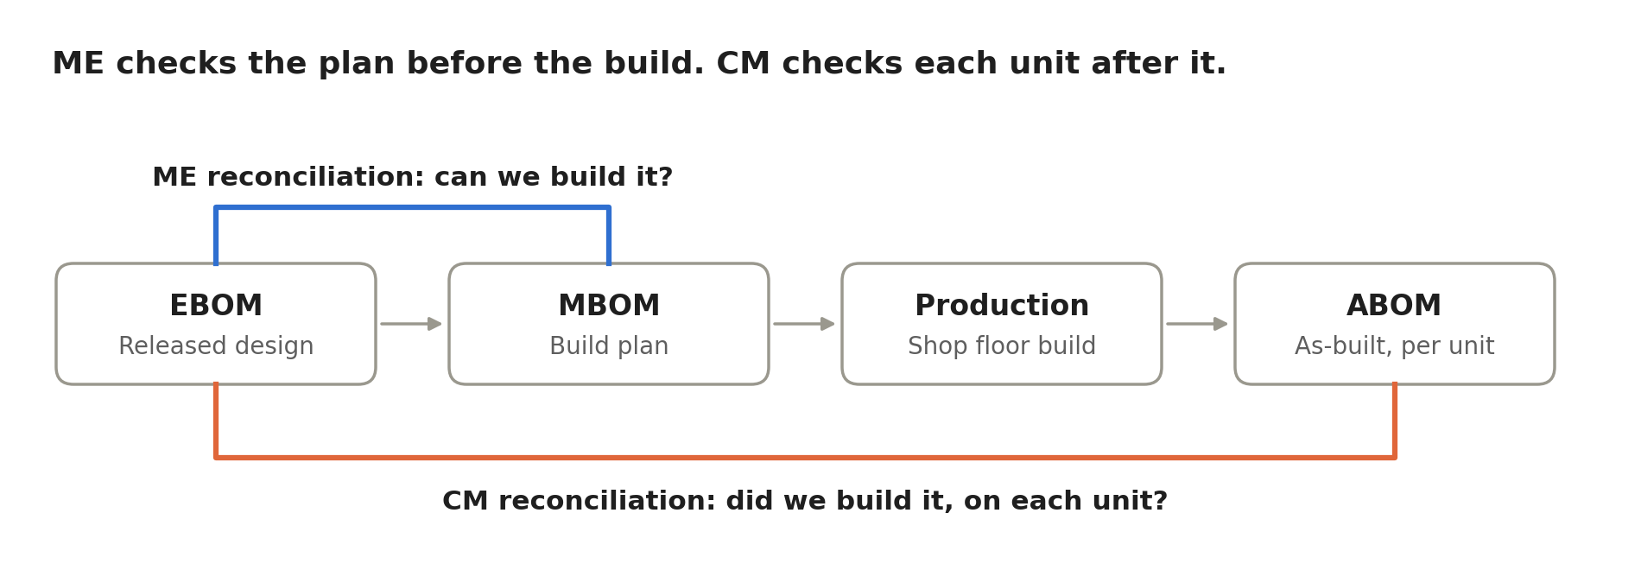
Figure 1. EBOM to ABOM flow with two reconciliation points
Each discrepancy has one owner and one destination.
Discrepancy | Found by | Routed to
EBOM item missing from the MBOM | ME | MBOM correction
MBOM item with no EBOM source or approved addition | ME | MBOM correction, or engineering change request if the EBOM is wrong
Installed part does not match the approved design | CM | Nonconformance process (Material Review Board)
Installed part departs from design under an approved variance | CM | No action. CSA records the variance against the unit.
Serial, lot, or batch number missing from the record | CM | Record correction per program procedure
As-built mismatch traced to an MBOM error | CM | ME for MBOM correction

Editor's note: confirm this routing against the program CM Plan and nonconformance procedure.

Why Both Functions Are Required
The two reconciliations work like two roles in corporate finance. ME is Accounting. ME prepares and maintains the operational ledger. CM is Internal Audit. CM checks the ledger against the requirements. Internal Audit sits inside the company. Internal Audit stays independent of the work it reviews. CM holds the same position.
Merging the two reconciliations removes a check. No function should be the only check on its own output. That principle applies to ME. It applies to CM as well.
Eliminating either reconciliation removes a capability. ME owns routings, build sequence, and work instructions. CM does not. CM owns configuration status accounting and unit-level traceability. ME does not.
One reconciliation asks whether we can build it. The other proves that we did.

Requested Action
Retain both reconciliations as separate activities.
- Keep EBOM-to-MBOM reconciliation with ME. Track it with PE-0400.
- Keep EBOM-to-ABOM reconciliation with CM. Report it through the As-Designed to As-Built Reconciliation Report.
- Adopt the discrepancy routing in this memo in the program CM Plan.

References
- DFARS 252.242-7004, Material Management and Accounting System (JAN 2025)
- SAE AS9100D, Quality Management Systems: Requirements for Aviation, Space, and Defense Organizations, clauses 8.1.2, 8.5.1, and 8.5.2
- SAE AS9102, Aerospace First Article Inspection Requirement
- SAE EIA-649-1, Configuration Management Requirements for Defense Contracts (confirm revision)
- SAE EIA-649, Configuration Management Standard (confirm revision)
- Program airworthiness authority. For FAA production, cite AC 21-43 at its current revision. For a military-only program, cite the program's military airworthiness authority instead.
- PE-0400, ME EBOM-MBOM Metric (internal)

Open question: confirm whether FAA production rules apply to this program.

