GUIDANCE · DRAFT FOR REVIEW
Controlling Inherited Ground Rules and Assumptions
What goes wrong when programs reuse assumptions, and the steps that prevent it
This guidance is proposed practice. No current standard requires an assumption register.
Two provisions of SM-0001 support it. Appendix 2 lists assumptions among the data a hazard log may hold. Section 6.2.2 lists acceptance of risk as part of risk assessment.

Audience | Engineers, configuration management specialists, safety risk management, safety assurance, human factors, and program management.
Applies to | Any ground rule or assumption that a hazard analysis or a certification finding depends on. This includes new assumptions. It also includes assumptions carried over from another program.
Related standards | SM-0001 Issue C · EIA-649-1A · GEIA-HB-649
Status | Draft guidance. Not yet adopted.

Contents

1. Purpose

1.1 The problem in one example
A pressure sensor flies on Program A. Program B is a derivative aircraft. Program B uses the same sensor. It has the same part number and comes from the same supplier.
Program B also copies Program A's assumptions about the sensor. One assumption says a blocked sensing line needs no design fix. That assumption was true on Program A. It depended on four conditions.
On Program B, all four conditions changed. Nobody noticed. Nothing in our process checks.
Section 2.3 walks through this example in detail.

1.2 What this document does
This document explains the gap. It explains why the gap matters for safety. It sets out the steps that close it.
It does not ask programs to stop reusing assumptions. Reuse is often correct. It asks that reuse leave a trace. Someone must be able to check that trace later.

1.3 Terms used in this document
Six terms carry this document. Each term keeps one meaning throughout. Appendix A gives the full glossary. It includes the standard definitions of the configuration management and safety terms used here.
Term | Definition
Assumption | A ground rule or assumption (GR&A): a statement a program adopts as true in order to bound analysis and design. This document uses "assumption" for both ground rules and assumptions.
Statement | The part of an assumption that asserts what is true or acceptable, written separately from the reasoning behind it.
Condition | A single, checkable claim that must be true for an assumption to hold.
Anchor | The specific controlled document, item, and revision that a condition depends on.
Risk credit | The reduction in assessed risk that an assumption provides. If the assumption fails, the credit is withdrawn and the hazard reopens.
Source program and receiving program | The source program is the program where an assumption was first written. The receiving program is the program that reuses it.

1.4 How this document is organized
Section | What it covers
2 | The situation. What an assumption is, how programs reuse assumptions, and the worked example.
3 | Why it matters. Lost conditions, risk nobody accepted, rising cost, and assumptions that are not about hardware.
4 | Nine principles. Every later step follows from them.
5 | Where the underlying facts are controlled, and why the SMS owns this practice.
6 | The assumption record. Fields, tiers, states, and dispositions.
7 | How the re-confirmation sweep detects change.
8 | Steps for each lifecycle state.
9 | Roles and responsibilities.
10 | Ways to implement the practice, including on model-based programs.
11 | Limits and open decisions.

2. The situation

2.1 What an assumption is
Start with a real assumption.
Example of a safety-relevant assumption
"Undetected blockage of the sensing line is acceptable without additional design mitigation, provided that (a) the crew is alerted within one flight, (b) the line is inspected every 400 flight hours, and (c) the unit is installed outside the icing-exposed bay."

This assumption lets the hazard analysis stop. It says the hazard needs no design fix. Three other things handle the hazard instead.
Every safety-relevant assumption works this way. Every one has three parts.
Part | In the example | What happens when the assumption is reused
The statement | "Undetected blockage is acceptable without additional design mitigation." | The statement is short. People quote it. It moves easily to another program.
The conditions | Items (a), (b), and (c). | The conditions make the statement true. They are longer. They are harder to remember. They are the first thing lost in a copy.
The risk credit | The hazard closed without a design change. | Someone accepted the residual risk. That acceptance does not move with the statement.

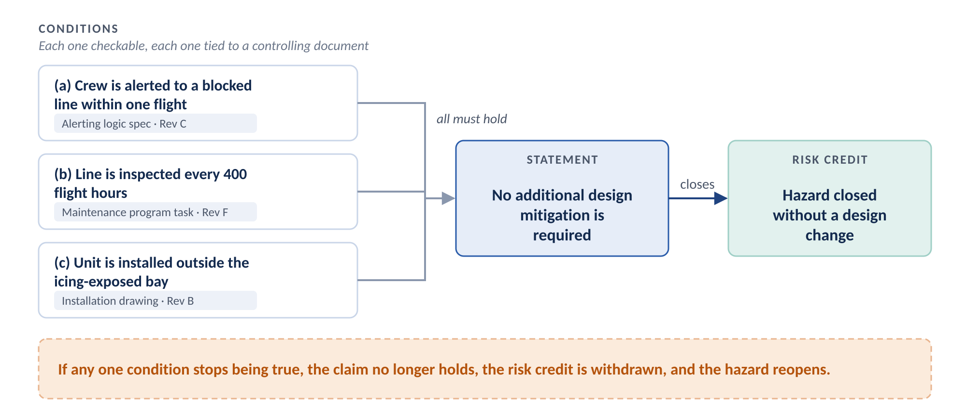
Figure 1. Anatomy of a safety-relevant assumption. The statement holds only while every condition holds.
Three safety terms appear throughout this document. Each has a standard definition. This document uses them exactly as SM-0001 defines them.
Term | Definition | Source
Hazard | A condition or an object with the potential to cause or contribute to an aircraft incident or accident. | ICAO Annex 19, as cited in SM-0001
Risk | The combination of predicted severity (criticality) and likelihood (probability) of the potential effect of a hazard. | NAS9927, as cited in SM-0001
Risk control | A means to reduce or eliminate the effects of hazards. | NAS9927, as cited in SM-0001

2.2 How programs reuse assumptions today
Programs write assumptions at proposal. Proposal is the most compressed phase of any program. Rebuilding a set of assumptions takes weeks of senior engineering time. The bid does not have that time.
So a program that reuses hardware usually reuses the source program's assumptions too.
This choice is rational. Rebuilding costs the bid money now. Everyone sees that cost. Not rebuilding costs money later, during execution or in the fleet. Nobody sees that cost at bid time.
Reuse is often correct. Suppose the part, the installation, the environment, the customer, and the maintenance program are all the same. Then the source program's assumption still holds. Rebuilding it would waste money.
The problem is not reuse. The problem is reuse in a form nobody can check.

2.3 A worked example
A pressure sensor is qualified and in service on Program A. Program B is a derivative. Program B uses the same unit, the same part number, and the same supplier. The bid team copies Program A's assumptions about the sensor.
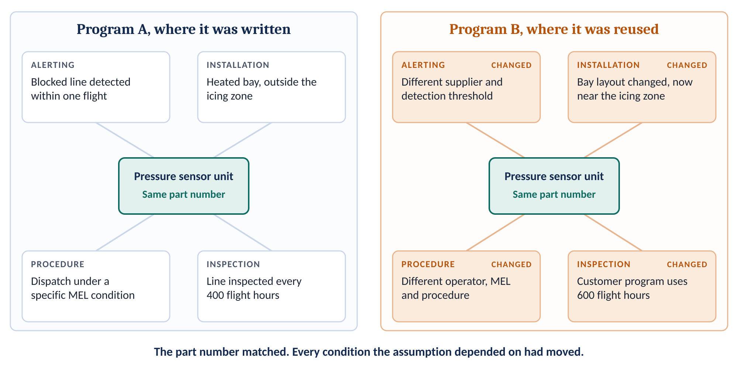
Figure 2. The worked example. The hardware is identical. Every condition the assumption relied on has changed.
Condition | Program A, where the assumption was written | Program B, where the assumption was reused
Alerting | Crew alerting detects a blocked line within one flight. | A different supplier provides the avionics. The detection threshold is different.
Procedure | A specific minimum equipment list (MEL) condition governs dispatch. | A different operator flies the aircraft. The MEL is different. The crew procedure was rewritten.
Inspection | Maintenance inspects the line every 400 flight hours. | The customer's maintenance program sets 600 flight hours.
Installation | The unit sits in a heated bay, outside the icing zone. | The bay layout changed. The unit now sits near the icing zone.
Result | The hazard closed without a design change. | The part number is identical. Every condition changed.

Nobody made an error. Four teams made four reasonable changes at four different times. No one saw all four changes next to the assumption they broke.

3. Why this matters

3.1 The statement travels. The conditions stay behind.
When a program copies an assumption, the statement moves. The reasoning does not.
The reasoning stays in the head of the engineer who wrote it. It stays in a review held years ago. It stays in the source program's documents.
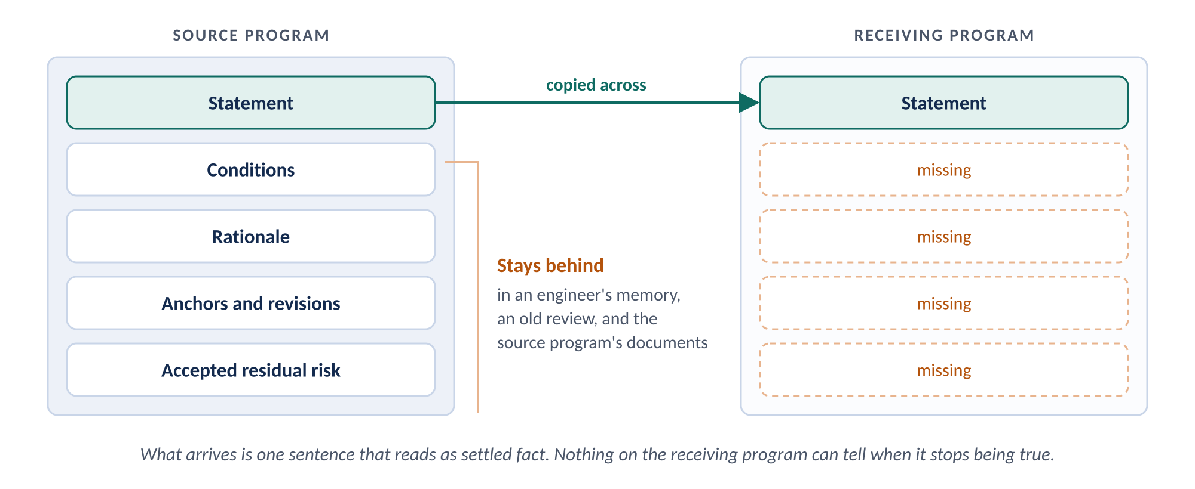
Figure 3. What moves when a program copies an assumption, and what stays behind.
A part number answers one question. It says the box is the same box.
An assumption makes many more claims. It claims how the box is installed. It claims how hard the box works and what environment it sees. It claims how often someone inspects the box. It claims what the crew sees and what the box connects to. Hardware similarity proves none of these claims.
SM-0001 Appendix 2 lists assumptions among the data a hazard log may hold. It gives a reason. Assumptions "can be examined when they change in order to identify whether the change in assumptions changes the risk assessment."
That reason presumes someone knows when an assumption changes. For an inherited assumption, nobody does.

3.2 Risk accepted by nobody
Every assumption that closes a hazard leaves residual risk. Someone accepted that residual risk. That person worked on the source program. That person used the source program's risk acceptance criteria.
The acceptance does not travel with the assumption. Nobody on the receiving program is asked to accept the risk. No record shows that anyone asked.
Within a year or two, the assumption stops reading as a decision. It reads as a fact.
This is a safety management gap, not only an engineering quality gap
SM-0001 Section 6.2.2 lists the activities of risk assessment and mitigation. Two of them apply here. One is "acceptance of risk (including identification of management personnel that can accept high, serious, and medium risks)." Another is "risk control decision (recognition and acceptance of residual risk)."
An inherited assumption can carry risk credit through critical design review with no risk acceptor on the receiving program. When that happens, the receiving program has skipped both activities.

3.3 Cost rises at each stage
The usual objection is cost. Programs say they do not have the time.
That objection compares the work against zero. The honest comparison is against the cost of finding the problem later.
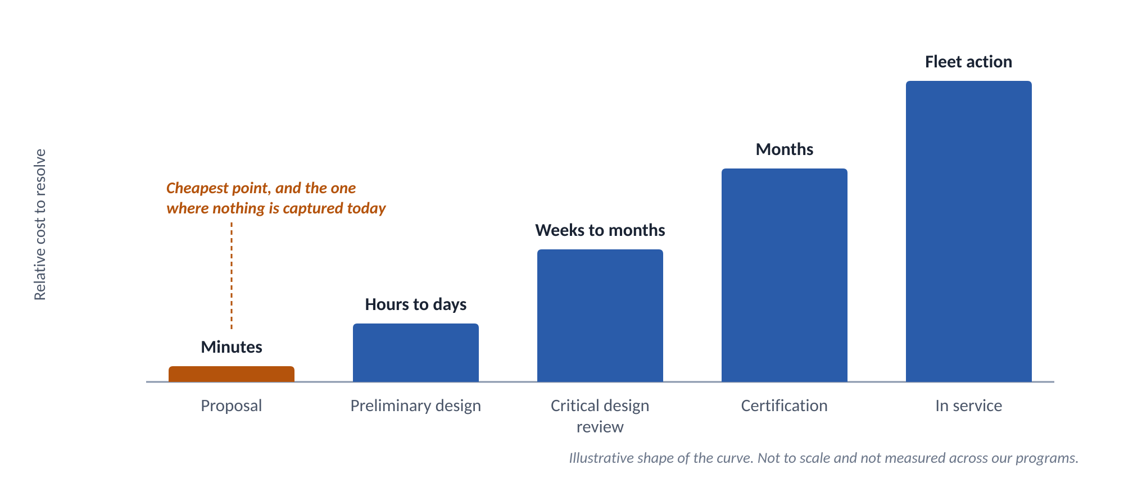
Figure 4. The cost to resolve a bad assumption rises at each stage. The shape is illustrative.
When the problem is found | What happens | Typical cost
Proposal | The author writes the conditions down while still knowing them. | Minutes per assumption
Preliminary design | An engineer checks the assumption against the emerging design. | Hours to days. Nothing is committed yet.
Critical design review | An engineer finds the assumption does not hold. | Weeks to months. Design change and rework.
Certification | The problem surfaces during compliance demonstration. | Months. Reanalysis and a possible schedule slip.
In service | Field evidence reveals the problem. | Fleet action. Service bulletin. A possible airworthiness directive.

These figures show the shape of the curve. They are illustrative. We have not measured them across our programs.
The cheapest point to capture an assumption is proposal. Proposal is also the one point where programs capture nothing today.

3.4 The assumptions most likely to fail are not about hardware
A similarity review compares parts. The assumptions most likely to be wrong are not about parts. That is why the current process misses them.
Assumptions about people. Examples include crew training and recency, crew workload in a phase of flight, maintainer skill level, and the chance that an inspector finds a defect. Others include the time available to complete a procedure, staffing, and fatigue. None of these has a part number. A parts comparison never raises them.
A further gap. A procedure revision generates no engineering change. Neither does a training change. So nothing prompts anyone to ask whether an assumption just broke.
Hidden assumptions about people. Some assumptions about people look like hardware data. A detectability rating in a failure modes and effects analysis (FMEA) is one. An assumed inspection interval is another. Each one assumes how a person will perform. A program that reuses them reuses another program's workforce.
Assumptions about interfaces. Reuse by similarity is a claim about the item. An interface assumption is a claim about the item's surroundings. The surroundings are exactly what did not come across.
Assumptions between organizations. These fail in a typical way. The supplier assumes the integrator covers the risk. The integrator assumes the supplier covers it. The assumption falls into the gap between two safety management systems.
Look again at the worked example. Three of the four broken conditions involved alerting logic, the maintenance program, and the crew procedure. The hardware really was identical. That is the common pattern, not the exception.

4. Principles
Nine principles govern the rest of this document. When a later step is unclear, apply the principle.
- Reuse is allowed. Reuse must leave a trace. A program may carry an assumption across. It must carry the conditions, the anchors, and the evidence with it.
- Write the conditions when the assumption is made. The author knows the conditions at that moment. Writing them takes minutes. Reconstructing them years later takes weeks. Often it cannot be done.
- Cite the controlling document. Do not restate its values. Record the document, the item, and the revision. Nobody can check a restated value. Anyone can check a cited revision.
- Name a risk acceptor on the receiving program. Every assumption that carries risk credit needs a risk acceptor. The risk acceptor is a named person on the receiving program. Acceptance on the source program does not count.
- Re-adopt. Do not inherit. An assumption enters a receiving program only after a documented comparison. The comparison covers each condition on both programs. A part number match is not enough. Any condition that cannot be verified goes back to safety risk management.
- Let the hazard analysis set the scope. An assumption gets full control if a hazard reopens when it fails. Apply this test using the hazard analysis. Do not borrow a list kept for another purpose.
- Keep verified and monitored separate. Test, analysis, inspection, demonstration, or an authority's approval can close some conditions. Other conditions can only be watched. Never record a monitored condition as verified.
- Convert to a requirement wherever possible. Sometimes a condition can be levied on a responsible party. When it can, levy it. A requirement has an owner and a compliance path. Each conversion shrinks the set of assumptions that need ongoing control.
- The SMS owns the practice. The facts that assumptions depend on are controlled in three different places. No owner of one place can see the whole picture. The safety management system (SMS) can.
Principle 5 changes current practice the most. Figure 5 compares the two paths.
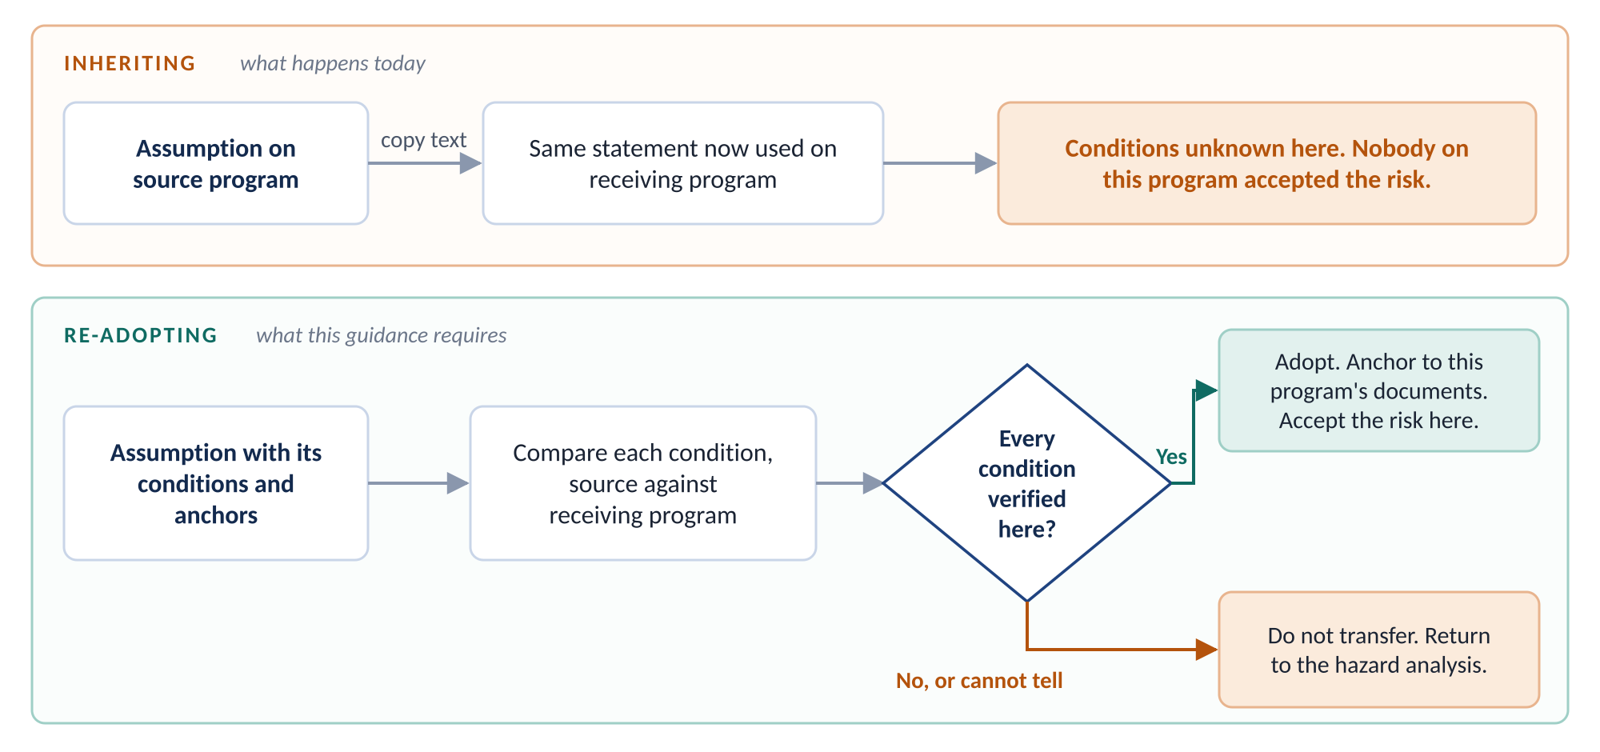
Figure 5. Inheriting copies a statement. Re-adopting compares conditions and makes a new risk decision on the receiving program.

5. Where the facts live, and who owns this practice
Go back to the worked example. The alerting threshold lives in an engineering specification. The inspection interval lives in the maintenance program. The crew's ability to detect the fault depends on training.
Each of those facts sits in a different control regime. A control regime is a place where documents are approved and changed under one authority and one change process.
Control regime | What it controls | Who approves changes | Assumptions anchored here
Engineering configuration control | Drawings, specifications, and interface requirements. | The engineering change board. | Hardware, installation, interface, loads, thermal, and duty cycle.
Maintenance program and operational control | Inspection intervals, MEL conditions, and flight and maintenance procedures. | The operator and the authority. No engineering change is involved. | Inspection, dispatch, procedures, and operations.
Training and competence control | Crew and maintainer qualification, recency, and curriculum. | The training organization. Engineering is not involved. | Human performance, detection, and workload.

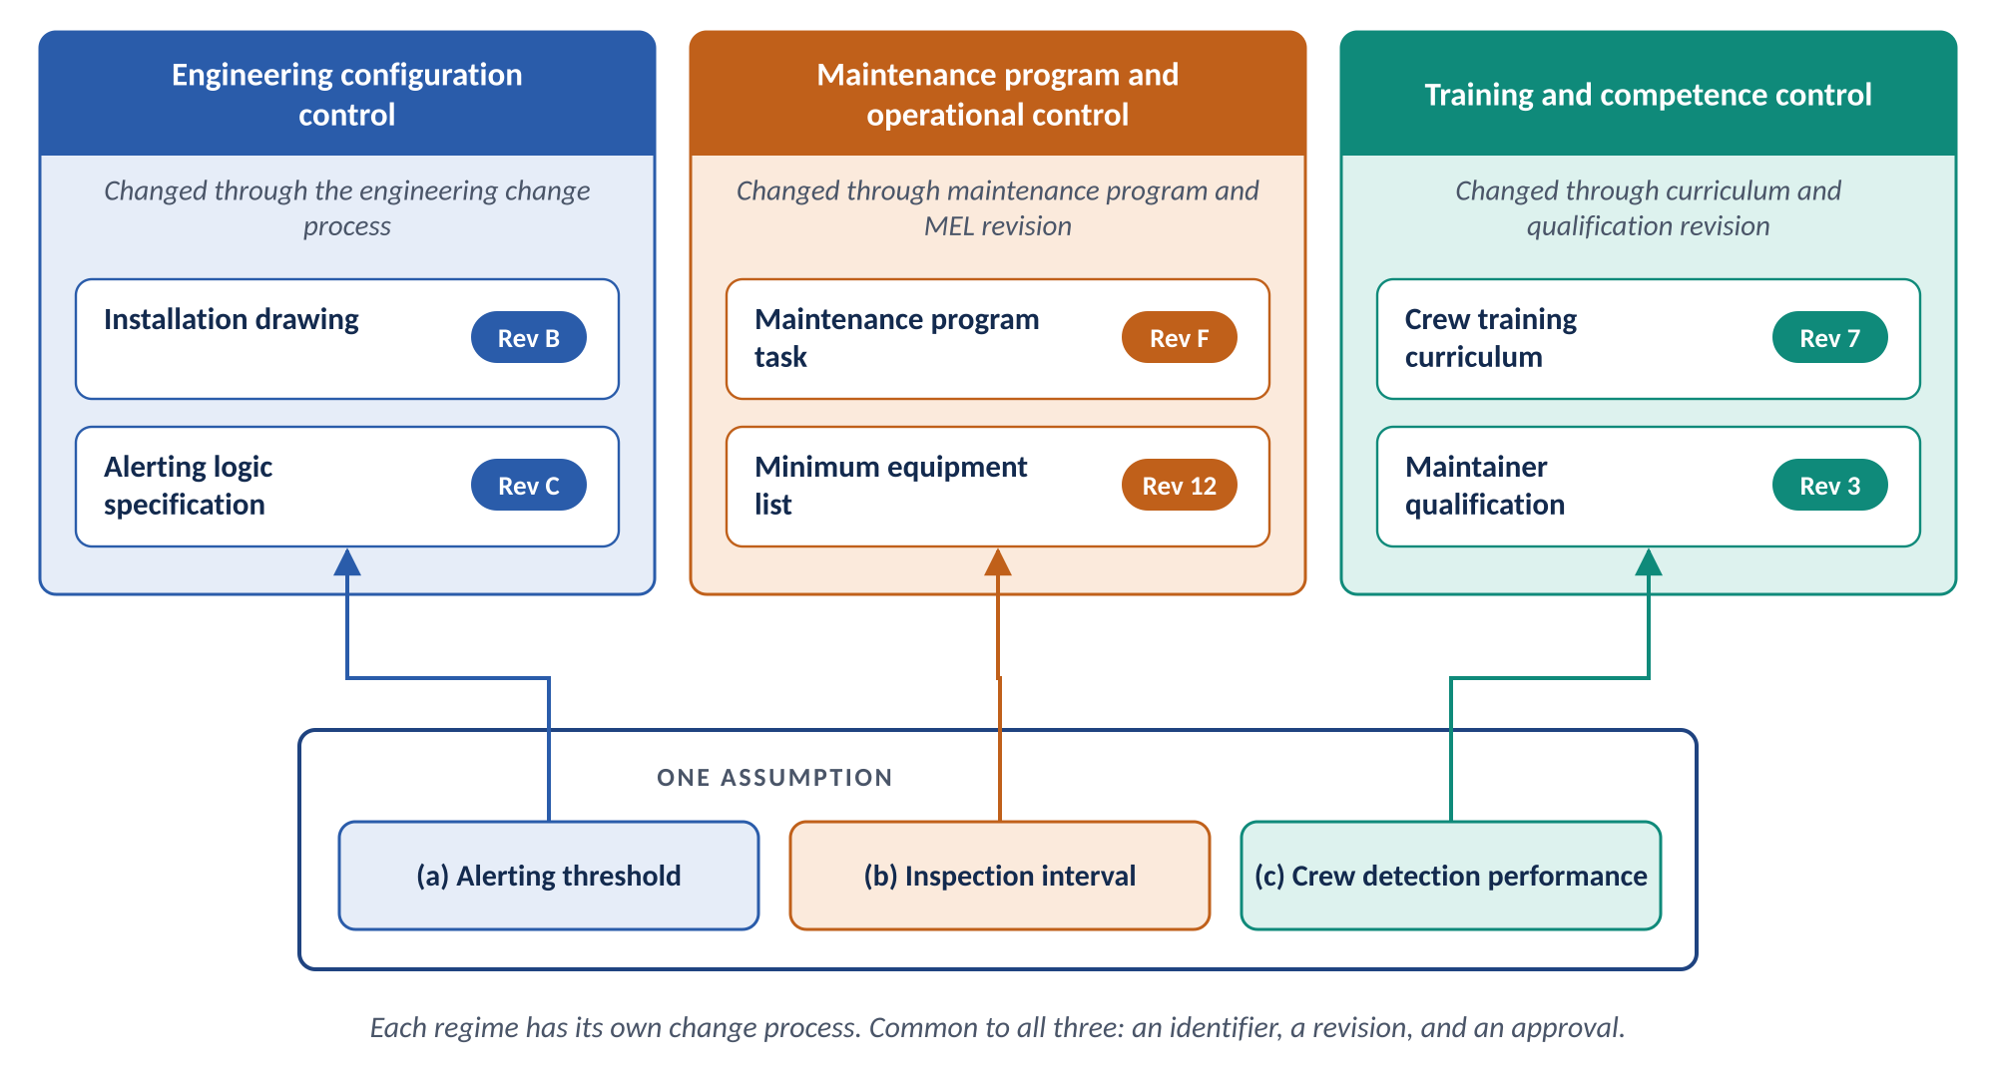
Figure 6. One assumption can depend on documents in all three control regimes.
All three control regimes produce documents. Each document has an identifier, a revision, and an approval. That is enough to anchor a condition. It is also enough to detect, later, that the anchor moved.
The three control regimes do not share a change process. They do not share an owner or an approval route. A practice tied to only one of them misses most failures. So the practice sits in the SMS.
Configuration management is a supplier, not the owner
Configuration management supplies the current revision of each engineering document. It also keeps document identifiers stable. Continued airworthiness supplies current revisions for the maintenance program. The training organization supplies current revisions for curricula and qualification standards. Each one supplies data to the SMS.
This guidance requires no change to the engineering change process. It requires no change to the engineering change proposal form.

Engineers and configuration management specialists use precise terms for the engineering control regime. This document uses those terms as EIA-649-1A defines them.
Term | Definition | Source
Configuration Item (CI) | A product or an aggregation of products (hardware, software, firmware, or documentation) that accomplishes an end-use function, is under separate configuration control and is designated for configuration management control. | EIA-649-1A
Configuration documentation | The technical documentation that identifies and defines the item's functional performance and physical characteristics. | EIA-649-1A
Revision | An attribute that distinguishes a change to a design or document in order to differentiate one closely related design or document iterations from another. | EIA-649-1A, adopted from ASME Y14.35
Engineering change | A change to the current approved configuration of a Configuration Item at any point in the item's life cycle. Also known as configuration change. | EIA-649-1A

Note the scope of these terms. A Configuration Item is a product. Its configuration documentation is engineering documentation. Neither term covers a maintenance program task or a training curriculum. That is why engineering configuration control alone cannot carry this practice.

6. The assumption record

6.1 What each record contains
Each assumption gets one record. The fields follow the hazard log content in SM-0001 Appendix 2. They apply that content one level down, to the assumption itself.
Field | Content | Tier 1
Identifier | A unique number within the program. | Required
Statement | The statement, written on its own and kept apart from the rationale. | Required
Rationale | Why the author made the assumption. Nobody can reconstruct this field later. | Required
Conditions | Each checkable claim that must be true, one per line. | Required
Anchor for each condition | The controlling document, item, and revision. Cite it. Do not copy its values. | Required
Control regime for each condition | Engineering, maintenance and operational, training, contractual, or none. | Required
Owner | The engineer accountable for the assumption. | Required
Risk acceptor | The named person on this program who accepts the residual risk. | Required
Dependent hazard | The hazard that reopens if the assumption fails. | Required
Tier, state, and disposition | See Sections 6.3 through 6.5. | Required
Provenance | For an inherited assumption: the source program, the source record and its revision, and the basis of the similarity claim. | If inherited
Last confirmed | The date someone last checked the conditions against the documents in force. | Required

6.2 Writing conditions
Compare two ways to write the same condition.
Restated (avoid) | Cited (use)
"Assumes the line is inspected every 400 flight hours."  The maintenance program moves to 600 hours. Nothing connects that change to this sentence. The sentence still reads as true. | "Assumes the inspection interval defined in [document, item, revision]."  The document is revised. The recorded revision no longer matches. The next sweep flags the condition.

The second version can be checked. The first cannot. Follow five rules.
- Write one claim per condition.
- Write each condition so a reader can answer yes or no.
- Cite the controlling document and its revision. Do not repeat the value it contains.
- Record which control regime holds that document.
- If nothing controls the condition, record the control regime as "none." Treat that as a finding. It is not missing data.

6.3 Tiers
Not every assumption needs full control. Full control for every assumption would be unaffordable. Tiers keep the practice affordable.
Safety risk management assigns the tier. It uses the hazard analysis. The test for Tier 1 is one question. Does a hazard reopen if this assumption fails?
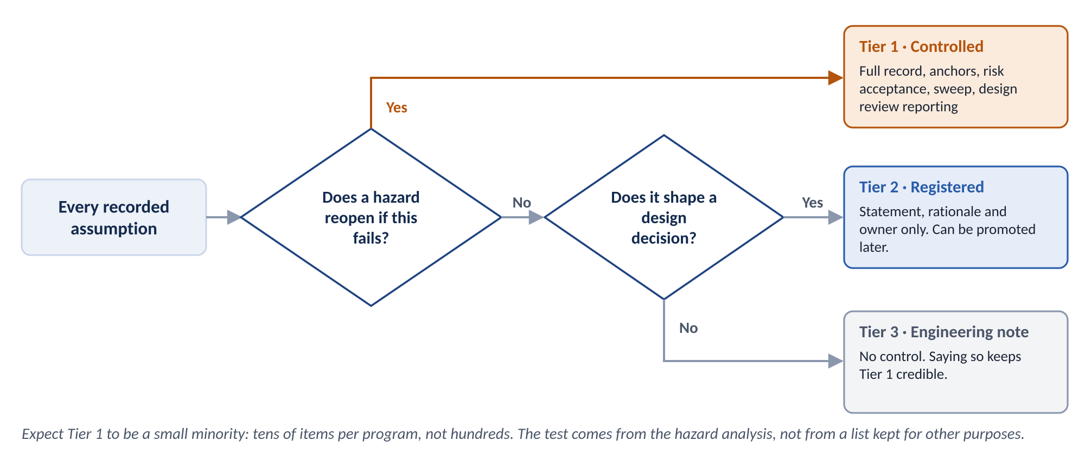
Figure 7. Tiering. The hazard analysis decides which assumptions receive full control.
Tier | Scope | Treatment
Tier 1, controlled | A hazard analysis or a certification finding depends on the assumption. | Full record, anchors, risk acceptor, sweep, and design review reporting. Expect tens of Tier 1 assumptions per program, not hundreds.
Tier 2, registered | The assumption shapes design decisions but carries no risk credit. | Identifier, owner, statement, and rationale only. A Tier 2 assumption can move to Tier 1 later.
Tier 3, engineering note | Working assumptions and modeling simplifications with no safety consequence. | No control. Saying so openly keeps Tier 1 credible.

6.4 States
Each assumption is in exactly one state at a time. The state shows how firmly the assumption is tied to evidence.
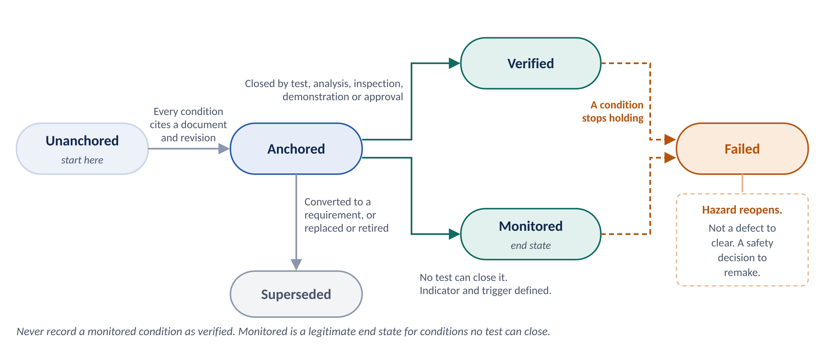
Figure 8. States of an assumption and the transitions between them.
State | Meaning
Unanchored | The record exists and lists conditions. No controlling document has been identified yet. This state is normal at proposal.
Anchored | Every condition cites a controlling document and revision.
Verified | Test, analysis, inspection, demonstration, or an authority's approval has confirmed every condition.
Monitored | No test can close the condition. A named indicator with a defined trigger watches it instead. Monitored is an end state, not a waypoint.
Failed | A condition no longer holds. The dependent hazard reopens in safety risk management. A failed assumption is not a defect to clear. It is a safety decision to remake.
Superseded | A later assumption replaced this one, or a requirement replaced it.

Verification has a precise meaning. ISO 9000:2015 defines it as "confirmation, through the provision of objective evidence, that specified requirements have been fulfilled." Programs provide that evidence by test, analysis, inspection, demonstration, or an authority's approval.
A monitored condition has no such evidence. Record it as monitored.

6.5 Dispositions
Each assumption ends in one disposition. Converting to a requirement is the preferred disposition.
Disposition | When to use it
Converted to requirement | Preferred. The condition is levied on a responsible party. That party owns it and has a compliance path.
Accepted | The assumption stands. A risk acceptor is named. The assumption stays under control.
Transferred to operator | The condition belongs to the operator. A document records the transfer.
Retired | The assumption no longer applies.
Open | No disposition has been made yet.

7. Detecting change: the re-confirmation sweep
Take the inspection condition from the worked example. The record cites maintenance program task 05-21 at revision F. Today the task is at revision G. Something changed. Someone must look.
The re-confirmation sweep finds those cases. The sweep compares the revision recorded for each condition with the revision in force. Any difference flags the assumption for re-confirmation.
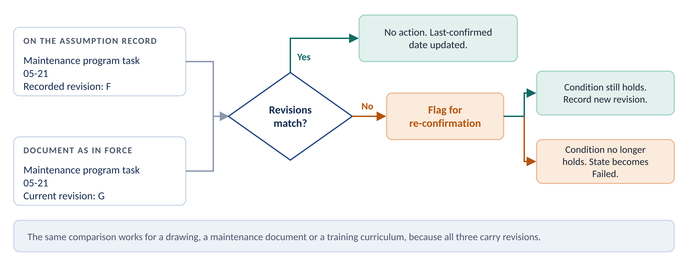
Figure 9. The re-confirmation sweep. A revision mismatch is the signal, whichever control regime holds the document.
Element | Guidance
Owner | SMS safety assurance.
Frequency | At an interval set in the program safety plan. Also before every design review.
Inputs | The current revision of each anchor document. The custodian for each control regime supplies it.
When a flag is raised | The assumption owner checks the condition. If the condition still holds, the owner records the new revision. If it does not hold, the assumption moves to Failed and the dependent hazard reopens.
Record | The outcome, the date, and the person who confirmed it. The last confirmed date is updated.

Two limits
Latency. The sweep finds a change at the next sweep, not on the day of the change. A trigger built into each change process would be faster. The sweep is slower. In exchange, it costs other functions nothing. It also covers all three control regimes.
A single point of failure. The sweep compares against current revisions. If those revisions are wrong, the sweep is wrong. Each anchor document needs a named custodian who keeps its revision current.

Model-based programs can run the same comparison continuously, as a model validation rule. Section 10 describes how.

8. Steps by lifecycle state
Programs write assumptions at proposal. At proposal almost nothing is fixed. The documents that conditions point at appear later, one after another.
Each new document lets a further set of conditions be anchored. Programs should not wait for a mature design. They should anchor conditions as documents appear. They should count what is still unanchored.
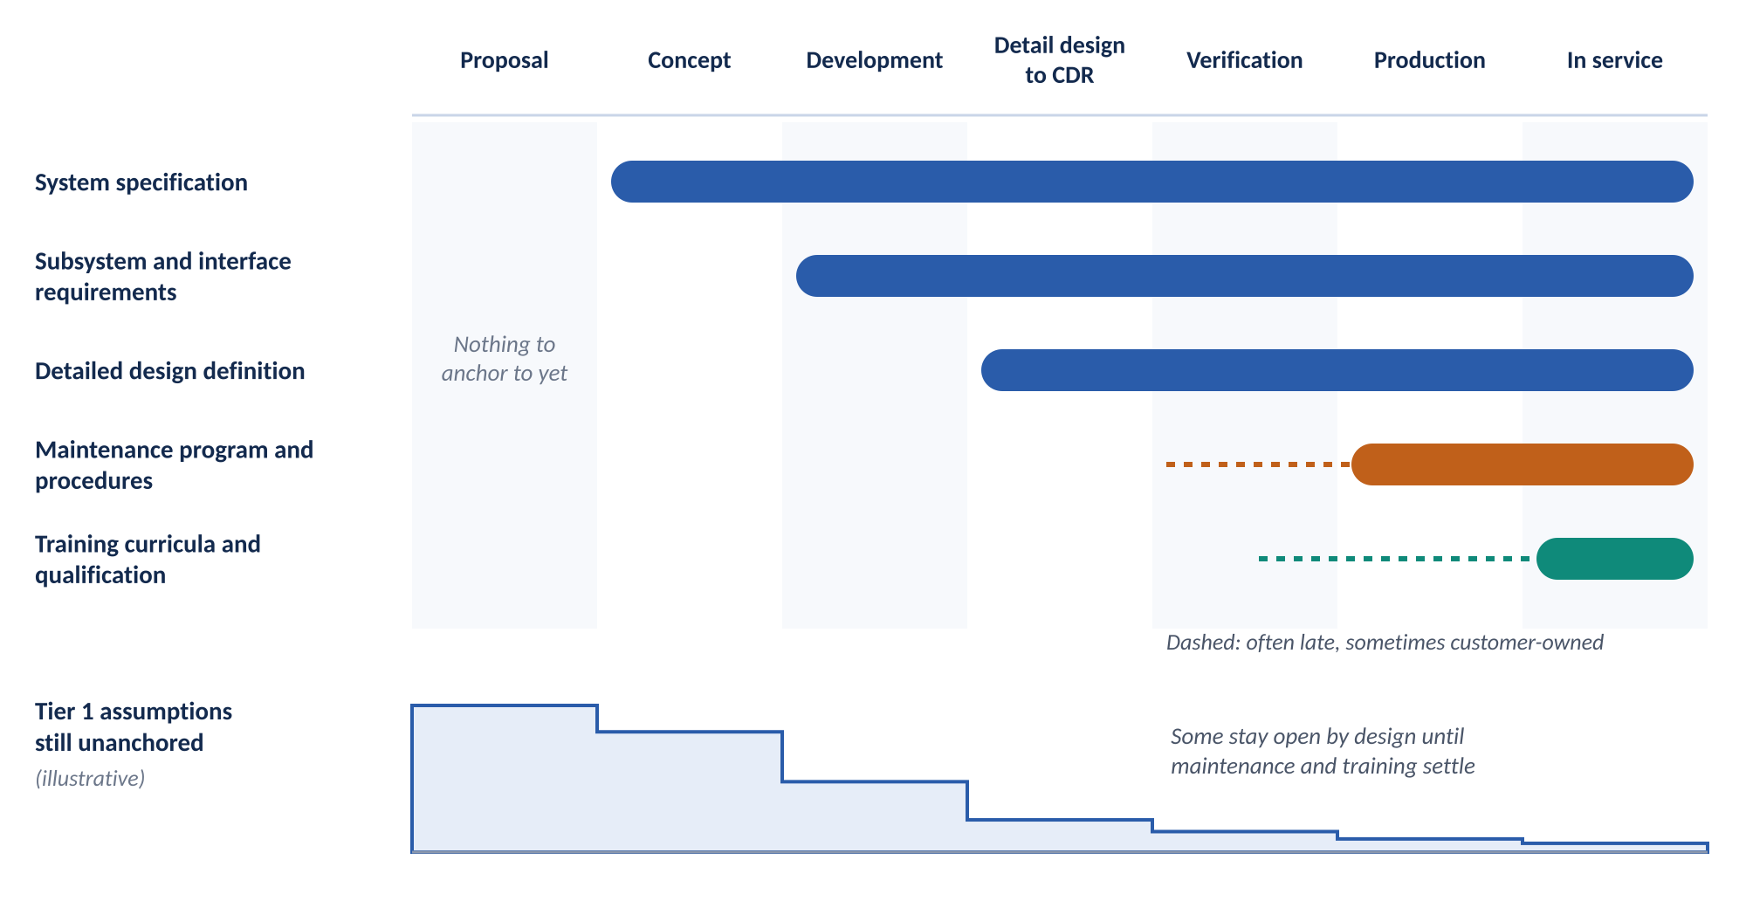
Figure 10. When each kind of anchor document becomes available, and how the count of unanchored assumptions should fall. Illustrative.
Anchor document | Typically available | Conditions it can anchor
System specification | Early design. | Operating environment and performance envelope.
Subsystem and interface requirements | Development. | Interface, installation, thermal, loads, and duty cycle.
Detailed design definition | Detail design through critical design review (CDR). | Item-level conditions at specific revisions.
Maintenance program and procedures | Often late. Sometimes the customer owns them. | Inspection intervals, MEL conditions, and crew and maintainer procedures.
Training curricula and qualification | Late. Revised continuously in service. | Competence, recency, workload, and detection performance.

Some conditions cannot be confirmed until the maintenance program and training are settled. On many programs, that happens at or after entry into service. Those conditions stay open by design. Record them as open. Never record a confirmation that nobody made.

8.1 Proposal and pre-award
No baselines exist yet. Nothing can be anchored. That is expected.
This state must produce a written record of what is assumed and why. The people who still know the answers must write it.
Action | Owner
Create a record for every assumption that closes or reduces a hazard. Include the identifier, owner, statement, and rationale. | Systems Engineering
Write each condition so a reader can answer yes or no. | Systems Engineering
For each inherited assumption, record the source program, the source record, its revision, and the basis of the similarity claim. | Systems Engineering
Capture the hazards and risk controls that each borrowed assumption served on the source program. | Safety Risk Management
Flag assumptions about people and organizations separately. A parts comparison will not surface them. | Human Factors
Mark every assumption unanchored. Start the count. | SMS Safety Assurance
Include the cost of anchoring and confirming assumptions in the bid. | Program Management

This state is where the work is cheapest. It is also where programs do none of it today.

8.2 Concept and early design
The first hazard analysis shows which assumptions carry risk credit. Tiering happens here.
This is also where the receiving program makes its own risk acceptance decision. Acceptance from the source program stops counting.
Action | Owner
Perform system-level hazard identification. Test each assumption: does a hazard reopen if it fails? | Safety Risk Management
Assign a tier to every assumption. | Safety Risk Management
Name a risk acceptor on this program for every Tier 1 assumption. | SMS, Accountable Executive or delegate
Confirm that the organizational system description bounds the scope. | SMS
Anchor operating environment and performance conditions to the system specification. | Systems Engineering
Stand up the assumption register, in a spreadsheet or in the model. | SMS Safety Assurance
Agree on a document identifier convention so citations stay stable. | Configuration Management

Good tiering here keeps everything downstream affordable. Poor tiering will kill the practice within a year.

8.3 Development and subsystem design
Most assumptions that fail are about an item's surroundings, not the item. This state makes those conditions anchorable.
This state catches more broken assumptions than any other.
Action | Owner
Push the hazard analysis down to subsystem level. Restate conditions at that level. | Safety Risk Management
Anchor interface, installation, thermal, loads, and duty cycle conditions to subsystem and interface requirements. | Systems Engineering
Identify the maintenance, procedure, and training documents that conditions depend on. Record a custodian for each document. | Systems Engineering, Human Factors
Convert conditions to derived requirements wherever a responsible party can be named. | Systems Engineering, Safety Risk Management
Flow assumption ownership and reporting duties to suppliers through interface agreements and contracts. | Supply Chain
Begin the sweep. Report unanchored Tier 1 assumptions at preliminary design review. | SMS Safety Assurance, Program Management

In the worked example, three of the four broken conditions become visible here. Someone has to look.

8.4 Detail design through critical design review
Until now, "the hardware is the same" has been a claim. Now both programs have enough design definition to compare.
This is the last inexpensive point to find an inherited assumption that does not hold.
Action | Owner
Anchor the remaining conditions to specific items at specific revisions. | Systems Engineering
For every inherited assumption, compare the source and receiving programs condition by condition. Do not compare part number to part number. | Systems Engineering, Safety Risk Management
Return any condition that cannot be verified against this program's own data to safety risk management. | Safety Risk Management
Raise a finding for any Tier 1 assumption that has no risk acceptor. | SMS
Check operator and maintainer assumptions against the draft procedures and the task analysis. | Human Factors
Hold the review criterion. The count of unanchored Tier 1 assumptions must be at or below the agreed threshold. | Program Management

If a program adopts only two steps from this document, adopt these two. Run the condition-by-condition comparison here. Run the sweep in Section 7.

8.5 Verification, audits, and certification
Evidence replaces claims. A failed assumption now becomes a change with cost and schedule consequences.
Action | Owner
Confirm conditions by test, analysis, inspection, demonstration, or an authority's approval. Record the evidence. Move them to Verified. | Systems Engineering, Quality
For conditions that no test can close, define the monitor: the indicator, the data source, and the trigger. Move them to Monitored. | SMS Safety Assurance, Human Factors
Treat a condition that fails a test as a reopened hazard. Any resulting design change follows the normal change process. | Safety Risk Management
Confirm assumed task times, alerting, and detection performance by test or simulation. | Human Factors
Validate the risk controls that depend on assumptions. | Safety Risk Management
Decide whether evidence that confirms an assumption becomes part of the certification evidence. | SMS, Certification lead

8.6 Production
The number of changes rises. The risk is that the discipline lapses quietly. The work here keeps the sweep running.
Action | Owner
Keep the sweep running at the planned interval. | SMS Safety Assurance
When a recurring variance is made permanent, reopen the assumptions it touches. | Safety Risk Management, Quality
Treat repeated nonconformances as a sign of an invalid manufacturing or human factors assumption. | Quality, Human Factors
Check whether re-confirmations actually happen, or whether they are quietly waived. | SMS Safety Assurance

Procedure and training revisions generate no engineering change. The sweep still catches them. Those documents carry revisions too.

8.7 In service, and handing on to the next program
Only field evidence can test assumptions about how the aircraft is actually flown and maintained.
In this state, the program also becomes a source program. The next program will borrow from it.
Action | Owner
Route continued operational safety findings to assumption owners. Do not route them only to hazard owners. | Safety Risk Management
Track monitored assumptions against their triggers. | SMS Safety Assurance
Re-confirm assumptions on schedule and on trigger. Track the time since each was last confirmed. | SMS Safety Assurance
Use configuration history to find which aircraft a failed assumption affects. | Configuration Management
When releasing assumptions to another program, send the conditions, anchors, and evidence with each statement. | Program Management, Systems Engineering
Do not release a bare statement to another program. | SMS

A program that exports well makes the next program cheaper. A program that exports badly makes the next program more dangerous.

9. Roles and responsibilities
No single function owns this practice end to end today. That is why assumptions fall through. The table below assigns each duty once.
Role | Responsibility
SMS Safety Assurance (owner) | Owns the register and the sweep. Enforces the risk acceptor rule. Reports the position. Checks that re-confirmations actually happen.
Safety Risk Management | Assigns tiers using the hazard analysis. Reopens assumptions that fail or cannot be verified. Routes in-service findings to assumption owners.
Systems Engineering | Writes conditions. Records anchors. Runs the source-to-receiving comparison. Converts conditions to requirements where possible.
Human Factors | Owns assumptions anchored in procedures and training. Validates claims about human performance by test.
Program Management | Funds and schedules the work. Owns the design review criteria and the reported position. Owns what the program releases to the next program.
Configuration Management (supplier) | Supplies current revisions of engineering documents. Keeps document identifiers stable. Uses configuration history to scope fleet impact.
Continued Airworthiness (supplier) | Supplies current revisions of maintenance program documents.
Training (supplier) | Supplies current revisions of curricula and qualification standards.
Supply Chain | Flows assumption ownership and reporting duties to suppliers.
Quality | Supports verification. Treats repeated nonconformances as a sign of a bad assumption.
Safety Accountable Executive | Holds the single accountable position. This is the only role with authority over both the cost pressure and the risk it creates.

10. Implementation options
A program can hold assumption records in two ways. Both use the same fields. Records can then move from one to the other without loss.

10.1 Assumption register
The register is a spreadsheet or database. It holds the fields in Section 6. It works on every program from the first day of proposal. It needs no model.
The sweep runs as a manual or scripted comparison. It compares each recorded revision with the current revision.
Every program starts here. Assumptions are written at proposal. Most programs have no model at proposal. Proposal is when capture matters most.

10.2 Assumptions as requirement objects
Requirements tools can hold assumptions as their own object type. On model-based programs that use Cameo or MSOSA, a custom requirement type can carry the assumption fields. The custom type inherits tables, matrices, relation maps, and reports. No custom development is needed.
What this adds | What to watch
Requirements quality rules make each condition checkable by default. | A requirement is imposed. An assumption is accepted. Stored with requirements, an assumption may be treated as something to satisfy. The assumption type must look and read differently from a requirement.
Model validation rules can enforce required fields. They can flag any condition whose recorded revision differs from the current revision. The sweep then runs continuously. | Some conditions can only be monitored. The tool needs a Monitored state that is separate from Verified.
Relation maps show every assumption and hazard that depends on a document. | Coverage stops at the edge of the model. Documents outside the model need stub elements. Each stub needs a custodian who keeps its revision current.
Converting a condition into a derived requirement is straightforward. | Some programs already ignore change notifications and validation warnings. On those programs, this approach adds a control nobody works. It gives false assurance.

A draft specification, "Assumption Control Profile for Cameo / MSOSA," Draft B, describes one way to build this. A companion guide, "Controlling Assumptions in the System Model," explains how to use it. Check both against each program's tool configuration before any build work.

10.3 Recommended approach
- Start every program in the register at proposal.
- Move records into the model when the model can hold them.
- Keep the register for programs with no model. Keep it for assumptions the model cannot represent.
- Use the same field names in both places. Then nothing is lost in the move.

11. Limits and open decisions
This practice has limits. Some decisions remain open. The table lists both.
Item | Status
Standards basis | No standard requires an assumption register. This guidance is a practice we are building. Label it as such.
Affordability | Applied to every assumption, the practice is unaffordable. Tiering decides whether it survives.
Sweep latency | The sweep detects a change at the next sweep, not on the day of the change. We accept that delay. In exchange, other processes stay untouched.
Revision custodians | The sweep depends on accurate current revisions. Each anchor document needs a named custodian.
Supplier assumptions | This practice can record that a supplier holds an assumption. It cannot see inside the supplier's analysis.
Incentives | The cost lands on the bid. The benefit lands on execution. This needs a governance answer from the Safety Accountable Executive. A tool will not solve it.
Certification evidence | Open. Decide on purpose whether evidence that confirms an assumption becomes certification evidence.
Model scope | Open for each program. Some models do not represent the operator, the maintenance organization, or the training organization. On those programs, assumptions about people stay in the register.

Appendix A. Glossary
Terms defined by a standard keep the standard's wording. Terms defined for this practice are marked "This document."
Term | Definition | Source
Anchor | The specific controlled document, item, and revision that a condition depends on. | This document
Assumption (ground rules and assumptions, GR&A) | A statement a program adopts as true in order to bound analysis and design. | This document
Condition | A single, checkable claim that must be true for an assumption to hold. | This document
Configuration documentation | The technical documentation that identifies and defines the item's functional performance and physical characteristics. | EIA-649-1A
Configuration Item (CI) | A product or an aggregation of products (hardware, software, firmware, or documentation) that accomplishes an end-use function, is under separate configuration control and is designated for configuration management control. | EIA-649-1A
Configuration status accounting (CSA) | The CM function that formalizes the recording and reporting of the established product configuration information (including historical information), the status of proposed changes, and the implementation of approved changes and changes occurring to product units due to operation and maintenance. | EIA-649-1A
Control regime | A place where documents are approved and changed under one authority and one change process: engineering configuration control, maintenance program and operational control, or training and competence control. | This document
Engineering change | A change to the current approved configuration of a Configuration Item at any point in the item's life cycle. Also known as configuration change. | EIA-649-1A
Engineering change proposal (ECP) | A proposed engineering change to the product and/or its configuration documentation, by which the change is described, justified, and submitted to a Configuration Approval Authority for approval/disapproval or deferral. | EIA-649-1A
Hazard | A condition or an object with the potential to cause or contribute to an aircraft incident or accident. | ICAO Annex 19, as cited in SM-0001
Interface | The functional and physical characteristics at a common boundary. | EIA-649-1A
Minimum equipment list (MEL) | A list which provides for the operation of aircraft, subject to specified conditions, with particular equipment inoperative, prepared by an operator in conformity with, or more restrictive than, the MMEL established for the aircraft type. | ICAO Annex 6
Re-adoption | Bringing an assumption into a receiving program only after a documented condition-by-condition comparison with the source program. | This document
Re-confirmation sweep | A periodic comparison of the revision recorded for each condition with the revision currently in force. | This document
Revision | An attribute that distinguishes a change to a design or document in order to differentiate one closely related design or document iterations from another. | EIA-649-1A, adopted from ASME Y14.35
Risk | The combination of predicted severity (criticality) and likelihood (probability) of the potential effect of a hazard. | NAS9927, as cited in SM-0001
Risk acceptor | The named individual on the receiving program who accepts the residual risk associated with an assumption. | This document
Risk control | A means to reduce or eliminate the effects of hazards. | NAS9927, as cited in SM-0001
Risk credit | The reduction in assessed risk that an assumption provides. If the assumption fails, the credit is withdrawn and the hazard reopens. | This document
Safety Management System (SMS) | A systematic approach to managing safety, including the necessary organizational structures, accountability, responsibilities, policies and procedures. | ICAO Annex 19, as cited in SM-0001
Source program, receiving program | The source program is the program where an assumption was first written. The receiving program is the program that reuses it. | This document
Statement | The part of an assumption that asserts what is true or acceptable, written separately from the reasoning behind it. | This document
Tier 1 assumption | An assumption whose failure would reopen a hazard, as determined by safety risk management using the hazard analysis. | This document
Variance | An authorized temporary departure from the approved configuration documentation information for a specific number of units under the contract or contracts identified and that does not require revision of approved product configuration documentation. | EIA-649-1A

Appendix B. References
- SM-0001 Issue C. Safety risk management, hazard logs, risk acceptance, and safety assurance.
- EIA-649-1A, Configuration Management Requirements for Defense Contracts. Definitions of configuration management terms.
- GEIA-HB-649, Configuration Management Handbook. Supporting guidance.
- NAS9927, AIA National Aerospace Standard. Source of the risk and risk control definitions cited by SM-0001.
- ISO 9000:2015, Quality management systems, fundamentals and vocabulary. Source of the definition of verification.
- ICAO Annex 19, Safety Management, and ICAO Annex 6, Operation of Aircraft. Sources of the hazard, SMS, and MEL definitions.
- Assumption Control Profile for Cameo / MSOSA, Draft B. Draft specification. Companion to this document.
- Controlling Assumptions in the System Model. Draft guidance on using the profile. Companion to this document.

