GUIDANCE · DRAFT FOR REVIEW
Controlling Assumptions in the System Model
How MBSE programs carry out assumption control with the Assumption Control Profile for Cameo / MSOSA
This guidance is a companion to two documents. "Controlling Inherited Ground Rules and Assumptions" sets out the practice. "Assumption Control Profile for Cameo / MSOSA," Draft B, specifies the model elements. This document explains how a program uses those elements.
The profile is a proposal. Confirm each tool capability against the installed version before any build work.

Audience | MBSE practitioners, systems engineers, configuration management specialists, safety risk management, and safety assurance.
Applies to | Programs that hold their system model in Cameo Systems Modeler or MSOSA, using SysML v1.
Companion documents | Controlling Inherited Ground Rules and Assumptions (the practice). Assumption Control Profile for Cameo / MSOSA, Draft B (the specification).
Status | Draft guidance. Not yet adopted.

Contents

1. Purpose

1.1 One assumption, in the model
Take the assumption from the companion guidance. Undetected blockage of a sensing line is acceptable without a design fix. Three conditions make that true. The crew is alerted within one flight. The line is inspected on a set interval. The unit sits outside the icing-exposed bay.
In a spreadsheet, that assumption is one row. In the model, it is a small set of linked elements. Figure 1 shows them.
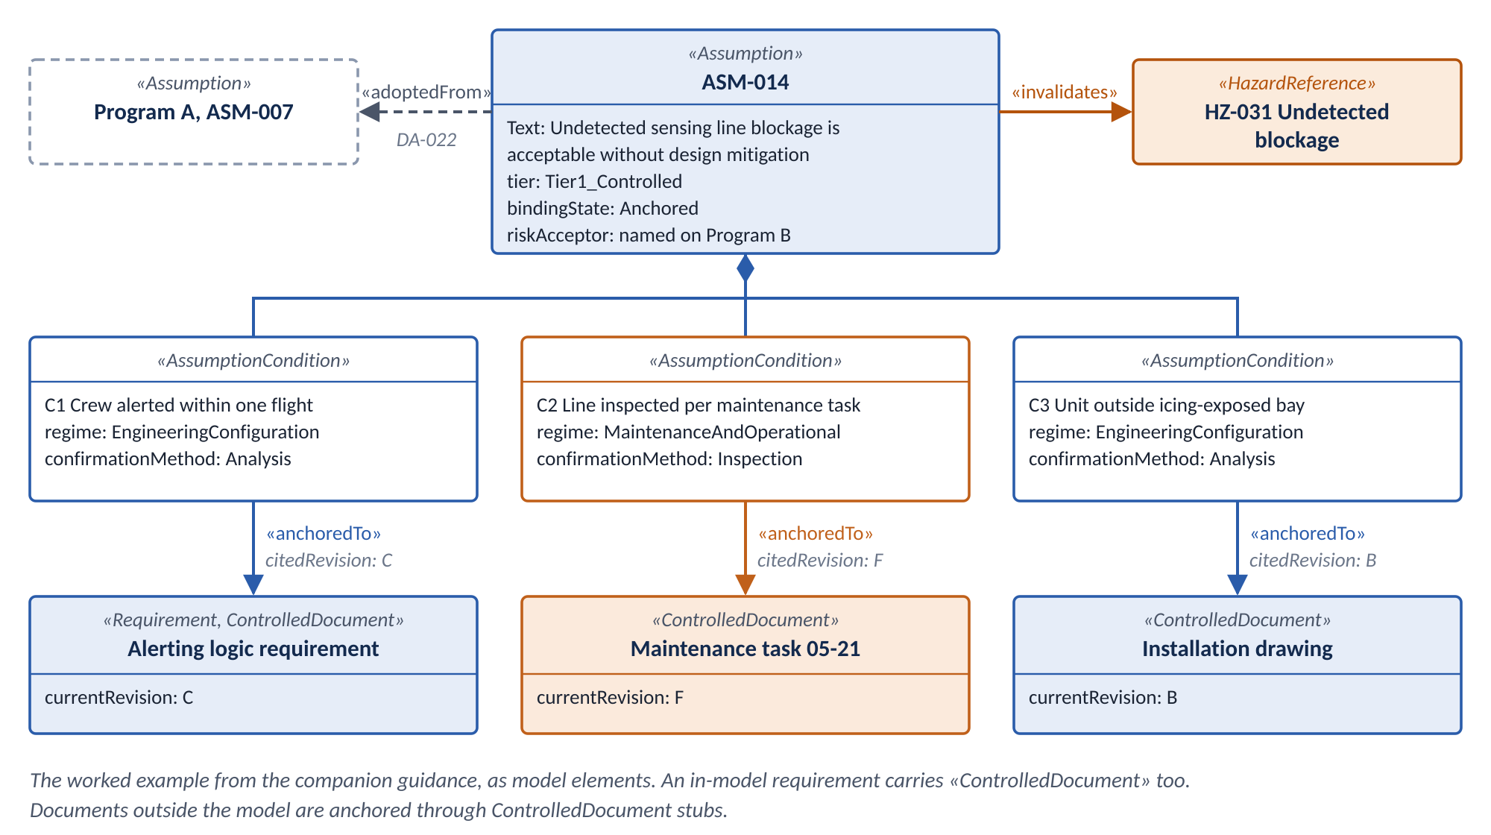
Figure 1. The worked example as model elements. Identifiers are illustrative.
Each box is a model element. Each arrow is a relationship. The rest of this document explains each one, and how to build it.

1.2 What the model adds
A register records assumptions. The model also checks them.
- The model rejects an incomplete record. A validation rule fires when a required field is empty.
- The model flags a moved anchor. A validation rule fires when a cited revision no longer matches the current revision.
- The model shows dependencies in one view. A relation map shows every assumption and hazard that depends on a document.

1.3 What the model does not fix
Most programs have no mature model at proposal. Proposal is when assumptions are written. So every program starts in the register and moves records into the model later. Section 8 explains how.
The model sees only what is in it. Maintenance documents and training curricula usually live outside the model. The profile handles them with stub elements. Someone must keep each stub current.
A warning nobody works is not a control. If a program already ignores validation warnings, this approach adds false assurance. Check that first.

1.4 Terms used in this document
This document uses the practice terms from the companion guidance without change. Those terms are assumption, statement, condition, anchor, risk credit, control regime, risk acceptor, source program, and receiving program.
This document adds modeling terms. Terms defined by a standard keep the standard's wording.
Term | Definition | Source
Profile | A Profile defines limited extensions to a reference metamodel with the purpose of adapting the metamodel to a specific platform or domain. | OMG UML 2.5.1
Stereotype | A Stereotype defines how an existing Metaclass may be extended, and enables the use of platform or domain specific terminology or notation in place of, or in addition to, the ones used for the extended Metaclass. | OMG UML 2.5.1
Requirement | A requirement specifies a capability or condition that must (or should) be satisfied. | OMG SysML 1.6
Validation rule | A constraint that the modeling tool checks against model elements. The tool reports each violation with a severity of error, warning, or info. | This document
Relation map | A tool view that shows the elements related to a chosen root element, following selected relationship types. | This document
Stub element | A model element that stands in for a document held outside the model. It records the document's identifier and current revision, not its content. | This document

Check the standard wording
The UML and SysML definitions in this document are quoted from the OMG specifications. Those specifications are not in the project files. Check each definition against the SysML version your tool runs before you publish this guidance.

2. An assumption is not a requirement
Start with two sentences that look alike.
A requirement: "The system shall alert the crew within one flight." Suppose the design does not do that. Engineers change the design until it does.
An assumption: "This hazard is acceptable, provided the crew is alerted within one flight." Suppose that stops being true. Nobody changes the design to make the assumption true. The hazard analysis reopens.
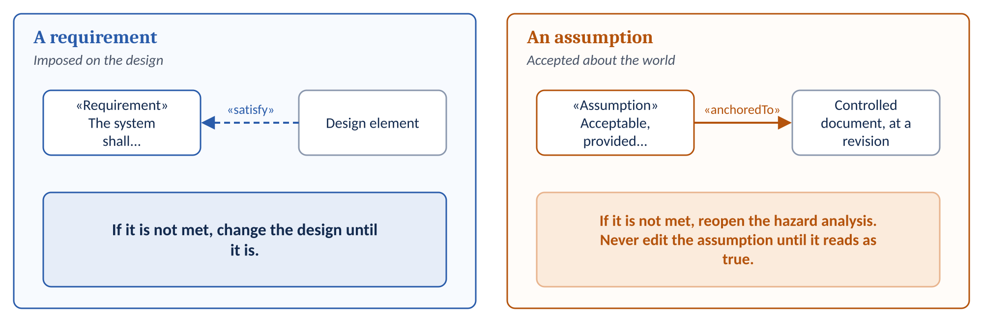
Figure 2. A requirement is satisfied by the design. An assumption is anchored to the world, and fails when the world changes.
The profile builds the «Assumption» stereotype on the SysML Requirement stereotype. It does that for one reason. Requirement tables, matrices, relation maps, reports, and the verify relationship then work for assumptions without custom development.
The specification considered building on the general UML Class metaclass instead. That choice would lose all of that tooling. Draft B builds on Requirement.
That reuse carries a risk. People may treat an assumption as something to satisfy. Then an inconvenient assumption gets narrowed until it is technically met. Nobody notices, because the change looks like an edit.
Four rules keep the two apart.
- Make assumptions look different. Give the «Assumption» stereotype its own icon and color. Give it its own property panels. A reader should never mistake an assumption for a requirement.
- Keep assumptions in their own package. Do not mix assumptions into the requirements tree.
- Never draw a satisfy relationship to an assumption. A satisfy relationship means a design element fulfills a requirement. Nothing fulfills an assumption. The world either matches its conditions or it does not. Rule ASM-13 catches a satisfy relationship to an assumption or a condition.
- Never edit a failed assumption until it reads as true. When a condition fails, set the state to Failed. The hazard reopens. Changing the statement is a new assumption with a new risk decision.

3. The profile at a glance
The profile adds five stereotypes and four relationships. Everything else is standard SysML.
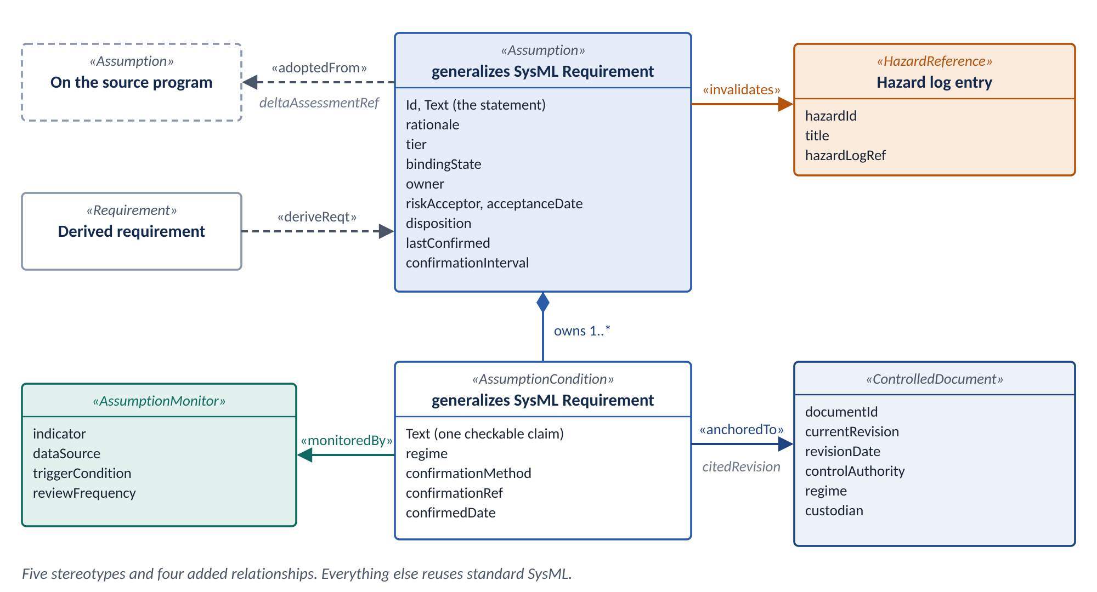
Figure 3. The Assumption Control Profile. Five stereotypes and four added relationships.
Each part of the practice has one home in the model. The table maps them.
In the practice | In the model
Assumption record | An «Assumption» element.
Statement | The Text property, inherited from Requirement.
Rationale | The rationale property.
Condition | An «AssumptionCondition» element, owned by its assumption. It also builds on Requirement, so a test case can verify it.
Anchor | An «anchoredTo» relationship from the condition to an element that carries «ControlledDocument». That element is either a stub for an outside document or an in-model element. The citedRevision property on the relationship records the revision.
Control regime | The regime property, on the condition and on the stub.
Owner and risk acceptor | The owner and riskAcceptor properties. The acceptanceDate property records when the risk was accepted.
Dependent hazard | An «invalidates» relationship from the assumption to the hazard. The target is a «HazardReference» stub, or a modeled hazard if the program has one.
Analyses that use the assumption | A trace relationship from the assumption to each analysis, such as the FHA or the FMEA.
Tier, state, and disposition | The tier, bindingState, and disposition properties.
Provenance | An «adoptedFrom» relationship to the source program's assumption. It carries deltaAssessmentRef and assessmentDate.
Monitor | An «AssumptionMonitor» element, linked by «monitoredBy».
Last confirmed | The lastConfirmed property on the assumption. The confirmedDate and confirmationRef properties on each condition.
Re-confirmation sweep | Validation rule ASM-05, running continuously.

4. Modeling an assumption, step by step
The steps below build Figure 1. Follow them in order for each new assumption.

4.1 Create the assumption
Create one «Assumption» element for each assumption. Put the statement in Text. Put the reasoning in rationale. Keep the two apart.
Property | Example value
Id | ASM-014
Text | Undetected blockage of the sensing line is acceptable without additional design mitigation.
rationale | Crew alerting and scheduled inspection detect a blockage before a second flight. The installation keeps the unit out of icing conditions.
owner | The engineer accountable for the assumption.
tier | Leave unset until the first hazard analysis.
bindingState | Unanchored.
disposition | Open.

Do not set the tier yourself. Safety risk management sets it, using the hazard analysis. The test for Tier 1 is one question. Does a hazard reopen if this assumption fails?

4.2 Write the conditions
Create one «AssumptionCondition» for each condition. Own each condition under its assumption.
Write each condition so a reader can answer yes or no. Set its regime. Set its confirmationMethod.
The «AssumptionCondition» stereotype builds on Requirement too. That lets a test case verify a condition directly.
ID | Text | regime | confirmationMethod
C1 | The crew is alerted to a blocked line within one flight. | EngineeringConfiguration | Analysis
C2 | The line is inspected at the interval set in the maintenance task. | MaintenanceAndOperational | Inspection
C3 | The unit is installed outside the icing-exposed bay. | EngineeringConfiguration | Analysis

Tier 1 assumptions need separate condition elements. Each condition can then anchor, confirm, and fail on its own. A Tier 2 assumption may nest its conditions as plain requirements under the assumption instead. That is cheaper. It loses the per-condition state.

4.3 Create stubs for documents outside the model
Condition C2 depends on maintenance task 05-21. That task lives in the maintenance program, not in the model. So the model needs a stand-in for it.
Create one «ControlledDocument» stub for that task. Record its identifier and current revision. Do not copy its content.
Property | Example value
documentId | Maintenance task 05-21
currentRevision | F
revisionDate | The date revision F was approved.
controlAuthority | The authority that approves changes to the task.
regime | MaintenanceAndOperational
custodian | The named person who keeps currentRevision accurate.

Create one stub per document. Reuse it for every condition that depends on that document.
Do not create a stub for something already in the model. Condition C1 depends on the alerting logic requirement. That requirement is a model element. Anchor C1 to it directly.
Apply «ControlledDocument» to that requirement as well. Set its currentRevision to the requirement's released revision. Rule ASM-14 fires on any anchor target without «ControlledDocument». Without it, rule ASM-05 has nothing to compare.

4.4 Anchor each condition
Draw an «anchoredTo» relationship from each condition to the document it depends on. Set citedRevision to the revision you checked. Set confirmedDate on the condition.
When every condition is anchored, set bindingState to Anchored.
Sometimes nothing controls a condition. Set its regime to None. Rule ASM-11 then reports it. Treat that report as a finding. It is not missing data.

4.5 Link the hazard and the analyses
Draw an «invalidates» relationship from the assumption to the hazard it helps close. In Figure 1, ASM-014 invalidates HZ-031.
The direction is deliberate. The assumption acts on the hazard. If the assumption fails, the hazard reopens.
Many hazard logs live outside the model. In that case, create a «HazardReference» stub. Record the hazard identifier, its title, and where the hazard log entry lives. If the program models hazards with its own safety profile, link to the modeled hazard instead.
Next, link the analyses that use the assumption. Draw a trace relationship from the assumption to each one, such as the functional hazard assessment or the FMEA. Refine works as standard SysML.

4.6 Name the risk acceptor
Set riskAcceptor to the named person on this program who accepts the residual risk. Set acceptanceDate.
Acceptance on the source program does not count. Rule ASM-02 fires on any Tier 1 assumption without a risk acceptor.

4.7 Record inheritance with «adoptedFrom», never with Copy
ASM-014 came from Program A. Draw an «adoptedFrom» relationship to Program A's assumption. Set deltaAssessmentRef to the written comparison of the two programs. Set assessmentDate.
Rule ASM-08 fires if deltaAssessmentRef is empty. No assumption enters a program without a comparison.
SysML offers another relationship that looks right. It is wrong here.
Term | Definition | Source
Copy | A Copy relationship is a dependency between a supplier requirement and a client requirement that specifies that the text of the client requirement is a read-only copy of the text of the supplier requirement. | OMG SysML 1.6

Copy moves the text and nothing else. That is the exact failure this practice exists to prevent. Rule ASM-09 fires on any Copy relationship that touches an «Assumption».

4.8 Convert to a requirement wherever possible
Condition C2 depends on an inspection interval. The interval can be levied on the maintenance program as a requirement. When a condition can be levied, levy it.
Term | Definition | Source
DeriveReqt | A DeriveReqt relationship is a dependency between two requirements in which a client requirement can be derived from the supplier requirement. | OMG SysML 1.6

Create the new requirement. Draw a deriveReqt relationship from it to the assumption. Set the assumption's disposition to ConvertedToRequirement. Set its bindingState to Superseded.
Rule ASM-15 fires if a converted assumption has no deriveReqt or is not Superseded.
Each conversion shrinks the set of assumptions that need ongoing control. That is the main way to keep the practice affordable. Convert before you confirm. Do not spend effort confirming a condition you are about to levy as a requirement.

4.9 Verify, confirm, or monitor each condition
Some conditions can be closed by test, analysis, inspection, or demonstration. Use the standard verify relationship for those.
Term | Definition | Source
Verify | A Verify relationship is a dependency between a requirement and a test case or other model element that can determine whether a system fulfills the requirement. | OMG SysML 1.6

Some conditions are confirmed by an authority's approval. An approved maintenance program revision is one example. Set confirmationMethod to AuthorityApproval.
Every confirmed condition needs evidence. Record the test report, analysis, inspection record, or approval document in confirmationRef. Rule ASM-16 fires on a confirmed condition with no evidence recorded.
Other conditions can only be watched. Inspector detection rates are one example. Procedural compliance is another. No test case closes them.
For those conditions, create an «AssumptionMonitor». Record the indicator, the data source, the trigger condition, and the review frequency. Link the condition to it with «monitoredBy». Set bindingState to Monitored.
Monitored is an end state. It is not a waypoint to Verified. Rule ASM-06 fires if a condition closed by monitoring is recorded as Verified.
When every condition is confirmed by test, analysis, inspection, demonstration, or authority approval, set bindingState to Verified. If any condition is monitored, set it to Monitored.

5. How the model detects change
Maintenance task 05-21 moves from revision F to revision G. Here is what happens next.
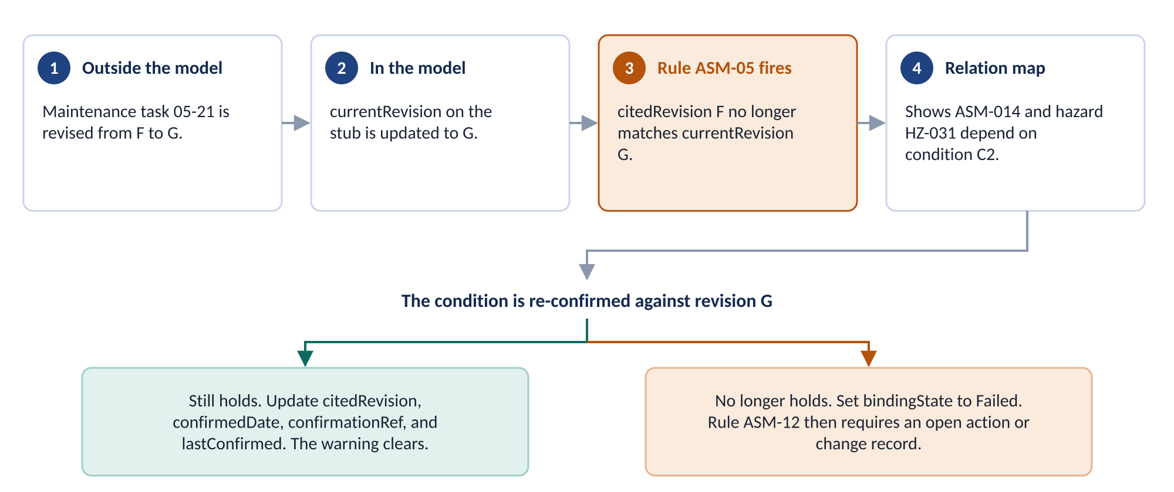
Figure 4. Detection in the model. A revision mismatch fires a warning on every condition anchored to the document.
The custodian updates currentRevision on the stub to G. Rule ASM-05 compares it with citedRevision on every «anchoredTo» relationship that points at the stub. Condition C2 cites F. The rule fires a warning on C2.
A relation map rooted on the stub shows what is exposed. Here it shows ASM-014 and hazard HZ-031.
The assumption owner checks C2 against revision G. One of two outcomes follows.
- The condition still holds. Update citedRevision, confirmedDate, confirmationRef, and lastConfirmed. The warning clears.
- The condition no longer holds. Set bindingState to Failed. The dependent hazard reopens. Rule ASM-12 fires until an open action or change record exists.

This is the re-confirmation sweep from the companion guidance. In the register, the sweep runs on a schedule. In the model, it runs whenever validation runs.
Two conditions for this to work
Someone must update currentRevision on each stub when the document changes. If the stub is stale, the rule stays silent. This is the single point of failure in the design. Name a custodian for every stub.
Someone must work each warning. A program that already ignores validation warnings will ignore these too. Run a full validation before every design review. Report open warnings at the review.

6. Validation rules
The profile specification defines sixteen rules. Each rule catches one specific gap. The table explains what each rule catches and what to do when it fires.
ID | Severity | Fires when | What to do
ASM-01 | error | An «Assumption» has an empty rationale. | Write the rationale now. Nobody can reconstruct it later.
ASM-02 | error | A Tier 1 assumption has no riskAcceptor. | Name the person on this program who accepts the residual risk.
ASM-03 | error | A Tier 1 assumption has no «AssumptionCondition». | Write the conditions. An assumption without conditions cannot be checked.
ASM-04 | error | A condition has no «anchoredTo» and its regime is not None. | Anchor the condition, or set its regime to None if nothing controls it.
ASM-05 | warning | citedRevision on an «anchoredTo» differs from currentRevision on its target. | Re-confirm the condition against the new revision. See Section 5.
ASM-06 | error | bindingState is Verified and confirmationMethod is Monitoring. | Set bindingState to Monitored. Monitoring does not verify.
ASM-07 | warning | lastConfirmed is older than confirmationInterval. | Re-confirm the assumption. It is overdue.
ASM-08 | error | An «adoptedFrom» has an empty deltaAssessmentRef. | Complete the written comparison with the source program.
ASM-09 | error | A Copy relationship has an «Assumption» at either end. | Delete the Copy. Use «adoptedFrom» with a delta assessment.
ASM-10 | warning | A Tier 1 assumption has no «invalidates» link to any hazard. | Link the hazard. Tier 1 is defined by hazard dependency.
ASM-11 | info | A condition's regime is None. | Treat it as a finding. Nothing controls this condition.
ASM-12 | error | bindingState is Failed and no open action or change record exists. | Open the action. A failure must go somewhere.
ASM-13 | error | A satisfy relationship targets an «Assumption» or an «AssumptionCondition». | Delete it. Assumptions are anchored, not satisfied. See Section 2.
ASM-14 | error | The target of an «anchoredTo» does not carry «ControlledDocument». | Apply «ControlledDocument» to the target. Set its currentRevision.
ASM-15 | error | The disposition is ConvertedToRequirement, and either no deriveReqt targets the assumption or bindingState is not Superseded. | Draw the deriveReqt from the new requirement. Set bindingState to Superseded.
ASM-16 | warning | A condition has a confirmedDate and an empty confirmationRef. | Record the evidence. No confirmation without evidence.

ASM-05 carries the most weight. It replaces the scheduled sweep with continuous detection. It works only while stub revisions stay current.

7. Views
Two questions come up again and again. A document just changed. What depends on it? A hazard is under review. What does its closure rest on? Two relation maps answer them.
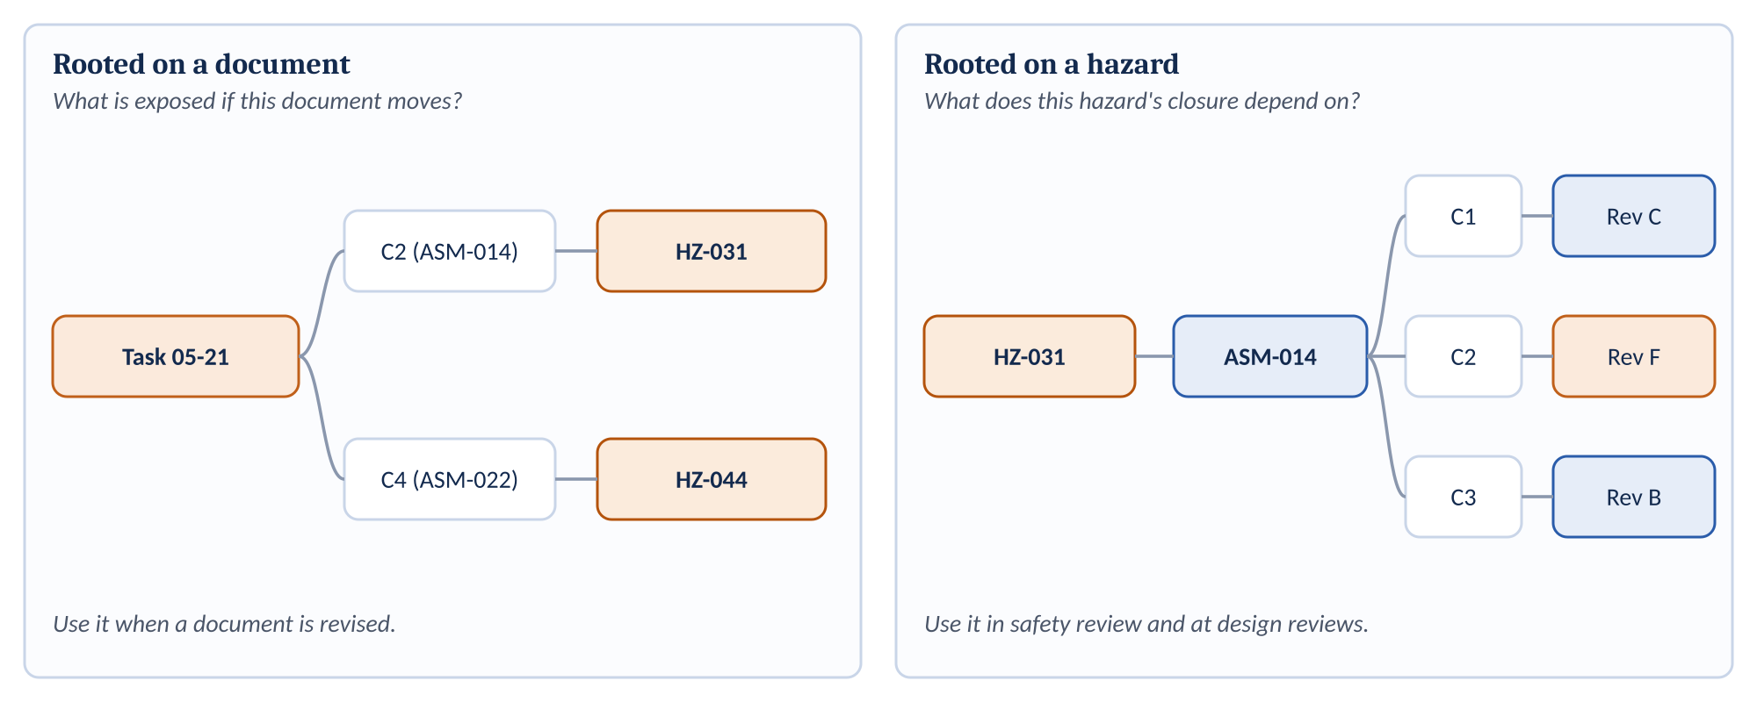
Figure 5. Two relation maps. One starts at a document. The other starts at a hazard.
The profile specification defines seven views in all. Each one answers a single question.
View | Question it answers | When to use it
Relation map rooted on a document | What assumptions and hazards depend on this document? | When a document is revised.
Relation map rooted on a hazard | What assumptions does this hazard's closure depend on? | In safety review and at design reviews.
Assumption table | What is the status of every assumption? | Routine work and reporting. Columns: Id, Text, tier, bindingState, owner, riskAcceptor, regime coverage, lastConfirmed, disposition.
Legend by bindingState | Which assumptions are Unanchored or Failed? | On any diagram. Color makes those states visible at a glance.
Smart package of unanchored Tier 1 assumptions | How many Tier 1 assumptions are still unanchored? | For the design review metric.
Report template | What does the register look like as a document? | For readers and suppliers who do not use the model.
Export filter | Are assumptions leaking into requirement exports? | Before the first supplier or customer export.

Set the export filter before the first export
The «Assumption» stereotype builds on Requirement. Without a filter, assumptions go out with supplier and customer requirement exports. Suppliers then read them as requirements. Set the filter before the first export, not after.

8. Across the lifecycle
Assumptions are written at proposal. Most programs have no model then. So the register comes first. The model takes over when it can hold the records.
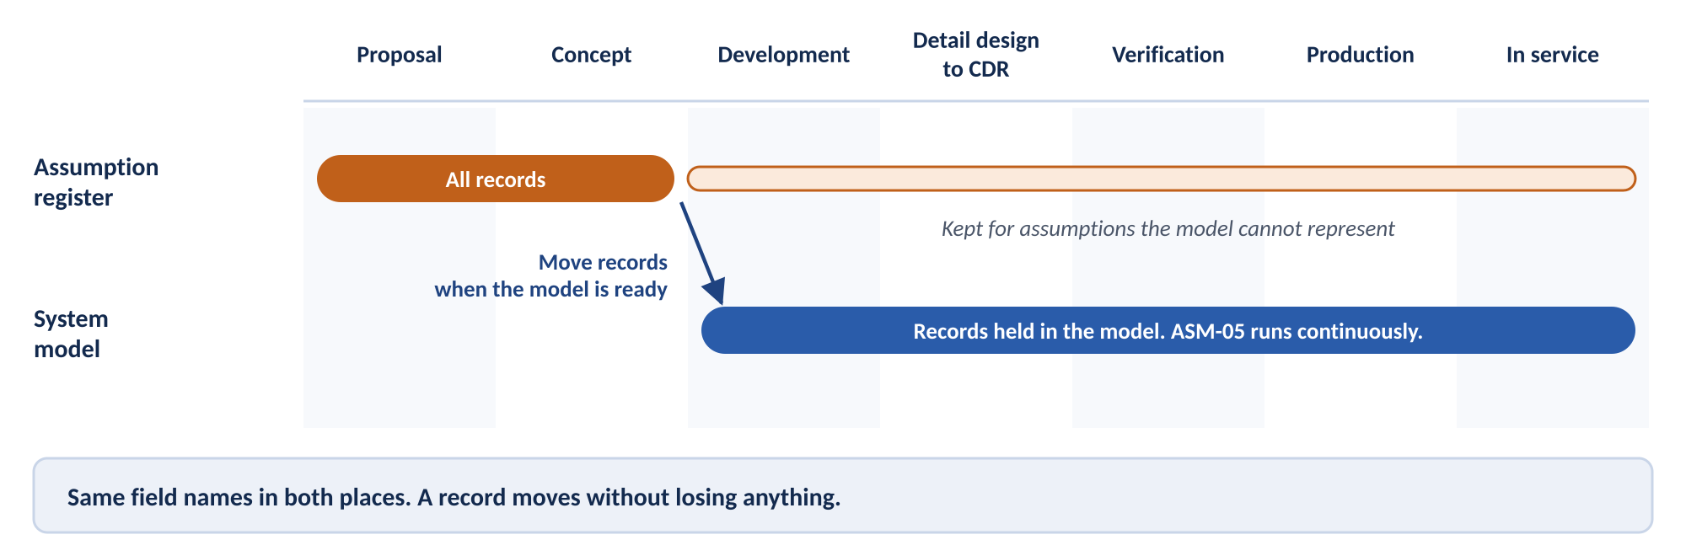
Figure 6. Register first, model later. The register stays in use for assumptions the model cannot represent.
The table shows what happens in the register and in the model at each state. The companion guidance, Section 8, assigns an owner to each action. This document does not repeat those assignments.
Lifecycle state | In the register | In the model
Proposal and pre-award | Create a record for each assumption. Write the statement, rationale, and conditions. Record provenance for inherited assumptions. | Usually nothing yet. If a model exists, create «Assumption» elements directly.
Concept and early design | Set tiers from the first hazard analysis. Name risk acceptors. | Load the profile. Create the assumption package. Create stubs for documents already known.
Development and subsystem design | Move records into the model. Mark each moved row in the register. | Create conditions and anchors. Apply «ControlledDocument» to each anchor target. Link hazards. Convert conditions to requirements where possible. Turn on active validation. Begin reporting ASM-05 warnings and unanchored Tier 1 assumptions.
Detail design through CDR | Keep records the model cannot represent. | Anchor to specific revisions. Complete every «adoptedFrom» delta assessment. Clear ASM-02, ASM-03, and ASM-08 errors before CDR.
Verification and certification | Keep records the model cannot represent. | Draw verify relationships for tested conditions. Record approvals for conditions confirmed by an authority. Record evidence in confirmationRef. Create monitors for watched conditions. Set bindingState to Verified or Monitored.
Production | Keep records the model cannot represent. | Keep stub revisions current. Work each ASM-05 warning. Reopen assumptions when a recurring variance becomes permanent.
In service | Keep records the model cannot represent. | Track monitors against triggers. Work ASM-07 overdue warnings. Export assumptions with conditions, anchors, and evidence attached.

8.1 Moving records from the register into the model
The register and the model use the same field names. That makes the move mechanical.
Register field | Model element or property
Identifier | Id
Statement | Text
Rationale | rationale
Conditions | One «AssumptionCondition» per condition
Anchor for each condition | «anchoredTo» with citedRevision
Control regime for each condition | regime
Owner | owner
Risk acceptor | riskAcceptor and acceptanceDate
Dependent hazard | «invalidates» to a «HazardReference» or a modeled hazard
Tier, state, and disposition | tier, bindingState, and disposition
Provenance | «adoptedFrom» with deltaAssessmentRef and assessmentDate
Last confirmed | lastConfirmed

Follow five steps.
- Import the properties. Use the tool's spreadsheet import to create «Assumption» elements with their properties. Confirm the import function on your installed version.
- Create the conditions. Create «AssumptionCondition» elements under each assumption.
- Draw the relationships. Draw «anchoredTo», «invalidates», and «adoptedFrom» relationships. Apply «ControlledDocument» to each anchor target. Import does not usually create relationships.
- Run validation. Run the full rule set. Clear every error before you retire the register rows.
- Mark the register. Mark each moved row as held in the model. Do not delete it. The register remains the record for anything the model cannot hold.

8.2 Releasing assumptions to another program
Every program becomes a source program. Release each assumption with its conditions, its anchors, and its confirmation evidence. Never release the statement alone.
The receiving program adopts with «adoptedFrom» and a delta assessment. It never uses Copy.

9. Common mistakes
Watch for eight mistakes. Each one is easy to prevent.
Mistake | Why it matters | How to prevent it
Treating an assumption as a requirement to satisfy. | An inconvenient assumption gets narrowed until it technically holds. | Distinct stereotype appearance. Separate package. No satisfy relationships to assumptions.
Using Copy to bring an assumption across. | The text moves. The conditions and the risk decision do not. | Use «adoptedFrom». Rule ASM-09 catches Copy.
Restating a value instead of citing a revision. | Nothing can detect when the value changes. | Anchor to a document with citedRevision. Never type the value into Text.
Letting stub revisions go stale. | ASM-05 stays silent. The model reports false assurance. | Name a custodian for every stub. Review stub currency before each design review.
Recording a monitored condition as verified. | The record claims evidence that does not exist. | Use «monitoredBy» and the Monitored state. Rule ASM-06 catches the error.
Mass-clearing warnings. | The control exists on paper only. | Report open warnings at design reviews. Track the count.
Exporting assumptions as requirements. | Suppliers treat assumptions as obligations. | Set the export filter before the first export.
Putting Tier 3 notes in the model. | The model fills with noise. Real warnings get lost. | Model Tier 1 and Tier 2 only.

10. Before you build

10.1 Questions for the MBSE lead
The profile specification lists seven open questions. Answer them before any build work.
# | Question | Why it matters
1 | Is a SysML v2 migration planned for this toolchain? | SysML v2 replaces profiles and stereotypes with metadata definitions. A rich profile built now may need rework.
2 | Do programs work validation warnings, or mass-clear them? | If warnings are ignored, ASM-05 adds false assurance. That is worse than an honest manual sweep.
3 | Does the model include the operator, the maintenance organization, and the training organization? | If not, assumptions about people have nothing to anchor to inside the model.
4 | Who maintains currentRevision on each stub? | Name a person, not a function. Every rule that detects change depends on it.
5 | Will the profile be site-wide, program-level, or project-local? | This decides whether it can change later without a change board.
6 | Are requirements mastered outside Cameo and synchronized in? | Synchronization may strip or alter «Assumption» elements.
7 | Will evidence that confirms an assumption become certification evidence? | The word "verify" invites the question. The cost difference is large. Decide on purpose.

10.2 Design decisions in Draft B of the specification
Writing this guidance exposed eight gaps in Draft A of the specification. Draft B settles each one. This guidance follows those decisions.
# | Decision | Where this guidance applies it
1 | Each «AssumptionCondition» is owned by its «Assumption». | Section 4.2.
2 | citedRevision on «anchoredTo» is the only revision record. confirmedRevision is removed. | Sections 4.4 and 5.
3 | «invalidates» is the only hazard record. The dependentHazard property is removed. | Section 4.5.
4 | A satisfy relationship to an «Assumption» or «AssumptionCondition» is prohibited. Rule ASM-13. | Section 2.
5 | Every «anchoredTo» target carries «ControlledDocument», including in-model elements. Rule ASM-14. | Section 4.3.
6 | A new «HazardReference» stereotype stands in for hazard log entries outside the model. | Section 4.5.
7 | ConvertedToRequirement requires a deriveReqt and bindingState Superseded. Rule ASM-15. | Section 4.8.
8 | «AssumptionCondition» builds on SysML Requirement, so verify can target it. | Sections 4.2 and 4.9.

Draft B also adds confirmationRef and rule ASM-16, so every confirmation records its evidence. It assigns trace a use: linking an assumption to the analyses that use it.

11. Limits
Limit | What it means
Programs with no model | The register is the only implementation. This guidance does not apply.
Proposal stage | Most programs have no model at proposal. Assumption capture matters most then. The register covers it.
Model boundary | The model sees only what is in it. Stubs bring external documents in by reference. Someone must keep them current.
Supplier assumptions | The model can record that a supplier holds an assumption. It cannot see inside the supplier's analysis.
Incentives | The cost of this work lands on the bid. The benefit lands on execution. A profile cannot change that. Governance must.
Tool capability | Every tool capability in this document needs confirmation against the installed version.

Appendix A. Glossary
Terms defined by a standard keep the standard's wording. Terms defined for this practice are marked "This document" or "Profile specification." Practice terms are defined in the companion guidance.
Term | Definition | Source
«adoptedFrom» | A relationship from an assumption to the source program's assumption it was adopted from. It carries deltaAssessmentRef and assessmentDate. | Profile specification
«anchoredTo» | A relationship from a condition to the element that makes it true. The target carries «ControlledDocument». The relationship carries citedRevision. | Profile specification
«Assumption» | A stereotype that generalizes the SysML Requirement stereotype and represents one ground rule or assumption. | Profile specification
«AssumptionCondition» | A stereotype that generalizes the SysML Requirement stereotype and represents one individually checkable condition of an assumption. | Profile specification
«AssumptionMonitor» | A stereotype that represents the indicator, data source, trigger, and review frequency for a condition that can only be monitored. | Profile specification
«ControlledDocument» | A stereotype that records a controlled document's identifier and current revision. It is applied to a stub for an outside document, or to an in-model element used as an anchor. | Profile specification
«HazardReference» | A stub element that stands in for a hazard log entry held outside the model. | Profile specification
Copy | A Copy relationship is a dependency between a supplier requirement and a client requirement that specifies that the text of the client requirement is a read-only copy of the text of the supplier requirement. | OMG SysML 1.6
DeriveReqt | A DeriveReqt relationship is a dependency between two requirements in which a client requirement can be derived from the supplier requirement. | OMG SysML 1.6
«invalidates» | A relationship from an assumption to the hazard that reopens if the assumption fails. | Profile specification
«monitoredBy» | A relationship from a condition to the «AssumptionMonitor» that watches it. | Profile specification
Profile | A Profile defines limited extensions to a reference metamodel with the purpose of adapting the metamodel to a specific platform or domain. | OMG UML 2.5.1
Relation map | A tool view that shows the elements related to a chosen root element, following selected relationship types. | This document
Requirement | A requirement specifies a capability or condition that must (or should) be satisfied. | OMG SysML 1.6
Satisfy | A Satisfy relationship is a dependency between a requirement and a model element that fulfills the requirement. | OMG SysML 1.6
Smart package | A package whose contents are gathered by a query rather than placed by hand. | This document
Stereotype | A Stereotype defines how an existing Metaclass may be extended, and enables the use of platform or domain specific terminology or notation in place of, or in addition to, the ones used for the extended Metaclass. | OMG UML 2.5.1
Stub element | A model element that stands in for a document held outside the model. It records the document's identifier and current revision, not its content. | This document
Validation rule | A constraint that the modeling tool checks against model elements. The tool reports each violation with a severity of error, warning, or info. | This document
Verify | A Verify relationship is a dependency between a requirement and a test case or other model element that can determine whether a system fulfills the requirement. | OMG SysML 1.6

Appendix B. Profile quick reference
This appendix restates the profile specification for convenience. If the two disagree, the specification governs.

B.1 Stereotype properties
Stereotype | Properties
«Assumption» | Id and Text (inherited). rationale, tier, bindingState, owner, riskAcceptor, acceptanceDate, disposition, lastConfirmed, confirmationInterval.
«AssumptionCondition» | Id and Text (inherited). regime, confirmationMethod, confirmationRef, confirmedDate.
«ControlledDocument» | documentId, currentRevision, revisionDate, controlAuthority, regime, custodian.
«AssumptionMonitor» | indicator, dataSource, triggerCondition, reviewFrequency.
«HazardReference» | hazardId, title, hazardLogRef.

B.2 Enumerations
Enumeration | Literals
AssumptionTier | Tier1_Controlled, Tier2_Registered, Tier3_Note
BindingState | Unanchored, Anchored, Verified, Monitored, Failed, Superseded
ControlRegime | EngineeringConfiguration, MaintenanceAndOperational, TrainingAndCompetence, Contractual, None
ConfirmationMethod | Test, Analysis, Inspection, Demonstration, Monitoring, AuthorityApproval
DispositionType | Open, ConvertedToRequirement, Retired, TransferredToOperator, Accepted

B.3 Relationships
Relationship | From | To | Carries
«anchoredTo» | «AssumptionCondition» | An element carrying «ControlledDocument» | citedRevision
«adoptedFrom» | «Assumption» | «Assumption» on the source program | deltaAssessmentRef, assessmentDate
«monitoredBy» | «AssumptionCondition» | «AssumptionMonitor» | None
«invalidates» | «Assumption» | «HazardReference» or a modeled hazard | None
deriveReqt (SysML) | Derived requirement | «Assumption» | None
verify (SysML) | Test case | «AssumptionCondition» | Test, Analysis, Inspection, or Demonstration only
trace (SysML) | «Assumption» | An analysis that uses the assumption | None
Copy (SysML) | Prohibited with an «Assumption» |  | Caught by ASM-09
satisfy (SysML) | Prohibited to an «Assumption» or «AssumptionCondition» |  | Caught by ASM-13

Appendix C. References
- Controlling Inherited Ground Rules and Assumptions. Draft guidance. The practice this document implements.
- Assumption Control Profile for Cameo / MSOSA, Draft B. The model elements this document uses.
- OMG Systems Modeling Language (SysML), version 1.6. Source of the requirement and requirement relationship definitions.
- OMG Unified Modeling Language (UML), version 2.5.1. Source of the profile and stereotype definitions.
- SM-0001 Issue C. Safety risk management, hazard logs, and risk acceptance.
- EIA-649-1A. Configuration management definitions used in the companion guidance.

