A Mandatory Floor for Engineering Requirements
Method summary: how to find the requirements the SMS obligates, in any engineering discipline
Prepared [DATE]. Worked examples: configuration management, and reliability, maintainability, system health and human factors.

1. Purpose
This paper describes a method. The method finds the engineering requirements that the organization must perform on safety-significant products, whether or not a contract invokes them. We call that set the mandatory floor.
The method was built and tested on two disciplines. The first was configuration management (CM). The second was reliability, maintainability, system health and human factors (R&M). It applies to any discipline that works to industry standards.

2. The idea in brief
Engineering standards reach a program by two pathways. The contract pathway invokes a standard, and the customer may tailor it. The SMS pathway binds the organization through its own safety management system, which is based on SM-0001.
SM-0001 names hazards the organization must control. Some clauses in engineering standards are the controls for those hazards. A clause that controls a named hazard binds through the SMS, even when the contract is silent. Tailoring a contract removes a contract obligation. It does not remove an SMS obligation.
Skipping a floor requirement is therefore a risk-acceptance decision. Floor requirements guard against Severity 1 (catastrophic) and Severity 2 (severe) outcomes. SM-0001 6.2.2 requires risk acceptance by management personnel empowered to accept it. For Severity 1 to 2, that is the Accountable Executive or a delegate.
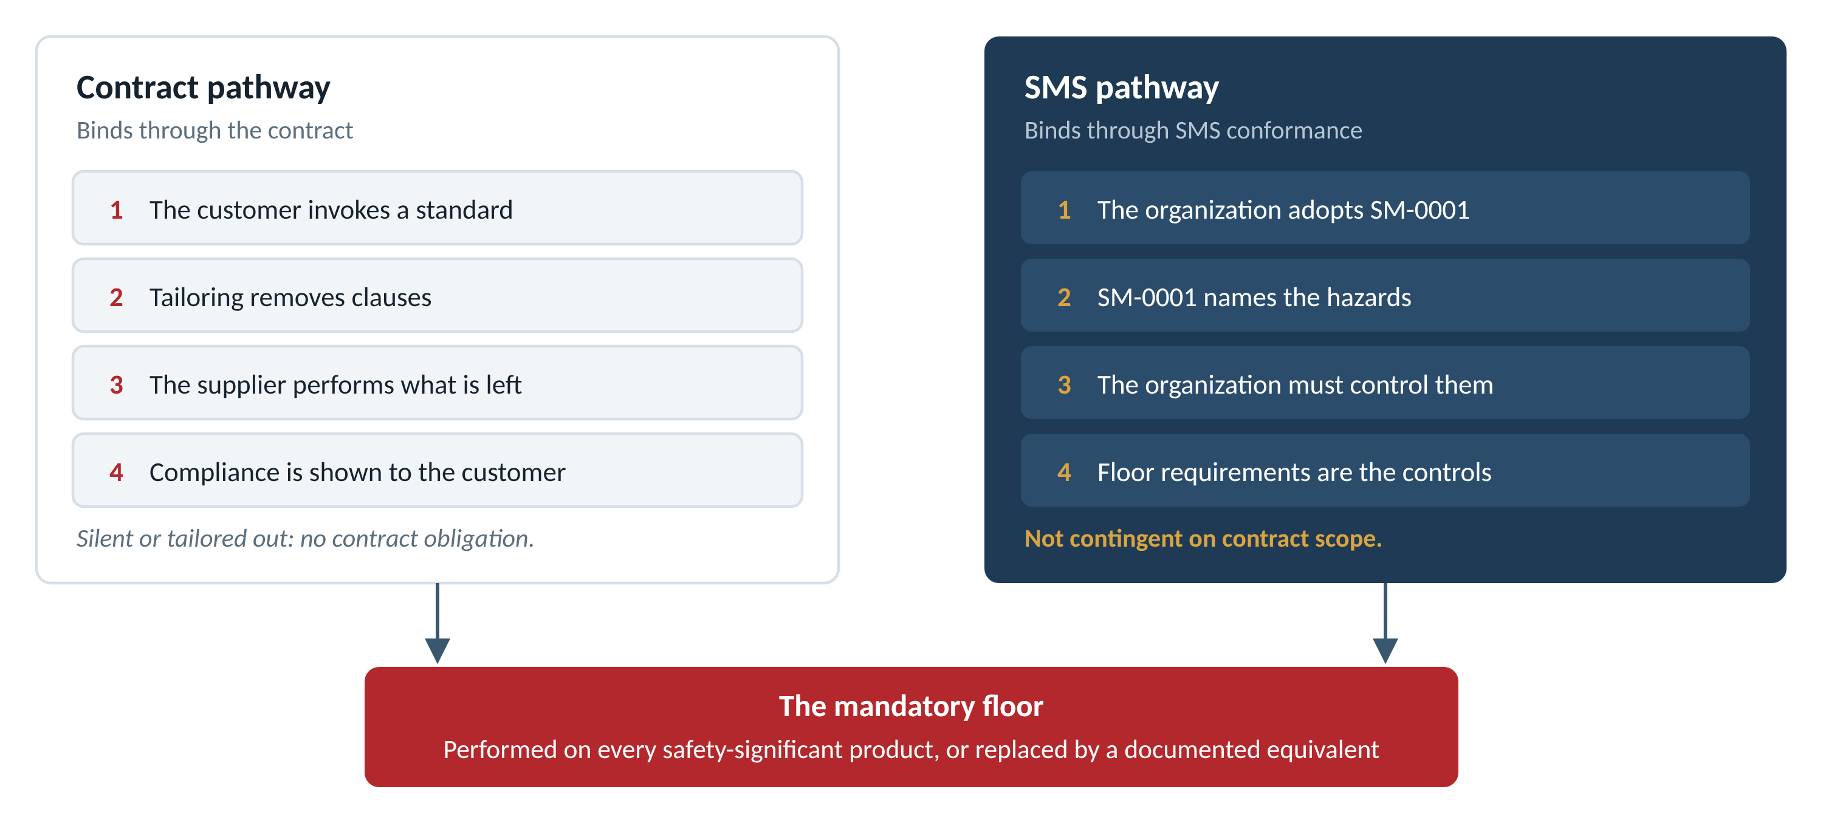
Figure 1. Two pathways, one floor

3. Terms
Term | Definition
Barrier | A risk control in SM-0001 terms: “a means to reduce or eliminate the effects of hazards.” In this method, a barrier is a requirement-based control that passes all three gates of the barrier test (Step 4).
Floor requirement | A clause-level requirement, taken from an anchor standard, that implements a barrier. It is performed on every safety-significant product, or replaced by a documented equivalent.
Anchor standard | An industry standard whose normative shall statements can support a floor requirement (Step 2).
Documented equivalent | An alternative control, recorded as an SMS record, that names the hazard it controls, the control itself, and the evidence that it works.
Severity | The organization's severity scale. Severity 1 is catastrophic. Severity 2 is severe. The whole effort uses this one scale.
Ownership tier | Discipline primary, shared, handoff or governance (Step 5).

4. The method
The method has seven steps. Each step produces a record that the next step builds on.
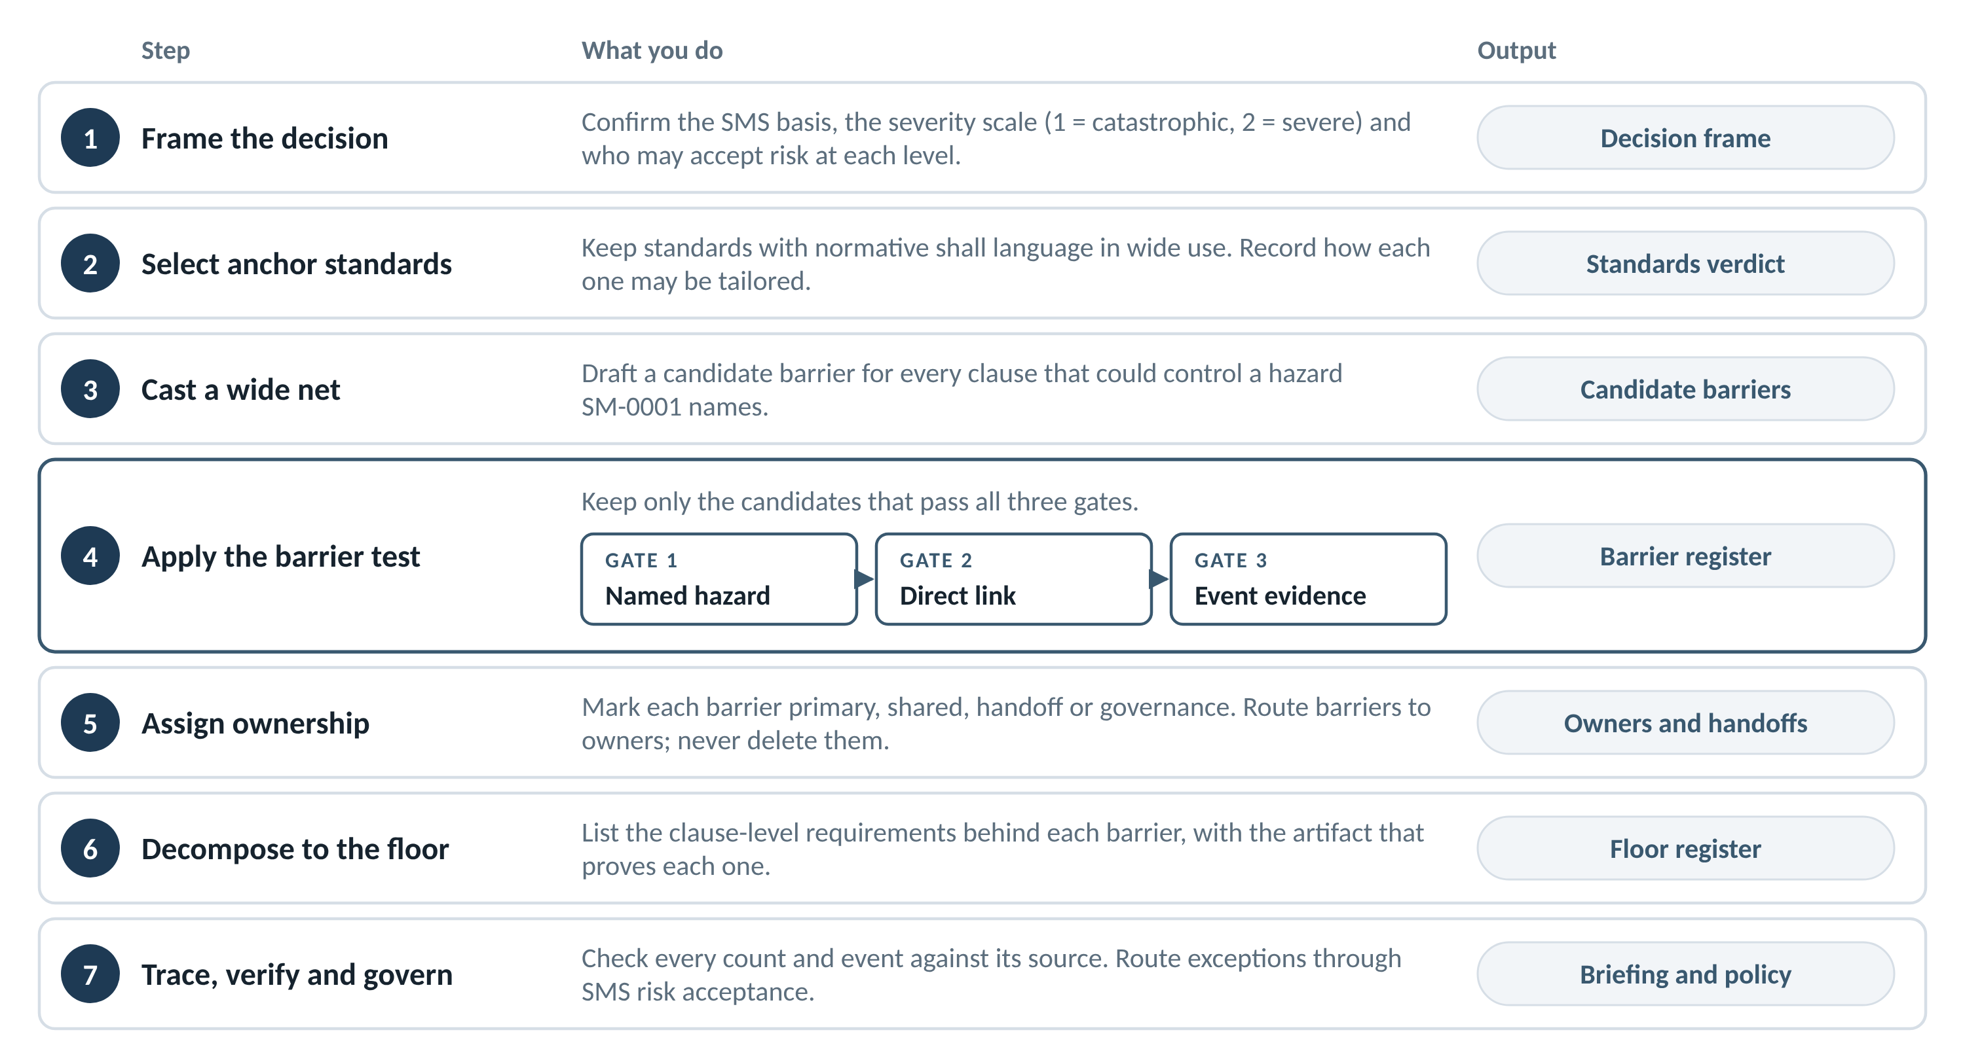
Figure 2. The method in seven steps

Step 1. Frame the decision
Confirm three things before any analysis. The SMS basis is SM-0001. The severity scale runs from Severity 1 (catastrophic) to Severity 5. The authority model names who may accept risk at each level: the Accountable Executive for Severity 1 to 2, an executive for Severity 3, and a first-line manager for Severity 4 to 5.
Output: a one-page decision frame.

Step 2. Select anchor standards
List every standard the discipline might use. Keep a standard as an anchor only if it meets four tests:
- Normative shall language. The shall statements sit in the body of the standard. A shall inside a worked example or an appendix does not count.
- Wide use. Aerospace and defense programs have applied the standard over time.
- Current status. The standard is active, reaffirmed, or replaced by a named successor.
- A known tailoring rule. Record how the standard may be tailored. Some allow only additions to a mandatory minimum. Some apply every shall unless an agreement excludes it.
Handbooks, guides, data item descriptions and case studies are not anchors. Rate each standard usable, marginal or not usable, and record why.
Output: a standards verdict table.

Step 3. Cast a wide net
Read each anchor standard for clauses that could control a hazard SM-0001 names (6.2.1, 6.2.3, 6.3 or 7). Draft a candidate barrier for each. Do not filter by discipline yet. Step 5 does that.
Output: a candidate barrier list, each candidate with its clause anchors.

Step 4. Apply the barrier test
A candidate becomes a floor barrier only if it passes all three gates:
- Gate 1, named hazard. SM-0001 names the hazard the requirement controls.
- Gate 2, direct link. Failure of the requirement directly enables that hazard, with no other healthy barrier in the path.
- Gate 3, event evidence. Documented events show a Severity 1 or 2 consequence when the barrier failed.
Investigated accidents carry the most weight. A documented industry pattern can anchor a barrier, but the register flags it as a pattern. A candidate that fails any gate stays a contract or good-practice requirement and is tailored through the contract.
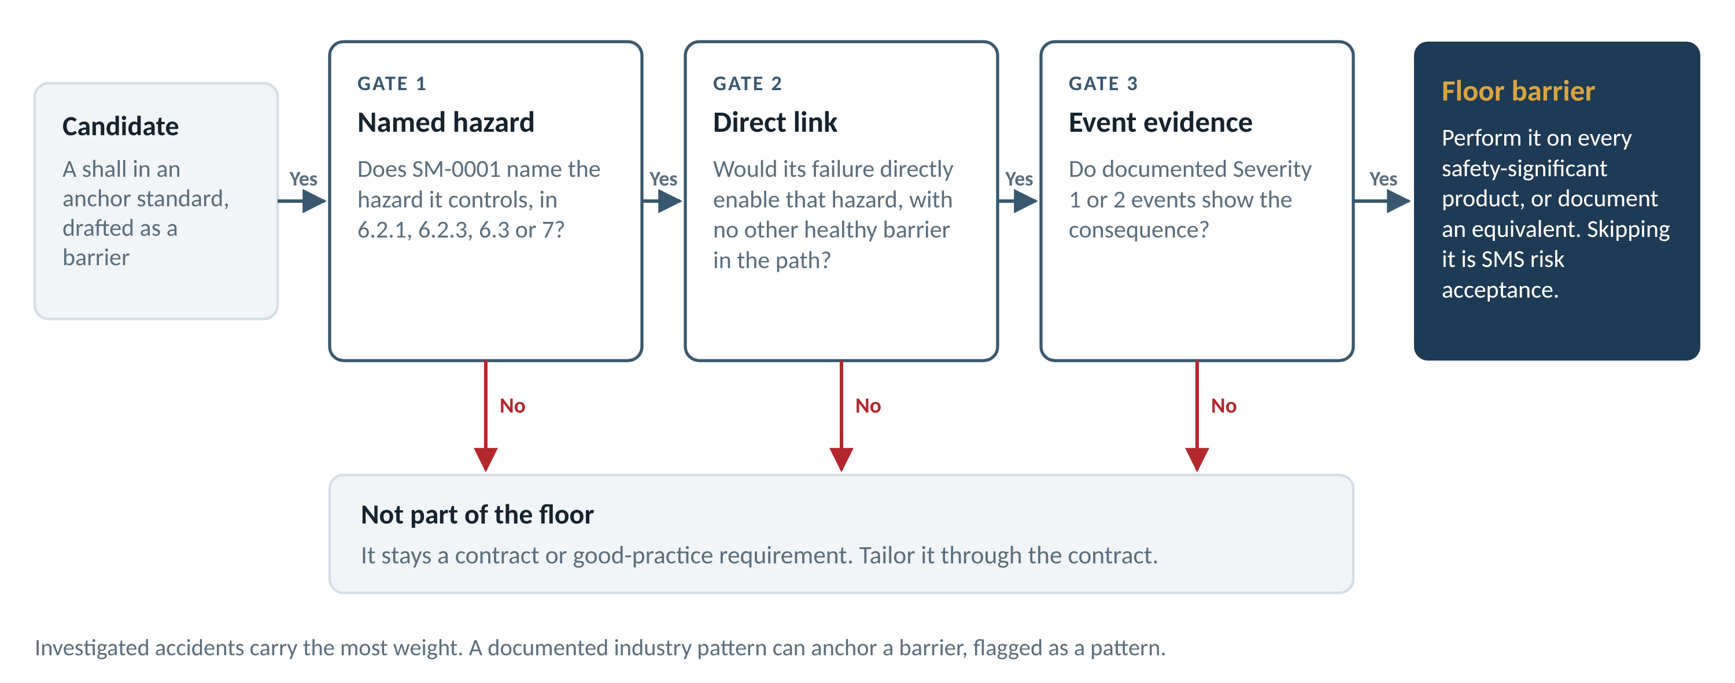
Figure 3. The barrier test
Output: the barrier register.

Step 5. Assign ownership
Most barriers touch more than one discipline. Assign each barrier to one of four tiers:
- Discipline primary. The discipline performs the barrier and accepts its own risk.
- Shared. Another discipline owns the barrier. This discipline supplies a defined input, such as an FMECA or field data.
- Handoff. Another discipline owns and performs the barrier. It is still a barrier, and it needs a named owner.
- Governance. The barrier binds every discipline: risk acceptance, documented tailoring, escalation and continuity. Write it once, at the SMS level.
Route barriers; never delete them. A handoff to an owner that does not perform it leaves the barrier open.
Output: owners for every barrier, and a handoff list for other disciplines.

Step 6. Decompose to the floor
List the clause-level requirements behind each barrier. Each row of the floor register records:
- The source standard and section.
- The requirement, paraphrased. The standard's own text governs.
- The barrier or barriers it serves.
- The SM-0001 hazard it controls.
- The events it traces to, and the severity.
- The artifact that proves it was done: a report, plan, database or record.
- An inclusion flag. Clean is a direct shall obligation. Judgment is contingent or indirect. Conditional applies only when its trigger exists.
Output: the floor register.

Step 7. Trace, verify and govern
Verify before anyone briefs the result. Compute every count from the register by formula. Check every event claim against its investigation report. For high-stakes claims, use a reviewer who did not do the analysis. Show the trace with two charts: a flow from standards to barriers, and one barrier traced end to end.
Then put the floor under SMS governance. A policy states that floor requirements, or documented equivalents, apply to every safety-significant product regardless of contract flow-down. Exceptions follow one route (Figure 4).
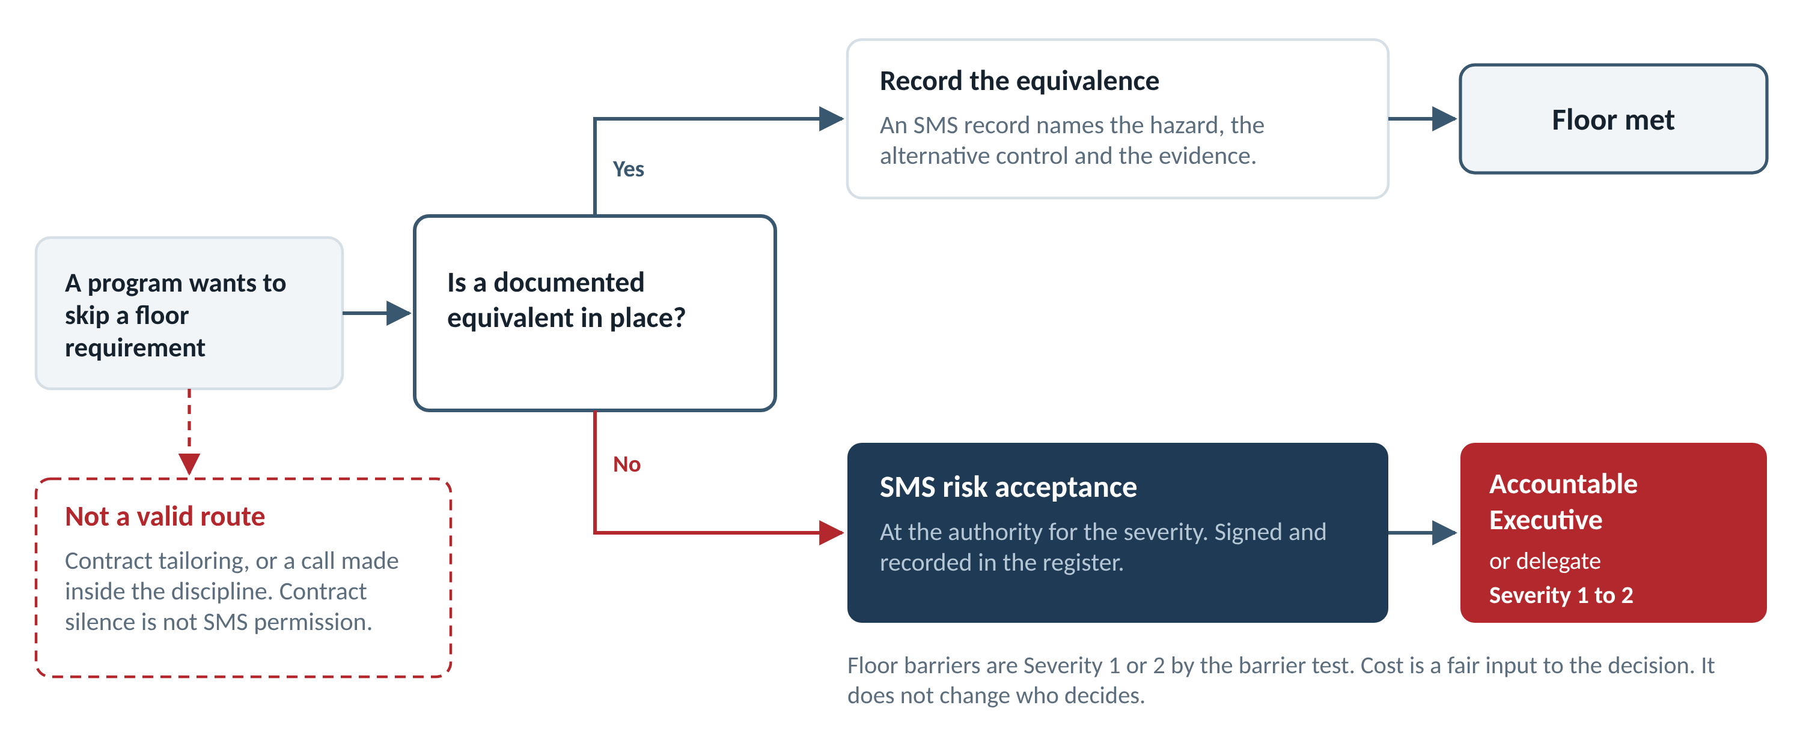
Figure 4. Routing an exception
Output: a briefing, a policy statement and the exception route.

5. Results to date
Measure | Configuration management | R&M, system health and human factors
Anchor standards | 1 (EIA-649-1A Rev. A) | 8 (7 usable, 1 marginal), from 33 reviewed
Barriers | 16 in 4 clusters | 47 in 6 clusters; 66 passed the test
Floor requirements | 44 (37 marked Clean) | 186, proved by 35 artifact types
Ownership routing | Not needed: one discipline | 35 primary, 12 shared, 12 handoffs, 7 governance
Fatalities in anchoring events | 880+, as cited in the CM deck | 1,384 across 17 events
The CM deck rates its events on an older scale on which 5 was catastrophic. This paper uses the organization's scale: those events are Severity 1 and 2.

6. Applying the method to another discipline
- Inputs: the discipline's candidate standards, the SM-0001 hazard lists, investigation reports for candidate events, and handoffs that other registers already identified.
- People: a discipline lead who knows the standards, a system safety partner for hazards and severity, a reviewer who checks every event at its source, and the SMS office for the authority model.
- Outputs: a standards verdict, a barrier register, a floor register, traceability charts, and one summary slide for leadership.
The next disciplines are already named. The R&M handoffs point to Structures (6 barriers), System Safety (3), and Human Engineering, Production Quality and Mechanical Systems (1 each). Each handoff is a starting row for that discipline's register.

7. Guardrails
- Let the standards set the count. CM has 16 barriers. R&M has 47. Neither number was forced.
- Anchor only on normative shall statements. A shall in a worked example or an appendix is not an obligation.
- Paraphrase. The standard governs. Some standards' licenses bar reproduction or AI processing of their text.
- Check every event at the source. Alaska 261 had redundant load-bearing threads in the jackscrew nut. One common failure mode, wear from inadequate lubrication, defeated both. The lesson is common-cause failure, not missing redundancy. The correction added R&M barrier 66.
- Use one severity scale. Severity 1 is catastrophic and 2 is severe. A mixed scale inverts the authority table.
- Count from the register, by formula. Hand counts drifted more than once during this work.

