[COMPANY] · CONFIGURATION MANAGEMENT
Configuration Audits
A guide to the functional and physical audits, with best practice
For: CM engineers, CM specialists, and the systems, design, test, software, quality, manufacturing, safety, and supplier staff who work with them.
Status: Guidance document. Written against the draft configuration audit process. Confirm it against the released version.
Date: October 16, 2026

Contents
1. About this guide
2. The problem this process solves
3. Key terms
4. Why this matters
5. Nine principles
6. Audit designation
7. Who conducts, and where
8. Preparing for the audit
9. The functional audit
10. The physical audit
11. The final system-level audit
12. Findings, closure, and the record
13. Steps by lifecycle state
14. Who does what
15. Records the process keeps
16. Best practice
17. Common mistakes
18. Quick reference
19. Limits and open decisions
Appendix A. Glossary
Appendix B. References
Figures
Figure 1. Two audits, two questions
Figure 2. The actuator’s path through the audit process
Figure 3. Two narrowings
Figure 4. The audit designation assessment
Figure 5. Which audit each factor points to
Figure 6. Who conducts, and where
Figure 7. Order and prerequisites
Figure 8. The FCA verification chain
Figure 9. Three comparison families
Figure 10. One unit, three defects
Figure 11. The final system-level audit
Figure 12. From findings to the record
Figure 13. Audit work across the lifecycle

1. About this guide
This guide explains the configuration audit process. It covers how a CI earns an audit. It covers which audit it gets and who conducts it. And it covers what each audit checks, and what it leaves behind.
The guide is written for two readers. Engineers need to know what an audit will ask of them, and why. CM specialists need to know how to designate, prepare, conduct, and close an audit, and how to defend each decision.
The guide explains the process. It does not replace it, and it adds no requirements. Where this guide and the released process differ, the process governs. Where the process and the contract differ, the contract governs. The preparation trackers and the CI selection tool help apply the process. Where they differ from it, the process governs too.
Technical definitions are quoted exactly, with their source. They are not simplified. The plain explanation sits around them.
This guide names parts of the process by what they are, not by number. A bare clause number in parentheses, such as (3.5.3), points to EIA-649-1A.

The standards behind the process
The process rests on two industry documents.
- EIA-649-1A sets configuration management requirements for defense contracts. Section 3.5 states the audit requirements: common supplier responsibilities, the FCA, the PCA, post-audit action, and the summary report.
- GEIA-HB-649A is a configuration management implementation handbook. The process takes its finding classes from it. Its FCA check set and FCA readiness checklist draw on the handbook’s audit procedures and checklists.
Four data item descriptions apply where a contract cites them: DI-SESS-81646 for the audit plan, DI-ADMN-81249 for the agenda, DI-ADMN-81250 for the minutes, and DI-SESS-81022 for the summary report.

Where this guide applies
Applies to | Programs where the company is prime contractor to a DoD Acquirer. Covers hardware CIs, computer software CIs, and firmware, audited at company, supplier, or sub-supplier facilities, at lower-tier and system levels.
Related documents | Configuration audit process · CI identification process · Sub-supplier CM flowdown process · FCA and PCA preparation trackers · FCA/PCA CI selection tool · Configuration audit training

How this guide is organized
Section | What it covers
2 | The problem. What a configuration audit is, how programs run audits today, and the worked example.
3 | Key terms.
4 | Why it matters. Records that agree with records, audits that test the machinery, what the PCA formalizes, and ceremony versus substance.
5 | Nine principles. Every later step follows from them.
6 | Audit designation. The two narrowings, the four-part assessment, evidence, scope, and triggers.
7 | Who conducts, and where. Supplier roles, supplier audits versus in-house audits, and vendor item CIs.
8 | Preparing for the audit. Order, entry criteria, the three closeout conditions, and the joint tracker.
9 | The functional audit. The allocation matrix, the verification chain, the check set, and the delta audit.
10 | The physical audit. The three comparison families, the check set, one unit with three defects, and software.
11 | The final system-level audit. Two populations, baseline coherence, and timing.
12 | Findings, closure, and the record.
13 | Steps by lifecycle state.
14 and 15 | Who does what, and the records the process keeps.
16 to 18 | Best practice, common mistakes, and a quick reference.
19 | Limits and open decisions.

2. The problem this process solves
Start with a unit. The elevator actuator has passed its qualification tests. Its build record lists every part. The reconciliation report for serial number 0004 shows no deltas. Every operation on the traveler carries a stamp.
Does that mean the unit on the bench is the unit the documentation describes? Not yet.
Each of those records was checked against another record. None of them was checked against the article. Records can agree with records while the hardware is wrong.
Two questions remain.
- Was the design proven against every requirement allocated to it?
- Is this unit that design?
The functional configuration audit (FCA) asks the first question. The physical configuration audit (PCA) asks the second.
Neither audit runs on every CI. Someone has to decide which CIs get an audit, which audit each one gets, and who conducts it. Decide badly and a safety-critical item reaches the fleet unaudited. Or the program spends its audit effort on brackets while the hazard controls go unexamined.

Two audits, two questions
Start with what a configuration audit is not. It is not an inspection of every unit. It is not a re-run of the test program. It is not a review of every change.
A configuration audit is a formal check, at a key point in the life cycle, that the verification machinery worked. EIA-649-1A calls audits “a summation of the configuration verification process, where necessary to establish approved configurations at key points in the product life cycle” (3.5, Principle CVA-4).
There are two audits. They ask different questions. They work from different evidence. Neither covers the other’s ground. Figure 1 sets them side by side.
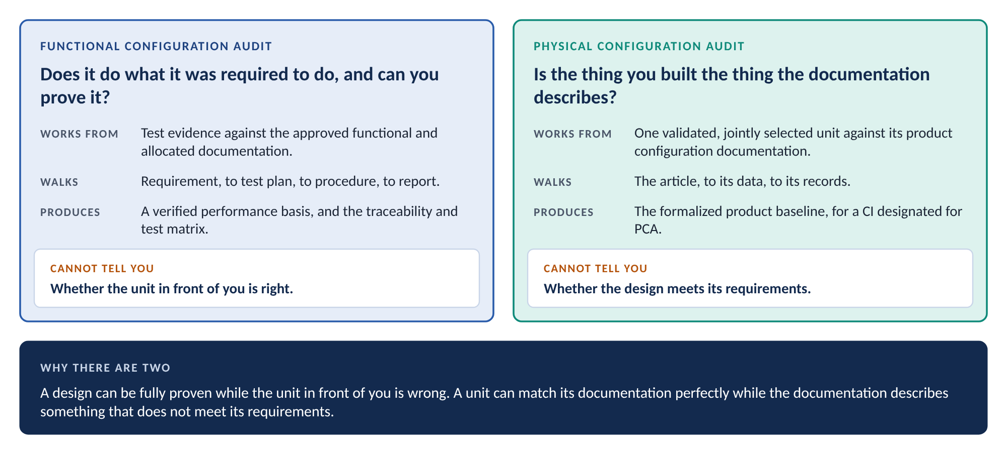
Figure 1. Two audits, two questions
A design can be fully proven while the article in front of you is wrong. A unit can match its documentation while the documentation describes something that does not meet its requirements.
That is why there are two audits.
One more distinction prevents confusion. A configuration audit examines a CI. A CM process audit examines a supplier’s CM process: its plan, its records, and whether it follows them. The two share one word and nothing else. In this guide, audit alone means a configuration audit.

How programs run audits today
Few programs skip audits. Many programs shortcut them. Five shortcuts are common.
Shortcut | Why it is tempting | What goes wrong
Audit every CI | It looks thorough. Nobody has to decide anything. | Audit effort spreads thin across items that never needed it. Designation stops meaning anything, because nothing was selected.
Audit only what the contract names | The contract is the obligation. Anything more costs money. | Safety-critical CIs the contract never named go unaudited. A safety yes designates both audits whatever the contract says.
Accept the supplier’s data package | The supplier offers every record. A desk review is cheaper than travel. | The evidence the PCA judges lives on the supplier’s floor. A shipped package is a sample the supplier chose. Swapping the audit for a package changes its substance.
Run the PCA when the hardware is ready | Hardware finishes early. Testing slips. The unit will not change. | The PCA examines a validated CI. Nothing is validated until the FCA runs. If the design later fails verification, the PCA examined a unit built to documentation that was about to change.
Sample the drawing set for the system audit | The system holds everything. A percentage of drawings sounds fair. | The sample lands in structure and wiring by drawing volume. No CI designated for audit is examined. No interface is checked against its definition.

Each shortcut starts from a real pressure. Cost, schedule, and supplier goodwill all belong in the planning. None of them belongs in place of the process.
The problem is not the audits. The problem is treating the audit as the verification, or the verification as the audit.

The worked example
Five items run through this guide. They come from the worked example in the companion guidance on CI identification, baselines, and supplier flowdown. Each one shows a different audit pattern.
Item | What it is | Who designs and builds | Audit pattern
Air vehicle | The system and top-level CI. Acquirer-spec controlled. | The company. Final assembly at the company’s facility. | Final system-level FCA and PCA, named in the contract.
Flight control system | Top-tier CI below the air vehicle. Acquirer-spec controlled. | The company. | FCA and PCA, named in the contract.
Control electronics unit (CEU) | Hardware CI. Company-spec controlled. | The company designs and builds it. | Designated by the safety questions. The company conducts.
Flight control software | Computer software CI that runs on the CEU. Company-spec controlled. | The company. | Named in the contract, and designated by the safety questions. Software FCA and software PCA with a witnessed build.
Elevator actuator | Hardware CI. Company-spec controlled. Bought whole under a source control drawing. | ACME Actuation designs and builds it, and writes its motor controller firmware. | Designated by the safety questions. ACME conducts both audits at its facility, plus the software functional audit and witnessed build for the firmware.

Two more suppliers appear. Apex Coatings plates machined details for ACME after award, as a sub-tier. A catalog position sensor, bought under a vendor item control drawing, shows how the company audits a vendor item.
The actuator is the main thread. Figure 2 shows its path from designation to the final system-level audit. Designation comes first and stands. Triggers re-run the assessment. Each audit waits for the one before it.
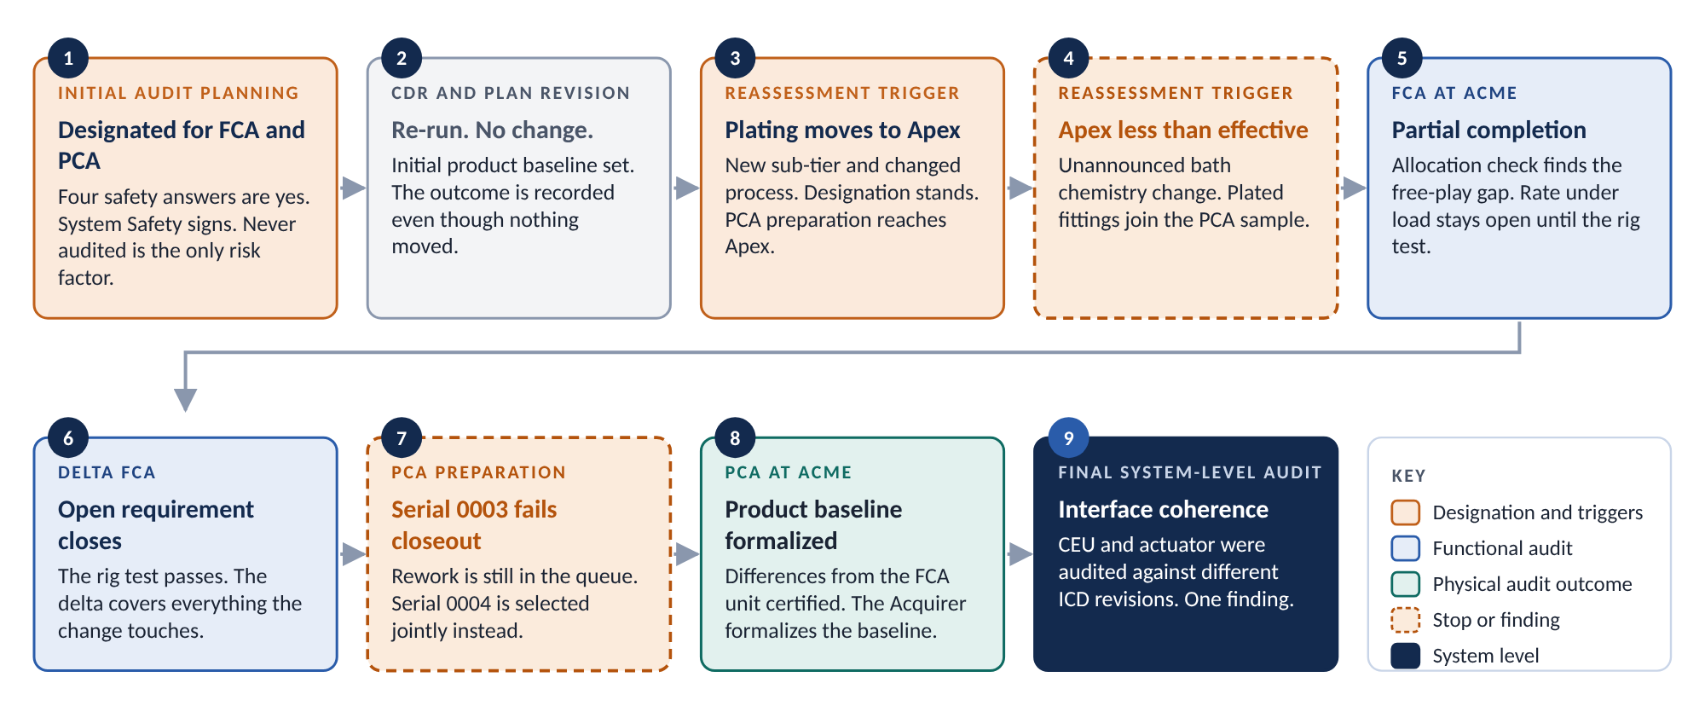
Figure 2. The actuator’s path through the audit process

3. Key terms
These terms carry exact meanings. Use them exactly. Do not swap in synonyms. Being a CI is not being designated for audit, and a PCA is not an inspection. Appendix A gives the full glossary.

The item and the audits
Term | Definition | Source
Configuration Item (CI) | Any hardware, software, firmware, or aggregation thereof that satisfies a system end-use function and is designated for separate configuration management. Designation includes establishing the CI’s requirements and verifying that its configuration meets those requirements and that its configuration documentation accurately describes its configuration. | CI identification process
Functional Configuration Audit (FCA) | The formal audit that verifies the CI’s and system’s tested performance against its approved functional and allocated configuration documentation; confirms specifications and interfaces are accurately and adequately defined; and confirms the Supplier’s change control system adequately controls processing and release of configuration documentation. | Configuration audit process
Physical Configuration Audit (PCA) | The formal examination of the as-built (or as-coded) configuration of a validated CI against its product configuration documentation, verifying the documentation is a clear, complete, and accurate representation of the CI. For a CI designated for PCA, successful PCA completion is the event that formalizes the product baseline (PBL). Until that event the CI carries the initial product baseline established at CDR. From that point all changes to the CI are processed by formal engineering change action. | Configuration audit process
Configuration Verification | The ongoing process, spanning CM, systems engineering, design, test, manufacturing, and quality, by which the design solution is verified: functionally through analyses, inspections, tests, and demonstrations, and physically by inspection, by process control, or by both, confirming as-built conformance to as-designed. | Configuration audit process
Designated for Audit | The recorded decision that a configuration item will receive a formal configuration audit. It is a decision separate from designation as a configuration item, made under the configuration audit process, and it is the second of the two facts required before any supplier audit obligation becomes due. | Sub-supplier CM flowdown process

EIA-649-1A defines both audits in shorter words. Its FCA is “the formal examination of functional characteristics of a Configuration Item to verity [sic] that it met the requirements specified in its functional and allocated configuration documentation.” Its PCA is “a formal examination of the actual (as-built) configuration of an item compared to its product configuration documentation.” The process wording adds the objectives of each audit from 3.5.2 and 3.5.3. This guide uses the process wording.

The unit and its records
Term | Definition | Source
As-Designed Configuration | The configuration defined by the released design at a stated revision, including approved changes at their stated effectivity. | Sub-supplier CM flowdown process
As-Built Configuration | The configuration actually manufactured and assembled in a specific delivered unit or lot, evidenced by closed work orders, dispositioned nonconformance records, and part traceability records. | Sub-supplier CM flowdown process

Notice the evidence in the as-built definition: closed work orders and dispositioned nonconformance records. A unit with open work is not yet as-built. Section 8 shows why that matters to the PCA.

The findings and what follows
Term | Definition | Source
Action Item / Request for Action (RFA) | The documented record of a discrepancy found during audit proceedings, defining the issue, agreed closure plan, responsible person, and agreed suspense and closure date. RFA is the standard DoD format. | Configuration audit process
Delta Audit | A follow-on audit of the portion of configuration and verification data that was open (e.g., testing not complete) at the original audit. Delta audit results are added to or supersede the original audit minutes. | Configuration audit process
Incremental Audit | Audits conducted bottom-up on lower-level CIs, then subsystems, concluding with a final system-level audit confirming all FBL/ABL/PBL requirements are satisfied. Open action items from lower-level audits are carried into system-level minutes. | Configuration audit process

4. Why this matters

Records agree with records
Some requirements arrive twice. They come through the contract. They also come through the safety management system, because they act as barriers against severe events. Conducting the FCA and conducting the PCA are both on the register of safety-mandatory CM requirements. On safety-significant product lines, they are performed whatever the contract flows down.
Three events show why.
- A door plug departs in flight. It was installed without all four retention bolts. The as-built configuration diverged from the approved configuration. No record flagged it. Every paper check agreed with every other paper check.
- Tools and debris are found in delivered aircraft. It happened repeatedly, across development, early production, and full-rate production. Deliveries halted more than once.
- A replacement wear strip falls onto a runway. It was made of a titanium alloy rather than the specified aluminum. A departing aircraft ran over it. The tire burst, and the debris ruptured a fuel tank. 113 people died.
Each event maps to a PCA check. The first is why the physical examination cannot be reduced to a record. The second is why the PCA examines the zone where an item is installed, and why it identifies differences between the production unit and the FCA unit. The third is why the PCA follows a material from its specification, to the build record, to the material certificate.
A parts list that matches the drawing proves the parts list. Only looking at the item proves the item.

Audits test the machinery. They do not replace it.
Configuration verification runs every day, on everything. Functional verification runs through the test program. Physical verification runs through inspection and process control, on every unit. The as-designed to as-built reconciliation runs at scale, on data for all CIs, through the configuration status accounting (CSA) system.
An audit is small by comparison. It examines CIs designated for audit. The PCA looks at one representative unit and an agreed sample. The process states its purpose plainly. Audits “confirm that this machinery works, not to substitute for it, and to establish baselines. It is not the intent of an audit to verify every change individually.”
Two rules follow.
- “We will catch it at the audit” is never a plan. The audit sees one unit and a sample. What the daily machinery misses, the audit will probably miss too. If the audit does find it, the finding is about the machinery, not the part.
- “Not designated for audit” never means “not verified.” A CI not designated for audit keeps its baselines, its change control, its status accounting, and its place in the at-scale reconciliation. Designation decides where the discrete checks fall. It does not decide where the discipline applies.
The audit also tests CSA itself. The PCA works from the reconciliation report for the audit unit. That report is a claim. The audit checks it against the article. A delta the audit finds that the report missed is a finding against the reconciliation process, not only against the unit.

What the PCA formalizes
The PCA is not only a check. For a CI designated for PCA, it is the event that formalizes the product baseline.
The product baseline has two states. Each has its own event.
- The initial product baseline is established at completion of CDR.
- The formalized product baseline is established no later than first production unit delivery or PCA completion. For a CI designated for PCA, the PCA is the formalizing event. The Acquirer formalizes the baseline after successful PCA completion and approval of the product specification.
Between the two events, the CI carries its initial product baseline. That is a real baseline under real control. What it lacks is the Acquirer’s acceptance of it as the definition of the CI.
So deferring a PCA does not save work. It holds the CI on its initial product baseline. Every unit built in the meantime is built against a baseline the Acquirer has not formalized. Section 19 records an open question about how the two deadlines interact.

Ceremony and substance
Not every audit is chaired by the Acquirer. Where risk-based designation, not the contract, put a CI on the list, the audit may be initiated internally. Then some parts of it may be simplified. Others may not.
Ceremony is the arrangement around the audit. Who chairs. Who signs. How formal the setting is. Whether a finding sits on a form or in the minutes. Ceremony may be proportionate. An internally initiated audit may use an internal co-chair and internal certification in place of Acquirer participation.
Substance is the audit itself. The process names it. The requirements-to-test reconciliation and its traceability matrix. The as-built examination, including approved-parts verification. The identification and certification of differences between the production unit and the FCA unit. The documented non-compliances. Who selects the audit unit and the sample. For the PCA, the examination of the build and its process controls where the work is performed. Substance is performed in full.
When you cannot tell which side a proposal falls on, ask one question. If this is removed, does anyone still find out? Changing who signs a certificate changes nothing about what is discovered. Removing the examination changes whether the organization learns what is true.
One proposal comes up often. A supplier says its toolchain enforces requirement-to-test links, so the reconciliation is redundant. It is not. The reconciliation is how anyone learns whether the toolchain works. Removing a verification because an automated system is said to prevent the failure is substance. Sampling the reconciliation, where sampling is agreed, is ceremony.

5. Nine principles
Every step in Sections 6 through 13 follows from these nine principles. Each one prevents a mistake described in Sections 2 and 4.
 | Principle | What it prevents
1 | Being a CI and being designated for audit are two separate screens. Most CIs are never audited. | Audit plans for every CI, and the belief that an unaudited CI is unverified.
2 | CM answers every assessment question from its source, and records the source. An answer nobody established is open, not no. | A “no” that means nobody checked.
3 | A safety yes designates both audits. Only the safety disposition gate can set an audit aside. | A safety decision made by the schedule.
4 | Scope follows the question each factor raises. Doubt about verification points to an FCA. Doubt about manufacture or records points to a PCA. | The wrong audit, run carefully.
5 | The order is structural. Approved baselines come before the FCA. A validated CI comes before the PCA. A closed-out unit comes before either examines it. | Audits against a draft, or against a unit that is still changing.
6 | Design authority and build decide who conducts. Willingness to send data does not. | An in-house desk review standing in for a supplier audit.
7 | The check set fixes the depth. Every check is recorded. Hazard risk controls are never sampled out. | A shortened audit with blind spots nobody chose.
8 | Classify findings by mechanism, not by count. There is no verbal finding. Evidence closes a finding, not assertion. | Proofreading treated as breakdown, breakdown treated as a slip, and findings that evaporate.
9 | Designation is a standing question. Re-run the assessment on every trigger. Record the outcome even when nothing changes. | An award-day answer that is wrong by delivery.

Principle 1 deserves one more sentence. CI selection decides what is managed separately. Audit designation decides which of those CIs get a formal audit. The two screens use different criteria, at different times, and leave two different records.

6. Audit designation

Two narrowings
Everything in the product is made, inspected, and controlled. Most of it is not separately managed. Two separate narrowings sit between the whole product and the items that get an audit.
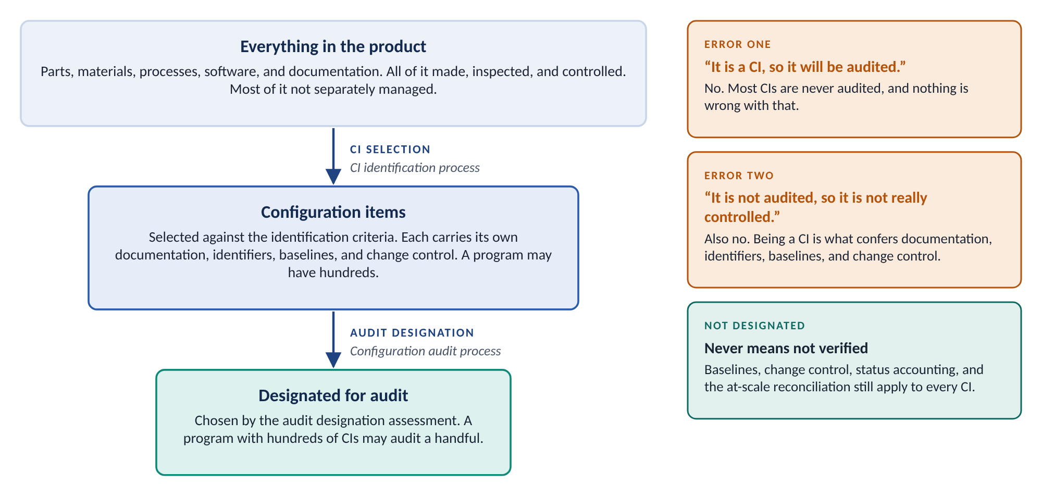
Figure 3. Two narrowings
The first narrowing is CI selection, under the CI identification process. It picks the items that carry their own documentation, identifiers, baselines, and change control. A program may have hundreds of CIs.
The second narrowing is audit designation, under the configuration audit process. It picks the CIs that receive a formal audit. A program with hundreds of CIs may audit a handful.
People collapse the two constantly. Two errors follow.
- “It is a CI, so it will be audited.” No. Most CIs are never audited, and nothing is wrong with that.
- “It is not audited, so it is not really controlled.” Also no. Being a CI is what confers documentation, identifiers, baselines, and change control.
The assessment applies only to CIs. An item controlled inside its parent’s documentation is not assessed. The real question is whether the parent is designated for audit.

The assessment has four parts
CIs reach an audit from two directions. Contract designation names them in the contract, the statement of work, or the CM plan. Risk-based designation assesses every other CI. One assessment carries both, in four parts.
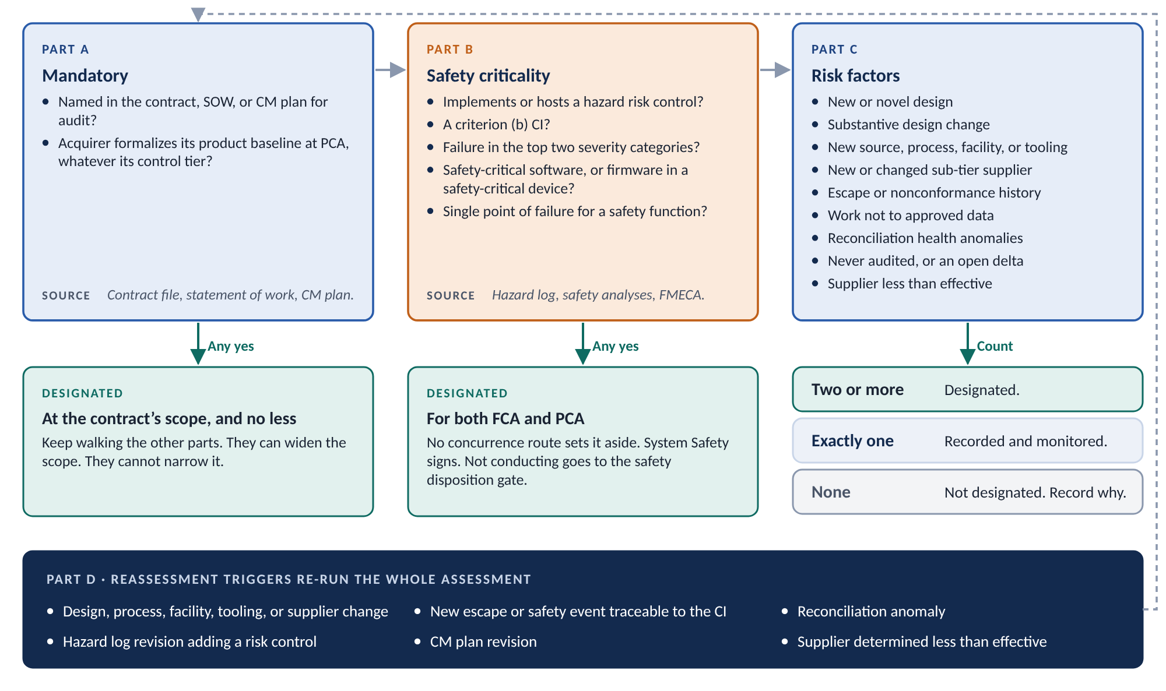
Figure 4. The audit designation assessment
Part | What it asks | What a yes does
A. Mandatory | Is the CI named in the contract, statement of work, or CM plan as requiring an audit? Does the contract have the Acquirer formalize the CI’s product baseline at PCA completion, whatever its control tier? | Any yes designates the CI at the contract’s scope. The other parts are still walked, because they can widen the scope.
B. Safety criticality | Does the CI implement or host a hazard risk control in the hazard log? Is it a criterion (b) CI under the CI identification process? Is its credible failure consequence in the top two severity categories? Is it safety-critical software, or firmware in a safety-critical device? Is it a single point of failure for a safety-related function? | Any yes designates the CI for both an FCA and a PCA. No concurrence route sets that aside. System Safety signs.
C. Risk factors | Nine factors: new or novel design; substantive design change since the last audit; new or changed source, process, facility, or tooling; new or changed sub-tier supplier; escape or nonconformance history; work not to approved data; reconciliation health anomalies; never audited, or an open delta; a supplier determined less than effective. | Two or more designate the CI. Exactly one is recorded and monitored.
D. Reassessment triggers | A substantive design, process, facility, tooling, or supplier change. A new escape or safety event. A reconciliation anomaly. A hazard log revision adding a risk control. A CM plan revision. A supplier determined less than effective. | Any one re-runs the whole assessment.

CM completes the assessment at initial audit planning. CM repeats it at each CM plan revision and on any reassessment trigger. CM records it for every CI evaluated, designated for audit or not. The CI selection tool and the selection checklist in the process carry the same four parts.

Answer from evidence
CM answers every question on the assessment. That is a deliberate design choice. The other functions own the documentation the answers come from. They do not answer the questions for CM.
Question family | Where the answer comes from | Who owns the source
Mandatory designation | The contract file, the statement of work, and the CM plan. The CI index and its control tiers. | Program management, CM
Safety criticality | The hazard log, the safety analyses behind it, the program safety risk matrix, and the pre-anchored severities. | System Safety
Single point of failure | The FMECA and the single point failure identification. | RM&SH
Design novelty and change | The design history, the released design definition, and the fielded heritage evidence. The change records against the CI since its last audit. The certification basis and previously approved data, where the program has one. | Systems Engineering and Design Engineering; CM; Airworthiness and Certification
Production risk | Procurement and process change records. The supplier classification log. | Supplier Requirements Engineering
History | Escapes, nonconformances, foreign object findings, and findings of work not to approved data, for the CI and its production line. | Quality
Reconciliation health, prior audits, supplier effectiveness | CSA reconciliation indicators, prior audit records, and supplier effectiveness determinations. | CM

Where the source is unclear or silent, CM marks the answer open. CM assigns the owning function and a date, and escalates. CM does not sign until every open answer resolves.
A “no” that means nobody checked looks exactly like a “no” somebody established. Record the source for every answer, so the next assessor can tell them apart.
A concurrence signature confirms that the technical basis is sound. It does not make the determination. The determination is CM’s.

A safety yes ends the question
Part B works differently from Part C. There is no threshold to reach. There is no concurrence route around it. Any yes designates the CI for both audits.
The reason is simple. A hazard risk control is verified in the design by the FCA. It is confirmed in the article by the PCA. Both assurances are needed. Neither substitutes for the other.
Sometimes a program proposes not to conduct an audit a CI is designated for. The usual reasons are a mature design and a tight schedule. That proposal does not go to CM or to System Safety for concurrence. It goes to the safety disposition gate, which has three doors:
- Perform it. The audit runs.
- Replace it. An independently validated equivalent control takes its place.
- Accept the risk. The authority that matches the recorded severity accepts it formally.
There is no fourth door. This puts the decision in front of the function that owns the hazard, not the function that owns the schedule.
Part B does not depend on control tier, contract, or supplier. A vendor item can carry a safety yes. Then the designation stands, and the company conducts both audits (Section 7).

Risk factors are counted as they stand
Part C counts nine factors. Two or more designate the CI. Exactly one is recorded and monitored. When a second factor arrives, CM reassesses against the recorded first one.
Four reading rules keep the count honest.
- Count factors as they stand now. A facility change three years ago, with a successful audit since, has been discharged. That audit is what closed the factor.
- Read history across the production line. The history questions cover the CI or its production line. Escapes on a shared line are evidence about the process this CI goes through. Reading the question as CI-only is the most common way a real factor is missed.
- Keep escapes and work-not-to-data apart. Escape history is about defects found in the product. Work-not-to-data findings are about how the work was done. A line can have a clean escape record and a history of building to superseded data.
- Heritage answers one question. A heritage design answers the design novelty question. It says nothing about tooling, sources, facilities, sub-tiers, escapes, or reconciliation health. In most cases the drawing stayed the same and everything that turns the drawing into hardware moved.
Never audited is one factor of nine. On its own it does not designate. But every new CI starts with it. So on a new program, the first other factor designates the CI.
A single factor is worth recording for one reason. The next factor should land on top of a documented one. Two single-factor assessments with no record between them is how a CI is never designated.

Scope: which audit
Designation decides whether a CI gets an audit. Scope decides which audit. Both come from the same assessment, and both are recorded on it.
Read scope from the question each factor raises. The FCA asks whether the design was verified against its requirements. The PCA asks whether the unit conforms to its product definition. A factor that raises doubt about verification points to an FCA. A factor that raises doubt about manufacture, records, or as-designed to as-built agreement points to a PCA.
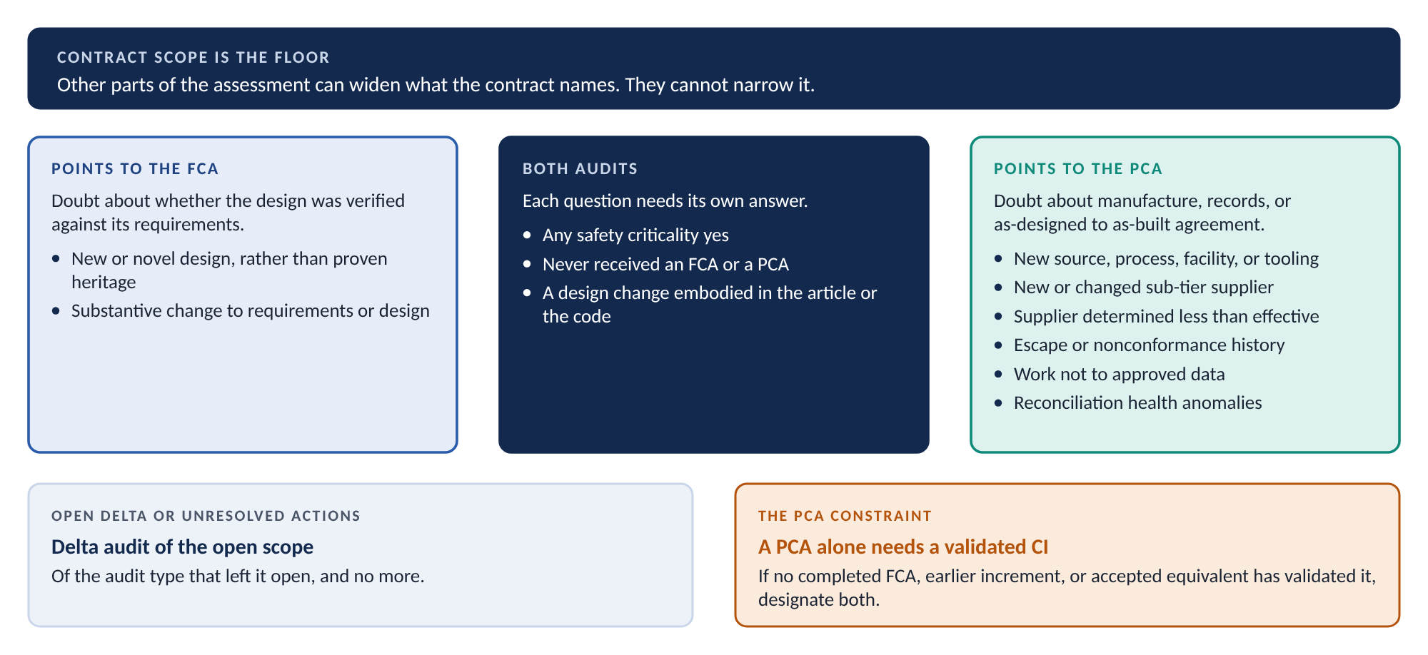
Figure 5. Which audit each factor points to
Assessment result | Scope | Why
Named in the contract | As named, and no less | Contract scope is the minimum. Other parts may widen it. They may not narrow it.
Acquirer formalizes the product baseline at PCA | PCA at minimum | The PCA is the only event that formalizes that baseline.
Any safety yes | FCA and PCA | The design and the article each need their own assurance.
New or novel design | FCA | The doubt is about the design. Nothing about manufacture is in question.
Substantive design change | FCA; PCA too where the change is embodied | A change reopens verification. A change in the unit also reopens the as-designed to as-built comparison.
New source, process, facility, tooling, or sub-tier; supplier less than effective | PCA | The design is unchanged. The doubt is about how the article is made and recorded.
Escape history; work not to approved data; reconciliation anomalies | PCA | The evidence is about manufacture, inspection, and records.
Never audited | FCA and PCA | Neither question has been answered for this CI.
Open delta or unresolved action items | Delta audit of the open scope | The delta covers what was left open, and no more.

One constraint shapes PCA scope. A PCA examines a validated CI, and the FCA is what validates it. So a PCA designated on its own is valid only where the CI is already validated. That can be a completed FCA, an earlier increment, or an Acquirer-accepted equivalent. Where the CI has not been validated and the assessment points to a PCA, designate both.
Record the scope with its rationale: FCA, PCA, or both. Record separately whether a delta audit of open scope is required. Record whether the audit will be initiated internally. An assessment that records a designation and leaves the scope blank is incomplete. It is not signed.

The worked example, assessed
CM runs the assessment on the actuator at initial audit planning.
Question | Answer | Source
Named in the contract for audit? | No. The contract names the air vehicle, the flight control system, and the flight control software. | Contract file, statement of work
Acquirer formalizes its product baseline at PCA? | No. | Contract file
Hosts a hazard risk control? | Yes. The no-back brake holds the elevator with power removed. | Hazard log
Criterion (b) CI? | Yes. Loss of pitch control is catastrophic. | CI index and selection rationale
Top two severity categories? | Yes. Catastrophic. | Program safety risk matrix
Safety-critical software or firmware? | Yes. The motor controller firmware runs in a safety-critical device. | Software criticality assessment
Single point of failure? | Open at first pass. The FMECA named a jam mode but not the item. RM&SH confirmed in writing that the jam lives in the ball screw, inside the actuator. Yes. | FMECA, single point failure identification
Never audited? | Yes. The only Part C factor at this point. | Prior audit records
Result | Designated for FCA and PCA. Initiated internally. System Safety signs.

Four safety answers are yes. One would have been enough. CM answers all of them anyway. A designation that rests on one answer falls if that answer changes. The actuator’s rests on five.
The open single point of failure answer shows the mechanics. The assessment was not signed until RM&SH closed it. Part B had already designated the CI. The signature still waited, because an open answer is open.
The other four items assess differently.
CI | Outcome | Basis
Air vehicle | Final system-level FCA and PCA | Named in the contract.
Flight control system | FCA and PCA | Named in the contract. It also hosts hazard risk controls, so Part B agrees.
Control electronics unit | FCA and PCA, initiated internally | Hosts the command monitoring hazard controls. New design as well.
Flight control software | Software FCA and software PCA | Named in the contract, and safety-critical software. Both parts reach the same answer.
Position sensor, catalog item | Recorded and monitored at first. Designated later. | One factor at award: never audited. A later hazard log revision assigns it a monitoring control. Section 7 follows it.

Designation is a standing question
The assessment runs again on any reassessment trigger. The answer can change for years.
ACME moves plating of the actuator’s machined details to Apex Coatings after award. That is a supplier change and a process change. CM re-runs the assessment. Two Part C factors now read yes: a changed process and a new sub-tier. Both point to a PCA.
The actuator is already designated for both audits, so the designation does not change. The preparation does. The PCA’s material and process conformance check now reaches Apex’s process certifications. The sub-supplier inspection check now covers the plated fittings.
Months later, Apex changes the supplier of its plating bath chemistry without notice. Company receiving finds it. The determining authority records Apex as conditionally effective, with safety relevance. That is less than effective, so it is a trigger for every CI Apex processes. CM re-runs each one. For the actuator, a ninth factor reads yes. The designation still stands. The audit plan now puts the plated fittings in the PCA sample.
For the other CIs Apex touches, the answer may change. A CI with one recorded factor and a new supplier effectiveness factor now has two. It is designated.
Designation is not an award-day answer. Triggers attach to CIs, not to suppliers. One finding at one supplier can change what gets audited across its whole scope of supply.

7. Who conducts, and where

Two gates, not one
An audit obligation at a supplier needs two facts. The CI must be designated for audit. The supplier’s work type must carry an audit role. Neither fact is enough alone.
Designation decides whether. No designation, no audit. A supplier whose work type carries a conduct role performs no audits where none of its CIs is designated.
Work type decides what part. If an audit happens, the supplier’s work type decides whether it conducts, hosts, supports, or provides data. Work type never decides whether an audit happens.
The sub-supplier CM flowdown process owns the work types and their audit roles. The configuration audit process restates them word for word. Where the two differ, the flowdown process governs.

Roles by type of work
Two questions place every supplier: who holds design authority, and who performs the build. The answers set the role.
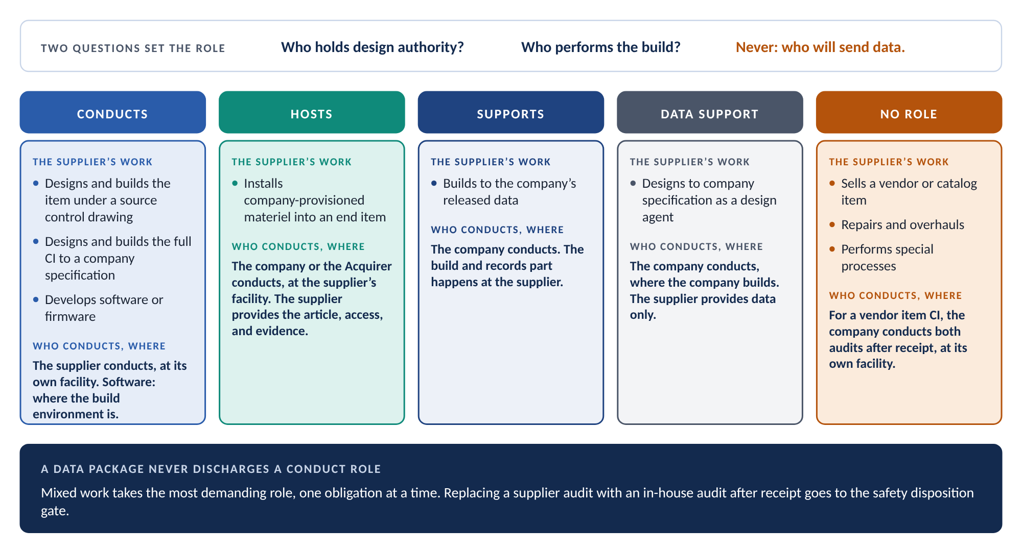
Figure 6. Who conducts, and where
The supplier’s work | Role if the CI is designated for audit | Who conducts, and where
Designs and builds the item under a source control drawing | Conducts the CI-level FCA and PCA. Substance in full. | The supplier, at its facility. An installed item is examined where it sits. The build and records part stays at the supplier.
Designs and builds the full CI to a company specification | Conducts the CI-level FCA and PCA. Substance in full. | The supplier, at its facility, as above.
Develops software or firmware | Conducts the software functional audit and the witnessed build and installation verification against the version description. | The supplier, where the build environment is.
Installs company-provisioned materiel into an end item | Hosts the end-item and system-level audit. Provides the article, the facility, access to the installation zone, the zone closeout records, and the assembled evidence. Provides data support to the end-item FCA. | The company or the Acquirer conducts, at the supplier’s facility.
Builds to the company’s released data | Supports the PCA on its build: facility access, as-built records, approved-parts evidence, and the manufacturing instructions used. No FCA role. | The company conducts. The build and records part happens at the supplier.
Designs to company specification as a design agent | Data support: the technical data package and traceability matrix inputs. No physical examination role. | The company conducts, where the company builds.
Sells a vendor, commercial, or catalog item | None. | The company conducts both audits at the procurement level, at its own facility, after receipt.
Repairs and overhauls | None in its own right. As-maintained records support audits of the parent item. | Not applicable.
Performs special processes | Not applicable. There is no item configuration at its facility. | Not applicable.

Three role labels are obligation classes. A supplier conducts, hosts, or supports. Data support is the form support takes for a design agent, which has no build of its own to examine.
Mixed work takes the most demanding role, one obligation at a time. ACME designs and builds the actuator under a source control drawing. It also writes the motor controller firmware. So ACME conducts the CI-level FCA and PCA. It also conducts the software functional audit and the witnessed build for the firmware. Classifying ACME by its dominant activity would lose the software obligations. Nothing in the design-and-build role produces a witnessed rebuild.
That union runs across kinds of work on one procured item. It never runs across two procured items in one procurement. The loose spare sensor ACME ships in the same crate is a catalog item. Its role is derived on its own.

Supplier audit, or in-house audit after receipt
ACME offers to send every record the company needs. The company could then run an in-house FCA and PCA after receipt, at its own facility. Is that the same audit?
It is not. The evidence the PCA judges lives on ACME’s floor: stamp authority, calibration, the instructions actually used, and the firmware build environment. A shipped package is a sample ACME chose. The company does not hold the actuator’s internals drawings. So an in-house review could only check the actuator against the source control drawing. That is a vendor item audit, and the actuator is not a vendor item.
Design authority and build decide who conducts. Willingness to send data does not.
Replacing a supplier audit with an in-house audit after receipt changes the audit’s substance. That proposal goes to the safety disposition gate. It is not settled by a program decision.
The fallback fails both ways. A design supplier that refuses to send data still owes the supplier audit. A catalog vendor that will not send data cannot be made to run an audit it never owed.

Buy the obligations at award
Audit obligations at a supplier are bought in the statement of work. Supplier Requirements Engineering authors it. CM provides the CM content.
Where a CI is designated at award, the statement of work imposes the audit obligations outright. ACME’s statement of work does that for the actuator.
Where a CI is not designated at award, designation can still arrive later. Awarding work to a new supplier is itself a trigger and a risk factor. So a subcontract can lead to the designation that imposes audit obligations on that same subcontract. The standing conditional audit clause handles this. It imposes conduct, host, or support obligations that take effect if and when the CI is designated. The audit plan, data package, and minutes are cited as triggered items. The flowdown process owns the clause. This process states the trigger.
Access needs its own words. Conduct and access obligations produce no submitted data. So each one is cited with the access right and the verification method that evidences it. Left implicit, access is a request, and a request can be declined. Joint unit selection and confirmation that work orders are closed are bought the same way.

CIs procured as vendor items
The position sensor shows the one case where the company conducts an audit of a supplier’s item after receipt.
The sensor is a catalog item, bought under a vendor item control drawing. At award, its only factor was never audited. Then a hazard log revision gave the sensor a monitoring control. That is a safety yes. The sensor is designated for both audits.
The vendor holds the design. The company controls selection only. So the vendor has no audit role, and the company conducts both audits at the procurement level.
- The FCA verifies the requirements allocated to the sensor against the company’s own verification evidence. That is usually company qualification testing. A vendor data sheet is a claim. It is not verification evidence unless the company verified the requirement it supports. The five software checks are recorded not applicable, because vendor firmware is not a company software CI.
- The PCA examines a received sensor against the vendor item control drawing, its acceptance criteria, and the vendor part number. Four checks compare against build records the company does not hold. Those are the child item reconciliation, the build traveler and buy-off, the manufacturing instructions, and the material and process conformance check. They are recorded not applicable, with the reason. The rest run against the drawing and the vendor’s pass-through data: traceability, marking, version and checksum, and change notices.
The company records the known limits before the audit, not as findings on audit day. The biggest limit is the FCA unit to PCA unit difference check. For a vendor item, that check rests on the vendor’s change notices. It cannot see a change the vendor did not notify.
The sensor’s safety yes raises one more question. Does the hazard control rely on a characteristic the company cannot see through a vendor item control drawing? If it does, the company is relying on qualification beyond selection. CM refers the drawing type to Systems Engineering, the Responsible Engineer, and System Safety. They decide whether the sensor needs a source control drawing. The designation stands while they decide.
A substantive vendor change notice against a vendor item CI is a design change the company did not make. It is a reassessment trigger. It also answers the design change factor yes.

8. Preparing for the audit

The order is structural
Each audit has prerequisites. In every case the reason is structural, not administrative. The audit has nothing to work on without them.
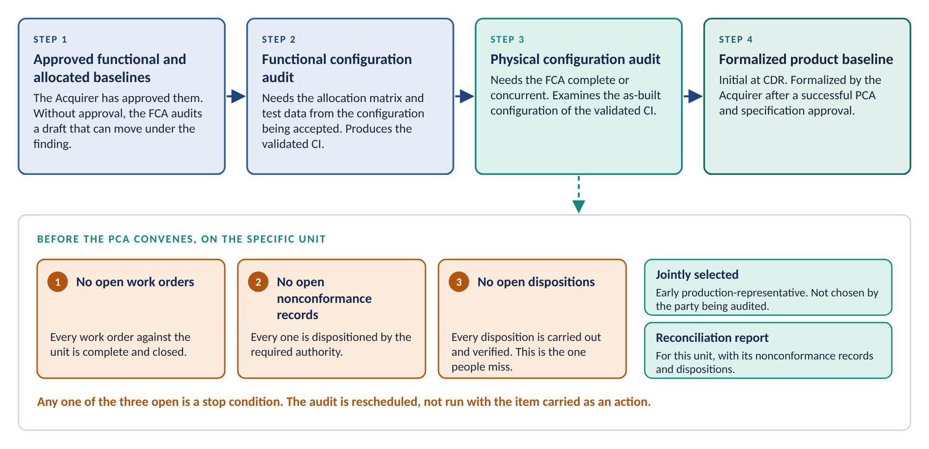
Figure 7. Order and prerequisites
Before | What must be true | Why
The FCA | The Acquirer has approved the functional and allocated baselines for the CI or system. | Without approval, the audit compares test results against a draft that can move under the finding.
The FCA | The approved requirements allocation matrix for the CI is available. The traceability matrix is reconciled against it. | The allocation matrix sets the audit’s scope. Without it, the audit verifies only the requirements someone chose to list.
The FCA | Test data comes from the configuration to be accepted or released for production. | Results from another build prove another build.
The PCA | The FCA is complete, or running concurrently. | The PCA examines a validated CI. The FCA validates it.
The PCA | The as-designed to as-built reconciliation report for the specific unit is available, with its nonconformance records and dispositions. | The report is the claim the PCA checks. Without it, the PCA becomes an inspection of the article.
The PCA | The unit is closed out on all three conditions. | Until then, the as-built configuration is not final.
The PCA | The unit is jointly selected, and access is arranged. | A unit chosen by the party being audited is an exhibit, not a sample.

Two words do more work than they look. Approved means the Acquirer has accepted the documentation, not that it is released internally or in review. Concurrent means the FCA is genuinely underway, with its evidence presented alongside the physical examination. It does not mean the two audits sit in the same quarter of the schedule.
FCA and PCA may be combined into one event. That is allowed only where there is high confidence that both sets of requirements will be met in the same timeline. Combining is a scheduling decision made from evidence of readiness. It is not a way to turn two problems into one.

The unit is closed out on three counts
CSA confirms three conditions for the specific unit to be audited.
- No open work orders. Every work order against the unit is complete and closed.
- No open nonconformance records. Every one has been dispositioned by the required authority.
- No open dispositions. Every disposition has been carried out and verified.
Any one open is a stop condition. The audit is rescheduled. It is not run with the item carried as an action.
The third condition is the one people miss. ACME offers actuator serial number 0003 for the PCA. Every work order is closed. Every nonconformance record is dispositioned. A status report shows the unit clean. But one disposition calls for rework on a connector, and the rework sits in the queue. The unit will change before the rework is done. Any reconciliation drawn from it now describes a configuration the unit does not yet have.
So serial number 0003 is not eligible. The company and ACME select serial number 0004 jointly instead. It meets all three conditions. The audit stays on schedule because the problem surfaced at preparation, not on audit day.

The plan, the package, and the tracker
CM prepares the audit plan and agenda. They cover scope, items, location, dates, co-chairs, team, documents to review, schedule, and security. The Acquirer approves them. Planning conferences are held early enough for both parties to prepare, normally 30 to 60 days ahead.
Where a supplier conducts, the supplier prepares the audit plan. It identifies the supplier’s requirements and responsibilities. It is submitted for the company’s agreement, not issued for information. Supplier Requirements Engineering cites it as a deliverable and calls it.
From that point the preparation tracker is the joint punch list. Each row is one required input: an entry criterion, a pre-audit submittal, or a data package item. Each row names a provider, a due date set back from the audit date, and a status. Rows that do not apply are marked not applicable and kept, so the record shows they were considered. Readiness is the share of rows complete or not applicable.
Tracker rule | Why it matters
One list across both organizations | Two lists meet for the first time on the audit date. One list exposes gaps weeks earlier.
A named provider for every row | Audits fail when something needed on the day had no owner.
Not applicable rows are kept | A deleted row looks the same as a forgotten one.
Entry criteria all complete before the audit convenes | Readiness short of that is a schedule conversation, not a footnote in the minutes.

The data package follows the readiness checklists in the process. For the FCA, it centers on specifications, the traceability matrix, test plans, procedures, and reports, the three test lists, and the change and variance listings. For the PCA, it centers on drawings and models, manufacturing instructions, acceptance test procedures and data, the parts selection list, and the records the check set consumes. Those include material and process certifications, part approval records, life records, zone closeout records, and release records for spares built before the audit.
CM assembles the package from the CSA system. The CSA system is the single source. A separate audit spreadsheet creates a second version of the truth.

An installed CI can still be audited
A PCA may run after the CI is installed in its next higher assembly. Embodiment is not a barrier. Access then extends to the installed CI and to the zone around it.
Embodiment moves the examination of the article. It does not move the examination of the build and its records. Where the supplier conducts, the supplier still conducts, and that part still happens at its facility.
Embodiment adds one check. The zone foreign object debris check examines the zone against its closeout records. It applies only where the CI is installed at the time of the PCA.

9. The functional audit

One question, asked of every requirement
At bottom, the FCA asks one question over and over. For this requirement, where is the evidence it was met?
Before that question can be asked, the audit needs a list of requirements. The approved requirements allocation matrix supplies it. It states which system and functional requirements are allocated to this CI. It is what the CI is accountable for.
The allocation matrix is not the traceability matrix. The allocation matrix answers what the CI must satisfy. The traceability matrix answers how each of those requirements was verified, and with what result. The audit needs both. The traceability matrix is checked against the allocation matrix, not against itself.
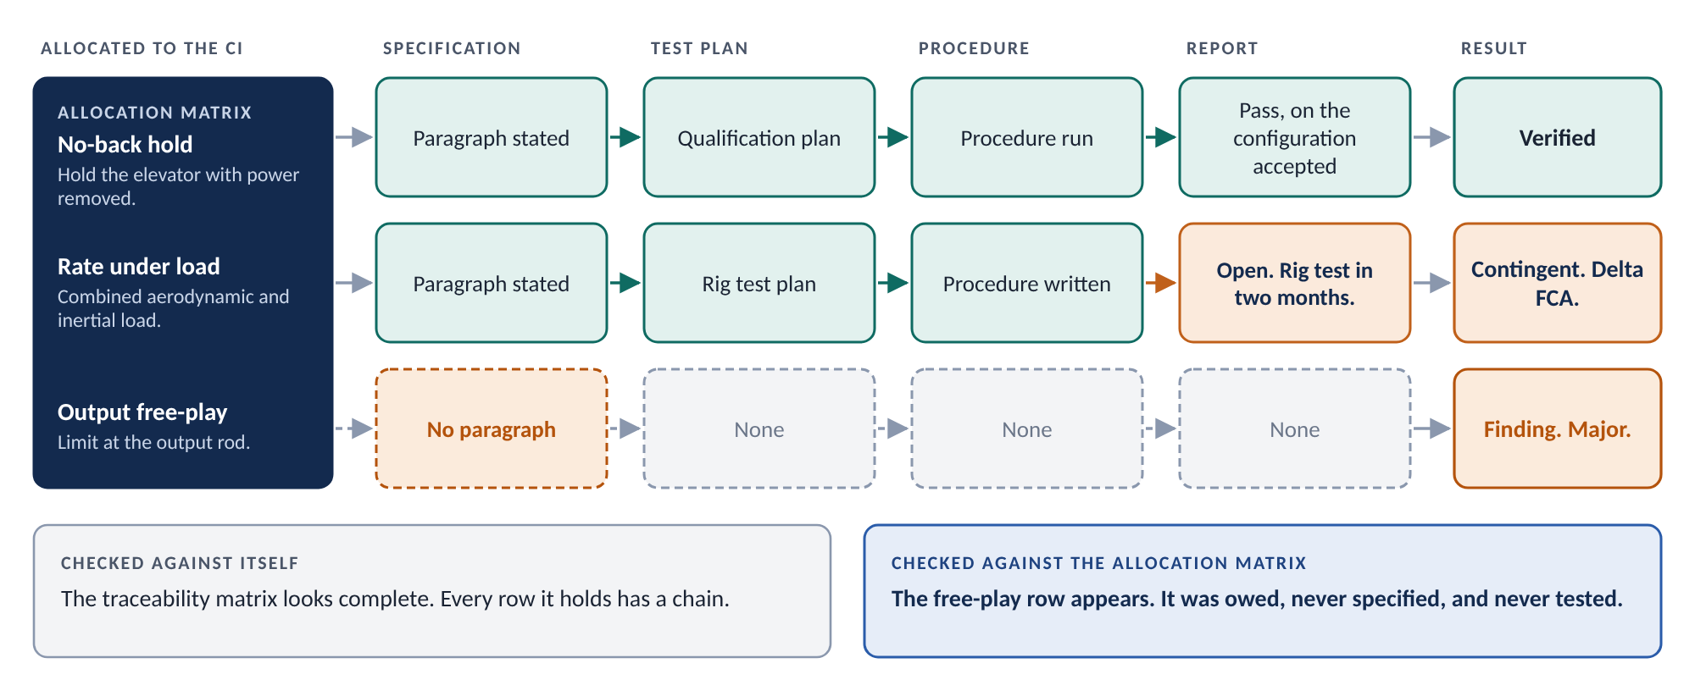
Figure 8. The FCA verification chain
That check is where the most serious FCA finding lives. A requirement allocated to the CI but never carried into its specification appears in no test plan. Nothing looks for it. Only the allocation matrix shows it was owed.
The traceability matrix is a pre-audit submittal. It covers all requirements. It cross-references test plans, procedures, test programs, and reports. It identifies each known deficiency by deficiency report number. It becomes part of the FCA minutes. Providing it is mandatory for safety.

Open with what failed
Each audited CI opens with a design-team briefing. The briefing covers an overview, test results and findings, requirements not met with proposed remedies, changes incorporated, tested, and proposed, and the overall test effort with its problem areas.
The slot for requirements not met is required. A briefing that reaches it with nothing to say has either an unusually clean program or a briefing problem. The audit establishes which.

The FCA check set
The FCA does not invent its own questions. The process carries a set of twenty named checks, in five groups. Every check is performed for every CI designated for FCA. Every check is recorded as pass, finding, or not applicable. A check that does not apply is recorded as not applicable. It is never omitted.
Each check carries its depth: in full, or sampled. The audit plan sets sample sizes within that depth. It does not decide which checks run in full. Requirements that verify hazard risk controls are in the sample for every sampled check.
Check | Depth | Why it exists
THE VERIFICATION CHAIN
Requirement allocation to the audited CI | In full | The allocation matrix is the audited population. Without it, “all requirements verified” has no agreed denominator.
Requirement to verification method | In full | A requirement with no stated method appears in no verification artifact. Nothing raises it as open.
Documentation flow, requirement to result | Sampled; in full for hazard risk controls | The chain breaks quietly: a plan with no procedure, a procedure with no report, a report that closes no named requirement.
Interface requirements in the verification flow | Sampled; in full for interfaces carrying hazard risk controls | An interface is owned at two boundaries. It is dropped by omission, not by failure, so nothing raises it.
Test configuration provenance | In full | A result from a different build or software version proves that build, not this one.
COMPLETENESS
Tests accomplished with recorded data | Sampled | A result whose data cannot be retrieved is an assertion.
Tests accomplished without recorded data | Sampled | These results rest on a signature, not on evidence. The list is kept separate so nobody mistakes one for the other.
Tests required and not yet performed | In full | An FCA may proceed with open verification. It may not proceed with open verification nobody named.
Analyses, inspections, and demonstrations | Sampled; in full for safety-related requirements | An analysis built on inputs from another configuration proves nothing about this one.
CHANGE AND VARIANCE
Engineering changes incorporated and tested | In full | A change can quietly invalidate a requirement verified months earlier.
Variances against the audited unit | In full | A variance is a knowingly accepted departure. If the audit cannot see it, the record claims an achievement that did not happen.
Deficiency reports against requirements | Sampled | A requirement marked verified with an open deficiency against it is not verified.
SOFTWARE, FOR EACH SOFTWARE CI
Software product documentation | In full | A document that describes behavior the software does not have misleads every user of it.
Database, storage, timing, and sequencing | In full | These characteristics are verified against the audited version, or they are not verified.
Developmental configuration change records | In full | Before the product baseline is formalized, the developmental configuration is what change control runs against.
Software library version listing | In full | A version in use with no library entry cannot be rebuilt or traced.
Internal CM and software quality audit findings | In full | These are the supplier’s own findings about its own control. An open one widens the sample. It is not a paperwork item.
CARRY-FORWARD AND CLOSURE
Prior review and lower-level audit closure | In full | Findings from PDR, CDR, and lower-level audits do not expire with the event that raised them.
Provisioning drawing sample | Sampled | The question is whether the drawing alone is enough to buy the part again.
Partial completion recorded, not assumed | In full | Open verification carries forward to a delta audit or the final system-level audit. It does not disappear.

Software follows the same logic with more surface. The standard puts it flatly. The software FCA “ensures that all requirements have a related test step, and the test, as performed by test engineers, passes successfully” (3.5.2). Not most requirements. Not the ones testable within the schedule.

Sampling has one hard limit
Sampling is allowed where it is agreed. A specification with 1,900 requirements may be audited on a sample.
Requirements that verify hazard risk controls, and other safety-critical requirements, are in the sample. They are never sampled out. System Safety identifies which requirements those are. The rest of the sample is drawn around them.
This is the rule a compressed schedule attacks first. Sampling is a concession to volume. It is not a lottery that safety requirements are allowed to lose.

The actuator’s FCA
ACME conducts the actuator’s FCA at its facility. The company co-chairs, because the audit is initiated internally. The actuator performance specification is the allocated documentation. The flight control system specification is the parent.
Walk one requirement. The allocation matrix allocates the no-back requirement to the actuator: hold the elevator at its commanded position, with power removed, under limit hinge moment. The actuator specification states it. The verification method is test. The qualification test plan names the test. The procedure runs it. The report records a pass, on the qualification unit, at the configuration being accepted. The chain is unbroken.
Walk a second. The allocation matrix also allocates a free-play limit at the output rod to the actuator. The actuator specification does not state it. No test plan carries it. The traceability matrix, checked only against itself, looks complete.
The allocation check finds it. The finding cites the allocation matrix row and the specification revision. It states that the allocated requirement has no specification paragraph and no verification. That is design data that is incomplete, so the finding is major.
Then the extent question. Was this one slip, or did the allocation process drop requirements? CM and Systems Engineering check the other allocated rows. Two more requirements on other CIs share the same gap. The finding goes against the allocation process, not only against the actuator.

Partial completion and the delta audit
Some verification can only finish after system integration. The actuator’s rate requirement under combined aerodynamic and inertial load depends on integrated testing on the flight control test rig. That test is two months away.
The FCA has three options. Postpone everything. Certify a completeness that does not exist. Or acknowledge partial completion. The third is the process answer.
The open requirement becomes an action item. The minutes record it as contingent. A delta FCA is planned to close it once the integrated test passes.
The delta audit is the mechanism that lets an audit tell the truth about what is not finished.
A delta audit is scoped to the delta. That means everything the delta touches, not only the requirement that prompted it. Suppose the rig test fails and ACME changes the motor winding. The change reaches torque, rate, and power requirements verified months earlier. The delta audit re-examines each one it touches. Deciding what a change touches is engineering judgment. It is recorded and signed.
A delta audit is not a smaller audit. It is a full audit of a smaller scope. Its results are added to the original minutes or supersede them. The program makes that choice once and applies it consistently.

The software FCA
The flight control software is a computer software CI. The company conducts its software FCA. The five software checks apply, in full.
One of them finds something. The internal software quality assurance audit of the software CI has an open finding against configuration control of the test scripts. That is the supplier’s own finding about its own control, and here the supplier is the company. The FCA evidence was produced by the process that finding questions.
So the audit widens the sample. It widens the documentation flow check, the interface check, and the deficiency report check. An open internal finding is grounds to look harder, not a line in the minutes.
ACME’s motor controller firmware gets its own software functional audit, conducted by ACME. The same five checks apply to it.

10. The physical audit

Identity is not conformity
The PCA takes one unit and asks whether the documentation describes it. Matching part numbers establishes identity. Every other check exists because identity is not conformity.
The PCA works from the as-designed to as-built reconciliation report for the specific unit. It does not perform the reconciliation. That already ran at scale through the CSA system. The audit checks whether that machinery produced the right answer for this unit.
The PCA samples to judge whether inspection and process control worked. It is not a re-inspection of the article. It cannot verify material, certification, or process conformance by looking. It verifies the evidence chain. Its findings are breaks in that chain.

Three comparison families
The PCA check set holds eighteen named checks. They fall into three families, by what each compares.
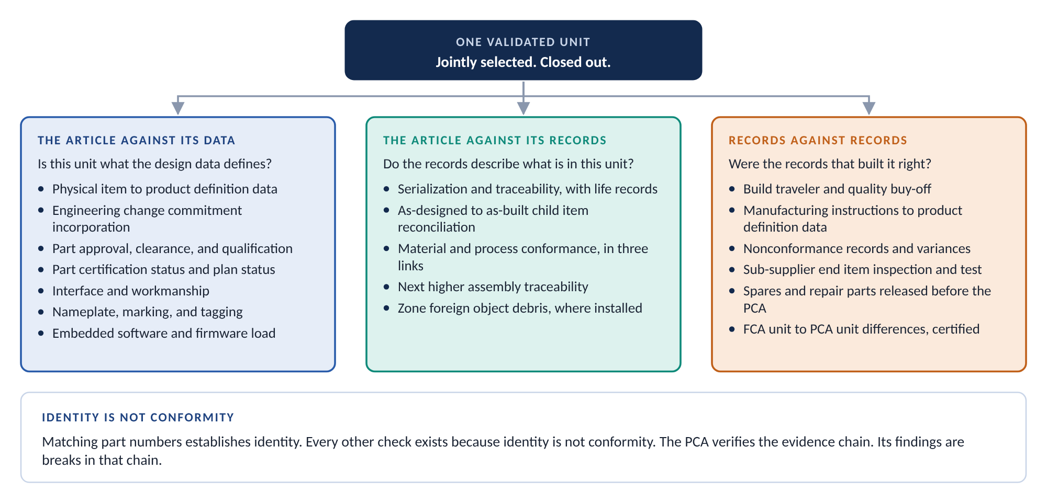
Figure 9. Three comparison families
Check | Depth | Why it exists
THE ARTICLE AGAINST ITS DATA
Physical item to product definition data | In full | A part number does not carry a revision. The governing revision has to be established from the article and its records, without inference.
Engineering change commitment incorporation | In full, for applicable approved changes | An approved change not in the unit, or a change in the unit nobody approved, are both departures.
Part approval, clearance, and qualification records | Sampled | A part can match the drawing and never have been approved for use. Verifying installed parts against the parts selection list is mandatory for safety.
Part certification status and plan status | In full | A certification credit can rest on a configuration other than the one audited.
Interface and workmanship | Sampled | A conforming feature whose inspection record disagrees with the article is evidence about the inspection system.
Nameplate, marking, and tagging | In full | A correct part with a wrong nameplate is delivered as a different item. No record will show it, because every record describes the right part.
Embedded software and firmware load | In full | A checksum that matches a drawing but not the witnessed build proves only that someone copied a number.
THE ARTICLE AGAINST ITS RECORDS
Serialization and traceability | In full | The identifiers on the article, the requirement, and the record must all agree. Two of three agreeing is a finding.
As-designed to as-built child item reconciliation | Sampled; in full for safety-related items | Small hardware, such as shims, washers, adhesives, and thread-locker, is easy to drop from a build record. Absence in the record is the finding.
Material and process conformance | Sampled; in full for safety-related items | Three links: material specification, to build record, to certificate. Only the third link catches a record that faithfully logged the wrong material.
Next higher assembly traceability | In full | After an escape, fleet-wide lot and heat questions must still be answerable.
Zone foreign object debris | In full, where installed | Applies only where the CI is installed. Tools and debris in a closed zone are what this check exists to find.
RECORDS AGAINST RECORDS
Build traveler and quality buy-off | Sampled | A stamp applied without authority, or data from out-of-calibration equipment, makes the evidence inadmissible.
Manufacturing instructions to product definition data | Sampled | The traveler check asks whether the traveler was followed. This check asks whether the traveler was right.
Nonconformance records and variances | In full | An adjudication below the authority the classification requires is no adjudication.
Sub-supplier end item inspection and test | Sampled | An installed supplier item needs its inspection record at point of manufacture, current for the installed configuration.
Spares and repair parts released before the PCA | In full | Articles already in stores or the field went out at whatever configuration their release records say. No audit will ever look at them.
FCA unit to PCA unit differences | In full | Tooling, process, source, and workmanship differ between preproduction and production. The certification is the deliverable. Identifying the differences is mandatory for safety.

Features that implement or protect hazard risk controls are in every sample. So are safety-critical characteristics. That rule is not tailorable. Where an Acquirer chairs, the Acquirer co-chair identifies the drawing sample and the items to examine.

One unit, three defects
The CEU shows why the full set matters. The company designs and builds the CEU, and conducts its PCA. The jointly selected unit has closed build records. It carries three defects.
- Defect A. A washer stack and lockwire on a ground stud appear on the as-designed data. The closed work orders have no entry for them. The joint looks complete.
- Defect B. The unit was built to a work instruction written against a superseded revision of the circuit card assembly drawing. The revision did not change the part number. Every operation is stamped.
- Defect C. A chassis bracket’s heat number on the article matches the heat number on the as-built record. The certificate for that heat is for a different alloy.
Figure 10 runs the three defects through seven checks. Each defect passes every check but one.
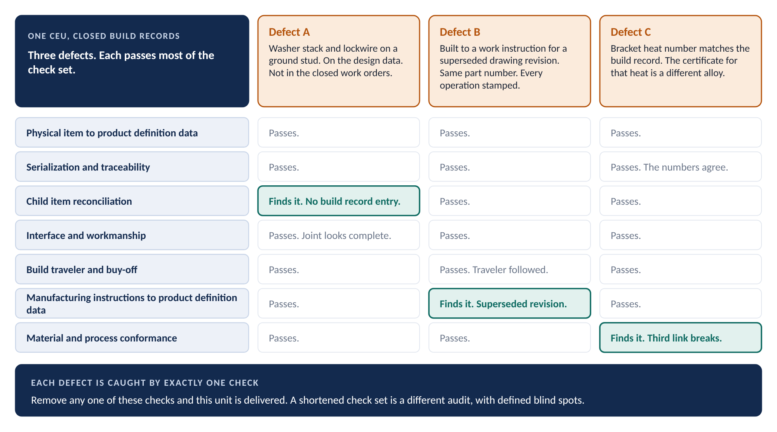
Figure 10. One unit, three defects
Three observations follow.
- Every defect passed most of the check set. Remove any one of these three checks and this unit is delivered.
- Defect C passed traceability correctly. The numbers agreed with each other. Numbers matching numbers is the failure the whole set exists to break. It reappears inside a single check.
- Defect A is the one people argue about. The joint looks complete, so someone proposes to close the finding by inspecting the article. That misses the point. The build record does not account for an as-designed item. That is a statement about the record system, and the record system serves every other unit on the line.
A shortened check set is not a faster audit. It is a different audit, with defined blind spots.

Differences between the FCA unit and the PCA unit
The PCA unit is rarely the FCA unit. The difference matters most on the actuator.
ACME built the actuator’s qualification unit in its development shop. Production unit serial number 0004 came off the production line. Its machined details were plated by Apex. Both units were built to the same source control drawing.
“Both were built to the same drawing” is not an answer. Tooling, process, source, and workmanship differ between development and production, even where the design data does not. ACME identifies each difference: the production tooling, the plating source, and a fastener lot from a second distributor. ACME certifies, or demonstrates, that none of them degrades the functional characteristics. Systems Engineering certifies that any element redesigned after the FCA still meets the performance specification.
Identification alone is not enough. The certification is the deliverable. An unidentified difference is a finding.

Acceptance testing and spares
Two PCA questions look past the audit unit.
The first is whether the acceptance testing in the documentation is adequate to accept production units. Read the acceptance procedure against the defect modes actually escaping on this CI and its production line. A known escape mode the acceptance test cannot detect is a finding against the documentation, not the unit.
The second is the spares. Spares and repair parts released before the PCA are already in a store or in the field. Their interim release records are the only statement of their configuration. The audit checks those records against the configuration it establishes. A difference that was never identified or dispositioned is a finding. The unit on the floor is the sample. The articles already gone are the population.

The software PCA
The software PCA examines the as-coded configuration against its documentation. It compares source listings to the released documentation. It verifies the version description, including the compiler, the compiler version, and the settings.
Then comes the part that surprises people. The build is produced during the PCA. It is installed on the target device. It is verified against the software version description. QA, or the entity the Acquirer designates, witnesses all three. Every update listed on the build’s problem reports is confirmed applied.
This is where toolchain identification pays off or fails in public. If the compiler version and settings were never captured, the build cannot be reproduced. Then the audit cannot be satisfied. An archived binary is not a substitute. Rebuilding is the test.
For the flight control software, the witnessed build reproduces the delivered image. Its checksum matches the version description.
For ACME’s motor controller firmware, the embedded load check reads the load back from the device. It compares version, part number, and checksum against the version description from the witnessed build, not against a value typed into a drawing. Where a device cannot be read back, the check calls for a load record for that unit, witnessed by QA, with the checksum verified at loading.

Results and the product baseline
Each PCA non-compliance is documented and provided to the Acquirer. Where inspections, tests, or audits must be re-accomplished, the Acquirer is invited to witness them.
After successful PCA completion and approval of the product specification, the Acquirer formalizes the product baseline for the CI. From then on, every change to the CI is processed by formal engineering change action. CM records the formalization in CSA.

11. The final system-level audit

Not an audit of everything
Where audits run in increments, a final system-level audit confirms that all functional, allocated, and product baseline requirements are satisfied (3.5.1 (2)). For the PCA, it confirms the system product baseline is correct (3.5.3 (3)). The standards and many contracts call it a capstone audit. This guide uses final system-level audit throughout.
The system is itself a CI, normally the top one. On this program it is the air vehicle. That raises a question. Audits cover a selected subset of CIs. So what does a system-level audit cover, when the system contains everything?
The tempting answer is everything. It produces two responses that fail the same way. One tries to audit the whole engineering bill of materials. That is unaffordable, so it collapses or becomes a paper exercise. The other samples a percentage of the installation drawing set. The sample lands in structure and wiring, by drawing volume. No CI designated for audit is examined. No interface is checked against its definition.
The installation drawing set is not the audit population. It is the means of locating what to examine. A percentage of the wrong population is not a sample. It is a number.

Two populations
The final system-level audit has two populations. Neither one is the drawing set.
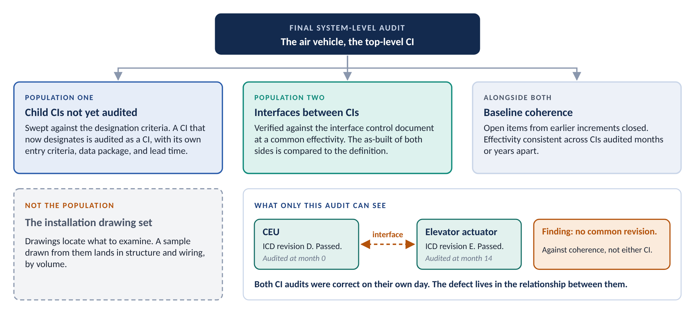
Figure 11. The final system-level audit
- Child CIs not yet audited. CM sweeps them against the designation criteria. A CI that now designates is audited as a CI, with its own entry criteria, data package, and lead time. A program accumulates triggers for years. A CI that failed designation at award may pass easily by the time the system is complete.
- Interfaces between CIs. Each interface is verified against its interface control document at a common effectivity. The as-built of both sides is compared to the definition. Each CI’s own audit verified its side against its own data. No CI-level audit establishes that two CIs meet correctly.
The interface population comes from the interface register, maintained under the CI identification process. It holds one row per interface between two sides, with each source that defines it and its revision. Priority goes to interfaces where both sides are designated, where the interface carries a hazard risk control, or where the interface document changed since either side was audited. An open coverage exception on the register, such as an unmapped row or a floor gap, is a finding against interface coverage, not against the article.

Baseline coherence
Alongside the two populations, the audit confirms baseline coherence. Open action items and deltas from earlier increments are closed. Effectivity is consistent across CIs audited months or years apart.
The CEU and the actuator show why. The CEU was audited against revision D of the interface control document between them. The actuator was audited fourteen months later, against revision E. Both audits were correct on their own day. The air vehicle was never verified against one consistent set.
Neither CI audit was wrong. The defect lives in the relationship between them, and only a system-level view sees a relationship. The finding goes against baseline coherence and interface control. Its extent check covers every air vehicle built in the window between the two revisions.
Coherence also covers the CI structure. Where a CI was split or consolidated between increments, the interface register must have been re-mapped. A split creates boundaries that did not exist when earlier increments were audited. No earlier audit can have covered them.

Timing and place
Run the designation sweep at the CM plan revision before the final system-level audit, not at its door. A CI that newly designates needs its own entry criteria, data package, and lead time. Confirm the sweep again at entry. A CI that newly designates at that point is itself a finding about how designation was maintained.
The final system-level audit convenes where the end item is assembled. On this program that is the company’s final assembly facility. Where an installation-build supplier assembles the end item, that supplier hosts, and the company or the Acquirer conducts. The supplier provides the article, the facility, access including the installation zone, the zone closeout records, and the assembled evidence. Those obligations are bought in the subcontract, or they are requests.

12. Findings, closure, and the record

There is no verbal finding
Every discrepancy becomes a written record. It defines four things: the issue, the agreed closure plan, the responsible person, and the agreed suspense date. The record is a request for action where the contract calls for one, or an entry in the body of the minutes.
Each element earns its place. A person, not a department, because you cannot ask a department for status. A suspense date, not an intention, because an undated commitment can never become overdue.
A discrepancy both sides discussed and nobody wrote down did not happen. It will be re-argued as though it never did. A finding fixed during the audit is still recorded. Its record tells the Acquirer and the next program that the gap existed.
A scribe is assigned before the audit begins. Daily minutes are reviewed jointly at the start of the next session. That is when a disagreement about what was found is cheapest to settle. Side-meeting conclusions are folded into the official minutes by the co-chair.

Writing a finding
A finding that survives has three statements, in order.
- The requirement. What was supposed to be true, cited to the document that says so, by number and revision. If you cannot cite it, you do not have a finding yet.
- The objective evidence. What you examined and what you saw, identified precisely enough that someone else can look at the same thing tomorrow.
- The non-conformance. The gap between the two, stated as a fact, not as a conclusion about anyone.
Weak | Why it fails | Stronger
Traceability is inadequate. | No requirement, no evidence, and an adjective doing the work. | The parts list at the governing revision requires serial traceability for the ball screw. The build record for actuator serial number 0004 records a lot number only.
The build records are a mess. | A judgment about the supplier, not a statement about the CI. | Four of eleven nonconformance records against serial number 0004 show a disposition with no accomplishment sign-off.
Wrong revision used. | No statement of which revision governs, or how that was established. | The governing revision for this unit’s effectivity is G, per the approved change. Revision F was released to the floor and used.

Then ask the extent question. Is this one instance, or is this the mechanism working as it does? Ask what would have had to work for this not to happen. Then ask whether that thing is working.
Write the finding against the thing that is wrong. A missing safety designation on a supplier part may be a finding against the supplier. It may be against the statement of work that never imposed it, or against the flowdown that never reached the supplier. Establish who owed it before you write it against anyone. Designation authorship follows one of three cases: company assigned, supplier proposed and company approved, or externally assigned.

Major, minor, and observation
Findings carry one of three classes. The classes and their criteria come from GEIA-HB-649A. That handbook is guidance, and the company has adopted them.
Class | Criteria
Major | Production definition documentation or design data incorrect or incomplete. A systematic breakdown of process control. Clear non-adherence to workmanship standards. Hardware or software not included in the build process. Non-adherence to specification, ICD, or SOW requirements. FAI data missing or incomplete.
Minor | Non-systematic errors, such as typographical errors, in production definition documentation, process control records, or workmanship standards documentation.
Observation | A general query, or a process improvement recommendation, that meets neither the major nor the minor criteria. Not cause for delay or for stopping production. Recorded on a request for action like any other finding.

Classify by mechanism, not by count. One instance produced by a broken mechanism is major. Fifty independent slips are fifty slips.
The line sits there because a broken mechanism will produce more instances. Every one of them is still to come. Two errors follow from counting.
- Counting up to major. Eleven typographical errors feel serious. If each is an independent slip, the mechanism is intact and the finding is minor.
- Counting down to minor. One connector installed off the approved parts list feels small. If it got there through informal substitution under shortage pressure, that route is open to every technician on every shortage. The finding is major.
The observation class exists so a real observation is not inflated into a minor finding. An audit with only two boxes pushes every general query into one of them.
One caution on words. EIA-649-1A does not classify audit findings at all. It classifies engineering changes as major or minor, and requests for variance as critical, major, or minor. Neither scheme belongs on a finding. There is no critical audit finding.

Closure, certification, and disposition
A finding is closed by evidence, not by assertion. The owning function performs the corrective action and the extent check. CM keeps the finding record and the closure evidence. System Safety dispositions any finding with safety consequence. Supplier Requirements Engineering routes supplier findings and executes the contractual action.
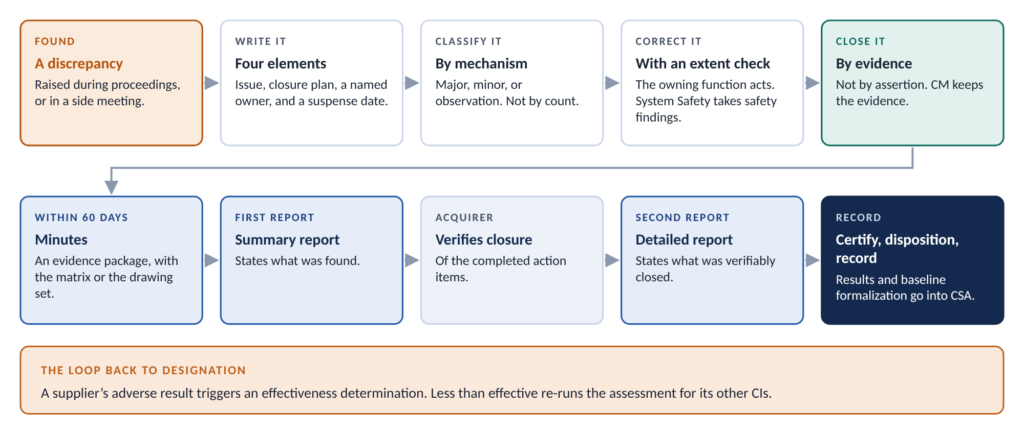
Figure 12. From findings to the record
Step | What happens
Publish | Finalized minutes reach the Acquirer no later than 60 days after audit completion, or per contract.
Close | Every action item is tracked to closure. Corrective action documentation goes to the Acquirer for review.
Report | The summary report states what was found. The detailed final report is issued only after the Acquirer verifies the completed action items (3.5.5 (1)).
Certify | The supplier audit lead, the program manager, and the Acquirer representatives sign. The result is complete and successful, with no open worksheets, or conditional, with resolutions agreed and tasks not yet done.
Disposition | The Acquirer records approval, contingent approval, or disapproval.
Record | CM records scheduled and actual audit dates, results, and the product baseline formalization in CSA, per CI.

The two reports matter. A single report issued on claimed closure collapses the difference between what was found and what was verifiably closed. CM does not certify closure until the closure evidence exists.

What the audit leaves behind
The checks are not the deliverable. What survives the audit is its record.
The minutes are an evidence package. They identify the audited CI, the decisions and proceedings, the attendees, and the action items. They list every document with its revision at the time of audit, and every requirement audited. They identify everything examined by name, specification number, product identifier, serial number, part number, and CAGE code. For the FCA, they include the traceability and test matrix. For the PCA, they include the drawing package with its manufacturing instructions and the completed inspection reports. They also carry the baseline records, including spares released before the PCA, the sub-supplier inspection confirmations, and the parts selection list.
The completed check sets are the record that the substance was performed in full. Every check reads pass, finding, or not applicable.
Findings also measure the process. Results from ACME’s audit are evidence about ACME’s configuration management, not only about the actuator. An adverse result triggers an effectiveness determination. A determination of less than effective is a risk factor and a trigger for every other CI ACME builds. A repeat finding two years later is telling you about the organization, not the item.

13. Steps by lifecycle state
Audit work starts long before the first audit convenes. It ends only when the program does. Figure 13 shows the work at each stage. The tables below list the actions and their owners.
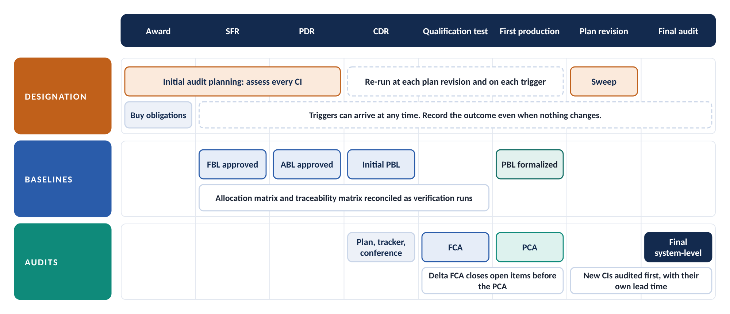
Figure 13. Audit work across the lifecycle

Award: buy the obligations
Action | Owner
Read the contract, statement of work, and CM plan for audit designations and their scope. | CM
Write audit obligations into each supplier statement of work. Impose them outright where the CI is already designated. Cite the standing conditional audit clause where the work type carries a role. | Supplier Requirements Engineering, CM
Cite access, joint unit selection, and work order closeout confirmation, each with the access right and the verification method. | Supplier Requirements Engineering

ACME’s statement of work imposes the actuator’s audit obligations outright, including the firmware audit and witnessed build.

Initial audit planning: designate
Action | Owner
Run the designation assessment on every CI. Answer each question from its source. Record the source. | CM
Mark unestablished answers open. Assign the owning function and a date. | CM
Supply the documentation the answers come from. Provide input where it is unclear or silent. | Systems Engineering, Design Engineering, System Safety, RM&SH, Quality, Supplier Requirements Engineering, Airworthiness and Certification
Record designation and scope for every CI, designated or not. Sign. System Safety signs wherever a safety answer is yes. | CM, Systems Engineering, System Safety
Route any proposal not to conduct a designated audit to the safety disposition gate. | System Safety

The actuator is designated for both audits on its safety answers. Its assessment waits for RM&SH to close the single point of failure answer.

Through SFR, PDR, and CDR: make the audits possible
Action | Owner
Obtain Acquirer approval of the functional and allocated baselines for each CI designated for FCA. | Systems Engineering, Acquirer
Approve the requirements allocation matrix for each CI. Reconcile the traceability matrix against it as verification proceeds. | Systems Engineering
Establish the initial product baseline at CDR. | CM
Re-run the assessment at each CM plan revision and on each trigger. | CM

The actuator’s allocation matrix comes from the flight control system specification. The free-play gap could have been caught here.

Before each audit: prepare
Action | Owner
Prepare the audit plan and agenda. Obtain Acquirer approval. Hold the planning conference 30 to 60 days ahead. | CM
Where a supplier conducts, receive its audit plan for agreement. Work the preparation tracker jointly. | CM, Supplier Requirements Engineering
Assemble the data package from the CSA system. Track every row to complete or not applicable. | CM, with each row’s provider
Select the PCA unit jointly. Confirm the three closeout conditions for that unit. | CM, Acquirer, Quality, Manufacturing
Produce the reconciliation report for the PCA unit. | CM status accounting
Identify the requirements and features that carry hazard risk controls, so no sample excludes them. | System Safety

Serial number 0003 fails the third closeout condition. Serial number 0004 is selected instead.

During and after each audit: conduct and close
Action | Owner
Work the check set. Record every check as pass, finding, or not applicable. | Audit team, CM
Record every finding with its issue, closure plan, owner, and suspense date. Classify it by mechanism. | CM
Acknowledge partial completion. Plan the delta audit. | CM, Test and Evaluation
Certify the FCA unit to PCA unit differences. Certify any element redesigned after the FCA. | CM, Systems Engineering
Deliver minutes within 60 days. Issue the summary report, then the detailed report after verified closure. | CM
Record results and the product baseline formalization in CSA. | CM

The actuator’s rate requirement closes by delta FCA after the rig test. Its PCA follows. The Acquirer formalizes its product baseline.

Before the final system-level audit: sweep
Action | Owner
Run the designation sweep at the CM plan revision before the final system-level audit. | CM
Audit every newly designated CI as a CI, with its own lead time. | CM
Scope the interface population from the interface register. Confirm common effectivity. | Systems Engineering, CM
Confirm the sweep again at entry. | CM

The interface between the CEU and the actuator is checked against one revision of its interface control document.

Throughout: keep the answer current
Action | Owner
Notify CM of any change in your own domain that could be a trigger. | All supplying functions
Re-run the assessment on every trigger. Record the outcome, even when nothing changes. | CM
Feed supplier audit results into effectiveness determinations. | CM, Supplier Requirements Engineering

Any function may raise a trigger. CM is accountable for acting on it, and for finding the ones nobody raised.

14. Who does what
CM owns the process, answers the assessment, and keeps the record. Other functions own the evidence the audit works from. The Acquirer approves, co-chairs, and dispositions.
Role | What it does in configuration audits
Configuration Management (CM) | Owns the process. Answers every assessment question from its source and records the rationale for every CI evaluated. Holds the change records and their effectivity. Runs the at-scale reconciliation and produces the report for the audit unit. Prepares the plan and agenda, assembles the data package, records minutes, documents each finding, tracks it to closure, prepares the summary report, and records results in CSA.
Audit co-chair (supplier) | Runs proceedings jointly with the Acquirer co-chair. Conducts the opening briefing and the management out-briefs. Folds side-meeting conclusions into the minutes.
Systems Engineering | Provides the allocation matrix, the traceability matrix, specifications, and interface documentation, and reconciles the two matrices. Supplies design history and heritage evidence. Signs the assessment. Presents verification evidence at the FCA.
Design Engineering | Provides released drawings, models, parts lists, and product specifications. Authors the technical content of each change. Supports the as-designed to as-built reconciliation at the PCA.
Test and Evaluation | Provides test plans, procedures, and reports. Accounts for tests not yet performed and the plan for each.
Manufacturing and Quality Assurance | Provide manufacturing instructions, process records, QA records, first article results, and acceptance test data. QA witnesses the software build. Confirms production processes match development, or that changes are documented.
Software Engineering | Produces the version description, build records, and developmental configuration status. Supports the witnessed build.
System Safety | Identifies the requirements and features that carry hazard risk controls. Supplies the hazard log and safety analyses. Signs wherever a safety answer is yes. Routes proposals not to audit to the safety disposition gate. Dispositions findings with safety consequence.
RM&SH | Supplies the FMECA, the single point failure identification, and reliability history. Identifies life-limited and criticality-designated parts in the PCA unit.
Airworthiness and Certification | Supplies the certification basis, previously approved data, and change classification, where the program has a certification basis.
Logistics | Provides provisioning, technical manual, and support equipment data. Identifies spares and repair parts released before the audit.
Supplier Requirements Engineering | Authors the supplier statement of work and buys the audit obligations, including access with its verification method. Arranges access and hosting. Calls the supplier audit plan. Identifies new sources and sub-tiers. Routes supplier findings.
Equipment managers and Responsible Engineers | Confirm the technical basis and data package sufficiency for their items. Answer technical questions during the audit. Own corrective action for findings against their items.
Sub-suppliers | Where one of their CIs is designated, plan, conduct, host, or support the audit per their work type. Submit audit plans for agreement. Field people who can discuss the technical detail.
Acquirer | Approves the schedule, plan, and agenda. Co-chairs. Selects the PCA unit jointly. Dispositions results. Formalizes the product baseline after successful PCA.

15. Records the process keeps
The audit’s value lies in what it can prove afterwards, to people who were not in the room. These records carry that proof.
Record | What it holds
Audit designation assessment records | The completed assessment for every CI evaluated, designated or not, with sources, rationale, scope, and signatures. Re-performed at each CM plan revision and trigger. Retained for the program life.
Audit plan and agenda | Scope, items, place, dates, co-chairs, team, documents, and schedule. Acquirer-approved.
Audit data package index | Every artifact assembled, with its document number and revision at the time of audit.
Preparation trackers | One per audit event. Each required input with provider, due date, and status.
Audit minutes | The evidence package described in Section 12. Delivered within 60 days.
Action item records | Each finding with its class, closure plan, owner, suspense date, and closure evidence.
Completed audit checklist package | The completed readiness checklists and both check sets, each check recorded as pass, finding, or not applicable, with findings cross-referenced to their records. The summary report is derived from it.
Configuration audit summary report | The summary report, then the detailed report after verified closure.
Certification forms | Joint FCA and PCA certifications, and the program manager’s baseline certifications.
CSA records | Scheduled and actual audit dates and results per CI. Product baseline formalization entries.

16. Best practice
The process says what must happen. These practices help it happen well. Each one rests on a rule already stated in this guide, or on guidance in GEIA-HB-649A where noted.
GEIA-HB-649A puts the reason in one sentence: “The more confidence the Government has in a contractor’s configuration verification process, the easier the configuration audit process becomes.” Most of the practices below build that confidence before the audit convenes. Few of them happen during the audit itself.

For CM
- Answer from the source, and say which source. Record the document, revision, and owner behind every assessment answer. The next assessor should never have to guess whether a no was established or assumed.
- Record the outcome when nothing changes. A re-run that leaves the designation alone is still a record. It shows the trigger was seen and acted on.
- Treat CSA accuracy as audit readiness. Use the CSA system as the single source for every data package. Retire separate audit spreadsheets. A second list becomes a second version of the truth.
- Plan early, and keep the plan current. GEIA-HB-649A notes that successful audits require planning in the early stages of development, with periodic updates to the audit plan. Build the preparation tracker when a CI is designated, not when the audit is scheduled.
- Agree the supplier’s plan. Do not just receive it. Work one tracker with the supplier from that point. Two lists meet for the first time on audit day.
- Look at the rework queue. A status report that tracks dispositions will show a unit clean while rework waits. Confirm the third closeout condition against the queue itself.
- Settle not-applicable checks before audit day. Record each one with its reason on the designation assessment, especially for vendor items. A not-applicable decided in the room looks like a check that was skipped.
- Staff the record before the audit opens. Assign a scribe. Ready the finding forms. Review the daily minutes at the start of each next session. GEIA-HB-649A notes that standard agendas, action items, and minutes keep data consistent across teams.
- Run the designation sweep one plan revision early. A CI that designates at the door of the final system-level audit has no time for its own audit.
- Trend findings across audits. A repeat finding two years later is a measurement of the organization, not the item. Report it that way.

For Systems Engineering and Test
- Reconcile the two matrices as verification runs. Check the traceability matrix against the allocation matrix at every verification milestone. A gap found at the audit is a gap that sat open for months.
- Name open verification early. Put every untested requirement on the not-yet-performed list, with its plan and the milestone that closes it. An FCA can proceed with open verification. It cannot proceed with open verification nobody named.
- Record the configuration under test. Note the build, software version, and serial number for every test run. The test configuration provenance check asks for it, and memory does not survive two years.
- Scope a delta by what the change touches. Write down which verified requirements the change could reach, and sign the judgment. A delta scoped only to the requirement that prompted it misses the ones the change broke.

For Software Engineering
- Capture the toolchain at every release. Record the compiler, its version, its settings, and the library state. The witnessed build cannot be reproduced without them.
- Rehearse the build before the audit. Rebuild from the controlled archive on a clean machine and compare checksums. Find a missing tool in rehearsal, not in front of the Acquirer.
- Keep a load record for every programmable device. Where a device cannot be read back, the witnessed load record for that unit is the only evidence the PCA can use.

For Quality and Manufacturing
- Close the rework before you offer the unit. Dispositioned is not carried out. The audit is rescheduled if any disposition is still open.
- Keep the instructions actually used. Retain the work instruction at the revision used on the floor, not only the current one. The manufacturing instructions check compares against what built the unit.
- Record calibration with every acceptance measurement. Data from out-of-calibration equipment is inadmissible, not merely suspect.
- Keep interim release records for spares. They are the only statement of the configuration those articles left at.

For System Safety
- Flag hazard risk controls before the audit plan is written. Mark the requirements, features, and characteristics that carry them. Then no sample can leave them out by accident.
- Route a proposal not to audit on the day it is raised. It belongs at the safety disposition gate. It does not belong in a schedule meeting.

For Supplier Requirements Engineering and program leads
- Buy the audit at award. Put the standing conditional audit clause in every statement of work where the work type carries a role. At award it is a contingency. After designation it is a negotiation from the weakest position.
- Write access down, with its verification method. Name facility access, installation zone access, joint unit selection, and work order closeout confirmation. Access left implicit is a request.
- Hold lead time for late designations. A program accumulates triggers for years. Budget the time for a CI that designates late.
- Send supplier audit results to the effectiveness determination. An adverse result is a trigger. It re-runs the designation assessment for everything else that supplier builds.

17. Common mistakes
Mistake | Why it is wrong | Do this instead
“It is a CI, so it gets an audit.” | Most CIs are never audited. Designation is a separate screen. | Run the designation assessment.
“It is mature, so we will skip the audit.” | A safety yes designates both audits. Only the safety disposition gate can set one aside. | Route the proposal to the gate.
Stopping at Part A | Contract scope is a floor. The other parts can widen it. | Walk all four parts.
Treating one risk factor as nothing | One factor is recorded so the next one lands on a documented assessment. | Record the factor and monitor the CI.
Answering no when nobody checked | It looks exactly like an established no. | Mark the answer open. Assign an owner and a date.
Accepting a data package in place of a supplier audit | The evidence lives on the supplier’s floor. Swapping the audit changes its substance. | The supplier conducts. A proposal to replace it goes to the gate.
Running the PCA before the FCA | The PCA examines a validated CI. Nothing is validated yet. | Hold the PCA until the FCA is complete or concurrent.
Offering a unit with rework in the queue | Dispositioned is not carried out. The configuration can still move. | Select a closed-out unit, or reschedule.
Checking the traceability matrix against itself | It cannot show a requirement nobody listed. | Check it against the allocation matrix.
Sampling out safety requirements to save time | They are never sampled out. | Draw the sample around them.
Demonstrating firmware from an archived binary | The test is whether the build reproduces. | Produce the build during the PCA, witnessed.
Closing a missing-record finding by looking at the part | The finding is about the record system, which serves every unit on the line. | Fix the record process and check the extent.
Classifying a finding by its count | The class follows the mechanism. | Ask what would have had to work for this not to happen.
Leaving a finding verbal | There is no verbal finding. | Write the issue, plan, owner, and suspense date.
Issuing one report on claimed closure | It erases the line between found and verifiably closed. | Issue the summary report, then the detailed report after verified closure.
Sampling the drawing set for the final system-level audit | It is the wrong population. | Scope it to unaudited child CIs and interfaces.

18. Quick reference
- Is it a CI? If not, it is controlled in its parent’s documentation. Assess the parent instead.
- Is it designated for audit? Walk Parts A to D. Record the source for every answer. Any yes in Part A or Part B designates. Two or more Part C factors designate. Exactly one is recorded and monitored.
- Which audit? Read scope from the question each factor raises. A safety yes, or a CI never audited, takes both. A PCA alone needs a validated CI.
- Who conducts, and where? Design authority and build decide. A data package never does. Only a vendor item is audited in-house after receipt.
- Are the obligations bought? Conduct, host, support, and access are in the statement of work, each with its verification method, or in a standing conditional clause.
- Is the FCA ready? Approved functional and allocated baselines. An approved allocation matrix. A traceability matrix reconciled against it. Test data from the configuration being accepted.
- Is the PCA ready? The FCA complete or concurrent. A jointly selected unit. Its reconciliation report. No open work orders, nonconformance records, or dispositions.
- Was every check recorded? Pass, finding, or not applicable, for every check. Hazard risk controls in every sample.
- Is every finding written and classified? Issue, plan, owner, and suspense date. Class by mechanism, not count.
- Is it closed and recorded? Minutes within 60 days. Summary report, then detailed report after verified closure. Results and product baseline formalization in CSA. Re-run designation on any trigger the audit raised.

19. Limits and open decisions
This guide has limits. Some decisions remain open. The table lists both.
Item | Status
Contract governs | Where a contract imposes different requirements, the contract governs. The program CM plan records the deviation.
Acquirer authority | The Acquirer approves the schedule, plan, and agenda, dispositions each audit, and formalizes each product baseline. The company proposes. It does not decide alone.
Two or more risk factors | Open. The process says two or more risk factors designate a CI. It also allows a CI with two or more factors to stay undesignated, with a signed rationale. This guide quotes both and does not resolve them. A ruling is needed on whether two factors are a rule or a presumption.
Product baseline deadline | Open. The process says the product baseline is formalized no later than first production unit delivery or PCA completion. It also says the PCA is the formalizing event for a CI designated for PCA. It does not say whether first delivery still sets a deadline when that PCA slips past it.
PCA after a partial FCA | Open. A PCA needs the FCA successfully completed or concurrent. The process does not say whether an FCA with acknowledged partial completion and a planned delta meets that test. The worked example holds the PCA until the delta closes.
Never audited | Every new CI answers the never-audited factor yes. So on a new program, the first other factor designates. That follows the process wording. Confirm it is intended.
Worked example alignment | The companion flowdown guidance shows the actuator designated later, when a second risk factor arrives. Under this process, the actuator’s safety answers designate it at initial audit planning. Align the flowdown guidance example.
Finding classes | The major, minor, and observation classes are adopted from GEIA-HB-649A, which is guidance. EIA-649-1A does not classify audit findings.
Delta minutes | Delta results are added to or supersede the original minutes. The program chooses once and applies it consistently.
Vendor item CIs | The company audits a vendor item from outside. It cannot see a change the vendor did not notify. Where a hazard control relies on what it cannot see, the drawing type is referred for decision.
Supplier visibility | An audit sees one unit and a sample. Between audits, supplier control rests on flowdown, deliverables, and effectiveness determinations.
The three events | Section 4 describes three real events without naming them. Confirm the descriptions with System Safety before release.

Appendix A. Glossary
Terms defined by the process keep the process wording. Terms defined by EIA-649-1A keep that wording. The source column says which. The terms in Section 3 are not repeated here.
Term | Definition | Source
Configuration audit | Review of processes, product definition information, documented verification of compliance with requirements and an inspection of products to confirm that products have achieved their required attributes and conform to released product configuration definition information. | EIA-649-1A
Functional configuration audit (FCA) | The formal examination of functional characteristics of a Configuration Item to verity [sic] that it met the requirements specified in its functional and allocated configuration documentation. | EIA-649-1A
Physical configuration audit (PCA) | A formal examination of the actual (as-built) configuration of an item compared to its product configuration documentation. The PCA verifies the product configuration documentation is a clear, complete, and accurate representation of the configuration item and is necessary to establish the product baseline. | EIA-649-1A (first two sentences)
Configuration Baseline | An agreed-to definition of the attributes of a product at a point in time, identifying a known configuration to which changes are addressed. Baseline types are functional (FBL), allocated (ABL), and product (PBL). | CI identification process
Configuration Documentation | Technical documentation whose primary purpose is to identify and define a product’s performance, functional, and physical attributes (e.g., specifications, drawings, models). Comprises functional, allocated, and product configuration documentation. | CI identification process
Effectivity | The point at which an approved change takes effect, stated as a unit, lot, line number, or date. It answers which unit is the first to carry the change. | Sub-supplier CM flowdown process
Engineering Bill of Materials (EBOM) | An aggregation of the product’s parts lists. The EBOM is the As-Designed dataset. It is part of the product definition and changes by engineering change. | Configuration audit process
Manufacturing Bill of Materials (MBOM) | An aggregation of the As-Planned dataset. The MBOM is a restructuring of the EBOM that carries the planning content the EBOM does not. Planning content is not product definition; a difference between the MBOM and the EBOM is not by itself a non-conformance of the unit. | Configuration audit process
As-Built Bill of Materials (ABOM) | An aggregation of the As-Built dataset, comprised of closed build records associated with embodiment. | Configuration audit process
Standing Conditional Audit Clause | A statement-of-work clause imposing configuration audit conduct or support obligations that take effect if and when the procured item is or becomes designated for audit, with the audit deliverables cited as triggered items. | Sub-supplier CM flowdown process
Work Type | A classification of the work a supplier performs, determined by who holds design authority and who performs the build, with item type (hardware, software, commercial item, service) as a modifier. | Sub-supplier CM flowdown process (first sentence)
Design Authority | The authority to establish and change the technical definition of an item, including its detailed design content, and to approve departures from that definition. Design authority may be held in whole or in part. | Sub-supplier CM flowdown process (first two sentences)
Safety-Mandatory Requirement | A CM requirement listed in the enterprise register of safety-mandatory CM requirements. It is imposed on every applicable procurement, or an exception is routed to the safety disposition gate and recorded with its risk acceptance. | Sub-supplier CM flowdown process (first two sentences)
Effectiveness Determination | The recorded judgment of whether a sub-supplier's CM process meets the requirements imposed on it, expressed as Effective, Conditionally effective, or Ineffective, made over rolling accrued evidence on a defined cadence and on defined triggers. | Sub-supplier CM flowdown process
Source Control Drawing (SCD) | A drawing that provides an engineering description, qualification requirements and acceptance criteria for commercial items or vendor-developed items procurable from a specialized segment of industry that provide the performance, installation, interchangeability, or other characteristics required for critical applications. | EIA-649-1A (first sentence)
Vendor Item Control Drawing (VICD) | A drawing that provides an engineering description and acceptance criteria sufficient to identify and select a vendor-developed or commercial item, and that identifies the vendor and the vendor item identification. It controls selection. It does not control the item, and the company holds no design authority over it. | CI identification process
Requirements allocation matrix | The record of which system requirements are allocated to a CI. It states what the CI is accountable for satisfying. | Company usage
Requirements traceability matrix | The record of how each applicable requirement was verified, and with what result. It is checked against the allocation matrix. | Company usage
Check set | The named list of checks an audit performs. Each check is recorded as pass, finding, or not applicable. | Company usage
Witnessed build | A software build produced during the audit, installed on the target, and checked against its version description while the auditors watch. | Company usage
Zone closeout record | The record that an installation zone was inspected and cleared, including for tools and debris, before it was closed. | Company usage
Preparation tracker | The shared list of audit inputs, each with a provider, a due date, and a status. | Company usage

Appendix B. References
Document | Title or relevance
Configuration audit process | The process this guide explains. It governs where the two differ.
EIA-649-1A | Configuration Management Requirements for Defense Contracts. Section 3.5 states the audit requirements.
GEIA-HB-649A | Configuration Management Standard Implementation Guide. Section 10, and the audit checklists from which the check sets are assembled. Source of the finding classes.
ANSI/EIA-649 | National Consensus Standard for Configuration Management.
CI identification process | Companion process. Selects CIs, sets baselines, and owns the interface register.
Sub-supplier CM flowdown process | Companion process. Owns the work types, their audit roles, the standing conditional audit clause, and effectiveness determinations.
CM planning and management process | Companion process. Defines the safety disposition gate.
Safety management system standard | Source of the hazard log, risk controls, and the register of safety-mandatory CM requirements.
FCA and PCA preparation trackers | Working trackers for each audit event.
FCA/PCA CI selection tool | Applies the audit designation assessment.
DI-SESS-81646 | Configuration Audit Plan, where cited on contract.
DI-ADMN-81249 and DI-ADMN-81250 | Conference Agenda and Conference Minutes, where cited on contract.
DI-SESS-81022 | Configuration Audit Summary Report, where cited on contract.
Companion guidance | CI identification guidance, configuration baselines guidance, and sub-supplier flowdown guidance. Same worked example, same format.

