GUIDANCE · DRAFT FOR REVIEW
Configuration Baselines
What the functional, allocated, and product baselines hold, what stays outside them, and how each one is set and kept current
This guidance explains configuration baselines as EIA-649-1A defines them and as the CI Identification Process, Revision I, establishes them (process 5.9). It adds no requirements. Where this guidance and the process differ, the process governs.
References in parentheses point to their source. (process 5.9) points to the process. A bare clause number, such as (3.2.3.2), points to EIA-649-1A.

Audience | Configuration management specialists, systems engineers, design engineers, test and verification engineers, System Safety, RM&SH, Manufacturing Engineering, Quality, Supplier Requirements Engineering, and program management.
Applies to | Programs where the company is prime contractor to a DoD Acquirer. Covers hardware, software, firmware, and their configuration documentation. Section 10 notes the parallel under FAA certification.
Related documents | CI Identification Process, Rev I · EIA-649-1A · GEIA-HB-649A · CI Identification Guidance · Configuration Audit Process · Nonconformance and Variance Guide · Roles in EBOM-MBOM-ABOM Reconciliation memo
Status | Draft guidance. Not yet adopted.

Contents
1. Purpose 2
2. The situation 4
3. Why this matters 7
4. Nine principles 9
5. The functional baseline 10
6. The allocated baseline 12
7. The product baseline 14
8. What the change board controls 18
9. Steps by lifecycle state 23
10. A parallel under FAA certification 25
11. Roles and responsibilities 26
12. Records 27
13. Limits and open decisions 28
Appendix A. Glossary 28
Appendix B. References 30

1. Purpose

1.1 The problem in one example
The elevator actuator’s FMECA finds a failure mode with catastrophic effect. The FMECA allocates a critical function to the actuator. The actuator specification states that function as a requirement. The SCD flags the critical characteristics that deliver it.
Three documents now carry one requirement. The FMECA allocates it. The specification states it. The SCD makes it inspectable. All three are baseline documents. The change board controls all three.
A year later an engineer proposes a change to the actuator’s ball screw. The change package updates the SCD. Nobody updates the FMECA, because someone filed it as background analysis. The change passes. The FMECA now describes a design that no longer exists. The hazard analysis that relies on it may claim a mitigation the hardware no longer provides.
The opposite mistake happens too. A program routes the acceptance test data sheet for one serial number through the change board. The board reviews a record of what one unit did. That record cannot change. It can only be checked against the baseline.
Both mistakes come from one missing rule: what a baseline holds. EIA-649-1A answers by content, not by document type.
Section 2.5 introduces the actuator and four neighbors. They run through every baseline in this document.

1.2 What this document does
This document explains what each configuration baseline holds. It explains why. It shows the mistake each rule prevents.
The emphasis is content. Sections 5 through 8 say what goes in the functional, allocated, and product baselines. That includes the analyses and test procedures that carry baseline content. It also says what stays outside as records. Section 9 covers timing. It says when each baseline is set, when the product baseline is formalized, and how each baseline stays current.
It is written for two readers. Engineers need to know which of their documents a baseline holds, and what that commits them to. CM specialists need to know how to set a baseline and how to defend its content.
It does not replace the process. The process holds the requirements. This document holds the reasons.

1.3 Terms used in this document
Nine terms carry this document. Each keeps one meaning throughout. Process terms keep the process wording. EIA-649-1A terms keep that wording. Appendix A gives the full glossary.
Term | Definition | Source
Configuration Baseline | An agreed-to definition of the attributes of a product at a point in time, identifying a known configuration to which changes are addressed. Baseline types are functional (FBL), allocated (ABL), and product (PBL). | Process 3.1
Baseline | A formally controlled and maintained set of data that serves as the basis for defining change. When used as a verb, baseline is the act of initially establishing and approving a set of data at a given point in time. | EIA-649-1A 2.3
Configuration documentation | The technical documentation that identifies and defines the item’s functional performance and physical characteristics. The configuration documentation is developed, approved, and maintained through three distinct evolutionary, increasing levels of detail. The three levels of configuration documentation are the functional configuration documentation, the allocated configuration documentation, and the product configuration documentation. | EIA-649-1A 2.3
Functional configuration documentation (FCD) | The information describing the system’s functional, performance, interoperability, and interface requirements as well as the verifications required to demonstrate the achievement of those specified requirements. | EIA-649-1A 2.3
Allocated configuration documentation (ACD) | The documentation describing a Configuration Item functional, performance, and interoperability requirements that are allocated from those of a system or higher-level configuration items; interface requirements with interfacing configuration items; and the verifications required to confirm the achievement of those specified requirements. | EIA-649-1A 2.3
Product configuration documentation (PCD) | A CI’s detailed design documentation including those verifications necessary for accepting product deliveries (first article and acceptance inspections). Based on program production/procurement strategies, the design information contained in the PCD can be as simple as identifying a specific part number or as complex as full design disclosure. | EIA-649-1A 2.3
Approved configuration | The baseline plus any approved changes. | EIA-649-1A 2.3
Product definition information | Information that defines the product’s requirements, documents the product attributes, including the process information and is the authoritative source for configuration management of the product. | EIA-649-1A 2.3
Product operational information | Information developed from product definition information used to test, operate, maintain, and dispose of a product. | EIA-649-1A 2.3

Two more words need fixing now. A document is in a baseline when it carries requirements, allocations, verifications, acceptance criteria, or design for the item. The change board controls it, and changes to it go through formal change action. A record captures what one unit is, or what one test run did. It is controlled as a record and checked against the baseline. It is not a basis for defining change.

1.4 How this document is organized
Section | What it covers
2 | The situation. What a baseline is, the three baselines, the top-level CI and the control tiers, how programs blur baselines, and the worked example.
3 | Why it matters. How a baseline decides a change, too little in a baseline, too much, and the moving current configuration.
4 | Nine principles. Every later section follows from them.
5, 6, 7 | The functional, allocated, and product baselines. What each one holds and what stays outside it.
8 | What the change board controls. The content test, and the hard cases: verification and test documents, interfaces, safety and reliability analyses, qualification, records, and keeping related documents in step.
9 | Steps by lifecycle state, from SFR to service.
10 | A parallel under FAA certification.
11, 12, 13 | Roles, records, and limits and open decisions.

2. The situation

2.1 What a baseline is
Start with what a baseline is not. A baseline is not a folder of documents. It is not the package shown at a design review. It is not the EBOM.
A baseline is an agreement. The company and the Acquirer agree on what the product is, at a point in time. From then on, every change is measured against that agreement. Principle CI-11 states it exactly:
“A configuration baseline is established by agreeing to the definition of the attributes of a product at a point in time and identifies a known configuration to which changes are addressed.”
The EIA-649-1A definition of a configuration baseline names what the agreement is for. It is quoted exactly:
“Configuration of a product, at a specific point in time, which serves as a basis for defining change, for conducting verifications and for other management activities. For a software product, the build baseline includes the actual product.” (2.3)
A baseline is the basis for | What that means | Where
Change | An ECP describes a change to a baseline. Its class and its approver depend on which baseline it touches. | 3.3.1; 3.3.1.2
Verification | The FCA verifies performance against the FCD and ACD. The PCA verifies the PCD against the built item. | 3.5.2; 3.5.3
Status accounting | The CSA system records each baseline and each approved change against it. | 3.4.1
Production and support | The PBL is the definition the company builds, accepts, and supports the product to. | 2.3 (PBL)

2.2 Three baselines, three levels of detail
EIA-649-1A names three baselines (3.2.3). Each is documented at a different level of detail. Figure 1 shows them side by side.
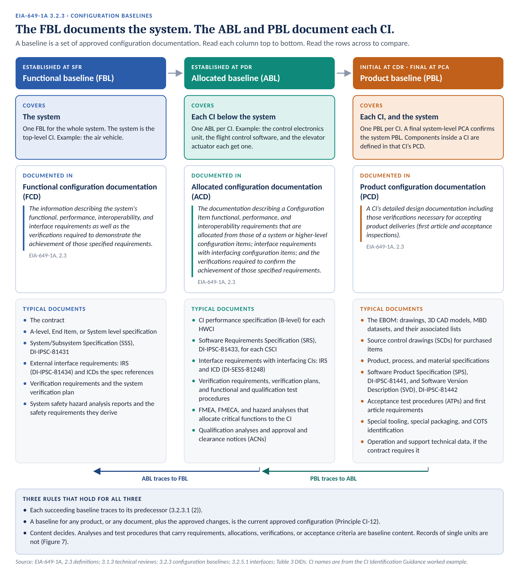
Figure 1. Three baselines and what each one holds. The FBL documents the system. The ABL and the PBL document each CI.
Read Figure 1 one way first. The FBL covers the system. The ABL and the PBL cover each CI. That answers the first question most people ask: which items have baselines? The system has an FBL and a PBL. Each CI below it has an ABL and a PBL. Section 2.3 says what the system is, and who controls each specification.
Then read it the other way. The baselines follow the design. The FBL says what the system must do. The ABL hands each CI its share. The PBL says how each CI is built. EIA-649-1A puts it this way:
“The FBL and ABL are part of the design requirements development process and used as inputs to the detailed design realization process. The PBL constitutes the final output of the design realization process.” (3.2.3)
Each succeeding baseline traces to its predecessor (3.2.3.1 (2)). A PBL feature with no ABL parent is either derived or orphaned. The trace says which.

2.3 The top-level CI and the control tiers
The FBL covers the system. The system is the top-level CI. It is usually the end item the contract specifies. On an aircraft program, it is often the aircraft itself. In the worked example, it is the air vehicle.
Below the top-level CI, the CI hierarchy assigns each CI a control tier (process 5.4). The tier records who baselines and controls the CI’s specification. Two tiers matter for baselines. Their definitions are the process definitions, quoted exactly.
Tier | Definition (process 3.1)
Acquirer-Spec Controlled CI | A CI with its own specification, which the Acquirer baselines and controls. The Acquirer takes control when it approves the baseline the specification belongs to: the FBL for the system specification, the ABL for item specifications.
Company-Spec Controlled CI | A CI below an Acquirer-spec controlled CI. The company baselines and controls its specification, where it has one. A change with Class I effect reaches the Acquirer through the parent CI’s baselines.

Read the two definitions together. Acquirer-spec controlled CIs sit at the top tiers of the decomposition. Their specifications go under customer control when the customer approves the baseline each specification belongs to. The system specification goes under customer control with the FBL. A top-tier item specification, such as the flight control system specification, goes under customer control with the ABL.
Company-spec controlled CIs, often called company-controlled CIs, sit under those specifications in the decomposition. The company baselines and controls their specifications. In the worked example, the control electronics unit, the flight control software, and the elevator actuator are company-spec controlled. They sit under the flight control system specification. The CI Identification Guidance, Figure 7, shows the hierarchy.
The tier does not change what a baseline holds. A company-spec controlled CI still has an ABL and a PBL, and the Acquirer still formalizes its PBL (process 5.9). The tier changes who controls the specification.
The control tier says whose specification carries a change. It does not say who approves it. No CI is changed on company authority alone (process 5.4).

2.4 How programs blur baselines today
Few programs skip baselines. Many programs blur them. Five habits are common.
Habit | Why it is tempting | What goes wrong
Call the review package the baseline | It is already assembled and approved. | A review package holds slides, plans, analyses, and test data. Some of it is baseline content. Some of it is not. A baseline built from the package, without the content test, holds the wrong mix.
Call the EBOM the PBL | The EBOM is released, structured, and declared at CDR. | The EBOM holds the drawing tree. It does not hold the ATPs, the software code-to documents, special tooling, or packaging. Those parts of the PCD go unrecorded.
Treat analyses as background | They look like engineering support, not definition. | An FMEA, FMECA, or hazard analysis that allocates critical functions is baseline content. Left outside change control, it stops matching the design.
Route unit records through the change board | More control looks safer. | A test data sheet or an as-built record describes one unit. It cannot change. Routing it through the board adds load and defines nothing.
Set the PBL at CDR and stop | CDR is the last big review. | A CI carries an initial PBL until its formalizing event. Without that event, nothing confirms the PCD matches the built item.

The problem is not the documents. The problem is sorting them by type instead of by content.

2.5 A worked example
Five items run through this document. They come from the worked example in the CI Identification Guidance. Each has a different control tier or design authority, so each shows a different baseline pattern.
Item | What it is | FBL | ABL | PBL
Air vehicle | The system and top-level CI. The end item the contract specifies. Acquirer-spec controlled. | Contract and air vehicle system specification | Not applicable. The FBL covers it. | The PBLs of its CIs. A final system-level PCA confirms it.
Flight control system | CI. Top-tier item below the air vehicle. Acquirer-spec controlled. | Covered by the system FBL | Flight control system specification | The PBLs of its CIs, plus its installation drawings
Control electronics unit (CEU) | HWCI. Company-spec controlled. Company design. | Covered by the system FBL | CEU performance specification | Full design disclosure: drawings, models, lists, ATP, process specifications
Flight control software | CSCI. Company-spec controlled. | Covered by the system FBL | SRS and IRS | SPS, source code, and SVD
Elevator actuator | HWCI. Company-spec controlled. Supplier design, bought whole on an SCD. | Covered by the system FBL | Actuator performance specification | The SCD, with its acceptance criteria and qualified sources

In this example the company writes a performance specification for the actuator. A program may instead carry the actuator’s allocated requirements in the flight control system specification. Process 5.9 allows both.

3. Why this matters

3.1 A baseline decides how a change is handled
Every ECP names the baseline it changes. That choice drives its class and its approver.
After the PBL is established, EIA-649-1A classifies a change as Major (Class I) when it meets any of a long list of criteria (3.3.1.2 (2)). Two of them name the baselines directly. A change that affects any physical or functional requirement in approved functional or allocated configuration documentation is Major (3.3.1.2 (2) b). So is a change to any approved baseline the Acquirer owns (3.3.1.2 (2) c). Once the Acquirer has configuration control of a baseline, it approves every Major change to it (3.3.1.5).
So the content of a baseline is not a filing question. It decides who must approve a change, and how fast the change can move.

3.2 Too little in a baseline
Return to the ball screw change in Section 1.1. The FMECA allocated a critical function to the actuator. The program treated the FMECA as background, so the change package never touched it.
The change board checked the change against the documents it controlled. The SCD was updated. The FMECA was not. Now the analysis and the hardware disagree, and no record shows when they parted.
EIA-649-1A closes this gap by content. The ACD describes the functional requirements “that are allocated from those of a system or higher-level Configuration Item” (3.2.3.2.1 (1) a). A critical function allocated to a piece of hardware is that kind of requirement. The document that allocates it is configuration documentation. The company controls it through the change board.
Process 5.9 adds a check at every baseline. System Safety confirms that hazard risk controls are captured in the baselined documentation.
The Sixteen Barriers analysis shows the stakes. It cites the NTSB finding on MCAS. Pilot responses did not match the assumptions used in the flight control system functional hazard assessments. An analysis whose assumptions drift from the configuration is a hazard in its own right.

3.3 Too much in a baseline
The opposite failure is noisier. A program routes every acceptance test data sheet through the change board. Each sheet describes one serial number on one day.
A record like that cannot change in any meaningful way. You cannot change a result. You can run a new test, or you can disposition the unit through the nonconformance process.
The same holds for the as-built record of each unit, inspection records, and the raw data from each test run. They are controlled as records. CM checks them against the baseline. The change board does not revise them.
If a document says what the item must be, how it is verified, or how it is accepted, the change board controls it. If it says what one unit did, it is a record.

3.4 The current approved configuration moves
The baseline stays fixed. The current approved configuration does not. Principle CI-12 states the rule:
“A baseline for any product, or any document, plus the approved changes, is the current approved configuration.”
Figure 2 shows the rule for the control electronics unit.
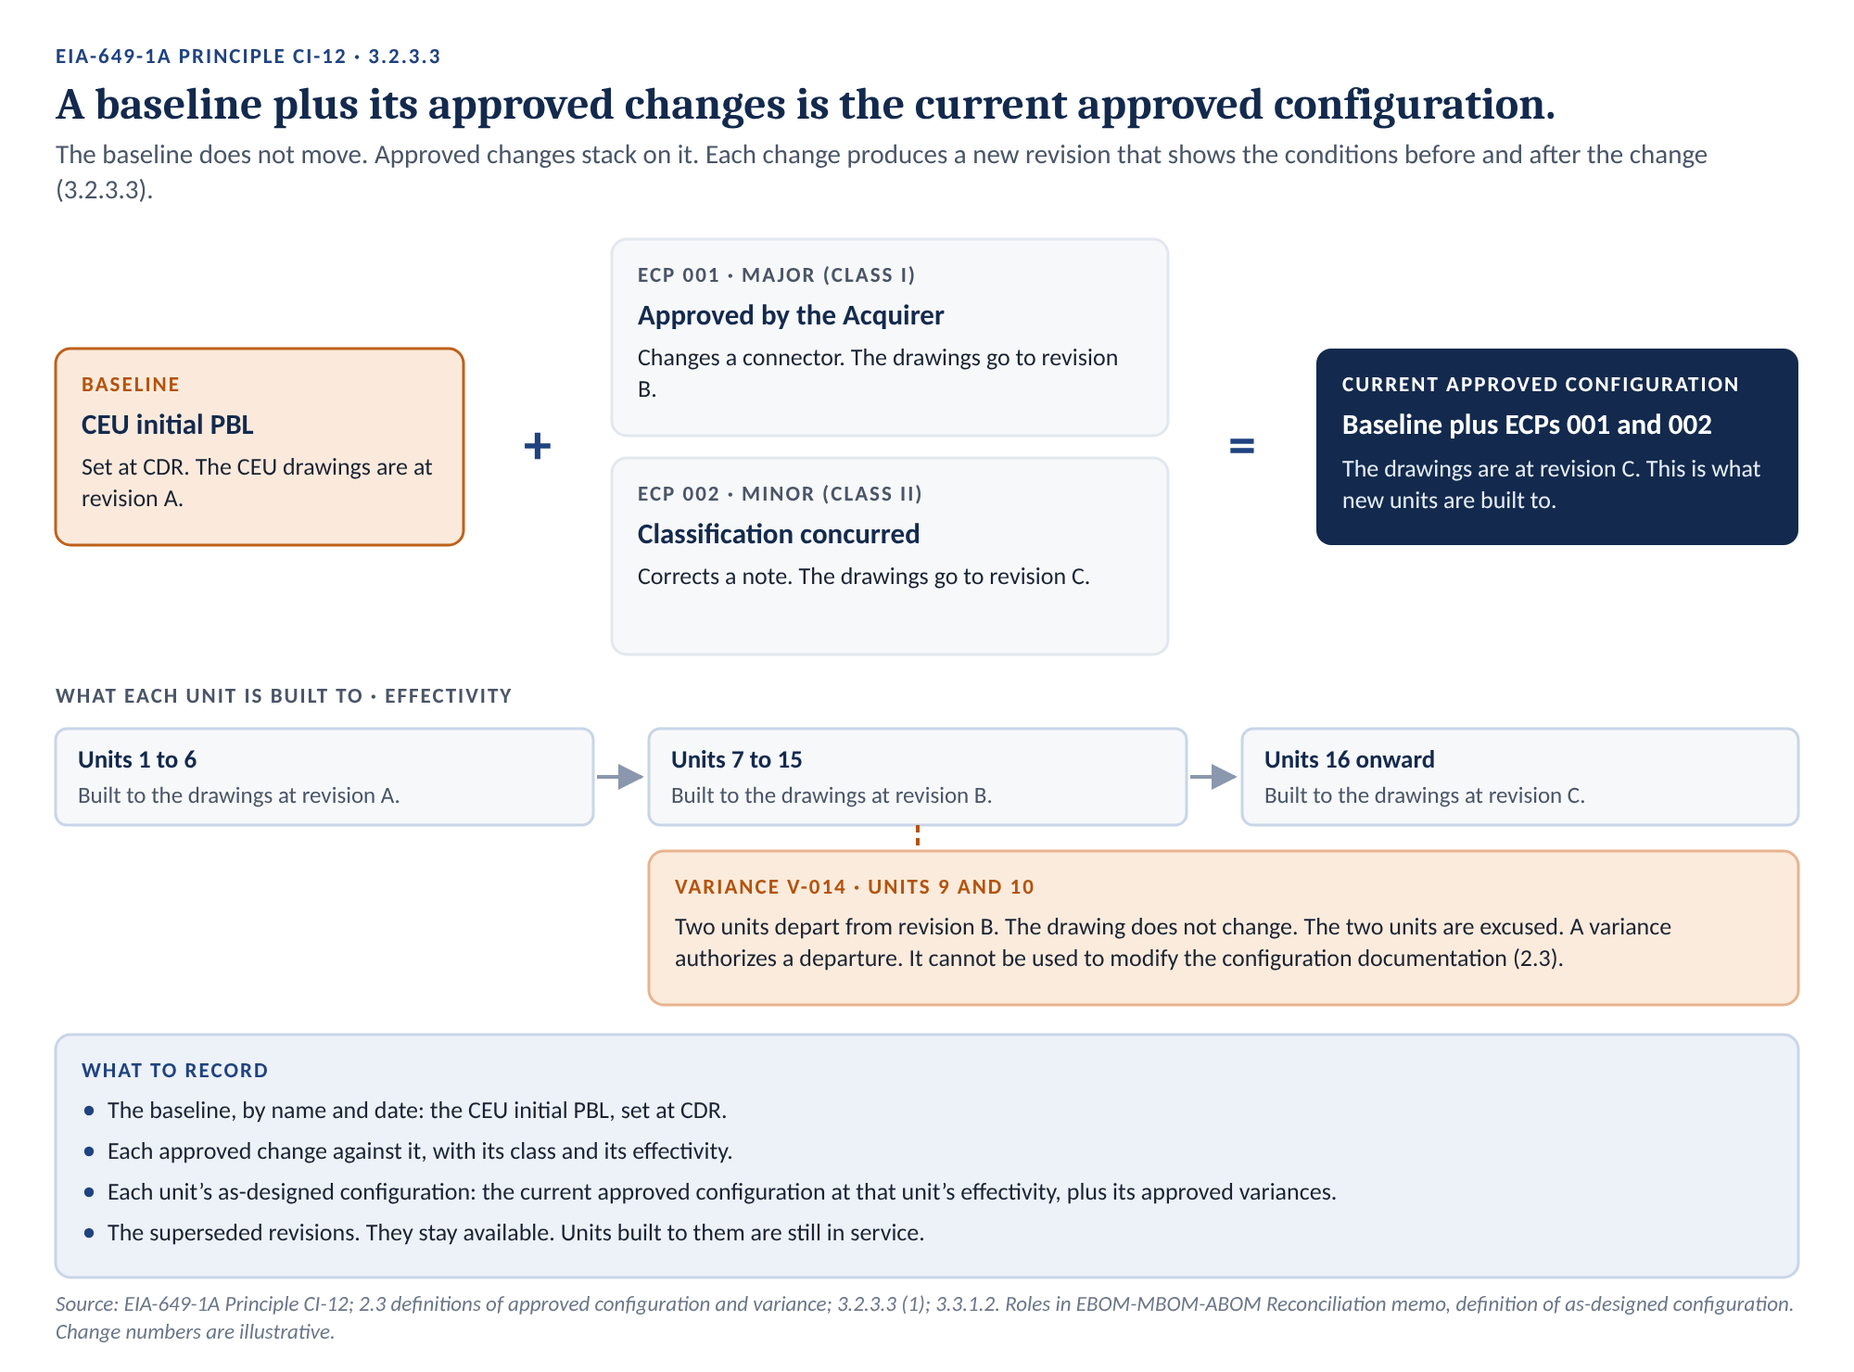
Figure 2. A baseline plus approved changes. The baseline stays fixed. The current approved configuration moves. Change numbers are illustrative.
Three points follow from Figure 2.
- The baseline is a fixed reference. Each approved change adds to it. The new revision shows the conditions before and after the change, and names the change as its revision authority (3.2.3.3 (1)).
- Units carry effectivity. Units 1 to 6 were built to revision A. They stay that way unless a retrofit changes them. The record must say which revision each unit was built to.
- A variance is not a change. It authorizes specific units to depart from the baseline. In the words of the definition, a variance “authorizes departure from the configuration, but cannot be used to modify the configuration documentation information” (2.3). The Nonconformance and Variance Guide covers variances in full.

4. Nine principles
Every step in Sections 5 through 9 follows from these nine principles. Each one prevents a mistake described in Sections 2 and 3.
 | Principle | What it prevents
1 | Content decides, not document type. A document is in a baseline when it carries requirements, allocations, verifications, acceptance criteria, or design for the item. | Analyses and procedures treated as background, and unit records treated as definitions.
2 | The FBL covers the system. The ABL and the PBL cover each CI. | Baselines set at the wrong level, or not at all.
3 | Each succeeding baseline traces to its predecessor. | Design with no requirement behind it, and requirements with no design.
4 | A baseline plus its approved changes is the current approved configuration. Record both. | A baseline nobody can reconstruct, and units nobody can place.
5 | Interface information sits in the baseline of the document that invokes it. | Interface documents that float outside every baseline.
6 | The EBOM is the backbone of the PBL. It is not the whole PBL. | ATPs, process specifications, and software documents with no baseline record.
7 | Name both product baselines: initial at CDR, formalized at the formalizing event. | A design treated as final before anyone checked it against the built item.
8 | Documents that carry the same requirement change together. One ECP updates the analysis, the specification, the drawing, and the procedure. | Analyses, specifications, drawings, and procedures that drift apart.
9 | CM keeps each baseline’s content aligned and current. That is an active duty, not filing. | Baselines that drift from the CI structure and the approved changes.

Principle 1 carries the most weight. Sections 5 through 7 apply it baseline by baseline. Section 8 applies it to the hard cases.

5. The functional baseline

5.1 What it holds
The FBL defines the system. It says what the system must do, how well, through which interfaces, and how each requirement will be verified. It does not say how the system is built.
EIA-649-1A sets three requirements for its documentation. They are quoted exactly:
“(1) The supplier shall document the FBL of a system by: a. Describing its functional, performance, interoperability, and interface requirements. b. Describing the verifications required to demonstrate achievement of those requirements. c. Identifying any specialized software and documenting the operating environment used to author the above requirements.” (3.2.3.2)
A note to the same clause names the content: “The FBL is made up of the contract and the A-level specification, End Item, or System level specification.” Figure 3 shows it for the air vehicle.
The note names the core. Two more documents carry FCD content. The system verification plan describes the verifications required (3.2.3.2 (1) b). The system safety hazard analysis reports identify the safety-critical functions and derive the system safety requirements (3.2.3.2 (1) a). The company controls both through the change board, with the FBL.
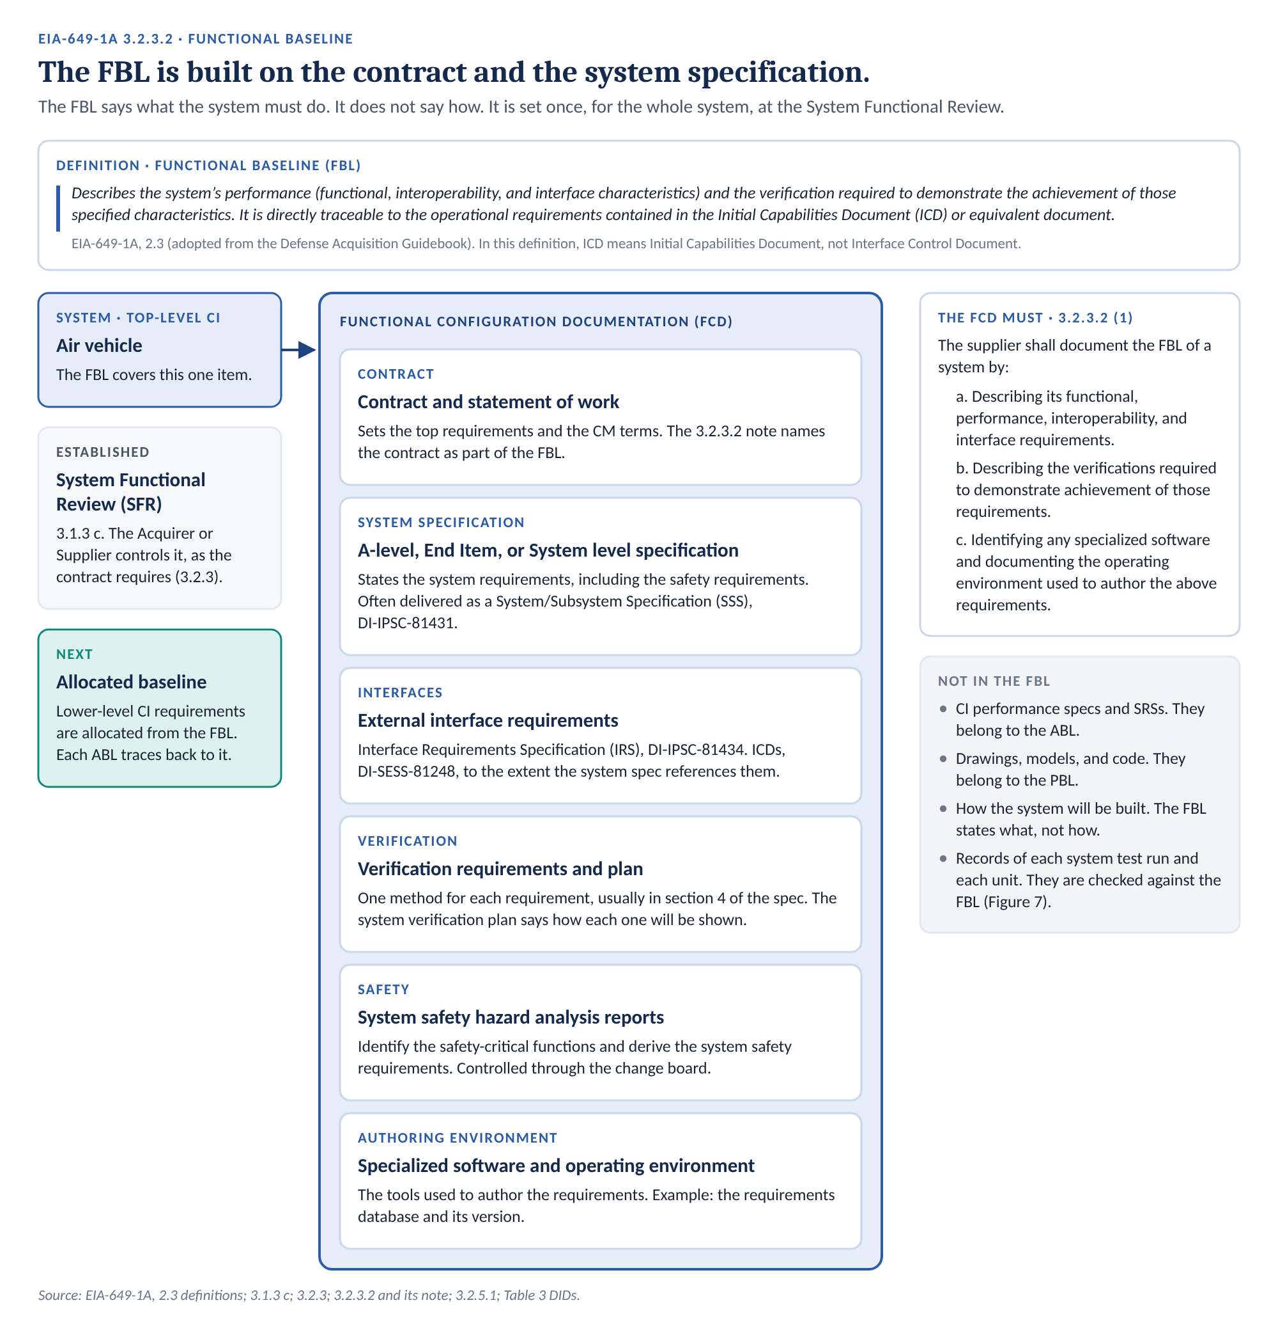
Figure 3. Functional baseline contents. The FBL is built on the contract and the system specification.
Content | In the example | Basis
Contract and statement of work | The air vehicle contract. | 3.2.3.2 note
System specification | The air vehicle system specification, often delivered as a System/Subsystem Specification (SSS), DI-IPSC-81431. | 3.2.3.2 note; Table 3
Interface requirements | External interfaces in the system specification, the IRS (DI-IPSC-81434), and the ICDs the specification references. | 3.2.3.2 (1) a; 3.2.5.1 (2)
Verification requirements and plan | One method for each requirement, usually in section 4 of the specification. The system verification plan says how each one will be shown. | 3.2.3.2 (1) b
System safety hazard analyses | The system safety hazard analysis reports. They identify the safety-critical functions and derive the system safety requirements. The specification states those requirements. | 3.2.3.2 (1) a; process 5.9
Authoring environment | The requirements tool and its version. | 3.2.3.2 (1) c

5.2 What stays outside it
Three kinds of document stay out of the FBL.
- Lower-level requirements. CI specifications and SRSs belong to the ABL.
- Design. Drawings, models, and code belong to the PBL.
- Records. The data from each system test run and the records of each unit. They are checked against the FBL. They are not in it.
One caution on terms. The EIA-649-1A definition says the FBL “is directly traceable to the operational requirements contained in the Initial Capabilities Document (ICD) or equivalent document.” There, ICD means Initial Capabilities Document. Everywhere else in this document, ICD means interface control document.

5.3 Who controls it
The air vehicle is the top-level CI, the end item the contract specifies. It is Acquirer-spec controlled. The Acquirer takes control of the system specification when it approves the FBL (process 3.1). From then on, the Acquirer approves every Major change to it (3.3.1.5). The FBL is set at or after the System Functional Review (3.1.3 c; process 5.9).

6. The allocated baseline

6.1 What it holds
The ABL gives each CI its share of the system. The system specification hands requirements down. Each CI’s specification records what it received. That specification, with its interfaces and verifications, is the CI’s ABL.
“(1) The Supplier shall document the ABL of a Configuration Item by: a. Describing its functional, performance, and interoperability requirements that are allocated from those of a system or higher-level Configuration Item, and interface requirements with interfacing Configuration Items. b. Describing the verifications required to demonstrate achievement of those requirements. c. Identifying any specialized software and documenting the operating environment used to author the above requirements.” (3.2.3.2.1)
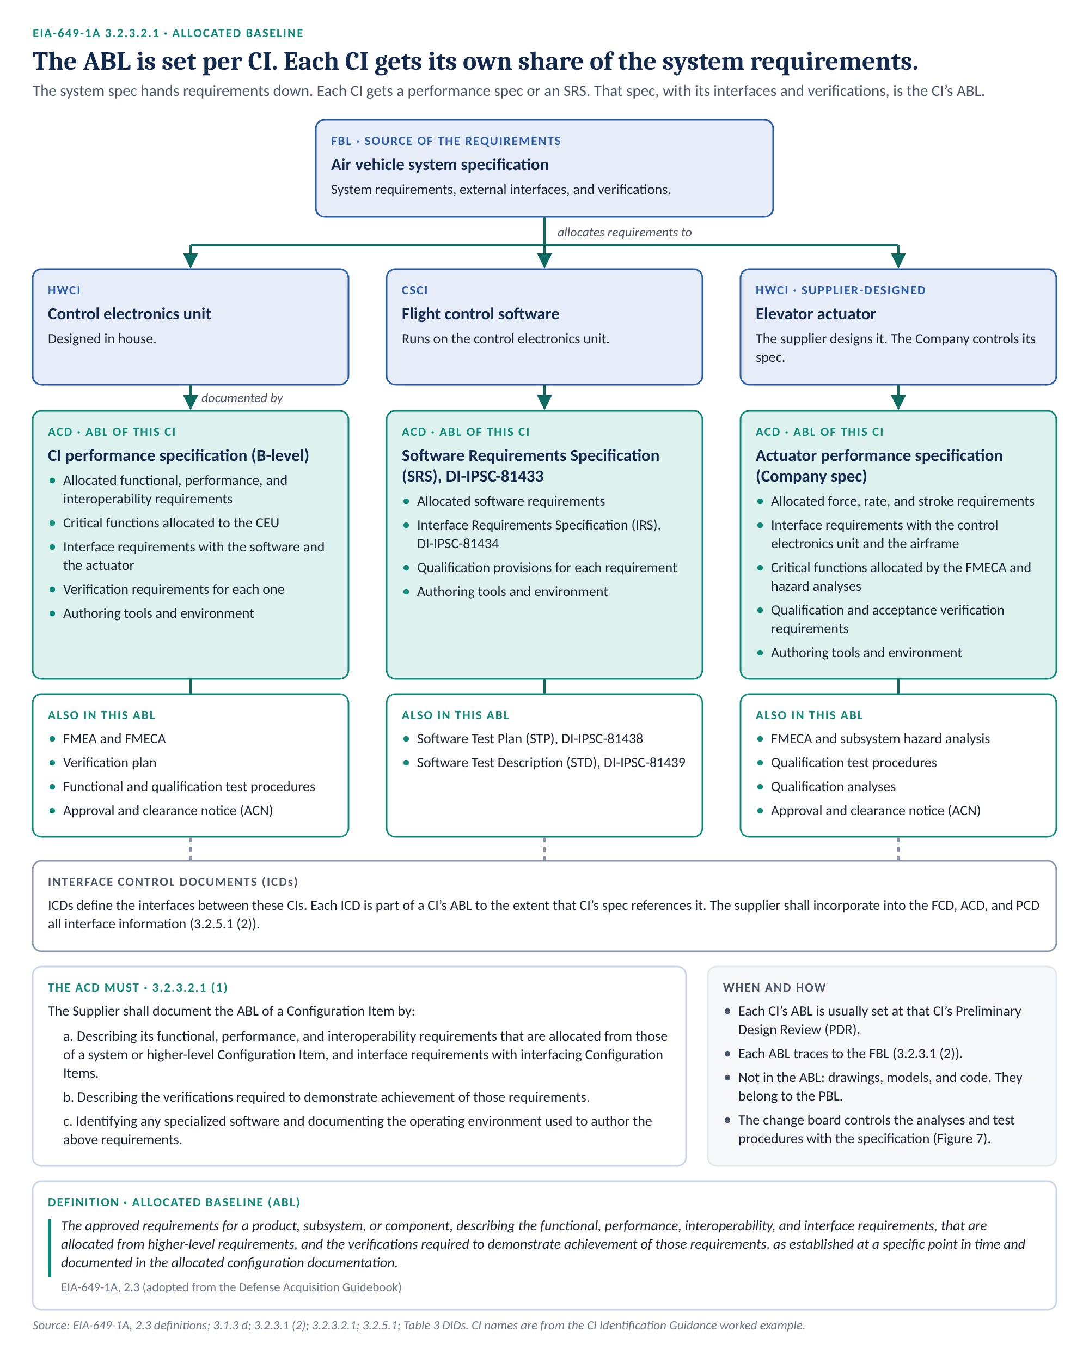
Figure 4. Allocated baseline contents. Each CI gets its own share of the system requirements. The flight control system level is omitted for space.
CI | Its ACD | Who controls it
Flight control system | Flight control system specification. | The Acquirer, once it approves the ABL.
Control electronics unit | CEU performance specification (B-level). | The company. A change with Class I effect reaches the Acquirer through the parent CI’s baselines.
Flight control software | SRS (DI-IPSC-81433) and IRS (DI-IPSC-81434). | The company, as above.
Elevator actuator | Actuator performance specification. | The company, as above.

The flight control system is the top tier below the air vehicle. Its specification goes under Acquirer control when the Acquirer approves the ABL. The three CIs below it are Company-spec controlled. Their specifications stay under company control (Section 2.3).
A Company-spec controlled CI carries its allocated requirements in its own specification, under company control, or in its parent CI’s specification (process 5.9). The control tier says whose specification carries a change. It does not say who approves it (process 5.4).

6.2 Safety and reliability analyses belong here
The FMEA, the FMECA, and the hazard analyses find what can go wrong in each CI. They also allocate critical functions to the hardware that must perform them. That allocation is ACD content (3.2.3.2.1 (1) a). So these analyses are baseline documents for the CI. The company controls them through the change board.
The CI specification states the allocated requirement too. Figure 4 shows it in the actuator’s ACD. The analysis and the specification carry the same requirement. They change together (Section 8.7).

6.3 Verification plans and test procedures belong here
The ACD also describes “the verifications required to demonstrate achievement of those requirements” (3.2.3.2.1 (1) b). Specification section 4 names the method. The verification plan and the functional and qualification test procedures say how each verification is done. They are baseline documents for the CI. The company controls them through the change board.
Qualification analyses fall here too. Where the verification method is analysis, the qualification analysis is the verification. The company controls it through the change board.
Qualification testing has an output of its own. The company calls it an approval and clearance notice (ACN). It states the CI’s current exceptions and limitations. Section 8.5 covers it.

6.4 What stays outside it
- Design. Drawings, models, and code belong to the PBL.
- Records. The data from each test run and the record of each test unit. They are checked against the ABL. They are not in it.
One more point. The ACD does not retire when the PBL is set. GEIA-HB-649A says that when the government reprocures a CI, “the product baseline documentation also includes the allocated configuration documentation to insure that performance requirements are not compromised.” Keep the ACD current for the life of the CI.

7. The product baseline

7.1 What the PCD holds
The PBL defines how each CI is built, accepted, and supported. Its documentation is the PCD. EIA-649-1A lists nine kinds of content. Figure 5 shows all nine for the control electronics unit.
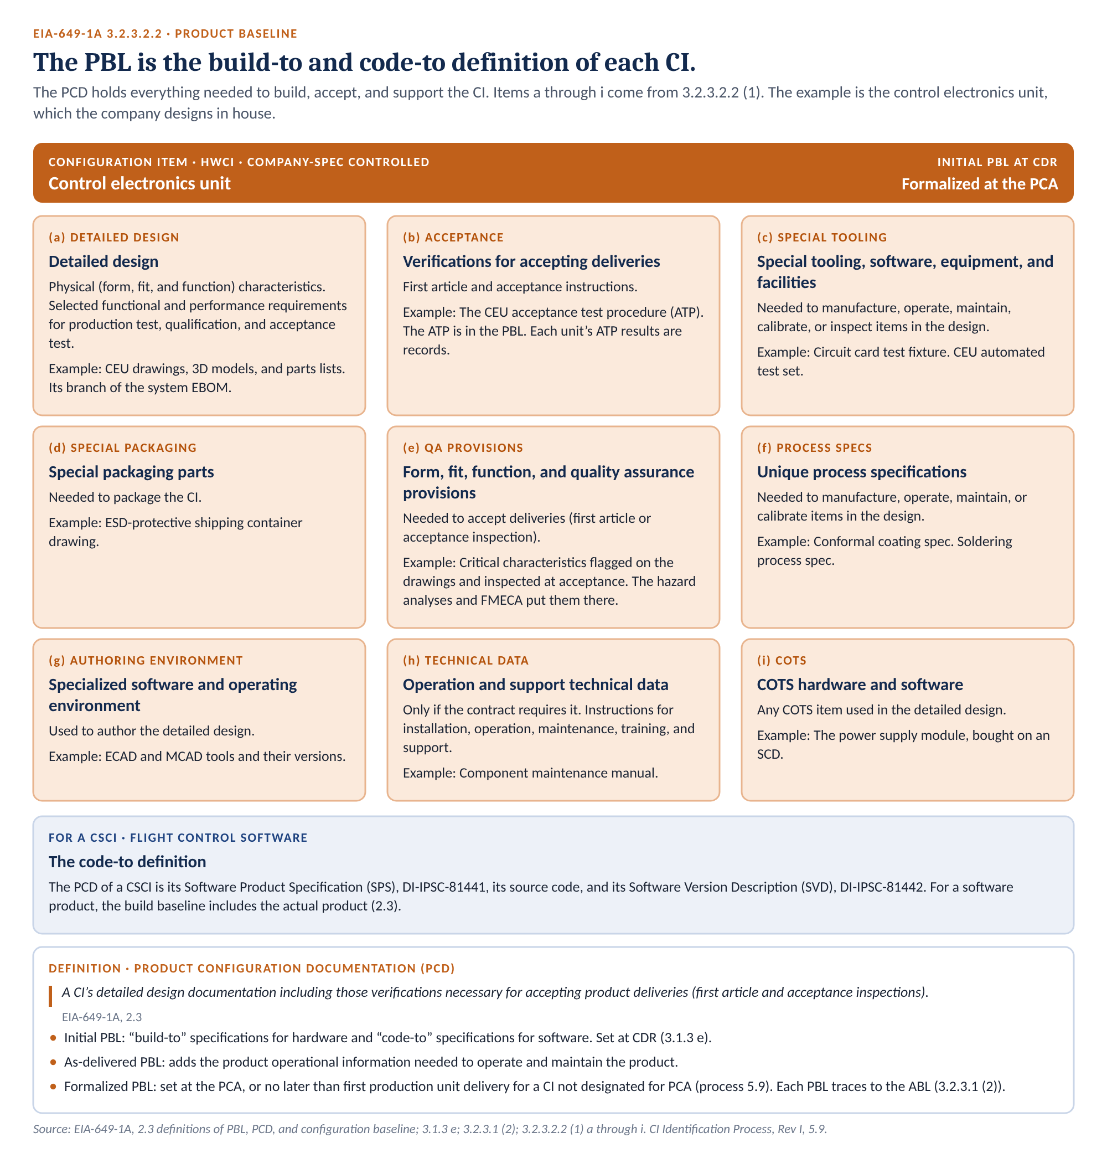
Figure 5. Product baseline contents. The nine kinds of PCD content in 3.2.3.2.2 (1), shown for the control electronics unit.
The nine items are quoted exactly below. The right column gives the CEU example.
 | The Supplier shall document the PBL of a Configuration Item by: | CEU example
a | Describing its detailed design including necessary physical (form, fit, and function) characteristics and selected functional/performance requirements selected for production test, qualification, and acceptance test. | Drawings, models, and parts lists
b | Identifying the verifications necessary for accepting product deliveries (first article and acceptance instructions). | The CEU ATP
c | Identifying and documenting the design of any special tooling, software, equipment, and facilities required to manufacture, operate, maintain, calibrate, or inspect items contained in the design. | Circuit card test fixture; CEU test set
d | Identifying and documenting the design of any special packaging parts required to package the CI. | Shipping container drawing
e | Including any form, fit, function and quality assurance provisions required to accept deliveries of the Configuration Item (first article or acceptance inspection). | Critical characteristics and their inspection
f | Including any unique process specifications required to manufacture, operate, maintain, or calibrate items contained in the design. | Conformal coating and soldering specifications
g | Identifying any specialized software and documenting the operating environment used to author the detailed design. | ECAD and MCAD tools and versions
h | If required by contract, may include technical data, which provides instructions for the installation, operation, maintenance, training, and support of a system or equipment. | Component maintenance manual
i | Identifying and documenting any COTS hardware or software used in the detailed design. | Power supply module on an SCD

Item (2) of the same clause adds a rule for privately developed CIs: “The Supplier shall document the PBL of a privately developed Configuration Item by including any verification provisions required to accept deliveries of the Configuration Item (first article or acceptance inspection).”
Note where acceptance sits. The ATP is in the PBL. The definition says the PBL “prescribes all necessary physical (form, fit, or function) characteristics and selected functional characteristics designated for production acceptance testing and production test requirements” (2.3). Every production unit is accepted to the ATP. Change the ATP, and you change what you deliver.

7.2 The EBOM is the backbone
The company declares the system EBOM at CDR, as part of the initial PBL. It lists every drawing and part from the air vehicle down. Figure 6 shows the branches for three CIs.
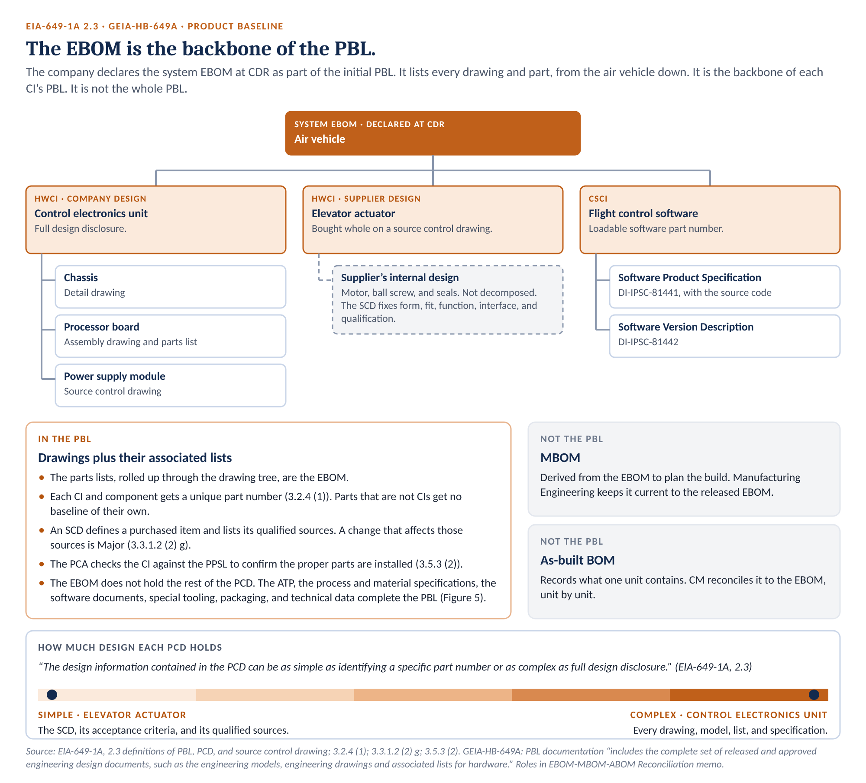
Figure 6. The EBOM is the backbone of the PBL. It gives every part a place. It is not the whole PBL.
GEIA-HB-649A describes the same thing. Product baseline documentation “includes the complete set of released and approved engineering design documents, such as the engineering models, engineering drawings and associated lists for hardware.” The associated lists are the parts lists. Rolled up through the drawing tree, they are the EBOM.
The EBOM matters for three reasons.
- It gives every part a place. Each CI and component gets a unique part number (3.2.4 (1)). Parts that are not CIs get no baseline of their own. They are defined in the PCD of the CI that contains them.
- It is what the PCA checks. The supplier confirms the CI against the PPSL and examines it “to ensure that the proper parts are actually installed” (3.5.3 (2)).
- It is what CM reconciles. CM compares each unit’s as-built record to the EBOM and its approved changes.
Declaring the EBOM at CDR sets the backbone of the initial PBL. It does not set the whole PBL.

The rest of the PCD sits outside the EBOM. For the CEU, that means the ATP, the process specifications, the test fixture and test set, and the shipping container drawing. It also means the component maintenance manual, where the contract calls for it. For the flight control software, it means the SPS and the SVD. Some of these appear as notes on drawings. Some appear nowhere in the EBOM. Each one still belongs to the PBL. Section 12 asks where each one is recorded.

7.3 Supplier-designed CIs sit at the simple end
The elevator actuator shows the other end of the range. The PCD “can be as simple as identifying a specific part number or as complex as full design disclosure” (2.3).
The company buys the actuator whole, on an SCD. The SCD gives the engineering description, the qualification requirements, the acceptance criteria, and the approved sources. That is the actuator’s PCD at the company level. The supplier holds the detailed design, under its own design authority.
The company does not decompose the actuator (process 5.4.1). It cannot baseline a design it does not hold. The SCD still carries weight. A change that affects the sources it defines is Major (3.3.1.2 (2) g).

7.4 Software in the PBL
A CSCI has a code-to definition, not a build-to one. Its PCD is the Software Product Specification (SPS), DI-IPSC-81441, the source code, and the Software Version Description (SVD), DI-IPSC-81442.
One sentence in the definition of configuration baseline matters most here: “For a software product, the build baseline includes the actual product” (2.3). The code is in the baseline, not just a description of it. The software PCA checks that the build installs and matches its SVD (3.5.3).

7.5 What is not the PBL
Two bills of material sit next to the EBOM. Neither one is the PBL.
Bill of material | What it is | How it relates to the PBL
MBOM | The parts and materials in the sequence and grouping used to build the product. Derived from the EBOM. May add consumables and process materials. | Derived from the PBL. Manufacturing Engineering keeps it current to the released EBOM.
As-built BOM | The parts and materials actually installed in one unit, with serial, lot, or batch numbers. | A record of one unit. CM reconciles it to the EBOM and its approved changes.

The Roles in EBOM-MBOM-ABOM Reconciliation memo assigns these checks. This guidance does not change them.

8. What the change board controls

8.1 The content test
EIA-649-1A does not sort documents by type. It sorts them by what they must describe. The FCD and the ACD describe requirements and “the verifications required to demonstrate achievement of those requirements” (3.2.3.2; 3.2.3.2.1). The PCD describes the detailed design and “the verifications necessary for accepting product deliveries” (3.2.3.2.2 (1) b).
So one question sorts every document. Does it carry requirements, allocations, verifications, acceptance criteria, or design for the item?
If yes, it is baseline content, and the change board controls it. That holds whether the document is a specification, a drawing, an analysis, or a test procedure. If no, it is a record of one unit or one run. Figure 7 shows the test and the documents on each side.
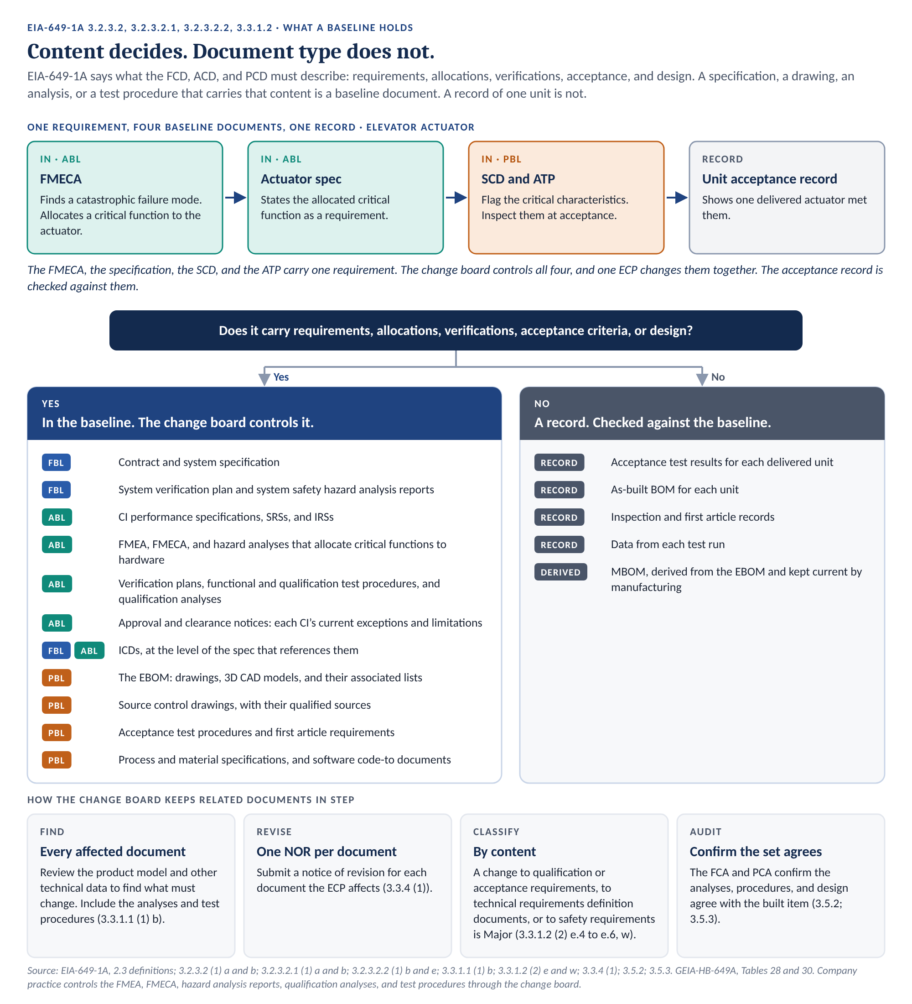
Figure 7. Content decides. Document type does not. Analyses and procedures that carry baseline content are controlled with the baseline. Records are checked against it.
The change rules point the same way. A change to “any imposed qualification and acceptance requirements” is Major. So is a change to “any other imposed technical requirements definition documents” (3.3.1.2 (2) e.4 and e.5). A change that affects specified and approved safety or reliability requirements is Major too (3.3.1.2 (2) e.6).

8.2 Verification and test documents
Document | Where it falls | Basis
Verification requirements (specification section 4, VCRM) | In the FBL and ABL | 3.2.3.2 (1) b; 3.2.3.2.1 (1) b
Verification plans | In the FBL and ABL, with the specification they verify | 3.2.3.2 (1) b; 3.2.3.2.1 (1) b
Functional and qualification test procedures | In the ABL of the CI they verify | 3.2.3.2.1 (1) b; 3.3.1.2 (2) e.4
Qualification analyses | In the ABL of the CI they verify | 3.2.3.2.1 (1) b
Acceptance test procedures and production test requirements | In the PBL | 2.3 (PBL); 3.2.3.2.2 (1) b and e
Approval and clearance notices (ACNs) | With the qualification basis, in the ABL. Tied to the CI configuration each one clears. | 3.3.1.2 (2) w; 3.5.3.1 (1) b
Data from each test run, and ATP results for each unit | Records | 3.4

A specification often invokes a procedure by reference, such as “qualify per QTP-123.” The reference ties the two together. A change to either one is a change to both.
The audits use both kinds. The FCA verifies that the CI “meets its performance requirements as documented in the approved FCD, ACD” (3.5.2 (2)). It uses “test data from the verification of the Configuration Item” (3.5.2 (4)). Before the PCA, the Supplier provides “Acceptance test procedures and associated test data from those procedures from the successful FCA” (3.5.3.1 (1) a.4). The procedures are baseline documents. The data are records.

8.3 Interface documents
An interface document falls where its level of detail puts it.
Level | Baseline | Example
System external interface requirements | FBL | The air vehicle system specification, or an ICD it references.
Interface requirements between CIs | ABL | The CEU specification, the SRS, the IRS, or an ICD they reference.
Interface design detail | PBL | Interface control drawings, installation drawings, and the Interface Design Description (IDD), DI-IPSC-81436.

EIA-649-1A requires all interface information in the FCD, ACD, and PCD (3.2.5.1 (2)). Process 5.9 adds the rule for ICDs. Interface control documentation “is part of the functional and/or allocated baselines to the extent referenced in the applicable specifications.” GEIA-HB-649A says the same. When a system specification references an ICD, “the ICD requirements are part of the System Specification.”
So an ICD’s baseline follows the document that invokes it. The interface register records that document (process 5.8). That entry sets the controlling baseline.

8.4 Safety and reliability analyses
The FMEA, the FMECA, and the system safety hazard analysis reports are baseline documents. The company controls them through the change board. Three things put them there.
- They allocate critical functions. A critical function allocated to a piece of hardware is an allocated functional requirement. The ACD must describe it (3.2.3.2.1 (1) a).
- They derive safety requirements. The system hazard analyses derive the safety requirements in the FCD. The CI-level analyses derive the safety requirements in each ACD.
- They set critical characteristics. The critical characteristics on a drawing or an SCD come from the analyses. Those characteristics are PCD content (3.2.3.2.2 (1) e).
Follow one requirement for the actuator. The top of Figure 7 shows the path.
- The FMECA finds a failure mode with catastrophic effect. It allocates a critical function to the actuator.
- The actuator is selected as a CI under criterion (b) of 3.2.1 (2).
- The actuator specification states the allocated critical function, in the ABL.
- The SCD flags the critical characteristics and their acceptance criteria, and the ATP inspects them, in the PBL.
- The acceptance record for each delivered actuator shows that unit met them.
The FMECA, the specification, the SCD, and the ATP are baseline documents. They carry one requirement, and they change together. The acceptance record is a record. It is checked against them.
The GEIA-HB-649A audit checklists ask whether the final FMECA “accurately represents” the current configuration. Change board control is how the company keeps the answer yes.

8.5 Qualification
Qualification shows that the design meets its requirements. The qualification basis lands in the baseline in four places.
- The qualification requirements. They sit in the CI specification. A change to “any imposed qualification and acceptance requirements” is Major (3.3.1.2 (2) e.4).
- The qualification procedures and analyses. They are the verifications the ACD describes. The company controls them through the change board.
- The qualified sources. For a purchased item, the SCD lists the sources that passed qualification.
- The approval and clearance notices. They state what each CI configuration is cleared to do today, and what it is not.
Two rules protect the qualified configuration. A change that requires requalification is Major (3.3.1.2 (2) w). And at the PCA, the supplier identifies any difference between the production CI and the development CI used for the FCA. It certifies or demonstrates “that these differences do not degrade the functional characteristics of the selected CI(s)” (3.5.3.1 (1) b).
Qualification testing produces approval and clearance notices (ACNs). Each ACN identifies the current exceptions and limitations of one CI. For example, an ACN may say the CI can be embodied on the aircraft but cannot be turned on during flight.
An ACN is not a record of one unit. It states what every unit of one CI configuration may and may not do, today. So it belongs with the qualification basis, in the CI’s ABL, not with the records.
Five rules keep the ACNs and the baseline in step.
- Name the configuration. Each ACN names the CI configuration it clears: the part number and revision, or the software version. Without that, nobody can tell which units the limitations apply to.
- Reassess on every change. A change to the CI configuration must say whether the current ACN still applies. A change that requires requalification is Major (3.3.1.2 (2) w). Requalification produces a new ACN.
- Account for limitations by unit. The CSA system records which ACN, and which open limitations, apply to each unit by effectivity (3.4.1 (3)).
- Carry limitations to the users. The people who embody, install, and operate the CI need the limitations. Where the contract requires operation and support data, the limitations belong in it (3.2.3.2.2 (1) h).
- Retire limitations with a new ACN. Further qualification lifts a limitation. A new ACN records the cleared state. The old ACN stays available for the units it covered.
An ACN and a variance both limit what a unit may do. They differ in scope. A variance excuses specific units from the baseline. An ACN limits every unit of a configuration until qualification clears it.

8.6 Records stay outside
Some documents describe one unit or one run. They are records. CM checks them against the baseline. The change board does not revise them.
Record | What it captures | How it is controlled
Acceptance test results for each unit | What one serial number did against the ATP. | Quality record. Checked against the ATP and the PCD.
As-built BOM | The parts installed in one unit. | CSA record. CM reconciles it to the EBOM.
Inspection and first article records | What inspection found on one unit or one first article. | Quality record.
Data from each test run | Measurements from one run of a controlled procedure. | Test record. Supports the FCA.
MBOM | The build sequence, derived from the EBOM. | Manufacturing process control. Kept current to the released EBOM.

A record can still reveal a baseline problem. A failed test may show that a requirement is wrong. Then an ECP changes the baseline. The record does not change.

8.7 Keeping related documents in step
One requirement often lives in several baseline documents. The FMECA allocates it. The specification states it. The drawing makes it inspectable. The test procedure verifies it. A change to one is a change to all of them.
Control | What it requires | Basis
Find every affected document | Review the product model and other technical data to determine what specific changes are needed. Include the analyses and test procedures. | 3.3.1.1 (1) b
One NOR per document | Submit a notice of revision for each document the ECP affects. | 3.3.4 (1)
Classify by content | A change to qualification or acceptance requirements, to technical requirements definition documents, or to safety and reliability requirements is Major. | 3.3.1.2 (2) e.4, e.5, e.6
Record the set | The CSA system records each document revision and the change that produced it. | 3.4.1 (3)
Audit the set | The FCA and the PCA confirm that the analyses, procedures, and design agree with the built item. | 3.5.2; 3.5.3

EIA-649-1A names the data an ECP carries. The Supplier supports each ECP “with drawings and other data (e.g., Logistics Product Data (LPD), detailed cost proposal data, test data and analyses, quality, packaging, interchangeability factors)” (3.3.1.4 (1)). An analysis that carries baseline content is more than supporting data. It is one of the documents the ECP revises.

9. Steps by lifecycle state
Content is the main subject of this guidance. Timing is the second. Figure 8 shows when each baseline is set. None of them ends.
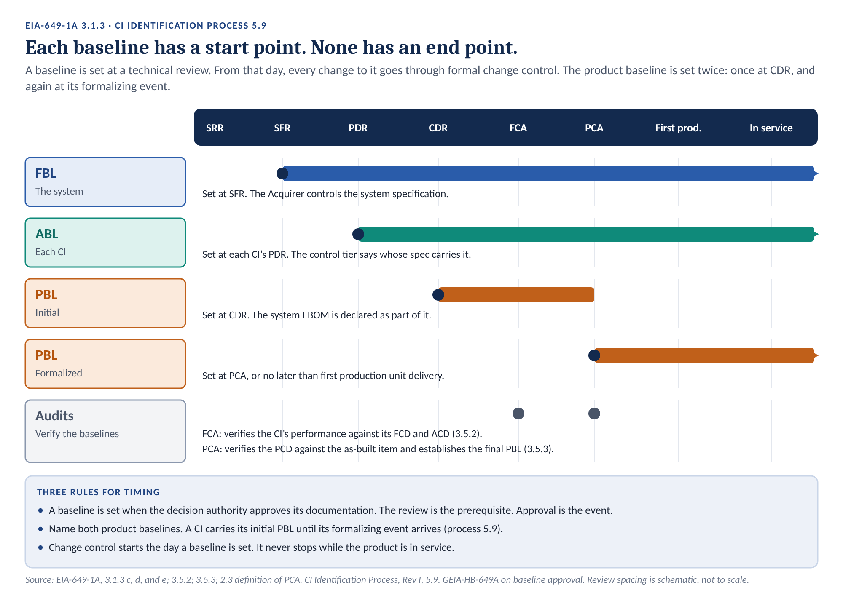
Figure 8. Baselines across the technical reviews. Each baseline has a start point. None has an end point. Spacing is schematic.
A review does not set a baseline by itself. GEIA-HB-649A is plain: “The baselines are officially established when the decision authority approves the baseline documentation.” The review is the prerequisite. The approval is the event.

9.1 Through SFR: the functional baseline
Action | Owner
Confirm the system specification states every system requirement, interface, and verification method. | Systems Engineering
Confirm the hazard risk controls from the system hazard analyses are stated in the system specification. | System Safety
Release the system verification plan and the system safety hazard analysis reports under change board control. | Systems Engineering, System Safety
Confirm the ICDs the system specification references are released and on the interface register. | CM
Establish and record the FBL. Name each document and its revision. | CM
Approve the FBL. Take control of the system specification. | Acquirer

For the air vehicle, the FBL holds the contract and the air vehicle system specification at its approved revision.

9.2 Through PDR: the allocated baseline
Action | Owner
Confirm each CI specification holds its allocated requirements, interfaces, and verifications. | Systems Engineering
Confirm the critical functions the FMEA, FMECA, and hazard analyses allocate to each CI are stated in its specification. | System Safety, RM&SH
Release each CI’s FMEA, FMECA, hazard analyses, verification plan, and test procedures under change board control. | RM&SH, System Safety, Test
Confirm each ICD sits at the baseline of the specification that invokes it. | CM
Establish and record the ABL for each CI. Trace it to the FBL. | CM
Approve the ABL of each Acquirer-spec controlled CI. | Acquirer

The actuator’s ABL holds the actuator performance specification. It traces to the air vehicle system specification through the flight control system specification.

9.3 Through CDR: the initial product baseline
Action | Owner
Release the drawings, models, lists, specifications, and code-to documents. | Design Engineering
Declare the system EBOM, as part of the initial PBL. | CM, Design Engineering
Identify the PCD content outside the EBOM for each CI: ATPs, process and material specifications, software documents, special tooling, packaging, and technical data. Record it. | CM
Confirm the critical characteristics from the hazard analyses and FMECA appear on the drawings or SCDs. | System Safety, RM&SH
Update the analyses and test procedures to match the detailed design. | System Safety, RM&SH, Test
Establish the initial PBL for each CI. Trace it to the ABL. | CM

The CEU’s initial PBL holds its branch of the system EBOM, its ATP, and its process specifications. The actuator’s holds its SCD.

9.4 Production: the formalized product baseline
Action | Owner
For a CI designated for PCA, treat PCA completion as the formalizing event. | CM, per the Configuration Audit Process
For a CI not designated for PCA, formalize the PBL no later than first production unit delivery. | Acquirer, supported by CM
Confirm each approval and clearance notice names the CI configuration it clears. Identify any difference between the production CI and the FCA unit. | Test, Quality
Confirm the PCD matches the CI structure and the approved changes. Drive any drift back into alignment. | CM
Where audits run in increments, support a final audit that verifies all FBL, ABL, and PBL requirements are satisfied (3.5.1 (2)). | CM

Name both product baselines. Process 5.9 is plain:
“The baseline established at CDR is the initial product baseline. The baseline established by the formalizing event is the formalized product baseline. Name both, because a CI carries its initial product baseline until its formalizing event arrives.”

9.5 In service: keeping each baseline current
Change control starts the day a baseline is set. It runs while the product is in service. Figure 2 showed how changes stack.
Action | Owner
Process each change against the baseline it affects. Classify it. | CM
Include every affected analysis and test procedure in each change package. | CM, System Safety, RM&SH, Test
Create a new revision after change approval. Show the conditions before and after, and name the change as revision authority (3.2.3.3 (1)). | Design Engineering
Record each approved change, its effectivity, and its implementation in each unit. | CM
Record the current ACN and its open limitations for each unit, by effectivity. | CM
Keep superseded baseline documentation available. Units built to it are still in service. | CM

GEIA-HB-649A states the last row as a duty: “It is vital that at least the three primary baselines be kept current throughout the product’s life cycle and that the superseded baseline documentation is maintained and available to the relevant stakeholders.”

10. A parallel under FAA certification
Some programs also certify under 14 CFR Part 21, or build military derivatives of FAA type-certificated products. The same line appears there, in different words.
This section is this guidance’s reading of the FAA rules. Confirm it with the program’s certification office, and against FAA Order 8110.4C, before relying on it.

14 CFR 21.31 defines the type design. It includes “the drawings and specifications, and a listing of those drawings and specifications,” needed to define the product’s configuration and design features. It also includes information on dimensions, materials, and processes, and the Airworthiness Limitations section of the Instructions for Continued Airworthiness.
FAA Order 8110.4C calls the type design “the engineering definition of a particular product.” It treats the adequacy of the type design and the adequacy of the substantiating data as separate questions.
The parallel is partial. The type design says what the product is. Substantiating data, such as test reports and analyses, shows that the design complies. The FAA draws that line for certification. It is not the EIA-649-1A line.
Under EIA-649-1A, an analysis or a procedure is baseline content when it carries requirements, allocations, or verifications (Section 8). The FAA distinction does not move those documents out of change board control. 21.31 (e) also adds “any other data necessary to allow, by comparison, the determination of the airworthiness” of later products of the same type. Where a program works under both regimes, keep the documents under change board control. Let the certification basis decide what goes in the type design.

11. Roles and responsibilities
CM establishes, records, and aligns the baselines. The other functions confirm content and produce and maintain the baseline documents, including the analyses and test procedures. Figure 9 shows the split. Four assignments come straight from process 5.9. The rest are this guidance’s recommendation.
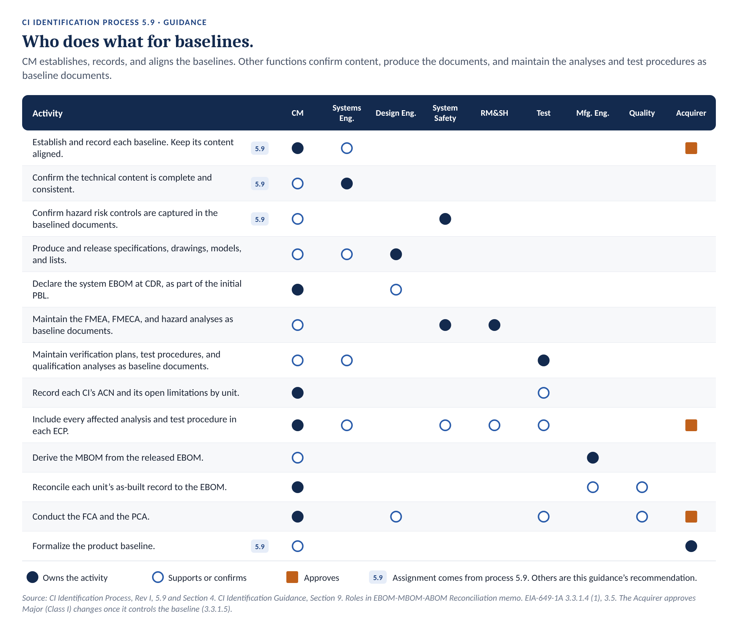
Figure 9. Who does what for baselines. Rows tagged 5.9 come from the process. The rest are recommendations.
Role | What it does for baselines
Configuration Management (CM) | Establishes and records each baseline. Keeps its content aligned with the CI structure and the approved changes. Declares the system EBOM and records the PCD content outside it. Logs the supplier deliverables that support each baseline. Confirms each change package includes every affected document, including analyses and test procedures. Reconciles each unit’s as-built record to the EBOM.
Systems Engineering | Confirms the technical content is complete and consistent at each baseline. Owns interface requirement content.
Design Engineering | Produces and releases the specifications, drawings, models, and lists. Creates the new revision after each approved change.
System Safety | Confirms hazard risk controls are captured in the baselined documentation. Maintains the system safety hazard analysis reports as baseline documents under change board control.
RM&SH | Maintains the FMEA and FMECA as baseline documents under change board control. Confirms critical characteristics reach the drawings and SCDs.
Test and verification | Maintains the verification plans, functional and qualification test procedures, and qualification analyses as baseline documents. Names the CI configuration in each approval and clearance notice. Supports the FCA.
Manufacturing Engineering | Derives the MBOM from the released EBOM and keeps it current.
Quality | Records acceptance results for each unit. Supports first article inspection and the PCA.
Reviewing function | Confirms the supplier deliverables that support each baseline were accepted (process 5.9).
Acquirer | Approves the baselines it controls and every Major change to them. Formalizes each CI’s PBL.

12. Records
The process names the baseline records: “Baseline definition documents/indices for FBL, ABL, PBL per CI, with approved change status” (process 6). The company meets part of that today. It does not meet all of it.
Record | What it holds | Status
System EBOM | The drawing tree and parts lists for the whole system. Declared at CDR as part of the initial PBL. | In place.
FBL and ABL content | The specifications, ICDs, analyses, verification plans, test procedures, and approval and clearance notices, at revision, that each FBL and ABL holds. | No dedicated record. Open (Section 13).
PCD outside the EBOM | The ATPs, process and material specifications, software documents, special tooling, packaging, and technical data for each CI. | No dedicated record. Open (Section 13).
Interface register | One row per interface, with the invoking specification and the controlling baseline. | Required by process 5.5.
CSA records | Each baseline, each approved change, its effectivity, and its implementation by unit. | Required by 3.4.1 and process 5.10.
Unit records | Acceptance results, inspection records, and test data for each unit and run. | Quality and CSA records. Checked against the baseline.

The test for a baseline record is simple. Hand it to someone outside the program. Ask them to list every baseline document for the CEU, at revision, on a given date. That list includes its analyses and test procedures. If they cannot, the record is incomplete.

13. Limits and open decisions
This guidance has limits. Some decisions remain open. The table lists both.
Item | Status
Contract governs | Where a contract imposes different requirements, the contract governs. The program CMP records the deviation.
Acquirer authority | The Acquirer approves the baselines it controls and formalizes each PBL. The company proposes the content. It does not decide it alone.
FBL and ABL record | Open. No dedicated record names the specifications, ICDs, analyses, verification plans, and test procedures, at revision, that each FBL and ABL holds.
PCD outside the EBOM | Open. The system EBOM, declared at CDR, covers the drawing tree. Confirm that each ATP, process specification, software document, special tooling item, packaging drawing, and technical data item has a baseline record. A drawing reference may serve. Where nothing references an item, it has no record.
ACN limitations by unit | Open. Confirm the CSA system records the current ACN and its open limitations for each unit, by effectivity.
Actuator ABL location | The example places the actuator’s allocated requirements in its own specification. A program may place them in the parent CI’s specification instead (process 5.9).
Supplier designs | The company does not hold the supplier’s detailed design. Its control rests on the SCD and on flowdown under the Sub-Supplier CM Requirements Flowdown and Effectiveness Process.
FAA parallel | Section 10 is this guidance’s reading. Confirm it with the certification office.

Appendix A. Glossary
Terms defined by the process keep the process wording. Terms defined by EIA-649-1A keep that wording. Terms from the Roles in EBOM-MBOM-ABOM Reconciliation memo keep the memo wording. The terms in Section 1.3 are not repeated here.
Term | Definition | Source
Allocated baseline (ABL) | The approved requirements for a product, subsystem, or component, describing the functional, performance, interoperability, and interface requirements, that are allocated from higher-level requirements, and the verifications required to demonstrate achievement of those requirements, as established at a specific point in time and documented in the allocated configuration documentation. | EIA-649-1A 2.3 (first sentence)
Approval and clearance notice (ACN) | The output of qualification testing conducted on a CI. It identifies the current exceptions and limitations associated with the CI. | Company usage
As-built configuration | The configuration of an item as actually produced. The as-built configuration consists of the as-designed configuration at the time of production as modified with approved engineering changes and variances. | EIA-649-1A 2.3 (first two sentences)
As-Built Bill of Materials (ABOM) | The record of the parts, assemblies, and materials actually installed in a specific product unit, including serial, lot, or batch numbers, as recorded during production. | BOM memo
Configuration baseline | Configuration of a product, at a specific point in time, which serves as a basis for defining change, for conducting verifications and for other management activities. For a software product, the build baseline includes the actual product. | EIA-649-1A 2.3
Acquirer-Spec Controlled CI | A CI with its own specification, which the Acquirer baselines and controls. The Acquirer takes control when it approves the baseline the specification belongs to: the FBL for the system specification, the ABL for item specifications. | Process 3.1
Company-Spec Controlled CI | A CI below an Acquirer-spec controlled CI. The company baselines and controls its specification, where it has one. A change with Class I effect reaches the Acquirer through the parent CI’s baselines. | Process 3.1
Control tier | The record of who baselines and controls a CI’s specification. The three tiers are Acquirer-spec controlled, Company-spec controlled, and GFE. | Process 3.1
Engineering Bill of Materials (EBOM) | The released, engineering-controlled list of parts, assemblies, and materials that defines a product, structured according to the design breakdown. | BOM memo
Functional baseline (FBL) | Describes the system’s performance (functional, interoperability, and interface characteristics) and the verification required to demonstrate the achievement of those specified characteristics. It is directly traceable to the operational requirements contained in the Initial Capabilities Document (ICD) or equivalent document. | EIA-649-1A 2.3
Functional configuration audit (FCA) | The formal examination of functional characteristics of a Configuration Item to verity [sic] that it met the requirements specified in its functional and allocated configuration documentation. | EIA-649-1A 2.3
Interface control documentation (ICD) | Interface control drawings, requirements, or other descriptive products, which define, describe, and/or depict physical, functional, and test interface of related or co-functioning Configuration Items. | EIA-649-1A 2.3
Manufacturing Bill of Materials (MBOM) | The list of parts, assemblies, and materials structured in the sequence and grouping used to build the product. The MBOM is derived from the EBOM and may add manufacturing items not shown in the EBOM, such as consumables and process materials. | BOM memo
Physical configuration audit (PCA) | A formal examination of the actual (as-built) configuration of an item compared to its product configuration documentation. The PCA verifies the product configuration documentation is a clear, complete, and accurate representation of the configuration item and is necessary to establish the product baseline. | EIA-649-1A 2.3 (first two sentences)
Product baseline (PBL) | Describes the detailed design at a specific point in time, for production, fielding/deployment, and operations and support. The PBL prescribes all necessary physical (form, fit, or function) characteristics and selected functional characteristics designated for production acceptance testing and production test requirements. | EIA-649-1A 2.3 (first two sentences)
Source control drawing (SCD) | A drawing that provides an engineering description, qualification requirements and acceptance criteria for commercial items or vendor-developed items procurable from a specialized segment of industry that provide the performance, installation, interchangeability, or other characteristics required for critical applications. | EIA-649-1A 2.3 (first sentence)
Variance | An authorized temporary departure from the approved configuration documentation information for a specific number of units under the contract or contracts identified and that does not require revision of approved product configuration documentation. | EIA-649-1A 2.3 (first sentence)

Appendix B. References
Document | Title or relevance
CI Identification Process, Rev I (Draft) | Section 5.9 sets baseline establishment. It governs where this guidance differs.
EIA-649-1A | Configuration Management Requirements for Defense Contracts. Section 3.2.3 defines the baselines and their documentation.
GEIA-HB-649A | Configuration Management Standard Implementation Guide. Baseline approval, PBL content, and interface documentation tables.
CI Identification Guidance | Companion guidance in the same format. Source of the worked example.
Configuration Audit Process | Companion process. Designates CIs for PCA and runs the audits.
Nonconformance and Variance Guide | Companion guidance. Variances against a baseline.
Roles in EBOM-MBOM-ABOM Reconciliation memo | Assigns the BOM reconciliation checks. Source of the BOM definitions.
Sub-Supplier CM Requirements Flowdown and Effectiveness Process | Companion process. Flowdown to suppliers who hold detailed designs.
EIA-649-1 Sixteen Barriers analysis | Source of the MCAS example in Section 3.2.
14 CFR 21.31 | Type design. Section 10 parallel.
FAA Order 8110.4C | Type Certification. Section 10 parallel.

