MEMORANDUM
TO: Executive Leadership; Engineering Management
FROM: [Name], Configuration Management
DATE: October 7, 2026
SUBJECT: Configuration baselines: what each one holds, what stays outside it, and what we need from you

Bottom line
A configuration baseline is the agreed definition of a product at a point in time. Every change is measured against it. What a baseline holds decides how a change is classified, who approves it, and what our audits check.
EIA-649-1A decides baseline content by what a document carries, not by what kind of document it is. A specification, a drawing, an analysis, or a test procedure belongs in a baseline when it carries requirements, allocations, verifications, acceptance criteria, or design. We already control our FMEAs, FMECAs, system safety hazard analysis reports, qualification analyses, and functional test procedures through the change board. That practice is correct. This memo explains why, and what still needs work.
One rule covers it. If a document defines, verifies, or accepts the item, the change board controls it. If it records what one unit did, it is a record, checked against the baseline. Figure 1 shows the three baselines and the rule.
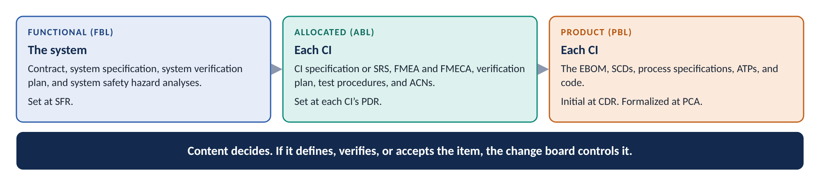
Figure 1. Three baselines, one rule
This memo asks for four commitments.

A concrete case
The elevator actuator’s FMECA finds a catastrophic failure mode. It allocates a critical function to the actuator. The actuator specification states that function as a requirement. The source control drawing flags the critical characteristics, and the acceptance test procedure inspects them.
Four documents now carry one requirement: the FMECA, the specification, the drawing, and the acceptance test procedure. All four are baseline documents. Each one meets an EIA-649-1A clause. A critical function allocated to hardware is allocated configuration documentation (3.2.3.2.1 (1) a). A test procedure describes a required verification (3.2.3.2.1 (1) b). An acceptance test procedure is product configuration documentation (3.2.3.2.2 (1) b).
A year later an engineer changes the actuator’s ball screw. The change package updates the drawing. Suppose nobody updates the FMECA. The change passes. The FMECA now describes a design that no longer exists. The hazard analysis that relies on it may claim a mitigation the hardware no longer provides.
Change board control prevents that. One change must revise every document that carries the requirement. The board sees the full set before it approves.
Here is the exact meaning of the word at the center of the case:
CONFIGURATION BASELINE
An agreed-to definition of the attributes of a product at a point in time, identifying a known configuration to which changes are addressed. Baseline types are functional (FBL), allocated (ABL), and product (PBL).

What each baseline contains
The table lists the items each baseline covers and the documentation it contains. The last row lists the records that stay outside every baseline.
Baseline | Items it covers | Documentation it contains | Set and controlled
Functional (FBL) | The system: the top-level CI.  Usually the end item the contract specifies, such as the aircraft. | The contract and statement of work.  The system specification (A-level), often a System/Subsystem Specification.  System external interface requirements: the IRS and the ICDs the specification references.  The system verification plan, with a verification method for each system requirement.  The system safety hazard analysis reports, and the safety requirements they derive. | Set at SFR.  The customer controls the system specification once it approves the FBL.
Allocated (ABL) | Each CI below the system.  Top-tier, Acquirer-spec controlled CIs, and the company-spec controlled CIs below them. | The CI performance specification (B-level), or the Software Requirements Specification for software.  Interface requirements with interfacing CIs: the IRS and the ICDs the specification references.  Critical functions allocated to the CI, and the FMEA, FMECA, and hazard analyses that allocate them.  The verification plan, and the functional and qualification test procedures.  Qualification analyses.  Approval and clearance notices from qualification testing, with the CI’s current exceptions and limitations. | Set at each CI’s PDR.  The customer controls top-tier specifications once it approves the ABL. The company controls the specifications below them.
Product (PBL) | Each CI, and the system.  Parts inside a CI are defined in its PBL. They get no baseline of their own. | The EBOM: drawings, 3D models, and parts lists.  Source control drawings for purchased items, with their qualified sources.  Critical characteristics from the FMECA and hazard analyses, flagged on the drawings and SCDs.  Product, process, and material specifications.  Acceptance test procedures and first article requirements.  For software: the Software Product Specification, the source code, and the Software Version Description.  Special tooling, special packaging, and COTS identification.  Technical data, when the contract requires it. | Initial at CDR, when we declare the system EBOM.  The customer formalizes it at the PCA, or no later than first production unit delivery.
Records, not in | What one unit is, or what one test run did. | Acceptance test results for each unit.  As-built records for each unit.  Inspection and first article records.  Data from each test run.  The MBOM, which manufacturing derives from the EBOM. | Controlled as records.  Checked against the baseline. Not revised by an ECP.

Two notes on the table. First, the EBOM is only part of the PBL. The rest of the PCD sits outside it. Second, a company-spec controlled CI still has an ABL and a PBL. Its tier decides who controls its specification. It does not decide who approves a Major change. No CI is changed on company authority alone.

Six things to know
1. There are three baselines, at three levels of detail. The functional baseline says what the system must do. The allocated baseline gives each CI its share. The product baseline says how each CI is built, accepted, and supported. Each one adds detail to the one before it and traces back to it.
2. The EBOM is the backbone of the product baseline, not all of it. We declare the system EBOM at CDR. That sets the drawing tree. The product baseline also holds the acceptance test procedures, the process and material specifications, the software code-to documents, special tooling and packaging, and technical data when the contract requires it. Today no record names that content for each CI.
3. Analyses and test procedures that carry baseline content are baseline documents. Our FMEAs, FMECAs, system safety hazard analysis reports, qualification analyses, verification plans, and functional test procedures allocate critical functions, derive safety requirements, or describe required verifications. EIA-649-1A puts that content in the functional and allocated configuration documentation. We control those documents through the change board, and we should keep doing so. Figure 2 shows how one requirement runs through them.
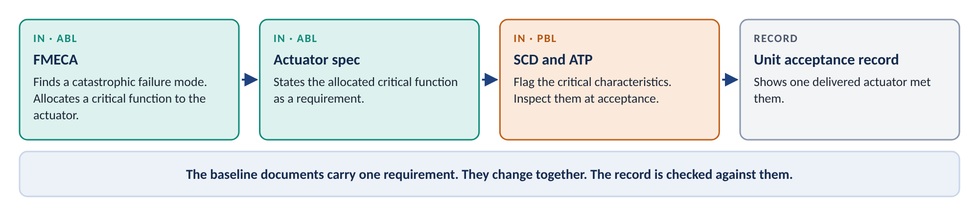
Figure 2. One requirement, several controlled documents
4. Documents that carry the same requirement change together. An engineering change must find every document it affects, including the analyses and test procedures, and revise each one (EIA-649-1A 3.3.1.1 and 3.3.4). A change to qualification, acceptance, or safety requirements is a Major change. So is a change that requires requalification. Requalification produces a new approval and clearance notice.
5. Records stay outside the baseline. An acceptance test data sheet, an as-built record, or the data from one test run says what one unit did. It cannot change. We control it as a record and check it against the baseline. Routing records through the change board adds load and defines nothing.
6. A baseline never ends. Change control starts the day a baseline is set. A baseline plus its approved changes is the current approved configuration. We must be able to reconstruct both for every unit in service.
If a document says what the product must be, how we verify it, or how we accept it, the change board controls it. If it says what one unit did, it is a record.

Why this matters
Exposure | How the rule addresses it
Analyses that drift from the design | The FMEA, FMECA, and hazard analyses sit under change board control. Every change that affects them revises them.
Silent loss of safety requirements | The critical functions the analyses allocate also appear in the specifications and drawings. System Safety confirms hazard controls are captured at each baseline, as the CI Identification Process requires.
Change board overload | Records of single units stay out of the change board. The board reviews documents that define, verify, or accept the item.
Audit findings | The functional and physical configuration audits check the analyses, procedures, and design against the product. A complete, consistent set is one the audit can verify.
Unrecorded baseline content | ATPs, process specifications, software documents, analyses, and test procedures gain a baseline record next to the EBOM.

What we need from you

Engineering management
- Apply the content test at each baseline. Direct engineering leads to sort their documents by what they carry. Requirements, allocations, verifications, acceptance criteria, and design go under change board control. Records of single units do not.
- Keep the analyses and test procedures under change board control, tied to their CI. Each FMEA, FMECA, hazard analysis, qualification analysis, and test procedure names the CI and the baseline it belongs to. Each approval and clearance notice names the CI configuration it clears. CM records its open limitations for each unit.

Executive leadership
- Require every ECP to include every affected document. Each change package lists the analyses and test procedures it touches, with a notice of revision for each. Staff System Safety, RM&SH, and Test to review changes on the change board’s schedule.
- Fund a record of the full content of each baseline. The system EBOM, declared at CDR, records the drawing tree. Add a record of the rest. For each FBL and ABL, that is the specifications, ICDs, analyses, verification plans, and test procedures at revision. For each PBL, it is the ATPs, process specifications, software documents, tooling, packaging, and technical data.

Next steps
- [Date]: Comments on the draft guidance due to Configuration Management.
- [Date]: Decision on the baseline content record.
- The practitioner guide, Configuration Baselines, accompanies this memo.
Questions go to [Name], Configuration Management, at [email].

