CYBERSECURITY PENETRATION TEST REPORT

Breach at the Perimeter
Firewall & Proxy Evasion using Metasploit and Nikto
Course-End Project - Advanced Executive Program in Cybersecurity
Field | Detail
Client / Scenario | ViceSolutions (simulated)
Target system | Metasploitable 2 - 192.168.67.129 (isolated lab)
Attacking host | Kali Linux 2026.2 - 192.168.67.128
Tooling | Metasploit Framework 6.5.3 · Nikto 2.6.1 · curl · AI-assisted analysis
Assessment type | Perimeter / web-layer black-box test (red-team simulation)
Prepared by | AkshayKumar Hiremath
Date | 6 October 2026

Contents
1. Executive Summary
2. Objective, Scope & Authorization
3. Test Environment
4. Methodology
5. Task 1 - Environment Setup & Target Resolution
6. Task 2 - Reconnaissance with Metasploit
7. Task 3 - Firewall & Proxy Evasion
8. Task 4 - Vulnerability Scanning with Nikto (Three Modes)
9. Task 5 - AI-Assisted Analysis
10. Consolidated Findings & Countermeasures
11. Troubleshooting & Tool Notes
12. Conclusion & Recommendations
Appendix A - Screenshot Index
Appendix B - Nikto Default Scan (Raw Evidence Excerpt)

1. Executive Summary
This assessment simulated a red-team attack against ViceSolutions, a fictional organisation represented in the lab by a Metasploitable 2 virtual machine at 192.168.67.129. The objective was to probe the target’s HTTP perimeter - fingerprinting the web stack, enumerating supported methods and exposed content, and attempting firewall/proxy evasion - using Metasploit and Nikto, with AI assistance for interpreting output and prioritising findings.
The perimeter was found to be weak. Nine distinct issues were identified, three of them High severity. The dominant risks are an end-of-life web stack (Apache 2.2.8 and PHP 5.2.4, both years out of support with known CVEs) and a publicly reachable phpMyAdmin database-administration interface. These are compounded by web-layer misconfigurations: the TRACE method is enabled (Cross-Site Tracing / XST), directory indexing exposes internal paths, phpinfo() leaks full system configuration, and every modern security-response header is absent.
Evasion was also demonstrated. Against this undefended host the scan results changed little under spoofing, but the mutated (encoded) Nikto run reported only 19 findings versus 31 in the default run - the obfuscation changed the request fingerprints enough that the scanner’s own signatures missed checks. That reduction is the core lesson: the same encoding that blinds a signature engine here is what defeats a signature-based IDS/WAF in production.
Severity summary: High 3 · Medium 3 · Low-Medium 2 · Low 1

Top three remediations (highest risk reduction)
- Patch or upgrade Apache and PHP to supported releases and migrate off the end-of-life operating system - this removes the two highest-risk findings and the bulk of CVE exposure in a single action.
- Lock down phpMyAdmin and remove phpinfo.php - restrict the admin interface to authenticated, authorised hosts and delete the diagnostic script. These close the two fastest paths to sensitive data.
- Harden the web layer - disable the TRACE method, switch off directory indexing, and set the missing security-response headers to blunt the XST, enumeration, and client-side-injection classes.

2. Objective, Scope & Authorization

2.1 Objective
To simulate real-world firewall and proxy bypass techniques against the target, focusing on fingerprinting, HTTP-header and User-Agent spoofing, directory scanning, and scanner evasion modes using Metasploit and Nikto - then to interpret the output with AI assistance in order to prioritise findings and recommend countermeasures.

2.2 Scope
- In scope: the single host 192.168.67.129 (TCP/80, HTTP), tested from the Kali attacker at 192.168.67.128 on an isolated virtual network.
- Out of scope: application-layer exploitation (SQLi, XSS, etc.), denial-of-service testing, and any system other than the designated target.

2.3 Authorization & ethics
All testing was conducted against virtual machines owned and operated by the tester, running offline on a private VMware network with no connection to any production or third-party system. “ViceSolutions” is a training scenario, not a live organisation. No real systems were accessed, and no activity was performed outside the authorised lab.

3. Test Environment
Component | Role | Details
Kali Linux 2026.2 | Attacker | 192.168.67.128 · MAC 00:0c:29:35:89:15 · Metasploit 6.5.3, Nikto 2.6.1, curl
Metasploitable 2 | Target | 192.168.67.129 · MAC 00:0c:29:ee:af:28 · Apache 2.2.8 (Ubuntu), PHP 5.2.4
VMware Workstation Pro | Hypervisor | Both VMs on NAT (VMnet8); network isolated from the physical LAN
No containerisation was used - Metasploit and Nikto were run natively on Kali. The two guests were confirmed to be distinct machines by their separate VMware-assigned MAC addresses, and the NAT (VMnet8) configuration kept the intentionally vulnerable target off the physical network throughout.

4. Methodology
The engagement followed a reconnaissance-led approach aligned with standard penetration-testing phases, structured as the project’s five tasks:
- Setup & target resolution - prepare the attacker, confirm connectivity, and positively identify the target’s address.
- Reconnaissance (Metasploit) - fingerprint the server banner, enumerate HTTP methods, test WebDAV exposure, and discover directories.
- Evasion - disguise requests via Host-header, virtual-host and User-Agent spoofing to model firewall/proxy bypass.
- Vulnerability scanning (Nikto) - run the scanner in default, spoofed, and mutated (encoded) modes and compare coverage.
- AI-assisted analysis - convert raw scanner output into prioritised findings, risk ratings, and concrete countermeasures.

5. Task 1 - Environment Setup & Target Resolution
The attacker was updated, tooling verified, and the target located and confirmed from two independent directions before any scanning began.

5.1 Update and verify tooling
sudo apt update && sudo apt full-upgrade -y
msfconsole --version # Framework Version: 6.5.3-dev
nikto -Version # Nikto 2.6.1 (LW 2.5)
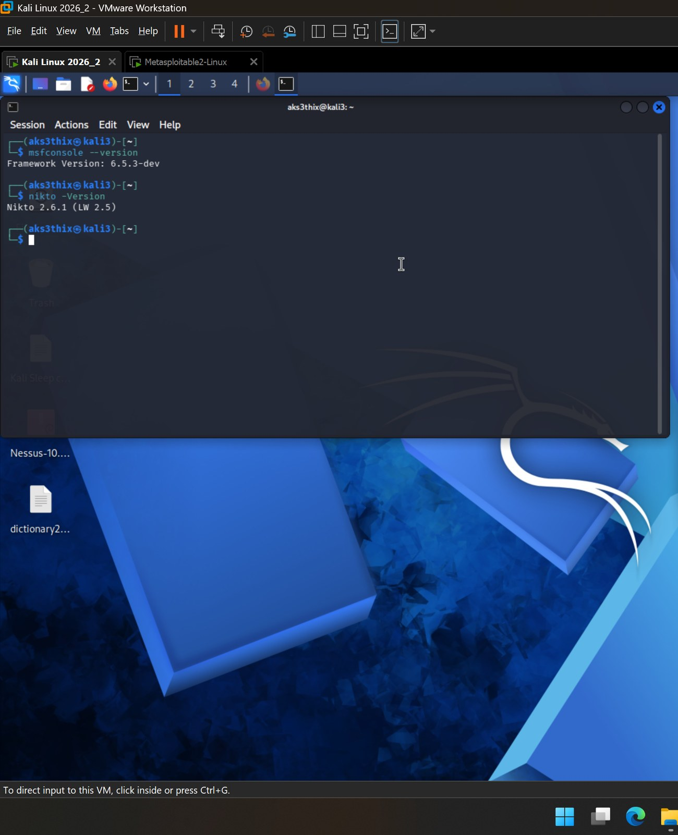
▸ Screenshot 01 - Kali updated; Metasploit 6.5.3 and Nikto 2.6.1 verified
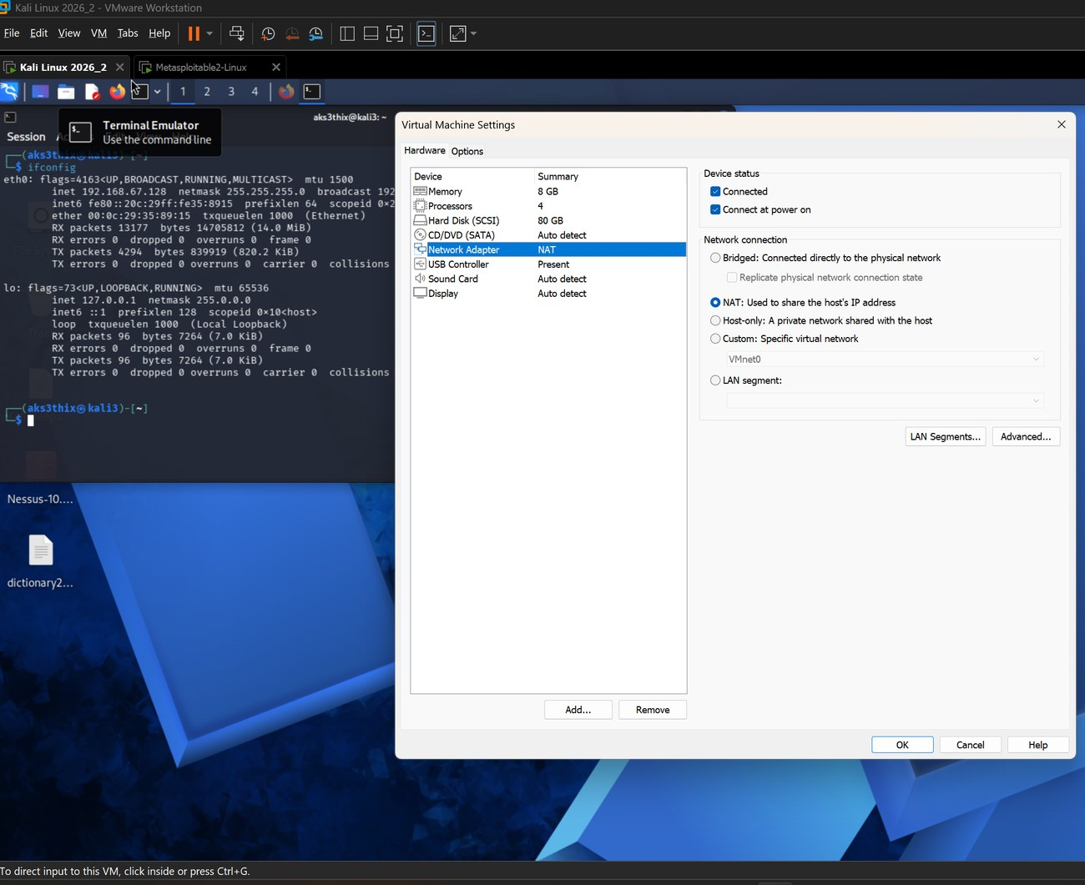
▸ Screenshot 02 - Kali network adapter set to NAT
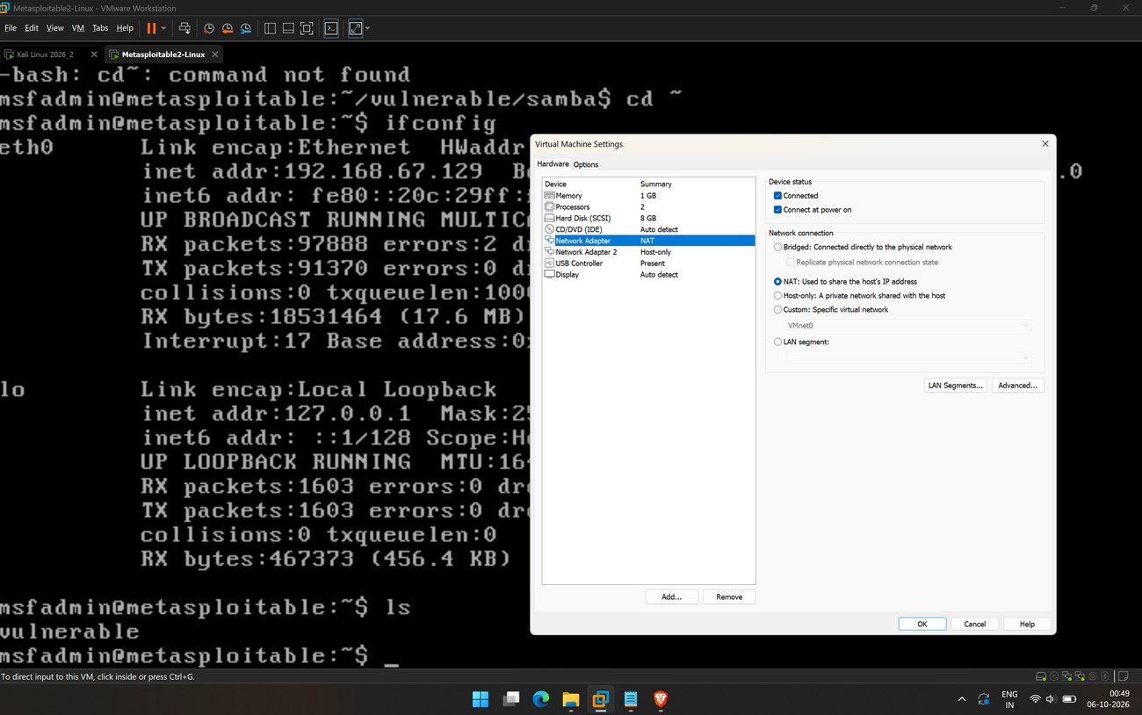
▸ Screenshot 03 - Metasploitable network adapter set to NAT

5.2 Resolve and confirm the target
ip a # Kali eth0 -> 192.168.67.128
sudo nmap -sn 192.168.67.0/24 # host discovery sweep
ping -c 3 192.168.67.129 # 3 received, 0% loss
On the target console, ifconfig reported eth0 inet addr: 192.168.67.129 with MAC 00:0c:29:ee:af:28 - a VMware guest address distinct from Kali’s, positively identifying the box as the target rather than a reflection of the attacker.
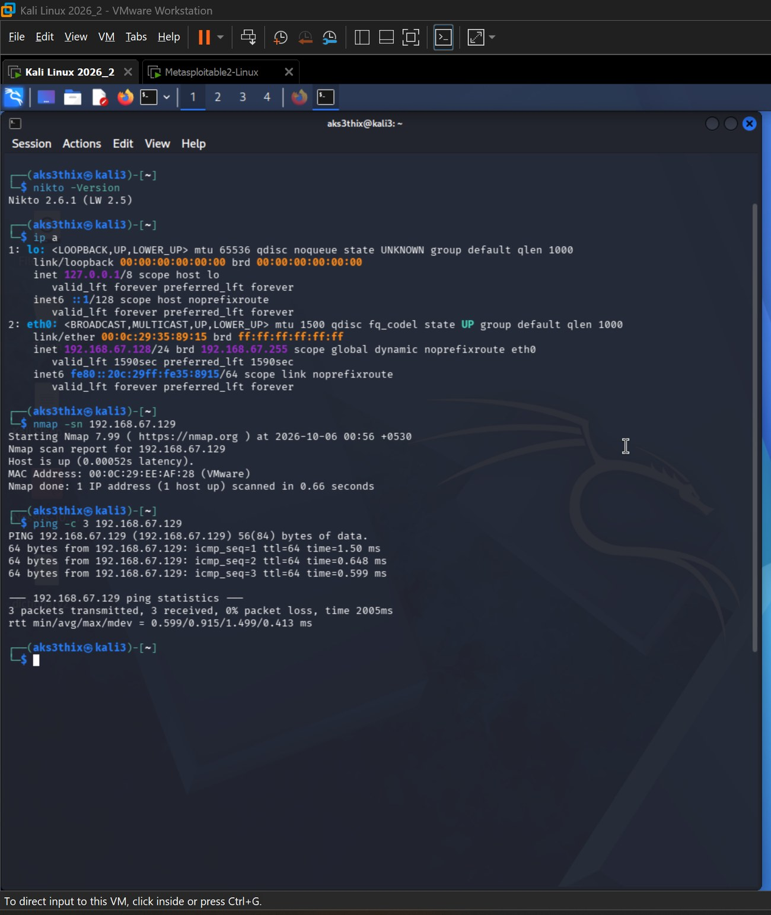
▸ Screenshot 04-06 - Kali IP (ip a), nmap -sn subnet sweep, and successful ping to 192.168.67.129
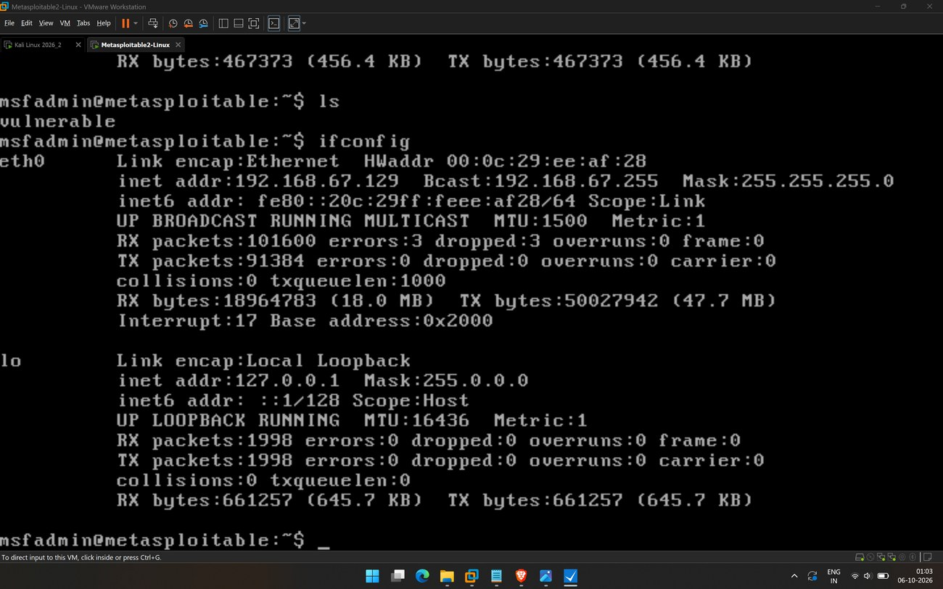
▸ Screenshot 07 - Metasploitable ifconfig confirming eth0 = 192.168.67.129

6. Task 2 - Reconnaissance with Metasploit
Metasploit’s HTTP auxiliary scanners were used to fingerprint the server and enumerate its exposure. The target was set once in the global datastore so every module inherited it.
msfconsole
setg RHOSTS 192.168.67.129
setg RPORT 80
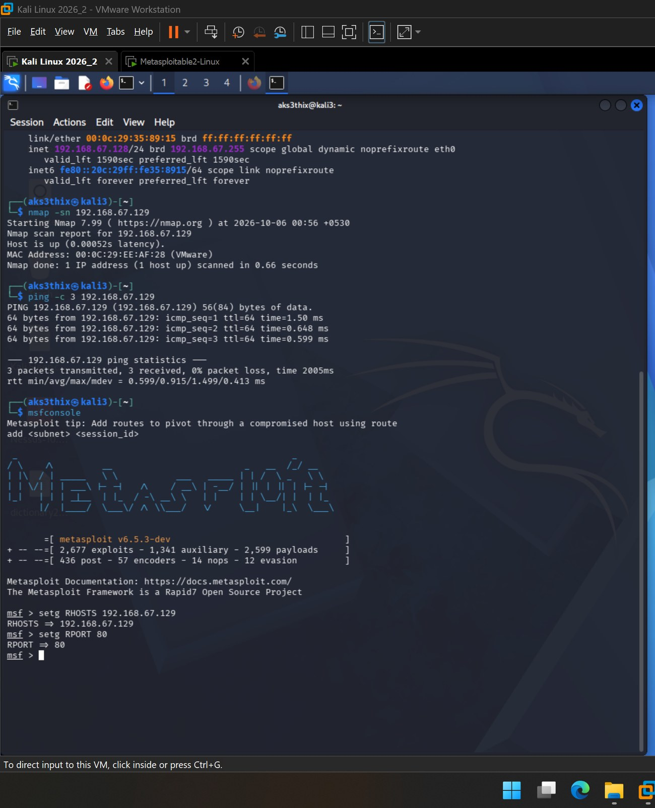
▸ Screenshot 08 - msfconsole launch banner (Framework 6.5.3-dev); RHOSTS / RPORT set globally

6.1 Server banner / version
use auxiliary/scanner/http/http_version
run
Result: Apache/2.2.8 (Ubuntu) DAV/2 ( Powered by PHP/5.2.4-2ubuntu5.10 ). The server openly advertises an outdated Apache and PHP, plus the DAV module - the WebDAV hint confirmed below.
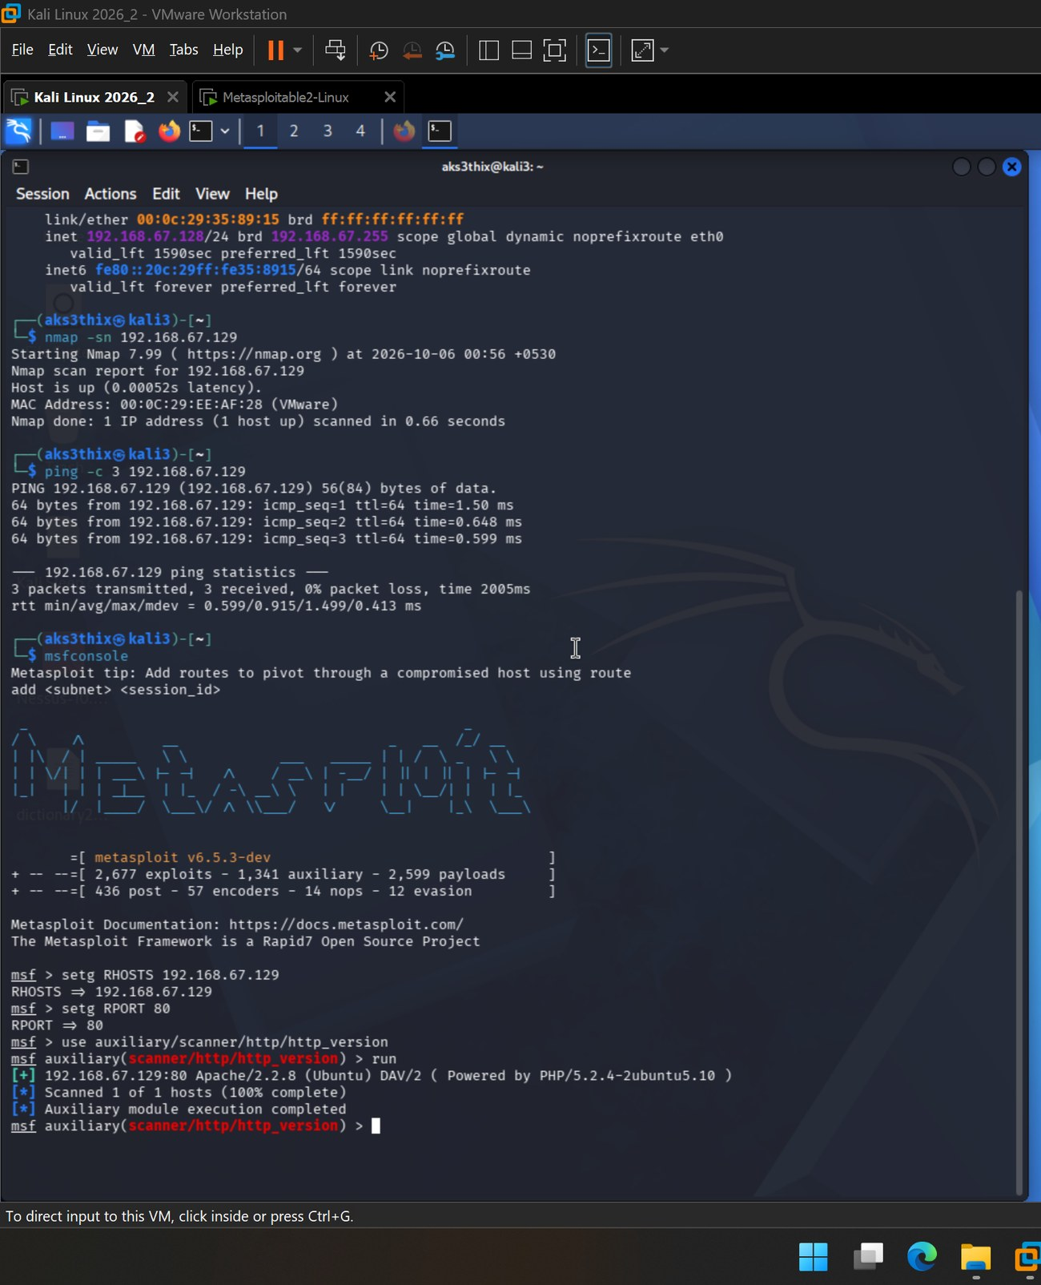
▸ Screenshot 09 - http_version - Apache/2.2.8 (Ubuntu) DAV/2, PHP/5.2.4

6.2 Supported HTTP methods (and a tool quirk)
The http/options module executed cleanly but returned no method list - Apache 2.2.8 does not emit a parseable Allow: header at the web root, so the module had nothing to parse. This is not a failure; the methods were confirmed directly with curl instead, which is stronger evidence.
curl -i -X OPTIONS http://192.168.67.129/ # 200 OK, no Allow header
curl -i -X TRACE http://192.168.67.129/ # 200 OK, echoes the request
The TRACE request returned 200 OK with Content-Type: message/http and the request echoed back verbatim - confirming the TRACE method is enabled and the host is vulnerable to Cross-Site Tracing (XST).
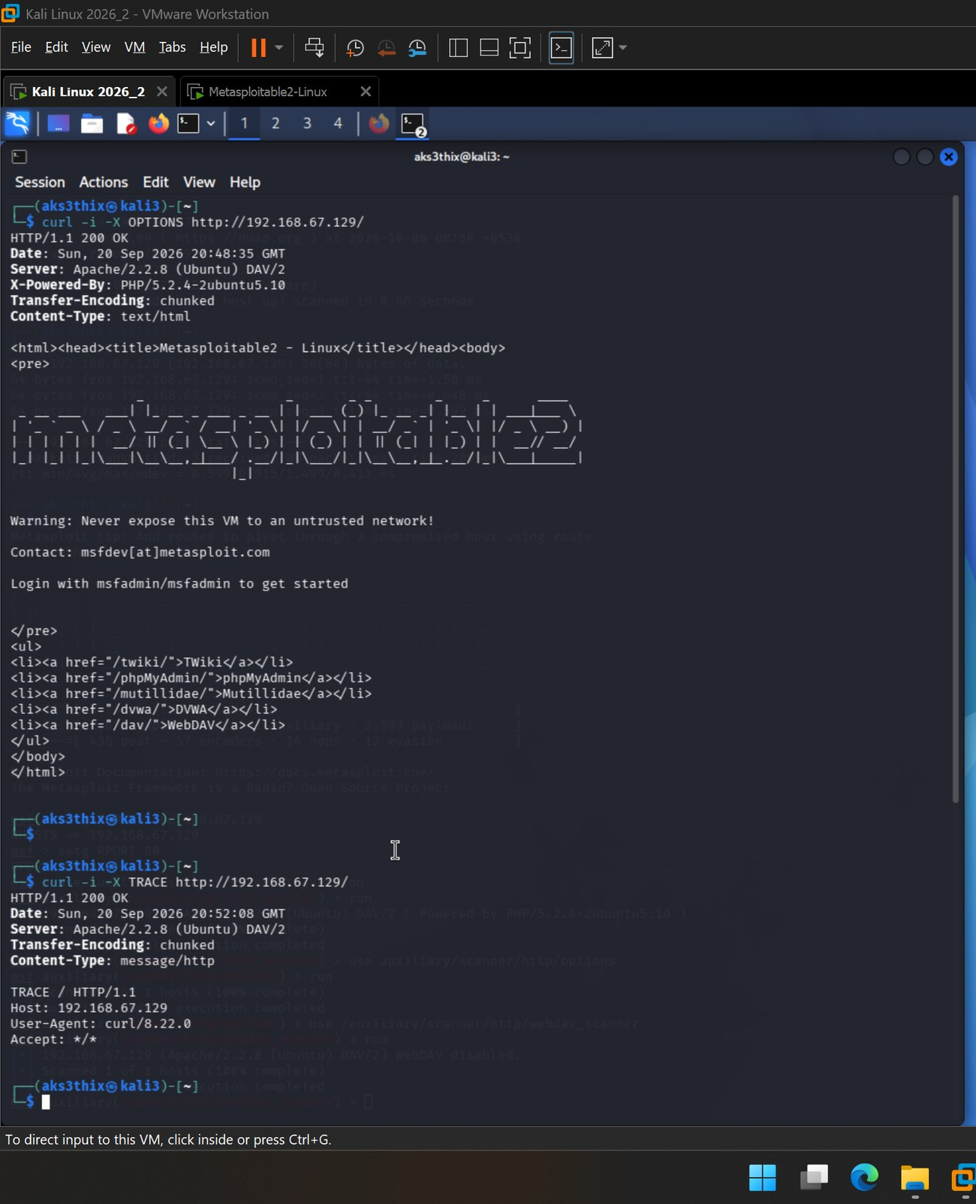
▸ Screenshot 10 - curl OPTIONS + TRACE - TRACE active, request echoed (message/http) = XST confirmed
The OPTIONS response also served the target home page, which openly enumerates the installed web applications - useful context for the exposed-directory findings below.
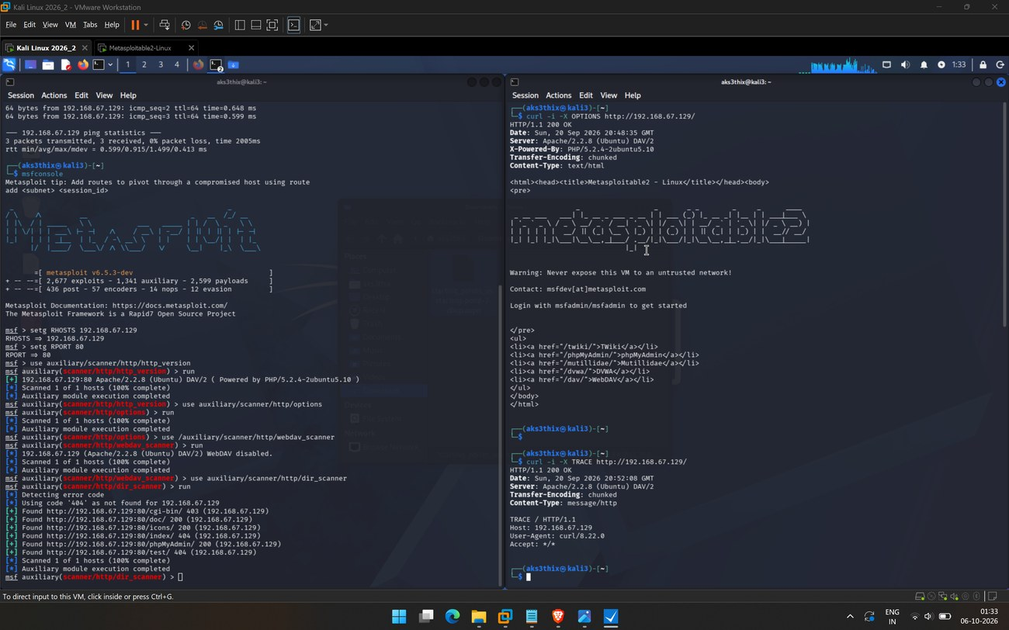
▸ Screenshot Supp. - Supplementary: home page lists TWiki, phpMyAdmin, Mutillidae, DVWA and WebDAV

6.3 WebDAV exposure
use auxiliary/scanner/http/webdav_scanner
run
Result: WebDAV disabled. Although the banner advertises DAV/2 and the home page links a /dav/ folder, the scanner confirms WebDAV is not active or writable on the tested path - a legitimate negative finding (advertised capability, not exploitable).
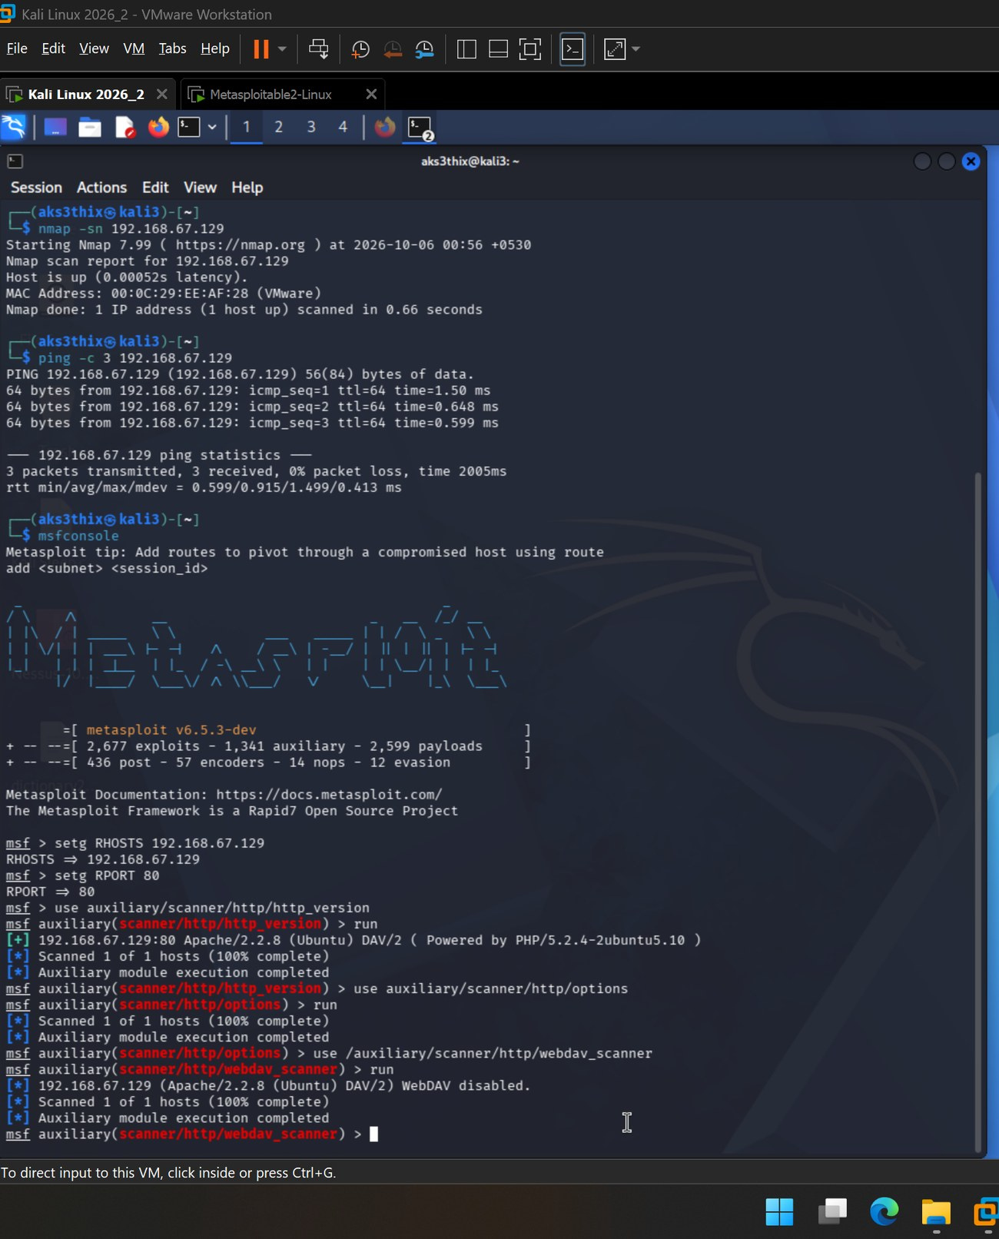
▸ Screenshot 11 - webdav_scanner - WebDAV disabled

6.4 Directory discovery
use auxiliary/scanner/http/dir_scanner
run
Path | HTTP status | Interpretation
/doc/ | 200 | Exposed and browsable - internal documentation directory
/icons/ | 200 | Exposed - Apache default icons directory
/phpMyAdmin/ | 200 | Exposed database-administration interface (notable)
/cgi-bin/ | 403 | Present but access forbidden
/index/ | 404 | Not present
/test/ | 404 | Not present (surfaced separately by Nikto)
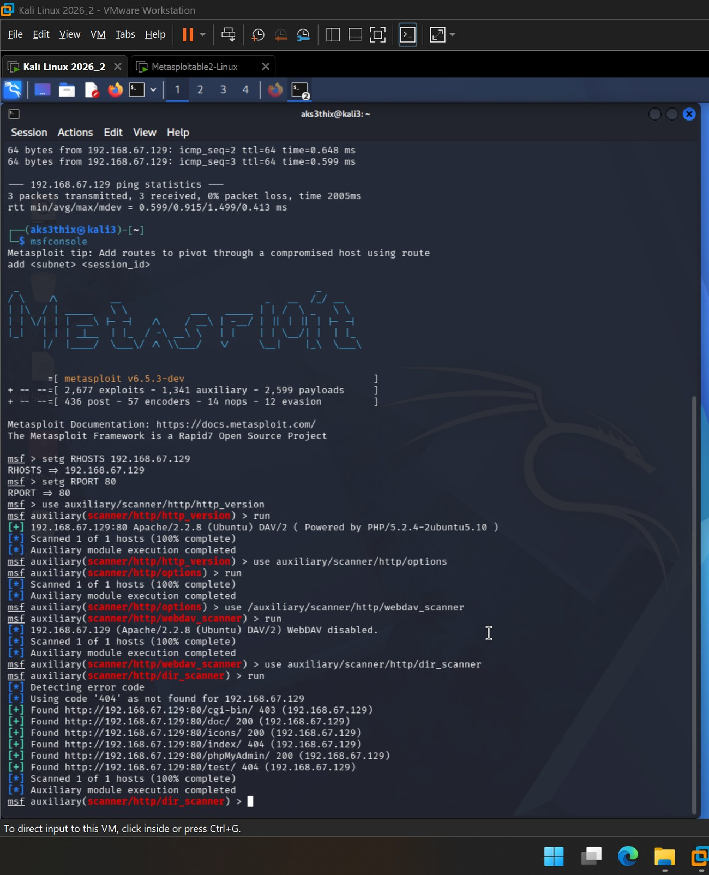
▸ Screenshot 12 - dir_scanner - /doc/ (200), /icons/ (200), /phpMyAdmin/ (200), /cgi-bin/ (403)

7. Task 3 - Firewall & Proxy Evasion
Evasion disguises requests so they resemble ordinary browser traffic - the technique used to slip a scanner past web filters, WAFs and proxies. It was demonstrated two ways: with curl (proving the spoofed headers leave the machine) and inside a Metasploit module.

7.1 Baseline request
curl -I http://192.168.67.129/
The undisguised request returned the real banner - Server: Apache/2.2.8 (Ubuntu) DAV/2 and X-Powered-By: PHP/5.2.4-2ubuntu5.10 - establishing a reference point.
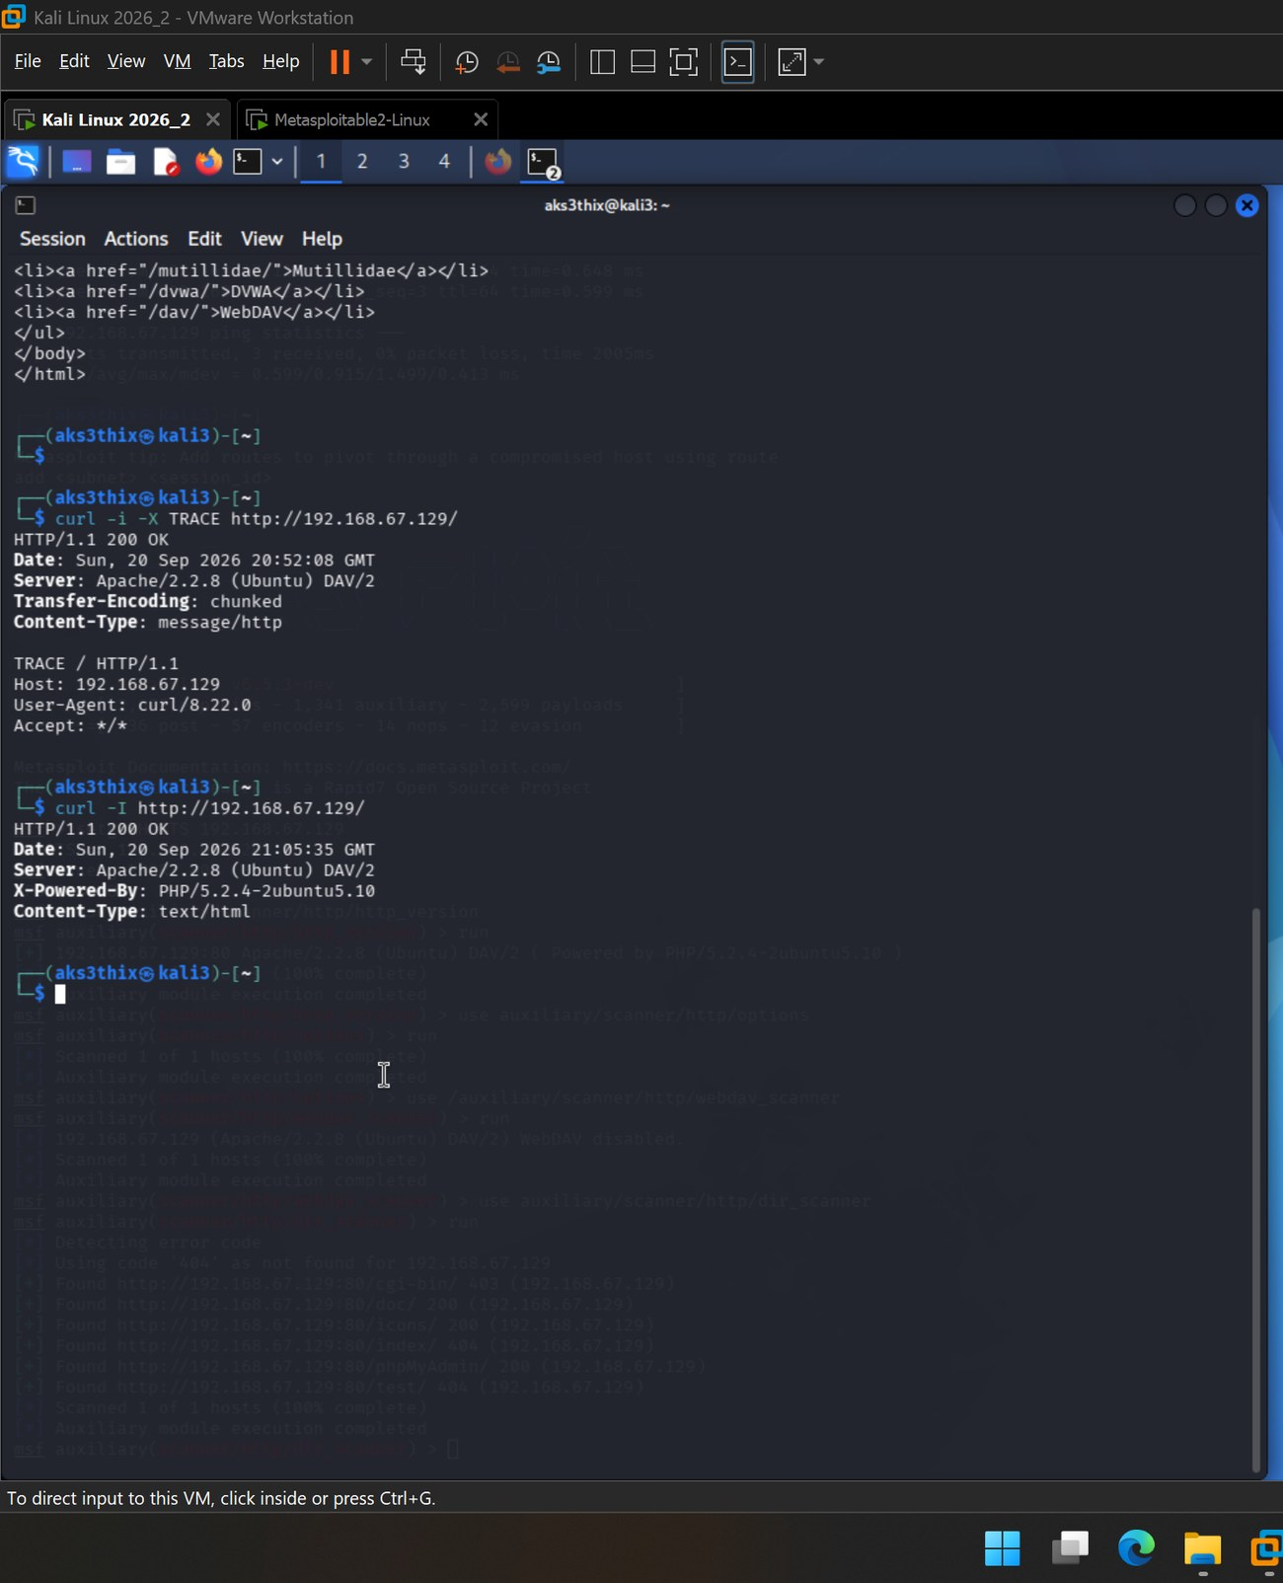
▸ Screenshot 13 - Baseline curl -I - Server: Apache/2.2.8, X-Powered-By: PHP/5.2.4

7.2 Spoofed request
curl -v -A "Mozilla/5.0 (Windows NT 10.0; Win64; x64) AppleWebKit/537.36
(KHTML, like Gecko) Chrome/120.0.0.0 Safari/537.36"
-H "Host: www.vicesolutions.local" http://192.168.67.129/
The verbose output showed the outgoing request lines carrying the forged values - > Host: www.vicesolutions.local and > User-Agent: Mozilla/5.0 … Chrome/120.0.0.0 - and the server replied 200 OK. Direct proof that a fake browser identity and a fabricated hostname were accepted on the wire.
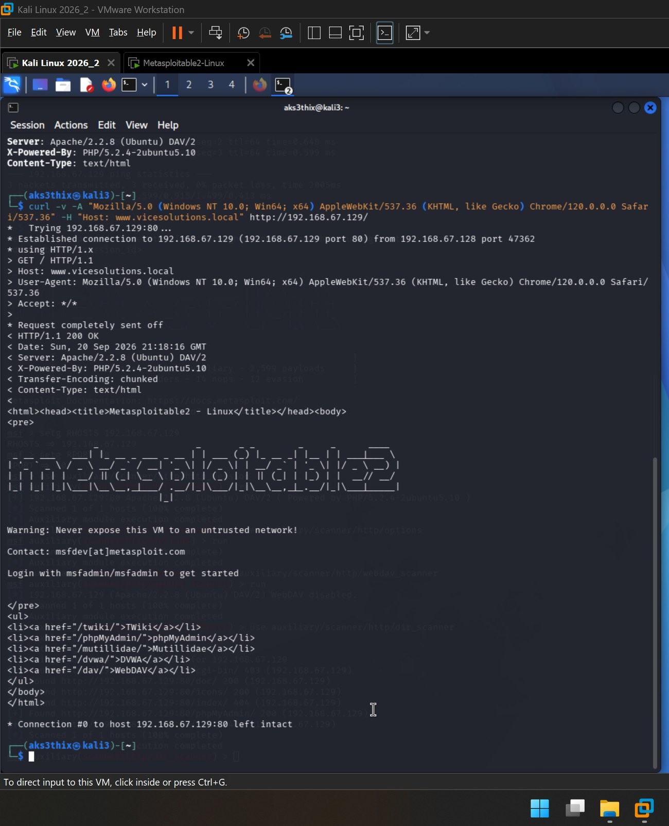
▸ Screenshot 14 - curl -v - spoofed Host (www.vicesolutions.local) and Chrome User-Agent on the wire

7.3 Spoofing inside Metasploit
use auxiliary/scanner/http/http_version
set VHOST www.vicesolutions.local
set UserAgent "Mozilla/5.0 (Windows NT 10.0; Win64; x64) Chrome/120.0.0.0 Safari/537.36"
show options
run
The show options table confirmed the spoofed VHOST and User-Agent were applied to the module before running - the same evasion, demonstrated within the tool.
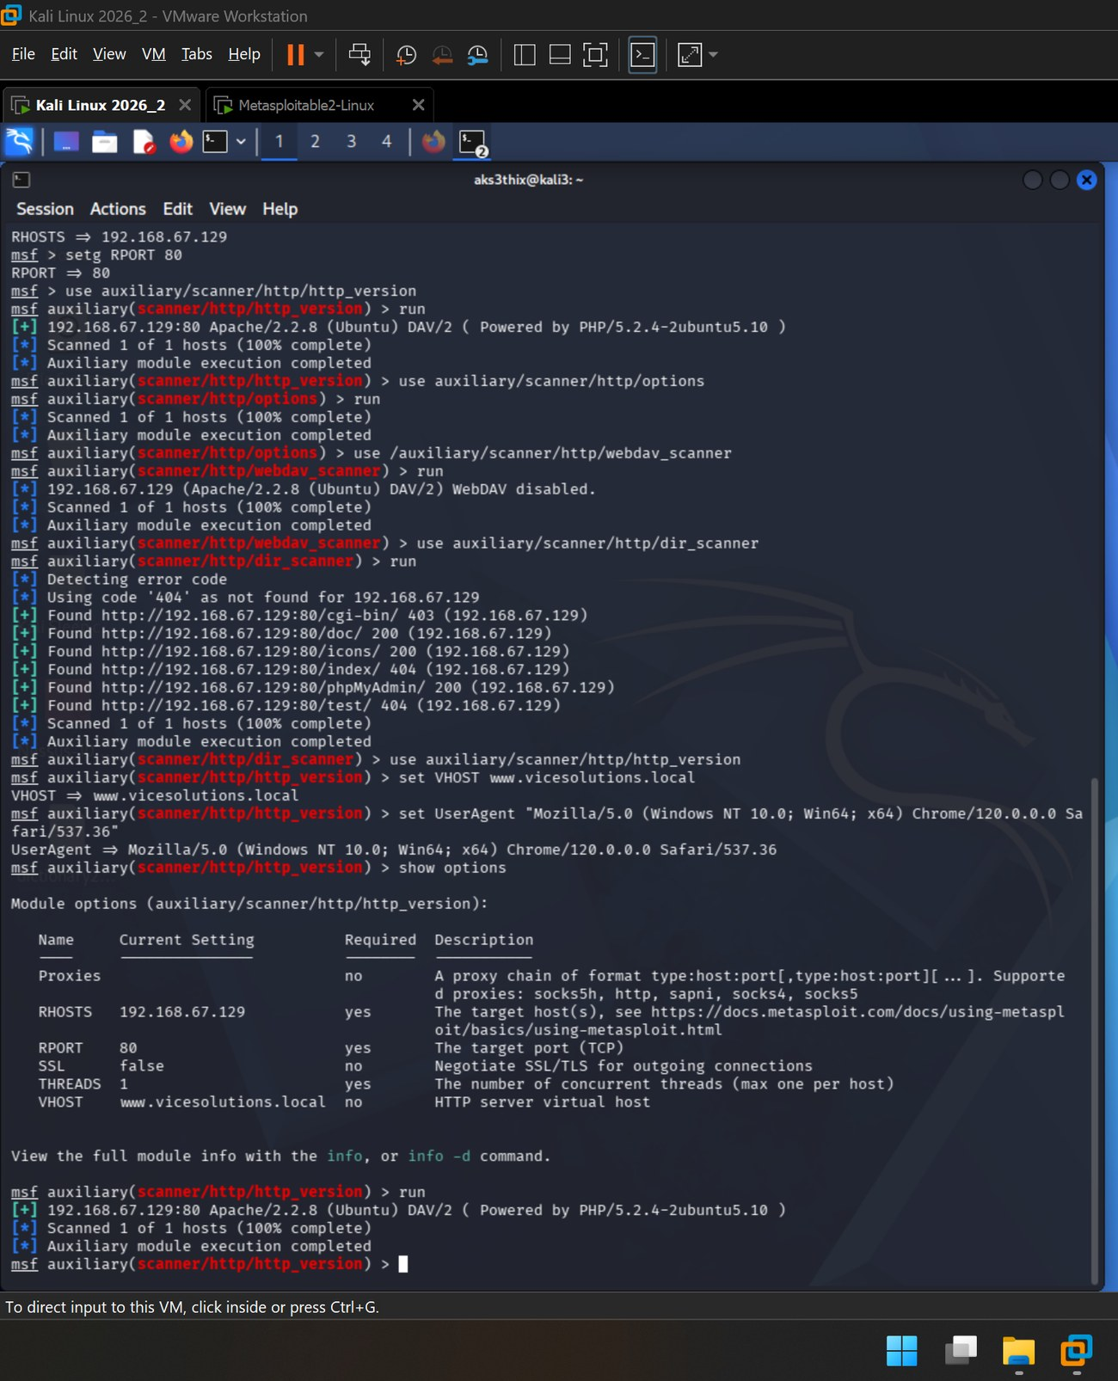
▸ Screenshot 15 - Metasploit show options - spoofed VHOST and UserAgent applied

7.4 Interpretation
Because the target has no WAF or proxy in front of it, the server’s response did not change when spoofed - the expected result for an undefended host. The deliverable is the demonstrated technique: the forged headers were constructed and placed on the wire. Against a filtered target, this is precisely the manipulation that evades simple User-Agent and host-based controls.

8. Task 4 - Vulnerability Scanning with Nikto (Three Modes)
Nikto was run three ways against the target, each saved to a file for evidence: a plain baseline, a spoofed scan, and a mutated (encoded) scan.
nikto -h http://192.168.67.129 -o nikto_default.txt
nikto -h http://192.168.67.129 -useragent "Mozilla/5.0 ... Chrome/120.0.0.0 Safari/537.36" -o nikto_spoofed.txt
nikto -h http://192.168.67.129 -evasion 1 -o nikto_mutated.txt
ls -l nikto_*.txt
Tool note: the spoofed scan was first attempted with the -vhost flag, which failed on Nikto 2.6.1 with a vhost-handling error (“Unable to connect … isn’t numeric”). Re-running with the -useragent spoof alone completed successfully - the User-Agent is the component that matters for this deliverable.
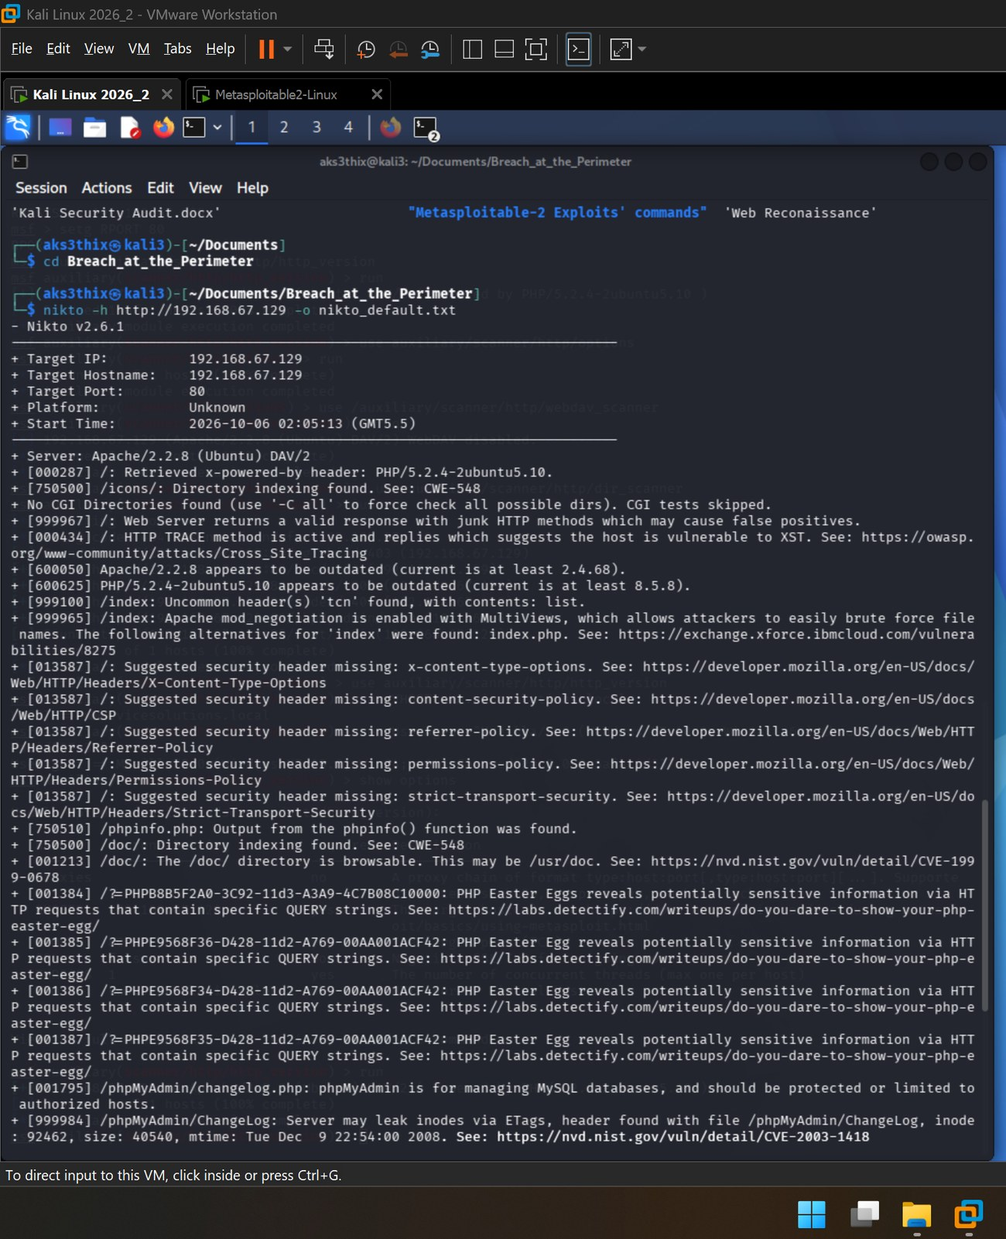
▸ Screenshot 16 (1 of 2) - Nikto default scan - 8235 requests, 31 items reported
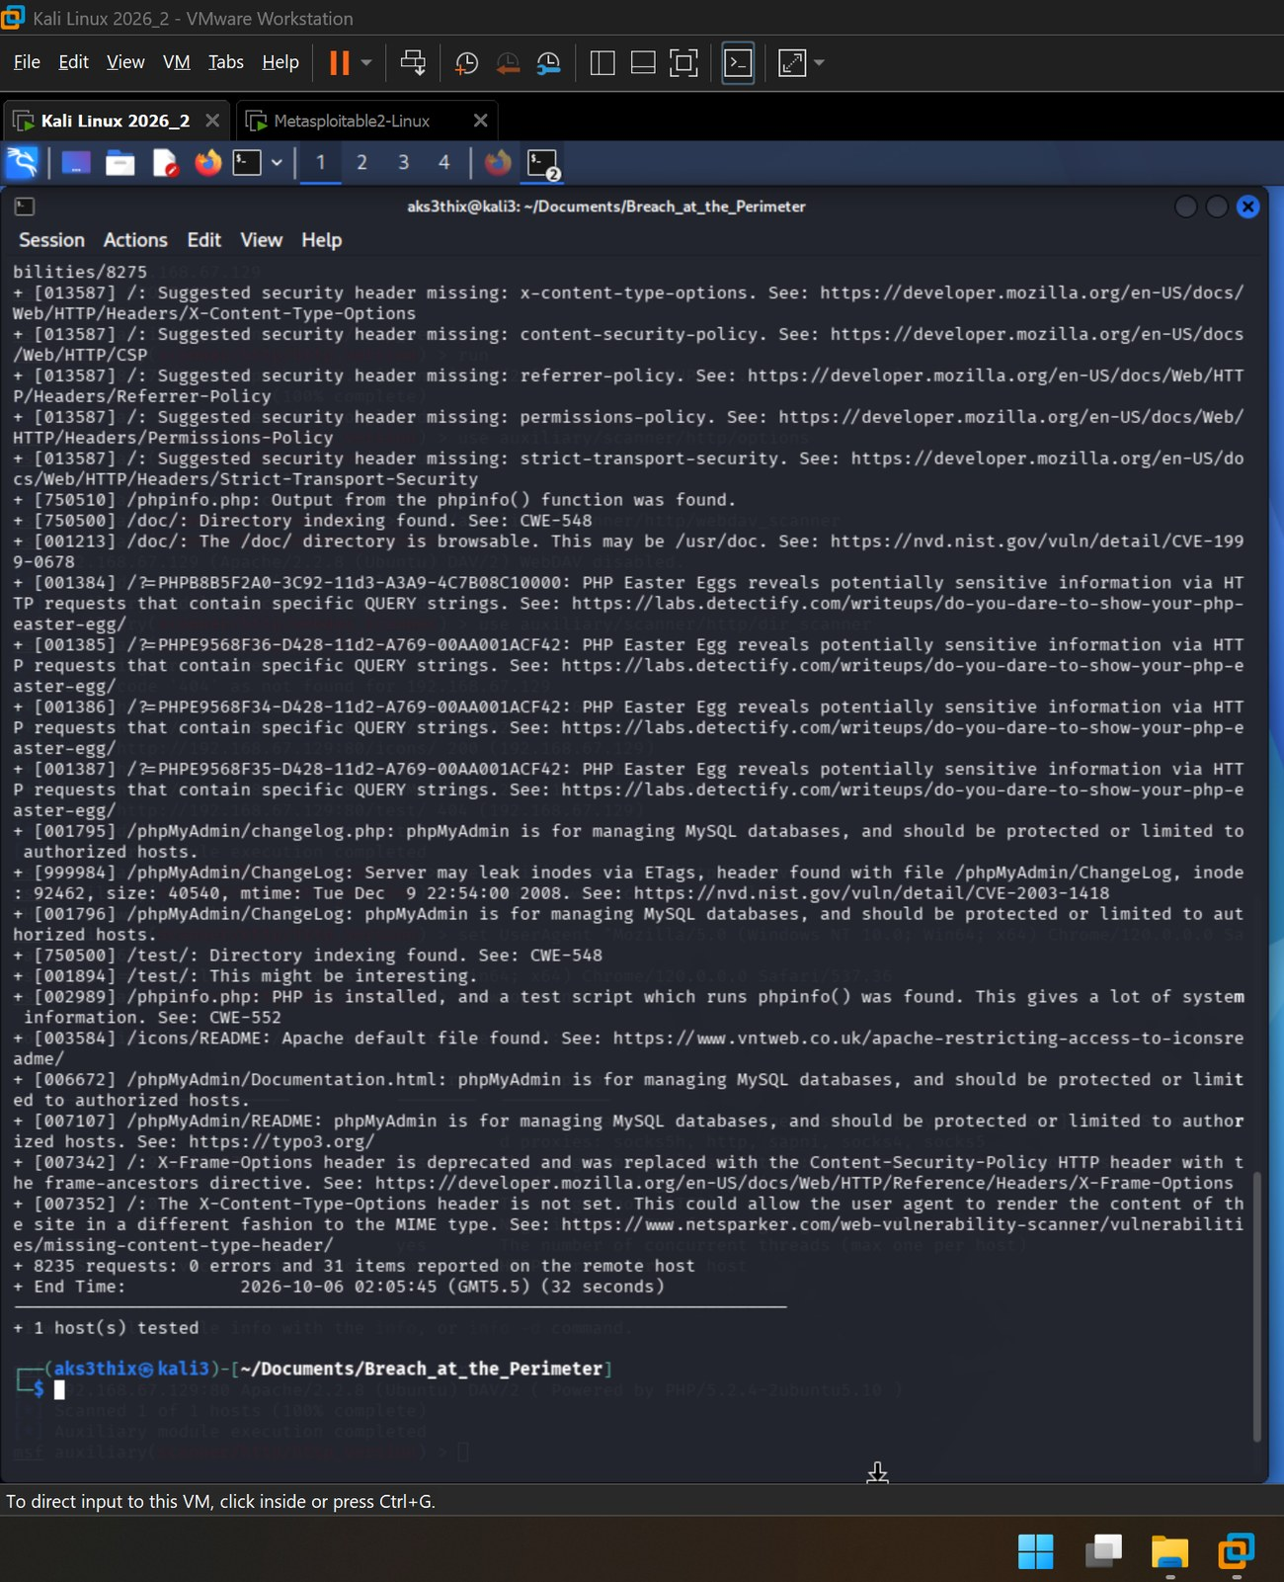
▸ Screenshot 16 (2 of 2) - Nikto default scan - 8235 requests, 31 items reported
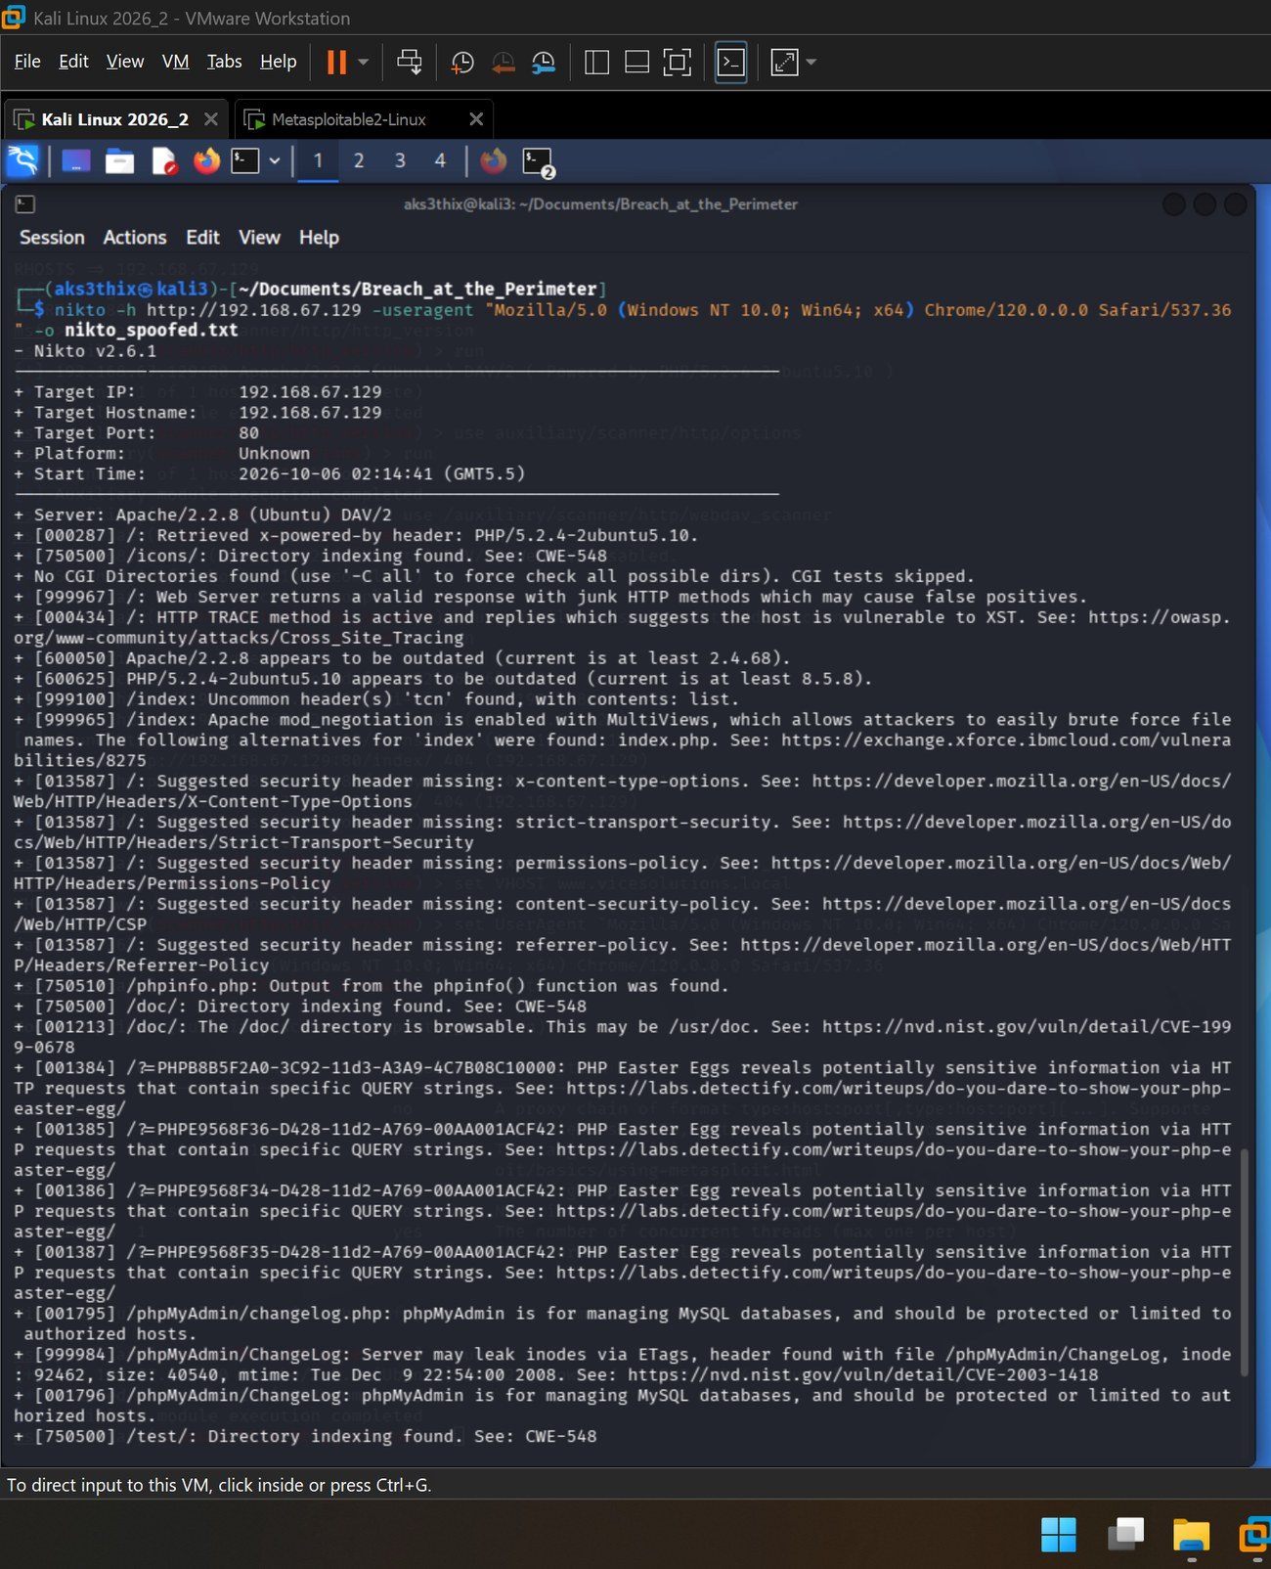
▸ Screenshot 17 (1 of 2) - Nikto spoofed scan (Chrome User-Agent)
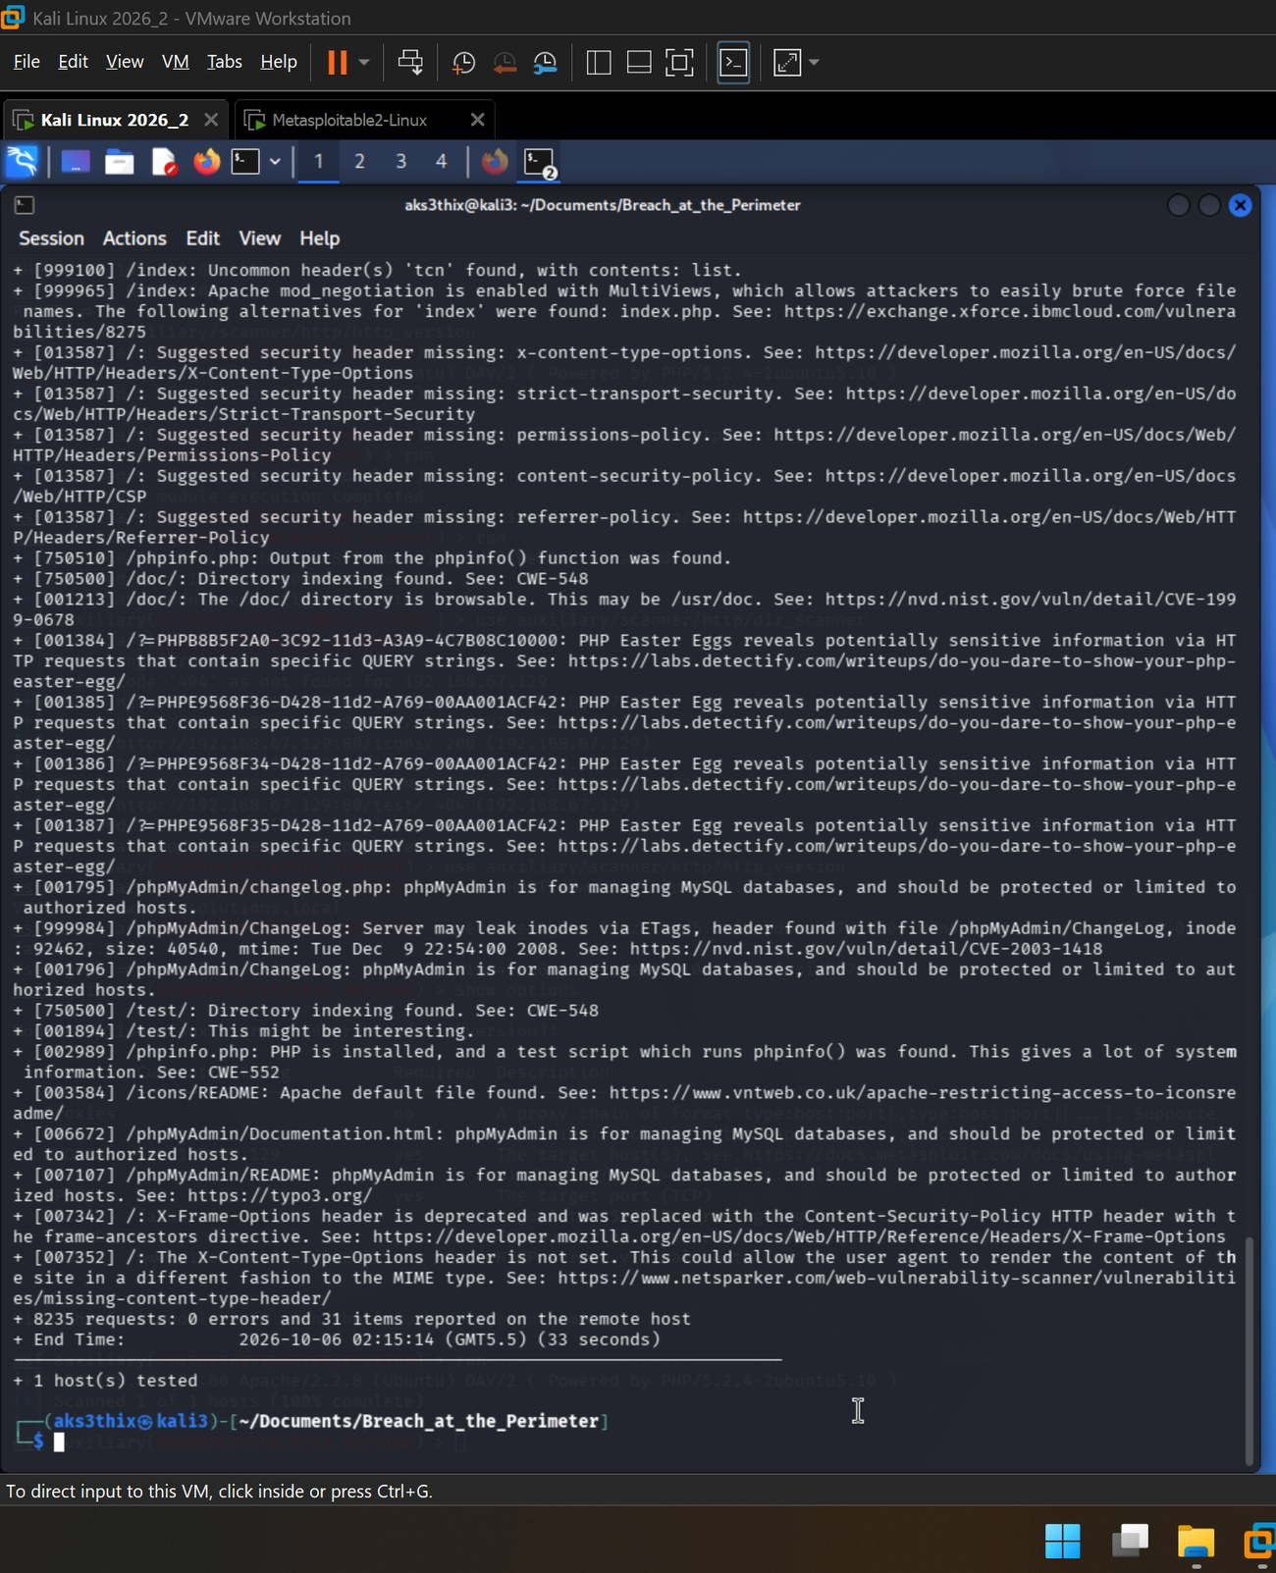
▸ Screenshot 17 (2 of 2) - Nikto spoofed scan (Chrome User-Agent)
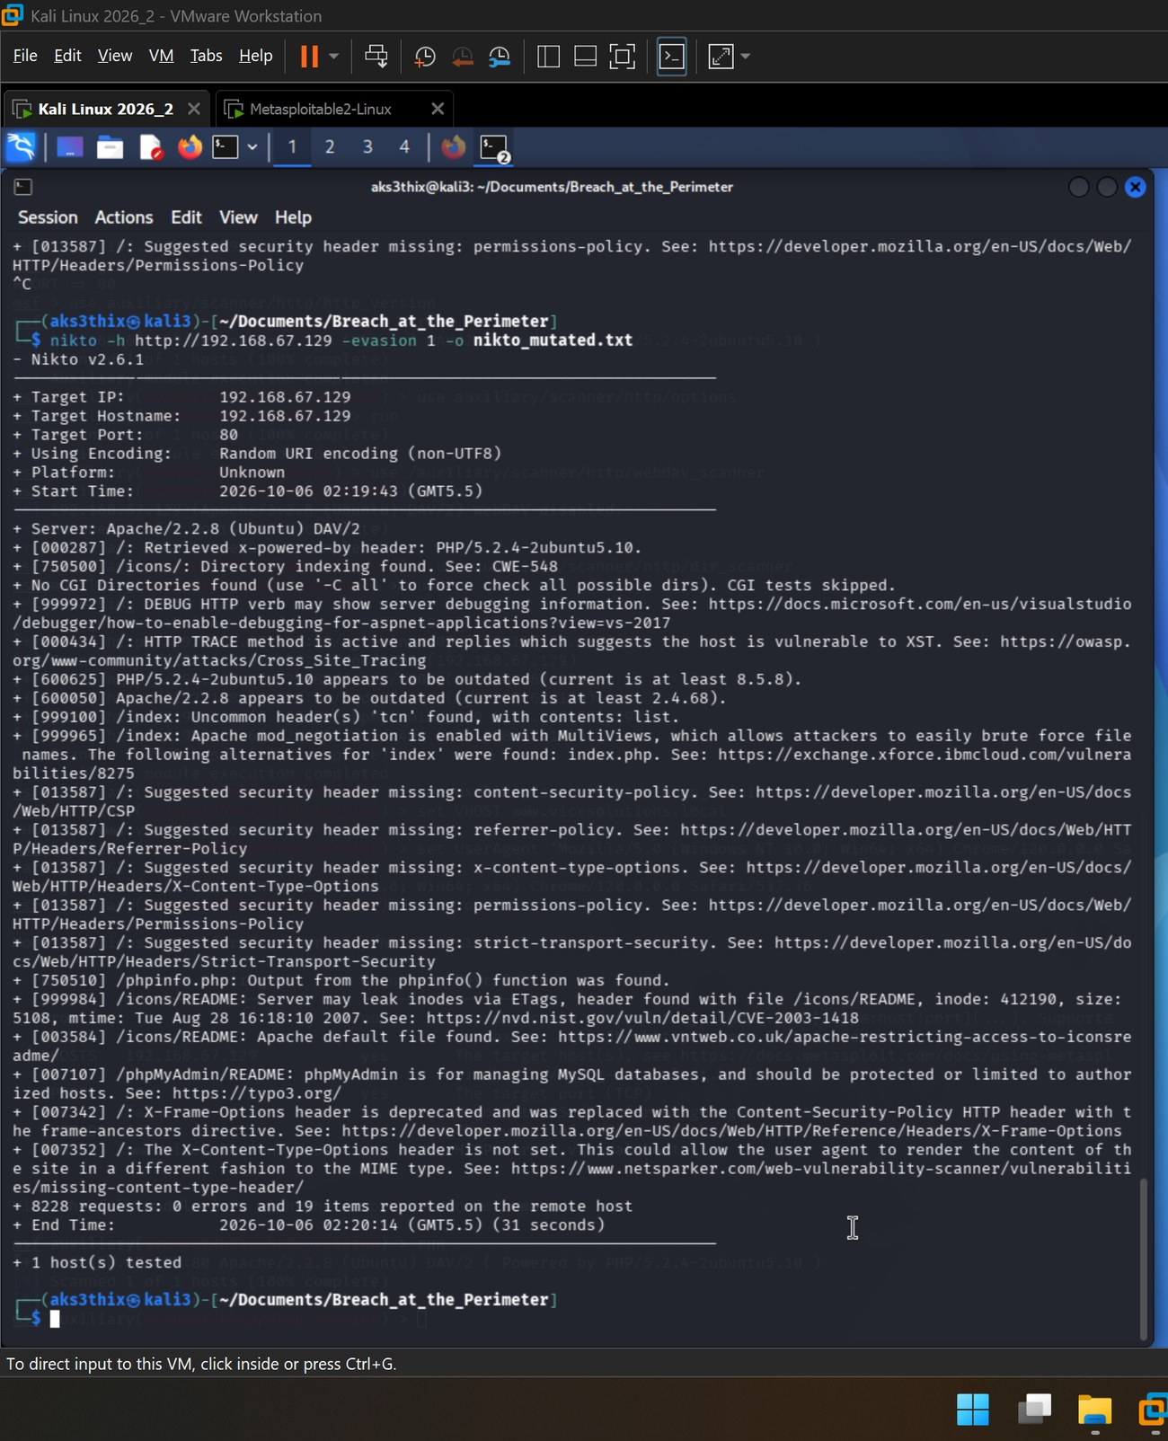
▸ Screenshot 18 - Nikto mutated scan (-evasion 1, random URI encoding) - 8228 requests, 19 items
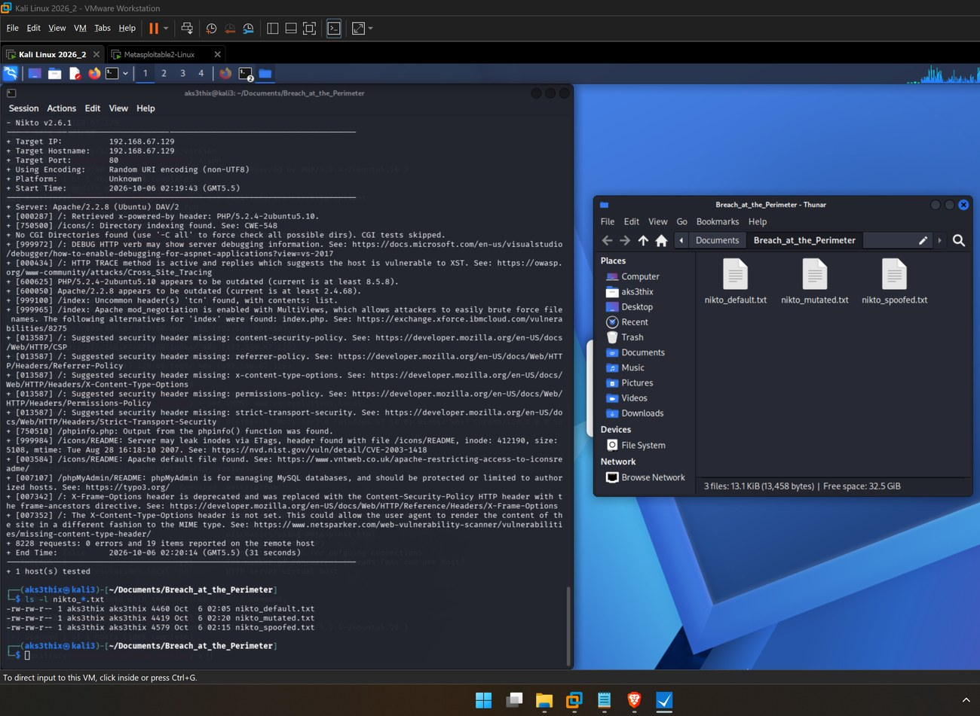
▸ Screenshot 19 - ls -l nikto_*.txt and the three saved reports in the file manager

8.1 Three-mode comparison
Mode | Items | What changed
Default | 31 | Full baseline - every check landed (8,235 requests).
Spoofed | ~31 | Same findings; only the reported Target Host label changed. An undefended server does not care who the client claims to be.
Mutated (-evasion 1, URI encoding) | 19 | Encoding altered request fingerprints: Nikto missed the phpMyAdmin, PHP Easter-egg, /doc/ and /test/ checks, but surfaced a new DEBUG-verb finding (8,228 requests).
Key takeaway: on this unprotected host the findings barely move under spoofing, but the drop from 31 to 19 items under mutation is the entire point of the exercise. The obfuscation that made Nikto’s own signatures miss findings is the same mechanism that defeats a signature-based IDS or WAF in the real world - demonstrating why request normalisation at the perimeter is a necessary control.

9. Task 5 - AI-Assisted Analysis
The raw scanner output (31 default findings, plus the Metasploit recon) was consolidated with AI assistance into prioritised findings, each rated and mapped to a concrete fix. Duplicate and advisory lines were collapsed - the four PHP Easter-egg entries became one information-disclosure finding; the five phpMyAdmin lines became one exposed-interface finding; the scanner’s “junk HTTP methods” note and the “X-Frame-Options deprecated” advisory were excluded as noise rather than vulnerabilities.
Finding | Risk | Why it matters | Recommended action
Outdated Apache 2.2.8 | High | Years end-of-life; multiple known CVEs enabling remote exploitation. | Upgrade Apache to a supported release; migrate off the EOL OS.
Outdated PHP 5.2.4 | High | Unsupported since 2011; unpatched RCE and memory-handling CVEs. | Upgrade PHP to a supported branch.
Exposed phpMyAdmin + ETag inode leak (CVE-2003-1418) | High | A public DB-admin panel is a direct route to the database; version files aid targeted exploits. | Restrict to authenticated/authorised hosts; disable inode ETags (FileETag None).
TRACE method enabled → XST | Medium | Server echoes the request; enables Cross-Site Tracing to read headers/cookies. | Set TraceEnable off in the Apache configuration.
phpinfo.php exposed | Medium | Leaks full PHP, OS and path configuration - a reconnaissance goldmine. | Remove phpinfo.php from the server.
Directory indexing (/icons/, /doc/, /test/); /doc/ browsable (CVE-1999-0678) | Low-Med | Reveals file structure and expands the attack surface. | Options -Indexes to disable directory browsing.
mod_negotiation / MultiViews (tcn header) | Low-Med | Lets attackers brute-force filenames via content negotiation. | Disable MultiViews (Options -MultiViews).
Missing security headers (X-Content-Type-Options, CSP, Referrer-Policy, Permissions-Policy, HSTS) | Medium | No client-side defences - MIME-sniffing, clickjacking and injection exposure. | Set the headers via mod_headers.
PHP Easter eggs + /icons/README default file | Low | Confirm the exact PHP build and server stack for an attacker. | Set expose_php = Off; remove default files.
The analysis above was produced with Claude. The three captures below are that AI session itself (Screenshot 20): the findings and risk ratings, the three-mode comparison, and the top remediations.
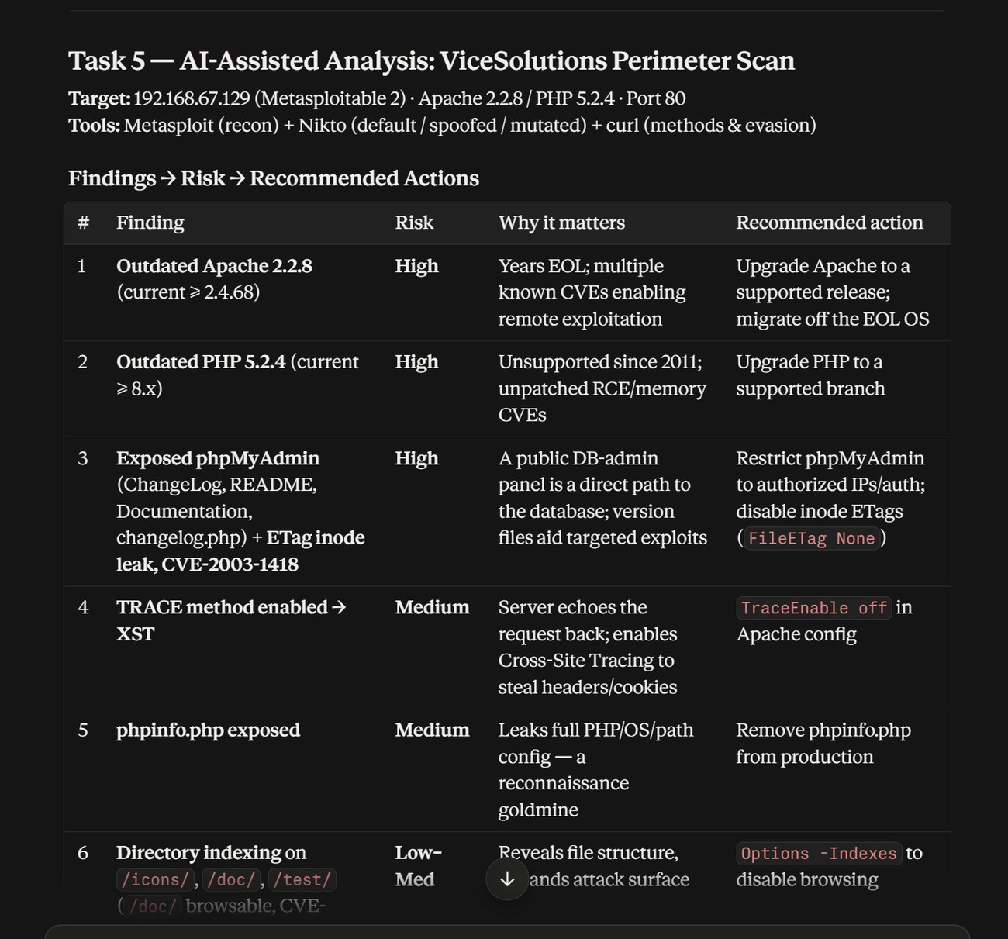
▸ Screenshot 20 (1 of 3): AI-assisted analysis - findings, risk ratings, and recommended actions
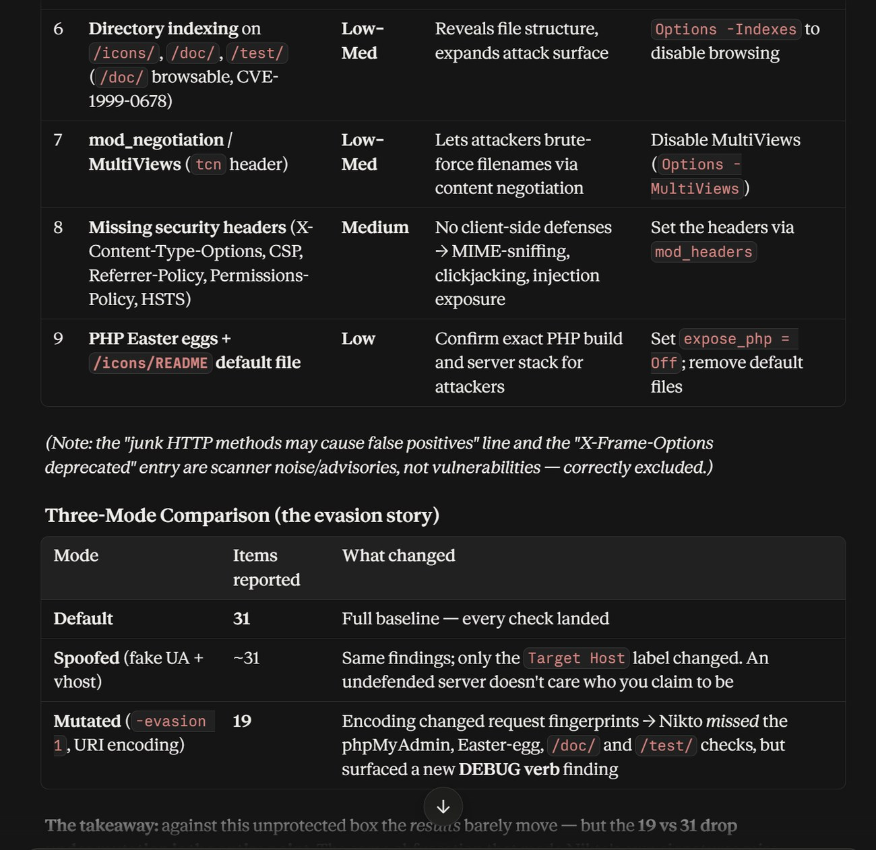
▸ Screenshot 20 (2 of 3): remaining findings and the three-mode (default / spoofed / mutated) comparison
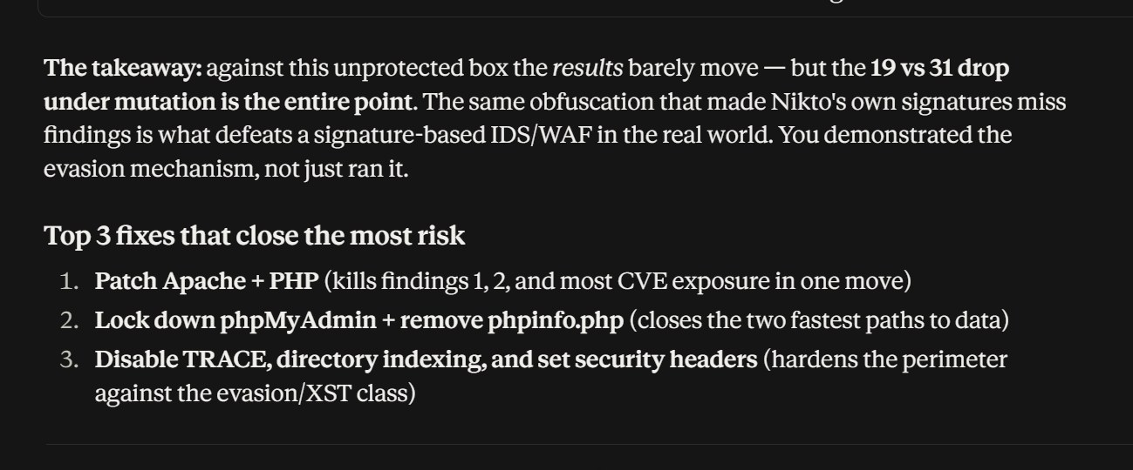
▸ Screenshot 20 (3 of 3): key takeaway and the top three remediations
Analytical integrity: every finding above traces directly to the recorded Metasploit or Nikto output; no issue was inferred beyond the evidence, and scanner advisories that are not vulnerabilities were deliberately set aside.

10. Consolidated Findings & Countermeasures
The table below is the remediation reference - each confirmed finding mapped to its hardening action.
Finding | Risk | Countermeasure
Outdated Apache version | High | Patch / upgrade Apache to a supported release; migrate off the EOL OS.
Outdated PHP version | High | Upgrade PHP to a supported branch; remove deprecated extensions.
Exposed phpMyAdmin interface | High | Restrict by IP/authentication; keep patched; remove version/changelog files.
ETag inode disclosure (CVE-2003-1418) | Medium | FileETag None (or MTime Size) in the Apache configuration.
TRACE method enabled (XST) | Medium | TraceEnable off.
phpinfo.php information disclosure | Medium | Remove the script; set expose_php = Off.
Directory indexing enabled | Low-Med | Options -Indexes to stop directory browsing.
mod_negotiation / MultiViews | Low-Med | Options -MultiViews.
Missing security headers | Medium | Set X-Content-Type-Options "nosniff", CSP, Referrer-Policy, Permissions-Policy, HSTS.
Default files / version leakage | Low | Remove /icons/README and default content; disable PHP Easter eggs.
Evasion succeeded against signature checks | Medium | Deploy/normalise a WAF to decode and inspect obfuscated requests.

11. Troubleshooting & Tool Notes
Several tool behaviours were encountered and resolved during testing. They are recorded here because interpreting them correctly is part of the assessment.
- Silent options module. Metasploit’s http/options returned no methods because Apache 2.2.8 emits no parseable Allow header; methods were confirmed directly via curl (OPTIONS and TRACE), which also proved the XST condition.
- Nikto -vhost failure. On Nikto 2.6.1 the -vhost flag threw a vhost-handling error against this target; the spoofed scan was completed with -useragent alone, which is the component relevant to the evasion objective.
- WebDAV “disabled” is a result, not an error. The DAV/2 banner and the linked /dav/ folder advertise WebDAV, but the scanner confirmed it is not active or writable - a valid negative finding.
- Fewer findings under mutation. The encoded run reporting 19 of 31 findings is expected behaviour: the obfuscation changes request fingerprints, which is exactly how evasion defeats signature-based detection.

12. Conclusion & Recommendations
The assessment confirms the scenario premise: the target had its obvious vulnerabilities addressed but left subtle HTTP-configuration and perimeter weaknesses in place. An attacker reaching this host would find an end-of-life web stack, an exposed database-administration interface, a diagnostic script leaking system internals, an XST-capable TRACE method, browsable directories, and a complete absence of modern security headers - more than enough to establish a foothold and enumerate the environment.
The evasion exercise adds the defender’s lesson: signature-based detection alone is insufficient, because trivial request encoding measurably reduced what an equivalent signature engine would flag. Perimeter controls must normalise and decode traffic before inspecting it.
Priority actions, in order: (1) patch Apache and PHP and retire the EOL OS; (2) restrict phpMyAdmin and remove phpinfo.php; (3) disable TRACE and directory indexing and set the missing security headers; (4) deploy a normalising WAF to counter evasion. Addressing the first three items alone would eliminate every High-severity finding and the majority of the attack surface identified in this report.

Appendix A - Screenshot Index
Evidence captured during testing, in report order.
Screenshot | Contents
01 | Kali updated; Metasploit 6.5.3 and Nikto 2.6.1 verified
02 | Kali network adapter = NAT
03 | Metasploitable network adapter = NAT
04-06 | Kali IP, nmap -sn subnet sweep, successful ping
07 | Metasploitable ifconfig - target 192.168.67.129
08 | msfconsole launch banner (6.5.3-dev)
09 | http_version banner - Apache 2.2.8 / PHP 5.2.4
10 | curl OPTIONS + TRACE - XST confirmed
11 | webdav_scanner - WebDAV disabled
12 | dir_scanner - exposed directories
13 | Baseline curl -I response
14 | curl -v - spoofed Host and User-Agent on the wire
15 | Metasploit show options - spoofed VHOST / UserAgent
16 | Nikto default scan (31 items) - 2 parts
17 | Nikto spoofed scan - 2 parts
18 | Nikto mutated / evasion scan (19 items)
19 | ls -l nikto_*.txt + file manager
20 | AI-assisted analysis (presented in Section 9)

Appendix B - Nikto Default Scan (Raw Evidence Excerpt)
Condensed raw output of the default scan (nikto_default.txt), retained as primary evidence. Full output files: nikto_default.txt, nikto_spoofed.txt, nikto_mutated.txt.
Target IP: 192.168.67.129 Port: 80
Server: Apache/2.2.8 (Ubuntu) DAV/2
Retrieved x-powered-by header: PHP/5.2.4-2ubuntu5.10
/icons/: Directory indexing found. (CWE-548)
TRACE method is active -> host vulnerable to XST
Apache/2.2.8 appears outdated (current >= 2.4.68)
PHP/5.2.4-2ubuntu5.10 appears outdated (current >= 8.x)
/index: mod_negotiation (MultiViews) enabled; 'tcn' header found
Missing headers: x-content-type-options, content-security-policy,
referrer-policy, permissions-policy, strict-transport-security
/phpinfo.php: Output from phpinfo() found (CWE-552)
/doc/: Directory indexing found; browsable (CVE-1999-0678)
/?=PHPE9568F3x...: PHP Easter Egg information disclosure (x4)
/phpMyAdmin/ChangeLog: ETag inode leak (CVE-2003-1418)
/phpMyAdmin/ (changelog.php, ChangeLog, Documentation.html, README): exposed
/test/: Directory indexing found; 'might be interesting'
/icons/README: Apache default file found
8235 requests: 0 errors and 31 items reported on the remote host

- End of Report -

