**How to use BGI script**

**Files:**

BGI.exe

000hr.jpg, 048hr.jpg. 072hr.jpg, 144hr.jpg – test images. (000hr.jpg serves as a control for each time point, including itself)

Biofilm Image Data.xls (an example data file)

**Running the program:**

1. Copy all of the above files to a folder
2. Open BGI.exe
3. Choose if you would like to analyze a single image (Single Run) or to analyze a group of images (Batch Run) that have been organized into a folder.
4. Choose to create a new data file or to choose an existing one. If this is your first image click “New file”. Otherwise you may select an existing file (Biofilm Image Data.xls).
   1. Proceed to type the desired name of the file you wish (extension is not necessary). If the file you specified already exists, it will be appended to.
5. If you chose a single image, a dialog box will ask you to choose a Biofilm image. If this is your first analysis choose any of the example images. If you chose batch, select the folder that contains all the images you wish to analyze
6. Dialog box will ask you to choose a Control image. If this is your first analysis choose “000hr.jpg”, which is the control for all example images, including itself

For each image selected for analysis:

1. Image will appear and you will be prompted to select corners of the biofilm region. Choose a point in the upper left corner and lower right corner such that a rectangle will be formed over the biofilm region, BUT excluding the edges of the sample and the stained holes in the corners.

Examples of good and bad biofilm selections

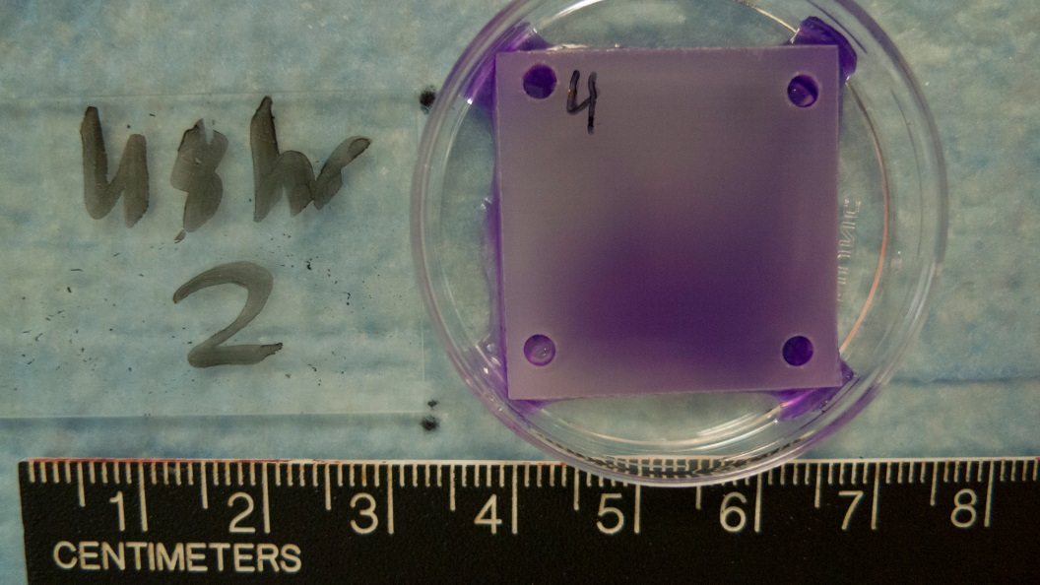  

OK! BAD! BAD!

Only select biofilm area Label, edges and holes Do not select the whole

were selected sample

1. Image of the control sample will appear and you will again be prompted to make a selection, as before.
2. You will be prompted to accept or reject the data. Look at the enhanced images to see if there was a selection error. Data that is rejected will not be saved. You will have to reopen and reanalyze this file if you wish to save the data.
3. Data will be saved to the data file you which will, unless specified, be located in the same directory as the images. Data stored includes the sample number, data and control file, BGI values for each color, and coordinates for your area selection.



1. Four .tif image files with BGI enhanced images will be saved to the same directory as the image analyzed (for example: “[Biofilm image file]_BGIgray.tif”)
   1. The images saved will replace any previous images generated with that file name in the same folder as the Biofilm image.
2. Repeat with subsequent files as desired