TECHNICAL PRESENTATION BRIEF
Co-valorization of bauxite residue
and soybean processing waste
SCWG · salt recovery · Rectisol · bi-reforming · OXZEO
A condensed briefing packet for a high-level technical and commercial presentation
Curtis Lee
Based on the final screening / pre-FEED process design report
5 August 2026

How to use this packet

The project in one minute
ONE-SENTENCE THESIS Use supercritical water to process wet soybean and bauxite residues, recover salts, clean and reform the gas, and convert syngas to light olefins—while treating this as a pilot-stage circular-economy service, not a financeable commodity plant.
1,500 t/day  five-train gross slurry throughput | 19.33 kt/y  base light-olefin output | 22.74 kt/y  B2 regional co-feed screen
RMB 1.90 bn  central screening CAPEX | −RMB 1.856 bn  20-year pre-tax NPV at 10% | 1–5 t/day  recommended continuous pilot

What the report actually concludes
- Technically coherent: the revised flowsheet resolves the salt, sulfur, and carbon-monoxide conflicts explicitly.
- Not commercially proven: every load-bearing yield, reliability, materials, product-quality, and contract assumption still needs evidence.
- Base economics fail: five trains generate only about RMB 5.2 million/year EBITDA against RMB 1.90 billion capital.
- Regional co-feeds help but do not rescue the base: B2 increases screened carbon input by 17.6% and output to 22.74 kt/year, yet the five-train NPV remains deeply negative.
- Next decision: fund a continuous hydrothermal pilot and Chinese vendor-budget study; do not authorise commercial FEED.
Source basis: Abstract; report-status statement; §§9.7–9.10 and §10.4.

01 · Why this project exists

Two difficult wet wastes, one integrated process proposition
The concept joins two waste-management problems. Okara is wet, perishable, dispersed, and expensive to dry. Bauxite residue—red mud—is alkaline, iron-rich, abrasive, and difficult to qualify for reuse. Supercritical water gasification (SCWG) is attractive because the water in okara becomes reaction medium rather than a drying burden.
Material | Why it is difficult | Proposed value in this process
Wet okara | ≈82.8 wt% water on the design basis; spoils quickly; variable protein, salt, ash, and sulfur. | Hydrated carrier and biomass carbon feed for SCWG.
Soybean straw | Fibrous, abrasive after milling, and limited by slurry pumpability. | Dry-solids and carbon-density partner; improves C/N.
Fresh red mud | Strong alkalinity, sodium, trace metals, and uncertain end-of-waste status. | Potential gasification catalyst, alkali reservoir/tar cracker, and residue to be dealkalized.
Regional co-feeds | Variable composition, contaminants, logistics, and certification burden. | Raise carbon density by substituting dry solids without increasing gross slurry.

The core proposition
A single high-pressure hydrothermal pass could convert hydrated biomass, mobilise alkali from red mud, recover salts, and produce a gas that can be cleaned and reformed into OXZEO feed. The mineral circuit may also produce a conditioned residue—but only after independent leach and performance qualification.
PRESENTER TAKEAWAY The design is compelling because it couples waste treatment and chemical manufacture. The same coupling also creates the main technical risk: the red mud chemistry that may help conversion is the chemistry most likely to precipitate and plug the plant.
Source basis: Introduction; §§1.1–1.9 and §2.2.

02 · Design basis

What has been designed—and what has not
Design item | Central basis | Status / qualification
Architecture | Five parallel B1–B4 hydrothermal trains; shared B5–B8 gas/product/mineral island | Screening design basis
Throughput | 300 t/day per train; 1,500 t/day total; 333 operating days/year | Selected scale-out basis
SCWG reactor | 625 °C, 25 MPa, 60 s hot residence | Requires continuous pilot validation
Base slurry | 250 t/day wet okara + 8 straw + 7 fresh red mud + 35 water | 57.20 t/day solids; 19.07 wt%
Product basis | 11.61 t/day light olefins per train; 19.33 kt/year complex | Calculated from assumed integrated carbon efficiency
Availability | ≈91.3% | Screening assumption; salt and slurry reliability dominate
Economic frame | 2026 China RMB; Class 4; 20 operating years; 10% discount rate | Not investment-grade FEED

Battery-limit logic
- The five parallel wet-end trains limit the consequence of salt plugging and feed-system failure.
- A central gas island avoids duplicating Rectisol, reforming, synthesis, and product separation.
- Water recycle is controlled by chloride and refractory organic carbon, not a fixed recovery percentage.
- Red-mud recycle R1 is controlled by sodium, chloride, trace metals, attrition, and product quality—not maximised.

Evidence labels used throughout the report
Calculated result = reconciled arithmetic, not measured performance. Design basis = selected configuration. Screening assumption = unquoted input used to close the model. Published evidence = literature context. Requires pilot validation = cannot be claimed as achieved. Base-case exclusion = no revenue or benefit credited without evidence.
Source basis: Report-status statement; §§4.1–4.10; Appendix D.

03 · Decisions that define the flowsheet

The report resolves three central contradictions
Conflict | Decision | Why it matters
Red mud cannot simultaneously be an indefinitely recycled catalyst, a continuously dealkalized product, and a fresh oxygen carrier. | Treat B3 as a purposeful salt-product and dealkalization unit; control R1 recycle and purge. | The concept is governed by salt withdrawal and residue quality, not merely reactor conversion.
SCWG produces methane- and CO₂-rich gas with almost no CO, but OXZEO consumes CO. | Insert B6 combined steam/dry bi-reforming after gas cleanup. | The route becomes chemically possible, but pays a large methane make–unmake energy penalty.
CaS is unstable in hot pressurised water and can hydrolyse back to H₂S. | Remove in-bed calcium sulfur capture; use Rectisol, a ZnO guard, then liquid-redox sulfur recovery. | Sulfur cleanup becomes vendor-guaranteeable and reaches <0.1 ppm total S, at added capital and refrigeration cost.

The fundamental trade-off
The flowsheet first makes methane under SCWG conditions and then reforms it at a higher temperature to produce CO/H₂. This is not a minor utility detail; it is the central thermodynamic penalty and one reason a simpler methanol or renewable-methane route remains a serious fallback.
PRESENTATION LINE The revised design is credible because it states its contradictions and pays the real equipment and energy cost to resolve them.
Source basis: Introduction, three design conflicts; §§2.3–2.5.

04 · Process walkthrough

From wet feed to light olefins
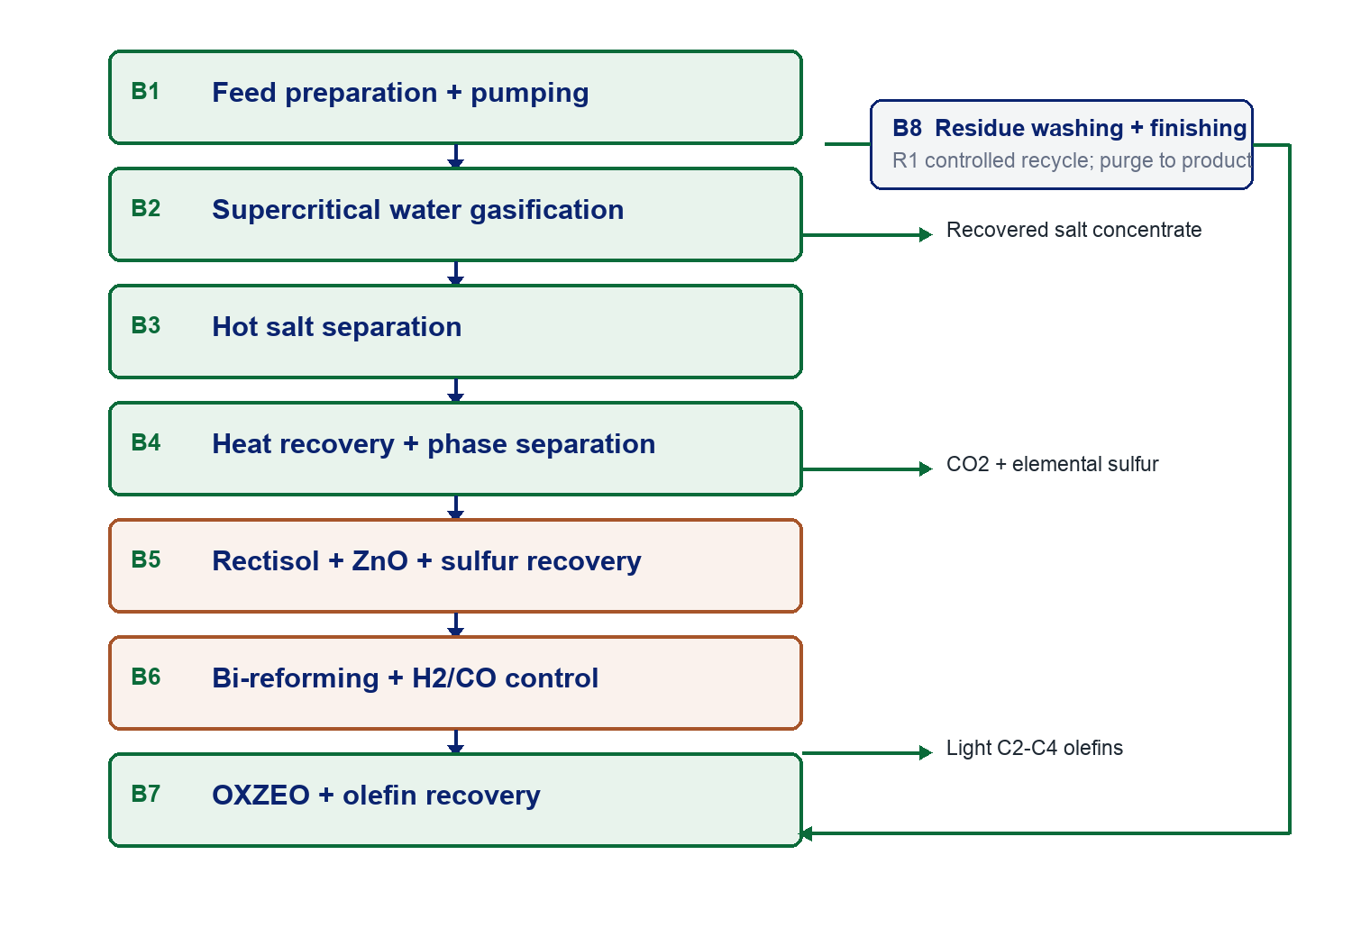
Figure 1. Presentation-level block flow. The full report contains the detailed B1–B8 and R1 equipment definitions.

Stage-by-stage speaking notes
Block | Purpose and presentation cue
B1 | Traceable reception, milling, high-shear blending, and positive-displacement pumping to 25 MPa.
B2 | SCWG at 625 °C, 25 MPa, ≈60 s; red-mud catalytic and alkali effects still to be proven.
B3 | Continuous purposeful Na/K salt withdrawal and red-mud dealkalization.
B4 | Dirty-service heat recovery, depressurisation, gas/liquid/solids separation, and water polishing.
B5 | Rectisol removes CO2/H2S/COS; ZnO protects catalysts; liquid redox recovers elemental sulfur.
B6 | Steam/dry bi-reforming converts CH4/CO2 into syngas and controls H2/CO.
B7 | OXZEO conversion, heat removal, recycle, and light-olefin recovery.
B8 / R1 | Wash and condition mineral solids; purge qualified product; recycle only within inventory limits.

Source basis: §§2.1–2.8 and §§4.2–4.9.

05 · Science in plain English

The chemistry behind the blocks

Supercritical water
Above water’s critical region, dielectric and transport properties change sharply. Hydrolysis begins during 200–370 °C preheat; free-radical chemistry dominates above the critical point. The gasifier therefore tends toward CH₄, CO₂, and H₂ with very little CO.

Red mud
Iron oxides may provide redox and gasification activity, while residual sodium/potassium alkalinity can promote tar cracking and water-gas-shift chemistry. These benefits are self-limiting as the residue is dealkalized. The actual catalytic contribution must be measured against red-mud phase, dose, sodium release, and residence time.

Salt behaviour
Inorganic salts lose solubility in supercritical water, nucleate, grow, and deposit. Salt plugging is therefore a first-order availability risk. B3 must prove continuous underflow withdrawal, wall-deposit recovery, stable pressure drop, and a useful salt/residue split.

Bi-reforming
Steam reforming (CH₄ + H₂O ⇌ CO + 3H₂) and dry reforming (CH₄ + CO₂ ⇌ 2CO + 2H₂) jointly convert the SCWG gas into synthesis gas. Steam/carbon ratio, temperature, impurities, and heat flux determine the carbon-deposition boundary.

OXZEO
A bifunctional oxide–zeolite system activates CO at oxide oxygen vacancies, transfers oxygenated intermediates, and uses CHA-cage shape selectivity to favour C₂–C₄ olefins beyond conventional Fischer–Tropsch Anderson–Schulz–Flory limits. Key deactivation modes are sulfur/water poisoning, coke, metal migration, proximity loss, and cycling.
DO NOT OVERCLAIM Published chemistry supports the route; it does not validate this specific feed, residence time, gas composition, catalyst lifetime, or selectivity.
Source basis: §§3.1–3.7.

06 · Mass and carbon balance

One 300 t/day train closes arithmetically
300.00 t/day  battery-limit input and output | 23.70 t C/day  feed carbon | 11.61 t/day  light C₂–C₄ olefins
33.04 t/day  CO₂ purge/export | 230.42 t/day  recycle or effluent water | 100%  screening mass and carbon closure

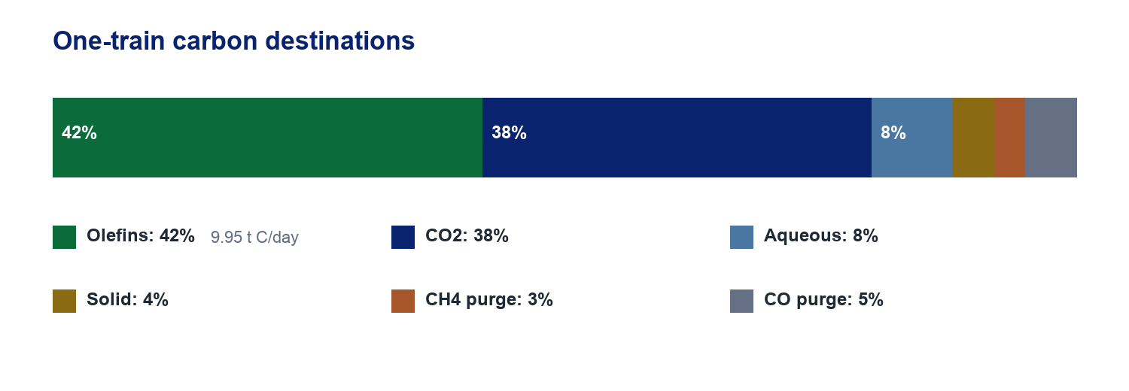
Figure 2. Carbon destinations on the one-train screening basis.
The reported 42% is battery-limit olefin-carbon efficiency, not reactor selectivity. It includes aqueous and solid rejection plus synthesis-loop purge losses. The integrated continuous pilot must replace it with a full measured carbon balance.
Outlet family | One-train amount | Presentation interpretation
Products | 11.61 t/day olefins; 0.13 t/day sulfur equivalent | Core chemical product plus minor sulfur recovery
Carbon losses | 33.04 t/day CO₂; 4.75 aqueous organics; 0.95 solid carbon | Largest yield-improvement opportunity
Gas purges | 0.95 CH₄; 2.75 CO; 1.95 H₂ t/day | Internal fuel and loop-control streams
Mineral/salt | 8.16 conditioned residue; 1.50 dry salt concentrate t/day | Value only after composition and product qualification
Water | 230.42 t/day | Recycle controlled by Cl and refractory TOC

Source basis: §§5.1–5.7; Appendix A.

07 · Energy integration

Heat recovery is essential, but it does not erase the reforming penalty
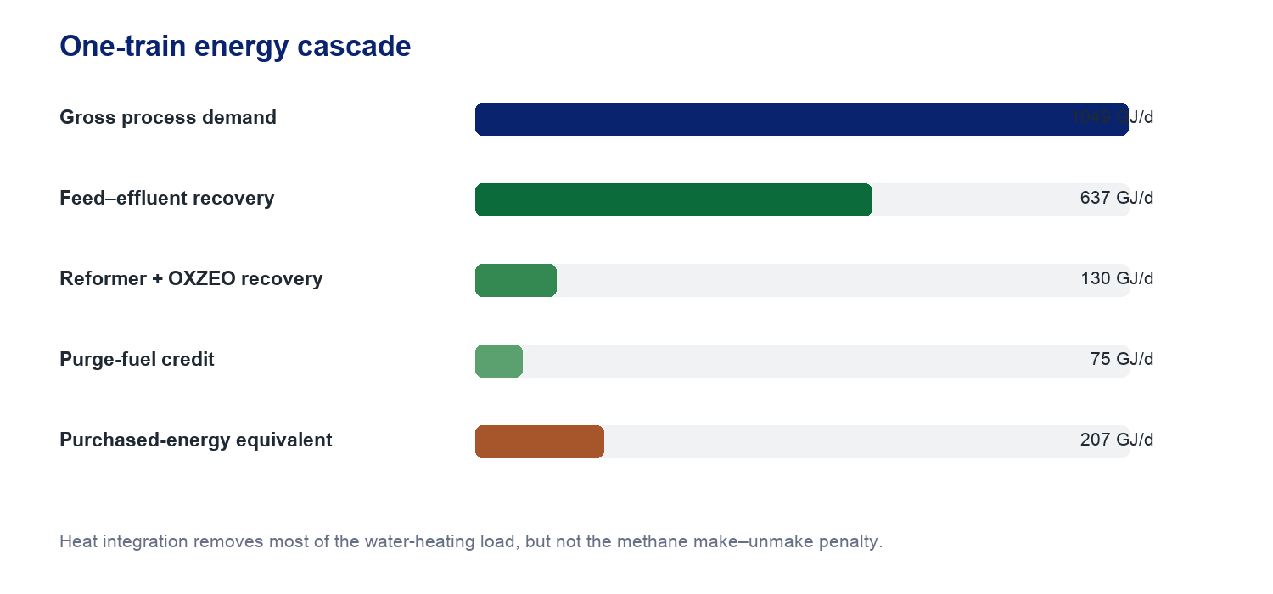
Figure 3. One-train energy cascade.
Energy element | GJ/day per train | Status
Feed sensible heating to 625 °C | 796 | Calculated
SCWG reaction/loss + pumping | 45 | Calculated / screening
Bi-reformer reaction and furnace loss | 150 | Screening
Gas compression, Rectisol, finishing | 58 | Screening
Gross requirement | 1,049 | Calculated subtotal
Feed–effluent recovery | −637 | 80% dirty-service effectiveness assumption
Reformer + OXZEO recovery | −130 | Screening
Purge-fuel credit | −75 | Screening
Purchased-energy equivalent | 207 | Calculated result

Energy-reduction priorities
Prove dirty-service exchanger effectiveness and fouling management; increase carbon conversion upstream; optimise reformer severity, purge use, steam balance, and OXZEO heat recovery; and treat energy reduction as a combined process-development objective rather than a utility-price assumption.
Source basis: §§6.1–6.6.

08 · Integrated regional feed strategy

Raise carbon density by substitution, not additional wet throughput
BINDING RULE Hold every train at 300 t/day gross slurry. Introduce each new waste by dry-solids substitution, remain near the 18–22 wt% pumpability envelope, and recalculate chloride, ammonia, salts, ash, metals, and product quality.
Regional co-feed | Preferred dry-solids share | Why it helps | Primary qualification
Cassava / starch cake | 20–35% | Raises carbon density with wet-cake handling compatibility | Rheology, cyanogenic residues, Cl, seasonality
Fruit / vegetable pulp | 5–10% | Readily gasifiable carbohydrate | Spoilage, grit, cleaning chemicals
Soluble organic liquor | Up to 5% | Adds soluble carbon without milling | Cl, S, refractory COD, cleaners
Milled crop residue | 15–25% | Raises C/N and extends straw concept | Fibres, silica, ash, bridging, milling power
Dewatered manure | 0–15%, trial only | Potential gate-fee and treatment value | Ash, N/P, Cu/Zn, residue outlets, paid gate fee

Four staged recipes per 300 t/day train
Input (t/day) | B0 control | B1 transition | B2 target | B3 manure trial
Wet okara | 250 | 150 | 80 | 80
Cassava cake | 0 | 60 | 100 | 80
Fruit pulp | 0 | 20 | 20 | 20
Organic liquor | 0 | 10 | 15 | 15
Crop residue | 8 | 12 | 18 | 13
Manure cake | 0 | 0 | 0 | 30
Fresh red mud | 7 | 7 | 7 | 7
Water | 35 | 41 | 60 | 55

Source basis: §§1.8–1.8.1; §4.2.1; §5.1.1.

09 · Co-feed outcomes

B2 is the preferred technical-development blend
Calculated property | B0 control | B1 transition | B2 target | B3 manure
Total solids, t/day | 57.20 | 62.40 | 66.16 | 65.66
Total solids, wt% | 19.07 | 20.80 | 22.05 | 21.89
Feed carbon, t C/day | 23.688 | 25.947 | 27.864 | 26.848
Slurry carbon, wt% | 7.896 | 8.649 | 9.288 | 8.949
Ash + mineral, t/day | 8.652 | 9.147 | 9.498 | 11.771
C/N ratio | 6.82 | 10.97 | 17.74 | 13.90

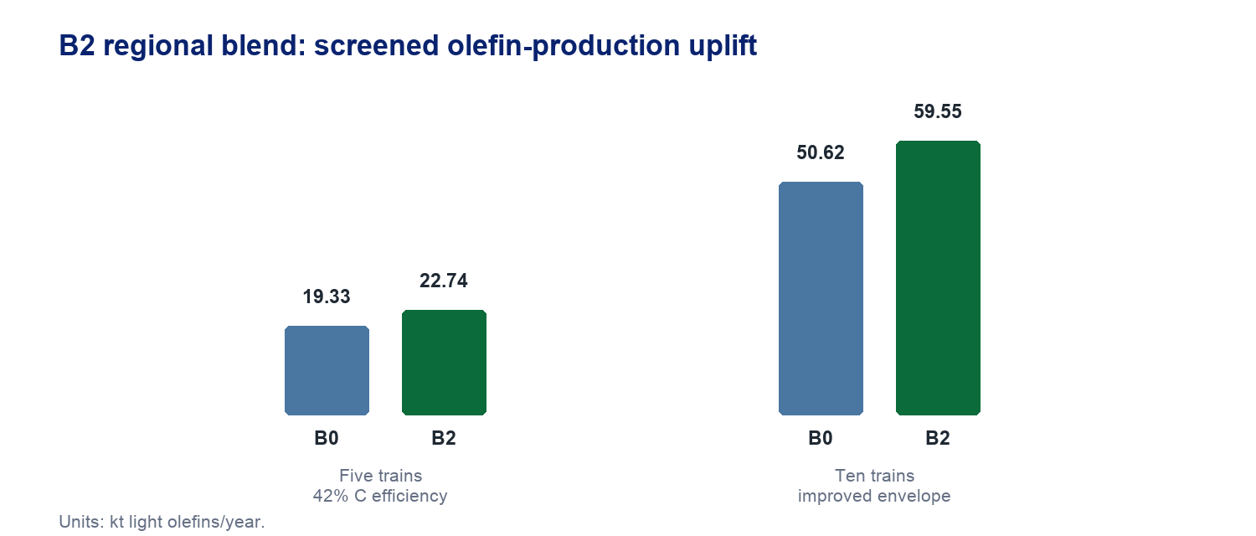
Figure 4. Co-feed production uplift. The ten-train case requires all listed improvement assumptions.

Commercial interpretation
- Five trains: B2 raises feed carbon by 17.63%, output from 19.33 to 22.74 kt/year, and gross product value by RMB 25.6 million/year at RMB 7,500/t.
- After RMB 10–18 million/year incremental OPEX and RMB 30–60 million receiving CAPEX, the 20-year NPV uplift is only RMB 4–102 million; revised NPV remains about −RMB 1.85 to −1.75 billion.
- Ten-train improved envelope: 55% carbon efficiency, RMB 7,500/t netback, RMB 250/t weighted gate fee, 15% CAPEX reduction, and 20% energy reduction. B2 reaches 59.55 kt/year and the combined case screens at positive RMB 243–411 million NPV.
- Manure: about RMB 163/t is needed just to replace screened lost product value; practical entry threshold is roughly RMB 200–250/t including handling/treatment.
PRESENTER CAUTION The positive ten-train range is a conditional decision envelope—not a forecast and not evidence that feed blending alone fixes the project.

10 · Base economics

The commodity-olefin case is not financeable
RMB 1.90 bn  central CAPEX; Class 4 range 1.4–2.8 bn | RMB 160.2m/y  cash OPEX | RMB 165.4m/y  revenue + conditional credits
RMB 5.2m/y  EBITDA | −RMB 1.856 bn  pre-tax unlevered NPV | ≈365 years  simple payback; no positive IRR

Where the money goes
CAPEX area | RMB million | Share / note
B2 SCWG reactors, heaters, HP pumps | 420 | Largest process area; 22.1%
B7 OXZEO + recycle/separation | 230 | 12.1%
Utilities/offsites/land/buildings | 240 | 12.6%
B6 bi-reformer + recovery | 190 | 10.0%
B5 Rectisol/ZnO/sulfur | 170 | 8.9%
Other process areas + EPCM + contingency + start-up | 650 | Remaining scope
Total | 1,900 | Class 4 screening estimate

OPEX is led by maintenance/turnarounds (RMB 46.5m/y), electricity (24.0), labour/support (22.0), purchased heat/gas (21.7), logistics (15.0), chemicals/catalysts (13.0), administration/certification (10.0), and water/waste handling (8.0).

Why the methanol comparison is misleading
The owner’s RMB 1.5 billion, 300 kt/year methanol benchmark is an order-of-magnitude anchor, not a scale factor. This concept handles dilute wet waste through five high-pressure trains and adds salt, mineral, Rectisol, reformer, and OXZEO systems. Much of the capital is sized by waste throughput rather than product output, producing an intensity near RMB 98,000 per annual tonne of olefins.
Source basis: §§9.1–9.7 and 9.11; Appendix B.

11 · What could change the economic answer

The project must be sold as a contracted circular-economy service
Lever | Base treatment | What would need to change
Waste gate fees | ≈RMB 70/t weighted; contractual | Largest controllable cash driver; NPV-zero all-in average ≈RMB 565/t without other improvements
Olefin netback | RMB 6,800/t | Even RMB 8,500/t adds only ≈RMB 33m/year—insufficient alone
Capital | RMB 1.90bn | Vendor design, modularisation, standard packages, or simpler route must reduce capital materially
Energy | China utility basis | 20% reduction is part of the improved envelope, not yet achieved
Availability | ≈91.3% | Must be demonstrated through salt, slurry, materials, and catalyst reliability
Certified premium | Zero credited | Requires ISCC PLUS evidence and binding premium offtake
Residue / fertilizer products | Low conditional value | Independent qualification, registration, and customer trials
Carbon credit | Zero | Approved methodology, additionality, registration, verified reductions, and title
Scandium | Zero | Assay, recovery, reagents, impurity penalties, and offtake

Strategic alternatives
- Keep the SCWG waste-treatment front end but select a simpler downstream product such as methanol or renewable methane.
- Increase scale only after reliability and feed contracting are proven; scale magnifies common-mode failures if salt or slurry systems are unresolved.
- Secure treatment-service contracts and offtake before commercial FEED; do not use speculative premiums to close the model.
COMMERCIAL MESSAGE The project’s value proposition is avoided waste cost plus certified circular products. Commodity olefin revenue alone cannot carry the capital.
Source basis: §§9.8–9.11 and §10.4.

12 · Product slate

Every co-product has a qualification gate
Output | Screening role | Qualification before sale or claim
Light C₂–C₄ olefins | Primary product; ≈19.33 kt/year base | Measured composition/yield, catalyst life, certification, binding offtake
Recovered salt concentrate | Purposeful B3 product and dealkalization stream | Composition, chloride/metals, use specification, disposal fallback
Elemental sulfur | Minor product after Rectisol/liquid redox | Purity, handling, market acceptance
N-K-P-S concentrate | Potential low-value nutrient product | Nutrient assay, Cl/metals/pathogens/organics, fertilizer registration
Conditioned mineral residue | Potential sorbent/cementitious product | Na/leach, trace metals, mineralogy, strength or SO₂ performance, customer trial
CO₂ stream | Purge or potential export | Purity, compression, use/storage route, carbon-accounting treatment
Recycle water | Internal recovery | Cl, refractory TOC, corrosion/fouling limits
Scandium / iron concentrate | Upside only | No base value; assay and recovery campaign required

Contaminant destinations to remember
- Nitrogen: ammonia/ammonium in water and trace N₂; affects treatment and nutrient concentrate.
- Sulfur: H₂S/COS in gas; Rectisol + ZnO protects reformer/OXZEO; recovered through liquid redox.
- Sodium/potassium: deliberately shifted toward B3 salt concentrate; residual inventory controls R1 recycle.
- Chloride: corrosion and recycle-water constraint; source-specific alloy limit rather than one assumed universal number.
- Metals: may concentrate in solids and foreclose product routes; feed acceptance and hold/release testing are required.
Source basis: §§2.6–2.7; §§7.1 and 8.5; Tables 8.1–8.2.

13 · Environmental and certification architecture

Circularity claims require separate evidence chains
Framework | High-level requirement | Economic treatment in the report
ISO 14067 | Separate product footprints; show waste cut-off and allocated-burden cases; do not assume biogenic neutrality | No footprint premium until metered balances and uncertainty ranges
ISCC PLUS | Point-of-origin, supplier identity, certified mass, conversion factors, losses, outgoing claims, period reconciliation | No bio/circular premium until auditable chain of custody
EU CBAM | Check product customs classifications; co-products may enter scope even if olefins do not | No implied olefin CBAM benefit
RED III | Relevant only where product/use pathway and sustainability criteria apply | Requires pathway-specific legal review
China ETS / CCER | Methodology, additionality, registration, verification, and contractual title | Zero base carbon-credit revenue
Waste/end-of-waste | Determine feed burden and legal status of every outgoing material | Maintain compliant disposal route until qualified
Fertilizer/product rules | Assay, contaminants, performance, registration, customer acceptance | Only low conditional product value

Monitoring and permits
The project requires conventional air, water, waste, toxic-gas, pressure-system, fire, and chemical-storage controls in addition to carbon/certification data. The analytical plan must reconcile batch feed identity, gas and liquid compositions, salts, residue, catalyst poisons, emissions, and product release status.
PRESENTER TAKEAWAY A circularity story is not a carbon credit. The report deliberately assigns zero value until the methodology, chain of custody, measurement, registration, and contract exist.
Source basis: §§8.1–8.6.

14 · Materials, control, and safety

The dominant risks are operability and containment—not chemistry alone
Hazard / failure mode | Why it matters | Design or validation response
25 MPa slurry pumping | Cavitation, bridging, erosion, loss of feed | Duty/standby PD pumps; cold/hot loop testing; torque and ΔP monitoring
Hot salt deposition | Rapid pressure-drop growth and forced shutdown | Continuous B3 underflow, flush recovery, wall-deposit inspection
Chloride/sulfide corrosion | Stress corrosion and pressure-boundary failure | Welded coupons, source-specific chemistry limits, wall-loss mapping
High-pressure letdown | Erosion, flashing, vibration, toxic release | Staged letdown, materials testing, isolation and blowdown philosophy
H₂S / CO | Acute toxicity and flammability | Enclosed systems, detection, ventilation, ESD, flare/oxidation and emergency response
Reformer furnace | Tube hot spots, coke, fuel-gas hazards | Steam/carbon control, tube monitoring, real-gas coking campaign
OXZEO heat release | Hot spots, catalyst deactivation, runaway potential | Heat-removal design, recycle control, trip logic, staged catalyst tests
Start-up/shutdown | Salt freezing/deposition and off-spec gas | Defined water/heat/feed sequencing, purge, controlled quench and cleanout

Feed acceptance controls
Total solids 18–22 wt%; organic D90 <0.5 mm and mineral D90 <0.15 mm; no hard settling bed after 30 minutes; stable pump-loop operation; chloride to source-specific alloy limit; first-in/first-out spoilage control; PFAS/metals hold-and-release by product route.
Source basis: §§4.2 and 4.10; §§7.1–7.7.

15 · Risk register

Eight risks determine whether the concept advances
Rank | Risk | Retirement evidence
1 | Salt plugging | 1,000 h continuous underflow/flush campaign with stable ΔP and deposit recovery
2 | Slurry pumpability | 25 MPa loop + hot feed-heater pressure-drop map across solids/particle size
3 | Red-mud catalytic claim | Factorial autoclave/continuous testing with Na release, phases, gas yields, char, carbon closure
4 | Bi-reformer coking | 1,000 h real-gas slipstream with carbon balance, catalyst inspection, upset tests
5 | OXZEO durability | Guard-bed challenge + 2,000 h cleaned-real-gas catalyst campaign
6 | Residue qualification | Independent leach/performance qualification and customer/offtake trial
7 | Materials durability | Long-duration welded coupons, erosion tests, wall-loss and deposit analysis
8 | Economics/contracting | Binding feed/offtake terms + Chinese vendor-budget quotations

THE COMMON THEME No single laboratory yield retires this project. It needs long-duration integrated evidence across feed handling, salt control, containment, gas cleanup, catalyst life, product qualification, and commercial contracts.
Source basis: §10.2, Table 10.2.

16 · Development programme

G0–G7: evidence before capital
Gate | Scale / duration | Decision unlocked
G0 Feed campaign | Composite testing + 12 months supplier records | Freeze representative design feed
G1 Batch chemistry | Autoclave severity matrix | Select B2 operating window
G2 Feed + salt loop | 100–500 h | Select B1 and B3 concepts
G3 Continuous pilot | 1–5 t/day; 1,000 h | Authorise integrated gas cleanup/synthesis pilot
G4 Cleanup + reforming | Real-gas slipstream; 1,000 h | Freeze B5 and B6
G5 OXZEO campaign | 2,000 h | Freeze B7 and catalyst/licensor architecture
G6 Demonstration | 30 t/day; ≈7,000 h/y campaign | Decide whether project can enter commercial FEED
G7 Commercial FEED | After G0–G6 + binding terms | Investment-grade FEED or simpler product route

Minimum package before commercial FEED
- Representative feed and B2 regional-blend specification with supply contracts.
- Closed mass, elemental, and carbon balances from continuous operation.
- Salt-separator availability, flush recovery, corrosion/erosion, and materials evidence.
- Real-gas sulfur cleanup, ZnO life, reformer coking, and H₂/CO control.
- OXZEO conversion/selectivity, heat removal, cycle life, and poison tolerance.
- Residue, salt, sulfur, nutrient-product, water, and emissions qualification.
- Chinese vendor quotations plus binding gate-fee, feed, certification, and product-offtake terms.
RECOMMENDATION Proceed to a 1–5 t/day continuous hydrothermal pilot and Chinese vendor-budget study. Do not authorise commercial FEED until salt availability, carbon balance, real-gas catalyst life, residue qualification, gate-fee economics, and offtake all pass.
Source basis: §§10.1–10.4.

17 · Suggested presentation structure

A strong 12-slide story
Slide | Headline | What to say
1 | Title + thesis | Two difficult wastes; one integrated circular-chemicals concept.
2 | Why these feeds | Okara is too wet to dry economically; red mud is alkaline and hard to reuse.
3 | Design basis | Five × 300 t/day trains; 625 °C, 25 MPa; 19.33 kt/y olefins.
4 | Three design conflicts | Salt/product role, CO deficit, and failed calcium-sulfur concept.
5 | Flowsheet | Walk B1–B8/R1 from feed reception to olefin and residue products.
6 | Chemistry | SCWG makes CH₄/CO₂; bi-reforming makes syngas; OXZEO makes olefins.
7 | Balances + energy | 42% olefin-carbon efficiency; 207 GJ/day purchased equivalent per train.
8 | Regional feed strategy | B2 raises carbon 17.6% without adding gross slurry.
9 | Economic reality | RMB 1.90bn CAPEX; RMB 5.2m/y EBITDA; −RMB 1.856bn NPV.
10 | What could work | Contracted gate fees, capital/energy reductions, scale, premiums, or simpler product.
11 | Risks + gates | Long-duration proof across salt, slurry, materials, catalysts, products, and contracts.
12 | Recommendation | Fund continuous pilot/vendor study; commercial FEED only after evidence passes.

Narrative discipline
- Lead with the decision, not the technology list: this is a pilot-stage circular-economy service concept.
- Use ‘screened’, ‘assumed’, and ‘requires validation’ consistently; never say the 42% efficiency or 22.74 kt/year has been achieved.
- State the negative economics early. Credibility rises when the audience sees that the report does not hide the answer.
- End on evidence and choice: which data will decide whether to scale, change product, or stop.
Source basis: Presentation synthesis of the full report; no new engineering claims added.

18 · Presenter quick reference

Likely questions—and concise answers
Why SCWG instead of drying? Okara is mostly water. SCWG uses that water as reaction medium, avoiding a front-end drying penalty.
What does red mud actually do? Potential catalyst and alkali/tar-cracking aid, while being dealkalized. All three roles need representative-feed testing.
Why is salt recovery central? The alkali that may help chemistry precipitates in supercritical water. Stable salt withdrawal controls availability and residue quality.
Why add a reformer? SCWG produces almost no CO; OXZEO needs CO. Bi-reforming converts CH₄/CO₂ into the required syngas.
Why not capture sulfur with calcium? CaS can hydrolyse in hot water and release H₂S again. Rectisol + ZnO is the defensible route.
Is 42% a measured yield? No. It is an integrated screening carbon-efficiency assumption that the continuous pilot must replace.
Does B2 make the project economic? No. It improves carbon density and offsets some loss; the five-train NPV remains strongly negative.
Why can ten trains screen positive? Only because scale is combined with better efficiency, price, gate fees, lower CAPEX, and lower energy. It is an envelope, not a forecast.
What is the biggest technical risk? Salt plugging, followed closely by slurry reliability and unproven integrated catalyst performance.
What is the biggest commercial risk? Unavailable gate fees/premiums and capital above the screening basis.
What should happen next? A 1–5 t/day continuous pilot, long-duration salt/feed testing, real-gas catalyst campaigns, product qualification, and Chinese vendor quotes.

Numbers worth memorising
300 t/day per train · five trains · 625 °C · 25 MPa · 60 s · 19.07 wt% base solids · 23.70 t C/day per train · 42% screened olefin-carbon efficiency · 19.33 kt/year base · 22.74 kt/year B2 screen · 207 GJ/day purchased-energy equivalent per train · RMB 1.90bn CAPEX · RMB 160.2m/year OPEX · RMB 5.2m/year EBITDA · −RMB 1.856bn NPV · 1–5 t/day recommended pilot.
Source basis: Final report dated 5 August 2026. This packet condenses the report and should not replace the full assumptions, calculation, HAZOP, equipment, or validation registers.

