Co-Valorization of Bauxite Residue and Soybean Processing Waste via Supercritical Water Gasification
A multifunctional red-mud bed, purposeful salt recovery, Rectisol purification, bi-reforming, and OXZEO light-olefin synthesis
Final Screening / Pre-FEED Process Design Report
Feedstock case: okara (douzha) + soybean straw co-slurry
Compliance frame: ISO 14067 · EU CBAM · ISCC PLUS · RED III · China ETS / CCER
Curtis Lee 3 August 2026
Contents
Abstract 2
Status, provenance conventions, and design basis 2
1. Feedstock characterization and blend design 5
2. Process concept and block architecture 12
3. Thermodynamic and kinetic basis 18
4. Detailed process design and equipment definition 26
5. Closed mass, elemental, and stream balances 33
6. Energy balance, heat recovery, and Chinese utility basis 37
7. Heteroatoms, materials, process control, and safety 39
8. Environmental policy, certification, and product qualification 41
9. China CAPEX, OPEX, and 20-year economic evaluation in RMB 44
10. Development programme, risk register, and conclusions 50
References 52
Appendices A-D: streams, calculations, economics, and validation register 53

Abstract
Okara (douzha) and bauxite residue are individually awkward wastes that become tractable when co-processed. Okara is 80-85 wt% water, a liability for any dry thermochemical route but an asset for supercritical water gasification, where water is the reaction medium rather than a drying burden. Bauxite residue is alkaline and iron-rich, impounded at roughly 170 Mt per year globally with under 3% utilization; its Fe₂O₃ content makes it a credible redox mediator and its residual sodium alkalinity a tar cracker, yet that same alkalinity is what makes it hazardous and unsaleable. This study proposes a flowsheet in which the supercritical water gasifier performs both duties at once: it gasifies the biomass over a multifunctional red mud bed and, in the same pass, dealkalizes the residue, transferring sodium into a separable N-K-P-S brine.
Three design conflicts are identified and resolved by decision. The salt separator is committed as a purposeful product unit rather than a protective device, because deliberate alkali removal is what converts a disposal liability into a saleable sorbent and cementitious feed. The absence of CO in hydrothermal product gas, which forecloses direct OXZEO coupling, is resolved by an intermediate bi-reforming stage; the alternative of suppressing methanation at higher gasifier severity is evaluated and rejected. Calcium-based desulfurization is removed entirely, on the grounds that CaS hydrolyses back to Ca(OH)₂ and H₂S in hot pressurized water, and is replaced by a conventional Rectisol acid gas wash reaching 0.1 ppm total sulfur including COS, with CO₂ separation in the same unit.
Analysis of the solids budget shows the binding constraint on the design is not moisture but pumpability: okara arrives at approximately 17.2 wt% solids, already within the 18-22 wt% window, so red mud dosing and straw loading compete directly for the remaining headroom. Product slate spans light olefins, an N-K-P-S fertilizer brine, elemental sulfur, and a tiered set of bauxite-derived materials from dealkalized residue through iron recovery to scandium and gallium. Feedstock geography is found to be unfavourable: no Chinese province holds red mud and okara at scale together, and the Guangxi-Guangdong corridor is identified as the shortest credible pairing.
The closed design basis uses one 300 t/d hydrothermal train and a five-train commercial complex. Overall mass closes at 300.00 t/d per train, feed carbon closes at 23.70 t C/d, and the central product case yields 11.61 t/d of C2-C4 olefins per train. The China-screening commercial case is expressed entirely in 2026 RMB and is anchored to domestic utility, wage, product-price, and project-capital evidence.
The economic evaluation assumes 20 operating years after construction. It reports nominal, pre-tax, unlevered project cash flow at a 10% hurdle rate and does not rely on uncontracted carbon credits, green premiums, or residue-product revenue.

Status of this report and provenance conventions
This final screening/pre-FEED report completes the ten-section structure. Sections 1-3 retain the source document's mechanism-first scientific argument. Sections 4-10 add the process definition, closed balances, equipment duties, heat integration, materials and safety basis, current certification requirements, and a China-specific economic model. The result is a decision document rather than a vendor guarantee: every unmeasured yield and equipment allowance remains labelled as a screening assumption and is tied to a validation test.
Provenance convention. Published facts are cited to the reference list. Calculated values follow directly from the stated basis and equations. Screening assumptions are used only where pilot data or vendor quotations do not exist; they are collected in Appendix D with an owner and retirement test. No commodity price, waste credit, carbon value, or residue revenue is treated as guaranteed without a contract or product qualification.

Introduction and design basis

The proposition
Two waste streams that are individually awkward become tractable when co-processed. Okara is 80–85 wt% water, which makes it a liability for any dry thermochemical route but an asset for supercritical water gasification, where the water is the reaction medium rather than a drying burden. Bauxite residue is alkaline, iron-rich and landfilled at roughly 120 Mt per year globally; its Fe₂O₃ content makes it a credible low-cost oxygen carrier and its residual sodium alkalinity makes it a tar cracker — but that same alkalinity is precisely what makes it an environmental liability and what has to be removed before the residue can be sold on. The central claim of this report is that the supercritical water gasification reactor performs both duties at once: it gasifies the biomass using red mud as a redox mediator and tar cracker, and in the same pass it dealkalizes the red mud, transferring sodium into an aqueous brine that is separable and saleable. The gasifier is simultaneously a biomass converter and a bauxite residue treatment unit.

Three design conflicts, and the decisions taken on each
A report that presented this as a clean cascade would not survive technical review. Three genuine conflicts sit inside the design. All three have now been resolved by decision, and the resolutions are recorded below with the reasoning that produced them. Two of the three cost something, and the report is stronger for saying what.

Conflict 1 — Red mud’s three assigned roles are not mutually compatible
The alkali that makes red mud an effective tar cracker and water-gas-shift promoter is the same alkali that precipitates as sodium salts in supercritical water, where inorganic salt solubility collapses. Salt deposition is the dominant plugging and corrosion failure mode in supercritical water systems, and adding alkali does not eliminate the corrosion problem so much as change its character (Marrone et al., 2004; Schubert et al., 2010). So the alkali-reservoir function is in direct conflict with sustained operability.
DECISION: the salt separator is a purposeful primary product unit, not a protective device. Alkali loss from the red mud is not treated as a degradation mechanism to be minimized. It is the dealkalization step — the transformation that detoxifies the residue and, per Wang et al. (2023), improves its subsequent SO₂ capture capacity. Sodium is therefore removed deliberately and metered, leaving as a saleable brine. Red mud dosing is consequently co-determined by the separator duty and the desired dealkalized-residue production rate, not by catalytic requirement alone. Block B3 is sized as a product unit carrying two duties — dealkalization of the residue and N-K-P brine recovery — with sulfur partitioning into the same brine as an incidental credit rather than a designed removal step. Managed this way the alkali is an output; managed by accident, the same chemistry plugs the reactor. The difference between a plant and a failed pilot sits entirely in B3.

Conflict 2 — Supercritical water gasification produces almost no CO, and OXZEO runs on CO
This is the same constraint encountered previously in the catalytic hydrothermal gasification of okara: hydrothermal conditions push carbon toward CH₄ and CO₂ with CO essentially absent, because the water-gas shift equilibrium at 400–650 °C in a large excess of water sits hard on the product side. OXZEO chemistry — the oxide–zeolite bifunctional route to light olefins — consumes CO. Recent ZnCr₂O₄@ZnOₓ + SAPO-34 work operates on feed compositions around 68% H₂ / 27% CO, i.e. H₂/CO ≈ 2.5 (Nature Communications, 2025). The two blocks are chemically incompatible as directly coupled units.
DECISION: an intermediate bi-reforming stage. The CH₄/CO₂-rich supercritical water gasification product is bi-reformed — combined dry and steam reforming in a single stage — to a CO-rich syngas at an adjustable H₂/CO. Steam is available at no marginal cost from the hydrothermal island, and steam co-feed is the principal mitigation for the coking that dominates Ni catalyst deactivation. This decision closes the alternative of suppressing methanation upstream by running the gasifier hotter and shorter; that route is retained in Section 3 as an evaluated-and-rejected option, with the rejection reasoning recorded, rather than carried as a live fork.
What this decision costs, stated plainly. Methane is made exothermically in the gasifier and unmade endothermically in a reformer running 200–300 °C hotter. No amount of heat integration removes that thermodynamic round trip; integration only limits how much of it shows up as fuel. Section 6 reports the fraction of feed energy consumed in the methane round trip as an explicit line item, because it is the single number a critical reviewer uses to judge the design and the single number that determines whether olefins beat simply selling the gas as bio-SNG.

Conflict 3 — In-bed calcium sulfur capture fights the hydrothermal environment
Calcium-based sorbents are the standard in-bed desulfurization route for solid fuel gasification, forming CaS (Cheah et al., 2010). But CaS is hydrolytically unstable in hot pressurized water: the hydrolysis CaS + 2H₂O ⇌ Ca(OH)₂ + H₂S is well established and is used deliberately as a CaS stabilization route. A supercritical water gasifier is close to an ideal reactor for running it. Lime dosed into the gasifier would capture sulfur and release it again — sorbent consumption with no corresponding removal. Moving the calcium duty downstream into dry warm gas would work, but it imports a consumable, generates a spent-sorbent disposal stream, and competes with HCl for capacity across the whole sorbent life cycle.
DECISION: remove calcium entirely and use a commercially proven acid gas removal unit. No lime, no limestone, no dolomite, in-bed or downstream, and no speculative sorbent. The sulfur train is a conventional physical-solvent acid gas wash — Rectisol — followed by a ZnO guard, with acid gas routed to liquid-redox sulfur recovery. This is the least novel block in the flowsheet and that is the point: it is the one place where the design should buy a vendor guarantee rather than invent something.
- Primary — Rectisol chilled-methanol wash. Rectisol purifies syngas to 0.1 ppm total sulfur including both H₂S and COS, which is exactly the specification OXZEO requires, in a single commercially guaranteed unit. It is the incumbent acid gas removal technology in Chinese coal-to-chemicals, so it is vendor-supported and locally sourceable. COS matters here specifically: protein-derived sulfur in a CO₂-rich gas forms carbonyl sulfide, which amine systems remove poorly and Rectisol removes well.
- The decisive integration argument. This flowsheet needs CO₂ control independently of sulfur — OXZEO co-produces CO₂ and the bi-reformer needs a metered CO₂ feed. Rectisol performs acid gas removal and CO₂ separation in the same unit, so the sulfur decision and the CO₂ recycle architecture collapse into one piece of equipment. At a 0.1 ppm H₂S target, reported CO₂ efficiency ranks Rectisol > Selexol > MDEA > sulfolane-MDEA.
- Lower-capital alternative — selective MDEA. A tertiary amine reacting quickly with H₂S and slowly with CO₂, giving selective H₂S removal to under 20 ppmv. Near-ambient, far cheaper, no methanol handling and no refrigeration — but it does not reach the OXZEO specification alone, handles COS poorly, and gives no CO₂ control. Section 9 evaluates it as the low-capital case against the Rectisol base case.
- Guard — non-regenerable ZnO. Retained regardless of which primary is selected. Cheap insurance immediately upstream of the synthesis loop, and mandatory if MDEA is chosen.
- Sulfur recovery — liquid redox, not Claus. Claus wants acid gas at 10–13 vol% H₂S or above to run well, and the sulfur load from a feed of this scale is very unlikely to reach that. A LO-CAT-type liquid redox unit suits small and moderate sulfur duties and yields saleable elemental sulfur rather than a spent-sorbent disposal problem.

What this decision costs and what it buys
Buys: a vendor-guaranteed outlet specification instead of an extrapolation. The earlier concept of polishing on the plant’s own dealkalized red mud was attractive for circularity, but the Wang et al. (2023) capacity result is for SO₂, not H₂S, and applying it to reducing-atmosphere H₂S capture would have been an assumption dressed as a citation. Sulfur breakthrough drops from a top-three kill risk to a routine design duty, and elemental sulfur becomes a clean product.
Costs: Rectisol is capital-intensive, operates at −30 to −60 °C, and brings methanol inventory and refrigeration duty into a plant that otherwise has neither. It is very likely the single largest CAPEX item after the high-pressure hydrothermal island. Section 9 tests whether the MDEA-plus-guard case is sufficient, because if it is, the saving is substantial.
Retained, but demoted: sulfur will still partition partly into the aqueous phase in B3 as sulfide and sulfate, and will still appear as the S in the N-K-P-S brine. That is physics, not a design choice. It is now a credit that reduces the acid gas removal duty, not the removal mechanism itself, and the Rectisol unit is sized without relying on it.

1. Feedstock characterization and blend design

1.1 Okara: a feed defined by its water
Okara — douzha in Mandarin, biji in Korean — is the insoluble residue remaining after soybeans are ground, extracted and screened in soymilk and tofu manufacture. Roughly 1.1–1.2 kg of okara arises per kg of soybeans processed into curd, and China generates approximately 2.8 Mt per year against 0.8 Mt in Japan and 0.31 Mt in Korea. Most is landfilled: the 70–85% moisture content makes it spoil within days and gives it negative value at the gate, which is precisely the favourable feedstock economics this project depends on.
Supply is ample in aggregate but constrained locally. The binding constraint is collection radius against spoilage, not a national tonnage estimate. A single large soy-beverage plant may support a hydrothermal train, whereas the same wet tonnage aggregated from small tofu workshops would require hundreds of collection points. The commercial capacity in Section 9 is therefore limited by contracted supplier audits, daily production records, seasonal variability, and a maximum practical haul radius; no national okara estimate is used to size the plant.
The defining physical property is water content. Wet okara has been reported at 82.8 wt% moisture with 6.34 wt% protein, 0.86 wt% lipid and 0.65 wt% ash on a wet basis (Li et al., 2012). On a dry basis the composition is approximately 27 wt% protein, 10 wt% crude fat, 14 wt% soluble fibre, 42 wt% insoluble fibre and 3 wt% ash (Li et al., 2012); an independent characterization reports 46.3% dietary fibre, 17.8% protein, 5.9% lipid and 3.9% ash on a dry basis, which brackets the variability introduced by cultivar and extraction severity.
Three consequences follow directly, and they set the entire process architecture.
- The moisture is an asset, not a penalty. At 80–85 wt% water, okara arrives at roughly the concentration a supercritical water gasifier wants. Any dry gasification route would spend more energy evaporating this water than the resulting gas contains — the standard argument for hydrothermal processing of wet feeds, and here it is decisive rather than marginal.
- Lignin is essentially absent. Okara’s fibre is cellulosic and pectic rather than lignified. Lignin is the fraction most resistant to hydrothermal depolymerization and the dominant char precursor, so its absence predicts high carbon conversion and low char at comparatively mild severity.
- Nitrogen and sulfur are structural components of the feed. At roughly 27 wt% protein, the indicative dry-basis C/N ratio is approximately 5.8, while cysteine and methionine introduce organic sulfur at the low-tenths-of-a-percent level. Both quantities must be replaced by ultimate analysis of the contracted okara source. The preliminary heteroatom allowances therefore define equipment capacity rather than forecast product quality.

1.2 Soybean straw: the dry-solids and carbon-density partner
Soybean straw is the field residue - stems, pods, and petioles - left after grain harvest. It is lignocellulosic, typically received at approximately 10-15 wt% moisture, and carries potassium- and silica-bearing ash characteristic of agricultural residues. The screening C/N range of 60-80 complements protein-rich okara, but regional proximate, ultimate, and ash-fusion analyses are required before procurement specifications are fixed.
Soybean straw is a demonstrated supercritical water gasification substrate in its own right: catalytic supercritical water gasification of soybean straw over Ni-based catalysts with varied supports and promoters has been reported, with ZrO₂ the most effective support for H₂ yield and selectivity among activated carbon, carbon nanotubes, ZrO₂, Al₂O₃, SiO₂ and Al₂O₃–SiO₂ at 10 wt% Ni loading (Okolie & Dalai, 2021). That work is the closest published analogue to the biomass half of this system and should be the principal kinetic reference in Section 3.

1.3 Why blend, and at what ratio
The blend ratio is not a free variable. Three independent constraints bound it, and the design point is the intersection rather than an optimization of any single one.

Constraint 1 — Slurry pumpability sets the upper bound on solids
Feeding solids into a 25 MPa reactor is the recurring practical failure of supercritical water gasification at scale. Reported successful feeds give a realistic envelope: 30 wt% glucose solution, 18 wt% corn cob and 24 wt% coal–water slurry have been fed to supercritical reactors, and twin piston pumps have delivered a 15% solids biomass slurry to 27 MPa; dewatered sewage sludge at only 7.69 wt% solids required blending with corn starch paste and a cement pump to be deliverable at all (Marrone, 2019, and references therein).
Okara is the rheological advantage here. Its fine, hydrated fibre particles form a pumpable paste rather than a settling suspension, which is exactly the behaviour the starch paste was added to sewage sludge to create. Okara can therefore act as the carrier medium for milled straw that would otherwise settle and bridge. A total solids loading of 18–22 wt% is proposed as the design window, with the straw fraction limited by particle size rather than by mass.

Constraint 2 — C/N balance
Okara at C/N ≈ 5.8 and straw at C/N ≈ 60–80 are complementary. Unlike anaerobic digestion, supercritical water gasification is not inhibited by ammonia in the way a methanogenic consortium is, so C/N is not a hard operating constraint here. It matters instead for two downstream reasons: the ammonia concentration in the aqueous effluent determines whether nitrogen recovery is economically worthwhile, and the nitrogen loading determines the corrosivity and the composition of the salt-separator brine. Blending to a combined C/N in the range 15–25 puts the brine into a composition band that is directly fertilizer-compatible.

Constraint 3 — Alkali loading from the red mud
Red mud brings its own sodium, and Section 1.4 shows how much. The straw brings potassium. Together these set the total alkali that the salt separator must remove per unit of feed, and that duty scales the separator rather than the reactor. Alkali loading is therefore the constraint that couples the biomass blend to the red mud dosing, and it is the reason the three feed streams have to be specified together rather than sequentially.
Constraint | Bounding variable | Design window | Binding?
Slurry pumpability | Total solids; particle size distribution | 18–22 wt% total solids; straw milled to <0.5 mm screening basis | Yes — upper bound
C/N ratio | Okara : straw mass ratio (dry) | Combined C/N 15–25 | Soft
Alkali loading | Red mud dose + straw K | Set by salt separator duty — see §2.3 | Yes — couples all three feeds
Sulfur loading | Okara protein fraction | Sets the sulfur train, not the blend | No
Table 1.1 — Blend design constraints. The intersection of the pumpability ceiling and the alkali loading duty defines the operating point; C/N is tuned within that envelope.

1.4 Red mud: composition, alkalinity and its three latent functions
Bauxite residue from the Bayer process is generated at over 120 Mt per year globally and is overwhelmingly impounded rather than used. Its composition varies with the source bauxite but sits in well-established ranges: Fe₂O₃ 30–60 wt%, Al₂O₃ 10–20 wt%, SiO₂ 3–50 wt%, Na₂O 2–10 wt%, CaO 2–8 wt% and TiO₂ up to about 10 wt%. A representative Chinese Bayer residue analyses at Fe₂O₃ 36.87 wt%, Al₂O₃ 22.11 wt%, SiO₂ 18.72 wt%, Na₂O 11.70 wt%, TiO₂ 3.14 wt% and CaO 2.49 wt% (Wang & Liu, 2012; Zhang et al., 2017). Leachate pH is 12.1–13.0, driven by the sodium content, and this alkalinity is the primary reason the material is classified as hazardous and the primary barrier to its reuse.
Component | Typical range (wt%) | Representative Chinese Bayer residue (wt%) | Function in this process
Fe₂O₃ | 30–60 | 36.87 | Oxygen carrier / redox mediator; water-gas shift and tar cracking activity
Al₂O₃ | 10–20 | 22.11 | Structural support; contributes to sintering resistance
SiO₂ | 3–50 | 18.72 | Inert diluent; forms iron silicates that deactivate the redox couple
Na₂O | 2–10 | 11.70 | Alkali reservoir — tar cracking and WGS promotion; also the source of salt plugging and the target of dealkalization
TiO₂ | trace–10 | 3.14 | Inert here; a recovery target in the residue valorization block
CaO | 2–8 | 2.49 | Native alkalinity; contributes to but does not substitute for the dedicated sulfur sorbent
Sc | 16–230 ppm | ~84 ppm | Recovery target — sets a secondary revenue line in §9
Table 1.2 — Bauxite residue composition and the function assigned to each constituent. Ranges from Wang & Liu (2012); Chinese representative analysis and scandium content from Zhang et al. (2016, 2017).
The dealkalization synergy — the strongest single argument in this report
Supercritical water treatment of red mud has been shown to give enhanced dealkalization performance, and — critically — the dealkalized residue exhibits improved SO₂ capture capacity (Wang et al., 2023).
That single result closes the loop three ways. It removes the sodium that would otherwise foul the reactor. It detoxifies the residue, converting a hazardous impoundment liability into a saleable material. And it produces, as the treated solid, a sulfur sorbent — meaning the process generates part of its own desulfurization capacity and an external sorbent product besides.
This should be treated as the load-bearing claim of the whole concept and verified experimentally first. If supercritical dealkalization does not proceed at the residence times required for biomass gasification, the economics revert to those of a conventional wet-biomass gasifier with a cheap iron catalyst, which is a much weaker proposition.

1.5 Contaminant inventory and assigned fate
Every heteroatom entering the system must leave it somewhere, and in a process whose products are sold against ISCC and ISO 14067 claims, "somewhere" has to be documented rather than assumed. The table below assigns a destination to each element and names the unit responsible.
Element | Source | Form after gasification | Assigned fate and responsible unit
N | Okara protein (dominant); straw (minor) | NH₃, some N₂; ammonia is the stable intermediate under hydrothermal conditions | Aqueous phase → salt separator brine → fertilizer-grade N-K-P-S product, or ammonium sulfate via the sulfur train
S | Okara cysteine / methionine | Aqueous sulfide / sulfate under alkaline reducing conditions; balance as H₂S with traces of COS and thiophenes | Calcium-free three-stage train: bulk capture into the B3 brine as the S of N-K-P-S → dealkalized red mud polishing bed → ZnO guard to OXZEO specification (§6)
Na | Red mud (11.7 wt% as Na₂O) | Dissolved Na⁺, precipitating as salts above the critical point | Salt separator — designed removal, not a loss. Simultaneously dealkalizes the residue
K | Soybean straw ash | Dissolved K⁺, co-precipitating with Na | Salt separator brine — raises the fertilizer value of the brine
Cl | Both biomass streams; process water | HCl / chloride | Corrosion driver, and competitor for red mud alkalinity in the polishing bed. Removing calcium eliminates the HCl-versus-Ca capacity problem but not the corrosion duty. Must be quantified before materials selection
P | Okara phytate | Phosphate | Brine — completes the N-P-K fertilizer specification
Fe | Red mud | Reduced oxide phases (Fe₃O₄ / FeO) | Retained in the solid; re-oxidized in the regeneration loop or recovered carbothermically (§9)
Sc, Ti | Red mud | Unchanged oxides | Concentrated in the spent solid → leaching recovery as a secondary revenue line
Table 1.3 — Heteroatom fate assignment. Chloride is the least characterized and is flagged as a data gap that directly affects sorbent sizing.
Chloride deserves specific emphasis because it is the element most often left out of this kind of table. Its role has changed with the decision to remove calcium from the flowsheet. In a calcium-based train chloride is a direct capacity competitor: HCl reacts not only with fresh CaO and Ca(OH)₂ but also with spent desulfurization sorbent containing calcium carbonate, oxide and hydroxide, and after calcining and slaking the spent material recovers essentially the reactivity of pure Ca(OH)₂ toward HCl (Wang, Ye & Bjerle, 1996) — so chloride consumes calcium inventory across the whole sorbent life cycle rather than only on the fresh charge. Eliminating calcium removes that failure mode, which is one of the arguments for the decision.

1.6 The solids budget: the binding constraint on the whole design
The blend constraints in §1.3 were expressed as independent bounds. Closing the arithmetic shows they are not independent, and that the pumpability ceiling is far more restrictive than it first appears. This is the single most consequential finding in Section 1 and it propagates into every downstream block.
Okara arrives at approximately 17.2 wt% solids on a 82.8% moisture basis (Li et al., 2012). That is already inside the 18–22 wt% design window with no dewatering whatsoever, which is a genuine argument for the feedstock and is the reason no thickening step appears in B1. But it also means the solids budget is almost entirely consumed before any other component is added.
Take 100 kg of wet okara as received: 17.2 kg of solids, of which roughly 0.5 kg is ash and 16.7 kg is organic. Now dose red mud. At only 5 kg of residue the slurry is at 22.2 kg solids in 105 kg total — 21.1 wt%, already at the ceiling, with no straw in the blend at all. Red mud is inorganic dead weight in this budget: it consumes pumpability headroom without contributing carbon or hydrogen.

Component | Contributes solids | Contributes carbon | Effect on the budget
Okara (as received, 17.2 wt% solids) | Yes — 17.2 wt% | Yes | Consumes ~78–96% of the available window on its own. Requires no dewatering.
Red mud | Yes | No | Dead weight. 5 kg per 100 kg okara reaches the ceiling unaided.
Soybean straw | Yes | Yes | Competes directly with red mud for the remaining headroom
Dilution water | Reduces wt% | No | Buys headroom, but must then be heated to 600 °C for no return
Table 1.4 — The solids budget. Red mud dosing and straw loading are in direct competition, and the constraint chain is: okara solids + straw + red mud ≤ ~22 wt%.
The solids constraint creates a genuine four-way trade. Dilution buys pumpability but increases the sensible-heat duty of water. Cutting red-mud circulation weakens both catalytic contact and residue-treatment throughput. Cutting straw reduces carbon density and the C/N benefit. Upstream okara dewatering lowers reactor water load but can disrupt a hydrated, protein-rich matrix and must be selected from measured press, centrifuge, or screw-press curves. The reference case therefore preserves the wet-feed advantage and makes the 19.1 wt% slurry conditional on a full-scale pump-loop test.
This result corrects the earlier qualitative framing. §1.3 described okara as the slurry carrier that allows milled straw to be transported into the reactor. That remains true rheologically, but the headroom available for straw is much smaller than that framing implies, and in a red-mud-rich case it may approach zero. Section 5 treats the okara : straw : red mud : water split as a constrained optimization with the 22 wt% ceiling as an active constraint, not as four independently chosen dosing rates.

1.7 Slurry formulation: whether dispersants and stabilizers are required
Coal–water slurry practice reaches for dispersants — naphthalene sulfonate condensates, lignosulfonates, polycarboxylates — to solve two problems this system does not have: wetting a hydrophobic solid, and suppressing viscosity at 60–70 wt% loading. Okara is hydrophilic, arrives fully hydrated, and the target loading is around 20 wt%. On the biomass fraction, no wetting agent is required.
The feed additionally supplies its own surfactant. Residual soy protein and phospholipids in okara are amphiphilic — soy lecithin is a commercial emulsifier derived from the same source material — so the organic fraction is substantially self-dispersing. This is a real and underused argument for the feedstock and should be stated in the report rather than left implicit.
The suspension problem that does exist is the red mud, not the biomass. Haematite has a density near 5.2 g/cm³ and the residue is finely divided, so it will settle out of a matrix that comfortably suspends its own fibre. Any additive requirement therefore arises from mineral suspension stability, not from organic wetting — a distinction that determines which additive class is even relevant.

The additive trap: the two standard choices each inject the contaminant this flowsheet exists to remove
Sodium carboxymethyl cellulose is the documented stabilizer for supercritical water gasification slurry feeding, and it works — one overview reports it being used to reach above 40% carbon gasification efficiency at 540 °C and 25 MPa, and it is noted as more consistent and cheaper than tragacanth, gum arabic, guar or xanthan for the same function. But it is the sodium salt. Block B3 exists to strip sodium from this system. Dosing sodium into the feed to fix rheology, then paying separation duty to remove it again, is self-defeating.
Lignosulfonate, the other standard dispersant, injects organically bound sulfur directly into the feed — straight into the acid gas removal duty that §2.4 has just committed a Rectisol unit to handling.
If a stabilizer proves necessary, xanthan gum is the clean selection: no sodium, no sulfur, strongly shear-thinning, effective at low dose. The CMC literature notes xanthan delivers the same function at higher cost and lower batch consistency — an acceptable premium here, because the cheap option carries a process penalty rather than merely a price.
The first question, though, is whether any additive is needed. Slurries at 30–50 wt% solids loading are reported as shear-thinning while 10–20 wt% loadings shear-thicken, so a ~20 wt% blend sits near an unfavourable rheological transition and its behaviour cannot be assumed. A recirculating feed loop with in-line static mixing and minimal residence between mixer and pump suction may remove the requirement entirely. No additive is always preferable to a clean additive.

1.8 Co-feeding other wet organic wastes
Supercritical water gasification is a credible route for a wide range of wet organic wastes, and the question of whether to widen the feed slate beyond okara and soybean straw deserves an explicit answer rather than silence. The chemistry is largely permissive. The commercial answer is much narrower, and for a reason specific to this flowsheet.
The governing constraint is residue purity, not gas yield. The value case in §2.6 rests on selling dealkalized red mud as a supplementary cementitious material or sulfur sorbent and on recovering iron, scandium and gallium from it. That is a materials-purity business. Any co-feed whose inorganic contaminants partition into the solid phase degrades the product the project depends on. Co-feeding therefore trades gas yield against residue saleability, and residue saleability is where the margin sits.
Table 1.5 — Co-feed evaluation ranked by residue-purity risk.
Co-feed | Case for | Why it is risky in this specific flowsheet
Soybean straw | Same supply chain, no contaminant burden, complementary C/N | Competes only for the §1.6 solids budget. Retained as the design basis.
Pig manure | Proven supercritical water gasification feed; abundant; genuinely co-located with straw in the Northeast; adds N/K/P to the brine product; supercritical water destroys veterinary antibiotics and antibiotic resistance genes, which is a regulatory asset rather than merely neutral | Moderate Cu and Zn from feed additives will report to the solid. Best reported gas figures are at ~6 wt% feed concentration, far below this design point. Recommended as the first co-feed to evaluate.
Food waste | High moisture and lipid content, energy-dense, abundant and urban | Chinese food waste carries high chloride from cooking salt, feeding directly into the corrosion and materials-selection problem already flagged in §1.5
Sewage sludge | The closest chemistry match in the literature, with an established red mud co-gasification precedent and a phosphorus recovery credit | Heavy metals — Cd, Pb, Cr, Cu, Zn — partition into the solid and foreclose the cementitious and sorbent product routes. Rejected on residue purity, not on chemistry.
Human faeces / septage | Technically near-identical to sewage sludge | Public-acceptance risk; compromises ISCC and fertilizer claims. Rejected.

1.9 Feedstock geography: the five red-mud-producing provinces
Red mud arises from the Bayer process in alumina refining. Aluminium smelting consumes alumina electrolytically and generates no bauxite residue whatsoever — its wastes are spent pot lining, carbon anode residues and fluoride-bearing dust — so smelter locations are irrelevant to this feedstock and are excluded from the analysis entirely. This distinction matters because the two industries follow opposite siting logic: smelting chases cheap electricity, which is why provinces such as Xinjiang and Yunnan hold large aluminium capacity, whereas refining follows bauxite and caustic logistics.
Chinese alumina refining is highly concentrated. Shandong, Shanxi, Henan, Guangxi and Guizhou together account for approximately 95% of national capacity, with Shandong, Shanxi and Guangxi alone exceeding 70%. Red mud is generated at every refinery in these five provinces, and they therefore constitute the complete candidate set for siting this plant.
Province | Principal refining centres | Assessment against okara supply
Guangxi | Baise, Pingguo, Fangchenggang (~2.4 Mt/y) | Strongest candidate. Roughly 400–700 km from Pearl River Delta industrial soy beverage plants, pairing real refining capacity with traceable point-source okara.
Henan | Zhengzhou, Sanmenxia, Jiaozuo | Refining capacity plus very high population density, so fragmented tofu okara is generated on top of the residue. No haul at all, but a self-declared supply chain that §2.9 identifies as the weakest control point in the project.
Shandong | Binzhou / Zouping (Weiqiao), Chiping (Xinfa), Zibo | Largest provincial capacity and the largest red mud arising, but its soybean industry crushes imported beans for meal, which yields no okara. Maximum residue, no local feedstock partner — an apparent match that is not one.
Shanxi | Jiaokou / Lüliang (Xinfa), Xiaoyi, Hejin | Major capacity, deep inland, no significant soy food processing within a spoilage-limited radius.
Guizhou | Guiyang, Zunyi (Chinalco) | Moderate capacity, no meaningful okara supply nearby.
Table 1.6 — The five red-mud-producing provinces, ranked by suitability rather than by capacity. Centres and capacities are approximate and flagged as unverified pending a primary source.
The geography is unfavourable; the siting case is therefore presented as a logistics constraint rather than a synergy claim. Okara arises where soy foods are manufactured, soybean straw arises where soybeans are cultivated, and neither coincides with alumina refining. No province in the candidate set holds red mud and okara at scale together. Which stream moves is therefore a live design decision, and it is constrained more tightly than any thermodynamic variable in the flowsheet: red mud is dense, cheap and travels badly; okara is 80% water and spoils within days; straw is bulky and low in density. Section 9 carries the Guangxi and Henan cases as distinct siting scenarios rather than assuming a single site.
Chloride does not, however, become harmless. It remains a corrosion driver in a supercritical, alkaline, sulfide-bearing environment where reactor internals are already specified in nickel-base alloys, and it remains a competitor for alkalinity in the dealkalized red mud polishing bed by the same chemistry that made it compete for lime. A chloride analysis of both biomass streams and of the process water is therefore still a prerequisite — now to materials selection and to sizing the red mud bed, rather than to sizing a calcium train.

2. Process concept and block architecture

2.1 Flowsheet overview
The process is organized into eight blocks. Blocks B1 through B4 constitute the hydrothermal island and are common to any product slate; blocks B5 through B7 constitute the gas conditioning and synthesis train and are specific to the olefin target; block B8 is the solids loop that closes the red mud cycle and generates the residue co-products.
Block | Unit | Conditions | Function
B1 | Feed preparation and slurry make-up | Ambient → 25 MPa | Straw milling; okara blending to 18–22 wt% solids; red mud dosing; high-pressure slurry pumping. Feed–effluent heat exchange against the reactor outlet.
B2 | Supercritical water gasifier with red mud bed | 600–650 °C, 25 MPa screening basis | Biomass gasification to CH₄/CO₂/H₂. Red mud acts as redox mediator, tar cracker and alkali source. Concurrent dealkalization of the red mud itself.
B3 | Salt separator — purposeful product unit | Supercritical; cooled-wall or cyclonic | Dealkalizes the red mud and recovers Na/K/P as brine. Sulfur partitions in as an incidental credit, not a designed removal step (§2.4). Sized as a product unit, not as plugging protection.
B4 | Depressurization, phase separation, aqueous polishing | 25 MPa → ~3 MPa | Gas / liquid / solid split. Ammonia-bearing aqueous phase to nitrogen recovery. Spent red mud to B8.
B5 | Acid gas removal (Rectisol) + ZnO guard | −30 to −60 °C, ~3 MPa | Commercial chilled-methanol wash to 0.1 ppm total S including COS, with CO₂ separation in the same unit feeding the B6 and B7 recycle architecture. ZnO guard immediately downstream. Acid gas to liquid-redox sulfur recovery. See §2.4.
B6 | Bi-reformer | 800–900 °C, 1–3 MPa screening basis | CH₄ + CO₂ + H₂O → CO-rich syngas at adjustable H₂/CO. The block that makes OXZEO reachable, and the largest energy penalty in the flowsheet.
B7 | OXZEO olefin synthesis | ~400 °C, 2.5–4 MPa | Oxide–zeolite bifunctional conversion of syngas to C₂–C₄ olefins. Unconverted syngas recycled; co-produced CO₂ recycled to B6.
B8 | Red mud regeneration and residue valorization | Air oxidation, then hydrometallurgy | Re-oxidation of reduced iron phases with heat recovery; bleed stream to SO₂ sorbent sale, cementitious use, or Fe/Sc/Ti recovery. Regenerated solid recycles to B1 (stream R1).
R1 | Red mud recycle, B8 → B1 | Re-slurried, ambient → 25 MPa | Closes the solids loop. Enters at slurry make-up, not at the reactor, because the solid must be re-slurried and re-pressurised. Bleed fraction is the key free variable — see §2.7.
Table 2.1 — Block architecture. Shaded rows carry the two claims most in need of experimental validation: the multifunctional gasifier bed with concurrent dealkalization (B2/B3), and the reforming stage that resolves the CO deficit (B6).

2.2 Red mud as a multifunctional bed — what each role actually delivers
The three roles specified for red mud in this design — oxygen carrier, gasification catalyst, and alkali reservoir / tar cracker — draw on different literatures with different operating conditions, and the report will be stronger for stating precisely which claims transfer to supercritical water and which do not.

2.2.1 Oxygen carrier — a role that changes meaning in supercritical water
Red mud is an established low-cost oxygen carrier for chemical looping. Fe₂O₃ content above roughly 40 wt% gives adequate oxygen transport capacity together with useful heat-carrying properties, and both the ferric oxide and the alkali and alkaline-earth metal species present enhance fuel conversion (Liu et al., 2020; industrial solid waste oxygen carrier review, 2024). Reported performance for agroforestry waste chemical looping gasification over red mud carriers calcined at 1000 °C reaches a total gas yield of 1.02 Nm³/kg at an LHV of 12.06 MJ/Nm³, with 91.49% cold gas efficiency and 82.65% carbon conversion (Processes, 2025). Red mud oxygen carriers have also been shown to improve syngas quality and reduce tar in biomass chemical looping gasification (Biomass Conv. Bioref., 2023).

Calibration warning: do not carry these efficiencies into this design
The cold gas efficiency of 91.49% and carbon conversion of 82.65% quoted above are from dry, atmospheric-pressure chemical looping, and they are quoted here only to establish that red mud is a credible oxygen carrier in that context. They are not achievable targets for this flowsheet and should not be used to anchor expectations.
Two effects push the realistic figure much lower. Supercritical water gasification efficiency falls as feed concentration rises, and the headline results in that literature are reported at low loading — pig manure reaching 87.59% gasification efficiency did so at 6 wt% feed with K₂CO₃ promotion, against the roughly 20 wt% this design requires for pumpability and energy balance. Separately, the one reported figure obtained under conditions resembling a real slurry feed is above 40% carbon gasification efficiency at 540 °C and 25 MPa with a Na-CMC-stabilized slurry.
There is therefore a three-way conflict at the heart of the design: pumpability wants high solids, the energy balance wants high solids, and gasification efficiency wants low solids. The 18–22 wt% window was selected on the first two. Section 3 must produce a carbon gasification efficiency versus feed concentration curve for this specific blend, because the economically optimal point is set by that curve and not by the pumpability ceiling alone. Until it exists, Section 5 carries a carbon gasification efficiency in the 40–60% band as the planning basis, flagged as an estimate.

The caveat is that all of this is atmospheric-pressure, high-temperature, dry chemical looping. In supercritical water at 600–650 °C the oxidant is already present in enormous excess — the water itself. Lattice oxygen donation from Fe₂O₃ is therefore not supplying an oxygen deficit; it is mediating the redox chemistry, with the Fe₃O₄/FeO couple most plausibly acting as a relay in the water-gas shift and steam-reforming steps rather than as a stoichiometric oxygen source. Section 4 establishes which iron couple is thermodynamically accessible under supercritical hydrothermal conditions and whether the oxygen transport capacity figure from chemical looping practice has any operational meaning here. Framing red mud as an oxygen carrier in the chemical looping sense, without this qualification, would be the easiest error for a reviewer to catch.

2.2.2 Gasification catalyst — the best-supported of the three claims
Red mud is directly documented as a supercritical water gasification catalyst. Its iron content gives good catalytic performance in gasification, and addition of red mud to supercritical water gasification of biomass produces hydrogen at yields comparable to those achieved with commercial alkali catalysts. Red mud has been shown to act as a support in its own right, replacing commercial Al₂O₃: a Ni-Cu bimetallic on a red mud support raised H₂ yield to 21.88 mmol/g, 6.7 times that of unpromoted Ni (Appl. Catal. A, 2024). There is also a directly analogous co-gasification precedent — red mud exhibits a synergistic catalytic mechanism in the co-gasification of spirit-based distillers’ grains with sewage sludge (Zhang et al., 2024), which is structurally the same proposition as this one: a protein-rich wet residue co-processed with an industrial waste solid over a red mud catalyst.

2.2.3 Alkali reservoir and tar cracker — real, but self-limiting
The alkali and alkaline-earth metal content of red mud promotes water-gas shift toward hydrogen and cracks tars, and this is part of why red mud performs comparably to purpose-made alkali catalysts. But in supercritical water this function is inherently transient. The alkali dissolves, and because inorganic salt solubility in supercritical water is extremely low, it then precipitates — on reactor walls, in the worst case as plugs that force shutdown (Marrone et al., 2004). The alkali-reservoir function therefore has a finite life measured in the residence of sodium in the solid, not in the life of the catalyst.
The design response is to stop treating this as degradation. Sodium loss from the red mud is the dealkalization step — the same transformation that Wang et al. (2023) show enhances the residue’s subsequent SO₂ capture capacity. Managed through a designed salt separator (B3), the alkali leaves as a saleable brine and the solid leaves detoxified. Managed by accident, the same chemistry plugs the reactor. The difference between a plant and a failed pilot is entirely in block B3.
Design consequence
Red mud dosing is not set by catalytic requirement alone. It is co-determined by the salt separator duty and by the desired production rate of dealkalized sorbent. If the residue-treatment revenue exceeds the catalytic requirement — plausible given disposal-cost avoidance — the gasifier is better understood as a red mud treatment reactor that happens to gasify biomass, and should be sized accordingly. Section 9 should test both framings and report which one the economics actually support.

2.3 Salt separation as a purposeful product unit
Salt precipitation is the best-documented failure mode of continuous supercritical water systems. Precipitating salts cause both corrosion and plugging; accumulation on reactor walls forms plugs that produce expensive and frequent downtime (Marrone et al., 2004; Marrone, 2019, on continuous supercritical water gasification specifically). Neutralizing acids by alkali addition does not solve this — the resulting salts remain corrosive — which is why supercritical reactor internals are built from nickel-based alloys, titanium or ceramics, with Inconel 625 typical for gasification service.
In this flowsheet the salt load is not incidental — it is deliberately large, because the red mud is dosed partly in order to be dealkalized. The design decision recorded in Part A is that B3 is a primary product unit rather than a protective device, and it carries two duties: it dealkalizes the residue, and it recovers sodium, potassium and phosphate as a fertilizer-precursor brine.
Sulfur also partitions partly into this brine as sulfide and sulfate under the alkaline reducing conditions, which is why the fertilizer product is described as N-K-P-S. That partitioning is a credit against the downstream acid gas removal duty, not a design mechanism: the Rectisol unit in B5 is sized without relying on it, so that an unfavourable sulfur split degrades operating cost rather than product specification. Section 6 should quantify the split, but no downstream unit depends on the answer.
Candidate configurations to be evaluated in Section 6 include cooled-wall separators that exploit the steep solubility gradient near the critical point, cyclonic separation with a controlled cold brine sink, and reverse-flow designs developed specifically to prevent salt deposition in supercritical water (Schubert et al., 2010). Materials selection follows from the combined Na, Cl and sulfide inventory rather than from any one of them.

2.4 Sulfur: why calcium was removed and a conventional wash adopted
The instinct with a calcium-based desulfurization requirement is to co-feed lime with the slurry and capture sulfur in the bed. In-bed capture with limestone and dolomite is the standard approach for solid fuel gasification, with downstream capture normally handled by regenerable metal oxides (Cheah et al., 2010). Applied to supercritical water, however, in-bed calcium capture runs into a direct thermodynamic objection.
Calcium sulfide is not stable in hot pressurized water. The hydrolysis CaS + 2H2O <=> Ca(OH)2 + H2S is established, and calcium-oxide desulfurization patents describe contacting calcium sulfide with hot liquid water specifically to regenerate calcium hydroxide and liberate H2S (US Patents 4,321,242 and 4,686,090). A supercritical-water gasifier is therefore close to the ideal reactor for reversing in-bed calcium capture. Moving the calcium duty into dry warm gas would function, but it imports a consumable, creates a spent-sorbent stream, and competes with HCl for capacity (Wang, Ye & Bjerle, 1996).
Calcium has therefore been removed from the flowsheet altogether, and the duty given to a conventional acid gas removal unit. A note on terminology, because it matters: "wet desulfurization" in common usage denotes limestone–gypsum wet flue gas desulfurization, which is an oxidising post-combustion SO₂ technology. The stream leaving B4 is a reducing syngas carrying H₂S and COS, so the correct standard analogues are the wet acid gas removal processes used in gasification and coal-to-chemicals practice — physical solvent or amine absorption — not WFGD.
Stage | Unit | Duty | Rationale and limits
S0 — aqueous credit | B3 salt separator | Sulfide / sulfate into the N-K-P-S brine | Physics, not a design mechanism. Reduces the B5 duty; B5 is sized without relying on it so an unfavourable split costs money, not specification.
S1 — primary wash | B5 Rectisol, chilled methanol, −30 to −60 °C | Physical absorption of H₂S, COS and CO₂ | 0.1 ppm total sulfur including COS — the OXZEO specification met in one vendor-guaranteed unit. Separates CO₂ in the same step, feeding the B6/B7 recycle. Incumbent technology in Chinese coal-to-chemicals. Cost: capital, refrigeration, methanol inventory.
S1-alt — low-capital case | Selective MDEA absorption, near-ambient | Fast with H₂S, slow with CO₂ | Under 20 ppmv H₂S. Much cheaper, but misses the OXZEO spec alone, handles COS poorly, and gives no CO₂ control. Evaluated in Section 9 as the competing case.
S2 — guard | ZnO, immediately upstream of B6/B7 | ZnO + H₂S → ZnS + H₂O | Non-regenerable final polish. Cheap insurance with Rectisol; mandatory with MDEA.
S3 — recovery | Liquid redox (LO-CAT type) | Acid gas → elemental sulfur | Chosen over Claus because Claus wants 10–13 vol% H₂S or more in the acid gas and this sulfur load will very likely fall short. Yields a saleable product rather than a disposal stream.
Table 2.2 — Sulfur architecture after removing calcium. The primary unit is deliberately the least novel block in the flowsheet: it is the one place the design should buy a vendor guarantee.

2.5 The CO deficit and the reforming resolution
Supercritical water gasification delivers a gas of CH₄, CO₂ and H₂ with CO effectively absent. This is not a catalyst artefact — it is the water-gas shift equilibrium asserting itself in a reaction medium that is overwhelmingly water. OXZEO chemistry consumes CO. The oxide–zeolite composite route achieves light olefin selectivities that exceed the Anderson–Schulz–Flory limit — 80% light olefin selectivity among hydrocarbons at 17% CO conversion over ZnCrOₓ–SAPO-34 at 400 °C and 2.5 MPa, and 64% CO conversion at 75% light olefin selectivity over ZnCr₂O₄@ZnOₓ + SAPO-34 at 4.0 MPa and 400 °C on a 68% H₂ / 27% CO feed (Nature Communications, 2025). Every one of those numbers is quoted against a CO-containing feed. Without CO there is no OXZEO chemistry.

2.5.1 Bi-reforming rather than dry reforming
The supercritical water gasification product is, compositionally, an upgraded biogas: CH₄ and CO₂ with hydrogen already present. Dry reforming, CH₄ + CO₂ → 2CO + 2H₂, converts exactly this mixture but delivers H₂/CO ≈ 1, below the ratio at which the cited OXZEO systems operate, and requires H₂ addition for downstream synthesis. Bi-reforming — combining dry and steam reforming in a single stage — provides the target H₂:CO without a separate ratio adjustment step, which is the reason it is preferred for methanol synthesis from biogas (Olah et al., 2015; Chein & Wang, 2020). Two features of this flowsheet make bi-reforming particularly natural here: steam is available at no marginal cost from the hydrothermal island, and steam co-feed is the principal mitigation for the coke deposition that is the dominant deactivation mode of Ni-based dry reforming catalysts.

2.5.2 The energy objection, stated plainly
Methanation in the gasifier is exothermic. Reforming in B6 is strongly endothermic and runs 200–300 °C hotter than the gasifier. The flowsheet therefore spends energy making methane and then spends more energy unmaking it. No amount of heat integration removes that thermodynamic round trip; integration only limits how much of it shows up as fuel. Section 6 reports this as an explicit line item — the fraction of feed energy consumed in the methane round trip — because it is the single number is required to judge the integration, and the single number that determines whether olefins beat simply selling the gas as bio-SNG.

2.5.3 The rejected alternative: suppressing methanation upstream
One alternative architecture was considered and is now closed. Methane formation in supercritical water gasification is favoured at lower temperature and longer residence time; hydrogen and CO₂ dominate at higher severity. Operating B2 hotter — above roughly 700 °C — and shorter, with a bed selected for low methanation activity, would shift the product toward H₂ and CO₂ and shrink the downstream duty from reforming methane to reverse water-gas shifting CO₂, which is far less endothermic per mole of CO produced and requires no hydrocarbon activation.
It was rejected on three grounds, recorded here so the decision is auditable rather than implicit. First, higher-severity hydrothermal service worsens every materials problem the design already has — corrosion in an alkaline sulfide-bearing supercritical medium, and pressure vessel cost at elevated temperature. Second, and more seriously, salt precipitation becomes more aggressive at higher severity, which attacks the one block the whole concept depends on: B3 must remain a controllable product unit, and pushing it toward its failure mode to save reformer duty is a poor trade. Third, the case rests on a kinetic assumption — that a bed can be selected with low methanation activity but retained gasification activity — for which no supporting result exists in the red mud literature.
Section 3 maps both routes on a common temperature–residence time diagram, because the rejection reasoning is only as good as the map that supports it, and the report preserves the option that was declined. But Section 6 carries one energy balance, not two, and the bi-reforming architecture is the design basis.

2.6 Product slate and by-product disposition
The commercial case does not rest on olefins alone, and framing it that way would understate it. Four saleable streams and one avoided cost leave the battery limits.
Stream | Origin | Basis of value | Certification exposure
C₂–C₄ light olefins | B7 | Bio-based olefin premium over naphtha-cracker product | ISCC PLUS mass balance is the operative scheme; ISO 14067 for the footprint claim
N-K-P-S brine | B3 salt separator | Fertilizer value plus avoided nitrogen-removal cost on the aqueous effluent | Fertilizer product regulation; nitrogen credit under the ISO 14067 boundary
Elemental sulfur | B5 liquid-redox recovery | Commodity sulfur; modest revenue but avoids a spent-sorbent disposal stream entirely | Low — a standard commodity with established markets
Dealkalized red mud | B8 bleed | SO₂ sorbent sale, or supplementary cementitious material; either way it displaces landfill | Waste-to-product reclassification is the gating regulatory question, not the technical one
Fe / Sc / Ti concentrate | B8 hydrometallurgy | Scandium at ~84 ppm is the value driver; iron units are volume | If iron units enter a steel value chain, CBAM applies to that chain — see §8
Avoided disposal | Gate fees on okara and red mud | Likely the largest single contributor in the Chinese context | Determines whether feedstocks are wastes, which determines zero-burden entry under ISO 14067
Table 2.3 — Product slate. The last row is not revenue in the accounting sense but is likely to dominate the economics, consistent with the avoided-cost pattern typical of Chinese industrial waste valorization.

2.7 The red mud recycle loop, and why the bleed fraction is a headline result
Blocks B1 through B8 form a closed solids circuit, and the recycle stream R1 from B8 back to B1 is what makes B8 a regeneration block rather than a disposal block. Without it the red mud is single-pass, and describing it as an oxygen carrier is meaningless — a single-pass solid is a consumed catalyst, not a carrier. Two features of the stream matter for the flowsheet.
First, R1 must enter at B1 rather than at the reactor. The solid leaves B8 hot, oxidised and near atmospheric pressure, and has to return to a 25 MPa slurry. That is a re-slurrying and re-pressurisation duty identical in kind to fresh red mud dosing, so the recycle merges into slurry make-up and competes for the §1.6 solids budget on exactly the same terms as fresh residue. The budget constraint is therefore on total red mud in circulation, not on make-up rate.
Second, and more interestingly, the recycle competes with the product. B3 strips sodium from the residue, which is the dealkalization that makes it saleable — but that same alkali supplied the tar-cracking and water-gas-shift promotion that made red mud useful in B2 in the first place. Recycled solid is therefore progressively less catalytically active on each pass. This inverts the usual chemical-looping logic, in which make-up rate is set by attrition and deactivation. Here the deactivation is the product being manufactured.
Bleed policy | Consequence for catalysis | Consequence for the residue product
Fast bleed, few passes | Circulating inventory stays alkaline and active; tar cracking and WGS promotion retained | Residue may leave before reaching a saleable dealkalization specification — the SCM and sorbent routes require the alkali actually gone
Slow bleed, many passes | Circulating solid is progressively dealkalized and catalytically depleted; the design leans entirely on iron | Fully dealkalized, saleable residue meeting the Tier 1 product specification
Table 2.4 - The bleed-fraction trade. This is a primary operating parameter because it sets the exchange rate between catalyst inventory and residue-product quality. Section 5 closes the recycle on an iron-inventory basis and reports the required purge explicitly.
The B8 oxidation step is not credited with restoring a stoichiometric oxygen-carrier capacity. Under the water-rich B2 conditions, the Fe3+/Fe2+ couple is treated as a redox relay, while B8 is sized for heat recovery, washing, phase conditioning, metals recovery, and purge control. This interpretation is conservative because it assigns no gasification yield benefit to an unverified lattice-oxygen cycle.

2.8 Where the compliance architecture constrains the process design
Three regulatory points bear on the flowsheet itself rather than only on its reporting, and Section 8 develops each. They are introduced here because two of them may change unit selection.
The zero-burden question is the largest single lever on the footprint. ISO 14067 provides a hierarchy for co-products, recycled content and material recovery: avoid allocation by subdivision, then allocate by physical relationship, then by economic value, documenting the choice. The cut-off or zero-burden method lets recycled material enter a system burden-free. For the same physical product, cut-off, 50/50 and substitution methods can produce carbon footprints differing by more than 20%. If okara and red mud enter burden-free as wastes, the product footprint is dominated by process energy alone. If red mud is instead treated as an aluminium-industry co-product carrying allocated Bayer-process burden, the result is materially different. ISO 14067 requires the allocation choice and its rationale to be documented transparently, and a footprint that does not disclose the method is non-compliant — so this must be decided and defended, not left implicit.
CBAM does not currently reach the olefin product — but may reach the metals stream. The definitive CBAM regime began on 1 January 2026 and phases in through 2034 alongside the withdrawal of free EU ETS allowances. Annex I scope remains aluminium, cement, electricity, fertilisers, hydrogen, and iron and steel. Chemicals and polymers are not in scope for 2026; the Commission has proposed extending coverage from 1 January 2028 to roughly 180 downstream products with high steel or aluminium content, and plans a 2027 report evaluating extension to indirect emissions and to further sectors including chemicals. The practical implication is counterintuitive: bio-olefins exported to the EU face no CBAM liability today, while any iron units recovered from the red mud that enter a steel value chain, and any fertilizer product from the brine, sit inside existing Annex I categories. The CBAM exposure of this project is on its by-products, not its main product.
ISCC PLUS mass balance is the operative voluntary certification route for the olefin claim. During 2026, the existing ISCC PLUS System Document chapter 9.4 remains valid through 31 December, while ISCC PLUS 203-2 Chain of Custody is already valid and becomes mandatory from 1 January 2027. The plant must therefore implement supplier identity, point-of-origin self-declarations, batch mass, sustainability characteristics, conversion factors, and stock reconciliation in a system capable of the 2027 transition. Environmental claims are treated as contractual and evidentiary matters; no unverified green-premium revenue is included in the base case.
Two design decisions that Section 8 may force
First, if red mud cannot be established as a waste entering burden-free, the footprint advantage of the whole concept weakens sharply and the case shifts toward the avoided-disposal and residue-treatment framing rather than a low-carbon-olefin framing. That is a marketing and contracting decision with a technical consequence — it changes whether the plant is optimized for olefin yield or for red mud throughput.
Second, ISCC certification integrity at the feedstock self-declaration stage is a known weak point, and okara sourced from many small tofu and soymilk producers is precisely the fragmented, self-declared supply profile where that weakness bites. A feedstock traceability protocol should be designed into the procurement model from the start rather than retrofitted at audit.

3. Thermodynamic and kinetic basis
This section supplies the chemistry and physics underlying each block. It is organised so that the unifying argument comes first: almost everything distinctive about this flowsheet — why the biomass dissolves and reacts, why the product gas contains no CO, why the salts crash out, and why the red mud behaves as it does — follows from a single property change in the solvent.

3.1 Supercritical water as a reaction medium: one property change explains the flowsheet
Water has a critical point at 373.95 °C and 22.064 MPa, with a critical density of 322 kg/m³. Crossing it does not merely remove the phase boundary; it dismantles the hydrogen-bond network that gives liquid water its solvent character. Three consequences follow, and they are not independent — all three are expressions of the same structural collapse.
Property | 25 °C, 0.1 MPa | 400 °C, 25 MPa | 600 °C, 25 MPa | Consequence
Density (kg/m³) | 997 | ~167 | ~71 | Gas-like transport, liquid-like collision frequency
Static dielectric constant ε | 78.4 | ~2 | ~1.2–1.5 screening basis | Water becomes a non-polar solvent — behaves like hexane, not like water
Ionic product K_w | 10⁻¹⁴ | ≈10⁻¹⁹ to 10⁻²¹ | ≈10⁻²³ screening basis | Acid/base catalysis switched off; free-radical chemistry takes over
Organic miscibility | Poor | Complete | Complete | Single-phase reaction — no interphase mass transfer resistance
Inorganic salt solubility | High | Very low | Negligible | Salts precipitate — the B3 duty and the plugging hazard
Table 3.1 — Water properties across the operating range. Densities from steam tables at 25 MPa; dielectric and ionic-product values from the hydrothermal literature, with the 600 °C entries flagged as extrapolated and requiring a cited source before final issue.

The unifying insight, worth stating explicitly in the report
The dielectric constant falling from 78 to roughly 2 is a single physical change with two opposite consequences, and the entire flowsheet architecture is a response to both at once.
Because ε collapses, water can no longer stabilise ions by solvation. Non-polar organics therefore become fully miscible — which is why biomass depolymerises and reacts in a single homogeneous phase with no interphase resistance, and why the moisture that would cripple a dry gasifier becomes an asset. But the same loss of solvation power means dissolved inorganic salts have nothing holding them in solution, so they crash out — which is why sodium separation is available as a designed product operation and why plugging is the dominant failure mode.
The gasifier and the salt separator are therefore not two independent units that happen to sit in series. They are two faces of one solvent property, exploited in the same vessel train. That is the strongest physical argument for the concept and it belongs near the front of any presentation of it.

The ionic-product collapse sets the reaction regime. Where K_w exceeds roughly 10⁻¹⁴, hydronium and hydroxide concentrations are high enough for acid- and base-catalysed ionic chemistry to dominate; where K_w falls far below that, homolytic free-radical pathways take over. K_w passes through a maximum near 250–300 °C, so a feed heated from ambient to 600 °C traverses an ionic regime on the way up and finishes in a radical regime. This is not a nuisance — it is the reason a single reactor can perform both hydrolytic depolymerisation and reforming, and the feed preheat profile is therefore a design variable rather than a utility calculation.

3.2 Reaction network in the gasifier (B2)

3.2.1 Stage 1 — ionic hydrolysis during preheat, 200–370 °C
In the near-critical region K_w is at or above its ambient value and water is simultaneously a strong acid and a strong base. Glycosidic bonds in okara’s cellulose and pectin, and in straw hemicellulose, hydrolyse to oligosaccharides and monosaccharides. Peptide bonds hydrolyse to free amino acids. Triglycerides hydrolyse to free fatty acids and glycerol. Because okara carries essentially no lignin, the most hydrolysis-resistant and char-prone biopolymer is absent, and depolymerisation is close to complete before the critical point is reached — the central kinetic advantage of this feedstock.
Sugars entering this window are not stable in it. Retro-aldol cleavage, dehydration and isomerisation produce glyceraldehyde, pyruvaldehyde, glycolaldehyde, furfural and 5-hydroxymethylfurfural, together with organic acids — chiefly formic, acetic and lactic. Formic acid is important out of proportion to its concentration because it decomposes by two competing routes, dehydrogenation to CO₂ and H₂ or dehydration to CO and H₂O, and the branching ratio between them is one of the levers on early gas composition.

3.2.2 Stage 2 — free-radical gasification above the critical point
Beyond roughly 400 °C the ionic route is suppressed and homolytic bond scission dominates. Fragments undergo steam reforming, water-gas shift and methanation on their way to a gas that is close to thermodynamic equilibrium. The governing reactions and their standard enthalpies are set out below; sign convention is endothermic positive.
Reaction | Stoichiometry | ΔH°₂₉₈ (kJ/mol) | Role here
Steam reforming of fragments | CₙHₘOₖ + H₂O → CO + H₂ | endothermic | Primary gas-forming step
Water-gas shift | CO + H₂O ⇌ CO₂ + H₂ | −41 | Drives CO to near zero — see §3.2.3
CO methanation | CO + 3H₂ ⇌ CH₄ + H₂O | −206 | Exothermic; buffered by the water inventory
CO₂ methanation | CO₂ + 4H₂ ⇌ CH₄ + 2H₂O | −165 | Consumes the H₂ that WGS produced
Steam–carbon (char gasification) | C + H₂O → CO + H₂ | +131 | Consumes char; favoured at high severity
Boudouard (reverse) | 2CO ⇌ C + CO₂ | −172 | Coke route; suppressed by low CO here
Methane cracking | CH₄ ⇌ C + 2H₂ | +75 | Negligible at 600–650 °C; matters in B6
Table 3.2 — Principal gas-phase reactions in the gasifier. Enthalpies are standard values at 298 K and are used for direction and relative magnitude only; Section 6 uses a conservative operating-duty allowance; investment-grade work requires temperature-corrected reaction enthalpies.

3.2.3 Why the product gas contains essentially no CO
This is the single most consequential result in the section and it is a thermodynamic certainty rather than a catalyst artefact. Water-gas shift is mildly exothermic, so its equilibrium constant falls with temperature — but the equilibrium position depends on the water-to-carbon ratio as strongly as on temperature, and in supercritical water gasification that ratio is enormous. At 20 wt% solids the molar ratio of water to feed carbon is of order 15–25 to one, against roughly 3 to one in a conventional steam reformer. Le Chatelier’s principle applied to CO + H₂O ⇌ CO₂ + H₂ with water in vast excess drives the reaction essentially to completion, leaving CO at trace level.
The consequence is structural, not incidental. No adjustment of catalyst, temperature or residence time within the hydrothermal window recovers CO, because the water excess that makes the process work is the same thing that destroys CO. Any CO-consuming downstream chemistry — Fischer–Tropsch, classical methanol synthesis, OXZEO — is therefore foreclosed on a directly coupled basis. This is the origin of the second design conflict and the justification for block B6.

3.2.4 Nitrogen and sulfur speciation from a protein-rich feed
Okara at roughly 27 wt% protein makes heteroatom chemistry a primary rather than a trace concern. Amino acids released by peptide hydrolysis follow two competing routes: deamination, which liberates ammonia and leaves a carboxylic acid, and decarboxylation, which liberates CO₂ and leaves an amine. Deamination dominates at hydrothermal severity, so nitrogen reports overwhelmingly as NH₃ rather than as N₂ or NOₓ. Because ammonia is highly soluble in the dense aqueous phase and is a base, it partitions strongly into the water and leaves with the B3 brine — which is why nitrogen recovery is an aqueous-phase operation in this flowsheet and not a gas-cleaning one.
Sulfur arrives almost entirely as cysteine and methionine. Thermolysis of cysteine gives H₂S directly; methionine gives methanethiol and dimethyl sulfide, which hydrolyse and reform toward H₂S under hydrothermal conditions. Two secondary species matter disproportionately downstream. Carbonyl sulfide forms readily from H₂S in a CO₂-rich environment by H₂S + CO₂ ⇌ COS + H₂O, and thiophenic sulfur can form by condensation of sulfide with carbonyl-bearing fragments. COS is the reason §2.4 selects a physical solvent wash over an amine — amines remove COS poorly, and COS passes through to poison the OXZEO catalyst.

3.2.5 Char and coke: the specific risk okara introduces
The absence of lignin removes the classical char precursor, but protein and reducing sugars together introduce a different one. Maillard condensation between amino groups and carbonyl carbons produces melanoidins — nitrogen-containing, highly conjugated, thermally robust polymers — and the near-critical preheat zone is close to ideal for forming them. Because they resist both hydrolysis and steam gasification, melanoidin formation converts feed carbon into a residue that reports to the solid phase and contaminates the red mud product.
This is an under-recognised feed-specific risk and creates a direct exchanger-network requirement: minimise residence in the 200-300 C Maillard window by rapid mixing and high heat flux. No quantitative melanoidin yield has been published for okara under the design conditions. The closed screening balance therefore assigns 4.0% of feed carbon to solid carbon and requires a continuous-pilot carbon balance to replace that allowance.

3.3 Red mud redox thermodynamics, and what buffers the iron
Section 2.2.1 flagged that describing red mud as an oxygen carrier in the chemical-looping sense may not survive scrutiny in supercritical water. The thermodynamics can be taken further than that, and the result resolves the open question raised for block B8.
Iron oxide reduces in a defined sequence, Fe₂O₃ → Fe₃O₄ → FeO → Fe, and each step is governed not by absolute temperature but by the reducing potential of the gas, expressed as the H₂/H₂O ratio. Two constraints bear on this system. First, wüstite (FeO) is thermodynamically unstable below approximately 570 °C, disproportionating to metallic iron and magnetite, so at the lower end of the proposed 600–650 °C window FeO is only marginally accessible. Second, and decisively, the steam–iron equilibria run in reverse when water is in excess: 3Fe + 4H₂O ⇌ Fe₃O₄ + 4H₂ and 3FeO + H₂O ⇌ Fe₃O₄ + H₂ both proceed to the right when H₂/H₂O is small.
In SCWG, H2/H2O remains small because water is the continuous phase. The screening design therefore treats the iron as magnetite-buffered rather than progressively depleted of lattice oxygen. B8 is not sized as an oxygen-restoration reactor; it is a heat-recovery and mineral-conditioning step. Phase-resolved XRD/XANES and a Gibbs-minimisation study remain required before any oxygen-transfer credit can be claimed.

3.3.1 The alkali contribution: a formate-mediated shift cycle
The alkali in red mud is not a generic promoter. Sodium carbonate and hydroxide participate in a stoichiometric formate cycle that constitutes a genuine homogeneous water-gas shift pathway, distinct from the surface redox mechanism operating on the iron:
Na₂CO₃ + H₂O → NaHCO₃ + NaOH; NaOH + CO → HCOONa; HCOONa + H₂O → NaHCO₃ + H₂; 2NaHCO₃ → Na₂CO₃ + H₂O + CO₂
The cycle closes on sodium carbonate, so alkali is formally a catalyst — but only while it remains in contact with the reacting fluid. Because §3.1 establishes that salts precipitate under these conditions, the alkali is continuously being removed from the reaction zone into the B3 brine. The formate pathway therefore has a finite life set by sodium residence in the solid, which is the mechanistic statement of the first design conflict: the same chemistry that promotes shift is the chemistry that dealkalizes the residue, and the two cannot be optimised independently.

3.4 Salt nucleation, growth and deposition (B3)
Salt behaviour in supercritical water divides into two classes, and the distinction determines separator design. Type 1 salts, of which sodium chloride is the archetype, retain appreciable solubility and form a dense brine that separates as a fluid phase. Type 2 salts, of which sodium sulfate and sodium carbonate are the relevant examples here, have very low solubility and precipitate directly as solids. Sodium sulfate is markedly less soluble than sodium chloride and correspondingly more prone to deposition.
This flowsheet is dominated by Type 2 behaviour, which is the harder case. The sodium arriving from red mud is present as carbonate, hydroxide and aluminosilicate-bound alkali; the sulfur partitioning into the aqueous phase appears as sulfide and sulfate; the potassium from straw ash accompanies it. The separator is therefore handling a mixed Na–K sulfate/carbonate system that precipitates as a solid rather than draining as a brine, and it must be designed to remove solids continuously.
The precipitation sequence is well characterised. Homogeneous nucleation initiates from a highly supersaturated solution, followed by mass-transfer-limited particle growth; molecular dynamics work resolves the early stages into ion pairs, then small ionic clusters, then large clusters, with nucleation complete within tens of picoseconds. Sodium sulfate particles are finer and more strongly aggregated than sodium chloride crystals, with primary particles of roughly 1–3 μm agglomerating into clusters up to about 20 μm.
The design-critical detail is where nucleation occurs. Hot surfaces present additional adsorption sites and therefore promote heterogeneous nucleation preferentially on high-temperature walls, where the resulting particles adhere. Deposition is thus not a random fouling process but a directed one, driven toward the hottest surface available. A cooled-wall separator inverts that gradient deliberately: by making the wall the coldest surface in the vessel, nucleation is driven into the bulk and onto a cold collection surface from which solids can be removed, rather than onto the process boundary. This is the physical justification for the configuration preference stated in §2.3, and it should be presented as mechanism rather than as vendor preference.

3.5 Bi-reforming: stoichiometry, coking limits, and why H₂/CO = 2 is not arbitrary
The reformer converts the CH₄/CO₂/H₂ mixture leaving the hydrothermal island into a CO-rich syngas. Its reaction set and enthalpies are as follows.
Reaction | Stoichiometry | ΔH°₂₉₈ (kJ/mol) | H₂/CO produced
Steam methane reforming | CH₄ + H₂O ⇌ CO + 3H₂ | +206 | 3
Dry (CO₂) reforming | CH₄ + CO₂ ⇌ 2CO + 2H₂ | +247 | 1
Bi-reforming (Olah stoichiometry) | 3CH₄ + 2H₂O + CO₂ ⇌ 4CO + 8H₂ | +659 | 2 exactly
Reverse water-gas shift | CO₂ + H₂ ⇌ CO + H₂O | +41 | —
Methane cracking (coke) | CH₄ ⇌ C + 2H₂ | +75 | —
Boudouard (coke) | 2CO ⇌ C + CO₂ | −172 | —
Carbon gasification (coke removal) | C + H₂O → CO + H₂ | +131 | —
Table 3.3 — Reformer reaction set. The bi-reforming stoichiometry is the combination 2×SMR + 1×DRM, and its H₂/CO ratio of exactly 2 is the reason it is preferred here.
Why H₂/CO = 2 is the correct target, and why dry reforming alone would waste half the carbon
Olefin synthesis from syngas must reject the oxygen that arrives bound to carbon monoxide. There are only two ways to do it, and they differ enormously in carbon efficiency:
Hydrogen-rich rejection as water: CO + 2H₂ → (–CH₂–) + H₂O. Requires H₂/CO = 2 exactly. Every carbon atom fed reaches the product. Carbon efficiency 100%.
Carbon-rich rejection as CO₂: 2CO + H₂ → (–CH₂–) + CO₂. Operates at H₂/CO = 0.5. Half the carbon fed leaves as carbon dioxide. Carbon efficiency 50%.
Dry reforming alone delivers H₂/CO = 1, which sits between these limits and forces a substantial fraction of carbon out as CO₂ regardless of catalyst. Bi-reforming delivers H₂/CO = 2, which is precisely the stoichiometric requirement for water rejection with no CO₂ co-production. The match is exact and it is not a coincidence of convenience: it is the reason bi-reforming rather than dry reforming is the correct unit operation here, and it is a stronger argument than the ratio-adjustment convenience cited in §2.5.1. It also reframes the CO₂ selectivity problem in the OXZEO block, treated in §3.6.4, as primarily a feed-ratio question rather than a catalyst question.

3.5.1 Carbon deposition and the thermodynamic carbon boundary
Coking is the dominant deactivation mechanism for nickel reforming catalysts and it proceeds by two routes with opposite temperature dependence. Methane cracking is endothermic and therefore worsens as temperature rises; the Boudouard reaction is exothermic and worsens as temperature falls. Between them they leave a window rather than a monotonic trend, and the practical consequence is that a reformer cannot be made coke-free by temperature alone.
The controlling variable is instead the oxidant-to-carbon ratio. Carbon deposition is suppressed thermodynamically when sufficient H₂O and CO₂ are present to gasify deposited carbon as fast as it forms, via C + H₂O → CO + H₂ and the reverse Boudouard reaction. This is the mechanistic reason steam co-feed is the standard coking mitigation, and it is why bi-reforming is more robust than dry reforming in practice as well as more favourable stoichiometrically: the steam component both sets the H₂/CO ratio and suppresses carbon.
One feature of this flowsheet deserves emphasis because it is a genuine and unearned advantage: steam is available at essentially zero marginal cost, because the hydrothermal island is already a water-dominated system. A conventional dry reforming installation must justify every mole of steam against its energy cost. Here the steam is a by-product of the process configuration, so the coke-suppressing oxidant-to-carbon ratio can be set generously without an economic penalty. Section 6 quantifies how far this offsets the reformer endotherm.

3.6 OXZEO: bifunctional catalysis and the origin of ASF-exceeding selectivity

3.6.1 Why Fischer–Tropsch cannot reach these selectivities and OXZEO can
Classical Fischer–Tropsch synthesis builds hydrocarbons by successive CH₂ insertion on a single metal surface. Because each chain-growth step has the same probability, the product distribution follows Anderson–Schulz–Flory statistics and the achievable C₂–C₄ fraction is capped near 58% irrespective of catalyst optimisation. The oxide–zeolite approach evades that ceiling by physically separating the two functions: CO activation occurs on the oxide, and carbon–carbon coupling occurs inside the zeolite, where pore geometry rather than surface statistics governs chain length. Reported performance exceeds the ASF limit accordingly — 80% light olefin selectivity among hydrocarbons at 17% CO conversion over ZnCrOₓ–SAPO-34 at 400 °C and 2.5 MPa, and 64% CO conversion at 75% light olefin selectivity over ZnCr₂O₄@ZnOₓ + SAPO-34 at 4.0 MPa and 400 °C.

3.6.2 CO activation at oxygen vacancies on the oxide
The active site on the oxide component is the surface oxygen vacancy. Spinel ZnCr₂O₄ is reduced by CO or H₂ under reaction conditions to generate vacancies, and both CO and H adsorption strengthen markedly as vacancy concentration rises; two-coordinate oxygen vacancy sites have been identified as the active centres for CO activation and subsequent hydrogenation, generating a sequence of CHO, CH₂O, CH₂ and CH₂CO surface intermediates. Recent work confines a ZnOₓ overlayer on the ZnCr₂O₄ spinel specifically to control this vacancy population.
This has a direct and unwelcome implication for the sulfur specification. If the active site is a reduced-oxide oxygen vacancy, then sulfide chemisorption competes for exactly the coordination position the mechanism depends on, and zinc has a high affinity for sulfur — the same affinity that makes ZnO an effective guard bed sorbent makes the ZnCrOₓ component vulnerable. Deactivation should therefore be expected to be effectively irreversible rather than merely inhibitory, which is the mechanistic justification for the sub-ppm outlet specification and for choosing a wash that removes COS as well as H₂S. [The sub-0.1 ppm figure remains an inference from this argument plus the Rectisol capability, not a cited deactivation study; a poisoning threshold measurement is required.]

3.6.3 Ketene as the coupling intermediate, and the role of proximity
The species that crosses from oxide to zeolite has been identified as ketene, CH₂CO. Mechanistic work combining neural-network potentials with microkinetic simulation over ZnCrOₓ|SAPO-34 attributes ketene formation to two competing routes with strongly unequal weight: approximately 86% arises from methanol carbonylation at neighbouring zeolite acid sites, and approximately 14% from direct CHO*–CO* coupling on the oxide by the sequence CHO* + CO* + H* → CHOCO* + H* → CH₂CO + O*.
The engineering consequence is that the dominant pathway requires the two functions to be close enough for a methanol-derived intermediate to reach a zeolite acid site before it is over-hydrogenated. Catalyst bed architecture — granule stacking versus intimate powder mixing versus core–shell arrangement — is therefore a primary design variable, not a preparation detail, and Section 7 must specify it. If the oxide and zeolite are too far apart the system reverts toward methanol synthesis; if they are too intimate, the zeolite acid sites can over-hydrogenate intermediates to paraffins and the olefin-to-paraffin ratio collapses.

3.6.4 Shape selectivity in the CHA cage, and where the CO₂ comes from
SAPO-34 has the chabazite topology: large cages of roughly 0.94 nm connected through eight-membered-ring windows of approximately 0.38 nm. Coupling occurs inside the cages, but only species small enough to pass the windows can leave, which excludes branched and heavier products and delivers the light olefin cut directly. Selectivity is therefore a geometric property of the framework rather than a kinetic accident, which is why it is robust across the operating window while conversion is not.
The CO₂ co-production that §2.6 flags as contested follows from the oxygen-rejection stoichiometry set out in §3.5. Carbon monoxide brings one oxygen atom per carbon, and that oxygen must leave either as water, consuming hydrogen, or as carbon dioxide, consuming a second CO. The observed CO₂ selectivity is therefore primarily a statement about the H₂/CO ratio at the reactor inlet, and only secondarily about the catalyst. Feeding at H₂/CO ≈ 2 pushes rejection toward water and suppresses CO₂; feeding CO-rich forces the carbon-consuming route. This is the quantitative link between the reformer specification and the disputed carbon efficiency claim, and it is the strongest available response to the published criticism of low-CO₂ claims for direct syngas-to-olefins.

3.6.5 Deactivation modes
These three mechanisms are carried in the Section 10 risk register. Coke accumulation inside the CHA cages is the familiar methanol-to-olefins failure mode and is addressed by the same remedy — periodic oxidative regeneration, which requires a swing reactor arrangement. Zinc migration and volatilisation degrades the oxide component and sets an upper temperature limit independent of selectivity considerations. Sulfur poisoning at the oxygen vacancy, per §3.6.2, is effectively terminal, which is why the guard bed is retained even when the primary wash is specified to 0.1 ppm.

3.7 Where the chemistry contradicts the flowsheet as drawn
Three findings in this section are not consistent with the block architecture as presented in Section 2, and the report is more useful for listing them plainly than for reconciling them prematurely.
- The B8 air regeneration has no oxygen-capacity justification. Section 3.3 argues the iron is buffered at magnetite by the steam–iron equilibrium in excess water, so no lattice oxygen is lost per pass. B8 should be re-scoped around heat recovery and metals conditioning, and the R1 recycle sized accordingly.
- The Maillard route is an unquantified carbon sink specific to this feedstock. Section 3.2.5 identifies melanoidin formation in the preheat zone as a char pathway that lignin-free framing had implicitly dismissed. It argues for rapid direct-contact preheat, which is a change to the B1 heat exchanger network.
- The catalyst bed architecture in B7 is unspecified but decisive. Section 3.6.3 shows the dominant ketene route depends on oxide–zeolite proximity, so B7 cannot be treated as a generic fixed bed. Section 7 must specify the arrangement and the olefin-to-paraffin consequence of getting it wrong.

4. Detailed process design and equipment definition
Sections 1-3 establish why the chemistry can work. This section fixes the plant configuration required to test that claim continuously. The reference project is a Guangxi-Guangdong supply corridor, one 300 t/d hydrothermal train, and a commercial complex of five identical B1-B4 trains feeding shared gas cleanup, reforming, synthesis, residue finishing, and utilities. Multiple trains isolate the salt-fouling risk and allow one module to wash while the common back end remains online.
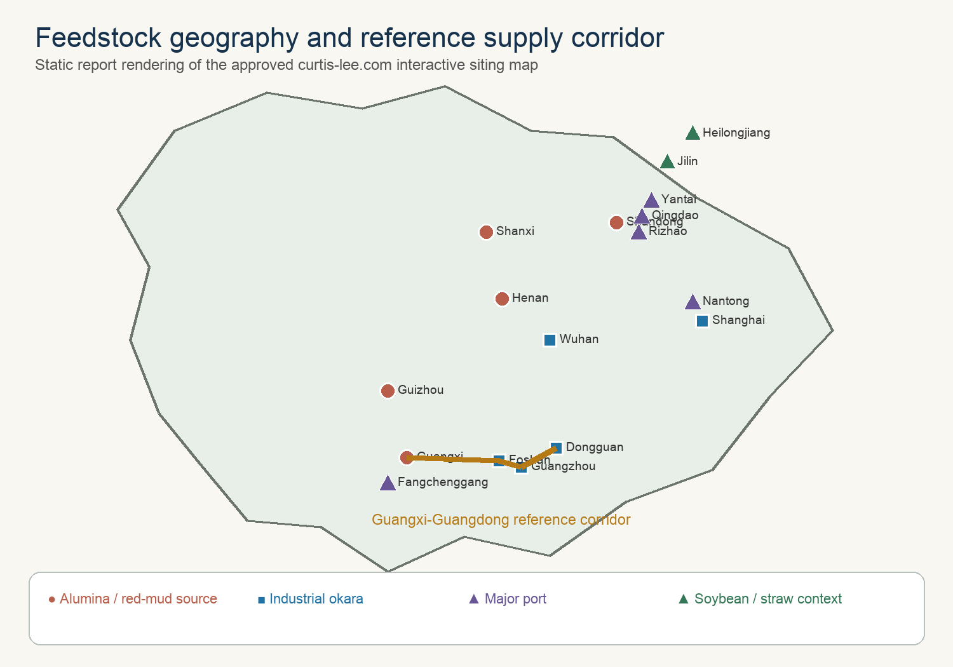
Figure 4.1. Feedstock geography retained from the approved curtis-lee.com project map. Wet biomass governs siting; dense red mud can travel farther than okara without spoilage or water-haul penalties.

4.1 Final design basis
Table 4.1 - Final plant design basis.
Parameter | One train | Five-train complex | Status
Gross slurry feed | 300 t/d | 1,500 t/d | Calculated basis
Operating time | 8,000 h/y | 333 d/y | Commercial target
Total solids | 19.1 wt% | 57.2 t/d per train | Requires pump-loop test
SCWG conditions | 625 C, 25 MPa | Five isolated reactors | Pilot severity
B2 hot residence | 60 s | Independent trips | Pilot variable
B6 reformer | 850 C, 2.8 MPa | Shared trains/headers | Vendor package
B7 OXZEO | 400 C, 4 MPa | Cooled multibed | Catalyst pilot basis
Light olefins | 11.61 t/d | 19.33 kt/y | Central screening case

DESIGN DECISION: The five-train complex is a scale-out design. A single 1,500 t/d pressure vessel would magnify the consequences of plugging, prevent online salt-separator switching, and create an unacceptable common-mode outage.

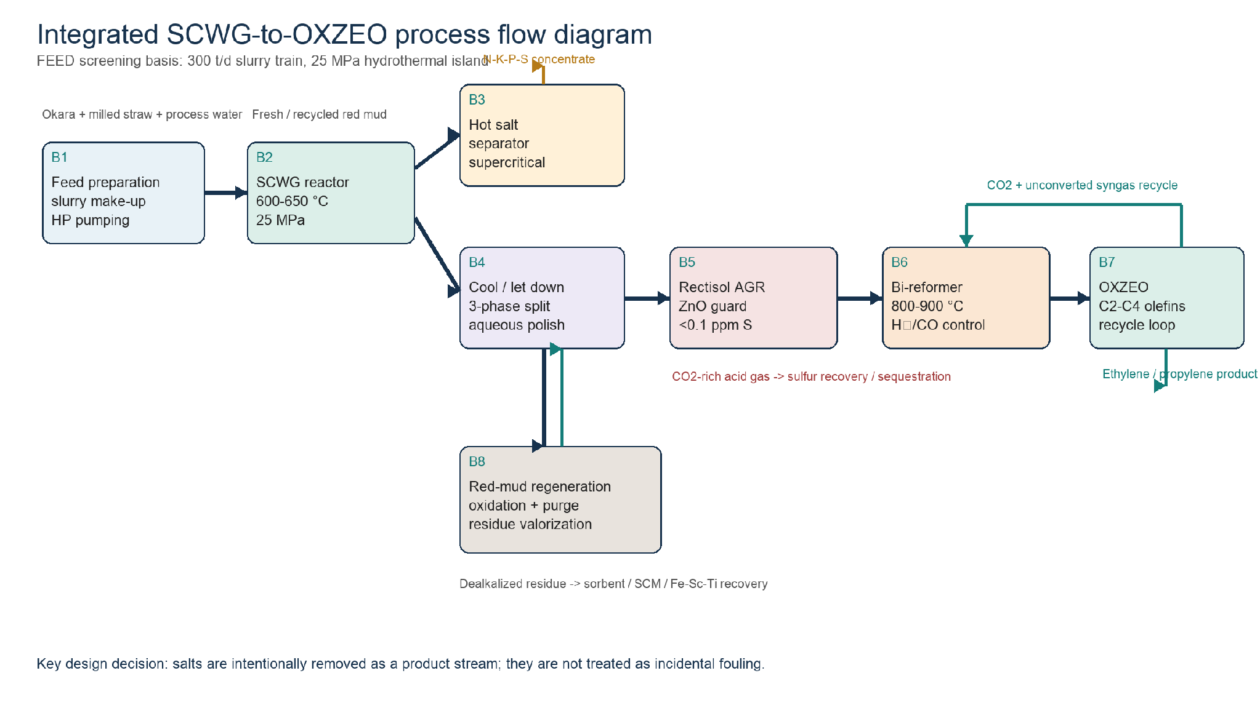
Figure 4.2. Integrated B1-B8 process flow. The figure is a process-flow definition, not a piping and instrumentation diagram; relief, isolation, drains, and sampling systems are specified separately.

4.2 B1 - feed reception, milling, slurry preparation, and pumping
Okara is received in two enclosed agitated tanks sized for 12 h normal residence and 24 h contingency. Chilled storage is used only to control spoilage before processing; the design does not cool material that can be consumed immediately. A first-in-first-out ledger links each supplier batch to moisture, total solids, protein, ash, chloride, sulfur, metals, and certification status. Off-specification material is diverted before it can contaminate the common recycle-water inventory.
Straw is magnetically cleaned, milled below 0.5 mm, and added through a loss-in-weight feeder into a high-shear okara loop. Red mud is slurried separately so its sodium concentration and particle-size distribution can be adjusted without changing the organic feed. The two suspensions meet only in the final surge tank. This arrangement prevents dry mineral agglomerates, permits a controlled red-mud campaign, and makes it possible to flush the organic line without mobilising the full mineral inventory.
Two 100% positive-displacement pumps per train raise approximately 12.5 t/h to 25 MPa. The standby pump is hot-tested weekly against a recirculation loop. A low suction-pressure trip, discharge-pulsation monitor, feed-heater differential-pressure trip, and automated high-pressure water flush protect against fibrous bridges. Pumpability is accepted by a 24 h cold loop and a hot feed-heater test; weight-percent solids alone is not an acceptance criterion.

Table 4.2 - B1 feed acceptance envelope.
Property | Screening acceptance | Instrument / response
Total solids | 18-22 wt% | Microwave density plus laboratory oven; dilute or reduce straw/red mud
D90 particle size | <0.5 mm organic; <0.15 mm mineral | Inline imaging and sieve; reject oversize
Yield stress | No hard bed in 30 min; pump-loop stable | Torque and differential pressure; increase okara or water
Chloride | Source-specific alloy limit | Ion chromatography; segregate batch
Spoilage / acids | FIFO, chilled contingency, daily COD/pH | Divert, sanitise, or blend down
PFAS / metals | Product-route-specific limit | Hold batch; prohibit fertilizer campaign

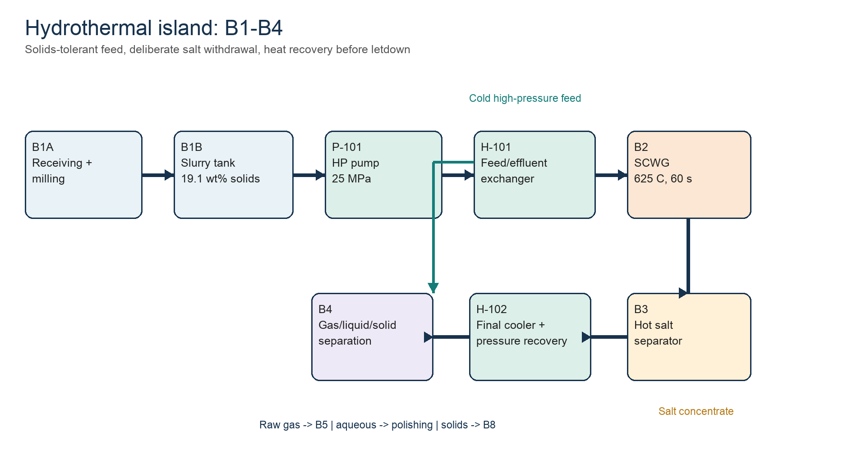
Figure 4.3. Hydrothermal island B1-B4. Heat recovery precedes pressure letdown; the B3 salt withdrawal remains online during normal operation.

4.3 B2 - supercritical-water gasifier
Each train uses a vertically oriented, externally heated, nickel-alloy-lined reactor with replaceable wetted internals. The calculated reacting volume is 1.74 m3 at an assumed 120 kg/m3 hot-fluid density and 60 s residence; a 2.3 m3 gross vessel provides disengagement and instrumentation allowance. A series of smaller parallel tubes may prove preferable because wall heat flux, inspectability, and relief segmentation dominate the mechanical design. The volume calculation is therefore a process minimum, not a fabrication drawing.
Cold slurry is brought through the near-critical ionic region rapidly. H-101 recovers heat from salt-depleted effluent, while a final trim heater supplies the approach to 625 C. The exchanger is a double-pipe, printed-circuit, or bayonet concept with erosion-tolerant passages and isolation for hydroblasting. A direct-contact quench start-up mode is retained for the pilot because it can cross the 200-300 C Maillard window faster than a fouling indirect heater.
The B2 control hierarchy is feed flow, pressure, wall temperature, salt differential pressure, and carbon conversion. High wall temperature or falling feed flow trips organic and red-mud feed while maintaining water flow to quench the reaction and sweep solids. The reactor depressurises to a closed blowdown receiver rather than atmosphere. Online gas chromatography provides H2/CH4/CO/CO2 response, but the acceptance test is a full carbon balance including aqueous TOC and recovered solids.
Table 4.3 - B2 process equipment definition.
B2 design item | Calculation / selection | Qualification test
Hot reacting volume | 12.5 t/h / 120 kg/m3 x 60 s = 1.74 m3 | Tracer test and hot-density package
Gross reactor volume | 2.3 m3 per train | Vendor thermal/CFD design
Pressure boundary | 25 MPa; replaceable Ni-alloy wetted liner | Weld coupons under chloride/sulfide/salt
Residence window | 30-120 s pilot sweep | Carbon, char, methane, dealkalization
Conversion target | 95% organic carbon leaves as gas/liquid products | Continuous 1,000 h campaign

4.4 B3 - hot salt precipitation and continuous separation
B3 is a deliberately oversized product separator. At supercritical conditions, sodium sulfate, sodium carbonate, potassium salts, and phosphate-rich species form a dense brine or crystal slurry. Tangential entry and a cooled or transpiring wall bias nucleation away from the pressure boundary. Two 100% vessels in lead-lag service allow one separator to be isolated, flushed, and inspected while the reactor remains at water circulation.
The screening vessel inventory is five minutes of hot flow, approximately 8.7 m3 at the assumed hot density; each separator is provisionally 10 m3 gross. Continuous underflow is cooled under pressure, flashed in a wear-resistant pot, filtered, and transferred to a product or quarantine tank. Sodium recovery and pressure-drop stability are guaranteed together. A dry salt yield without an availability guarantee is not an acceptable B3 performance test.
The concentrate is not automatically fertilizer. It is sold only after nutrient assay, chloride, heavy metals, pathogens, organics, and applicable registration tests. Until then it is a segregated N-K-P-S-bearing concentrate with a disposal route. The base economic case assigns only a low conditional value; it does not assume a fertilizer price.

4.5 B4 - heat recovery, depressurisation, phase separation, and water polishing
Salt-depleted B2 effluent gives up heat to H-101 before pressure letdown. Where an erosion test supports it, a hydraulic power-recovery device reduces valve duty; otherwise the pressure drop is divided among three sacrificial-trim stages. The first separator remains at sufficient pressure to keep the acid gases with the gas stream. A second flash removes dissolved gas, and a three-phase decanter splits polished water, mineral solids, and any immiscible organic phase.
The aqueous train uses filtration, ammonia recovery, activated carbon or catalytic wet oxidation for residual organics, and a controlled chloride purge. Water recycle is governed by chloride and refractory TOC, not by a fixed percentage. Ammonia recovered as a separate nitrogen stream is preferable to leaving it in an unqualified mixed brine. A 230.42 t/d recycle/effluent-water stream closes the one-train mass balance, but only the fraction meeting feed and corrosion specifications returns to B1.
The B4 trip strategy recognises that flashing a dirty supercritical stream through a single valve converts pressure into erosion. High vibration, valve travel mismatch, or downstream high level initiates water-only operation and routes depressurised material to the closed receiver. The mineral stream is washed counter-currently so sodium leaving with B8 solids does not silently defeat the B3 balance.

4.6 B5 - Rectisol, ZnO guard, and sulfur recovery
The shared Rectisol plant receives compressed raw gas after bulk water removal. Chilled methanol selectively absorbs H2S, COS, and CO2. Flash staging produces a sulfur-rich fraction for liquid-redox sulfur recovery and a CO2-rich fraction for B6 recycle or sequestration. Refrigeration is integrated with methanol regeneration, but its shaft work remains an irrecoverable utility demand and is reported separately in Section 6.
A lead-lag ZnO guard follows the solvent unit. This bed is intentionally small and non-regenerable: its function is to absorb breakthrough and analytical uncertainty, not to replace bulk sulfur removal. Two independent total-sulfur analysers vote the bed switch and isolate B7 on disagreement. The design outlet is below 0.1 ppmv total sulfur, including COS, because the OXZEO oxide vacancies and zeolite acid sites cannot be allowed to become the plant's final sulfur sorbent.
Table 4.4 - Acid-gas-removal selection.
Alternative | Capital / utility consequence | Decision
Rectisol + ZnO | Higher capital; refrigeration; simultaneous deep H2S/COS and CO2 removal | Base case: preserves controlled CO2 recycle and sub-ppm sulfur
Selective MDEA + ZnO | Lower capital; no refrigeration; weak COS/CO2 separation without extra units | Value-engineering case only after real-gas absorber simulation
Solid sorbent only | Low initial capital; large consumable and waste duty | Rejected for continuous bulk removal

4.7 B6 - bi-reforming and ratio control
B6 combines dry and steam reforming so the methane-rich hydrothermal gas becomes CO-bearing synthesis gas. The stoichiometric relationship 3CH4 + CO2 + 2H2O -> 4CO + 8H2 gives H2/CO = 2 exactly. In practice, the feed is adjusted by measured gas composition, not by a fixed recipe. Excess steam protects the nickel catalyst; the CO2 split controls ratio and provides a sink for captured carbon.
The reformer is a fired tubular package at approximately 850 C and 2.8 MPa. The central heat input, including furnace loss, is 150 GJ/d per hydrothermal train equivalent. Tube-skin temperature, steam/carbon, methane slip, and pressure drop are the primary constraints. A sulfur-tolerant pre-reformer and decoking connections are included. The hot product generates high-pressure steam before the final ratio trim and B7 compression.
Reforming is the thermodynamic weakness of the concept because B2 first forms methane and B6 then spends high-grade heat to unmake it. The design carries this penalty explicitly. A future high-severity SCWG route is valuable only if the measured reduction in methane is larger than the additional char, salt, materials, and heat-transfer penalties.

4.8 B7 - OXZEO reaction, heat removal, recycle, and product recovery
The OXZEO train uses a zinc-chromium oxide function for CO activation and a CHA-type molecular sieve such as SAPO-34 for confined carbon-carbon coupling. The functions are packed in an arrangement that preserves short intermediate-transfer distance without allowing excessive hydrogenation. Bed architecture is a licensor and pilot decision; the report does not infer it from catalyst powder data.
The central calculation uses 45% single-pass CO conversion and 70% carbon selectivity to C2-C4 olefins on converted carbon, with recycle of unconverted syngas. The overall battery-limit olefin-carbon efficiency is 42% after aqueous organics, solid carbon, CO2 rejection, and purge losses. Multiple cooled beds or a boiling-water reactor remove reaction heat and hold the 400 C selectivity window. High bed delta-T cuts syngas immediately and maintains recycle/inert gas for controlled cool-down.
Product recovery condenses water and oxygenates, removes CO2, and separates fuel gas from ethylene, propylene, and a C4 cut. Cryogenic purity is not assumed blindly: the final separation package must be matched to the offtake specification. A mixed polymer-grade light-olefin contract may require less capital than separate ethylene and propylene products, while a chemical-grade specification imposes deeper dehydration, acetylene control, and fractionation.
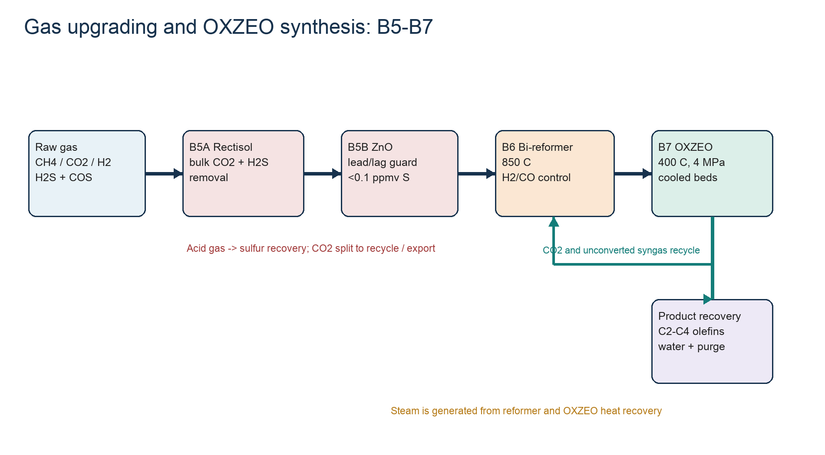
Figure 4.4. Shared B5-B7 gas upgrading, bi-reforming, OXZEO, recycle, and product-recovery train.

4.9 B8 and R1 - red-mud conditioning, purge, and recycle
B4 solids are counter-currently washed to remove soluble sodium and partially dried with recovered heat. Controlled oxidation is retained for heat management and stable mineral conditioning, not credited as restoration of a stoichiometric oxygen carrier. XRF, XRD, sodium leach, particle size, surface area, and magnetic response determine whether material returns to B1 or leaves through a qualified product route.
The recycle closes on an iron inventory. At 7.0 t/d dry fresh red mud, an 80% active-solids return implies 28 t circulating inventory for a four-day notional campaign and a 20% purge of the solids leaving B2. The actual purge is set by sodium, silica, titanium, chloride, trace metals, surface loss, and catalyst performance. A low fresh-mud rate is valuable only if it does not cause contaminants to accumulate indefinitely.
Purge products are tiered. The first route is a qualified SO2 sorbent or supplementary cementitious material after leach and performance tests. Magnetic iron concentration and hydrometallurgical Fe/Sc/Ti recovery are secondary routes. No scandium revenue is included in the base case: assay, recovery yield, reagent cost, impurity penalties, and offtake must be demonstrated first.
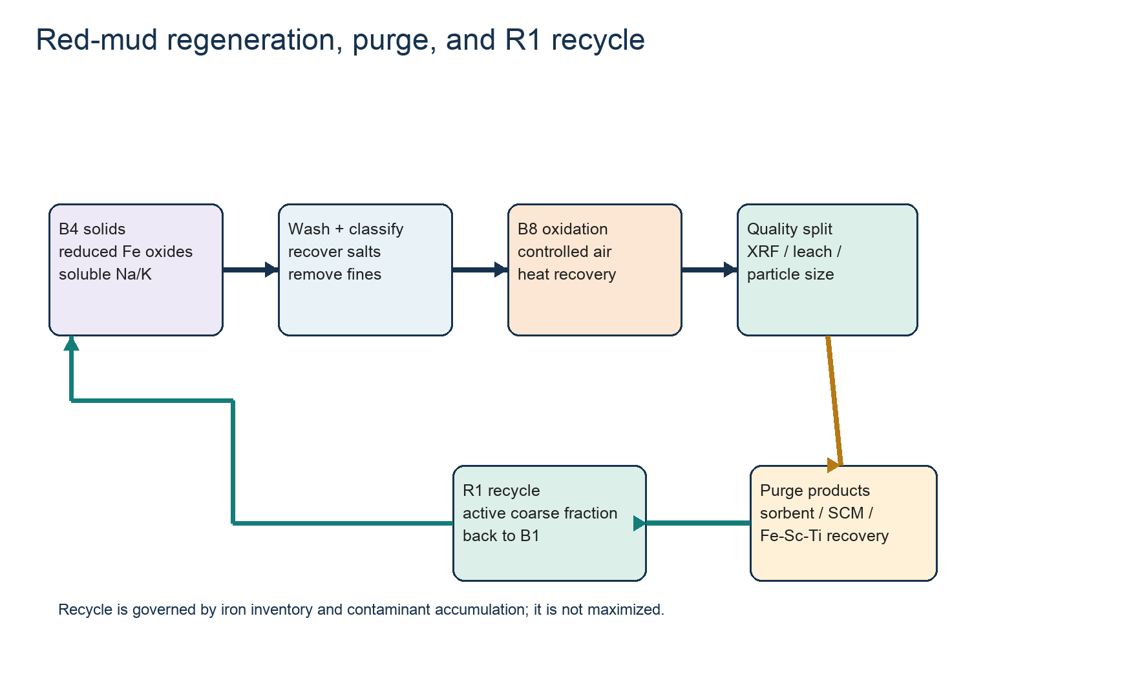
Figure 4.5. B8 conditioning, controlled purge, and R1 recycle. Recycle is governed by iron inventory and contaminant accumulation; it is not maximised.

4.10 Availability, control architecture, and common-mode risk
The commercial target is 8,000 h/y per gas-processing train, but hydrothermal modules are expected to cycle through water flush and inspection. Isolation valves, check valves, common headers, and permissives must prevent one dirty train from contaminating the shared Rectisol or synthesis loop. A train can feed common gas only after sulfur, pressure, water, and composition are inside the acceptance window.
Table 4.5 - High-level process control architecture.
Control layer | Measured variable | Automatic action
B1 feed protection | Suction pressure, pump pulsation, H-101 delta-P | Stop organic/red mud; maintain water flush
B2 reactor protection | Feed flow, pressure, wall temperature, salt delta-P | Trip heat/feed; water quench; isolate module
B3 availability | Interface, underflow density, wall temperature | Switch lead/lag; flush standby; reduce solids
B5 catalyst protection | Dual total sulfur analysers | Switch ZnO; isolate B7 on disagreement
B6 coking control | Steam/carbon, tube skin, methane slip | Trip fuel; maintain steam purge
B7 selectivity control | Bed delta-T, CO conversion, sulfur | Cut syngas; maintain recycle/inert cooling
R1 inventory | Fe, Na, Cl, trace metals, surface area | Adjust fresh mud, recycle, and purge

5. Closed mass, elemental, and stream balances
The balance is closed at the battery limit of one 300 t/d train. Internal gas, water, CO2, and red-mud recycles are shown separately because they size equipment, but they cancel in the overall balance. The model is a reconciled pseudo-component balance: total mass, dry-feed elements, and carbon close exactly on the stated allocations. A rigorous H/O closure by molecular species requires measured gas composition, dissolved-organic formulas, and oxide stoichiometry and is therefore a pilot/simulator deliverable rather than an invented table.
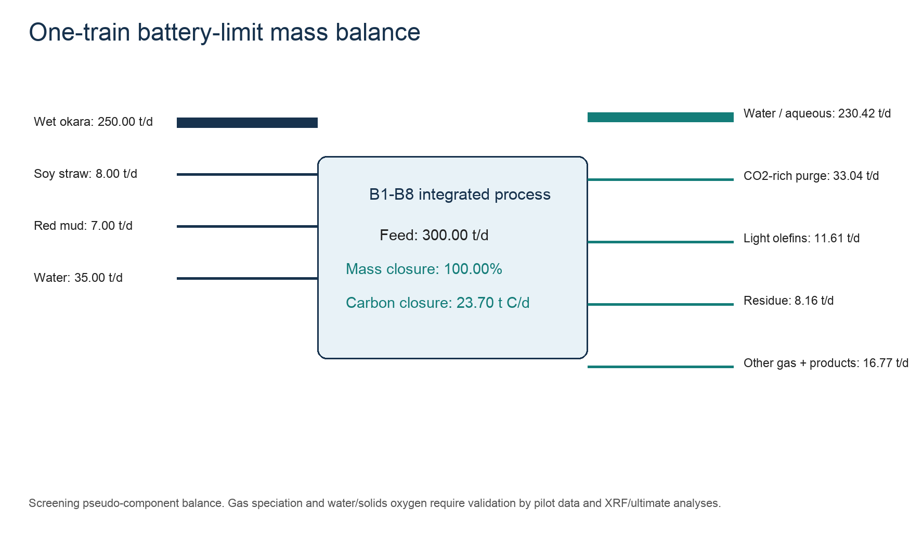
Figure 5.1. One-train battery-limit mass balance. The detailed stream and elemental tables below reproduce the plotted closure.

5.1 Feed and solids basis
Table 5.1 - One-train feed balance.
Feed | As received t/d | Dry solids t/d | Water t/d
Wet okara | 250.00 | 43.00 | 207.00
Soybean straw | 8.00 | 7.20 | 0.80
Dry red mud | 7.00 | 7.00 | 0.00
Make-up/recycled water | 35.00 | 0.00 | 35.00
TOTAL | 300.00 | 57.20 | 242.80

Total solids are 57.20/300.00 = 19.07 wt%; biomass dry matter is 50.20 t/d. The five-train complex therefore processes 251 t/d biomass dry matter and 1,500 t/d total slurry. At 333 operating days the annual slurry throughput is 499,500 t/y, including 416,250 t/y wet okara, 13,320 t/y straw, and 11,655 t/y fresh red mud.

5.2 Overall product and purge balance
Table 5.2 - Closed overall one-train mass balance.
Outlet stream | Mass t/d | Basis
Light C2-C4 olefins | 11.61 | Calculated product
CO2 purge / export | 33.04 | Recycle/sequestration split
Aqueous organics | 4.75 | Polishing load
Solid carbon | 0.95 | Residue carbon
CH4 fuel purge | 0.95 | Internal fuel credit
CO purge | 2.75 | Fuel/recycle purge
H2 purge | 1.95 | Fuel/recycle purge
NH3 equivalent | 3.47 | Nitrogen recovery basis
N2 / trace gas | 0.32 | Nitrogen closure
Sulfur equivalent | 0.13 | Brine/sulfur product
Dealkalized mineral residue | 8.16 | Red mud + ash + carbon
Salt concentrate, dry | 1.50 | Conditional product
Recycle/effluent water | 230.42 | Water and dissolved fraction
TOTAL | 300.00 | 100.00% closure

5.3 Carbon balance and olefin yield
Table 5.3 - Closed one-train carbon balance.
Carbon destination | t C/d | % of feed carbon
C2-C4 olefins | 9.95 | 42.0
CO2 purge/export | 9.01 | 38.0
Aqueous organics | 1.90 | 8.0
Solid carbon | 0.95 | 4.0
CH4 fuel purge | 0.71 | 3.0
CO in purge | 1.18 | 5.0
TOTAL | 23.70 | 100.0

Olefin mass follows from 9.95 t C/d divided by an average carbon mass fraction of 0.857 for a C2-C4 olefin mixture, giving 11.61 t/d. This 42% carbon efficiency is not the OXZEO reactor selectivity; it includes carbon rejected before synthesis and the purge required to control inert and methane accumulation. The five-train annual product is 11.61 x 5 x 333 = 19,330.7 t/y.

5.4 Dry-feed elemental closure
Table 5.4 - Dry-feed pseudo-component elemental closure.
Element / group | Feed t/d | Product allocation t/d | Closure
Carbon | 23.700 | 23.700 | 100.0%
Hydrogen | 3.400 | 3.400 | 100.0%
Oxygen | 18.630 | 18.630 | 100.0%
Nitrogen | 3.180 | 3.180 | 100.0%
Sulfur | 0.130 | 0.130 | 100.0%
Ash + fresh red mud | 8.160 | 8.160 | 100.0%
TOTAL DRY FEED | 57.200 | 57.200 | 100.0%

Nitrogen closes as 2.86 t N/d in 3.47 t/d NH3 equivalent plus 0.32 t/d N2/trace nitrogen. Sulfur closes as 0.13 t/d sulfur equivalent split between the B3 concentrate and B5 sulfur recovery. Sodium and potassium do not receive a universal product credit: 1.50 t/d dry concentrate is withdrawn, but any residual soluble alkali in R1 wash water returns only if the chloride and sodium limits are satisfied.

5.5 Gas conversion and OXZEO calculation
Table 5.5 - Conversion assumptions connecting the carbon balance to product flow.
Step | Screening input | Calculated implication
Carbon entering cleaned reformer/synthesis train | 17.8 t C/d | After aqueous and solid-carbon rejection
Bi-reformer methane conversion | 92% | Residual CH4 controlled by recycle purge
Reformer ratio | H2/CO = 2.0 | CO2 and steam trimmed to measured feed gas
OXZEO single-pass CO conversion | 45% | Recycle loop required
Olefin selectivity | 70% of converted carbon | Catalyst pilot assumption
Overall olefin-carbon efficiency | 9.95/23.70 | 42.0%

The OXZEO loop is not closed by assuming complete CO conversion. Single-pass conversion, product selectivity, methane slip, CO2 rejection, and purge fraction are coupled. The final loop requires a licensed steady-state simulation. The present balance is sufficient to size the product, purge, and utility cases without pretending that a catalyst powder result is a plant guarantee.

5.6 Principal stream table
Table 5.6 - Principal one-train stream summary. Dashes mark internal gas quantities that require a licensed molecular simulation.
ID | Description | t/d | C | P MPa | Comment
S01 | Wet okara | 250.00 | 20 | 0.1 | 82.8 wt% water
S02 | Milled straw | 8.00 | 20 | 0.1 | 90 wt% dry matter
S03 | Fresh red mud | 7.00 | 20 | 0.1 | Dry basis
S04 | Water make-up/recycle | 35.00 | 20 | 0.1 | Blend control
S05 | High-pressure slurry | 300.00 | 250 | 25 | 19.1 wt% solids
S06 | SCWG effluent | 300.00 | 625 | 25 | Gas/water/salt/mineral
S07 | Salt concentrate | 1.50 | 80 | 0.3 | Dry equivalent
S08 | Separated raw gas | 52.4 | 40 | 3.0 | Internal stream; wet
S09 | Treated gas | - | -35 | 3.0 | Rectisol + ZnO
S10 | Reformer syngas | - | 850 | 2.8 | H2/CO trimmed
S11 | Light-olefin product | 11.61 | -20 | 1.8 | C2-C4
S12 | CO2-rich purge | 33.04 | 30 | 1.2 | Recycle/export split
S13 | Aqueous product | 238.64 | 40 | 0.2 | Water + organics + NH3 eq.
S14 | Mineral residue | 8.16 | 80 | 0.1 | Dealkalized mud + ash

5.7 Red-mud recycle and purge calculation
Let F be fresh dry red mud, R the returned active solids, and p the fraction purged after B8. At steady state, F = p(F + R) if attrition and product losses are included in the purge. For F = 7.0 t/d and p = 0.20, the gross solids leaving B8 that are attributable to the red-mud inventory are 35 t/d and R is 28 t/d. This is an equipment-sizing recycle, not an additional battery-limit feed.
Table 5.7 - Recycle inventory sensitivity for 7.0 t/d fresh red mud.
Purge fraction | Gross red-mud solids through B8 t/d | R1 recycle t/d | Interpretation
50% | 14 | 7 | Low accumulation; high fresh-mud demand
20% | 35 | 28 | Central screening basis
10% | 70 | 63 | Large inventory; contaminant risk
5% | 140 | 133 | Not credible without long campaign data

BALANCE LIMITATION: The overall mass and carbon balances are closed. Molecular gas composition, rigorous water H/O, salt speciation, and iron-oxide phase equilibrium must be replaced by pilot analytics and a property-package simulation before investment-grade FEED.

6. Energy balance, heat recovery, and Chinese utility basis
The energy model separates recoverable sensible heat from reaction enthalpy and shaft work. This prevents the large temperature swing from being mistaken for an equal purchased-energy demand. Every duty is stated per 300 t/d train; the commercial utility system multiplies the train duties only after common-unit diversity and steam integration are applied.
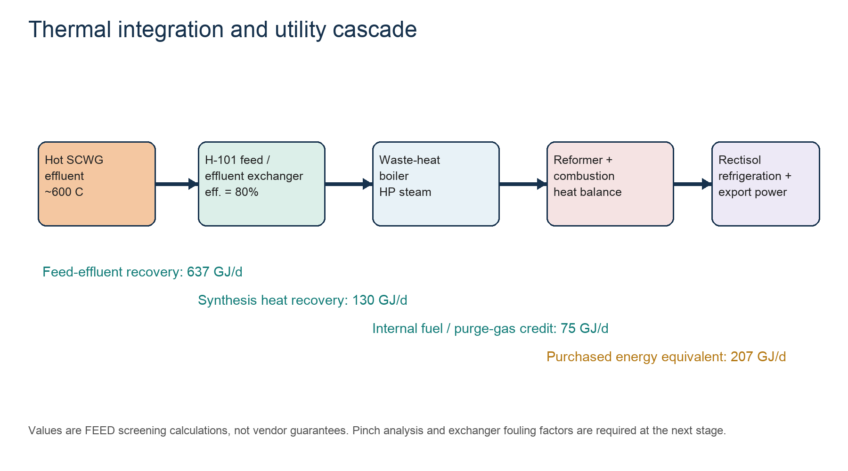
Figure 6.1. Thermal integration and utility cascade. The methane round-trip and refrigeration/compression work remain after sensible-heat recovery.

6.1 One-train energy balance
Table 6.1 - One-train screening energy balance.
Duty | GJ/d per train | Calculation / interpretation
Feed sensible heating to 625 C | 796 | 300,000 kg/d x 4.42 kJ/kg-K x 600 K
Pressurisation and slurry pumping | 10 | 25 MPa x 300 m3/d / 75% hydraulic efficiency
SCWG reaction + thermal loss | 35 | Pilot-calibrated heat input allowance
Bi-reformer reaction + furnace loss | 150 | Endothermic chemical duty
Gas compression / OXZEO recycle | 25 | Electric equivalent
Rectisol refrigeration / regeneration | 18 | Electric/steam equivalent
Aqueous polishing / residue finishing | 15 | Electric/thermal equivalent
GROSS REQUIREMENT | 1,049 | Before recovery and fuel credits
H-101 feed/effluent recovery | -637 | 80% of sensible feed duty
Reformer + OXZEO heat recovery | -130 | HP/MP steam credit
CH4/CO purge fuel credit | -75 | Closed carbon-product streams
PURCHASED ENERGY EQUIVALENT | 207 | 8.6 GJ/h or 2.4 MW per train

For five trains and 333 d/y, purchased energy is 207 x 5 x 333 = 344,655 GJ/y. Approximately 144,000 GJ/y is modelled as electricity and 200,655 GJ/y as pipeline-gas or steam equivalent. This split is an economic convention; detailed motor, refrigeration, furnace, and steam balances must replace it at FEED.

6.2 Reproducible calculation checks
Table 6.2 - Reproducible headline energy calculations.
Quantity | Expression | Result
Average heat capacity rate | 300,000 kg/d x 4.42 kJ/kg-K | 1.326 GJ/d-K
Gross sensible duty | 1.326 x 600 K | 795.6 GJ/d
H-101 recovery | 795.6 x 0.80 | 636.5 GJ/d / 7.37 MW
Ideal pump work | 25 MPa x 300 m3/d | 7.50 GJ/d
Actual pump work | 7.50/0.75 | 10.0 GJ/d / 116 kW
Net purchased energy | 1,049 - 637 - 130 - 75 | 207 GJ/d

6.3 Heat-exchanger network
Table 6.3 - Heat-recovery network and principal fouling risks.
Service | Hot side | Cold side | Design risk
H-101A/B | Salt-depleted SCWG effluent | 25 MPa slurry feed | Erosion, fouling, bypass for start-up
WHB-201 | Reformer effluent | HP boiler-feed water | Metal dusting, carbon, steam drum protection
WHB-301 | OXZEO reaction heat | MP steam generation | Temperature control sets selectivity
E-401 | Rectisol lean/rich methanol | Rich/lean solvent | Cold-box integration, water freeze margin
E-501 | B8 conditioning exhaust | BFW / combustion air | Dust, sodium, alkali carryover

A conventional pinch target must be modified for dirty-service reality. H-101 effectiveness above 80% may be thermodynamically attractive but can require narrow passages that are incompatible with fibres and mineral solids. The correct optimum includes cleaning frequency, parallel surface area, erosion allowance, and lost production. The exchanger network should therefore be piloted with representative red mud rather than optimised from clean-water correlations.

6.4 China utility prices and annual quantities
Table 6.4 - Chinese utility assumptions. Guangxi published investment guides support the electricity, gas, and water rates.
Utility | China screening rate | Annual quantity | Annual cost RMB m
Electricity | 0.60 RMB/kWh | 40.0 GWh | 24.0
Pipeline gas / heat | 3.86 RMB/Nm3; approx. 108 RMB/GJ | 200,655 GJ eq. | 21.7
Industrial water | 3.68 RMB/m3 | 0.20 million m3 make-up | 0.7
Cooling-water chemicals | Site allowance | Closed-loop programme | 1.5
Wastewater / purge | Site allowance | Analytical and discharge load | 3.0

6.5 Energy performance and exportable steam
Recovered reformer and OXZEO heat is first used to support B6 steam/carbon ratio, Rectisol regeneration, and B4 ammonia recovery. Export steam is credited only after those internal duties are met. No electricity-export revenue is included. The central purchased-energy intensity is 344,655 GJ/y divided by 19,330.7 t/y olefins = 17.83 GJ/t olefin, before allocating energy to residue treatment and waste services.
The intensity appears high because product production is deliberately modest relative to wet waste throughput. On a slurry basis it is 0.69 GJ/t feed. Both numbers must be reported: the product basis exposes commercial competitiveness, while the waste basis describes treatment performance. Presenting only one would bias the project narrative.

6.6 Energy-reduction priorities
- Measure the methane fraction leaving B2 and determine whether higher severity reduces the B6 endotherm without increasing char or salt deposition.
- Demonstrate at least 75-80% dirty-service feed/effluent heat recovery with cleanable geometry and stable pressure drop.
- Optimise Rectisol pressure and CO2 split; avoid chilling gas that will be reheated without a process reason.
- Use B7 reaction heat for controlled steam generation; do not permit temperature control to depend on emergency quench.
- Value steam internally at the marginal avoided gas cost, not at an inflated external tariff.

7. Heteroatoms, materials, process control, and safety

7.1 Nitrogen, sulfur, sodium, potassium, and chloride destinations
Every heteroatom must leave in a controlled stream. Nitrogen is recovered primarily as ammonia from B4 water; sulfur is split between B3 aqueous sulfide/sulfate and B5 acid-gas recovery; sodium and potassium leave in the B3 concentrate and controlled aqueous purge; chloride follows the water purge and must not be allowed to accumulate in R1. The economic model assigns no product value until analytical release.
Table 7.1 - Heteroatom and metal destinations.
Species | Principal destination | Release / control
Nitrogen | B4 ammonia recovery; trace N2 | NH3 assay, water balance, product registration if sold
Sulfur | B3 brine + B5 liquid-redox sulfur | Dual sulfur balance; ZnO remains polishing only
Na / K | B3 concentrate + aqueous purge | ICP/IC on each batch; sodium leach on residue
Chloride | B4 water purge | Online conductivity plus laboratory IC; corrosion alarm
Fe / Al / Ti | B8 residue or metals circuit | XRF/XRD, magnetic split, leachability
Sc / Ga | Optional hydrometallurgical concentrate | Independent assay, yield, reagent, and offtake trial

7.2 Materials of construction
The material challenge is the combination of hot water, chloride, sulfide, alkali, and precipitating salts. A nickel-base alloy wetted surface is assumed in B2/B3, with replaceable internals and welded corrosion coupons. Carbon steel is used only after temperature, water, and acid-gas chemistry permit it. This is a materials-test programme, not a catalogue selection.
Table 7.2 - Materials qualification matrix.
Service | Candidate strategy | Qualification requirement
B1 ambient slurry | Lined carbon steel / suitable stainless | Erosion, chloride, cleanability, food-waste biofilm
B2/B3 hydrothermal | Nickel-base wetted liner / replaceable internals | Welded coupons under chloride, sulfide, salts, red mud
B4 wet acid gas | Corrosion-resistant alloy selected after condensate chemistry | Wet H2S/CO2 chloride stress-corrosion review
Rectisol cold box | Low-temperature carbon/stainless by licensed design | Brittle-fracture, methanol, water-freeze margin
B6 reformer | High-temperature reformer tube alloy | Creep, carburisation, metal dusting, cycling
B8 solids | Abrasion-resistant steel with replaceable liners | Dust, caustic wash, attrition

7.3 Corrosion, erosion, fouling, and inspection
Corrosion monitoring combines permanent coupons, electrical-resistance probes where chemistry permits, wall-thickness mapping, and salt-deposit sampling. Erosion is highest at pump check valves, B3 inlets, letdown trims, and slurry elbows. Inspection intervals are initially campaign-based and lengthened only after measured wall-loss trends. Design corrosion allowance does not replace access for inspection.
The salt separator is the availability bottleneck. Differential pressure alone cannot distinguish crystal inventory from wall adhesion, so underflow density, interface position, wall temperature, acoustic response, and flush recovery are trended together. A separator that returns to baseline pressure drop after a controlled flush is behaving as designed; one that requires mechanical cleaning has failed the continuous-service criterion even if no safety trip occurred.

7.4 Preliminary HAZOP register
Table 7.3 - Preliminary HAZOP-style safeguard register.
Deviation | Credible cause | Consequence | Automatic response
Low B2 feed flow | Cavitation, fibre bridge, feed-heater plug | Wall overtemperature, coke | Stop organic/red mud; water flush and quench
High B3 delta-P | Salt bridge, underflow failure | Reactor isolation / overpressure | Switch separator; reduce solids; flush standby
High letdown vibration | Flashing solids, eroded trim | Loss of containment | Close upstream; route to blowdown receiver
Sulfur after ZnO | Bed exhaustion or analyser disagreement | B7 catalyst poisoning | Switch lead/lag; isolate B7
Low B6 steam/carbon | Steam loss, control failure | Coke, tube hot spot | Trip fuel; maintain steam purge
High B7 bed delta-T | Cooling loss, excess conversion | Runaway selectivity loss | Cut syngas; recycle/inert emergency cooling
Loss of power | Utility failure | Pump/compressor stop | Fail-safe isolation; UPS controls; closed depressurisation

7.5 Relief, blowdown, fire, and toxic-gas philosophy
Each hydrothermal train is independently isolatable and depressurises to a water-filled quench/blowdown receiver sized for the liquid inventory and flash gas. Relief devices do not discharge a salt-bearing two-phase stream directly to a common flare header without a knock-out and quench design. B5/B6/B7 hydrocarbon and syngas relief is segregated from dirty hydrothermal relief until composition and backpressure permit safe combination.
CO, H2, CH4, H2S, methanol, and oxygen-deficient atmospheres require fixed detection, mechanical ventilation, classified electrical equipment, and remote isolation. Methanol storage has closed drains, nitrogen blanketing, spill containment, and fire-water coverage. The red-mud finishing area uses enclosed transfer and dust extraction because caustic/metal-bearing particulate is a personnel exposure even after the bulk process is wet.

7.6 Analytical and sampling plan
Table 7.4 - Minimum analytical campaign.
Location | Online measurement | Laboratory release
B1 feed | Density, torque, pH, conductivity | Ultimate/proximate, C/N/S/Cl, metals, particle size
B2 effluent | GC H2/CH4/CO/CO2, pressure, temperature | Aqueous TOC/COD, NH3, solids carbon, XRD
B3 underflow | Density, conductivity, interface | IC/ICP nutrients, Na/K/S/Cl, metals, organics
B5 outlet | Dual total sulfur, dew point | COS/H2S audit samples, methanol carryover
B6/B7 | GC ratio/conversion, bed delta-T | Full product slate, oxygenates, catalyst metals
B8/R1 | Mass, moisture, magnetic response | XRF/XRD, leach, surface area, strength/performance

7.7 Start-up and shutdown sequence
Start-up establishes clean-water pressure and verified wall temperatures before organic slurry enters. Red mud and straw ramp only after stable okara flow. B3 lead/lag behaviour is proven with a controlled salt challenge before certification product is collected. B5 and ZnO must be on specification before B6 heat-up gas can approach the synthesis loop. Shutdown reverses the sequence: isolate B7, maintain steam through B6, stop red mud and straw, stop okara, then water-flush each hydrothermal train until conductivity, solids, and carbon fall below the cleaning endpoint.

8. Environmental policy, certification, and product qualification

8.1 ISO 14067 product-carbon-footprint boundary
ISO 14067:2018 remains current after confirmation in 2024. It quantifies climate change for a product consistently with ISO 14040/14044; it does not certify broader environmental or social performance. The project therefore requires separate product footprints for light olefins and residue products, with transparent allocation between waste treatment and co-products.
Table 8.1 - ISO 14067 implementation requirements.
Footprint item | Required project treatment
Feed burden | Report both cut-off waste and allocated-burden cases; retain supplier proof of waste status
Electricity / heat | Use site and year-specific factors; allocate recovered energy consistently
Biogenic carbon | Track feed carbon, CO2, aqueous carbon, solid carbon, and olefin carbon without assumed neutrality
Co-products | Test mass, energy, and economic allocation; disclose avoided-burden sensitivities separately
Data quality | Replace screening yields with metered continuous-operation balances and uncertainty ranges

8.2 ISCC PLUS chain of custody
ISCC PLUS is the operational certification route for circular or bio-based olefin claims. In 2026 the transition matters: chapter 9.4 of the existing system remains valid through 31 December 2026, while ISCC PLUS 203-2 is already valid and mandatory from 1 January 2027. The plant information system must therefore retain point-of-origin declarations, supplier identity, incoming certified mass, sustainability characteristics, conversion factors, storage losses, outgoing claims, and period balances under both rule sets.
Physical mixing is allowed only with bookkeeping that remains auditable. The certification system does not cure poor feed control; a misdeclared okara batch or red-mud stream can invalidate the claim. Procurement contracts must specify status, evidence, mass, correction rights, and audit access. Olefin sales contracts must distinguish physical carbon content from mass-balance attribution.

8.3 EU CBAM and RED III
The definitive EU CBAM regime began on 1 January 2026 and currently covers selected cement, iron and steel, aluminium, fertilisers, electricity, and hydrogen goods. Light olefins are not automatically in scope. The project's exposure is therefore product-specific: an iron, aluminium, cementitious, or nutrient co-product may require classification and embedded-emissions data even when the olefin does not. Customs classification must be checked at each intended point of export.
RED III becomes relevant only if an intermediate or product is placed on a regulated fuel market. The design does not label olefins as renewable transport fuel. Any future methanol, methane, or hydrogen route requires a separate RED pathway, greenhouse-gas calculation, and sustainability evidence. Certification claims cannot be transferred from one product route by analogy.

8.4 China ETS, CCER, and carbon-price treatment
China's national ETS expanded in 2025 to include steel, cement, and aluminium smelting alongside power generation. The Ministry of Ecology and Environment reported a 2025 allowance average of 62.36 RMB/tCO2 and a CCER average of 70.76 RMB/tCO2. These figures are market evidence, not automatic project revenue. The base model excludes carbon-credit sales because the project has no approved methodology, additionality demonstration, registered project, verified reductions, or contractual title.
Carbon prices are nevertheless used in sensitivity testing and in procurement comparisons with fossil olefins. If red-mud or nutrient products enter ETS-covered chains, the benefit depends on the customer's accounting boundary and on whether the product displaces a more carbon-intensive material. Avoided emissions and credits are kept separate to prevent double counting.

8.5 Waste status, fertilizer status, and end-of-waste

Table 8.2 - Product-claim evidence and conservative economic treatment.
Stream / claim | Evidence before sale | Base-case economic treatment
Bio-based olefin | ISCC PLUS chain of custody, conversion yield, product footprint | Commodity netback only; premium excluded
N-K-P-S concentrate | Nutrient assay, metals, pathogens, organics, chloride, registration | Low conditional value; disposal route retained
Dealkalized residue | Leaching, sodium, strength/sorbent performance, customer trial | RMB 120/t only for qualified fraction
Fe/Sc/Ti concentrate | Assay, recovery yield, impurity penalty, reagent inventory | Excluded from base revenue
Carbon credit | Approved methodology, additionality, monitoring, verification, title | Excluded

8.6 Environmental monitoring and permits
Table 8.3 - Environmental monitoring architecture.
Aspect | Monitoring point | Design response
Methanol / acid gas | Rectisol cold box and regeneration | Closed drains, gas detection, sulfur recovery, flare
CO / H2 / CH4 | B6/B7 loop | Continuous detection, ventilation, inerting, burner management
Alkaline metals | B8 wash, filter, storage | Enclosed handling, lined drainage, batch traceability
Aqueous COD / chloride | B4 water recycle and purge | Online TOC/conductivity plus laboratory release
Stack emissions | B6 furnace / oxidiser | NOx/CO/O2 measurement; fuel and heat-recovery controls
Product claims | Each residue and brine batch | Hold-and-release certificate linked to analytical record

9. China CAPEX, OPEX, and economic evaluation in RMB
All costs are expressed in 2026 RMB. No dollar conversion is used. The estimate is a China-screening pre-FEED model based on domestic utility and labour evidence, published Chinese project investments, Chinese commodity prices, and the owner-supplied Inner Mongolia benchmark of RMB 1.5 billion for a 300,000 t/y methanol plant. VAT is treated as recoverable and excluded from operating revenue/cost comparisons; financing, land-specific incentives, and tax holidays are excluded.

9.1 Recommended commercial scale
Table 9.1 - Recommended scale-out commercial configuration.
Parameter | One train | Commercial complex
Slurry feed | 300 t/d | 1,500 t/d
Wet waste / red mud feeds | 265 t/d | 441,225 t/y
Biomass dry matter | 50.2 t/d | 251 t/d
Light olefins | 11.61 t/d | 19.33 kt/y
Operating time | 8,000 h/y | 333 d/y
Configuration | Independent B1-B4 | Shared B5-B8, utilities, product recovery

The five-train plant is much smaller in product output than the 300,000 t/y methanol comparator. It is similar in installed complexity because it adds five high-pressure hydrothermal trains, hot salt handling, Rectisol, reforming, OXZEO, product separation, and mineral finishing. Product-normalised capital will therefore be much higher. This is not an error in currency conversion; it is the commercial consequence of processing dilute wet waste into a relatively small olefin stream.

9.2 Chinese price and cost basis
Table 9.2 - China-specific economic assumptions.
Item | Base value | China evidence / interpretation
Electricity | 0.60 RMB/kWh | Published Guangxi investment factor; site contract required
Industrial gas | 3.86 RMB/Nm3 | Published Guangxi investment factor
Industrial water | 3.68 RMB/m3 | Published Guangxi investment factor
Enterprise labour | 160,000 RMB/FTE-y burdened | 2025 enterprise average 106,080 RMB/y plus benefits, shifts, PPE, training
Methanol reference price | 2,423 RMB/t | NBS, early July 2026
LLDPE / PP reference | 7,550 / 8,053 RMB/t | NBS, early July 2026; downstream boundary
Light-olefin netback | 6,800 RMB/t | Monomer/mixed-product screening value below polymer prices
LNG reference | 5,693 RMB/t | NBS, early July 2026; pipeline gas used in base case
China ETS allowance | 62.36 RMB/tCO2 | 2025 national average; revenue excluded
CCER | 70.76 RMB/tCO2 | 2025 national average; eligibility not assumed

9.3 Capital benchmark reconciliation
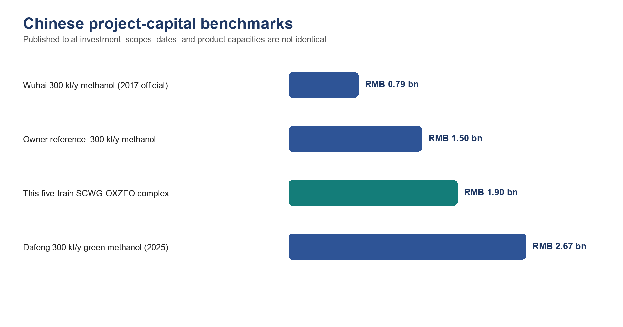
Figure 9.1. Chinese project-capital comparators. The owner benchmark is treated as a current commercial anchor; published projects show that feedstock route and scope can move a 300 kt/y methanol plant from below RMB 1 billion historically to above RMB 2.5 billion for a green route.
Table 9.3 - Benchmark reconciliation. Capacity and scope differences prevent direct RMB/t-y scaling.
Comparator | Investment | Capacity | Use in this report
Owner-supplied Inner Mongolia methanol plant | RMB 1.50 bn | 300 kt/y methanol | Primary owner anchor; scope/date to verify
Wuhai coke-gasification methanol project (2017) | RMB 0.786 bn | 300 kt/y methanol | Historical lower comparator; official Wuhai release
Dafeng green methanol project (2025) | RMB 2.67 bn | 300 kt/y methanol | Recent upper comparator for renewable route
Guizhou coal-to-polyolefin project (2018) | RMB 16.77 bn | 600 kt/y polyolefins | Full coal gasification-to-polymer scope; not a scale factor
This SCWG-OXZEO complex | RMB 1.90 bn | 19.33 kt/y olefins + waste service | Central China screening estimate

The user benchmark equals 5,000 RMB per annual tonne of methanol capacity. Applying that factor to 19.33 kt/y olefins would imply only RMB 97 million and would omit nearly every pressure, salt, gas-cleaning, residue, and utility system. Conversely, scaling the full coal-to-olefins project would import coal mines, oxygen, gasification, methanol, and polymerisation outside this boundary. The central RMB 1.90 billion estimate is therefore built area by area and then checked against the Chinese project range.

9.4 Central CAPEX estimate
Table 9.4 - China Class 4 capital estimate, five-train complex, 2026 RMB.
CAPEX area | RMB million | Share
B1 feed reception and slurry systems | 75 | 3.9%
B2 SCWG reactors, heaters, HP pumps | 420 | 22.1%
B3/B4 salt separation, letdown, water | 130 | 6.8%
B5 Rectisol, ZnO, sulfur recovery | 170 | 8.9%
B6 bi-reformer and heat recovery | 190 | 10.0%
B7 OXZEO, recycle, product separation | 230 | 12.1%
B8 residue washing and finishing | 100 | 5.3%
Utilities, offsites, land, buildings | 240 | 12.6%
EPCM and owner's cost | 140 | 7.4%
Process contingency | 185 | 9.7%
Start-up and working capital | 20 | 1.1%
TOTAL CAPITAL INVESTMENT | 1,900 | 100.0%

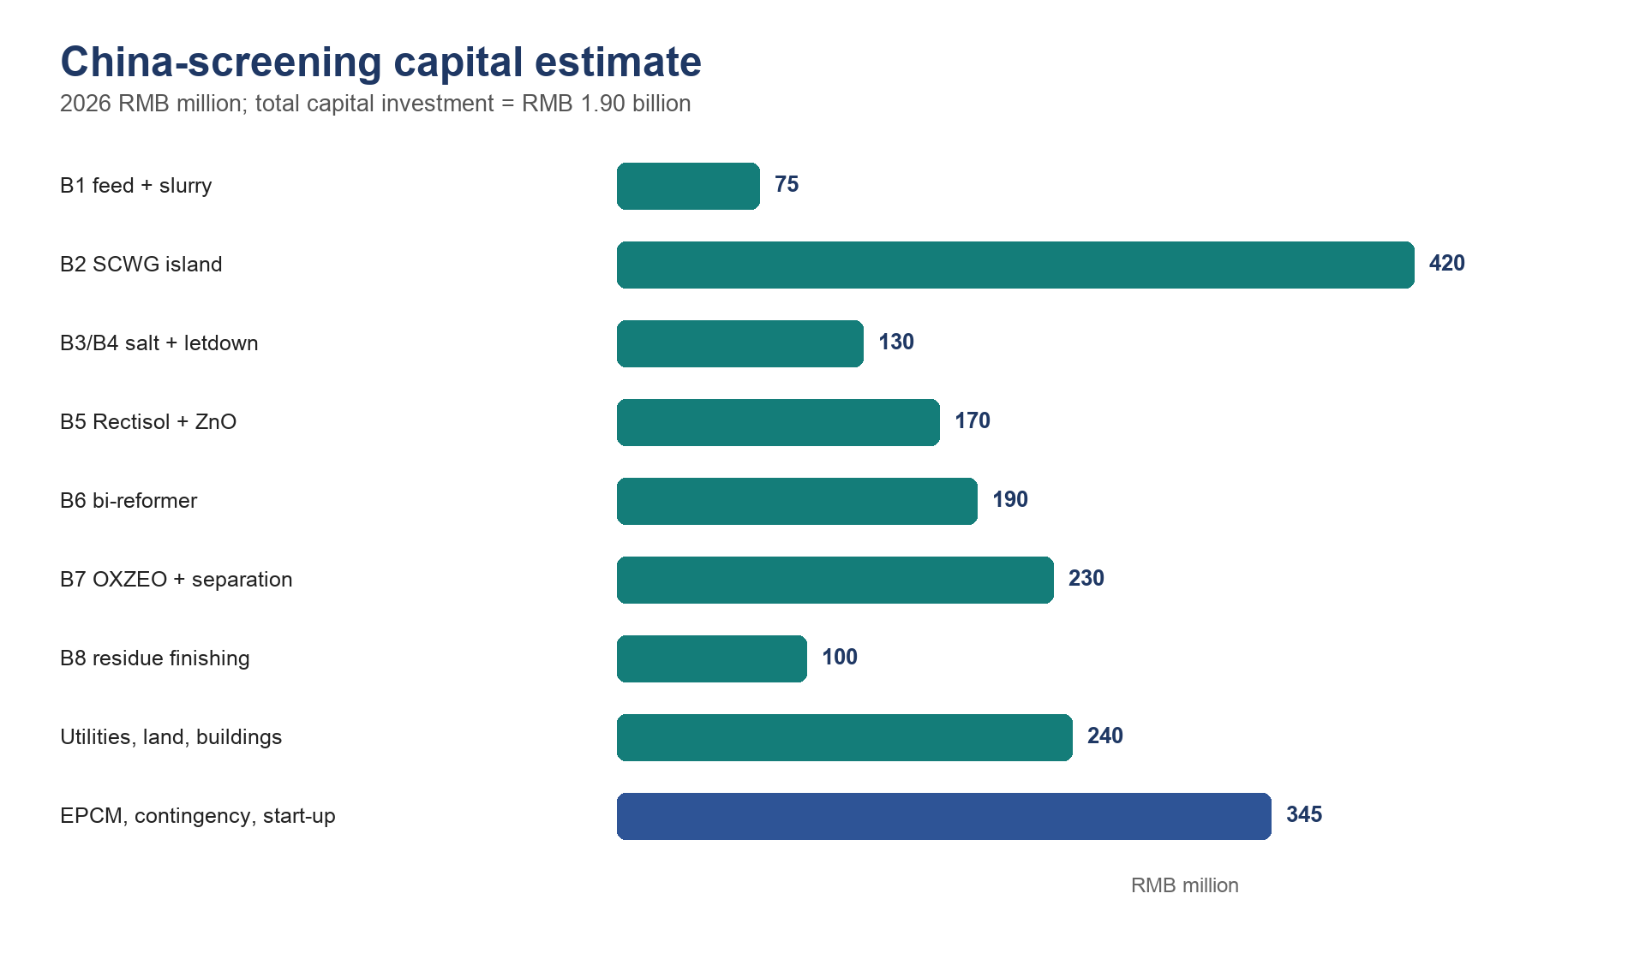
Figure 9.2. Capital distribution. The hydrothermal island is the largest process area; downstream gas conversion and shared utilities remain material despite the small product rate.
The Class 4 uncertainty range is approximately RMB 1.4-2.8 billion. The high-pressure hydrothermal and hot-salt systems receive the largest contingency because no mature commercial reference plant is available. The estimate excludes downstream polymerisation, financing during construction, recoverable VAT, and material foreign-exchange escalation. Imported catalyst or alloy packages must be quoted in RMB at the contracting stage.

9.5 Annual OPEX using Chinese rates
Table 9.5 - Annual China cash operating cost.
Cash OPEX | RMB million/y | Basis
Labour and plant support | 22.0 | Approx. 128 FTE; burdened China wage basis
Maintenance and turnarounds | 46.5 | 3.0% of direct installed plant
Electricity | 24.0 | 40 GWh/y at 0.60 RMB/kWh
Pipeline gas / purchased heat | 21.7 | 200,655 GJ/y equivalent
Catalysts, ZnO, methanol, treatment chemicals | 13.0 | Replacement and solvent-loss allowance
Feed logistics | 15.0 | Short-haul wet okara, straw, and red mud
Water, wastewater, residue handling | 8.0 | Industrial water plus analytical/disposal allowance
Insurance, administration, certification | 10.0 | Site and audit allowance
TOTAL CASH OPEX | 160.2 | RMB 8,287/t olefin or RMB 321/t slurry

Maintenance and labour are deliberately not reduced to match an overseas percentage model. Five pressure trains, salt separators, a methanol wash, fired reformer, synthesis loop, and solids finishing require continuous shifts and specialised inspection. Domestic labour is lower than in many imported estimates, but high-pressure alloys, catalysts, cold-box maintenance, and outage work remain globally traded technical costs.

9.6 Revenue and credits
Table 9.6 - Conservative base revenue and gate-fee assumptions.
Revenue / credit | Calculation | RMB million/y
Light olefins | 19,330.7 t/y x 6,800 RMB/t | 131.4
Wet okara gate fee | 416,250 t/y x 70 RMB/t | 29.1
Red-mud gate fee | 11,655 t/y x 160 RMB/t | 1.9
Qualified residue | 13,586 t/y x 120 RMB/t | 1.6
N-K-P-S concentrate | 2,497.5 t/y x 500 RMB/t | 1.2
Sulfur / minor products | Screening allowance | 0.2
Carbon credit / green premium | Excluded from base case | 0.0
TOTAL REVENUE AND CREDITS | Contract-dependent | 165.4

Gate fees are not commodity prices; they are negotiated waste-service contracts. The base okara fee of 70 RMB/t and red-mud fee of 160 RMB/t are screening assumptions with ranges in the sensitivity analysis. They must be tested against each supplier's actual disposal cost, competing animal-feed uses, moisture, transport distance, seasonality, and liability allocation. No revenue is recorded for scandium or carbon credits.

9.7 Base-case cash flow, NPV, and payback
Base EBITDA is 165.4 - 160.2 = RMB 5.2 million/y. At a 10% nominal pre-tax unlevered discount rate and 20 operating years, the annuity factor is 8.5136. NPV = -1,900 + 5.2 x 8.5136 = approximately -RMB 1.856 billion. There is no positive project IRR and simple payback is about 365 years. Even if total capital equalled the owner's RMB 1.5 billion methanol benchmark, base-case NPV would remain approximately -RMB 1.456 billion.
Table 9.7 - Explicit base-case economic evaluation.
Metric | Formula / convention | Base result
Revenue + credits | Table 9.6 | RMB 165.4 m/y
Cash OPEX | Table 9.5 | RMB 160.2 m/y
EBITDA | 165.4 - 160.2 | RMB 5.2 m/y
Pre-tax unlevered NPV | -1,900 + 5.2 x 8.5136 | -RMB 1.856 bn
IRR | Rate making 20-y NPV = 0 | No positive IRR
Simple payback | 1,900 / 5.2 | Approx. 365 y
NPV-zero EBITDA | 1,900 / 8.5136 | RMB 223.2 m/y

COMMERCIAL CONCLUSION: The plant is not financeable as a commodity-olefin project at the central yield. It must be contracted primarily as a waste-treatment and decarbonisation asset, obtain substantially higher gate fees and product premiums, reduce capital through piloting and domestic modularisation, or select a simpler product route.

9.8 Sensitivity and break-even conditions
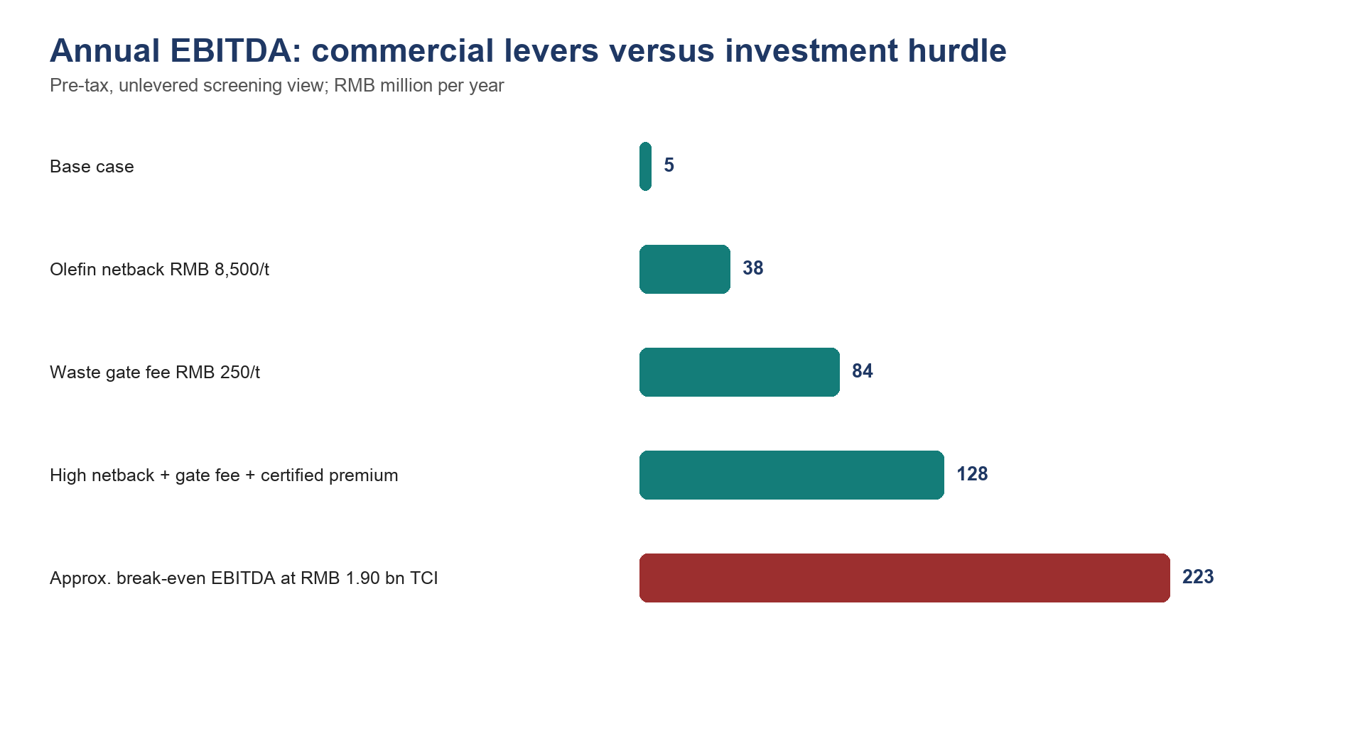
Figure 9.3. Commercial levers. Even strong single-variable improvements do not reach the approximate RMB 223 million/y EBITDA required to earn 10% on RMB 1.90 billion over 20 years.
Table 9.8 - Economic sensitivity ranges.
Variable | Low case | Base | High case | Economic interpretation
Light-olefin netback | 5,500 RMB/t | 6,800 | 8,500 | High case adds about RMB 33 m/y
Combined waste gate fee | 30 RMB/t | Weighted 70 | 350 | Largest controllable cash driver
Train availability | 70% | 91.3% | 92% | Affects products and variable cost; salt system decisive
Purchased energy | -20% | China base | +30% | Bi-reformer and Rectisol expose the project
Total capital | RMB 1.4 bn | RMB 1.9 bn | RMB 2.8 bn | Dominates NPV; not EBITDA
Residue value | Disposal cost | 120 RMB/t | 400 RMB/t | Requires end-of-waste and customer trial

With base product and by-product values, the additional EBITDA needed for NPV = 0 is approximately RMB 218 million/y. Spread over 441,225 t/y of incoming waste/red mud, this is roughly RMB 494/t above the base contract. The implied all-in average gate fee is therefore about RMB 565/t. Alternatively, holding gate fees at base, the required olefin netback exceeds RMB 18,000/t. Neither condition is a normal commodity case.

9.9 Scenario economics
Table 9.9 - Scenario economics. The upside is a decision case, not a forecast.
Scenario | TCI RMB bn | Revenue RMB m/y | OPEX RMB m/y | NPV at 10% | Interpretation
Conservative | 2.45 | 135 | 190 | -RMB 2.92 bn | Lower yield/netback; salt outages
China base | 1.90 | 165 | 160 | -RMB 1.86 bn | Not financeable
Contracted circular | 1.90 | 285 | 160 | -RMB 0.84 bn | High gate fee + premium still short
Owner-capex upside | 1.50 | 342 | 150 | +RMB 0.14 bn pre-tax | Requires 350 RMB/t gate fee, 8,500 RMB/t product, premium

The owner-capex upside produces a pre-tax unlevered IRR of roughly 11-12% before corporate income tax. China's statutory corporate income-tax rate is 25%, and a qualifying western-region or encouraged-industry rate cannot be assumed before legal confirmation. After tax, financing, ramp-up, and working capital, the upside margin narrows materially.

9.10 Comparison with the 300,000 t/y methanol benchmark
The methanol benchmark is useful for checking installed-plant order of magnitude but not for selecting capacity. The five-train feed contains approximately 39.46 kt/y carbon. Even if every carbon atom became methanol, the stoichiometric maximum is about 105 kt/y methanol; realistic conversion and purge would be lower. A 300 kt/y methanol plant therefore requires roughly three to five times the available carbon or a large external syngas feed.
At the July 2026 NBS methanol price of 2,423 RMB/t, 300 kt/y gross product revenue is about RMB 727 million/y before feedstock and utility costs. At the user benchmark of RMB 1.5 billion, the simple capital intensity is 5,000 RMB/(t/y). The present SCWG-OXZEO plant has a capital intensity near 98,000 RMB/(t/y) olefins because the wet-waste treatment capacity, not product capacity, sizes much of the plant. The comparison reinforces the commercial conclusion: the project must be paid for waste service and circular claims, not product mass alone.
A methanol alternative should nevertheless remain in the next stage. Replacing B7 OXZEO and deep olefin fractionation with a conventional methanol loop could lower technical risk and create a liquid product with easier storage, but it does not remove B1-B6, the methane round-trip, or the feed carbon limit. A renewable methane route is simpler still and should be compared on a common contracted-gate-fee basis.

10. Development programme, risk register, and conclusions

10.1 Stage-gated development programme
Table 10.1 - Stage-gated validation programme.
Gate | Scale / duration | Required evidence | Decision
G0 analytical closure | Composite feed campaign | Ultimate/proximate, rheology, C/N/S/Cl, XRF/XRD, feed contracts | Freeze representative design feed
G1 batch chemistry | Autoclave severity matrix | Carbon conversion, gas speciation, char, Na release, red-mud phases | Select B2 window
G2 pressurised feed/salt loop | 100-500 h | Pumpability, heater delta-P, salt underflow, wall deposition, flush recovery | Select B1/B3 equipment
G3 continuous hydrothermal pilot | 1-5 t/d; 1,000 h | Closed balances, availability, corrosion, water recycle, residue batches | Authorize integrated pilot
G4 gas train pilot | Real-gas slipstream; 1,000 h | Rectisol surrogate, ZnO life, reformer coke, H2/CO control | Freeze B5/B6
G5 OXZEO campaign | 2,000 h | Conversion, C2-C4 selectivity, heat removal, cycle life, sulfur challenge | Freeze B7/licensor
G6 demonstration | 30 t/d; contracted feeds | 7,000 h/y equivalent campaign, product qualification, auditable carbon data | Commercial FEED

10.2 Ranked project risk register
Table 10.2 - Ranked technical and commercial risks.
Rank | Risk | Failure mechanism | Retirement test
1 | Salt plugging | Na/K salts bridge B2/B3 and force shutdown | 1,000 h underflow/flush campaign with representative red mud
2 | Slurry reliability | Straw/red-mud settling, bridge, erode pumps | 25 MPa loop and hot feed-heater pressure-drop map
3 | Red-mud claim | Dealkalization or catalytic benefit insufficient | Factorial autoclave/continuous tests with Na leach and gas yields
4 | Reformer coking | Gas impurities and low steam/carbon deactivate Ni | 1,000 h real-gas slipstream carbon balance
5 | OXZEO durability | Sulfur, water, metals, coke, cycling alter selectivity | Guard-bed challenge and 2,000 h catalyst campaign
6 | Residue status | Product fails leach or performance specification | Independent qualification and offtake trial
7 | Materials | Chloride/sulfide stress corrosion or erosion | Long-duration welded coupons and erosion testing
8 | Economics | Gate fees/premium unavailable; capital exceeds anchor | Binding supplier/offtake terms and vendor-budget quotes

10.3 Minimum data package before commercial FEED
- Twelve months of supplier mass, moisture, spoilage, composition, and logistics records for each okara/red-mud source.
- A closed 1,000 h continuous hydrothermal mass, carbon, nitrogen, sulfur, sodium, and water balance at the selected solids loading.
- Salt-separator availability, underflow recovery, flush duration, wall-deposit mass, and corrosion/erosion measurements.
- Real-gas Rectisol/MDEA simulation, sulfur breakthrough curve, ZnO loading, and reformer carbon balance.
- OXZEO product slate and cycle life on cleaned real reformer gas, including sulfur/water upset response.
- Independent residue leach/performance qualification and customer trial; no assumed fertilizer or scandium revenue.
- Chinese vendor budget quotations for B1-B8, utility tie-ins, land, construction, and a schedule-based contingency estimate.
- Binding gate-fee, feed-supply, product-offtake, and certification clauses sufficient to support project finance.

10.4 Final conclusions
The source concept is chemically coherent after three conflicts are resolved explicitly. Salt removal must be a primary product operation; acid gas removal and ZnO must protect the synthesis catalyst; and bi-reforming must supply the CO that hydrothermal equilibrium removes. Red mud can provide catalytic and dealkalization value, but B8 should not be sold as oxygen-carrier regeneration without phase and equilibrium evidence.
The engineering model closes. One train processes 300.00 t/d slurry at 19.07 wt% solids, contains 50.20 t/d biomass dry matter, and produces a central 11.61 t/d light-olefin stream. Total mass and 23.70 t C/d feed carbon close at 100%. Five trains process 499,500 t/y slurry and make approximately 19,331 t/y olefins. H-101 recovers 637 GJ/d per train; net purchased energy is 207 GJ/d per train after reformer/OXZEO recovery and purge-fuel credit.
The China-specific economics are not attractive on commodity product value. Central total capital is RMB 1.90 billion, annual cash OPEX is RMB 160.2 million, and base revenue plus gate-fee credits is RMB 165.4 million. Pre-tax unlevered NPV at 10% over 20 years is approximately -RMB 1.86 billion. The user-supplied RMB 1.5 billion methanol benchmark is a reasonable order-of-magnitude anchor, but it produces fifteen times more product and does not include this project's five high-pressure wet-waste trains and mineral circuit.
The project can advance only as a contracted circular-economy service: gate fees, certified premiums, capital support, and residue qualification must carry most of the value. The next expenditure should be a continuous salt-tolerant pilot and binding commercial term sheets, not a larger spreadsheet. If those results are weak, renewable methane or methanol should replace OXZEO before commercial FEED.
RECOMMENDATION: Proceed to a 1-5 t/d continuous hydrothermal pilot and parallel Chinese vendor-budget study. Do not authorize commercial FEED until salt-separator availability, full carbon balance, real-gas catalyst life, residue qualification, and contracted gate-fee/offtake economics have all passed their stage gates.

References
1. Marrone, P. A., Hodes, M., Smith, K. A. & Tester, J. W. (2004). Salt precipitation and scale control in supercritical water oxidation - Part B. Journal of Supercritical Fluids 29, 289-312. https://doi.org/10.1016/S0896-8446(03)00092-5
2. Hodes, M., Marrone, P. A., Hong, G. T., Smith, K. A. & Tester, J. W. (2004). Salt precipitation and scale control in supercritical water oxidation - Part A. Journal of Supercritical Fluids. https://www.sciencedirect.com/science/article/abs/pii/S0896844603000937
3. Wang, P. & Liu, D.-Y. (2012). Physical and chemical properties of sintering red mud and Bayer red mud. Materials 5, 1800-1810. https://doi.org/10.3390/ma5101800
4. Li, B., Qiao, M. & Lu, F. (2012). Composition, nutrition, and utilization of okara. Food Reviews International.
5. Okolie, J. A. et al. (2021). Catalytic supercritical water gasification of soybean straw. Industrial & Engineering Chemistry Research 60, 5770-5782. https://doi.org/10.1021/acs.iecr.0c06177
6. Schubert, M., Regler, J. W. & Vogel, F. (2010). A novel reactor design for preventing salt deposition in supercritical water. Chemical Engineering Research and Design.
7. Wang, X. et al. (2023). Red mud with enhanced dealkalization performance by supercritical water technology for efficient SO2 capture. Journal of Environmental Management.
8. Kumar, N., Shojaee, M. & Spivey, J. J. (2015). Catalytic bi-reforming of methane. Current Opinion in Chemical Engineering. https://doi.org/10.1016/j.coche.2015.07.003
9. ZnOx overlayer confined on ZnCr2O4 spinel for direct syngas conversion to light olefins (2025). Nature Communications 16, 3711. https://doi.org/10.1038/s41467-025-58951-8
10. Unraveling the mechanisms of ketene generation and transformation in syngas-to-olefin conversion over ZnCrOx/SAPO-34 catalysts (2025). Chemical Science.
11. Bandura, A. V. & Lvov, S. N. (2006). The ionization constant of water over wide ranges of temperature and density. Journal of Physical and Chemical Reference Data.
12. ISO. ISO 14067:2018 - Greenhouse gases - Carbon footprint of products. Confirmed current in 2024. https://www.iso.org/standard/71206.html
13. ISCC System. Mass-balance requirements and ISCC PLUS 203-2 transition. https://contact.iscc-system.org/support/solutions/articles/103000349237-where-do-i-find-information-on-the-requirements-related-to-mass-balance-
14. European Commission. CBAM definitive regime from 1 January 2026. https://taxation-customs.ec.europa.eu/carbon-border-adjustment-mechanism/cbam-definitive-regime_en
15. Ministry of Ecology and Environment, China. 2025 national carbon-market operation: allowance average 62.36 RMB/tCO2 and CCER average 70.76 RMB/tCO2. https://www.mee.gov.cn/ywgz/ydqhbh/wsqtkz/202601/t20260101_1139528.shtml
16. National Bureau of Statistics, China. Market prices of important means of production in circulation, early July 2026. https://www.stats.gov.cn/sj/zxfbhjd/202607/t20260713_1964100.html
17. National Bureau of Statistics, China. Average annual wages of employees in urban units in 2025. https://www.stats.gov.cn/sj/zxfbhjd/202605/t20260515_1963707.html
18. Guangxi investment project guide. Published industrial electricity 0.60 RMB/kWh, gas 3.86 RMB/Nm3, and water 3.68 RMB/m3. https://tzcjj.gxzf.gov.cn/gzdt/P020240402426792897646.pdf
19. Qinzhou investment guide. Industrial water and Guangxi transmission-price references. https://tzcjj.gxzf.gov.cn/gzdt/P020240918318427841445.pdf
20. Wuhai Development and Reform Commission (2017). 300 kt/y methanol project, RMB 786.12 million investment. https://fgw.wuhai.gov.cn/fgw/507572/507579/619439/index.html
21. Yancheng Municipal Government (2025). Dafeng 300 kt/y green methanol project, RMB 2.67 billion. https://www.yancheng.gov.cn/art/2025/9/22/art_34234_4368196.html
22. Guizhou Development and Reform Commission (2018). 600 kt/y coal-to-polyolefin project, RMB 16.77 billion. https://fgw.guizhou.gov.cn/fggz/ywdt/201807/t20180728_62004060.html
23. National Development and Reform Commission. Financial benchmark returns for construction projects. https://www.ndrc.gov.cn/fggz/gdzctz/tzfg/201907/W020191104862129391071.pdf
24. China Foreign Exchange Trade System (20 July 2026). LPR: 3.0% one-year and 3.5% over five years. https://www.chinamoney.com.cn/chinese/rdgz/20260720/3379021.html
25. Ministry of Finance, China. Enterprise Income Tax Law: statutory rate 25%. https://jgxt.mof.gov.cn/webfile/flfg/2019-07-25/40.html
26. Curtis Lee. Co-Valorization of Bauxite Residue and Soybean Processing Waste via Supercritical Water Gasification. Interactive siting map. https://www.curtis-lee.com/projects/supercritical-water-gasification
27. US Patent 4,321,242 and US Patent 4,686,090. Calcium-oxide desulfurization and hot-water regeneration teachings.
28. Wang, W., Ye, Z. & Bjerle, I. (1996). Kinetics of hydrogen chloride reaction with fresh and spent Ca-based sorbents. Fuel 75, 207-212. https://doi.org/10.1016/0016-2361(95)00242-1

Appendix A - Detailed stream and balance audit
Table A.1 - Reproducible headline calculations.
Output | Input values | Calculation | Result
Total solids | 43.0 + 7.2 + 7.0 | Sum | 57.20 t/d
Slurry solids | 57.20 / 300.00 | Mass fraction | 19.07 wt%
Biomass dry matter | 43.0 + 7.2 | Sum | 50.20 t/d
Feed carbon | Assumed ultimate analyses | Dry-feed carbon | 23.70 t C/d
Olefin carbon efficiency | 9.95 / 23.70 | Ratio | 41.98%
Olefin product | 9.95 / 0.857 | Average HC carbon fraction | 11.61 t/d
Annual olefins | 11.61 x 5 x 333 | Five trains | 19,330.7 t/y
Gross sensible heat | 300,000 x 4.42 x 600 / 1e6 | m Cp delta-T | 795.6 GJ/d
H-101 recovery | 795.6 x 0.80 | Effectiveness | 636.5 GJ/d
Purchased energy | 1,049 - 637 - 130 - 75 | Energy credits | 207 GJ/d
Base EBITDA | 165.4 - 160.2 | Revenue less OPEX | RMB 5.2 m/y
20-y annuity factor | (1-(1+0.10)^-20)/0.10 | Real discounting | 8.5136
Base NPV | -1,900 + 5.2 x 8.5136 | Pre-tax unlevered | -RMB 1,855.7 m

Appendix B - China economic assumptions
Table B.1 - Economic assumption register.
Assumption | Base | Range / treatment
Operating hours | 8,000 h/y | 6,100-8,060 h/y
Project life | 20 y | 15-25 y
Discount rate | 10% nominal pre-tax | 8-15%; project hurdle, not LPR
Corporate income tax | 25% statutory | Excluded from base pre-tax NPV
Olefin netback | 6,800 RMB/t | 5,500-8,500 RMB/t
Gate fees | 70 okara / 160 red mud RMB/t | Contract range 30-350 RMB/t
Electricity | 0.60 RMB/kWh | 0.50-0.75
Industrial gas | 3.86 RMB/Nm3 | 3.0-4.5
TCI | RMB 1.90 bn | Class 4: approx. RMB 1.4-2.8 bn
Carbon credit | Excluded | Only after eligibility, title, verification
Scandium revenue | Excluded | Only after assay/recovery/offtake
Residue value | 120 RMB/t | Disposal cost to 400 RMB/t qualified product

Appendix C - Equipment list and calculation basis
Table C.1 - Preliminary equipment list.
Tag / area | Service | Quantity | Screening size / duty | FEED retirement item
T-101A/B | Okara receiving | 2 per train | 12 h normal / 24 h contingency | Supplier schedule and rheology
P-101A/B | HP slurry pumps | 2 x 100%/train | 12.5 t/h, 25 MPa | Vendor pump-loop test
R-201 | SCWG reactor | 1/train | 1.74 m3 active; 2.3 m3 gross | Hot density, CFD, heat flux
V-301A/B | Salt separators | 2 x 100%/train | Approx. 10 m3 gross each | Underflow/flush campaign
H-101A/B | Feed/effluent exchanger | 2 modules/train | 7.37 MW recovery | Dirty-service U/fouling
V-401 | Three-phase separation | 1/train | Gas/water/solid split | Flash/property simulation
B5 | Rectisol + ZnO | Shared | Five-train gas rate | Licensed package quotation
R-601 | Bi-reformer | Shared modules | 150 GJ/d/train equivalent | Real-gas coking test
R-701 | OXZEO reactor | Shared multibed | 11.61 t/d/train product basis | 2,000 h catalyst campaign
B8/R1 | Residue wash/finish/recycle | Shared | 8.16 t/d residue/train | Product and recycle campaigns

Appendix D - Assumption and validation register
Table D.1 - Assumptions that must be retired before investment-grade FEED.
ID | Assumption | Base value | Owner / retirement method
A01 | Wet okara moisture | 82.8 wt% | Composite sampling; overrun Karl Fischer
A02 | Straw moisture | 10 wt% | Every delivery lot
A03 | Slurry solids | 19.07 wt% | Mass balance + online density
A04 | SCWG T/P | 625 C / 25 MPa | Continuous pilot severity sweep
A05 | Residence time | 60 s | Tracer + carbon campaign
A06 | Hot density | 120 kg/m3 | Property package + PVT/pilot data
A07 | H-101 effectiveness | 80% | Dirty-service heat/fouling test
A08 | OXZEO CO conversion | 45% | Real-gas catalyst pilot
A09 | OXZEO olefin selectivity | 70% | Real-gas catalyst pilot
A10 | Overall olefin-carbon efficiency | 42% | Integrated continuous carbon balance
A11 | Availability | 8,000 h/y | Demonstration run history
A12 | Central TCI | RMB 1.90 bn | Chinese vendor quotations + site estimate
A13 | Gate fees | RMB 31.0 m/y | Binding supplier terms
A14 | Residue product value | RMB 1.6 m/y | Independent qualification + offtake
A15 | Carbon credit | Zero | Approved method + registration + verified title

