Steam Valve Controller
  - Project Plan
F10-19
Client: Iowa State University
Advisors: Lee Harker
Jason Boyd
Team Leader: Ben Cao
Communication Liaison: Benjamin Jusufovic
Web Master: Curtis Mayberry
System Engineer: Thinh Luong
  - 10/14/2010
Table of Contents
List of Figures 3
Executive Summary 6
Acknowledgement 6
Problem statement 7
Operating Environment 8
Intended User(s) and Intended Use(s) 8
Assumptions and Limitations 9
Assumptions: 9
Limitations: 9
Market Research 10
Honeywell Radiator Thermostat 10
Market Considerations 10
Summary 11
Expected End Product and Other Deliverables 11
Controller Box 11
Control Panel 12
Project Design Documentation 12
Proposed Approach 12
Functional Requirements 14
Non-Functional Requirements 15
Constraint Considerations 15
Technology and Technical approach Considerations 15
Testing requirements considerations 22
Security considerations 24
Safety considerations 24
Intellectual property considerations 25
Commercialization considerations 26
Possible risks and risk management 26
Project proposed milestones and evaluation criteria 26
Project tracking procedures 28
Statement of Work 28
Estimated Resource Requirements 38
Personnel Effort Requirements 38
Other Resource Requirements 39
Financial Requirements 41
Schedule 41
Project Team Information 41
Client Information 42
Student Team Information 42
Closing Summary 42
References 43
Appendix A 44
Equipment 44
Procedure 44
Results 45
Appendix B 46
Gantt Chart 46
48

List of Figures
Figure 1: System Level Design 13
Figure 2: High Level Design of the Controller Box 13
Figure 3: High level Design of the Control Panel 14
Figure 4: Xbee Wireless Transceiver 15
Figure 5: LCD Display 16
Figure 6: Electric Motor Advantages and Disadvantages 18
Figure 7: Logic Levels for Electric Motor Communication 19
Figure 8: Electric Motor Summary 19
Figure 9: Motor Driver Circuit Summary 20
Figure 10: PID Control Algorithm 21
Figure 11: Personnel Requirements 39
Figure 12: Other Required Resources 39
Figure 13: Controller Box Budget 40
Figure 14: Control Panel Budget 40
Figure 15: Estimated Project Costs 41
Figure 16: Client Information 42
Figure 17: Team Information 42

List of Definitions
Alternating current (AC) (hardware) - The movement of electric charge periodically reverses direction.
Analog-to-digital converter (ADC) (hardware) - A device that converts a continuous quantity to a discrete digital number.
Complementary metal-oxide-semiconductor (CMOS) (hardware) - A technology for constructing integrated circuits.
Controller Box (hardware) - A module that holds all the electrical components that rotates the steam valve.
Direct current (DC) (hardware) - The unidirectional flow of electric charge.
Emitter-coupled logic (ECL) (hardware) - A logic family that achieves high speed by using an overdriven BJT differential amplifier with single-ended input.
Ethernet (hardware) - A family of frame-based computer networking technologies for local area networks (LANs).
General Purpose Input/Output (GPIO) (hardware) - An interface available on some devices to interface with external devices and peripherals.
IEEE 802.15.4 (hardware and software) - A wireless communication standard under the IEEE 802.15 standards for Wireless Personal Area Networks, currently used as a medium for a wide variety of network protocols including Zigbee.
Liquid crystal display (LCD) (hardware) - A thin, flat electronic visual display that uses the light modulating properties of liquid crystals.
Plant (hardware) - The steam valve.
Printed Circuit Board (PCB) (hardware) - Used to mechanically support and electrically connect electronic components using conductive pathways, tracks or signal traces.
Proportional–integral–derivative controller (PID controller) (hardware) - A generic control loop feedback mechanism (controller) widely used in industrial control systems.
Serial Peripheral Interface Bus (SPI) (hardware and software) - A synchronous serial data link standard named by Motorola that operates in full duplex mode.
Transceiver (hardware) - A device that has both a transmitter and a receiver combined and share common circuitry or a single housing.
Transistor–transistor logic (TTL) (hardware) - A class of digital circuits built from bipolar junction transistors (BJT) and resistors.
Universal asynchronous/synchronous receiver/transmitter (UART/USART) (hardware) - A type of "asynchronous receiver/transmitter", a piece of computer hardware that translates data between parallel and serial forms.
User Interface (hardware and software) - synonymous with Control Panel.

Executive Summary
Iowa State University buildings built prior to the late 1960’s utilize steam valves and radiators to heat rooms. These heating systems link multiple rooms through steam pipes and consist of a single valve that controls the temperature heat output through radiators within each room. The user does not have knowledge of the magnitude of revolutions needed to accommodate a desired temperature within the room and causes over and under heating throughout the rooms. Since these heat systems consist of physical controls, Facilities Planning and Management does not have remote access to the system in order to regulate temperature in times of little to no occupancy. As a result, significant energy is lost during campus night hours and school breaks, consequently increasing energy bills.
In order to solve these issues, our group has proposed to perform a system level integration in which we will design a steam valve controller unit and a user interface unit. The steam valve controller unit will consist of a DC motor - used to rotate the steam valve, a microcontroller - used to run the control algorithm, a wireless transceiver - used to communicate to the user interface, and Ethernet connectivity – used to connect to the Iowa State network. The user interface will consist of a LCD display – human machine interface, push buttons – used to receive user input, a temperature sensor – used to record the room temperature, a wireless transceiver - used to communicate to the steam valve controller, and a microcontroller - used to control the user interface unit. Through design, we will integrate these components into an efficient temperature control system.
The end product will consist of two units: the user interface and the steam valve controller. The user interface will be a wall mountable unit similar to a thermostat. It will prompt for and accept temperature values from users. The unit will also be used as a means of sensing and recording current room temperature. It will communicate the current room temperature and user input temperature values to the steam valve controller unit. The controller unit will resemble a box structure and will be situated on top of the steam valve. It will run an algorithm based on received temperature values and adjust the steam valve appropriately through the DC motor. This system will allow user friendly temperature control and monitoring.
The only major issue that the group foresees is a shortened project deadline. Our product will be used throughout winter. Unfortunately, this is the only time that steam heat will be available. This means that our final prototype must be ready before the end of winter in order to finish final testing and assure that the product works as expected. Our group will have to put in extra effort in order to accommodate this change in schedule.

Acknowledgement
Our team would like to thank Lee Harker and Jason Boyd for their contributions to the project. Not only are they our clients, but they also serve as valuable resources throughout the project. Instead of just providing our team with just a description of the project, they have been proactively working with us to adapt the project to meet their needs and ensure the highest chance of success.
We are thankful for the opportunity to work with such enthusiastic advisors like Lee and Jason, and acknowledge all their contributions to the project.

Problem statement
Buildings at Iowa State University built prior to the late 1960’s utilize steam valves and radiators to heat rooms. The controls of these heating systems consist of steam pipes and simple knobs that allow the user to adjust the flow of steam through the radiator, thus adjusting the temperature.
It is common for one steam valve to control temperature throughout several different rooms. The problem arises from the heat gradient between these rooms, created when the steam valve is adjusted too high or too low. The user does not have knowledge of the magnitude of revolutions needed to accommodate a desired temperature within the various rooms. In result, the user must constantly adjust the valve in order to accommodate a desired temperature, leading to over and under heating of the system of rooms.
Since these valves are spread across remote areas of buildings and consist only of physical controls, Facilities Planning and Management have no control over temperature ranges during times of little to no occupancy of rooms. In result, significant energy is lost during campus night hours and school breaks, consequently increasing energy bills.
Coover, the electrical and computer engineering building, utilizes this steam system. Within Coover, radiators are used to heat a multitude of adjacent rooms and steam valves are used to control temperature. In extreme cases, one steam valve controls the temperature in five different rooms through five radiators. This creates a temperature gradient across the rooms and requires continuous adjustment of the steam valve in order to accommodate the individuals within each room.
The steam pipes run along one side of the room’s perimeter, sit approximately a foot off of the ground, and are routed through walls, floors, and ceilings. There exists only one steam valve control for a number of adjacent rooms. From this constraint, it is evident that there will need to be a unit placed on the valve that adjusts the valve to control the temperature in the system of rooms. Since this unit will control temperature conditions in several rooms, a device will be needed in each room that will sense each of the temperatures. The piping route through walls, floors, and ceilings restricts wired communication between temperature sensors and creates a need for a wireless communication between sensor units and the steam valve controller unit.
The most important mechanism of the project is the user interface that allows the user to control the temperature within each room. Since several rooms are governed by one steam valve and multiple individual users, a user interface will be required in each room. In that respect, the steam valve controller will accommodate an averaged input temperature. Because the pipes are low to the ground and are in remote areas, the user interface will be a separate unit from the steam valve controller. Remote override access into the system and temperature control will be provided for Facilities Planning and Management because they will be in charge of controlling room temperature throughout Coover.
Our group has formulated a general solution approach to this problem. In order to rotate the valve, we will utilize a DC motor. The motor will be connected to control circuitry that will run an algorithm based on the temperature in the various rooms and force the valve to adjust appropriately. The control circuitry will utilize wireless communication schemes in order to communicate back and forth between the temperature sensors. The controller unit - DC motor and control circuitry- will need to draw a lot of power in order to turn the valve and will therefore will require an outlet plug in. In order to provide Facilities Planning and Management with override access to set and control temperature, we will integrate an Ethernet port into the steam valve controller unit with access to the Iowa State University network.
In order to receive desired temperature inputs from users, we will utilize a separate user interface wall mountable unit. This unit will consist of a backlit LCD display and several push buttons that allow users to access menus and set desired options. Integrated into this unit will be a temperature sensor that will read the current room temperature and communicate this information to the steam valve controller unit. Another feature integrated into the user interface is a small speaker that will sound when an error or hardware malfunction occurs. Since this is a low power unit and highly digital unit, it will run off of regular AA batteries.

Operating Environment
The end product consists of two different units that will operate in two different environments. These two products will operate in offices and classrooms throughout Coover and ideally throughout various buildings at Iowa State University. The user interface will regularly operate at room temperature and will occasionally experience temperatures ranging from 50 degrees Fahrenheit to 90 degrees Fahrenheit. The unit will be situated on the wall via a mounting device and may experience a drop upon installation or an occasional bump from a passerby. It will be exposed to mildly dusty conditions and operate in an open environment. The unit will experience various forms of humidity and sunshine but will be sheltered from the weather elements such as rain and snow. Because it will be located in a busy environment, it will experience everyday use.
The controller box will be situated directly on top of the steam valve and will thus operate at temperatures ranging from 50 degrees Fahrenheit to 120 degrees Fahrenheit. It will constantly be exposed to highly dusty conditions and will operate in open environments and tight spaces. The unit will experience various forms of humidity and sunshine but will be sheltered from the weather elements such as rain and snow. It may experience the occasional bumps from nearby objects. Because the controller has to maintain the desired temperature, it will experience continuous use.

Intended User(s) and Intended Use(s)
Intended users of our product, the user interface unit, will be Iowa State University students and faculty members. The users will be young adults – early to late twenties, of various sizes, both male and female, and will have a college education. The majority of use will come from students and professors. They will be tired from work and studies and therefore require a simple, easy to use interface. These individuals will come from varying ethnic backgrounds; therefore reducing the amount of text based commands will benefit usability.
The end product is expected to be used as a means of controlling the temperature to an appropriate level across various rooms by the individuals within them as well as Facilities Planning and Management during times of low to little occupancy. The product is used to help cut heat cost when individuals are not present and maintain a constant temperature when individuals are present. Through implementation, the end product eliminates the possibility of one individual dictating the temperature across various rooms and removes ambiguity from temperature setting. It also gives Facilities Planning and Management the power to set and regulate temperature across various rooms in which they have no current control over.

Assumptions and Limitations

Assumptions:
- Iowa State University students and faculty will use this product.
- This product will not be used outside of the United States.
- This product will be used indoors.
- Users of various ethnic backgrounds, age groups, and genders will use this product.
- This product will be used in rooms of varying sizes, sunlight exposure, and temperature sensitivities.
- The maximum number of simultaneous users for the product will be five.

Limitations:
- The end product will have to communicate wirelessly between components.
- The end product has to have Ethernet connectivity.
- Our group has limited experience with mechanical implementation – product casing and situating.
- Temperature gradient across rooms will cause constant temperature offset.
- There exists only one valve for various rooms.
- Financial budget.
- Plant restrictions (volume of steam/heat output).
- Conflicting Temperature Preferences.
- Part’s lead time.
- The controller box must be able to operate on 60 Hz 120 V.
- The user interface must be operable using standard AA batteries.
- Both units must withstand dust accumulation.
- The end product needs to be completed prior to May 2011.
- Prototype testing must occur during the winter months.

Market Research
Iowa State University buildings constructed prior to the late 1960’s share a unique heat system design. These buildings require heat steam valve controller units in order to regulate temperatures and create an energy efficient system. Currently, the impact of the project is limited to Coover, the electronic and computer engineering building. However, there are definite opportunities for implementation at the campus level throughout Iowa State University. During our market research analysis, we found one product from Honeywell that provides some of the services we are trying to achieve with the steam valve controller project.

Honeywell Radiator Thermostat
The Honeywell Thera-EL (T850) radiator thermostat includes a valve controller unit and a wired user interface that meets a fraction of our client’s needs. The unit is capable of rotating the valve. However, the unit cannot communicate with multiple user interfaces and has not Ethernet capability for connection to the Iowa State University network. This unit was the only product encompassing a fraction of services that our project is aiming to provide. Our product provides higher value and more flexibility in meeting the EcpE department's needs. By employing our group, the EcpE department has the power to tailor the features and specifications of the end product and does not have to limit itself to an existing product of similar cost.

Market Considerations
Iowa State University buildings constructed prior to the late 1960’s share a unique heat system design. Clients external to Iowa State University may have different HVAC implementations, making it hard for a single product to meet a broad spectrum of needs. In order to consider the market value of our product, we need to understand how the design, test, and implementation can fit a broad range of client needs. We can do this by designing a robust product with a wireless communication interface that will allow for various controller implementations. In result, we are not restricted by obstructions or distance to the controller unit.
In the current HVAC market, we face powerhouse competitors like Honeywell and Johnson Controls. Both Honeywell and Johnson Controls provide expertise regarding steam valve controller implementation and offer numerous HVAC control products. These companies would likely have design, testing, and implementation approaches analogous to the approaches set in part by our team. However, they have a larger resource pool but we have proximity and constant client contact. When we evaluate our products and services for the HVAC market, we must keep in mind that we are competing with powerhouses such as Honeywell and Johnson Controls. They have the expertise and the resources to improve or upgrade the steam valve system. Nevertheless, our group offers an extremely low labor cost and total product design flexibility.
Companies like Honeywell and Johnson Controls will charge premiums for their services because of their expertise and resources. However, some clients are financially constrained, but still need to improve their HVAC system. This gives our group an advantage. If we demonstrate our ability to design, test, and implement a steam valve controller that meets clients' requirements at a lower cost, we can win their businesses.

Summary
In summary, there is a market for our products and services as clients seek to improve their HVAC systems. We would be competing with established companies, Honeywell and Johnson Controls, but we would be able to offer our services at a lower cost and full design flexibility. Our lack of experience and brand name will limit our business in the short term, but our low cost solutions and client relations will help us overcome these obstacles.

Expected End Product and Other Deliverables
Prior to the end of the project in April 2011, our team will deliver one controller box, one control panel, and project design documentation.

Controller Box
The controller box will include the metal platform, the mechanical components, microcontroller, the PCB housing all the electronics, the transceiver, the Ethernet module, and the power supply. The controller box will be designed to fit and securely about the steam valve. There will be a metal bar connecting the DC motor to the steam valve allowing it to turn clockwise and counterclockwise.
The controller box will use a power supply fed by the wall electrical outlet to supply power to the controller box. The PCB board within the controller holds all the major electronics. The transceiver will allow wireless communication between the controller box and control panels. The controller box will use the transceiver to receive information on temperature set point and room temperature measurement.
The Ethernet module will allow communication through the ISU network. The microcontroller will control all the modules on the PCB board. The microcontroller will send and receive information through the Ethernet connection to remotely configure the controller box. Our clients will have a web interface to view and configure the controller box through the Ethernet connection. Lastly, the controller box will have a buzzer that will sound in case the unit malfunctions.

Control Panel
The control panel will include an LCD display, push buttons, microcontroller, temperature sensor, buzzer, transceiver, and two AA batteries. There will be an on board microcontroller that will handle the LCD, temperature sensor, buzzer, and transceiver. The LCD display will output current temperature of the room and the desired temperature set by the user.
The microcontroller will send the user's input data and the temperature sensor's readings to the transceiver which in turn will send that wirelessly to the controller box located on top of the steam valve. The control panel will have a buzzer that will sound in case of malfunction. The control panel will be modularized and multiple control panels can communicate to a single controller box. The range of the control panel to the controller box will be limited by the transceiver. Our clients want the range to be around 300 meters indoors. The two AA batteries will power the control panel. Lastly, the control panel will have an outer casing that allows it to be convenient attached to the wall.

Project Design Documentation
The project design documentation will allow our clients to review the components used in our design. The documentation allows our clients to troubleshoot, repair, and maintain the operations of the steam valve controller in the future. We will include a user guide on how to access and control the steam valve controller box through the ISU network. Overall, the project design documentation will formalize and prepare the project to be handed over to our clients.

Proposed Approach
The nature of the project is of integrating a variety of components together to create a system that will accomplish our functional and non-functional requirements. The overall design of the system, shown in figure 1, gives an overview of how each sub-system contributes to meeting the requirements of the system. Our project consists of two basic sub-systems, the controller box and the control panel, outlined in figures 2 and 3 respectively. Each of these sub-systems has a number of components which have their own selection and design considerations.
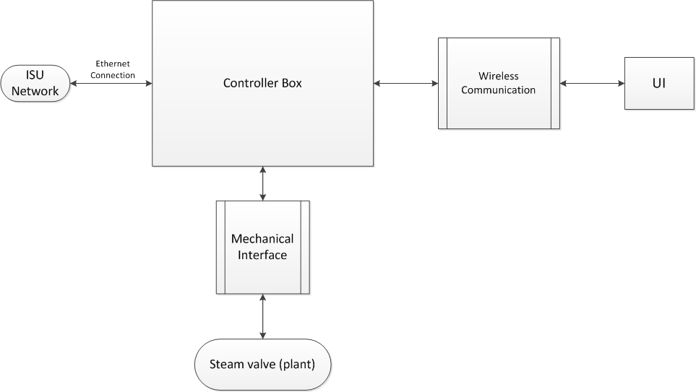
Figure 1: System Level Design
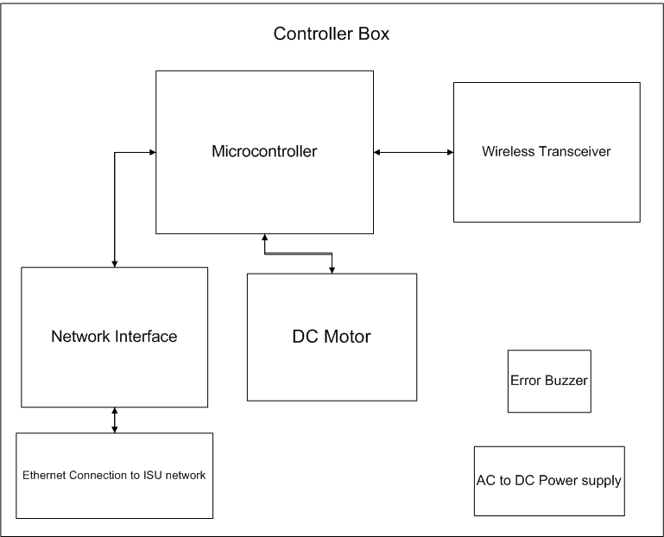
Figure 2: High Level Design of the Controller Box
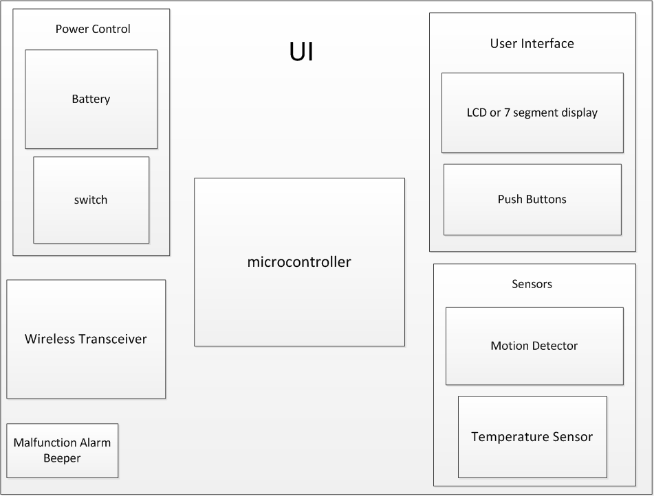
Figure 3: High level Design of the Control Panel

Functional Requirements
The project has functional requirements that revolve around the product’s intended use as a thermostat. It has to imitate many of the capabilities of a modern heating system while utilizing existing heating methods. The functional requirements of the product include:
- Effectively control the temperature in the room: The most important functional requirement is that the controller must be able to effectively control the temperature by adjusting the attached steam valve appropriately.
- Take occupant’s preferences: The unit must have a user interface that allows the occupant to specify a temperature preference.
- Multiple room control: There are often multiple rooms that have their temperature regulated by a single steam valve. The product should be able to take preferences from each occupant to try and find the best possible valve setting.
- External control: The facilities and maintenance personal need to have a method to set limits on the temperature control.
- Removable mechanical interface: The mechanical interface to the valve must be able to be easily removed. To avoid plumbing complications and to simplify installation and removal the unit must interface with the current valve knob with minimal alterations to existing infrastructure.
- Network interface: The unit will have a network interface that will be able to communicate over the internet. The interface shall be able to configure the controller from a remote computer terminal.

Non-Functional Requirements
We did not receive non-functional requirements from our client. From experience with HVAC controllers, our group has a fundamental understanding of product usability and the importance of aesthetics in a successful product. With this in mind, our group has drafted non-functional requirements that will allow us to design a successful product. The portion that we will consider is the user interface unit. The following lists these requirements in no particular order:
- Large LCD in order to improve visibility for users.
- Graphical based LCD in order to ease usability and decrease the need for text based commands.
- Gray, green, yellow, or blue tint of LCD to increase aesthetic appeal.
- Large rubber base push buttons in order to ease usability.
- Translucent push buttons to add aesthetic appeal.
- Neutral color of user interface casing – white, off white, or gray to offset from the push buttons and LCD.

Constraint Considerations
- Minimum alteration to existing infrastructure: The facilities planning and management would like the existing infrastructure to remain as unaltered as possible in order to preserve the integrity of the existing steam pipes. Minimum alterations of the valve knob are allowable.
- Limited heat output: The controller of our design is limited by the heat output of the current steam heat distribution systems. This severely limits the ability of our controller to quickly adjust the temperature in the room.
- User rationality: The extended response time of the system may also lead to irrational use by the user. The user may increase the temperature prematurely in an attempt to arrive at the desired temperature.
- Limited testing period: The steam heating system is only active during the winter months. This limits our functional testing to the early spring semester.

Technology and Technical approach Considerations
Each component of the two sub-systems must be selected according to certain technical specifications and considerations. Both subsystems require a wireless transceiver and microcontroller. The other major components for the controller box include an electric motor and network interface adapter. The other major components for the control panel include the LCD display and temperature sensor.
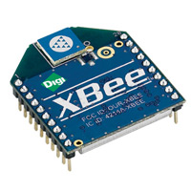
Wireless transceiver: The wireless transceiver is used to communicate between the controller box and the control panel. A mesh networking structure is used to allow each of the control panels to communicate with the controller box and with each other in an effort to extend the range of the system. Use of the existing Wi-Fi wireless network was considered. However the mesh network architecture eliminates any need for a separate wireless network infrastructure and is considerably more affordable.
Figure 4: Xbee Wireless Transceiver
A standard n network interface is 2-4 times the price of the chosen mesh network protocol, the IEEE 802.15.4 standard. This standard was chosen to ensure compatibility with the largest number of products. Although there are products with proprietary technology that expand the functionality of the wireless transceiver, the standard protocol was elected. The Xbee product by Digi has been selected as a product that meets all of our requirements, including the ease with which it can be integrated with the microcontroller using a simple serial interface, the affordability and the flexibility provided.
Microcontroller: A microcontroller is needed to provide the control logic for both the controller box and the control panel. The microcontroller was selected for both its capabilities and from the past experience of the group. The microcontroller must be capable of controlling and processing information from each of the devices.
Because two different products are needed with differing characteristics and levels of performance, two different microcontrollers will be needed. The user interface unit will require a microcontroller with one SPI for the LCD interface, one ADC for the temperature sensor, a UART for the wireless communication, and 5 general purpose input output pins for the 3 push buttons, one speaker, and one potential motion detector. This microcontroller needs to operate on 3.3 V technology or better.
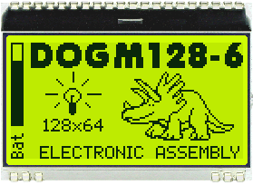
The steam valve controller unit will need to have one USART for the wireless communication, Ethernet port capability, and 3 GPIOs for a shaft encoder, the motor driver, and a speaker. This microcontroller can operate at various voltage technologies. Since this unit will be close to the steam pipes, the microcontroller will need to operate at around 100 degree Fahrenheit temperatures. We are searching for Atmel microcontrollers in order to save time with programming due to previous experience with Atmel. This will also save on cost since many ISU computer engineering labs have Atmel compatible programming devices and compilers.
LCD display: The LCD is used as an aid for our human machine interface -to communicate between the controller box and the individual. A super twisted pneumatic LCD was chosen in order to achieve a high contrast ratio and reduce back light intensity, thus reducing power consumption.
The DOGM128-6 Electronic Assembly family of LCDs was chosen because they have low power consumption and they offer more flexibility in graphics programing and tools to help ease the programming process. The DOGM128-6 family includes an integrated LCD driver and uses the SPI communication protocol, allowing for easy integration with a variety of microprocessors.
Figure 5: LCD Display
Another factor in our decision was the size of the display. Many of our users are weary students and faculty members. We needed an LCD that allowed for large easy to use text and graphics. Most of our electrical components function on 3.3 V technologies. The DOGM128-6 was one of the few LCDs with an appropriate size with a capacity to function with 3.3 V. Our group had to find a display that would be able to operate under varying temperature conditions. This particular LCD met our standards for operating temperature range between -20 degrees Celsius and 70 degrees Celsius.
The final consideration was availability. According to Mouser Electronics, this is one of the most widely available LCDs with a large stock. Given the size, quality, and availability, the estimated LCD cost is around 15 dollars. The DOGM128-6 family has LCDs that range from 4 to 18 dollars based on various backlighting and color schemes. This allows us to create an extremely flexible and cost effective product.
Temperature sensor: The temperature sensor is a mandatory component for the Steam Heat Controller prototype design. Below are some of the technical selection qualifications for the temperatures sensor:
- The team has decided that the temperature sensor should not be embedded on the microcontroller. This will reduce the maintenance cost since the entire microcontroller will need to be replaced if a malfunction or damage occurs to the embedded temperature sensor. By using an independent temperature sensor also eliminates possible reading errors caused by the heat produced by the microcontroller or other components for the prototype.
- The team has decided to use a temperature sensor with a voltage output over digital output. Price is an important factor that needs to be considered when dealing with the temperature sensor. Even though temperature sensors with digital output type have wider sensing temperature range and more accuracy, its price compared to a temperature sensor with voltage output is significantly higher.

Electric motor: In choosing the appropriate motor for turning the steam valve, we considered characteristics of motors one by one and identified the appropriate characteristics for our needs. We looked at type of electric motor, operating supply voltage, torque requirement, speed requirement, availability, functionality, safety, and cost.
Type of Electric Motor: At the highest level, we looked at the advantages and disadvantages for AC versus DC motors and not consider the different technologies with AC and DC motor designs for now. The advantages and disadvantages are shown in figure 1.

Figure 6: Electric Motor Advantages and Disadvantages
Since our project requires a high level of control of the steam valve, speed, torque, and positioning control are major concerns. Because of those functional requirements, we are willing to shoulder the higher cost, larger size, higher maintenance, lower reliability, and additional circuitry to use a DC motor in our design.
Operating Supply Voltage: We consulted our clients' expertise in choosing an appropriate operating supply voltage. Their recommendation was 12V to 24V would fit our needs. However, they mention that there will be tradeoffs for choosing higher operating supply voltage like power consumption. Since we want our product to have low power consumption and use that as a selling point, we will be choosing a DC motor that can operate at low supply voltage and still deliver reasonable performance.
Torque Requirement: To ensure that selected motor would be able to turn the steam valve, we performed torque measurements on the steam valve to set a lower limit on the torque requirement. The data was gathered using a wrench and balance measurement machine to get an estimate of the minimum torque needed to turn the steam valve clockwise and counterclockwise at its open and close positions. This set up was to ensure that worst case scenario would provide the true minimum torque requirement.
The results of the data can be viewed in Appendix A. The minimum torque requirement is approximately 0.632 lb*ft for both clockwise and counterclockwise turns. We will only consider motors with torque output greater than 0.632 lb*ft.
Speed Requirement: We investigated the speed requirement and consulted with our clients about their own preference on the requirement. For the steam valve, testing reveals approximately five revolutions from fully close to fully open. We then conferred with the clients to see which speed would be appropriate. Their response was one revolution per 10 seconds would be appropriate. The clients have requested one revolution per 10 seconds hence we will set this speed as our requirement when choosing a motor for our design.
Functionality: For the motor, we require two specific functionalities: shaft encoder and reversible motor. The shaft encoder is essential for converting the angular position of the motor shaft to a digital code. There are three types of binary logic level technologies: CMOS, TTL, and ECL. The operations of all three are shown below.
Figure 7: Logic Levels for Electric Motor Communication
Since we are not dealing with negative voltage biasing, we are looking to use either CMOS or transistor-transistor logic (TTL). Either standard will allow effective communication between the shaft encoder and microcontroller. This is a functional requirement and we will look into possibly choosing a motor with integrated shaft encoder or a motor outfitted with a shaft encoder. For both choices, there will be a requirement that the shaft encoder communicate using CMOS or TTL.
The second functionality required for the motor is the ability to turn both clockwise and counterclockwise, or reversible operations. This requirement removes the possibility of using servo motor since their range is limited to within one revolution. The reversible operation requirement confirmed our previous design choice to use a DC motor over an AC motor.
The DC motor requires a complementary shaft encoder, either integrated or detached.
Summary: We sum up our design considerations for the electric motor in the table below.
Figure 8: Electric Motor Summary
Driver circuit: In conjunction with the DC motor, we will choose a driver circuit to regulate the DC motor. In choosing the appropriate driver circuit, we will need to choose the DC motor beforehand in order to define the minimum requirement for the driver circuit. Some of these considerations are operating supply voltage, accepted input standard, current output, safety, and cost.
Operating Supply Voltage: The operating supply voltage of the driver circuit will depend on the DC motor that we will use.
Accepted Input Standard: The microcontroller will be controlling the driver circuit through a digital signal hence the driver circuit will need to accept either CMOS or TTL logic level communication.
Current Output: The maximum current output of the driver output should be able to meet the needs of the DC motor. This requirement will be dependent upon the DC motor that we will choose.
Summary: We sum up our design considerations for the motor driver circuit in the table below.
Figure 9: Motor Driver Circuit Summary
Controller box platform: In considering the platform to hold all the electrical components near the steam valve, our clients recommended using extrusion aluminum to be the material of choice to use in the design of the platform. With our clients’ expertise in platform design using this type of material, we strongly believe that using this material will leverage our clients’ mechanical expertise and compensate for our lack of mechanical experience.
Once we have all the major components including the microcontroller, motor, and power supply on hand, we will work with the clients to craft the platform to house all the components. Since there are potential variations in the physical arrangement of the steam valve, the platform implementation will need some custom modifications. However, we will strive for modularity of the controller box platform.
Integration: After formal testing of the individual components, we will work with the clients in crafting the controller box platform to house the DC motor. The motor driver circuit will probably have to wait since it will be integrated with the PCB housing the microcontroller.
The power supply will also need to be chosen before crafting the final design of the controller box platform. Once we have the controller box platform completed, the DC motor selection will be finalized, but the motor driver circuit will have some flexibility in placement on the microcontroller PCB.
Control algorithm: The control algorithm used to control the valve is a PID feedback control algorithm as outlined in figure 10. This algorithm uses feedback to control the heat output of the heating system and regulate the output according to the set point. This feedback is provided by the control panel’s temperature sensor. The input from 3 separate temperature sensors will be used in a weighted average to provide the feedback signal. Similarly the set point will be a weighted average of each user’s preference. The algorithm is a well-established standard control algorithm that is often used in industrial control processes. The PID’s controller must be tuned in order to adjust the response of the system. There must also be some mechanism to simplify the tuning process. There will be a method to profile a room in order to simplify the tuning process and potentially improve the efficiency of the temperature control using the added information. The PID controller will undergo extensive testing and revision as necessary.
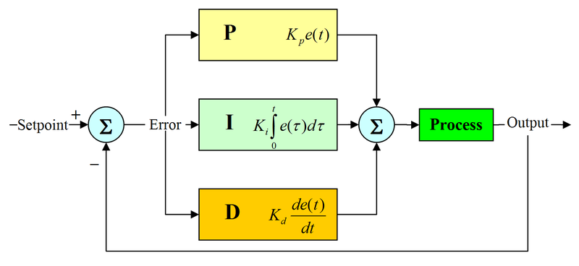
Figure 10: PID Control Algorithm
Power supply: We are considering two different power supply implementations. Since the controller box will be powered using the electrical outlet and the control panel will be powered using AA batteries, we have two sets of evaluating criteria for choosing the appropriate power systems of the two modules.
Controller Box: The power system of the controller module will consist of 120V 60 Hz outlet input and an AC to DC converter. This system is used to power the microcontroller, electrical components, and the DC motor. The power system will be housed with the rest of the components on the platform rested above the steam valve. The design of the platform will impact how we will choose the appropriate power supply because it will constrain the design in terms of size and placement. The length of the power supply cable will need to reach the nearest electrical outlet. Since our product will be used in rooms of varying sizes, the cord length will have to be chosen in order to accommodate a broad arrange of room sizes.
Another consideration of the power supply system includes the step down voltage and current ratings. The step down voltage must be low enough in order to accommodate the voltage technology of our product while the current rating must be high enough in order to provide enough power for the electrical components. The DC motor is the largest load for the power supply from our controller module. We will need to take the efficiency of the power supply into consideration. We cannot allow the converter to burn off power in order to achieve the appropriate step down voltage. A configuration similar to buck configuration will provide good enough efficiency. Since the controller box will be connected at all times, the idle power consumption of the power supply will be taken into account for further cost savings.
The power supply will be subject to medium and high temperature environments. This condition poses a fire hazard due to overheating as well as product malfunction. To mitigate these safety concerns, we will research AC to DC converters with high temperature ratings. Once we choose a supply, we will perform extended live testing to confirm power supply reliability.
User Interface: We will use standard AA batteries to power the user interface. We want a highly mobile design that can be mounted on any wall regardless of outlet proximity. The unit contains various low power digital components and will therefore have low power consumption. It must be small in size and low cost. Given these considerations, standard AA batteries are the logical choice as the system’s power supplies.
For both the controller box and user interface, we anticipate additional circuitry will be needed in order to provide correct voltage and current levels to the individual electronic components. In addition, because power supply components pose significant risk for overheating and breakdown, we will perform extended live testing to confirm the reliability of both power supply systems.

Testing requirements considerations
Our testing approach will be broken into two phases. In the first phase each of the components will be tested individually to ensure they meet their own individual requirements. This phase will also assist in developing our understanding of each component. After this phase our integration plan may need to be altered as we understand each component’s functionality better. Then in the second phase the entire integrated system will be tested including functional and non-functional tests. This will have to take place during the winter months and will be a vital link in the success of the project. A PID (Proportional Integral Derivative) feedback control algorithm will used to actually control the temperature of the rooms by adjusting the steam valve. This type of controller will require significant adjustments to the controller’s parameters (coefficients) for the controller to be effective.
Phase 1 testing requirements and procedures for each component are outlined below:
Wireless transceiver: There are a number of tests that must be performed. The unit must be tested to ensure basic functionality, range, and reliability. The most basic test would be to test basic functionality to ensure the unit can properly transfer data bytes. Then the transceiver’s range must be tested. This must be done in the product’s intended environment. A variety of environmental factors must be tested, including having a transceiver that needs to reliably communicate up to 3 rooms away. Incorporated into the range tests will be a test of reliability, with reliability being measured as the percentage of the transmitted bytes that were received by each transceiver as a function of the range.
LCD display: There is a multitude of tests that must be performed. The first tests to be performed should ensure basic functionality and reliability. The most basic test would be to test basic functionality to ensure the unit can properly display data and graphics. Then, the LCD backlight should be tested. This should be done in the product’s intended environment across various lighting conditions and temperature ranges. This testing will allow us to set the appropriate contrast and brightness and allow for minimum power consumption. Pixel reliability needs to be measured in order to make sure that the LCD is displaying the transmitted data properly.
Mechanical interface: In testing the DC motor and motor driver circuit, we have a selection of items available from the EcpE resource department. We plan to use an Atmel microcontroller available from the Ecpe resource department to test different selections of available DC motors and motor driver circuits.
Once we feel comfortable with a particular DC motor and motor driver circuit, we will put an order out through the Ecpe resource department and begin formal testing of our chosen components.
For the testing, we will test for functionality, safety, and reliability of each component of the mechanical interface before moving forward in integrating the DC motor, motor driver circuit, and controller box platform.
Temperature sensor:
There are a few considerations when beginning to do testing.
- Temperature range: 0 degrees Celsius to 40 degrees Celsius
- Accuracy: within ±1 degrees Celsius of the real temperature
- Reliability: popular user ratings (over 2500 users)
- Availability: readily available from its distributors (20,000 units in stock )
- Price: $1-$2
Microcontroller: There are a number of tests that must be performed. The unit must be tested to ensure basic functionality and reliability. The most basic test would be to test pin functionality to ensure that the units perform the appropriate functions and have good signal integrity. The voltage rails need to be tested in order to ensure low ringing on the lines. The microcontroller’s operation needs to be tested at a wide range of temperatures in order to assure a reliable product. The signal communication lines need to be tested for reliability, with reliability being measured as the percentage of the transmitted bytes that were received correctly.
Control algorithm: The control algorithm must undergo extensive testing and revision in the final stages of the project. The control algorithm is a software implementation that is dependent on the hardware configuration and hence must be part of the last stages of development. However as a critical component to the success or failure of the project there must be sufficient time allocated to the testing, tuning and revision of the control algorithm.
The testing of the control algorithm will need to include live testing where the system is ran and monitored over a series of tests under different environmental standards and operating conditions. Testing will begin with a single room that is controlled using a single control panel and controller box. The testing will then be expanded to include multiple rooms with multiple user interfaces.

Security considerations
The major security considerations to be addressed are the wireless interface and the web interface. Both of these are vulnerable to attack by outside sources. Below are the security considerations for each:
Network interface: There are two main security vulnerabilities in the network interface. First, the traffic going from the internet interface to the Iowa State network might be prone to attacks. Anyone from the room will have access to the physical Ethernet connection interface connecting to the Iowa State network and alter the data sent to the web or instructions send from the web. A possible solution is to lock the Ethernet connection between the microcontroller and Iowa State network from the users in the room.
The wireless traffic might be prone to attacks. The data broadcasted uses a common protocol and can be easily picked up by surrounding devices using snipping programs. This gives attackers the ability to perform attacks to the network interface using false authentication and change the temperature of the room. A possible solution is to encrypt data being broadcasted, and create an authentication password.
Wireless transceiver: The Xbee includes built-in security features. These security features include the addressing method used by the transceiver. There are over 65,000 unique addresses that can be set for each transceiver. The source and destination of each message is addressed. The system also has the ability to encrypt the sent data using 128-bit AES (Advanced Encryption Standard). This will help secure information sent over the wireless serial link between the control panel and the controller box. Even though the Xbee does an excellent job of securing data when configured properly, the system is designed so that the data being transmitted wirelessly is not very sensitive to intrusion. The two pieces of data that will be sent though the transmitter are the current temperature of the room to be used to complete the feedback loop of the control algorithm and the user’s preference.

Safety considerations
Safety is always a major concern for any product. Our system has safety concerns related to a number of components:
LCD: The LCD consists of a glass plate structure. It needs to be properly insulated from the casing of the user interface unit in order to assure minimal stress and decrease the possibility of shatter. On the two sides of the LCD, protective plastic coverings are placed in order to protect against damage during shipping. These must be removed prior to design integration in order to the chance of reduce circuit malfunction and overheating.
Mechanical implementation: Safety is a real concern for the mechanical implementation. Our clients are concern about fire hazards should there be any malfunctions with the motor. One method to reduce this safety concern is by use of the shaft encoder. Because the shaft encoder relays information about the movement of the motor, any unresponsive movement from the motor after issuing a movement command would indicate failure in the motor. This will prevent burn out of the motor and in turn decrease the potential for fire hazards.
The other method of reducing potential fire hazards is to choose an accompanying motor driver circuit with over current protection or over temperature protection, preventing burn out of the motor. Our clients are actively concern about the safety of the product and are willing to spend additional funding to provide both solutions. We are required to have a shaft encoder to use with the DC motor and a motor driver circuit with over current protection and over temperature protection.
Driver Circuit: The driver circuit will be critical in providing the safety mechanism for the DC motor. The over temperature protection available in some driver circuits would be a plus in ensuring our DC motor avoids burn out. Over current protection will be in addition to the over temperature protection and provide further mitigation of burn out events. We will try to find a motor driver circuit that provides both features.
Temperature sensor: The Temperature sensor could malfunction due to incorrect reading or broken sensor. This can lead to huge room temperature fluctuations, which can cause extreme heating or cooling. Possible solutions to this issue are to set a low and high boundary for the motor control unit (15 degrees Celsius to 30 degrees Celsius). Another solution is to have a secondary temperature sensor that would become primary temperature sensor once an error is detected
Microcontroller: The only safety consideration is microprocessor overheating. If the microprocessor becomes too hot, it may burn individuals, cause damage to the unit, and even cause a fire. This can be avoided by smart design. Our group is experienced enough with hardware to design around these issues. We will pay great attention to detail and follow through with the manufacturer recommendations.

Intellectual property considerations
Many of the components that are integrated into our project have certain designs and company proprietary information that must be respected. Although each component has parts that are protected by intellectual property rights, the design of our system does not call for any alteration of any of the components which would warrant investigation of these rights. Each component will be used according to the user interface outlined by the component’s manual and the guidelines specified by the supplier.
Besides consideration of the component supplier’s intellectual property rights there are also the intellectual property rights of heating control system companies. Near the beginning of the project’s planning stage a possible interface between the system under development and the currently established Johnston Controls system was considered. However intellectual property concerns about having access to the system’s communication protocols were a string consideration in the decision not to pursue an interface.

Commercialization considerations
Although there is no plan to commercialize the product, the intention of the project is to eventually implement the system campus-wide. The wide scale implementation plan has been outlined by the client to include 2 phase. The first phase is the implementation of the system throughout Coover hall, excluding the new addition. After a successful implementation in Coover Hall a campus wide implementation in buildings with similar heating systems will be considered for phase 2.

Possible risks and risk management
There are a number of risks that may affect the progress of the project. These risks include:
Loss of a team member: There is some chance that we could lose a team member due to unforeseeable circumstances. In order to mitigate this risk each member of the team has been documenting their work throughout the design process. Continued documentation would make it easy to assume that person’s role.
Hardware failure: There is always the possibility that one or more of the components may fail and cause schedule delays if there is a long lead time on the component.
Mechanical interface integration delays: Integration of the DC motor, motor driver circuit, and controller box platform poses a high risk for delay. This is due to the controller box platform requiring other components to be finalized before working with our clients to design the platform. One way we going to manage this risk are by working on other modules side by side in schedule with the mechanical implementation.
Mechanical interface integration scheduling: Another potential risk is scheduling work time with our clients during the construction of the controller box platform. Our clients have responsibilities pertaining to their full time work that could impede the schedule. One way we are going to manage this risk is by providing flexibility in our schedules and accommodating our clients' schedule to speed up the controller box platform implementation. We will also try to have components, design requirements, and prepared design documents readily available when we work with our clients.
Short testing window: Due to the steam valve being in operation only during the winter time and our team taking vacation during winter break, the window of opportunity for testing and data collection will be limited to early January to the spring months. Weather is an unpredictable factor and may not swing in our favor. We will try to finish the prototype as soon as possible and begin data collection to mitigate this risk of a short winter season.
Power Failure: Power failure is always a risk with electronic hardware. This risk can be mitigated by planning for a potential power failure. This includes storing critical data in non-volatile memory.

Project proposed milestones and evaluation criteria
Milestone evaluations of our progress are critical in demonstrating our ability to stay on schedule, react to changes, adapt to varying circumstances, and complete project on time, on budget, and meet requirements. Each milestones listed below will be evaluated using the suggested 1-7 scale, with 1 being 'very successful' and 7 being 'did not attempt'.
High Level Design Proposal: Once we received details of the project and had the opportunity with the clients to cover the problem statement, the constraints, the requirements, and how our performance will be evaluated, we completed a high level design proposal to the clients. We presented our solution and convinced the clients that our proposal would meet their needs.
Finalize Research and Order Parts: Currently, we are finalizing research for many of the components. We are looking to complete a major parts order by late-October. This milestone will be evaluated on the basis of having the major components being ordered. We aim to have the motor, transceiver, LCD, and Ethernet controller ordered.
Test Components and Confirm Functionality: Once we have the major components on hand, we will dedicate two weeks to test and confirm functionality of the components. This milestone will be evaluated in mid-November and serve to finalize the components used in the prototype and final design.
Software Operating Correctly: As hardware development slows down and is being finalized, we will work on developing the software codes to run on the hardware. Specifically, we aim to have the software operating correctly on the hardware late-November.
Integration with Steam Valve: With both hardware and software coming together, we will complete the integration by physically attaching the hardware onto the steam valve. We will consult with our clients to ensure proper integration with the steam valve. We aim to have this integration completed by mid-December.
Testing and Data Collection: From mid-December to early-January, we will be conducting tests and performing data collection. We will evaluate the completion of this milestone by setting a 100 hours data collection benchmark.
Revisions and Improvements: The prototype will be bounce between revisions and testing as we improve the prototype. We will set the deadline for this improvement process mid-March. The milestone will be evaluated on the basis of how we have improved the design since the initial prototype.
Post-Improvement Evaluations: Upon completion of revisions and testing, we will perform a formal evaluation of the prototype to final design. We will consult with our clients to discuss the results and request feedback on our ability to fulfill and exceed the clients' needs. We plan to have this evaluation late-March.
Complete Project Documentation: In wrapping up the completion of the project, we will finalize the project documentation, which will include an operating manual for the clients to work with our design. This milestone will be in mid-April.

Project tracking procedures
During this semester long project, there are many unexpected events that could derail the schedule of the project. To address this issue, we emphasize our use of the milestones, weekly meetings with our clients, weekly team meetings.
Milestones: Having milestones is a great way to keep track of major development progress during the project. In the previous section, we listed milestones with specific evaluation criteria and deadlines. Should there be any delays or design failures, the milestones will provide a medium to long term outlook that we can adapt and meeting changing design environments.
Weekly Meetings with Clients: For short term project tracking, we have mandatory weekly meetings with our clients. Our clients' strong interest in the success of this project motivates us to make progress every week. We use these weekly meetings to gather clients' feedback and inform them of any progress or impediment we faced. Our weekly meetings with our clients serve as a powerful project tracking procedure.
Weekly Team Meetings: Within our own group, we have weekly team meetings to share individual progress, overall progress, identify concerns, resolve open issues, and hold each other accountable. Due to the busy schedule that each member of the team face, we strongly believe that having this mandatory weekly team meeting have kept and continue to keep us on schedule.

Statement of Work
The table below illustrates the tasks and associated subtasks necessary to describe the work that the project team will perform for the Steam Heat Controller project.
- Task 1 – Problem Definition
Task Objective: State the general description of the problem for the Steam Heat Controller, understand the needs of the clients and users, and identify possible constraints for the Steam Heat Controller.
Task Approach: The team will first do a detailed analysis of the problem, identify points of ambiguity, definitions of terms, and restate the problem statement.
The team will then talk with the clients to clarify the points of ambiguity, and refine the problem according to the needs of the clients.
Finally, the team will work with the clients to list all possible constraints for the problems facing the Steam Heat Controller project.
Task Expected Results: After the task completion, the problems for the Steam Heat Controller project should be listed clearly with proper definitions for terms, and all constraints for each problem stated clearly. The problems includes the clients and end user needs. There should be no ambiguities from the list of problems for the Steam Heat Controller project
  - Subtask 1a – Problem Definition Completion
    - Subtask Objective
      - State the general description of the problem for the Steam Heat Controller
    - Subtask Approach
      - The team needs to have a comprehensive understanding of what is been asked for the Steam Heat Controller project. This includes but not limited to: agreeing on definitions of terms, clarifications on any ambiguities, and restate the problem statement.
      - The team will need to break down the requirements / problems to be solved to a list, with the most important problems on the top of the list
    - Subtask Expected Results:
      - The problems for the Steam Heat Controller project should be listed clearly with proper definitions for terms.
      - There should be no ambiguities from the list of problems for the Steam Heat Controller project
  - Subtask 1b – End-User(s) and End-Use(s) Identification
    - Subtask Objective
      - Understand the needs of the clients and users
    - Subtask Approach:
      - The team will need to arrange several meetings with the clients and go over the problems for the Steam Heat Controller project thoroughly. The team shall work with the clients to make sure that all problems for the end users are identified and addressed
    - Subtask Expected Results:
      - The clients and end-users problems for the Steam Heat Controller project should be listed clearly with proper definitions for terms.
      - There should be no ambiguities from the list of clients and end-user problems for the Steam Heat Controller project
  - Subtask 1c – Constraint Identification
    - Subtask Objective:
      - Identify possible constraints for the Steam Heat Controller project
    - Subtask Approach:
      - Thoroughly go through the problems and objectives for Steam Heat Controller project with clients and team and identify all possible constraints / limitations.
      - Schedule a time to exam the physical environments for the Steam Heat Controller project and list out all possible restrictions.
    - Subtask Expected Results:
      - A comprehensive list of all constraints and limitations and how that will limit the scope of the Steam Heat Controller project
- Task 2 – Technology Considerations and Selection
Task Objective: Identify all possible technologies (protocols, interfaces, and standards) for the Steam Heat Controller project, construct measures to compare different technologies, research technologies for Steam Heat Controller project, and identify the most suitable technologies for Steam Heat Controller project.
Task Approach: Discuss and research all possible technologies dealing with the Steam Heat Controller project. After research and analysis, the team will talk with advisors to narrow down choices on specific technologies based on constraints and cost. The team will then do a side-by-side comparison with all the technologies picked, and make a final selection of a suitable technology. With each technology, a justification will be provided for why the technology is selected.
Task Expected Results: the expected results should be a list of technologies needed for Steam Heat Controller project, with justifications corresponding to each technology selected
  - Subtask 2a – Identification of Possible Technologies
    - Subtask Objective:
      - identify all possible technologies (protocols, interfaces, standards) for the Steam Heat Controller project
    - Subtask Approach:
      - List out all possible technologies needed for the Steam Heat Controller project
      - Do a comprehensive search for all possible technologies for the Steam Heat Controller project.
      - Identify key qualifications for each technologies, such as protocols, interfaces, and standards
    - Subtask Expected Results:
      - A comprehensive list of all the technologies needed for the Steam Heat Controller project with key qualifications.
  - Subtask 2b – Identification of Selection Criteria
    - Subtask Objective: construct measures to compare different technologies
    - Subtask Approach:
      - Select from the comprehensive list of technologies, identify their commonalities and variability
      - From the variability identified, define parameters of variations and measures
      - From the parameters of variations and measures, construct a set of evaluation criteria that best fits the needs of the Steam Heat Controller project
    - Subtask Expected Results:
      - The results should include a set of evaluation criteria for the technologies that best fits the needs of the Steam Heat Controller project
  - Subtask 2c – Technology Research
    - Subtask Objective:
      - Research technologies for Steam Heat Controller project
    - Subtask Approach:
      - Based on the evaluation criteria for the technologies, evaluate the technologies from the comprehensive list
      - Narrow down the technologies based on evaluation and further research the narrowed list of technologies. Research would include the compatibilities between different technologies and their use cases
    - Subtask Expected Results:
      - The results should include a narrowed list of technologies with in depth analysis of each use case and compatibilities with other technologies
  - Subtask 2d – Technology Selection
    - Subtask Objective:
      - Identify the most suitable technologies for Steam Heat Controller project
    - Subtask Approach:
      - From the narrowed list of technologies and each in depth analysis, the team will make initial technology decisions and go onto distributor websites such as digikey for the technology user evaluations and the availability of parts
      - After the initial selection, the team will consult with advisors and get feedback to finalize the technologies to be used for the Steam Heat Controller project based on cost, lead time, and availabilities.
    - Subtask Expected Results:
      - The expected results should include the finalized list of technologies to be used for the Steam Heat Controller project, with cost and availabilities.
- Task 3 – End-Product Design
Task Objective: Define design requirements for Steam Heat Controller project based on constraints and client needs, define the design process for Steam Heat Controller project, and finalize the documentation of design for the Steam Heat Controller project.
Task Approach: From the requirements of the clients and the scope of the Steam Heat Controller project, the team will work to define a clear and practical design process. Following the design process, the team will consult with advisors and clients to finalize the documentation of design for the Steam Heat Controller project
Task Expected Results: The results should include a concise and easy to follow design process and the finalized documentation of design for the Steam Heat Controller project
  - Subtask 3a – Identification of Design Requirements
    - Subtask Objective:
      - Define design requirements for Steam Heat Controller project based on constraints and client needs
    - Subtask Approach:
      - Consult with advisors and clients and list out all constraints and the client's needs to narrow down the scope for the Steam Heat Controller project
      - Based on the scope, list the design requirements for Steam Heat Controller project
    - Subtask Expected Results:
      - The result should include a set of precise design requirements for the Steam Heat Controller project
  - Subtask 3b – Design Process
    - Subtask Objective:
      - Define the design process for Steam Heat Controller project
    - Subtask Approach:
      - Based on the design requirements the team will list the Steam Heat Controller project approach, and alternative design decisions.
      - From the list of design decisions, the team will work to define a clear and practical design process for the Steam Heat Controller project.
    - Subtask Expected Results:
      - The result should include a concise and easy to follow design process
  - Subtask 3c – Documentation of Design
    - Subtask Objective:
      - Finalize the documentation of design for Steam Heat Controller project
    - Subtask Approach:
      - The team will follow the design process when working on the documentation of design.
      - The team will consult with clients and advisors to finalize decision models, component diagram flow charts, modules, and design details
    - Subtask Expected Results:
      - The expected result should include finalized documentation of design for the Steam Heat Controller project
- Task 4 – End-Product Prototype Implementation
Task Objective: Define the limitations of prototype and possible substitutions for Steam Heat Controller project, and construct the prototype end product for the Steam Heat Controller project.
Task Approach: Based on the design document, the team will define the limitations of the prototype. The team will also identify prototype risks and implement substitutions for backups. The team will then construct the end product project prototype from the technologies selected
Task Expected Results: the expected result should include the end product for the Steam Heat Controller project
  - Subtask 4a – Identification of Prototype Limitations and Substitutions
    - Subtask Objective:
      - Define the limitations of prototype and possible substitutions for Steam Heat Controller project
    - Subtask Approach:
      - From the design document, the team will list out all possible limitations of the prototype for the Steam Heat Controller project.
      - The team will refer back to project limitations and risks for the technologies, prototype, and plan alternative / substitutions solutions for the prototype.
    - Subtask Expected Results:
      - The result should include the list of limitations and possible substitutions for the Steam Heat Controller project.
  - Subtask 4b – Implementation of Prototype End Product
    - Subtask Objective:
      - Construct the prototype end product for Steam Heat Controller project
    - Subtask Approach:
      - The team will construct the end product project prototype from the technologies selected closely following the design document
      - The substitutions / failsafe should be built in for the end product, and components should be modularized for easy modification.
    - Subtask Expected Results:
      - The result should include the end product for Steam Heat Controller project
- Task 5 – End-Product Testing
Task Objective: Set up comprehensive test plans for Steam Heat Controller project prototype, develop test cases from the test plan for Steam Heat Controller project prototype, execute the test cases for Steam Heat Controller project prototype, evaluate the test results from test execution for Steam Heat Controller project prototype, and document all test results and evaluations for Steam Heat Controller project prototype.
Task Approach: The team will list out end product use cases and set up a set of test plans for every use case for Steam Heat Controller project prototype. After that, the team will develop various test cases from the test plan for Steam Heat Controller project prototype. After the completion of the test cases, the team will execute the test cases for Steam Heat Controller project prototype, and evaluate the test results from test execution for Steam Heat Controller project prototype. The team will document all test results and evaluations for Steam Heat Controller project prototype.
Task Expected Results: The result should include the comprehensive test plans for Steam Heat Controller project prototype, the test plan for Steam Heat Controller project prototype, document for all test results and evaluations for Steam Heat Controller project prototype.
  - Subtask 5a – Test Planning
    - Subtask Objective:
      - Set up comprehensive test plans for Steam Heat Controller project prototype
    - Subtask Approach:
      - The team will list out end product use cases and for every use case set up a set of test plans for Steam Heat Controller project prototype.
      - For each use case, the team will be exploring a full range of methods for conducting the tests, including setting up software test cases, and beta user testing.
    - Subtask Expected Results:
      - The result should include a set of comprehensive test plans for Steam Heat Controller project prototype
  - Subtask 5b – Test Development
    - Subtask Objective:
      - Develop test cases from the test plan for Steam Heat Controller project prototype
    - Subtask Approach:
      - Using the test plan, the team will devise a set of test cases for each use case, which will include but will not be limited to boundary, exception, and user test cases
    - Subtask Expected Results:
      - The result should include a list of test cases for the Steam Heat Controller project end-product
  - Subtask 5c – Test Execution
    - Subtask Objective:
      - Execute the test cases for Steam Heat Controller project prototype
    - Subtask Approach:
      - Using the test cases developed, the team will run each test case against the end product for the Steam Heat Controller project prototype
      - To execute the test cases, we will include some overnight runs and iterative inputs from the users
    - Subtask Expected Results:
      - The results should include successful execution of all the test cases for the Steam Heat Controller project prototype
  - Subtask 5d – Test Evaluation
    - Subtask Objective:
      - Evaluate the test results from test execution for Steam Heat Controller project prototype
    - Subtask Approach:
      - Based on the results from the test case executions, the team will analyze the results, and sort out the test cases that had failed.
      - From the failed test cases the team will categorize each by its severity and the cost to fix
    - Subtask Expected Results:
      - The results should include the comprehensive test evaluation for the Steam Heat Controller project.
  - Subtask 5e – Documentation of Testing
    - Subtask Objective:
      - Document all test results and evaluations for Steam Heat Controller project prototype
    - Subtask Approach:
      - From the test analysis, the team will document all test runs from the test cases.
      - The team will document the test cases, the expected results, and the actual results, analyzing the severity of the failures and the cost to fix the failures.
    - Subtask Expected Results:
      - The result should include the complete documentation for the testing for Steam Heat Controller project prototype.
- Task 6 – End-Product Documentation
Task Objective: Develop the End-User Documentation for Steam Heat Controller project, and develop the Maintenance and Support Documentation for Steam Heat Controller project.
Task Approach: The team will refer back to the use cases for help when developing the End-User Documentation for Steam Heat Controller project. The team will refer to the list of references for the technology picked and develop the Maintenance and Support Documentation for Steam Heat Controller project, including the limitation and scope of the end project
Task Expected Results: The result should include End-User Documentation, Maintenance and Support Documentation for the Steam Heat Controller project
  - Subtask 6a – Development of End-User Documentation
    - Subtask Objective:
      - Develop the End-User Documentation for Steam Heat Controller project
    - Subtask Approach:
      - The team will refer back to the use cases for help when developing the End-User Documentation for Steam Heat Controller project.
      - The team will thoroughly go through the project design and features to make sure that all end user conditions are covered
    - Subtask Expected Results:
      - The results should include the end-user documentation for the Steam Heat Controller project.
  - Subtask 6b – Development of Maintenance and Support Documentation
    - Subtask Objective:
      - Develop the Maintenance and Support Documentation for Steam Heat Controller project
    - Subtask Approach:
      - The team will refer to the list of references for the technology picked and develop the Maintenance and Support Documentation for Steam Heat Controller project
      - The team will include the limitation and scope of the end project when developing the Maintenance and Support Documentation for the Steam Heat Controller project
    - Subtask Expected Results:
      - The result should include the comprehensive maintenance and support documentation for the Steam Heat Controller project
- Task 7 – End-Product Demonstration
Task Objective: Plan for Steam Heat Controller project prototype demonstration, demonstrate the Steam Heat Controller project prototype for faculty advisors, demonstrate the Steam Heat Controller project prototype for clients, and demonstrate the Steam Heat Controller project prototype for Industrial Review Panel.
Task Approach: The team will devise a plan to showcase the end product for the Steam Heat Controller project, and have a live demonstration of the working prototype. The team will demonstrate the Steam Heat Controller project prototype for faculty advisors through live demonstration of how the technologies picked where used for the prototype and the results from the testing phase of the project. The team will demonstrate the Steam Heat Controller project prototype for clients by showing the clients a live demonstration of how the prototype has successfully performed the tasks / features requested by the clients. The team will also demonstrate the Steam Heat Controller project prototype for Industrial Review Panel by showing the test result documents for the prototype, stating all the constraints and future scope of the projects along with the feedbacks of the clients and advisors.
Task Expected Results: The results should include successfully executed demonstrations of the Steam Heat Controller project prototype for faculty advisors, clients, and Industrial Review Panel.
  - Subtask 7a – Demonstration Planning
    - Subtask Objective:
      - Plan for Steam Heat Controller project prototype demonstration
    - Subtask Approach:
      - The team will devise a plan to showcase the end product for the Steam Heat Controller project, and have a live demonstration of the working prototype.
      - The team will set up different Steam Heat Controller project demonstrations for the advisors, client, and the Industrial Review Panel
    - Subtask Expected Results:
      - The result should include complete demonstration plans / guidelines when presenting to advisors, clients, and Industrial Review Panel.
  - Subtask 7b – Faculty Advisor(s) Demonstration
    - Subtask Objective:
      - Demonstrate the Steam Heat Controller project prototype for faculty advisors
    - Subtask Approach:
      - The team will demonstrate the Steam Heat Controller project prototype to faculty advisors through a live demonstration of how the technologies where used in the prototype and presentation of results from the testing phase of the project.
    - Subtask Expected Results:
      - The result should include successfully executed demonstrations of the Steam Heat Controller project prototype for faculty advisors.
  - Subtask 7c – Client Demonstration
    - Subtask Objective:
      - Demonstrate the Steam Heat Controller project prototype for clients
    - Subtask Approach:
      - The team will demonstrate the Steam Heat Controller project prototype for clients by showing the clients a live demonstration of how the prototype has successfully performed the tasks / features requested by the clients.
    - Subtask Expected Results:
      - The result should include successfully executed demonstrations of the Steam Heat Controller project prototype for the client.
  - Subtask 7d – Industrial Review Panel Demonstration
    - Subtask Objective:
      - Demonstrate the Steam Heat Controller project prototype for Industrial Review Panel
    - Subtask Approach:
      - The team will demonstrate the Steam Heat Controller project prototype for Industrial Review Panel by showing the test result documents for the prototype, stating all the constraints and future scope of the projects along with the feedbacks of the clients and advisors.
    - Subtask Expected Results:
      - The result should include successfully executed demonstrations of the Steam Heat Controller project prototype for Industrial Review Panel.
- Task 8 – Project Reporting
Task Objective: Complete Project Plan Development report for Steam Heat Controller project, complete Project Poster Development report for Steam Heat Controller project, complete End-Product Design Report Development for Steam Heat Controller project, complete Project Final Report Development for Steam Heat Controller project, and complete Weekly Email Reporting for Steam Heat Controller project.
Task Approach: The team will complete the various reports for Steam Heat Controller project by referencing the design and testing documents already completed. Each team member will be assigned a section he is most knowledgeable in. The documents will be reviewed by all the team members and also the faculty advisors
Task Expected Results: The results should include: completed Project Plan Development report, Project Poster Development report, End-Product Design Report, Project Final Report, and Email Reporting for Steam Heat Controller project.
  - Subtask 8a – Project Plan Development
    - Subtask Objective:
      - Complete Project Plan Development report for Steam Heat Controller project
    - Subtask Approach:
      - The team should meet on a weekly basis to work on the Project Plan Development report for Steam Heat Controller project and delegate parts to each of the team members.
      - Each team member will work on the section they are most knowledgeable. Once each members have completed their sections the team will do a full review of the document and also ask the faculty advisor to review the documents
    - Subtask Expected Results:
      - The result should include the completed Project Plan Development report
  - Subtask 8b – Project Poster Development
    - Subtask Objective:
      - Complete Project Poster Development report for Steam Heat Controller project
    - Subtask Approach:
      - After the completion of the Project Plan Development report the team should meet on a weekly basis to work on the Project Poster Development report for Steam Heat Controller project and delegate parts to each of the team members.
      - The team members will be using the Project Plan Development report as a reference.
      - Each team member will work on the section they are most knowledgeable. Once each members have completed their sections the team will do a full review of the document and also ask the faculty advisor to review the documents
    - Subtask Expected Results:
      - The result should include the completed Project Poster Development report
  - Subtask 8c – End-Product Design Report Development
    - Subtask Objective:
      - Complete End-Product Design Report Development for Steam Heat Controller project
    - Subtask Approach:
      - The team should meet on a weekly basis to work on the End-Product Design Report Development for Steam Heat Controller project and delegate parts to each of the team members.
      - Each team member will work on the section they are most knowledgeable. Once each members have completed their sections the team will do a full review of the document and also ask the faculty advisor to review the documents
    - Subtask Expected Results:
      - The result should include the completed End-Product Design Report Development for the Steam Heat Controller project
  - Subtask 8d – Project Final Report Development
    - Subtask Objective:
      - Complete Project Final Report Development for the Steam Heat Controller project
    - Subtask Approach:
      - The team should meet on a weekly basis to work on the Project Final Report Development for Steam Heat Controller project and delegate parts to each of the team members.
      - Each team member will work on the section they are most knowledgeable. Once each members have completed their sections the team will do a full review of the document and also ask the faculty advisor to review the documents
    - Subtask Expected Results:
      - The result should include the completed Project Final Report Development
  - Subtask 8e – Weekly Email Reporting
    - Subtask Objective:
      - Complete Weekly Email Reporting for Steam Heat Controller project
    - Subtask Approach:
      - A person from the team will be in charge of taking meeting minutes and tracking progress on a weekly basis and before sending out the final weekly email report ask each team members to verify the validity of their progress of the week.
    - Subtask Expected Results:
      - The result should include the completed Weekly Email Reporting for the Steam Heat Controller project

Estimated Resource Requirements
The estimated resource requirement includes (1) personnel effort requirements, (2) other resource requirements, and (3) financial requirements. We have developed the following tables for our estimated resource requirement to provide transparency in our project plan.

Personnel Effort Requirements
Due to the variety of modules within the controller box and control panel, we have assigned individual team members to handle particular modules. Each of us will be in charge of one or two modules,
responsible for research, selection, design, implementation, design, and documentation before integration into the overall system.
Figure 11: Personnel Requirements
Our personnel effort table estimates equal contribution for all team member as we progress through the project schedule. We will document any unexpected issues and modify the content of the personnel effort table as needed. We planned for the total hours spent to be close as possible to the other resource requirements table. However, we are aware of possible circumstances and cannot say with full certainty that this will be an accurate projection. Overall, we will plan to adhere to our personnel effort projection and record hours using weekly reports.

Other Resource Requirements
The other resource requirements table highlights the top level resources needed to complete the project. We considered parts and materials, metal services, testing, and data collection.
Figure 12: Other Required Resources

Under the metal services, we will be working in conjunction with our clients to cut, weld, and mount the platform onto the steam valve. We consulted with the clients to approximate these hours.
Since the Coover building only runs its steam operations during the winter, our project is susceptible to high risk of losing data collection if we do not have a prototype ready. To reduce the risk of missing deadline, we are aiming for completion of the prototype design and having it available for testing during winter break. Testing and data collection will have additional hours outside of the academic school year as a result of this situation. We will allocate a schedule to team members still on campus to run the tests.
For parts and materials, we listed the top level modules including additional development kits. We also created a bill of materials for the controller box and control panel since there are significant amounts of details within them.
Figure 13: Controller Box Budget
Figure 14: Control Panel Budget
Please note that the bill of materials for the controller box and control panel is for a prototype design. Under this condition, individual parts and materials cost significantly higher than for the final design. The bill of material for the final design will take into account the benefits of large volume orders that will drive down the cost per unit. We will finalize the bill of material for the final design once we are comfortable with the prototype and receive additional information from our clients about the scope of our project outside of Coover.

Financial Requirements
We looked at just the parts and materials cost with the labor cost to estimate the overall project cost. Again, the parts and materials are currently priced for prototype design. Our labor cost estimates use information provided by Career Services. Our estimated project costs are based on a scope of one steam valve providing heat to three rooms.
Figure 15: Estimated Project Costs
Our estimated project costs for parts and materials are within the clients' budget of $1,000. Please note that many of the parts and materials are available from the Ecpe resource department allowing us further cost saving. However, we will evaluate the financial performance of our project using real cost for our parts and components. We will update the spreadsheet with new information if we make any decisions impacting our financial plan.

Schedule
The Gantt chart below shows the tasks and associated subtasks across the proposed project calendar for the Steam Heat Controller project. The Gantt chart also indicates when each project deliverable will be delivered. The time line for the Gantt chart includes tasks the team needs to accomplish for both the fall and spring semesters.
Please see the Gantt chart in Appendix B

Project Team Information
Should there be any questions or interested clients about our project, please use the following project team information to get in contact with us.

Client Information

Figure 16: Client Information

Student Team Information

Figure 17: Team Information

Closing Summary
Iowa State University buildings built prior to the late 1960’s utilize steam valves and radiators to heat rooms. These heating systems link multiple rooms through steam pipes and consist of a single valve that controls the temperature heat output through radiators within each room. The user does not have knowledge of the magnitude of revolutions needed to accommodate a desired temperature within the room and causes over and under heating throughout the rooms. Since these heat systems consist of physical controls, Facilities Planning and Management does not have remote access to the system in order to regulate temperature in times of little to no occupancy. As a result, significant energy is lost during campus night hours and school breaks, consequently increasing energy bills.
In order to solve these issues, our group has proposed to perform a system level integration in which we will design a steam valve controller unit and a user interface unit. The steam valve controller unit will consist of a DC motor - used to rotate the steam valve, a microcontroller - used to run the control algorithm, a wireless transceiver - used to communicate to the user interface, and Ethernet connectivity – used to connect to the Iowa State network. The user interface will consist of a LCD display – human machine interface, push buttons – used to receive user input, a temperature sensor – used to record the room temperature, a wireless transceiver - used to communicate to the steam valve controller, and a microcontroller - used to control the user interface unit. Through design, we will integrate these components into an efficient temperature control system.
The end product will consist of two units: the user interface and the steam valve controller. The user interface will be a wall mountable unit similar to a thermostat. It will prompt for and accept temperature values from users. The unit will also be used as a means of sensing and recording current room temperature. It will communicate the current room temperature and user input temperature values to the steam valve controller unit. The controller unit will resemble a box structure and will be situated on top of the steam valve. It will run an algorithm based on received temperature values and adjust the steam valve appropriately through the DC motor. This system will allow user friendly temperature control and monitoring.
The only major issue that the group foresees is a shortened project deadline. Our product will be used throughout winter. Unfortunately, this is the only time that steam heat will be available. This means that our final prototype must be ready before the end of winter in order to finish final testing and assure that the product works as expected. Our group will have to put in extra effort in order to accommodate this change in schedule.

References
Boley, Brian L. "Overview Tutorial of Electric Motor Types." Odd Parts. Web. 23 Sept. 2010. <http://www.oddparts.com/acsi/motortut.htm>.
"ELECTRONIC ASSEMBLY : LCD DOG Series, Flexibe, Flat and Colorful." ELECTRONIC ASSEMBLY : making Things Easier, Serial Graphic Displays with Built-in Intelligence TFT Display, Touchpanel LCD Module, Dotmatrix, Graphic Module. Web. 1 Oct. 2010. <http://www.lcd-module.com/products/dog.html>.
"Logic Level." Wikipedia, the Free Encyclopedia. 21 June 2006. Web. 24 Sept. 2010. <http://en.wikipedia.org/wiki/Logic_level>.
"PID Controller." Wikipedia, the Free Encyclopedia. Web. 23 Sept. 2010. <http://en.wikipedia.org/wiki/PID_controller>.
"XBee® & XBee-PRO® 802.15.4 OEM RF Modules - Digi International." Digi International - Making Wireless M2M Easy. Web. 25 Sept. 2010. <http://www.digi.com/products/wireless/point-multipoint/xbee-series1-module.jsp#overview>.

Appendix A
To ensure that selected motor would be able to turn the steam valve, we performed torque measurements on the steam valve to set a lower limit on the torque requirement. The data was gathered using a wrench and balance measurement machine to get an estimate of the minimum torque needed to turn the steam valve clockwise and counterclockwise at its open and close positions. This set up was to ensure that worst case scenario would provide the true minimum torque requirement.

Equipment
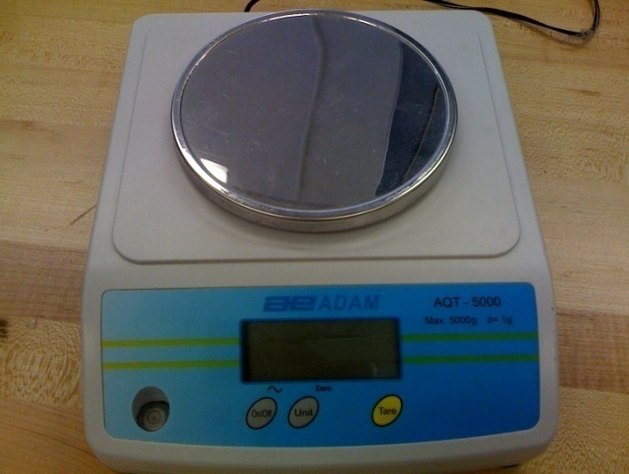
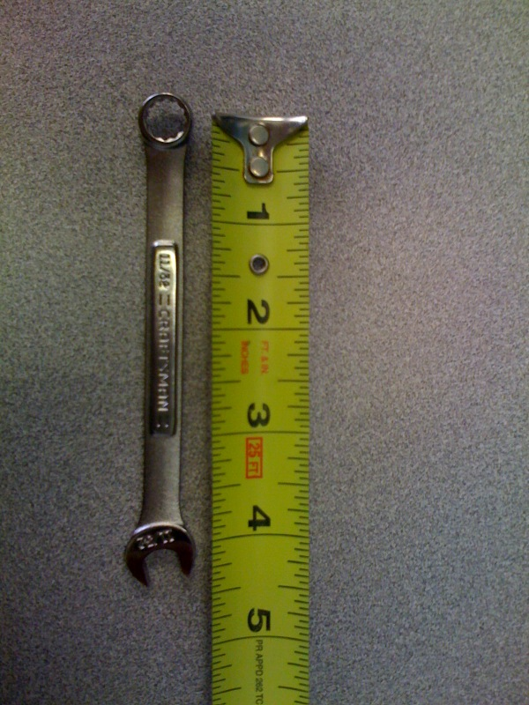
The equipment used included the following items:

Figure 2: Balance measurement AQT 5000 from Adam Equipment
Figure 1: 4.25 in wrench

Procedure
We placed the wrench on top of the valve knob and measured the force needed to jumpstart the valve from the fully close position and the fully open position.
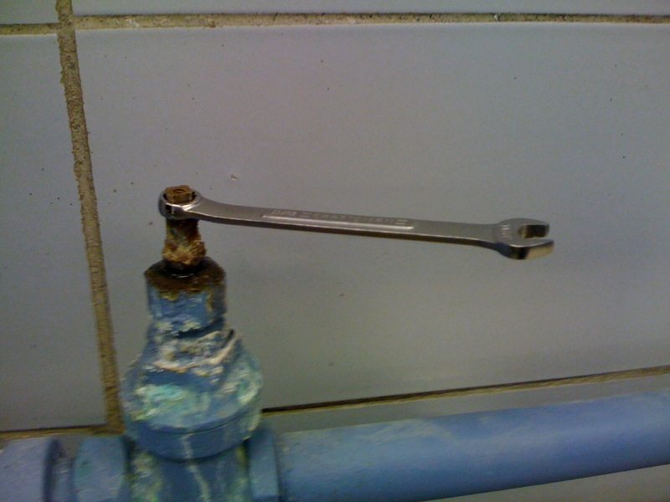
Figure 3: Wrench in position

Results
We then performed 10 measurements from each starting position and found the average torque needed to initially move the valve. We then transform the units of torque to include a variety since some motors report torque in different units.
Figure 4: Results from torque measurements

Appendix B

Gantt Chart
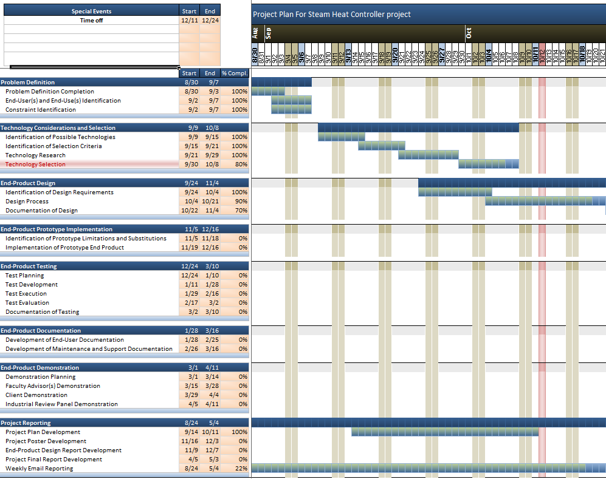
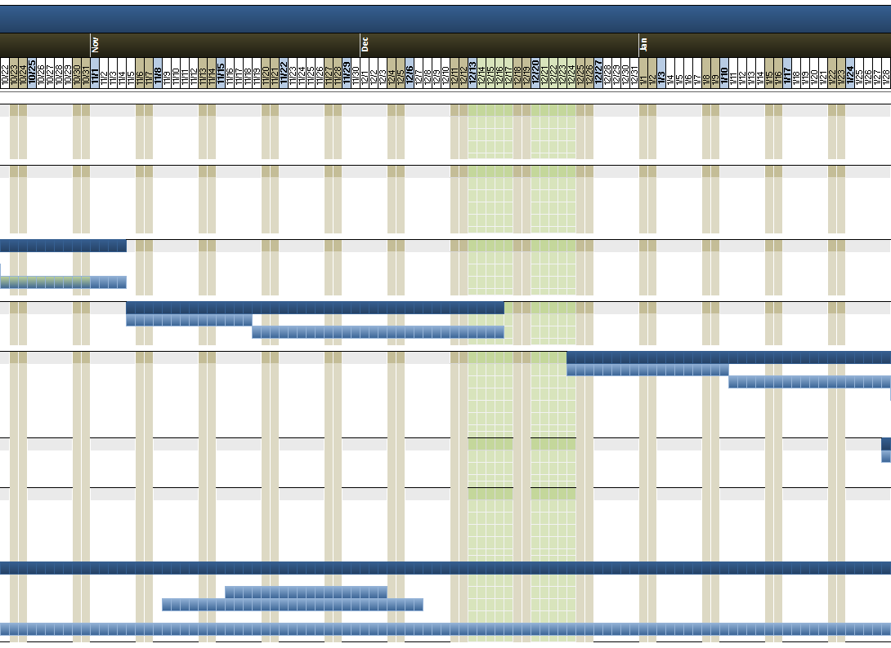
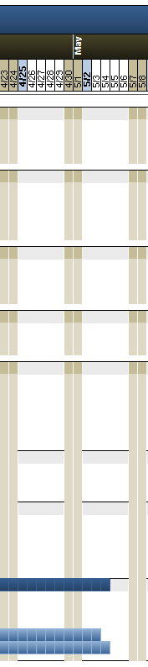
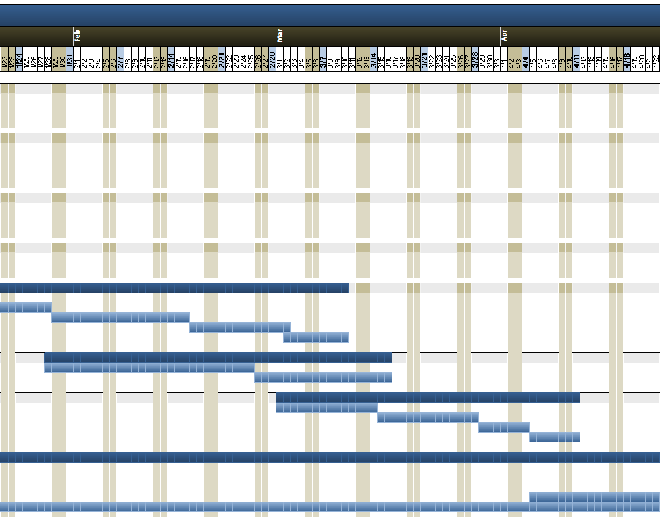

*Please see Gantt chart file for a more accessible view of the Gantt chart

