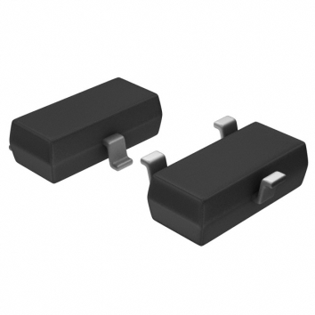
Temperature Sensor

Technology and Technical approach Considerations
The temperature sensor is a mandatory component for the Steam Heat Controller prototype design. Below are some of the technical selection qualifications for the temperatures sensor:
- The team has decided that the temperature sensor should not be embedded on the microcontroller. This will reduce the maintenance cost since the entire microcontroller will need to be replaced if a malfunction or damage occurs to the embedded temperature sensor. By using an independent temperature sensor also eliminates possible reading errors caused by the heat produced by the microcontroller or other components for the prototype.
- The team has decided to use a temperature sensor with a voltage output over digital output. Price is an important factor that needs to be considered when dealing with the temperature sensor. Even though temperature sensors with digital output type have wider sensing temperature range and more accuracy, its price compared to a temperature sensor with voltage output is significantly higher.

Testing requirements considerations
- Temperature range: 0 degrees Celsius to 40 degrees Celsius
- Accuracy: within ±1 degrees Celsius of the real temperature
- Reliability: popular user ratings (over 2500 users)
- Availability: readily available from its distributors (20,000 units in stock )
- Price: $1-$2

Final selection based on qualifications
Digi-Key Part Number | TC1046VNBTRCT-ND | Price Break Unit Price Extended Price  1 0.70000 0.70  10 0.59000 5.90  25 0.49000 12.25  100 0.45000 45.00
Quantity Available | 18,497  Note
Manufacturer | Microchip Technology
Manufacturer Part Number | TC1046VNBTR
Description | IC TEMP-VOLT CONV PREC SOT23B
Lead Free Status / RoHS Status | Lead free / RoHS Compliant
All prices are in US dollars.

Safety considerations
Temperature sensor can malfunction due to incorrect reading or broken sensor. This can lead to huge room temperature fluctuations, which can cause extreme heating or cooling. Possible solutions to this issue are to set a low and high boundary for the motor control unit (15 degrees Celsius to 30 degrees Celsius). Another solution is to have a secondary temperature sensor that would become primary temperature sensor once an error is detected

Possible risks and risk management
Possible Risks includes faulty temperature sensor unit or incompatible with microcontroller. To prevent the risks from occurring, the team will order 10 temperature sensor units and do extensive research on both the microcontroller and temperature sensor before ordering the parts.

References
http://search.digikey.com/scripts/DkSearch/dksus.dll?Detail&name=TC1046VNBTRCT-ND

