# Mechanical Implementation

The steam valve controller has a large mechanical implementation which is needed to perform the physical turning of the steam valve. The initial investigation into possible solutions revealed a variety of design choices in choosing components and choosing capabilities. At the top level of the mechanical implementation, we consider the electric motor, motor driver circuit, and the controller box platform.

## Electric Motor

In choosing the appropriate motor for turning the steam valve, we considered characteristics of motors one by one and identified the appropriate characteristics for our needs. We looked at type of electric motor, operating supply voltage, torque requirement, speed requirement, availability, functionality, safety, and cost.

### Type of Electric Motor

At the highest level, we looked at the advantages and disadvantages for AC versus DC motors and not consider the different technologies with AC and DC motor designs for now. The advantages and disadvantages are shown in figure 1.



Since our project requires a high level of control of the steam valve, speed, torque, and positioning control are major concerns. Because of those functional requirements, we are willing to shoulder the higher cost, larger size, higher maintenance, lower reliability, and additional circuitry to use a DC motor in our design.

### Operating Supply Voltage

We consulted our clients' expertise in choosing an appropriate operating supply voltage. Their recommendation was 12V to 24V would fit our needs. However, they mention that there will be tradeoffs for choosing higher operating supply voltage like power consumption. Since we want our product to have low power consumption and use that as a selling point, we will be choosing a DC motor that can operate at low supply voltage and still deliver reasonable performance.

### Torque Requirement

To ensure that selected motor would be able to turn the steam valve, we performed torque measurements on the steam valve to set a lower limit on the torque requirement. The data was gathered using a wrench and balance measurement machine to get an estimate of the minimum torque needed to turn the steam valve clockwise and counterclockwise at its open and close positions. This set up was to ensure that worst case scenario would provide the true minimum torque requirement.

The results of the data can be viewed in Appendix A. The minimum torque requirement is approximately 0.632 lb*ft for both clockwise and counterclockwise turns. We will only consider motors with torque output greater than 0.632 lb*ft.

### Speed Requirement

We investigated the speed requirement and consulted with our clients about their own preference on the requirement. For the steam valve, testing reveals approximately five revolutions from fully close to fully open. We then conferred with the clients to see which speed would be appropriate. Their response was one revolution per 10 seconds would be appropriate.

As the clients have requested one revolution per 10 seconds, we will set this speed as our requirement when choosing a motor for our design.

### Availability

Although we are limited to producing one or two prototype products in the short term, our clients are interested in expanding the scope of the project and will possibly have more rooms within in Coover that need to be outfitted with our steam valve controller. Older buildings on the Iowa State University campus would also be an option to expand the scope and uses of the project. Once we can demonstrate the feasibility our project to client, the prototype could by mass produced and use for years to come.

With that in mind, our clients want components that have available for the next 5 to 10 years for maintenance and repairing operations. Although we cannot guarantee the life time of a product, we will be proactive in demonstrating the availability of the product in considering the motor.

### Functionality

For the motor, we require two specific functionalities: shaft encoder and reversible motor. The shaft encoder is essential for converting the angular position of the motor shaft to a digital code. There are three types of binary logic level technologies: CMOS, TTL, and ECL. The operations of all three are shown below.



Since we are not dealing with negative voltage biasing, we are looking to use either CMOS or transistor-transistor logic (TTL). Either standard will allow effective communication between the shaft encoder and microcontroller. This is a functional requirement and we will look into possibly choosing a motor with integrated shaft encoder or a motor outfitted with a shaft encoder. For both choice, there will be a requirement that the shaft encoder communicate using CMOS or TTL.

The second functionality required for the motor is the ability to turn both clockwise and counterclockwise, or reversible operations. This requirement removes the possibility of using servo motor since their range is limited to within one revolution. The reversible operation requirement confirmed our previous design choice to use a DC motor over an AC motor.

The DC motor requires a complementary shaft encoder, either integrated or detached.

### Safety

Safety is a real concern for the mechanical implementation. Our clients are concern about fire hazards should there be any malfunctions with the motor. One method to reduce this safety concern is by use of the shaft encoder. Because the shaft encoder relays information about the movement of the motor, any unresponsive movement from the motor after issuing a movement command would indicate failure in the motor. This will prevent burn out of the motor and in turn decrease the potential for fire hazards.

The other method of reducing potential fire hazards is to choose an accompanying motor driver circuit with over current protection or over temperature protection, preventing burn out of the motor. Our clients are actively concern about the safety of the product and are willing to spend additional funding to provide both solutions. We are required to have a shaft encoder to use with the DC motor and a motor driver circuit with over current protection and over temperature protection.

### Cost

Cost is a concern for our clients. They want a design that would be appropriately priced for campus-wide implementation. However, we have to balance cost with required features previously presented when considering the DC motor. We have talked with the clients and their funding will allow for prioritizing the motor and any moving components, since they are more prone to degradation and safety concerns.

### Summary

We summed up our design considerations for the electric motor in the table below.



## Motor Driver Circuit

In conjunction with the DC motor, we will choose a driver circuit to regulate the DC motor. In choosing the appropriate driver circuit, we will need to choose the DC motor beforehand in order to define the minimum requirement for the driver circuit. Some of these considerations are operating supply voltage, accepted input standard, current output, safety, and cost.

### Operating Supply Voltage

The operating supply voltage of the driver circuit will depend on the DC motor that we will use.

### Accepted Input Standard

Since the microcontroller will be controlling the driver circuit through a digital signal, the driver circuit will need to accept either CMOS or TTL logic level communication.

### Current Output

The maximum current output of the driver output should be able to meet the needs of the DC motor. This requirement will be dependent upon the DC motor that we will choose.

### Availability

Similar to the DC motor selection criteria, we will aim to identify driver circuits that will be generic and widely available 5 - 10 years out. This is provide supplies for repair and maintenance after mass implementation of the design on the Iowa State University campus.

### Safety

The driver circuit will be critical in providing the safety mechanism for the DC motor. The over temperature protection available in some driver circuits would be a plus in ensuring our DC motor avoids burn out. Over current protection will be in addition to the over temperature protection and provide further mitigation of burn out events. We will try to find a motor driver circuit that provide both features.

### Cost

We will try to minimize cost in choosing a motor driver circuit which still meets the requirements listed above. Many of the factors will be determined after our selection of the DC motor.

### Summary

We sum up our design considerations for the motor driver circuit in the table below.



## Controller Box Platform

In considering the platform to hold all the electrical components near the steam valve, our clients recommended using extrusion aluminum to be the material of choice to use in the design of the platform. With our clients’ expertise in platform design using this type of material, we strongly believe that using this material will leverage our clients’ mechanical expertise and compensate for our lack of mechanical experience.

Once we have all the major components including the microcontroller, motor, and power supply on hand, we will work with the clients to craft the platform to house all the components. Since there are potential variations in the physical arrangement of the steam valve, the platform implementation will need some custom modifications. However, we will strive for modularity of the controller box platform.

## Testing Requirements Considerations

In testing the DC motor and motor driver circuit, we have a selection of items available from the Ecpe resource department. We plan to use an Atmel microcontroller available from the Ecpe resource department to test different selections of available DC motors and motor driver circuits.

Once we feel comfortable with a particular DC motor and motor driver circuit, we will put an order out through the Ecpe resource department and begin formal testing of our chosen components.

For the testing, we will test for functionality, safety, and reliability of each component of the mechanical interface before moving forward in integrating the DC motor, motor driver circuit, and controller box platform.

## Integration

After formal testing of the individual components, we will work with the clients in crafting the controller box platform to house the DC motor. The motor driver circuit will probably have to wait since it will be integrated with the PCB housing the microcontroller.

The power supply will also need to be chosen before crafting the final design of the controller box platform. Once we have the controller box platform completed, the DC motor selection will be finalized, but the motor driver circuit will have some flexibility in placement on the microcontroller PCB.

### **Possible risks and risk** **management**

Integration of the DC motor, motor driver circuit, and controller box platform poses a high risk for delay. This is due to the controller box platform requiring other components to be finalized before working with our clients to design the platform. One way we going to manage this risk is by working on other modules side by side in schedule with the mechanical implementation.

Another potential risk is scheduling work time with our clients during the construction of the controller box platform. Our clients have responsibilities pertaining to their full time work that could impede the schedule. One way we are going to manage this risk is by providing flexibility in our schedules and accommodating our clients' schedule to speed up the controller box platform implementation. We will also try to have components, design requirements, and prepared design documents readily available when we work with our clients.

# References

Boley, Brian L. "Overview Tutorial of Electric Motor Types." Odd Parts. Web. 23 Sept. 2010. <http://www.oddparts.com/acsi/motortut.htm>.

"Logic Level." *Wikipedia, the Free Encyclopedia*. 21 June 2006. Web. 24 Sept. 2010. <http://en.wikipedia.org/wiki/Logic_level>.

# Appendix A

To ensure that selected motor would be able to turn the steam valve, we performed torque measurements on the steam valve to set a lower limit on the torque requirement. The data was gathered using a wrench and balance measurement machine to get an estimate of the minimum torque needed to turn the steam valve clockwise and counterclockwise at its open and close positions. This set up was to ensure that worst case scenario would provide the true minimum torque requirement.

## Equipment

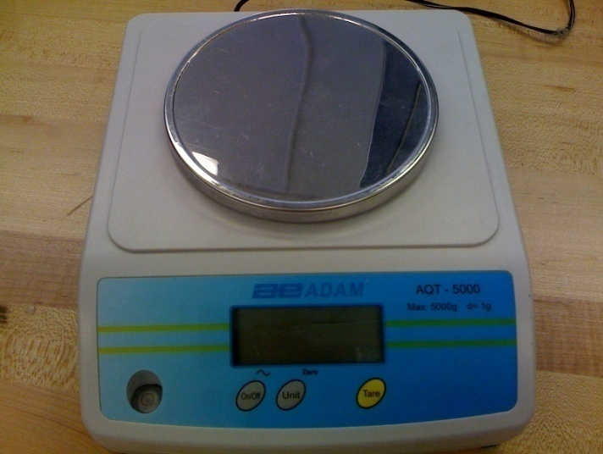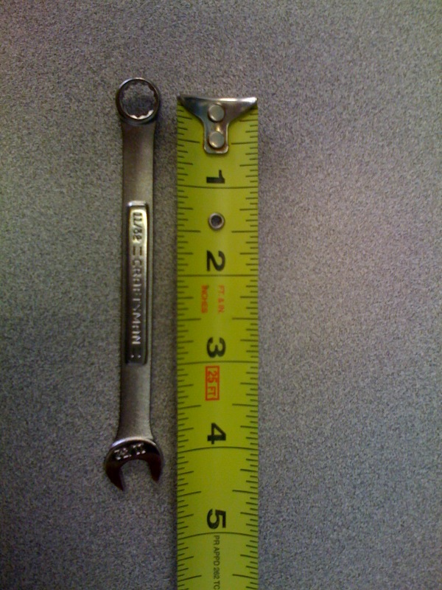The equipment used included the following items:

Figure 2: Balance measurement AQT 5000 from Adam Equipment

Figure 1: 4.25 in wrench

## Procedure

We placed the wrench on top of the valve knob and measured the force needed to jumpstart the valve from the fully close position and the fully open position.

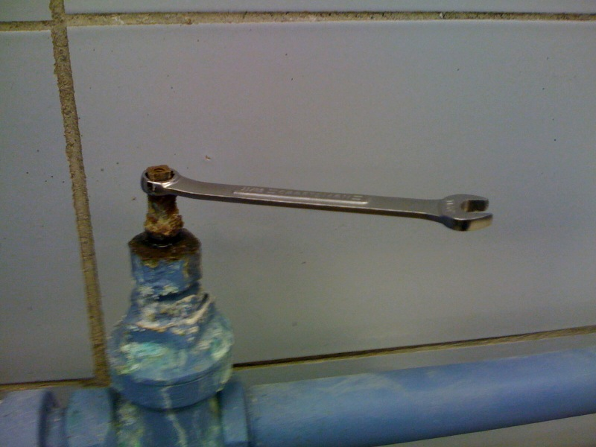

Figure 3: Wrench in position

## Results

We then performed 10 measurements from each starting position and found the average torque needed to initially move the valve. We then transforms the units of torque to include a variety since some motors report torque in different units.

Figure 4: Results from torque measurements

