Student Name: Curtis Foster

Class and Section CIS 2212 103

# Assignment: Consecutive Equal Numbers

## Problem Description:

Write the following function that tests whether a two-dimensional list has four consecutive numbers of the same value, either horizontally, vertically, or diagonally.

**public** **static** **Boolean** isConsecutiveFour(**int**[][] values)

Write a test program that prompts the user to enter the number of rows and columns of a two-dimensional list and then the values in the list. The program will display.

Found four consecutive occurrences of *n.*

if the list contains four consecutive numbers with the same value *n*. Otherwise, it will display.

Did not find four consecutive occurrences.

Here are some examples of the true cases:

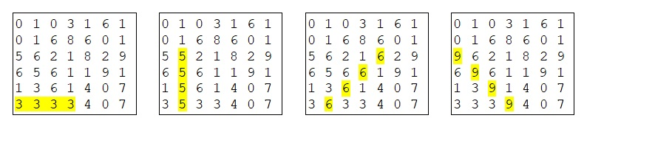

**Analysis:** (Describe the problem including input and output in your own words.)

In the main method, I will declare scanner object to collect input from the user for number of rows and columns. I will need to loop to iterate through the array for filling and searching horizontally.

**Design:** (Describe the major steps for solving the problem.)

* Import Java Utility Scanner
* Declare public class.
* Declare main method.
  + Prompt User for number of columns.
  + Declare integer variable “numberOfColumns” to scanner method for next Prompt User for number of rows.
  + Declare integer variable “numberOfRows” to scanner method for next int.
  + Declare 2-D array “values”.
  + Assign the 2-D array “values” to new integer and assign length of array row to “numberOfRows” and columns to the “numberOfColumns”.
  + Declare selection statement that calls “isConsecutiveFour” and outputs “Found four consecutive or did not find four consecutive occurrences. “
  + Declare a loop to iterate through rows of the “values” array.
    - Declare a nested loop to iterate through the columns of the “values” array.
      * Prompt User to enter a number.
      * Declare integer variable “numbers” to scanner method for next int.
      * Declare “values” with index of rows and columns to the number.
  + Declare a selection statement that calls the method: “isConsecutiveFour”.
* Declare “isConsecutiveFour” method that takes 2-D array “values”.
  + Declare selection statement that returns either horizontal, vertical, or diagonal search.
* Declare method “isThereFourHorizontal” method that takes 2-D array “values”.
  + Declare a loop that iterates through the 2 – D array for the rows and columns.
  + Declare a local variable in column loop assigned to first values of column.
    - Declare a selection statement that checks the 2, 3, 4 and returns true.
    - Declare a selection statement that calls “verticalSearch” if not found.
* Declare method “verticalSearch” method that takes 2-D array “values.
  + Declare a loop that iterates through the 2 – D array for the rows and columns.
  + Declare a local variable in column loop assigned to first values of column.
    - Declare a selection statement that checks the 2, 3, 4 and returns true.
    - Declare a selection statement that calls “diagonalSearch” if not found.
* Declare method “isThereFourDiagonal” method that takes 2-D array “values.
  + Declare selection statement that returns either diagonal left to right or diagonal right to left search.
* Declare “isThereFourDiagonalLtoR” method that takes 2-D array “values”.
  + Declare a loop that iterates through the 2 – D array for the rows and columns.
  + Declare a local variable in column loop assigned to first values of column.
    - Declare a selection statement that checks the 2, 3, 4 and returns true.
    - Declares selection statement that calls the second “diagonalSearch” if not found.
* Declare a second “diagonalSearch” method that takes 2-D array “values.
  + Declare a loop that iterates through the 2 – D array for the rows and columns.
  + Declare a local variable in column loop assigned to first values of column.
    - Declare a selection statement that checks the 2, 3, 4 and returns true.
    - Return false if not found.

**Coding:** (Submit the archive file)

**Testing:** (Describe how you test this program)

Used the debugger to check for values, used the console to check