Student Name: Curtis Foster

Class and Section CIS 2212 103

# Assignment: Investment-Value Calculator

## Problem Description:

Write a program that calculates the future value of an investment at a given interest rate for a specified number of years. The formula for the calculation is as follows:

futureValue = investmentAmount * (1 + monthlyInterestRate)years*12

Use text fields for interest rate, investment amount, and years. Display the future amount in a text field when the user clicks the Calculate button. Sample interface is shown in the following figure.

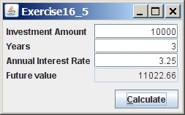

**Analysis:** (Describe the problem including input and output in your own words.)

This would require four text field and I will use anonymous labels and use a grid pane to order the scene along with a calculate button to handle an action event.

**

**Testing:** (Describe how you test this program)

I made debug class with a main method and used default value through the constructor to check the values.