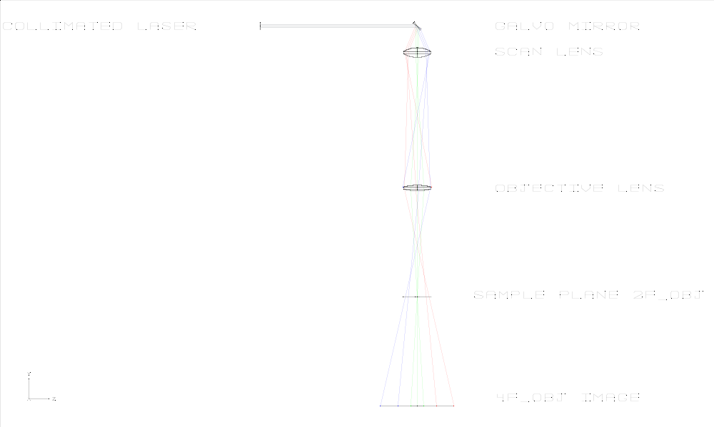
f_scan = 25 mm, f_obj = 50 mm. Galvanometer mirror angles = ±11.5°. Image formed at 4*f_obj confirms my suspicion that light goes out from the objective lens when remitted from a flat mirror placed at the sample plane, the size of the image at 4*f_obj is around 35 mm, larger than the lens diameter (25.4mm). Notice how the rays at different mirror angles, focus at different depths near the sample plane. Transmission = 77-79% for all the galvo positions.
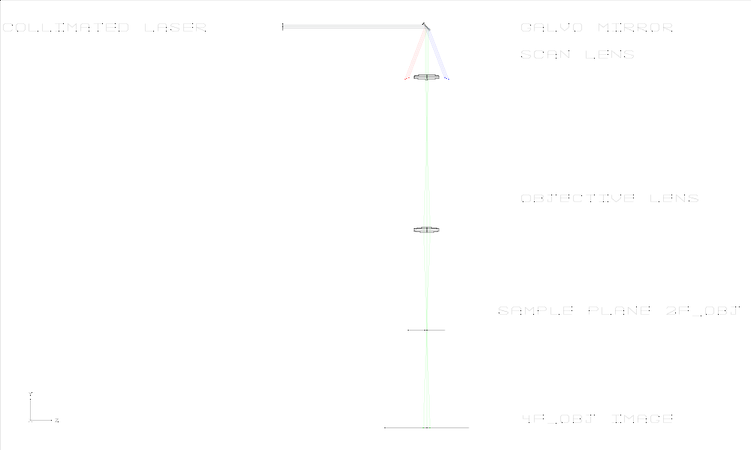
f_scan = f_obj = 50 mm. Galvanometer mirror angles = ±11.5°. It is even worse, the rays go out the scan lens, so it doesn’t help much.

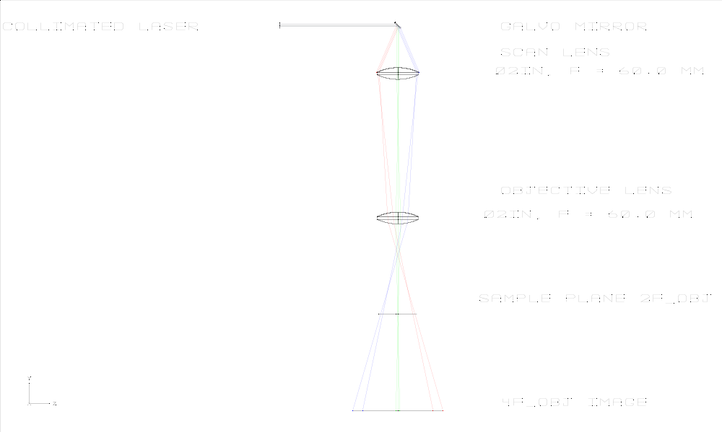
With a 2in lens of focal = 60mm, we have clipping in the scan lens, we have 79% transmission for the center position of the galvo and 58% transmission for the extremes. The image at 4f is still larger than the diameter of the objective lens, but I begin to think it is unavoidable for all the configurations tested.

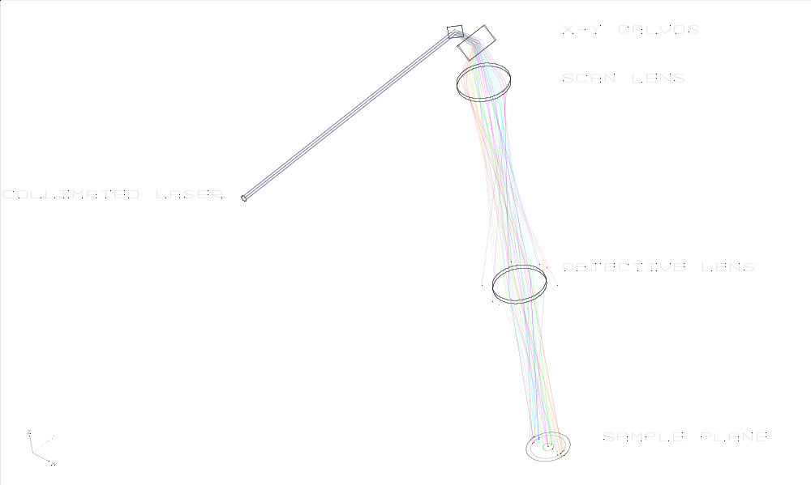
Implementation of the x-y galvanometric scanning system.

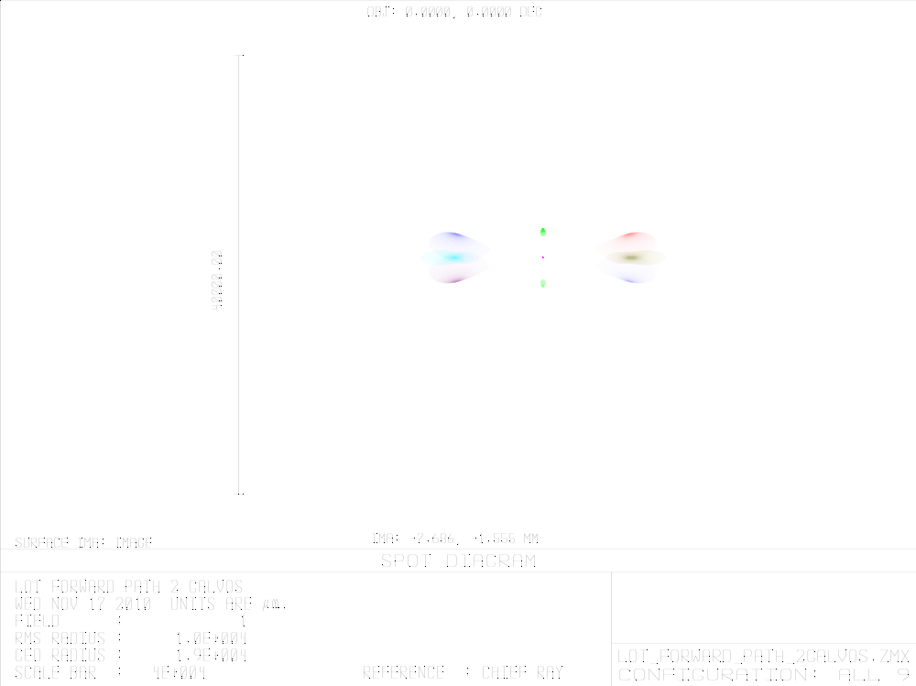
Spot diagram for several positions of the galvanometers, we cannot keep a good focus on the image plane, due to the movement of the mirrors, gotta try a telecentric system. Transmission from 55% in the sides up to 75% in the center.

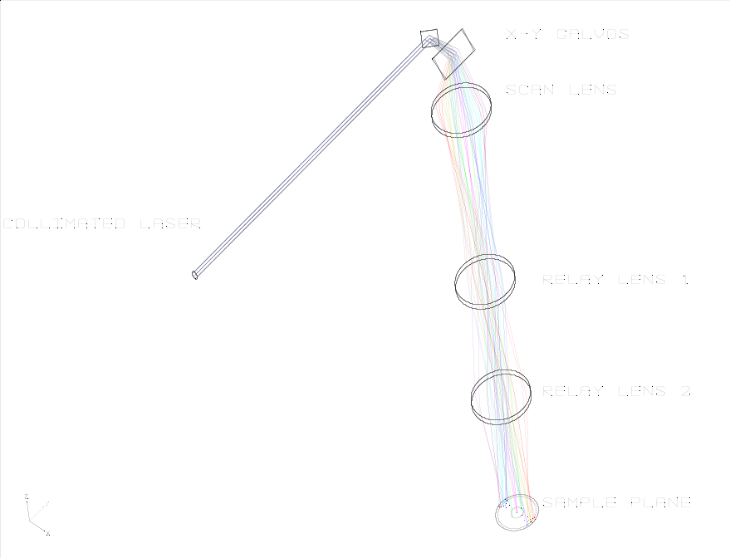
Quasi-telecentric design

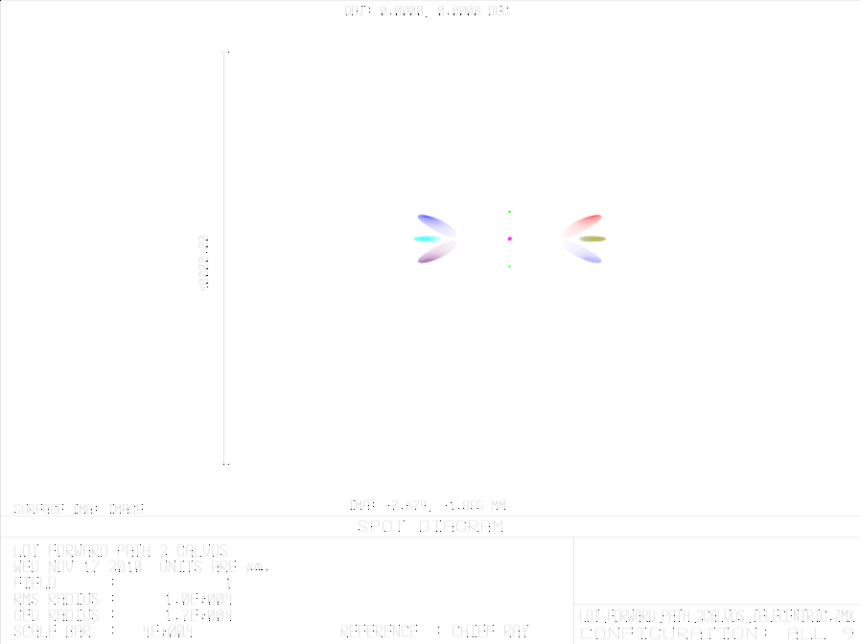
The spot is distorted outside the center of the FOV, although it is less enlarged than in the original configuration. Transmission 67-69%.

