Dear [NAME],

My name is Curtis. I am an engineer by trade and a web developer by passion.

Reading through your website, I was really inspired by what [COMPANY NAME] is doing and would love to be a part of it. In particular, I liked [ATTRIBUTE 1], and think that I’d be a great fit with the company culture.

Personally, I’m always trying to learn and improve. My motto as a developer is if I am the smartest person in the room, I am in the wrong room. I love learning and want to become the best developer I can be. I also love to create, both in my career and in my free time.

For example, here’s a glimpse at a couple full-stack websites I’ve recently created:

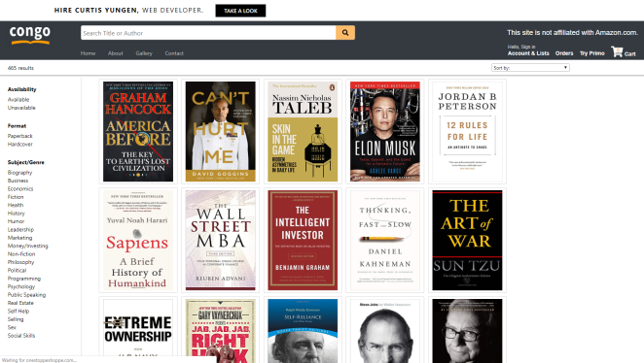**Congo:** a website to sell my book collection.

**Outwork:** a website where users can log workouts and compete for titles.

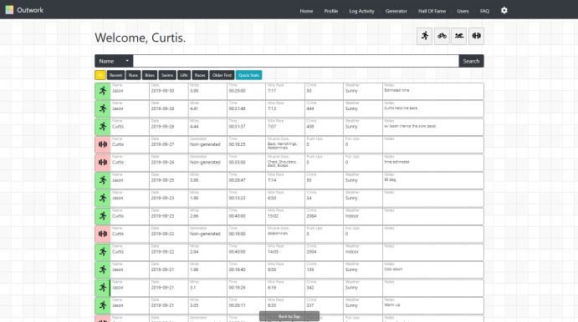

You can explore these projects as well as learn about the technology I used by checking out my portfolio here: <https://curtisyungen.github.io/Portfolio>.

Currently, I’m working on learning Typescript as well as studying algorithms and data structures. If you and I were to work together, I’d be fully committed to helping your project succeed and contributing to it as best as I can.

I look forward to hearing from you!

Sincerely,

Curtis Yungen