Dear Zonar,

My name is**Curtis Yungen**. I'm an engineer by trade and a developer by passion. I came across your job posting for a **Software Developer I** on LinkedIn and believe I'd be a great fit for the position.

I’ve been an engineer at Boeing for the last seven years, but I recently graduated from a coding boot camp and have discovered that my real passion is in web development. Since graduating the boot camp, I’ve spent nearly all my free time continuing to build my skills as a developer.

For example, here’s a glimpse at a couple projects I’ve recently created using HTML, CSS, JavaScript, NodeJS, and React:

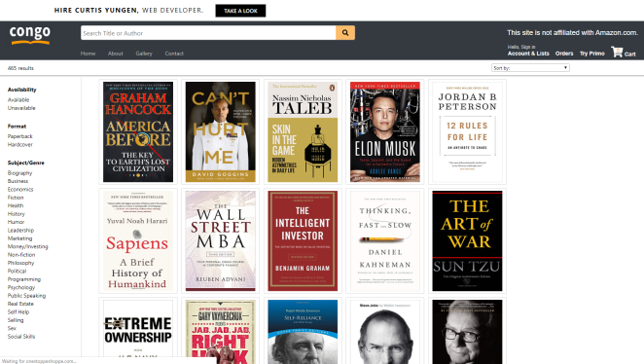**Congo:** a website to sell my book collection.

**Outwork:** a website where users can log workouts and compete for titles.

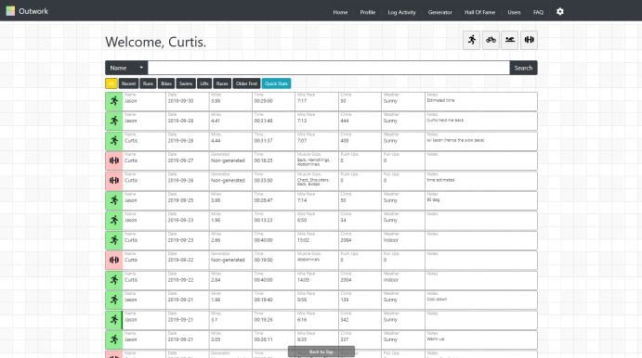

You can explore these projects and see the technology I used by checking out my portfolio: <https://curtisyungen.github.io/Portfolio>.

My philosophy as a developer is that I should always be learning and seeking new challenges. I try to put myself in places where I’m a little fish in a big pond. I enjoy technology and want to be the best developer that I can be.

I'd love to have an opportunity to discuss with you the Software Developer I position or another role that would better suit my qualifications.

In the meantime I’ve attached my resume, and once again you can check out my portfolio here: <https://curtisyungen.github.io/Portfolio>.

I look forward to hearing from you.

Sincerely,

Curtis Yungen