**NOTES FOR PREPARATION OF POSITION DETERMINATION AND BEHAVIORAL MODIFICATION WEARABLE DEVICES PATENT APPLICATION**

**SUMMARY**

**Summary - Engineering Around Our Own Patent:** In reviewing material for this patent application I have often asked myself ‘if I wanted to engineer my way around this patent, what would I do?’ The core innovation of this device is the application of an array of thermal sensors to establish presence or absence of a human body (torso), and to determine the position of the sensors relative to the body if a body is detected. The habit awareness and feedback version of the device makes a very limited use of this innovation with just four to five sensors worn on the body and directed outward, covering a field of view of approximately 180 degrees by 80 degrees. This limited implementation only allows for the detection of proximity to a pre-targeted (recorded) portion of the body. Any number of array configurations are possible to achieve a variety of purposes.

*If I were a competitor and wished to build something which mimicked our device as closely as possible while still clearly not in violation of any sort of patent we might obtain I would either employ a miniature thermal camera mounted on the wrist or a flat thermopile grid array sensor such as the Panasonic Grid-EYE 8x8 64 thermopile sensor mounted on the wrist.* Most digital cameras, both thermal and normal visible light, can be thought of as sensor arrays. Because most thermal sensors do not discriminate based on frequency, the images they create are essentially monochrome. Each pixel in an image can be compared to a single thermopile value in a thermopile array. Although the Panasonic Grid-EYE sensor is explicitly an array of thermopiles as opposed to a full on “camera”, for my purposes they are conceptually the same.

*This paper describes how gesture detection can be accomplished using a ‘flat’ thermopile grid array sensor: “Hand Waving Gesture Detection using a Far-infrared Sensor Array with*

*Thermo-spatial Region of Interest”*

*http://www.murase.nuie.nagoya-u.ac.jp/publications/1334-pdf.pdf*

*We are differentiated from this method by the following:*

1. *Thermopile array positioned so that thermal sensor elements are pointed in different directions*
2. *Placement on the wrist*
3. *Use for behavior modification including user alert and behavior information tracking (in the case of behavior modification device)*

Parallels between thermopile arrays, including our thermopile arrays, and what are more traditionally thought of as thermal cameras extend beyond hardware. Our data processing firmware and software uses machine learning techniques that are very popular in image analysis. Existing prototype firmware and software leans heavily on open source neural network machine learning algorithms and code. When writing code for data analysis we conceptualize everything we do with thermopile array data as image processing and image recognition. When we set a target for a certain part of the head, we are taking a thermal picture of that part of the head and surrounding area. When we detect proximity to that target, we are essentially comparing a live thermal video feed from the device to the stored thermal image of the target and determining how similar they are.

In addition to an outright comparison between divergent thermopile arrays and grid or camera-based solutions, it is worth considering a hybrid approach. Our innovation extends to any sort of thermal sensors which have been arranged in an array such that they are oriented in non-parallel directions. So if we were to replace the single-pixel thermopiles in our device with a multitude of thermal cameras or Panasonic Grid-EYE sensors, this would still be within the realm of our invention.

**Summary - Invention Fundamentals:** Although the cost/benefit distinctions between our device and a hypothetical mimic using a thermal camera or flat thermopile grid are many, the primary distinction is the physical spacing and orientation of the device’s thermopile sensors. Compared to a thermal camera or single-sensor thermopile array, our sensors are spaced very far apart. This has significant advantages at close proximity. Most significantly of all, our sensors our positioned at divergent angles. This is advantageous for a number of reasons, notably area of coverage and determination of distance. The minimalist four-thermopile array on one of our habit awareness prototypes has a larger viewing angle than the Panasonic 64 thermopile array or any thermal camera. The current absolute position prototype has hemispherical coverage (180x180 degrees) with just 15 thermopiles. Theoretically (Figures 11 and 12) it might be possible to approach total spherical coverage using a toroidal or other novel configuration.

The language used to make distinctions related to our thermopile array position(s) might be particularly important. Here are some synonyms or leads worth pursuing:

Area from which Sensor/Array can obtain data:

* “Field of view”
* “Viewing angle”
* “Viewing area”
* “Frustum”
* “Viewport”
* “Coverage”

Describing the unique configuration of our sensor array:

* “Divergent angles” (angle)
* “Non-parallel” (angles/directions/lines of sight)
* “Non-collimated” (angles/directions/lines of sight)
* “Distributed” (position)
* “Spread out” (position)

In deciding on what language to use it may be useful to review documentation for the thermopile sensor we use, the MLX90615: https://www.melexis.com/en/product/MLX90615/Digital-Plug-Play-Infrared-Thermometer-Ultra-Small-TO-Can

**Advantages of a distributed, divergent array of thermopiles over thermal cameras and ‘flat’ thermopile grid array sensors:**

* Traditional thermal cameras are usually much larger - a general disadvantage but especially unsuitable for wearables.
* Traditional thermal cameras are much more expensive. The total cost our behavior modification prototype is $38 (not including replacement wristband and using $26 AliExpress price for base device).
* Traditional thermal cameras consume large amounts of power, making them unsuitable for battery-powered devices. Thermopile sensors are in general extremely low-power.
* Traditional thermal cameras are much higher resolution (thousands of pixels vs. our 15- thermopile ‘pixels’) and require significantly more computational power for analysis.
* Traditional thermal cameras, with their higher resolution, could elicit privacy concerns.
* Even with sophisticated lenses, traditional thermal cameras have a more limited field of view.
* Because all sensor elements in a traditional thermal camera or integrated thermopile grid sensor are concentrated in a small area, at close proximity to an object they can only detect an area of the object of approximately the same size as the grid sensor itself. Even by spacing sensors a single centimeter from each other we are able to greatly increase performance when placed at close proximity to an object. This is particularly important for use in conditions such as trichotillomania, excoriation, and nail biting, where the gesture being detected involves close proximity of the hand and device to the skin or proxy. By using multiple independent thermal sensors spread across the surface of our device we are able to obtain more valuable data at close range.

**COMPETING TECHNOLOGY AND DEVICES**

**1) Electric Near-Field Sensors:** Detects disturbances in an electric field with to obtain 3D coordinate of the object doing the disturbing. This is possibly the only true 3D coordinate position sensor small enough to fit in a wearable device currently on the market. The sensor, integrated into an IC with supporting MCU and firmware, will spit out 3D coordinates right off the shelf. However it has about a 10cm functional range, far from arm’s distance possible with our absolute position device. Just as important, it does not have the ability to differentiate what it detects based on temperature.

<https://www.microchip.com/design-centers/capacitive-touch-sensing/gestic-technology/technology/sensing-method>

<https://www.google.com/patents/WO2016026947A1>

**2) IR Gesture detection with multiple IR photoreceptors:** These devices use multiple near-visible IR proximity sensors to detect hand waves and the like. They are 2D, not 3D in terms of function.

An example is the APDS 9960: <https://www.broadcom.com/products/optical-sensors/integrated-ambient-light-and-proximity-sensors/apds-9960>

Also see: <https://www.silabs.com/documents/public/application-notes/AN580.pdf>

**3) HabitAware Keen Device** (<https://www.habitaware.com/>)

This wearable device with vibration alert is designed to do the exact same thing as our behavior modification device. We have a copy of the device. We have tested it, taken it apart and know exactly how it works. It is described in detail in the provisional patent application. Because it depends entirely on an IMU (they use a chip, the MPU 9250, which contains an accelerometer, gyroscope and magnetometer) sensor it cannot differentiate between identical angular positions and thus performs extremely poorly. The number of false positives when using the device is fairly extreme.

**4) Pavlok Behavior Modification Wearable Device** (<https://pavlok.com/>): This device shocks users with an electric charge when they exhibit the undesired behavior. It doesn’t actually detect the undesired behavior, users press a button to shock themselves.

**5) Leap Motion and Kinect 3D cameras:** These devices use a combination of side by side cameras (the way 3D videos are filmed) and near-visible IR proximity detectors to track motion and gestures in 3D coordinate space. They are not mobile or wearable. They must be set up in a stationary position in front of the user and anything not in their field of view cannot be detected.

<https://www.leapmotion.com/>

https://en.wikipedia.org/wiki/Kinect

**6) Oculus and HTC VR Controllers as well as Google Tilt Brush:** All of these devices use an array of IR LEDs spread out over a hand held controller, and a stationary near-visible IR sensitive camera at a distance from the user. The LEDs act as “markers” just like the colored balls actors attach to themselves when doing motion capture for Hollywood movies (like Gollum in Lord of The Rings). The fact that the LEDs can be quickly turned on and off makes it that much easier to pick them out of the video feed, since this action can be coordinated between controller and camera. The arrangement of LEDs as perceived by the camera changes depending on the location and angular position (where its pointed) of the hand held controller. The geometry of this arrangement is analyzed to determine position. It is not a mobile solution, you have to have a camera setup in addition to the controller and you have to stay within view of the controller - if you turn around and face away from the controller it won’t capture your gestures. Lack of mobility makes it a non-starter for behavior modification and is in general a major disadvantage. Another disadvantage of marker based solutions is size: markers, whether IR LED or anything else, must be spaced out enough for a camera to adequately distinguish them.

<https://www.ifixit.com/Teardown/Oculus+Touch+Teardown/75109>

<https://ifixit-guide-pdfs.s3.amazonaws.com/pdf/ifixit/guide_75109_en.pdf>

<https://www.tiltbrush.com/>

**7) Markerless ‘Inside Out’ Tracking:** Our position detecting device is a markerless ‘Inside Out’ tracking solution. There are many large companies spending a lot of money and time in pursuit of an effective markerless ‘Inside Out’ solution. They are by and large failing. If we are successful with this device, this is an area where our intellectual property may be very valuable. It may be worth exploring patents in this area for prior art research, particularly Google and Sony. Our expectation is that this will be one of the areas where prior art research is most focused. Most of the solutions we have read about involve using a camera or multiple cameras worn by the user, usually on a VR or AR headset, to construct a 3D model of the environment surrounding the user. Data from these cameras is used to determine the position of the user (or part of the user) in reference to this 3D model of the environment. Our device does exactly this, though our focus is on the human body. We do not actually create a 3D model of the human body per say, but the information inherent to a 3D model of the human body is incorporated into neural network training. The 3D model of the body is embedded inside the neural network so to say, though neural networks are “black boxes” so it is impossible to extract that information from a trained neural network in recognizable form. All of the discussed reasons that a divergently angled thermopile array is superior to a camera or flat thermopile grid array for position tracking apply here. In addition there is the hope that, unlike the surrounding environment (house, car, boat, plane, whatever), the human body can be generalized whether it be in the form of a 3D model or trained neural network equivalent. General environment based solutions might have to construct a new model of the environment every time they are used because of the extreme variety in 3D geometries of possible environments. The shape of the human body however is relatively predictable. Our device may be able to function with a generalized model of the human body (they can be pre-trained or only trained once by the user). Because thermal sensors can isolate the body from the rest of the environment so easily they are uniquely suitable for leveraging the predictable shape of the human body.

https://www.wareable.com/vr/inside-out-vs-outside-in-vr-tracking-343

<https://xinreality.com/wiki/Markerless_inside-out_tracking>

https://xinreality.com/wiki/WorldSense

<https://uploadvr.com/new-sony-patent-filed-inside-out-vr-tracking/>

<https://www.marxentlabs.com/markerless-augmented-reality-marxent-part-1/>

https://www.theverge.com/2017/8/24/16195850/microsoft-wand-augmented-reality-mixed-reality-controller

*Other companies pursuing wearable hand tracking or position tracking technologies:*

**8) Noitem:** http://hi5vrglove.com/

<https://www.crunchbase.com/funding-round/a228bb3255b9de26346c2f74b908e971>

There are a variety of glove based controllers on the market. Gloves look silly and have a variety of other obvious disadvantages. The fact that our device is extremely small and can be worn on the underside of the wrist is a distinct advantage. The position detection prototype thermopile array could potentially be miniaturized to something the diameter of a penny. You may be confused by the way DOF (degrees of freedom) are referenced. Some people will say that their device is 6 or 9 DOF simply because they have multiple IMU sensors which detect angular position. For example, some chips (MPU 9250 and others) contain an accelerometer, gyroscope and magnetometer all in a single package smaller than a pencil eraser. Some people would refer to the MPU-9250 as a “9DOF” sensor. This is misleading though, it is really three 3DOF sensors. These three 3DOF sensors might be combined to obtain a more accurate measure of angular position (3DOF) but they do not add up to 9DOF.

**9) Ommor:** <http://spectrum.ieee.org/view-from-the-valley/at-work/start-ups/for-precise-hand-tracking-in-virtual-reality-start-with-a-magnetic-field>

This device is really two devices, one on the hand and another on the torso. Two device solutions are definitely capable of determining position of the hand in 3D coordinate space relative to the torso. An advantage of our solution is that it requires only one device. There are a variety of other disadvantages to the Ommor device, for example magnetic sensors can easily be fooled by magnets or magnetic fields in the environment.

**MPI Hand Tracking Central** lists a wide variety of hand tracking technologies: http://handtracker.mpi-inf.mpg.de/

**NOTE:** There are a wide variety of wrist worn devices that depend mostly on an accelerometer or other IMU for all sensor data. The Nintendo Wii controller, Fitbit and HabitAware biofeedback wearables are essentially the same device from a hardware perspective. They all contain a IMU (accelerometer etc.), a vibration motor, a microcontroller, a radio (Bluetooth etc.) and a battery power supply. The primary thing which sets them apart is the code i.e. firmware on the device and interfacing software for each device’s specific application.

**ILLUSTRATION EXPLANATIONS**

**FIGURE 1**: This illustration is taken directly from the provisional patent application. The components of the device are divided into [a] skin-facing sensor(s), [b] non-sensor components, and outward-facing (thermopile) sensor(s) [c]. The illustration was originally meant to depict use of a single thermopile, since that was the existing design at the time. This can be abstracted to refer to thermopile sensors in general in the case of a thermopile array. Although this illustration may be superseded by other provided illustrations, it might be useful as a point of reference for discussing the many sensors which could be added to the device for a multitude of reasons. Although many types of sensors are available, facing towards the skin vs. away from the body is still a useful distinction. [a] Skin-facing sensors might take the form of a PPG (photoplethysmograph) optical heart rate sensor, pulse oximetry optical heart rate sensor, EEG (Electroencephalograph), ECG (Electrocardiograph), EMG (Electromyograph), EDA (Electrodermal skin activity) sensor, and skin thermometer. Outward-facing sensors [c] may consist of thermal sensors, electric near-field 3D gesture sensors, ambient light sensors, active optical proximity sensors using intensity of reflected light from LED to measured surface to photoreceptor, active optical proximity detectors using time of flight, RGB color sensors, ambient light sensors, GPS, radar, etc.

**FIGURE 2**: This illustration is also taken directly from the provisional patent application. It serves as a general explanation of behavior modification biofeedback devices. It includes supplemental use of sensors which may derive emotive states through biosignals such as heart rate.

**FIGURE 3:** This illustration is also taken directly from the provisional patent application. It outlines the various fundamental components of overall device use. It is still valid, though additional illustrations may serve the same purpose with more specificity.

**FIGURE 4:** An update of **Figure 1** from the provisional, this illustration demonstrates differentiation of thermopile sensor values as determined by viewport coverage around the head. Three thermopiles are included for ease of illustration, though the number could be greater. The device might contain additional components as well, for example a heart rate sensor or temperature sensor facing the skin opposite the device.

**FIGURE 5**: An explicit comparison between thermopile array coverage patterns. If we were to assume that the body uniformly emits thermal radiation corresponding to a surface temperature of 100 degrees, and the background similarly emits as if 0 degrees, T2a, T4b, T2b and T3b would read a value of 100, while T4a and T1b will read approximately 60. The thermopile sensor value is an average across the area of reception. As a thermopile pans from an object of temperature x across a boundary to an object of temperature y, it will produce a gradient from x to y. This is very useful for edge detection. The shape of the individual thermopile coverage areas is simplified; in reality most if not all would be a non-circular ellipse because circular coverage implies that the thermopile direction is perpendicular to the surface (head) and none of the thermopiles are parallel to each other meaning no more than one can be perpendicular to the surface. In fact, T3 and T1 are meant to represent the thermopiles positioned furthest away from the center of the wrist, and will point approximately 160 degrees from each other. This means that as the device changes proximity from the head, thermopile array coverage (“viewport”, “viewing”) area will change greatly. This is extremely significant: it is an advantage over flat integrated grid thermopile array sensors and thermal cameras. Think of a “flat” thermopile grid sensor as a camera with a regular lens and our divergently angled thermopile array as a camera with a fisheye lens. As a camera with a regular lens gets farther away from an object the image changes gradually. As a camera with a fisheye lens gets farther from an object the image changes dramatically. If a thermal camera is 8 inches from the head and backs away to 9 inches from the head, the image will not change much. If one were to run edge detection and pattern detection software against these two thermal camera images it would be difficult to meaningfully differentiate them, at least in our context, where detection software must be extremely complex. In contrast, at 8 inches away from the head at least one thermopile will see the head occluding the torso or background. At 9 inches at least one thermopile will have made a significant shift and see more of the torso or background. The thermopile coverage patterns illustrated here would correspond to a distance of approximately 3 inches from the head, where you would likely detect a target for user alert.

**FIGURE 6:** These are orthogonal views of the 3D model used for 3D printing the thermopile array sensor enclosure for the current absolute position sensing prototype. In real life you would see a single piece of 3D printed ABS plastic. Regardless, it is a depiction of what a ‘general use’ thermopile array might look like.

**FIGURE 7:** Orthogonal views of the absolute position detection device by way of monochrome photos. These could be traced to produce line drawings. The bottom view shows a photoplesmography (PPG) heart rate sensor and battery charging pads.

**FIGURE 8:** Orthogonal views of the 3D model used for 3D printing the behavior modification pilot study device enclosure top cap, including mounts for thermopile sensors, button, switch and indicator LED. This configuration includes 5 thermopile sensors and no IR active optical proximity sensor, in comparison to the currently functional development prototype which has 4 thermopile sensors and one APDS-9960 combined RGB color, proximity and four-point gesture detection optical sensor. This sort of rearrangement is simply a refinement of the underlying invention. The button on top allows the user to interact with the mobile phone app for training and settings from the device. The button also allows the user to temporarily disable the alert function if it becomes annoying or the user engages in an activity (like eating for a nail biting target) that renders alerts superfluous. The indicator LED might serve any number of purposes, the first being a notification to the user that they must sync the device with the mobile app to set the time.

**FIGURE 9**: Orthogonal views of the current functioning behavior modification development prototype by way of monochrome photos. These can be traced to produce line drawings. Four thermopile sensors are visible, exposed on the surface. At the center an APDS-9960 integrated optical sensor is visible. The bottom view shows a PPG heart rate sensor and power switch.

**FIGURE 10:** This illustration depicts a speculative use for the position detection device thermopile array. Head tracking is extremely significant for realistic virtual reality (VR) and augmented reality (AR) experiences. This is partially accomplished with IMU sensors such as accelerometers. However, IMU sensors will only determine angular position and cannot differentiate between distinct head movements and head positions which overlap in angular position. For example, head tracking based purely on an IMU sensor might not be able to differentiate between nodding the head and leaning the torso forward. By adding a hemispherical (or any number of other configurations) thermopile array to IMU sensors, it would be possible to differentiate between a bow and a nod, and greatly increase the realism and immersivity of some VR and AR experiences. [[EDITORIAL]] There are many possible applications for body sensing, or even general environment sensing using such an array. For example, this very same thermopile array could be placed on the underside of a small drone to help it avoid hitting people. It might even be an inexpensive way to make any number of robotic applications more safe, for example it could be placed on a dangerous or fragile robotic arm to monitor proximity to human bodies. I do not know if these highly speculative applications are of any use for the patent application, but I am happy to do more research on anything you find of interest.

**FIGURE 11:** This is a speculative application of the position detection thermopile array in which the array is placed on a hand-held controller. This might be relevant for gaming, VR, AR, or control of aerial drones. It would function very much in the same way as the current absolute position detection prototype with possible addition of a trigger or buttons on the handle.

**FIGURE 12:** In addition to sensing the position of the hand relative to the body in 3D coordinate space, the current position detection device can recognize simple finger and hand gestures. Because the viewports of the peripheral thermopile sensors closest to the hand hardly ever pass across the user’s body, we discovered that the position detection software performs best if they are not included. However, we created a second very simple neural network which only uses these peripheral thermopile sensors closest to the fingers. We are able to train the neural network to detect simple hand and finger gestures. It is possible that this could be a standalone function. In other words, the device might be entirely purposed for detecting hand and finger gestures instead of position relative to the torso. We are already exploring possible applications in computer recognition and translation of American Sign Language.

**FIGURE 13:** The current position detection device prototype only functions correctly if the device is kept pointing at the user. This leads to a somewhat awkward (at least at first) scenario where the user must attempt to make the bottom of their wrist face their torso throughout a range of movement in which this does not feel particularly natural. When all's said and done, the thermopile array is still just a camera, and cameras only work if you point them at what you need to analyze. The ideal way to determine position of the hand relative to the body is with a full 6 degrees of freedom (6DOF). This means that the angular position of the hand (where it's pointing) and coordinate position of the hand are determined simultaneously. We have only just begun writing software for the existing absolute position prototype and there is an excellent chance we can accomplish far more with it than we have thus far. However, in all likelihood, full 6DOF determination will require greater thermopile array coverage. The device illustrated here is a toroidal array of thermopiles (excluding internal positions which would point towards the wrist). The goal is to have thermopile array coverage of the torso at all times. Ideally the user would be able to wave the hand wearing the device around them naturally without any awareness of the device itself while position of the hand relative to the torso in 6DOF is captured.

**FIGURE 14:** A flowchart of behavior modification device use, primarily to illustrate device target training.

**FIGURE 15:** A flowchart of position determination device use, primarily to illustrate device training. Three separate methods of device training and position triangulation are mentioned. We are still in the process of figuring out what the best method is for particular use cases. There are many tradeoffs and a great deal of improvement to be made in code.

**FIGURE 16:** To the right, there is a screenshot of the existing behavior modification device training and management mobile application at work. The graph at the bottom of the screen shows live sensor data.

1. The user first connects to the device. This updates the time on the device to match the time on the phone (or other computer), assures continuous data streaming and initiates graphical depiction of device sensor data in the mobile app.
2. The user places their hand at the target location and presses the “gather true data” button. The application is now gathering data about the target until the user again presses this button to stop data gathering. While data is being gathered, the user moves their hand around the target and in various positions and angles around the target to ensure full coverage. The user can move their hand over a large area to create a large target, or keep the device hovering around a single point to make target detection as specific as possible. The user can stop data collection, move their hand to another area, restart data collection and then stop it again to target two entirely different areas which may be highly distinct.
3. The user makes sure their hand is not at a target area and then presses the “gather false data” button. The user should move their hand over a variety of areas which are not targeted, particularly boundary areas. For example if I were targeting an area above one or both of my ears, I would pan the device all across my face while gathering false data because the areas are fairly similar in terms of sensor values and contrast must be found. The user should also wave their hand around them to pick up random background data to augment differentiation of the target from whatever is found in the surrounding environment.
4. When both “true” on-target data and “false” off-target data have been gathered, the user presses the “train neural network” button. This creates a trained neural network activation function and accompanying neural network weights (think of it as an equation which is three pages of plain text long). The activation function is standard to the neural network architecture and will already be stored on the device firmware. Once the training is complete, the mobile application sends the neural network weights to the device. The device is able to apply its sensor data combined with these trained neural network weights to the neural network activations function ‘equation’ to arrive at a probabilistic estimate of whether the device is near the target.

To the left is an illustration of a neural network architecture used to process raw sensor data and determine the probability that the device is positioned at the target. There is a single output: probability that the device is at the target. Three input nodes are shown for thermopile sensor array inputs, but this is purely for illustrative purposes. It could be more or fewer. IMU sensor input node and node connections are dotted because inclusion is optional. The current prototype only uses thermopiles, but perhaps we will find a better way which incorporates IMU data. The current prototype DOES use IMU data, but as a low power, low accuracy alternative to the neural network. The IMU sensor by itself is able to determine very broad information about proximity of the device to the target, for example whether the user has raised their hand above their shoulders. Running sensor data against the neural network activation function is computationally intensive, which means decreased speed and increased power consumption. Currently the device does not run the neural network activation function or even sample the thermopile sensors unless the IMU sensors detect that the device is close enough to the target to warrant computational resources. For example, if the target is the area above the ear and the user's hand is next to their waist, no thermopile sensor data are gathered and no neural network calculations are made. When the IMU sensor data are compared to the average target IMU sensor reading and the two are similar enough, for example if the previously mentioned user raised their hand with the device above their chest, thermopile sensor sampling and neural network activation function calculation would kick in for fine-grain detection of the target area.

**FIGURE 17:** A neural network architecture and simple 3D coordinate position triangulation context for the position determination device. Although only three thermopile sensor input nodes are shown the actual number would be much greater, 10 or more. IMU sensor input node and connections are dotted to show that they are optional. The current absolute position determination prototype does make use of IMU sensor data in its neural network software.

The data the device seeks to obtain - position in 3D coordinate space - has three values: x,y and z coordinate values or roll and pitch euler angles (direction) plus distance for vector format. This means that there is a minimum of three output nodes for the data processing neural network. This is a minimal neural network architecture, and maybe eventually an optimal architecture. The key to training the absolute position device is reference data. Basically an alternate method of determining position in 3D coordinate space is necessary, and this alternate method of determining position in 3D coordinate space must be combined with corresponding device sensor values. This alternate method can (and has) been as simple as a tape measure. Other sources of reference data might include 3D position cameras like LeapMotion and Microsoft Kinect, computer modeling using a thermal body of a human body and surrounding environment, a joystick and distance sensor held by the hand and connected to the torso by a boom, etc.

**FIGURE 18:** A neural network architecture and heat map-based 3D coordinate position triangulation context for the absolute position determination device. In some ways the heat map method of determining position in 3D coordinate space is similar to the behavior modification device: sensor data are gathered at specific positions, and the probability that the device is at one of those positions is calculated. However, the heat map method uses many such positions. The probabilities that the device is at each of the trained positions is combined into a probability gradient between all the positions - in other words a heat map. Each position in the heat map grid is an output node in the neural network. The addition of more heat map positions increases the resolution of the heatmap and the accuracy of the positions in 3D coordinate space thus triangulated. What this boils down to is contextual data: we are feeding the neural network more valuable training information. Unlike a free-for-all association of sensor data with position data obtained by alternate means as in **Figure 17**, with the heatmap we have more control over what contextual information is prioritized. However, we have yet to discover a particularly effective way of obtaining training data for the heatmap method. It is also extremely computationally intensive. Unlike the behavior modification device where neural network software runs on the device itself, all data processing and position determination with the position determination device is done on a fast computer, my laptop, for example. Even so, the neural network routine for the position determination device is still thousands of times more intensive than that of the behavior modification device. A heatmap architecture with more than 28 output nodes has been problematic. Still, so far we have had more success with the heatmap method than anything else.

**Figure 18** Absolute Position Heat Map Neural Network Architecture

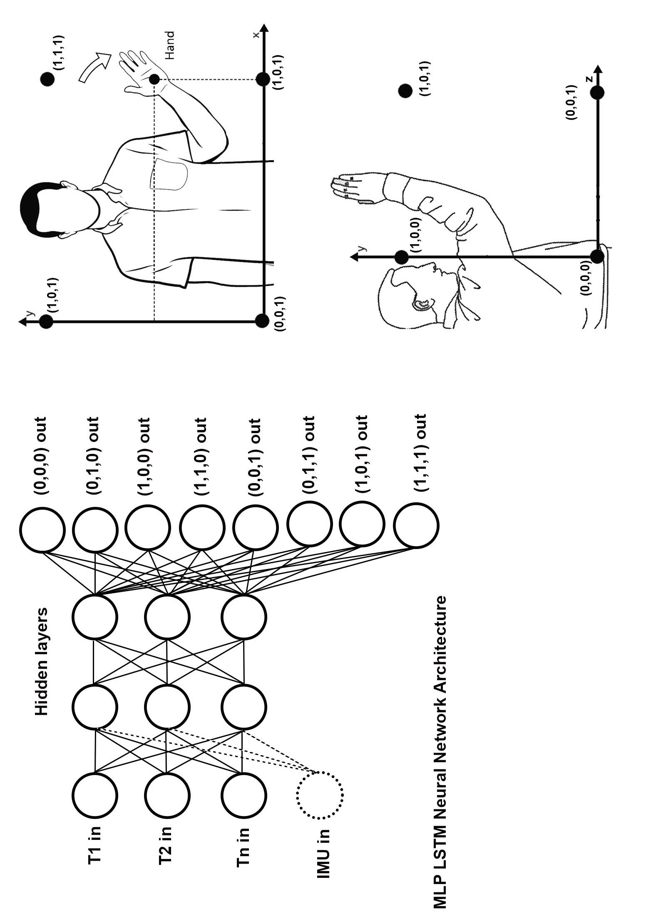

**Figure 17** Absolute Position Coordinate and Vector Space Neural Network Architecture

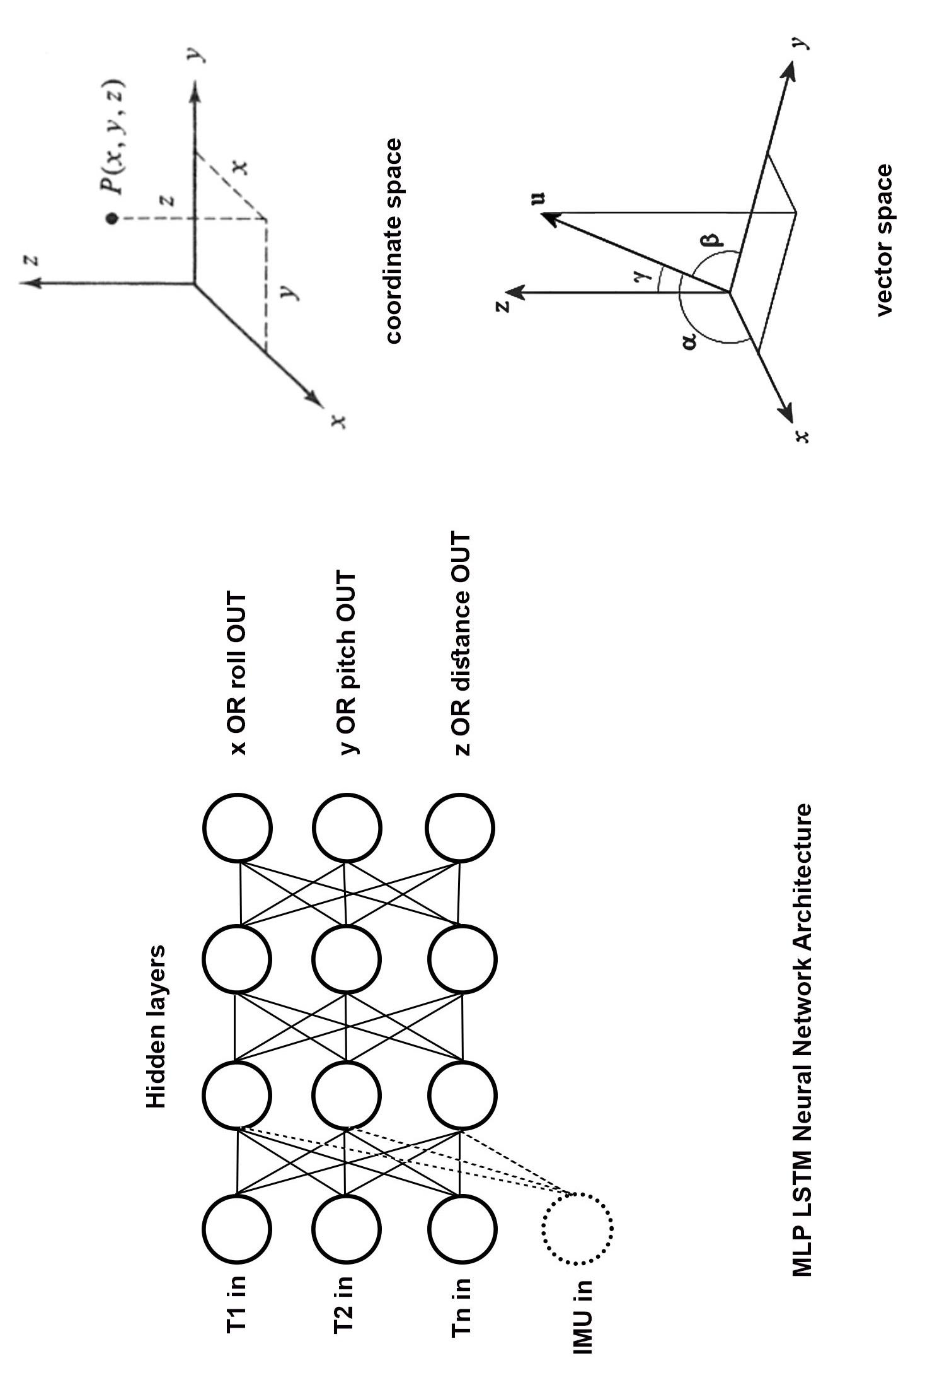

**Figure 16** Behavior Modification Device: Training Application and Neural Network

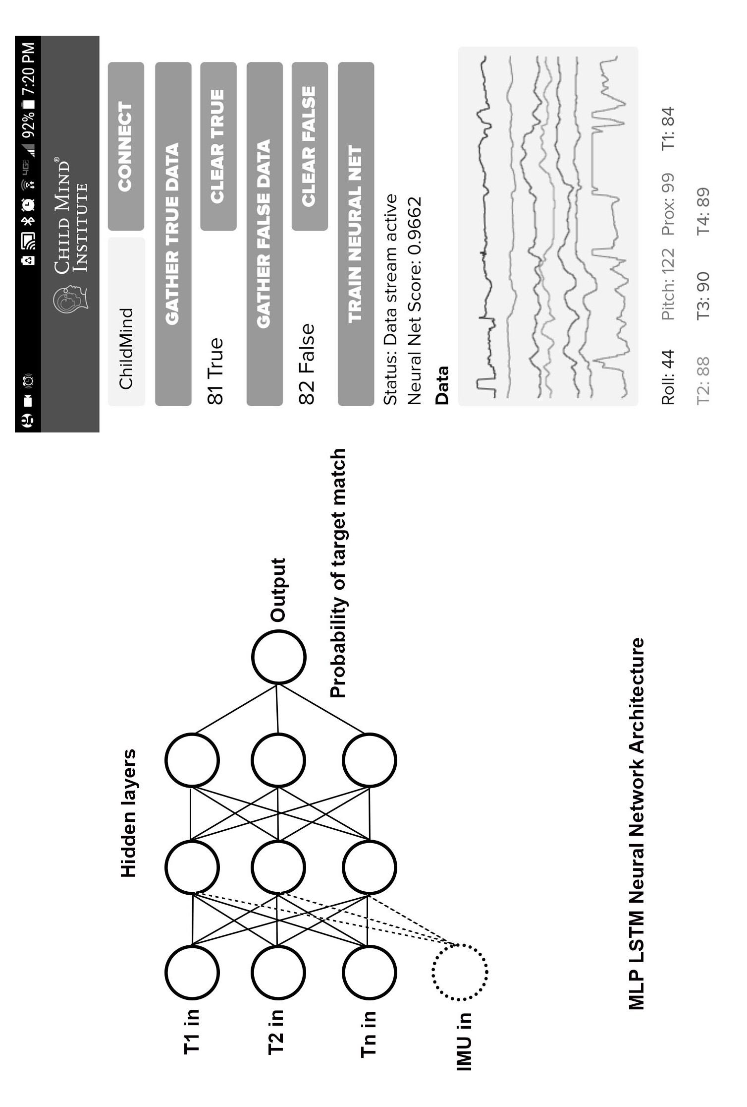

**Figure 15** Flowchart of Position Training to Output Data

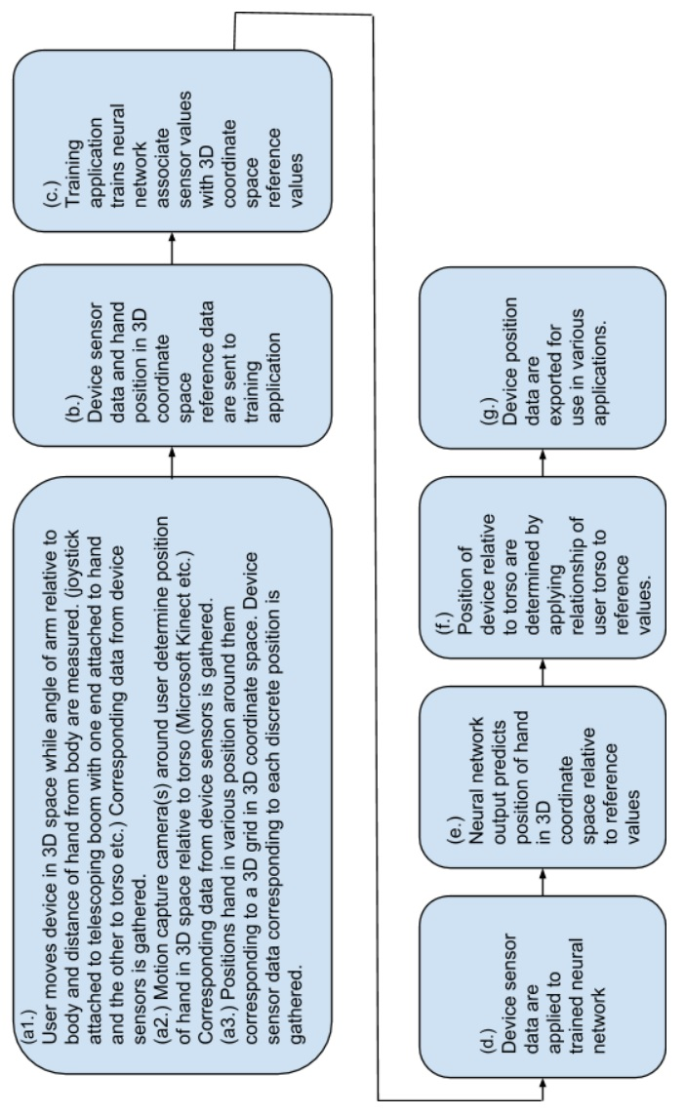

**Figure 14** Flowchart of Behavior Modification Training to Alert User of Repetitive Behavior

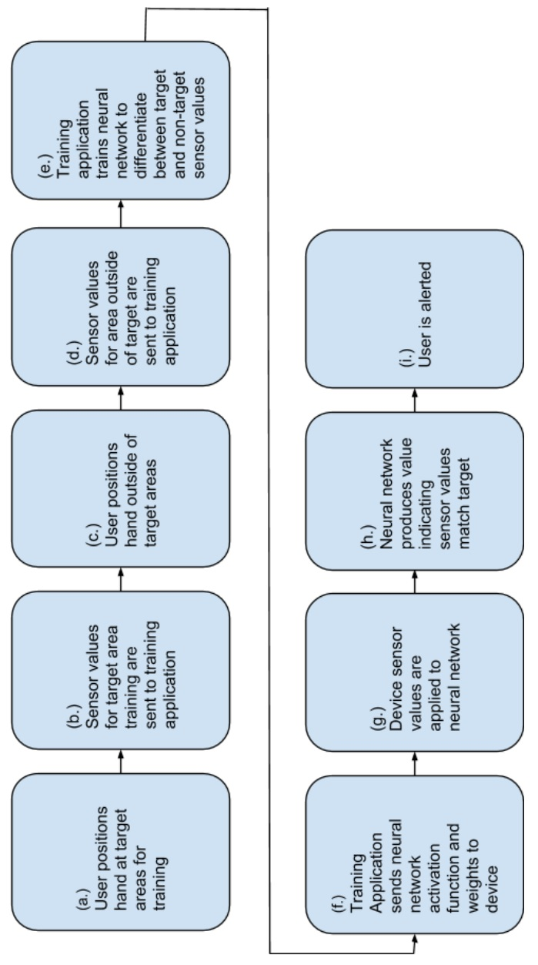

**Figure 13** Position Detection: Wrap-around Wrist Embodiment

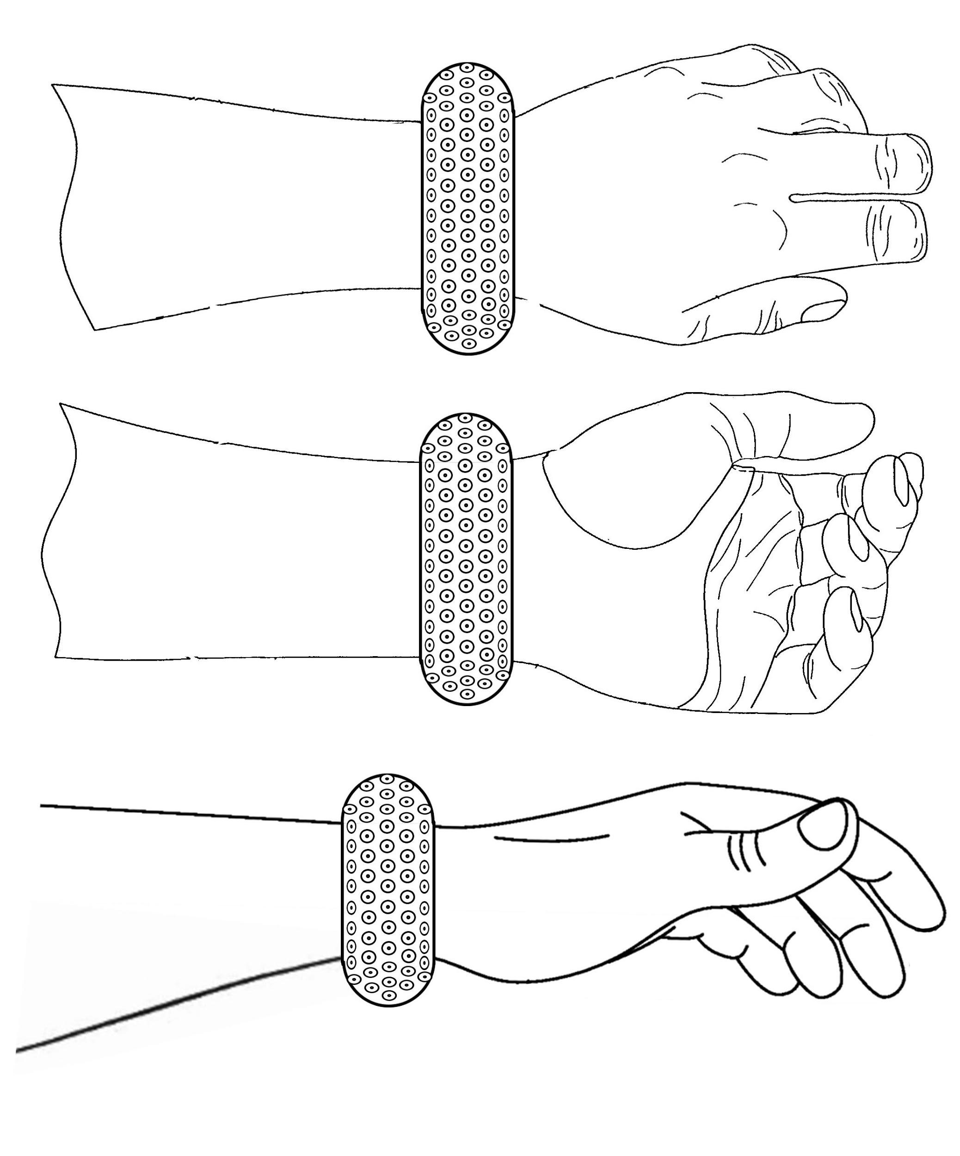

**Figure 12** Position Detection Prototype: Finger and Hand Gesture Recognition Use Case

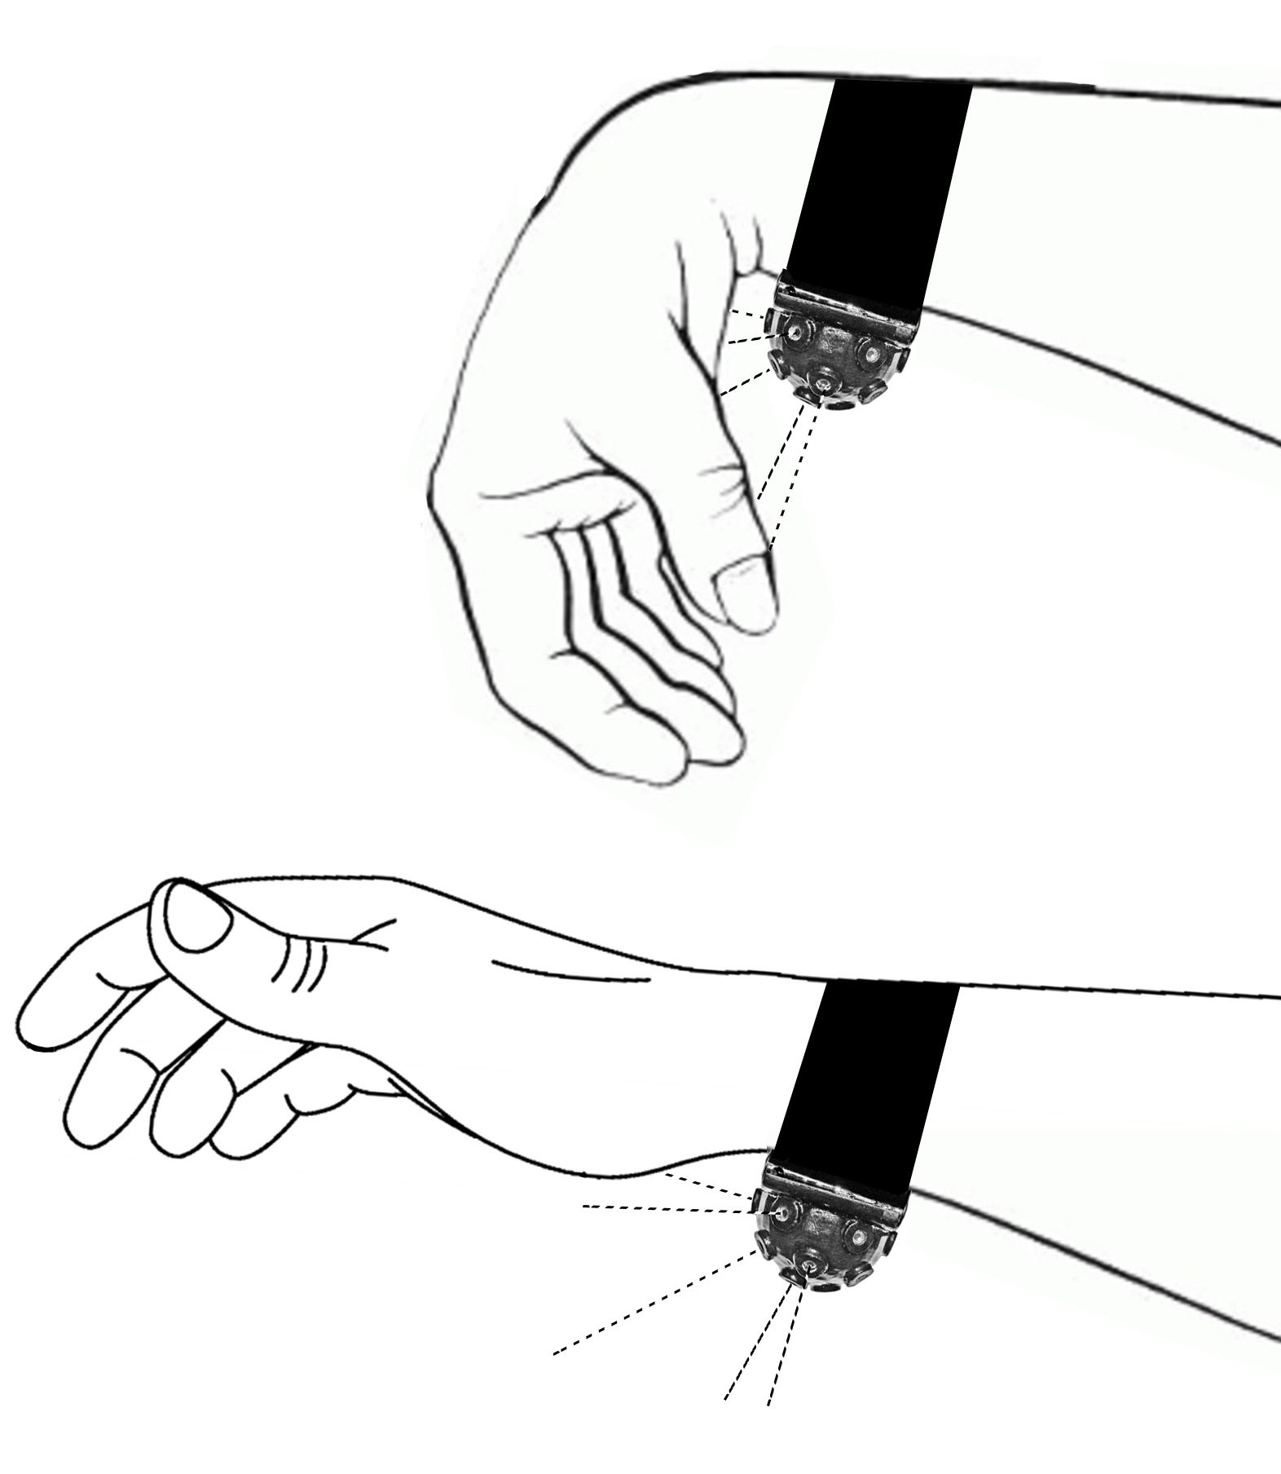

**Figure 11** Position Detection Prototype: Hand-held Controller Use Case

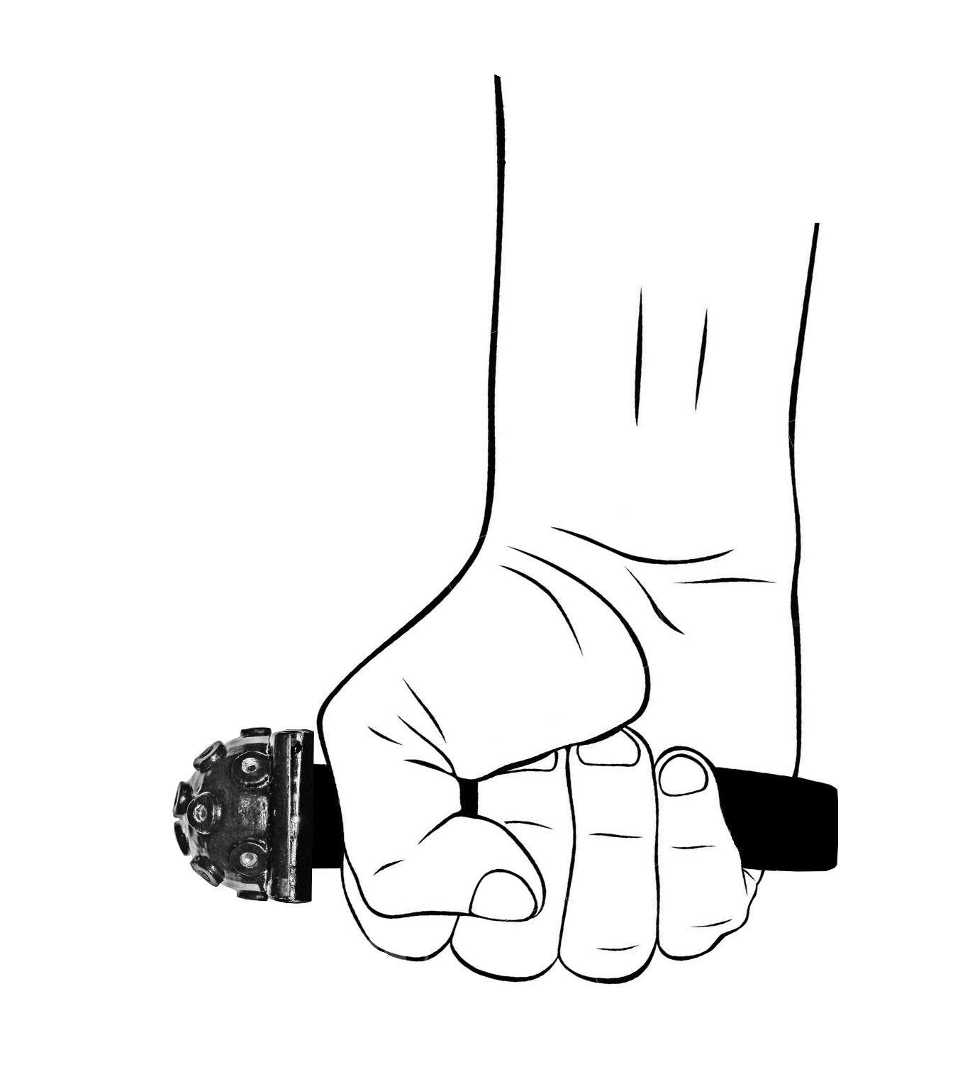

**Figure 10** Position Detection Prototype: Head Tracking Use Case

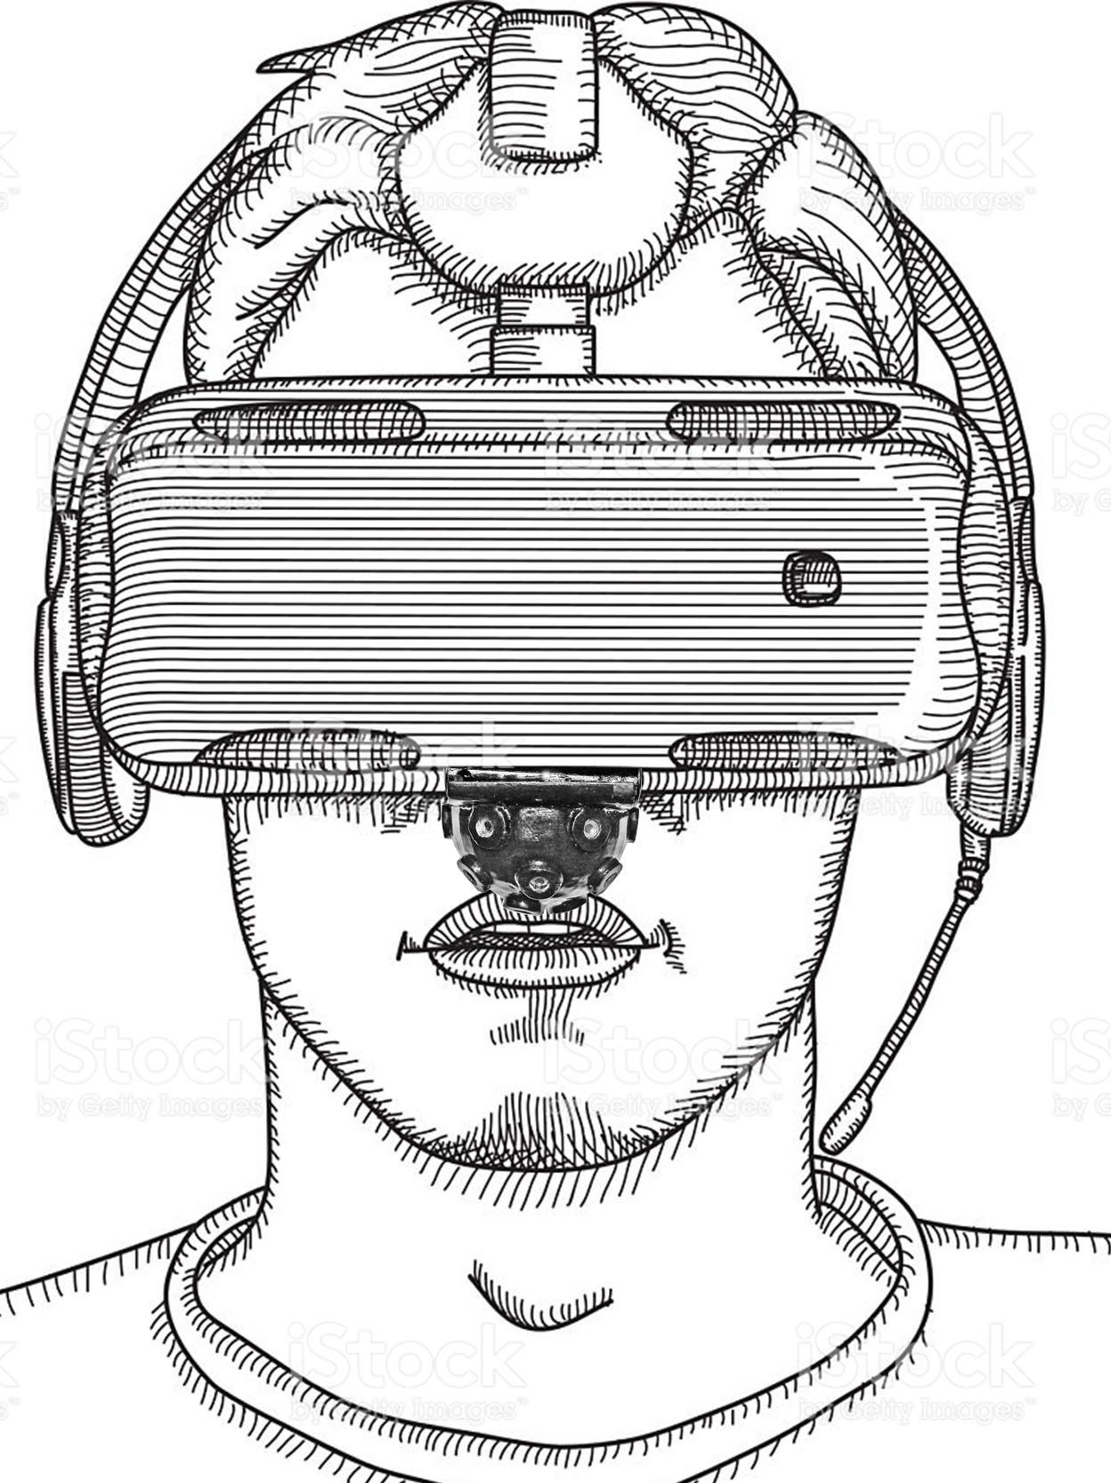

**Figure 9** Trichotillomania Prototype: Photos of Orthogonal Views

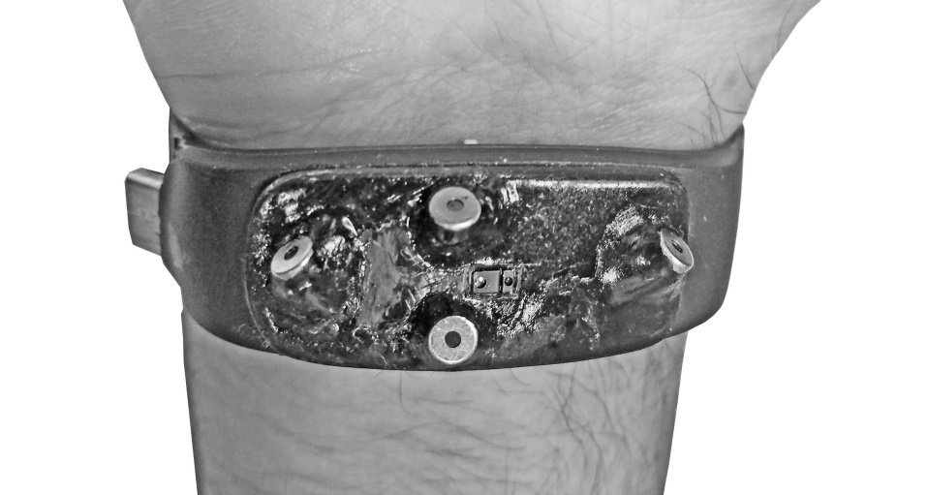

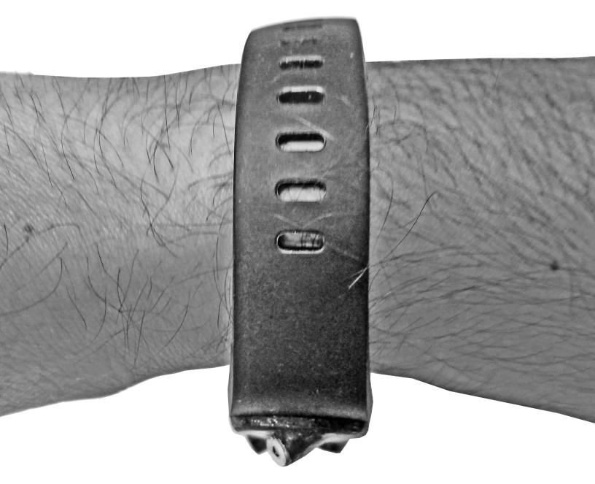

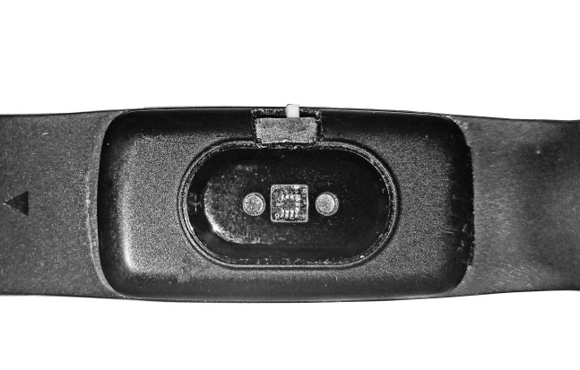

**Figure 8** Trichotillomania Prototype: Orthogonal Views of Enclosure Model

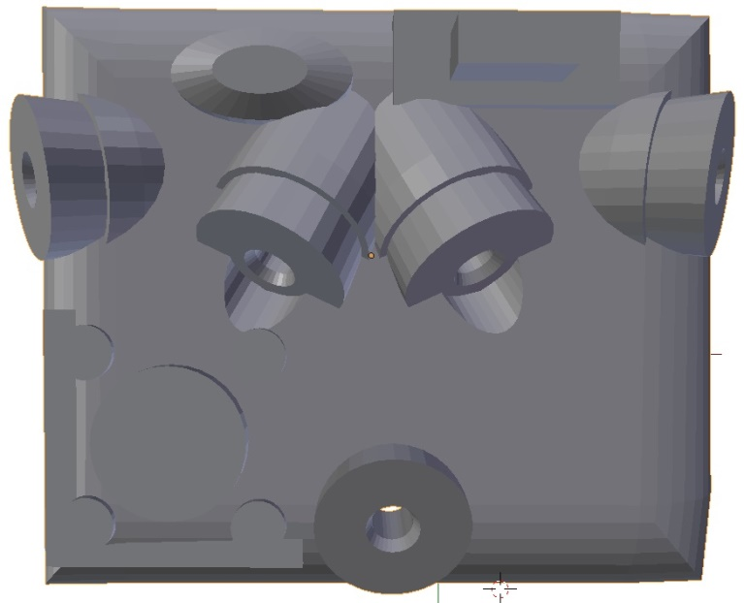

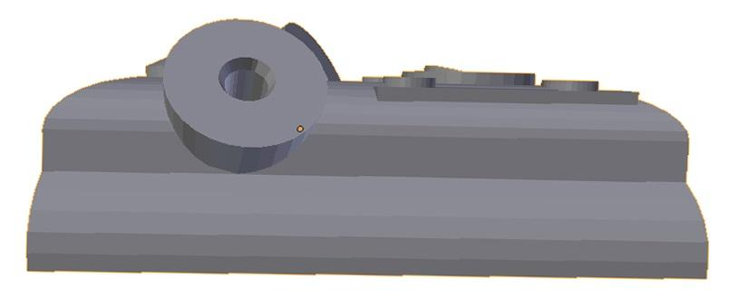

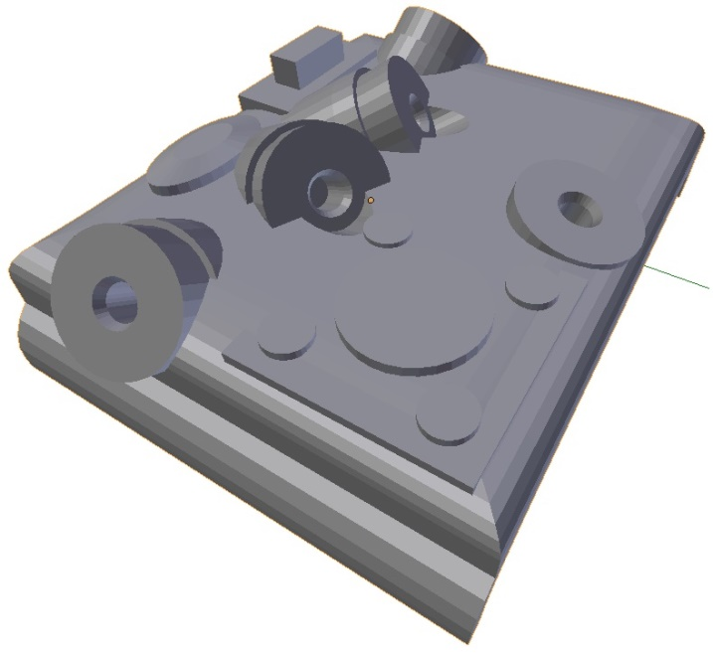

**Figure 7** Position Detection Prototype: Photos of Orthogonal Views

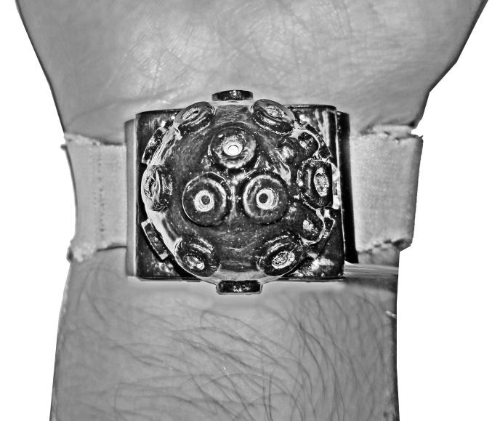

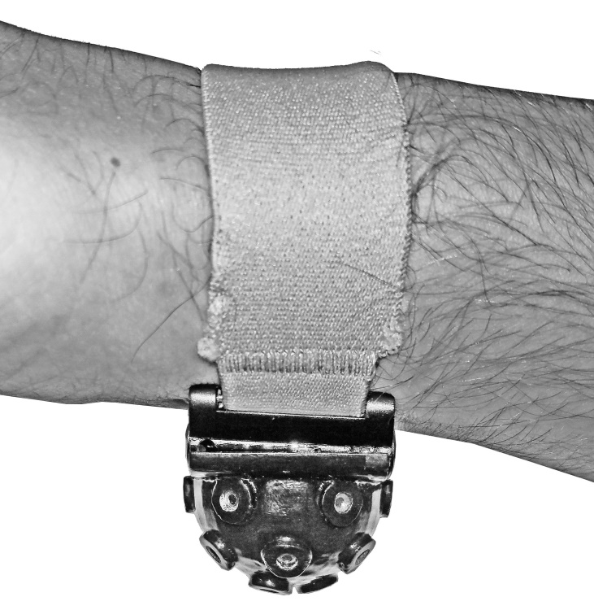

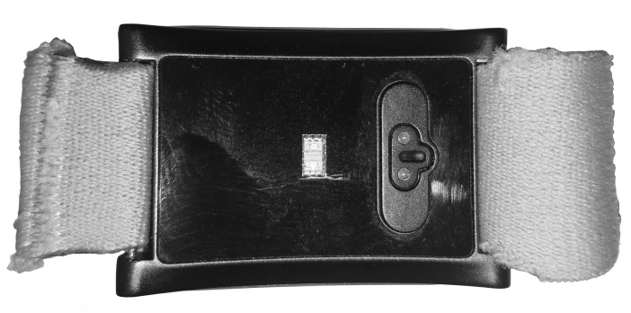

**Figure 6** Position Detection Prototype: Orthogonal Views of Enclosure Model

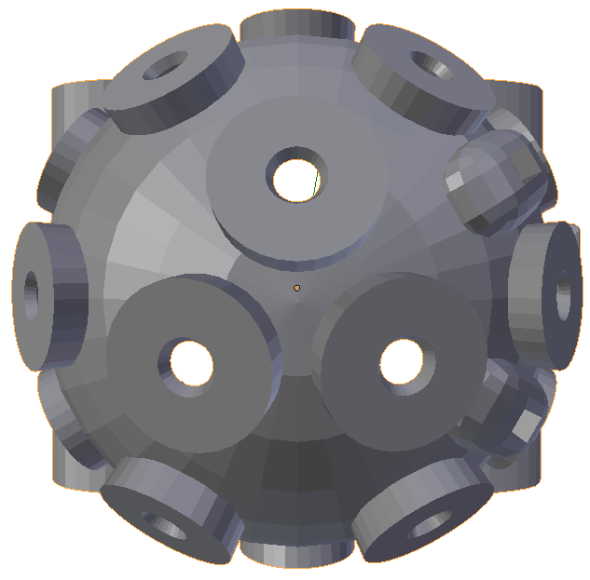

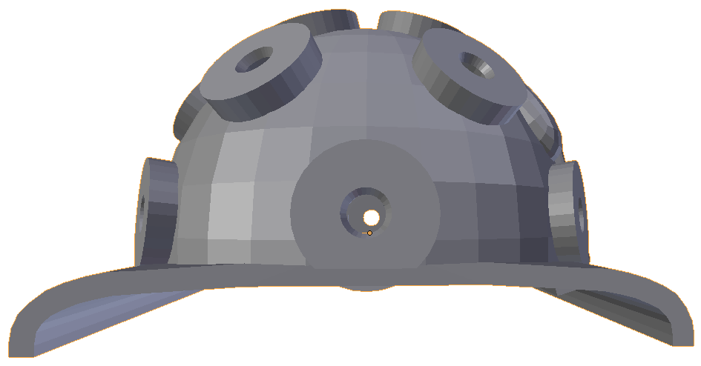

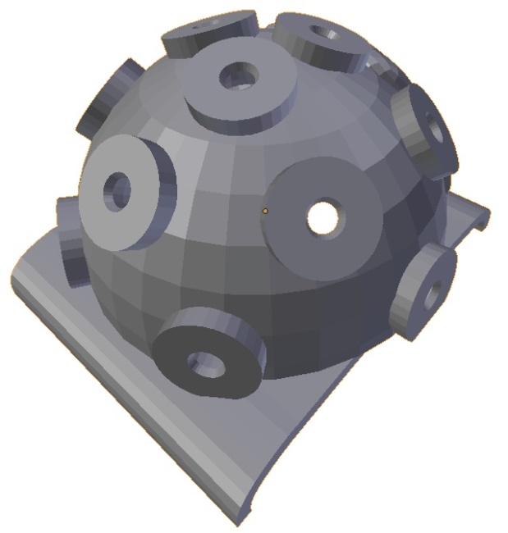

**Figure 5** Trichotillomania thermopile sensor coverage areas

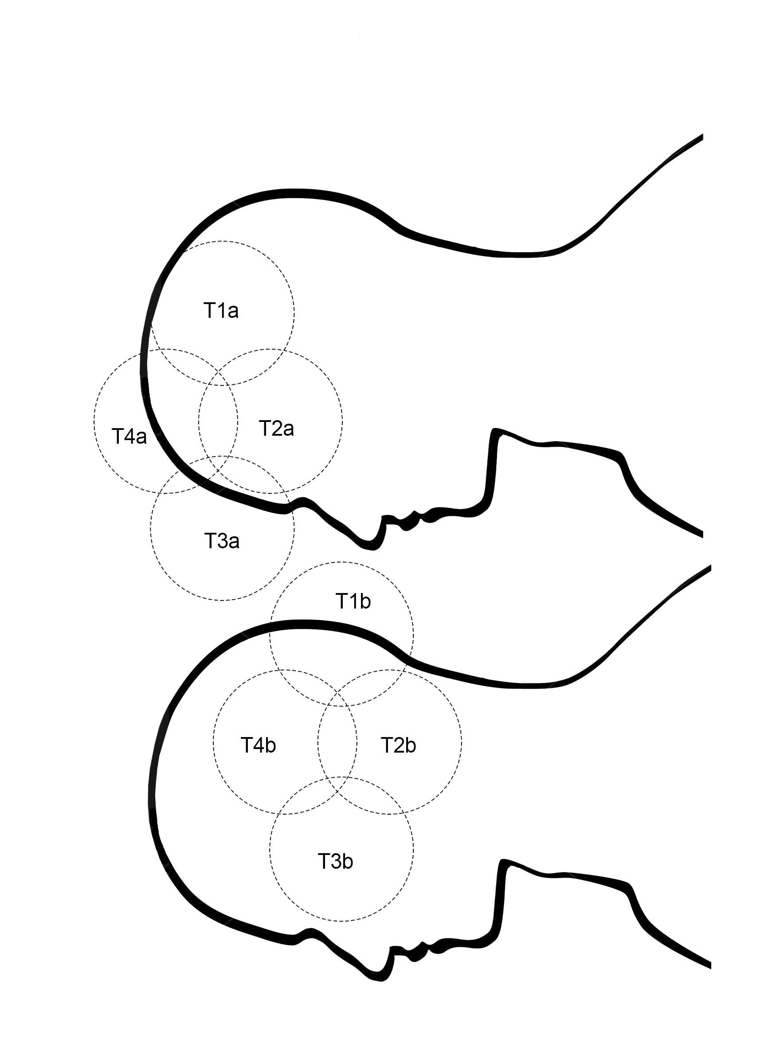

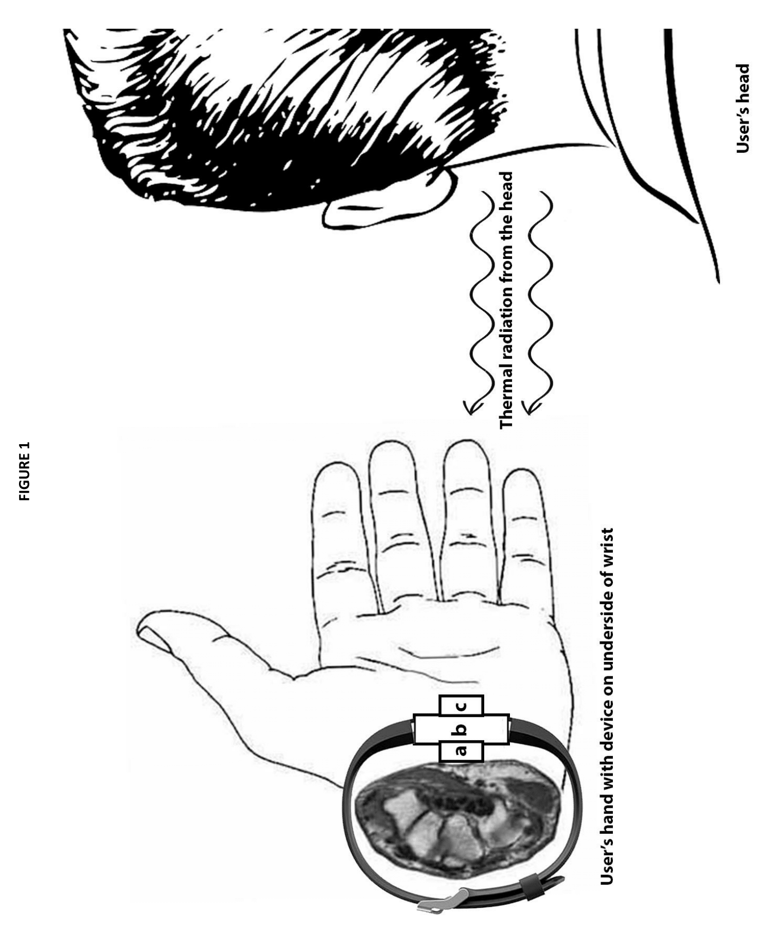

**Figure 4** Profile of thermopile sensor coverage area

