1. Dimensions
   * Franchise
     1. FranchId -ERD
     2. FranchRegion -ERD
     3. FranchPostalCode -ERD
     4. FranchModelType -ERD
   * Merchandise
     1. MerchId-ERD
     2. MerchName-ERD
     3. MerchType-ERD
   * ServiceCategory
     1. ServCatId-ERD
     2. ServCatName-ERD
   * Member/Customer
     1. MmbrId-ERD
     2. MmbrName –ERD
     3. MmbrZip-ERD
     4. MmbrEmail-ERD; hierarchical (top level domain → second level domain → local part)
     5. MmbrDate; hierarchical (year → month → day)
   * Calendar
     1. Date columns in ERD & Spreadsheet (ServPurchDate, SaleDate, & EventDate); hierarchical (year → month → day)
2. Measures
   * PurchaseFacts
     1. PurchaseId
     2. SalesId
     3. ServPurchId
     4. Quantity
     5. Price
3. Grain Calculation
   * Dimensions
     1. Franchise row & postal codes = 550
     2. MemberType row 10
     3. Merchandise row & values = 530
     4. ServCat row = 20
     5. Member row & zip = 50500
     6. Days per year = 365
   * Fact table
     1. Sale row = 150000
     2. Contains row = 450000
     3. ServicePurchase row = 100000
     4. SpecialEvent rows = 300*200
   * Calculation
     1. (1-(150000+450000+100000+60000)/(350*10*500*20*50000 *365)
     2. (1-(760000)/( 1074614750000000)
4. Inventory
   * InventoryNo
   * InventoryQty
   * InventoryDate

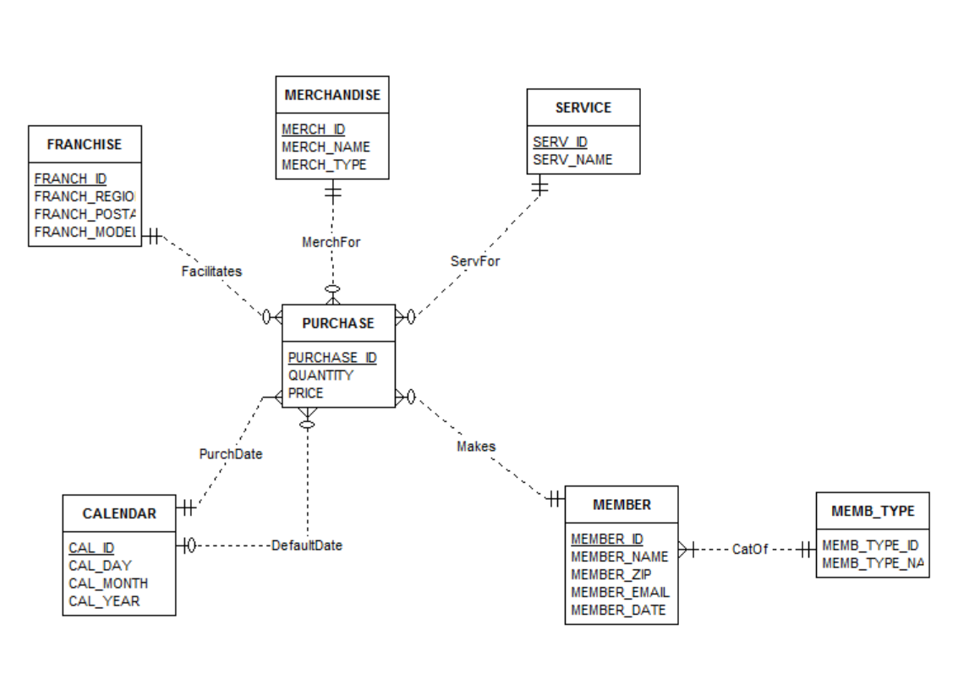

1. Problems
   * Missing date issues w/ PurchDate. Correct by adding default date constraints.
2. Sample Data

|  |  |  |  |  |  |  |
| --- | --- | --- | --- | --- | --- | --- |
| **Franchise** | | | |  |  |  |
| *FranchId* | *FranchRegion* | *FranchPostalCode* | *FranchModelType* |  |  |  |
| F1 | Northwest | 98011 | Full |  |  |  |
| F2 | Mountain | 80111 | Medium |  |  |  |
| F3 | Central | 45236 | Limited |  |  |  |
|  |  |  |  |  |  |  |
|  |  |  |  |  |  |  |
|  |  |  |  |  |  |  |
| **Member** | | | | |  |  |
| *MmbrId* | *MmbrName* | *MmbrZip* | *MmbrDate* | *MmbrEmail* |  |  |
| 1111 | Joe | 98011 | 1-Feb-09 | joe@serv1.com |  |  |
| 2222 | Mary | 80112 | 1-Jan-10 | mary@serv2.com |  |  |
| 3333 | Sue | 45327 | 3-Mar-11 | sue@serv3.com |  |  |
| 4444 | George | 45236 |  | george@serv4.com |  |  |
|  |  |  |  |  |  |  |
|  |  |  |  |  |  |  |
|  |  |  |  |  |  |  |
| **Service** | |  |  |  |  |  |
| *ServId* | *ServName* |  |  |  |  |  |
| SC1 | Ball machine |  |  |  |  |  |
| SC2 | Private lesson |  |  |  |  |  |
| SC3 | Adult class |  |  |  |  |  |
| SC4 | Child class |  |  |  |  |  |
|  |  |  |  |  |  |  |
|  |  |  |  |  |  |  |
|  |  |  |  |  |  |  |
| **Merchandise** | | |  |  |  |  |
| *MerchId* | *MerchName* | *MerchType* |  |  |  |  |
| MC1 | Wilson balls | Balls |  |  |  |  |
| MC2 | Wilson racket | Racket |  |  |  |  |
| MC3 | Adidas shoes | Shoes |  |  |  |  |
| MC4 | Racket stringing | Racket |  |  |  |  |
|  |  |  |  |  |  |  |
|  |  |  |  |  |  |  |
|  |  |  |  |  |  |  |
| **Member** | | | | | | |
| *MmbrId* | *MmbrName* | *MmbrZip* | *MemTypeId* | *MmbrDate* | *FranchId* | *MmbrEmail* |
| 1111 | Joe | 98011 | M1 | 1-Feb-09 | F1 | joe@serv1.com |
| 2222 | Mary | 80112 | M2 | 1-Jan-10 | F2 | mary@serv2.com |
| 3333 | Sue | 45327 | M3 | 3-Mar-11 | F3 | sue@serv3.com |
| 4444 | George | 45236 |  |  | F3 | george@serv4.com |
|  |  |  |  |  |  |  |
|  |  |  |  |  |  |  |
|  |  |  |  |  |  |  |
| **MemberType** | |  |  |  |  |  |
| *MemTypeId* | *MemTypeName* |  |  |  |  |  |
| M1 | Platinum |  |  |  |  |  |
| M2 | Gold |  |  |  |  |  |
| M3 | Value |  |  |  |  |  |
|  |  |  |  |  |  |  |
|  |  |  |  |  |  |  |
| **Calendar** | | | |  |  |  |
| *CalId* | *CalDay* | *CalMonth* | *CalYear* |  |  |  |
| C10000211 | 1 | 2 | 2013 |  |  |  |
| C10000212 | 2 | 2 | 2013 |  |  |  |
| C10000213 | 3 | 2 | 2013 |  |  |  |
| C10000214 | 4 | 2 | 2013 |  |  |  |
| *C10000215* | *5* | *2* | *2013* |  |  |  |
| C10000216 | 6 | 2 | 2013 |  |  |  |
| C10000217 | 7 | 2 | 2013 |  |  |  |
| C10000218 | 8 | 2 | 2013 |  |  |  |
| C10000219 | 9 | 2 | 2013 |  |  |  |
| *C10000220* | *10* | *2* | *2013* |  |  |  |
| C10000221 | 11 | 2 | 2013 |  |  |  |
|  |  |  |  |  |  |  |
|  |  |  |  |  |  |  |
|  |  |  |  |  |  |  |
|  |  |  |  |  |  |  |
| **Purchase** | | | | |  |  |
| *purchase_id* | *SalesId* | *ServPuchId* | *quantity* | *price* |  |  |
| 1 | 1111 |  | 2 | 3 |  |  |
| 2 | 1111 |  | 1 | 200 |  |  |
| 3 | 2222 |  | 1 | 100 |  |  |
| *4* | *3333* |  | *1* | *100* |  |  |
| 5 | 4444 |  | 1 | 40 |  |  |
| 6 |  | 1111 | 1 | 15 |  |  |
| 7 |  | 2222 | 1 | 75 |  |  |
| *8* |  | *4444* | *1* | *150* |  |  |