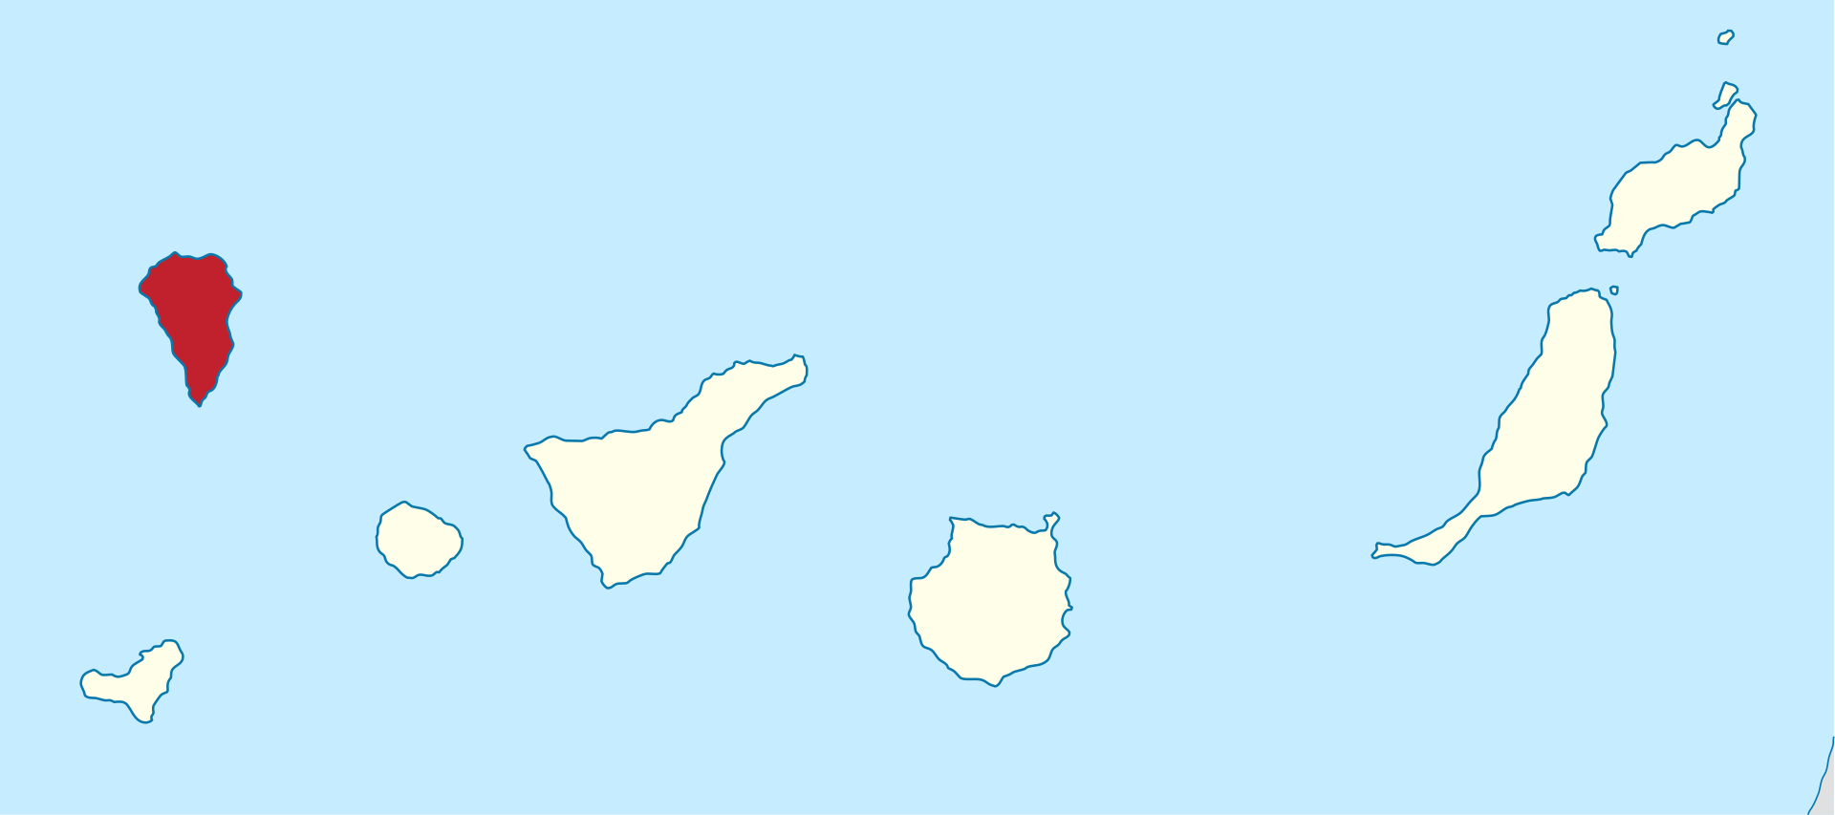

Figure 1 – Map showing the Canary Islands with La Palma highlighted.

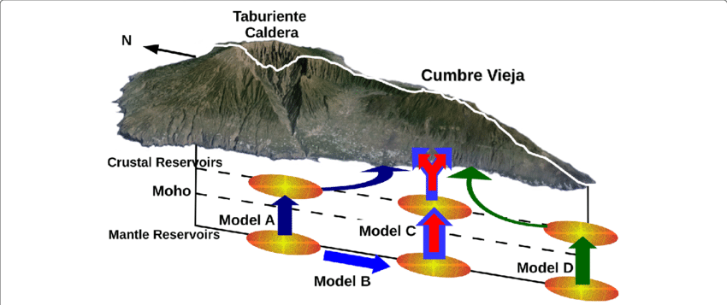

Figure 2 – Proposed dual reservoir model.

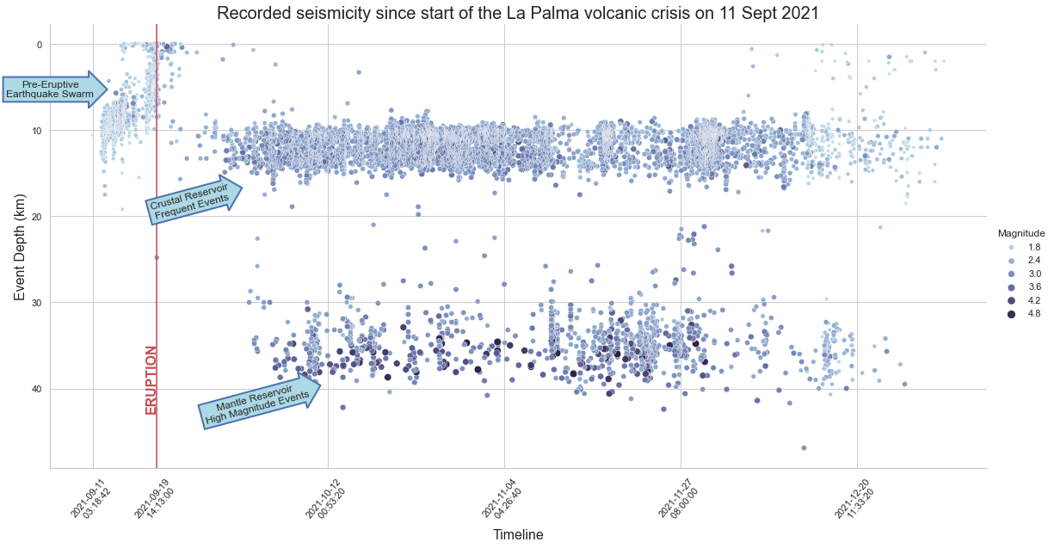

Figure 3 – Seismicity during the eruption.