Supporting Information Appendix
Connectivity before function: the structural connectivity that distinguishes sub-regions of the adult dorsolateral prefrontal cortex is already present in neonates
Chiara Caldinelli and Rhodri Cusack
Contents: SI Methods; Figs. S1 to S9; Table S1.

SI Methods

Adult participants and acquisition
Already preprocessed data from the The Human Connectome Project (HCP; (https://www.humanconnectome.org/) was used for this study, and it was obtained through Amazon Web Services. Here, data from a subgroup (n = 176) of the 1,200 healthy subject release with especially low head motion was used. The participants were those identified by Ito and colleagues in their exploratory cohort (Ito et al., 2017). The participants comprised 99 females with a mean age of 29 years (range = 22–36 years). All subjects gave signed, informed consent and this study was approved by the Washington University institutional review board.
fMRI acquisition
Whole-brain multiband echo-planar imaging acquisitions were collected on a 32-channel head coil on a modified 3T Siemens Skyra with TR = 720 ms, TE = 33.1 ms, flip angle = 52o, Bandwidth = 2,290 Hz/Px, in-plane FOV = 208x180 mm, 72 slices, 2.0 mm isotropic voxels, and a multiband acceleration factor of 8. Data for each subject was collected over the span of two days. On the first day, anatomical scans were collected (including T1-weighted and T2-weighted images acquired at 0.7 mm isotropic voxels) followed by two resting-state fMRI scans (each lasting 14.4 minutes), and ending with a task fMRI component. The second day consisted of a diffusion imaging scan, followed by a second set of two resting-state fMRI scans (each lasting 14.4 minutes), and again ending with a task fMRI session.
Diffusion acquisition
High-quality diffusion-weighted MRI data were acquired using a 3T Scanner Siemens Prisma. Images were acquired using a spin echo EPI sequence with a multiband factor of 3, with a 210x180 field of view (RO x PE), flip angle was 78 degrees, TR was 5520 ms, TE was 89.5 ms, 111 slices were acquired, each with a thickness of 1.25 mm, voxels were 1.25 mm isotropic, echo spacing was 0.78 ms, b-values were 1000, 2000, and 3000 s/mm2. Acquisition time was approximately 9 m and 50 s, 270 diffusion weighting directions, diffusion weighting consisted of 3 shells of b=1000, 2000, and 3000 s/mm2 interspersed with an approximately equal number of acquisitions on each shell within each run. The diffusion directions were obtained using a toolbox available from Emmanuel Caruyer that returns uniformly distributed directions in multiple q-space shells. The directions are optimized so that every subset of the first M directions is also isotropic.

Neonatal participants and acquisition
Infant data included in this study is part of the second data release of the The Developing Human Connectome Project (dHCP), comprising 558 neonates, with 490 fully usable sessions diffusion imaging data from 445 unique participants, 400 with a single session and 45 with two sessions. Participants born preterm (less than 37 weeks of gestation, n=119) were excluded. Participants included in this study were born at term, with a gestational age ranging from 37 to 42 weeks. Of the 326 term-born participants, usable tractography was obtained for 325, who form the analysed sample: 175 males (mean gestational age 39.87 weeks, mean birth weight 3.42 kg) and 150 females (mean gestational age 39.98 weeks, mean birth weight 3.26 kg). One female participant was excluded for failed diffusion processing. Infants were scanned while sleeping (without sedation) at the Evelina Newborn Imaging Centre, St Thomas' Hospital, London, UK. Ethical approval was obtained from the UK Health Research Authority.
Diffusion acquisition
Diffusion weighted MRI (DW-MRI) images were obtained with a 3T Philips Achieva scanner using a customized 32-channel neonatal head coil. Images were acquired using an optimized multi-shell HARDI sequence which varied the number of directions on four shells (b = 0, b = 400, b = 1000, b = 2600) designed to optimize the white and grey matter contrast in neonates. All four phase encoding directions were used and the voxel size was 1.5 mm isotropic. The scan lasted approximately 20 minutes. If the neonate woke up during the scan and subsequently settled, scan was restarted to overlap with the previous acquisition. More details regarding the diffusion acquisition can be found in (Bastiani et al., 2019).
Diffusion preprocessing
Data used in this study was already preprocessed, and more information can be found in [Bastiani et al., 2019]. Susceptibility induced distortions were corrected using estimation from the four PE directions acquired. Images were corrected for Eddy's currents and motion using FSL's EDDY. Outlier slices were detected, replaced and slice-to-slice motion correction was performed. A super resolution algorithm was applied to resample the thicker slice spacing (3 mm) onto the isotropic grid (1.5 mm).

fMRI tasks
The tasks were: working memory, motor function, language processing, social cognition, relational processing, emotion processing and incentive processing. The tasks were extensively described in (Barch et al., 2013), a brief description is given below.
Working memory
There were 2 runs, each showing 4 categories: faces, places, tools and body parts. Half of the run was used for a 0-back task and the other half for a 2-back task. In the 0-back task, a target cue was presented at the start of each block, and the participant had to press a button to any presentation of that stimulus during the block. In the 2-back task, participants had to respond to any item that was the same as the one 2 before. A cue was presented for 2.5 s, indicating the task type at the start of the block. There were 8 blocks for each of the 2 runs, (10 trials of 2.5 s each, for a total of 25 s) and 4 fixation blocks (15 s each). For each trial, the stimulus was presented for 2 s, followed by 500 ms during which the participant needed to answer. Each block contained 10 trials, of which 2 were targets, and 2–3 were non-target lures (e.g., repeated items in the wrong n-back position, for example 3-back). The four categories of stimuli were chosen because previous studies showed that they reliably activate different cortical regions across participants (Downing et al., 2006; Fox et al., 2009; J. C. Taylor et al., 2007).
Motor
This task was adapted from the one developed by Buckner and colleagues (Buckner et al., 2011). There were 2 runs in total. A visual cue instructed participants to tap their left or right fingers, squeeze their left or right toes, or move their tongue. The cue was lasting for 3 s and each block of a movement type lasted for 12 s (10 movements). For each run there were 13 blocks, with 2 of tongue movements, 4 of hand movements (2 right and 2 left), 4 of foot movements (2 right and 2 left) and three 15 s fixation blocks per run. This task was previously shown to reliably identify specific activations in individual subjects (Thomas Yeo et al., 2011).
Language processing
This task was developed by (Binder et al., 2011) and consisted in two runs that each interleaved 4 blocks of a story task and 4 blocks of a mathematical task. The story blocks were a brief (5-9 sentences) auditory story adapted from Aesop's fables, followed by a 2-alternative forced-choice question asking the participants about the topic of the story. The example provided in the original Binder paper (p. 1466) is "For example, after a story about an eagle that saves a man who had done him a favor, participants were asked, 'That was about revenge or reciprocity?'". During the mathematical task, the subjects were asked to complete addition and subtraction problems. One example of a question is: "Fourteen plus twelve"; followed by "equals" and then two choices: "twenty-nine or twenty-six". The mathematics blocks were included because they provided a comparison task that was attentionally demanding, similar in auditory and phonological input, and unlikely to generate activation of anterior temporal lobe regions involved in semantic processing, though likely to engage numerosity related processing in the parietal cortex (Binder et al., 2011). The blocks did not have the same length (average was 30 s) but the mathematical task was matching the length of the story task blocks, with several additional mathematics trials at the end of the task to complete the 3.8 min run as needed. The mathematical task was adaptive to maintain a similar level of difficulty across the participants. For more details on the task, see Binder et al. (2011).
Social cognition (theory of mind)
A series of video clips was previously shown to be a reliable measure of social cognition, generating robust task related activation in brain regions associated with social cognition across subjects (Castelli, 2002; Castelli et al., 2000; Wheatley, T., 2007; White et al., 2011). For this task, a shortened version of the original clips was used (20 s instead of the original 40 s). A pilot study confirmed that the shorter videos elicited similar responses to the longer videos. Each video clip was showing objects (squares, circles, triangles; Abell et al., 2000) either interacting, or moving randomly. After each video clip, the participants had to choose between 3 answers: 'the objects interacted socially between each other', 'Not Sure', or 'No interaction'. Each of the two task runs had 5 video blocks (2 Mental and 3 Random in one run, 3 Mental and 2 Random in the other run) and 5 fixation blocks (15 s each).
Relational processing
This task was adapted from a task published in (Smith et al., 2007), who used it as a localizer for the anterior prefrontal cortex in individual subjects. There, stimuli were 6 shapes filled with 6 different textures. In the relational processing condition, the participants needed to choose which one of the two pairs of objects presented at the bottom of the screen was matching a pair shown at the top of the screen. First, they only needed to decide if the two top objects had different shapes or textures, then, if the two bottom objects also differed similarly. In the control matching condition, the participants were shown two objects at the top of the screen and one object at the bottom of the screen, and a word in the middle of the screen (either "shape" or "texture"). They were told to decide whether the bottom object matched either of the top two objects on that dimension (e.g., if the word is "shape", is the bottom object the same shape as either of the top two objects). In the relational processing condition, the stimuli were presented for 3.5 s, with an ITI of 0.5 s, and there were 4 trials per block. In the matching condition, stimuli were presented for 2.8 s, with an ITI of 0.4 s, and 5 trials per block. Both blocks were 18 s long, and there were 3 blocks of each type (relational processing and matching), plus 3 fixation blocks lasting 16 s each.
Emotion processing
This is an adapted version of a task published by Hariri and colleagues that was shown to be a functional localizer (Hariri et al., 2006). The task is organized in blocks. For each block the participant needed to decide which one of the two faces at the bottom of the screen was matching one face shown at the top, or which one of the two shapes was matching the shape at the top. The faces were either angry or fearful. Every block was composed of 6 trials of either shapes or faces. Every stimulus was shown for 2 s and ITI was 1 s. A cue lasting 3 s was shown before the block started and it was indicating if it was a shape of face block. There were in total 3 faces and 3 shapes blocks.
Incentive processing
This task was adapted from the [Delgado et al. (2000)], and was chosen for its ability to activate reward regions in a way that is robust and reliable across subjects (Delgado et al., 2000, Forbes et al., 2009, May et al., 2004, Tricomi et al., 2004). Participants need to play a card game where they are asked to guess the number on a mystery card (represented by a "?") in order to win or lose money. They are told that potential card numbers range from 1 to 9 and to indicate if they think the mystery card number is more or less than 5 by pressing one of two buttons on the response box. Feedback is the number on the card (generated by the program as a function of whether the trial was a reward, loss or neutral trial) and either: 1) a green up arrow with "$1" for reward trials, 2) a red down arrow next to − $0.50 for loss trials; or 3) the number 5 and a gray double headed arrow for neutral trials. The "?" is presented for up to 1.5 s (if the participant responds before 1.5 s, a fixation cross is displayed for the remaining time), following by feedback for 1.0 s. There is a 1.0 s ITI with a "+" presented on the screen. The task is presented in blocks of 8 trials that are either mostly reward (6 reward trials pseudo randomly interleaved with either 1 neutral and 1 loss trial, 2 neutral trials, or 2 loss trials) or mostly loss (6 loss trials interleaved with either 1 neutral and 1 reward trial, 2 neutral trials, or 2 reward trials). In each of the two runs, there are 2 mostly reward and 2 mostly loss blocks, interleaved with 4 fixation blocks (15 s each). All the participants are provided with money as a result of completing the task, though it is a standard amount across subjects.

fMRI preprocessing and modelling
The preprocessed data from the HCP pipeline were used in this study. A summary is given below, but for a detailed description of the analysis see [Glasser et al. 2013]. FSL topup (Andersson et al., 2003) and FLIRT (Jenkinson et al., 2002; Jenkinson & Smith, 2001) were used to correct for the distortion of EPI images. The distorted EPI images with opposite phase-encoding directions were registered to the distorted gradient reference images. This registration is concatenated with the topup-derived distortion field, producing a nonlinear transform that can be used to undistort the fMRI images. The single-band reference image was corrected for distortions using spline interpolation and was next registered to the T1W image, by successively using FLIRT and FreeSurfer (Greve & Fischl, 2009). This ensured an accurate registration between the structural and the fMRI data. The native volumes acquired in native space were then transformed into MNI space using nonlinear warping with a single spline interpolation, minimizing interpolation- induced blurring. One of the volume parcellations resulting from the FreeSurfer processing (Glasser, 2013), the wmparc, was binarized, dilated three times and eroded twice to produce an accurate subject-specific brain mask of the gray and white matter. This brain mask was then applied to the volume registrations and normalized to a 4D whole brain.
Images were smoothed using an unconstrained 3D Gaussian kernel of FWHM = 4 mm. A general linear model (GLM) estimated time series for each run, using FILM (Improved Linear Model with autocorrelation correction; (Woolrich et al., 2001). Predictors were convolved with a double gamma "canonical" hemodynamic response function (Glover et al., 2000) to generate the main model regressors. Temporal derivative terms derived from each predictor were used as confounds to compensate for slice-timing differences and variability in the HRF delay across regions. A Gaussian-weighted linear high pass filter with a cutoff of 200 s was also applied. Finally, the time series was prewhitened within FILM (Woolrich et al., 2001) to correct for autocorrelations in the fMRI data.
GLM design and contrasts
Below it is a brief description of how the GLM model was designed, as described in [Barch 2013].
Working memory
Eight predictors were included in the model for the Working Memory task, one for each type of stimulus in each of the N-back conditions (i.e., 2-Back Body, 0-Back Body, 2- Back Face and 0-Back Face). Each predictor covered the period from the onset of the cue to the offset of the final trial (27.5 s). Linear contrasts for these predictors were computed to estimate effects of interest: 2-back (vs. fixation), 0-back, 2-back vs. 0-back, each stimulus type versus baseline (e.g., Body vs. fixation, collapsing across memory load), and each stimulus type versus all others.
Incentive processing
Two predictors were included in the model for Incentive Processing –- mostly reward and mostly loss blocks, each covering the duration of 8 trials (28 s). For this task, as with all other tasks, linear contrasts of the parameter estimates were computed to compare each condition to baseline and to each other.
Motor
Five predictors were included in the Motor model –- right hand, left hand, right foot, left foot, and tongue. Each predictor covered the duration of 10 movement trials (12 s). The 3 s cue period prior to each motor block was modeled separately to account for visual activation related to the cue word presented on the screen at the beginning of each block. Linear contrasts were computed to estimate activation for each movement type versus baseline and versus all other movement types.
Language and social cognition
The Story predictor covered the variable duration of a short story, question, and response period (~30 s). The Math predictor covered the duration of a set of math questions designed to roughly match the duration of the story blocks. Two predictors were included in the Social Cognition model –- Social and Random motion. Predictors were based on the category of the video clip rather than the rating of the individual. Each predictor covered the duration of a single video clip (20 s).
Relational processing
Relational processing and a control Matching condition. Each predictor covered the duration of 18 s composed of four trials for the Relational condition and five trials for the Matching condition.
Emotion processing
Two predictors were included in the Emotional Processing task model. Each predictor covered a 21 s duration composed of a cue and six trials.
Contrasts used
All contrasts calculated against baseline were excluded from the analysis, leaving 31. The full list of contrasts used for this analysis is the following: WORKING_MEM_2BK_BODY, WORKING_MEM_2BK_FACE, WORKING_MEM_2BK_PLACE, WORKING_MEM_2BK_TOOL, WORKING_MEM_0BK_BODY, WORKING_MEM_0BK_FACE, WORKING_MEM_0BK_PLACE, WORKING_MEM_0BK_TOOL, WORKING_MEM_2BK, WORKING_MEM_0BK, WORKING_MEM_BODY, WORKING_MEM_FACE, WORKING_MEM_PLACE, WORKING_MEM_TOOL, GAMBLING_PUNISH, GAMBLING_REWARD, MOTOR_CUE, MOTOR_LF, MOTOR_LH, MOTOR_RF, MOTOR_RH, MOTOR_T, MOTOR_AVG, LANGUAGE_MATH, LANGUAGE_STORY, SOCIAL_RANDOM, SOCIAL_TOM, RELATIONAL_MATCH, RELATIONAL_REL, EMOTION_FACES, EMOTION_SHAPES. For more details of the contrasts and a full description of the tasks, see the previous paragraph Stimuli and [Barch et al., 2013].

Adult diffusion preprocessing and tractography
The diffusion-weighted images preprocessing consisted of normalization of the b0 image intensity across runs, then EPI distortions using TopUp, then eddy-current-induced distortions and subject motion were removed using Eddy. Images were corrected for gradient-nonlinearities, by calculating the gradient bvalue/bvector deviation, diffusion images were then registered to the structural images by registering mean b0 images to native T1w volumes using FLIRT BBR+bbregister and transformation of diffusion data, gradient deviation, and gradient directions to 1.25mm structural space. Finally, the brain was extracted using the final brain mask based on FreeSurfer segmentation.
Bayesian Estimation of Diffusion Parameters Obtained using Sampling Techniques (BEDPOSTX - with the X standing for modeling Crossing Fibers; Behrens et al., 2007) output was used in this analysis. BEDPOSTX runs Markov Chain Monte Carlo sampling to build up probability distributions on diffusion parameters at each voxel. It creates all the files necessary for running probabilistic tractography.
Seeds and targets
The HCP surface based parcellation (Glasser, 2016) was used to create two individual masks, one per hemisphere, each containing the 13 regions composing the DLPFC. Additionally, individual masks for each of the 334 regions not belonging to the DLPFC were created. The 13 regions of the DLPC were used as seeds for the tractography analysis, and each of the other ROIs elsewhere in the brain as a target. The regions were all defined in surface space, and were each transformed to volume individual space by using the workbench's command label to volume mapping (Connectome Workbench v1.5.0; https://www.humanconnectome.org/software/connectome-workbench), using the label from the vertex closest to the voxel center with a distance of 1 mm. The results from the tractography analysis were then transformed back from volume into surface space, by using the volume to surface mapping workbench's command, using the values of the enclosing voxel. The left and right DLPFC masks were used as seeds and were excluded from tractography targets. All the other 334 regions from the parcellation served as individual target regions in the analysis.
Tractography
Analyses were performed on the AWS cloud using a cluster made using parallelcluster (https://docs.aws.amazon.com/parallelcluster/), with SLURM as a queue manager. Tractography was run using the probabilistic tracking with crossing fibers (PROBTRACKX2; Behrens et al., 2007) package of FMRIB's Diffusion Toolbox (FDT; Behrens et al., 2003), using 5,000 streamlines (-P 5000), random seeds of value 1234 (\–rseed=1234), one-way condition (\–onewaycondition) and output path distribution (\–opd). Tractography was run for each hemisphere separately, using a mask containing all of the 13 ROIs composing the DLPFC as seed, and 334 images of each of the ROIs outside the DLPFC as targets. The output seed-to-target option (\–os2t) was used to output images that indicated for each seed voxel how many streamlines terminated in each target ROI (i.e., one image per target ROI).

Transformation of the adult parcellation into neonatal space
A schematic summary of these transformations is shown in Fig. S1 and an example of the results is shown in Fig. S2. To register the adult to the infant space, we used the Advanced Normalization Tools (ANTs). ANTs has proven performance in lifespan analyses of brain morphology (Tustison et al., 2014) and function (Avants et al., 2014) in both adult (Tustison et al., 2014) and pediatric brain data (Avants et al., 2014; Jain et al., 2012; Lawson et al., 2013) including infants (Pineda et al., 2014). ANTs employs both probabilistic tissue segmentation (via Atropos (Avants et al., 2011) and machine learning methods based on expert labeled data (via joint label fusion (H. Wang et al., 2011) in order to maximize reliability and consistency of multiple modality image segmentation. We used antsRegistrationSyN to register from an adult MNI-152 v.6 asymmetric T1-weighted template to the dHCP 40 weeks T1-weighted template (https://gin.g-node.org/BioMedIA/dhcp-volumetric-atlas-groupwise). We identified two issues, discussed in more detail in Cabral et al (2022). First, the cerebellum is substantially smaller in infants than adults relative to the size of the cerebrum, which would cause misregistration. We therefore masked the cerebellum during registration. Second, the skull and scalp are thinner in infants. We therefore masked these. The final registration can be seen in Cabral et al, (2022).
This transformation derived from the T1 was used to transform an adult parcellation into the infant space. Specifically, the Glasser (Glasser et al., 2016) parcellation label file was transformed into a volume aligned with the MNI 152 v.6 template using the Workbench Connectome software v1.5.0 (label to volume mapping command). From this volume template, antsApplyTransforms was used to register this parcellation to the dHCP 40 weeks template volume.
The dHCP release included the transformations from the dHCP 40 week template in volumetric space to the individual infant's diffusion image space to the, which was applied to the parcellation using FSL's applywarp with nearest neighbor interpolation. See Fig. S2 for an example of the transformation of the adult DLPFC mask to the infant space (T1 template).
Tractography was run in native space . The resulting seed-to-target maps were then transformed back to the adult MNI space in stages. First, they were transformed from the individual's native space to the dHCP 40 week space using the dHCP releases's transformations with FSL's applywarp. They were then transformed from the dHCP 40 week space to the adult MNI space. Lastly, workbench software v1.5.0 was used to sample the resulting volumes onto a surface.
All the registration steps were manually checked for each infant to ensure that the registration was successful.

Representational similarity analysis and hierarchical clustering
To measure the degree of similarity in the spatial distribution of activation across the contrasts, we used representational similarity analysis. Specifically, we extracted the mean beta value within each of the 26 DLPFC parcels for each of the 31 contrasts that were not simple task-versus-baseline comparisons, averaged across participants, and calculated the Pearson correlation between every pair of contrasts across parcels to assess the similarity of the spatial patterns. It was hypothesized that some contrasts would be quite similar in the DLPFC (e.g.. working memory for different stimuli) but that others would be distinct. To capture this, hierarchical clustering was used. This was implemented using Ward's linkage (Ward, J. H., Jr., 1963), and displayed as a dendrogram using scipy.cluster.hierarchy package in python 3.8. Before clustering, correlations were rescaled from [-1, 1] to [0, 1]. This rescaling is not cosmetic: it halves the distances entering the linkage, and the threshold of 1.0 reported below yields five clusters with it and eight without.
The RSM (Fig. S3) showed that some contrasts evoked similar patterns of activity while others were more dissimilar. To characterize this structure, we used hierarchical clustering (Fig. S4) and visually identified a threshold (1.0) that isolated five clusters. From the hierarchical clustering we visually identified a threshold that would be a candidate to create a number of reliably distinct clusters. For each cluster we then chose a representative contrast (an arbitrary choice was taken: the contrast shown on the y axis in the RSM which had the shortest stem, and in case more than one had the same length then the top one was chosen) that was taken forward for further analysis.
For each of these we identified a contrast that exemplified each. These were: Shape contrast from the Emotion task; Theory of Mind contrast from the Social task; 2-back contrast from the Working Memory; Average contrast from the Motor task; and Story contrast from the Language task. Profiles of activation across the 26 DLPFC parcels for these five contrasts are shown in Fig. S5.
Profiles of activation across DLPFC parcels
To characterize the profiles of activity from the contrasts representing the different clusters, we extracted the mean beta values for each of the subjects within each of the 26 ROIs forming the DLPFC. These were entered into a two-way repeated-measures ANOVA with contrast and parcel as within-subject factors, the error term for each effect being that effect's interaction with participant. Both factors are within-subject because every participant contributes a value for every contrast and every parcel; a fixed-effects model that pooled this within-participant variance into the residual would inflate the denominator degrees of freedom by more than an order of magnitude. We highlight that there is circularity to this analysis, as these contrasts were chosen to be distinct. If the ANOVA is not significant, despite this selection, it would suggest no evidence for distinct patterns.

Elastic-net prediction of activation from connectivity
For each subject and fMRI contrast, an Elastic net regularized regression model was trained to predict the activation for each seed vertex (num. seed vertices), from the connectivity as determined by the tractography (num. seed vertices num. target regions). As a measure of activation, the betas resulting from the GLM models were included in the model, and regarding the structural connectivity, the number of streamlines resulting from the tractography analysis were included. The Elastic net model implements linear regression, with a cost-function equal to the sum-of-squared errors for the fitted values but regularizing by adding penalties to the cost function for non-zero beta values based on the L1 (sum of absolute betas) and L2 (sum of squared betas) metrics. Two hyperparameters, alpha and L1 ratio determine the relative strength of the regularization vs. the accuracy of the fit. The ElasticNet was implemented using sklearn.linear_mode.ElasticNet (sklearn v.1.0.2). The alpha hyperparameter controls the overall degree of regularization and the L1 ratio controls how much of the penalty is L1 vs. L2.
The fMRI activations from adults were then related to the patterns of connectivity as derived from tractography in infants. The selection of contrasts resulted from this analysis is the following: Emotion, the Language - Story, Motor - Average, contrast Social - TOM, Working Memory - 2-back. For each infant subject and adult fMRI contrast, an Elastic net regularized regression model was trained to predict the activation for each seed vertex (vector of size num. seed vertices), from the connectivity as determined by the tractography (num. seed vertices num. target regions).
For each of the five contrasts, from the infant vertex-level structural connectivity, the task-specific model predicted the adult fMRI activity. To test if the predicted pattern of adult fMRI activation corresponded to the true activation pattern for this contrast, we calculated a Pearson correlation between the predicted fMRI activation as resulted from the model and the true activity. Lastly, to test whether the tasks were different between each other, a t-test was performed to test whether the predicting the activity from a given task's model (i.e., correlation values on leading diagonal) gave better prediction than using a different task's model (i.e., correlation values within a row of Figs. 2 and 3 of the main text but off the leading diagonal).
Hyperparameter selection
The classification hyperparameters were explored to choose the best parameter combination for this data. The classification model was run with L1 ratio and alpha ranging from 0.1 to 3.2 in an exponential fashion (alpha: 0.1, 0.2, 0.4, 0.8, 1.6, 3.2, 6.4, 12.8, 25.6, 51.2; l1 ratio: 0, 0.2, 0.4, 0.6, 0.8, 1.0). The best parameters were visually chosen and were alpha of 0.4 and L1 ratio of 0.6. The same parameters were used for every contrast. Results are shown in Fig. S6.
Prediction of the adult group-average activation
To provide a like-for-like comparison with the neonatal analysis, in which adult models predict the adult group-average activation map, we repeated the adult analysis with each participant’s connectivity used to predict the group-average activation map rather than that participant’s own map. This was leave-one-participant-out: the held-out participant was excluded from the group average as well as from the training set, so the target is independent of the participant being predicted, matching the neonatal analysis in which no neonate contributes to the adult average. Results are shown in Fig. S7.
Spatial null
Rotating a map defined only on the DLPFC displaces most vertices outside the mask, with no values available to replace them. We therefore used variogram-matched surrogate maps (Burt et al., 2020) generated within the DLPFC mask, which preserve the spatial autocorrelation and the exact value distribution of the observed map while destroying its correspondence with the prediction. For each contrast and hemisphere we generated 1,000 surrogates of the adult group-average activation map, held each neonate's predicted map fixed, and correlated it against every surrogate; the null distribution is that of the across-neonate mean correlation, matching the observed statistic. No model is refitted. p_spin was computed as (k + 1) / (n + 1), where k is the number of surrogates reaching the observed value. Observed accuracy exceeded the null for all ten task-by-hemisphere combinations (p_spin ≤ 0.002, Benjamini-Hochberg corrected); null distributions were centred near zero (mean ≈ 0.000, SD 0.055) and the smallest margin over the null mean was 0.160 (right motor, 3.4 null SD). We note that this null is approximately three times wider than a permutation null that ignores spatial autocorrelation (SD 0.055 against ≈ 0.02): on a patch as compact as the DLPFC, two independently generated smooth maps can correlate at |r| ≈ 0.7 from shared spatial structure alone.
Scan-age analysis
Prediction accuracy from neonatal connectivity, averaged across the five contrasts and both hemispheres, was regressed on postmenstrual age at scan, gestational age at birth, and mean relative (volume-to-volume) motion from the diffusion preprocessing (n = 325). Accuracy increased with age at scan (β = 0.0024 per week, p = 0.040) and with gestational age at birth (β = 0.0043 per week, p = 0.007), and decreased with motion (β = −0.0037 per mm, p = 0.014); R² = 0.123. Of the five contrasts, only language showed an independent association with age at scan after correction (β = 0.0044 per week, p_FDR = 0.0065). Two limits should be borne in mind. Age at scan and gestational age at birth are correlated in a term-born cohort (r = 0.71), so their contributions cannot be separated: the data show that accuracy rises with age, not which age. And the effect is small — 0.017 in r across the full 7.3-week range of scan ages, against a between-infant spread in accuracy of 0.28 to 0.42. We therefore report these associations as exploratory.

SI Figures
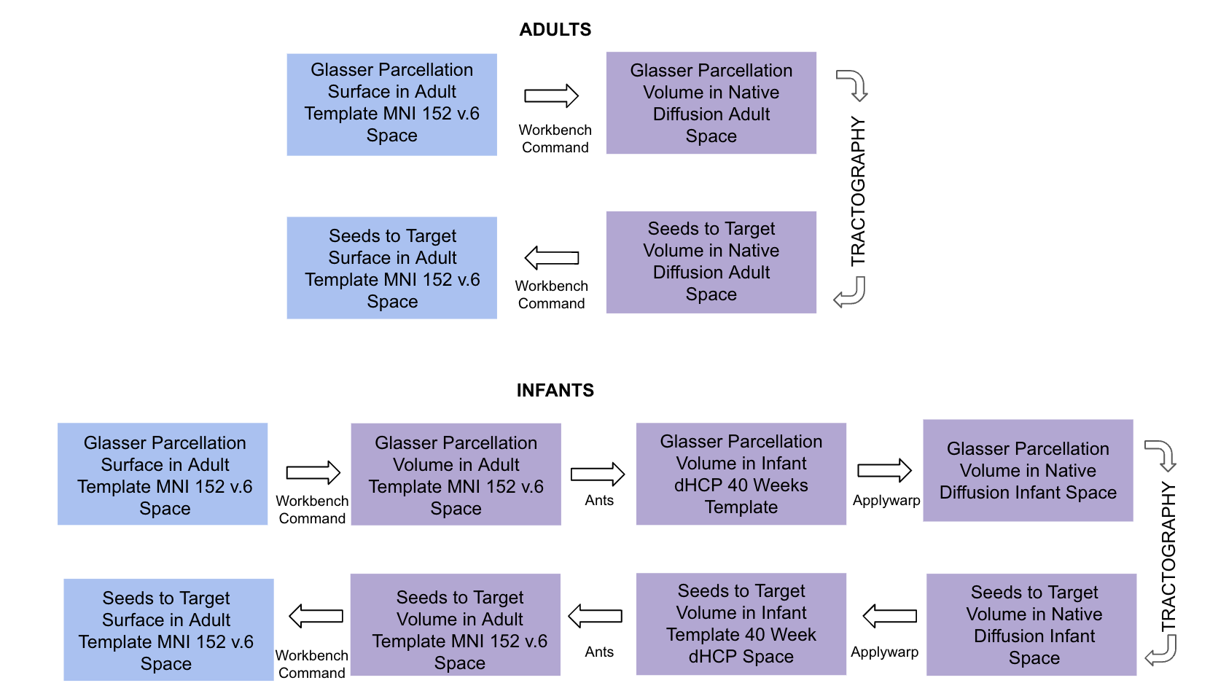
Fig. S1. Schematic of the transformations used to move surface parcellations to volume space in adults and to carry the adult parcellation into neonatal brains. Blue indicates surface space and purple indicates volume space.
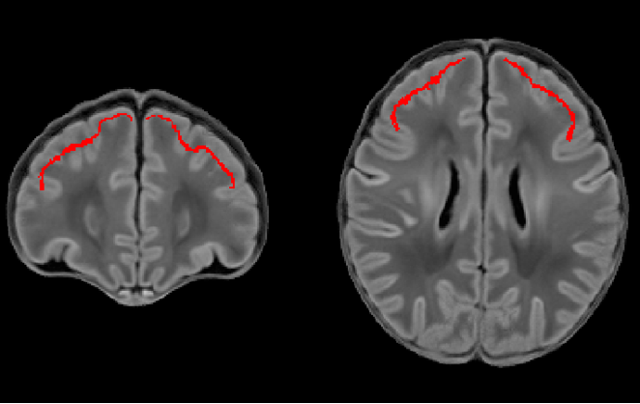
Fig. S2. Example of the transformation from adult to neonatal space. Left and right DLPFC masks after transformation from the adult MNI152 volume (Glasser et al., 2016 parcellation) to the dHCP 40-week template using ANTs.
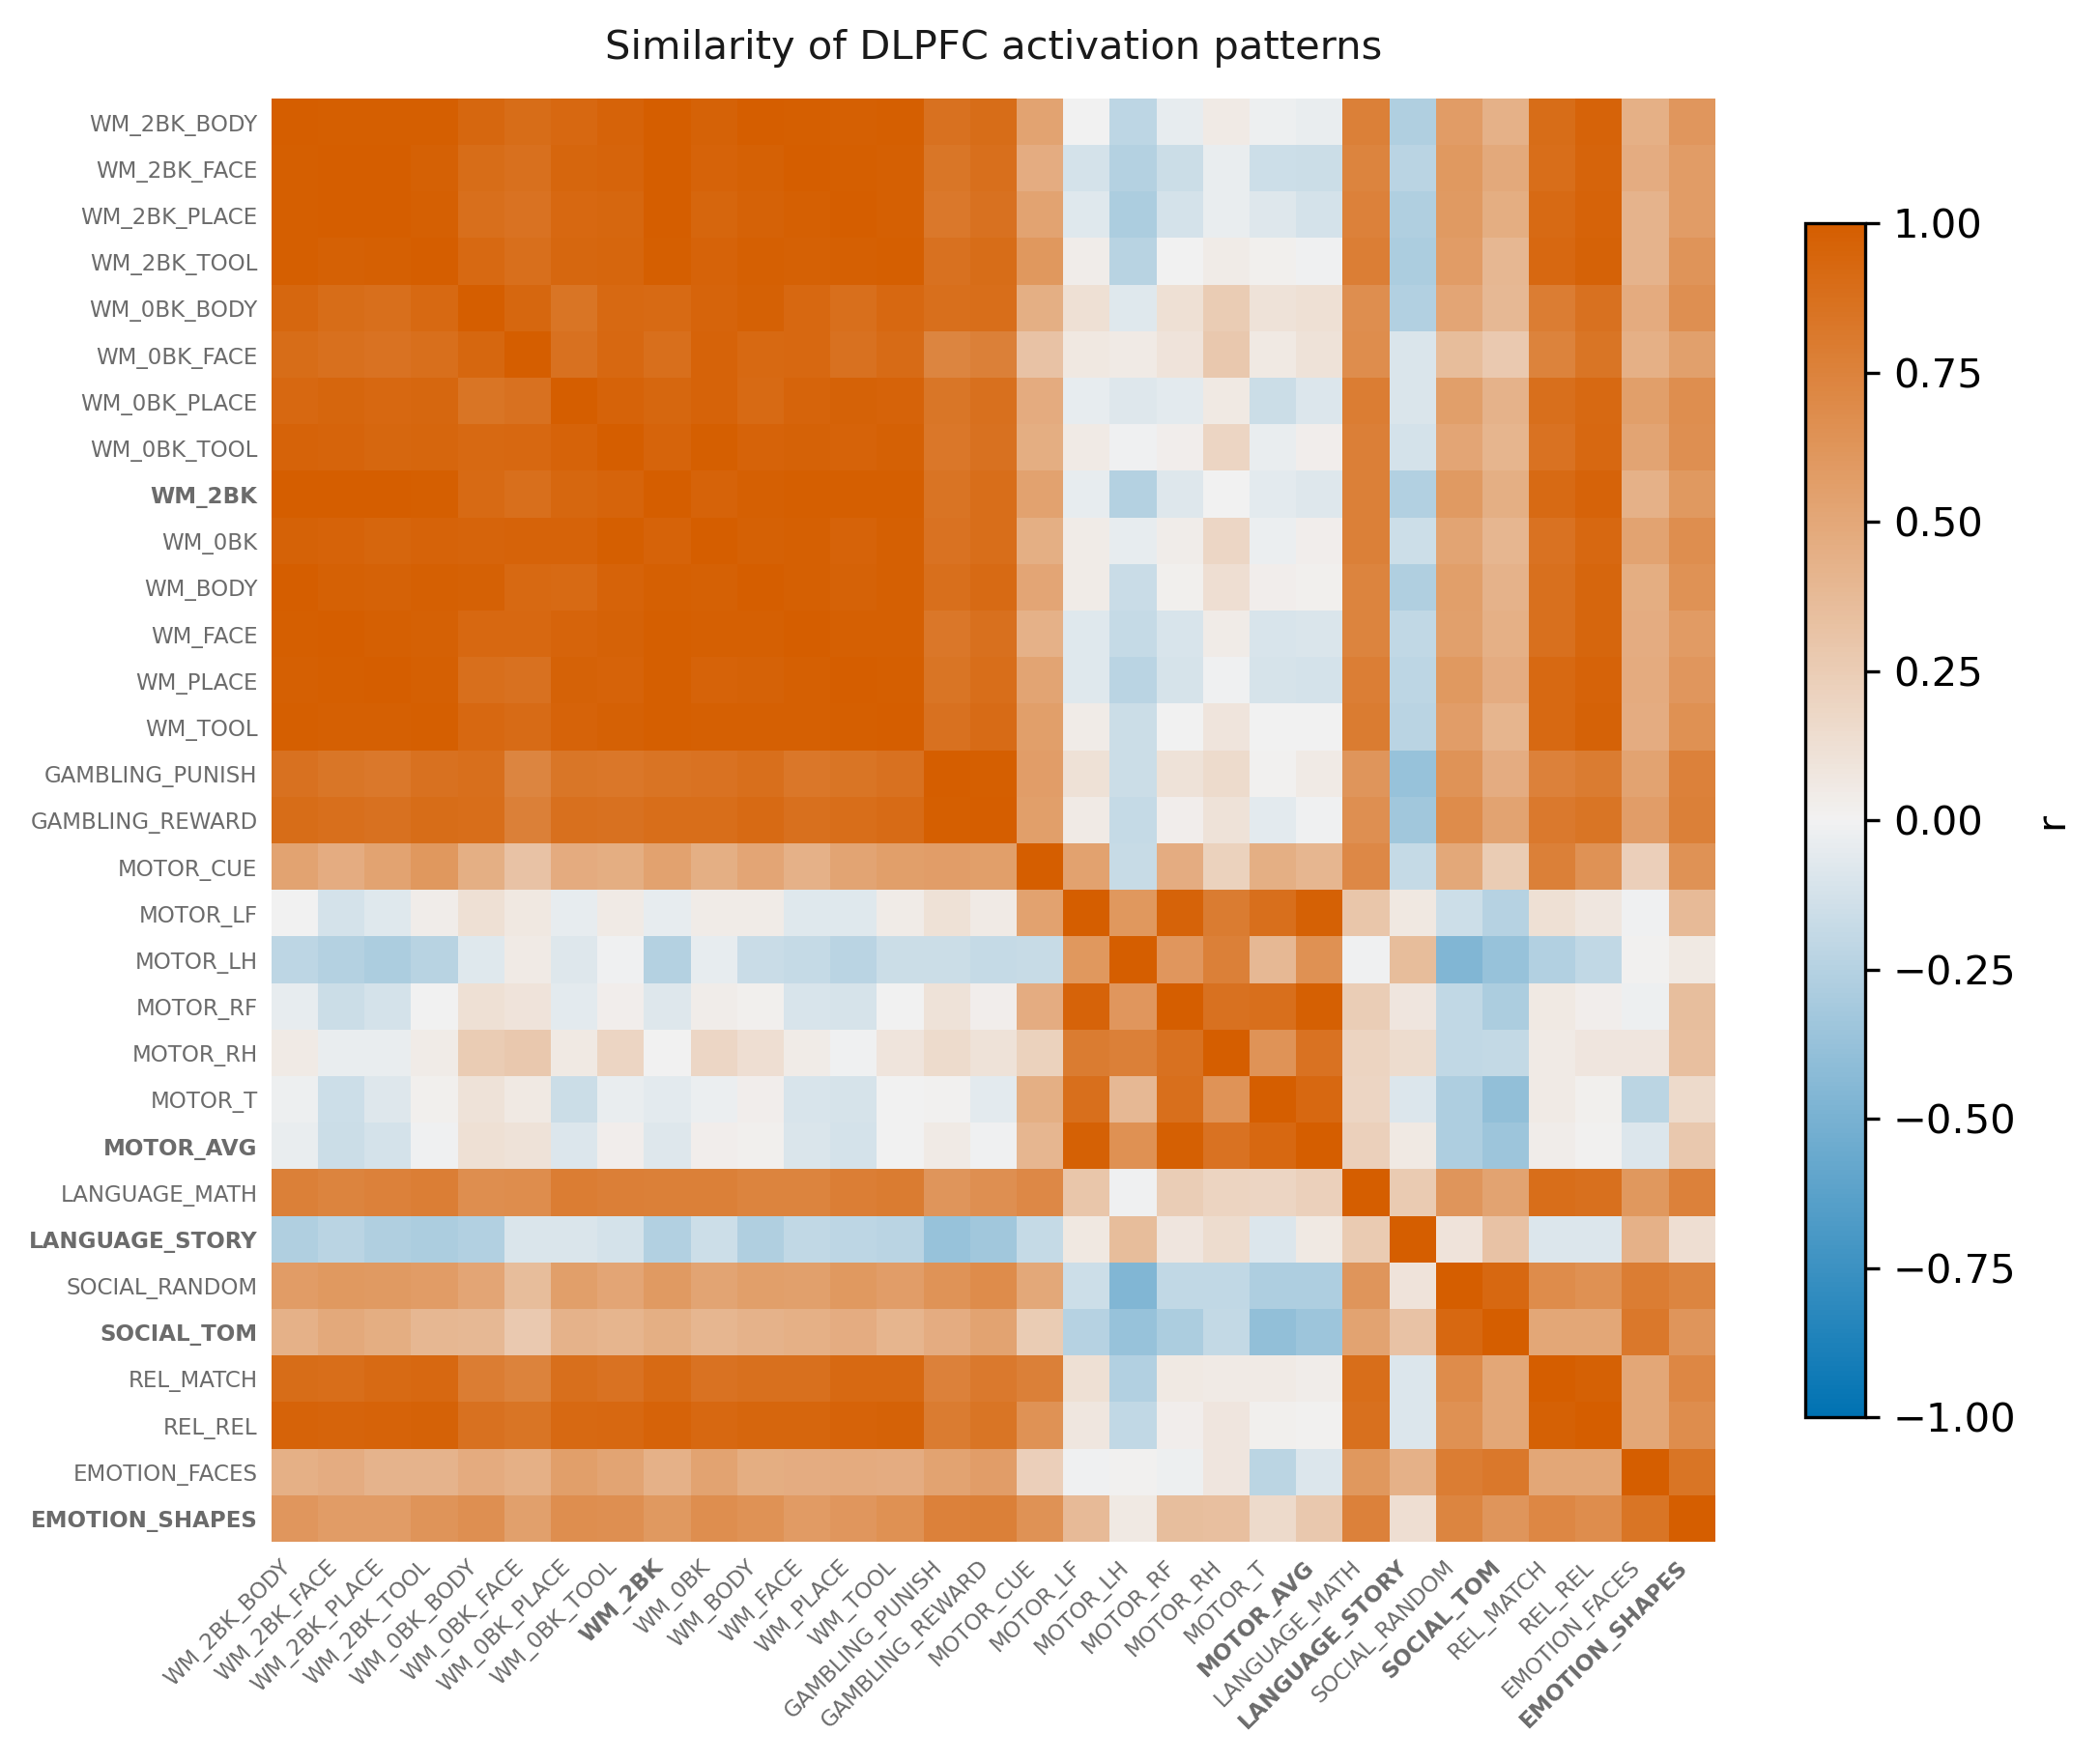
Fig. S3. Representational similarity matrix. Pearson correlation between the spatial patterns of activation across the DLPFC for each pair of task contrasts. Some contrasts evoked similar patterns while others were dissimilar.
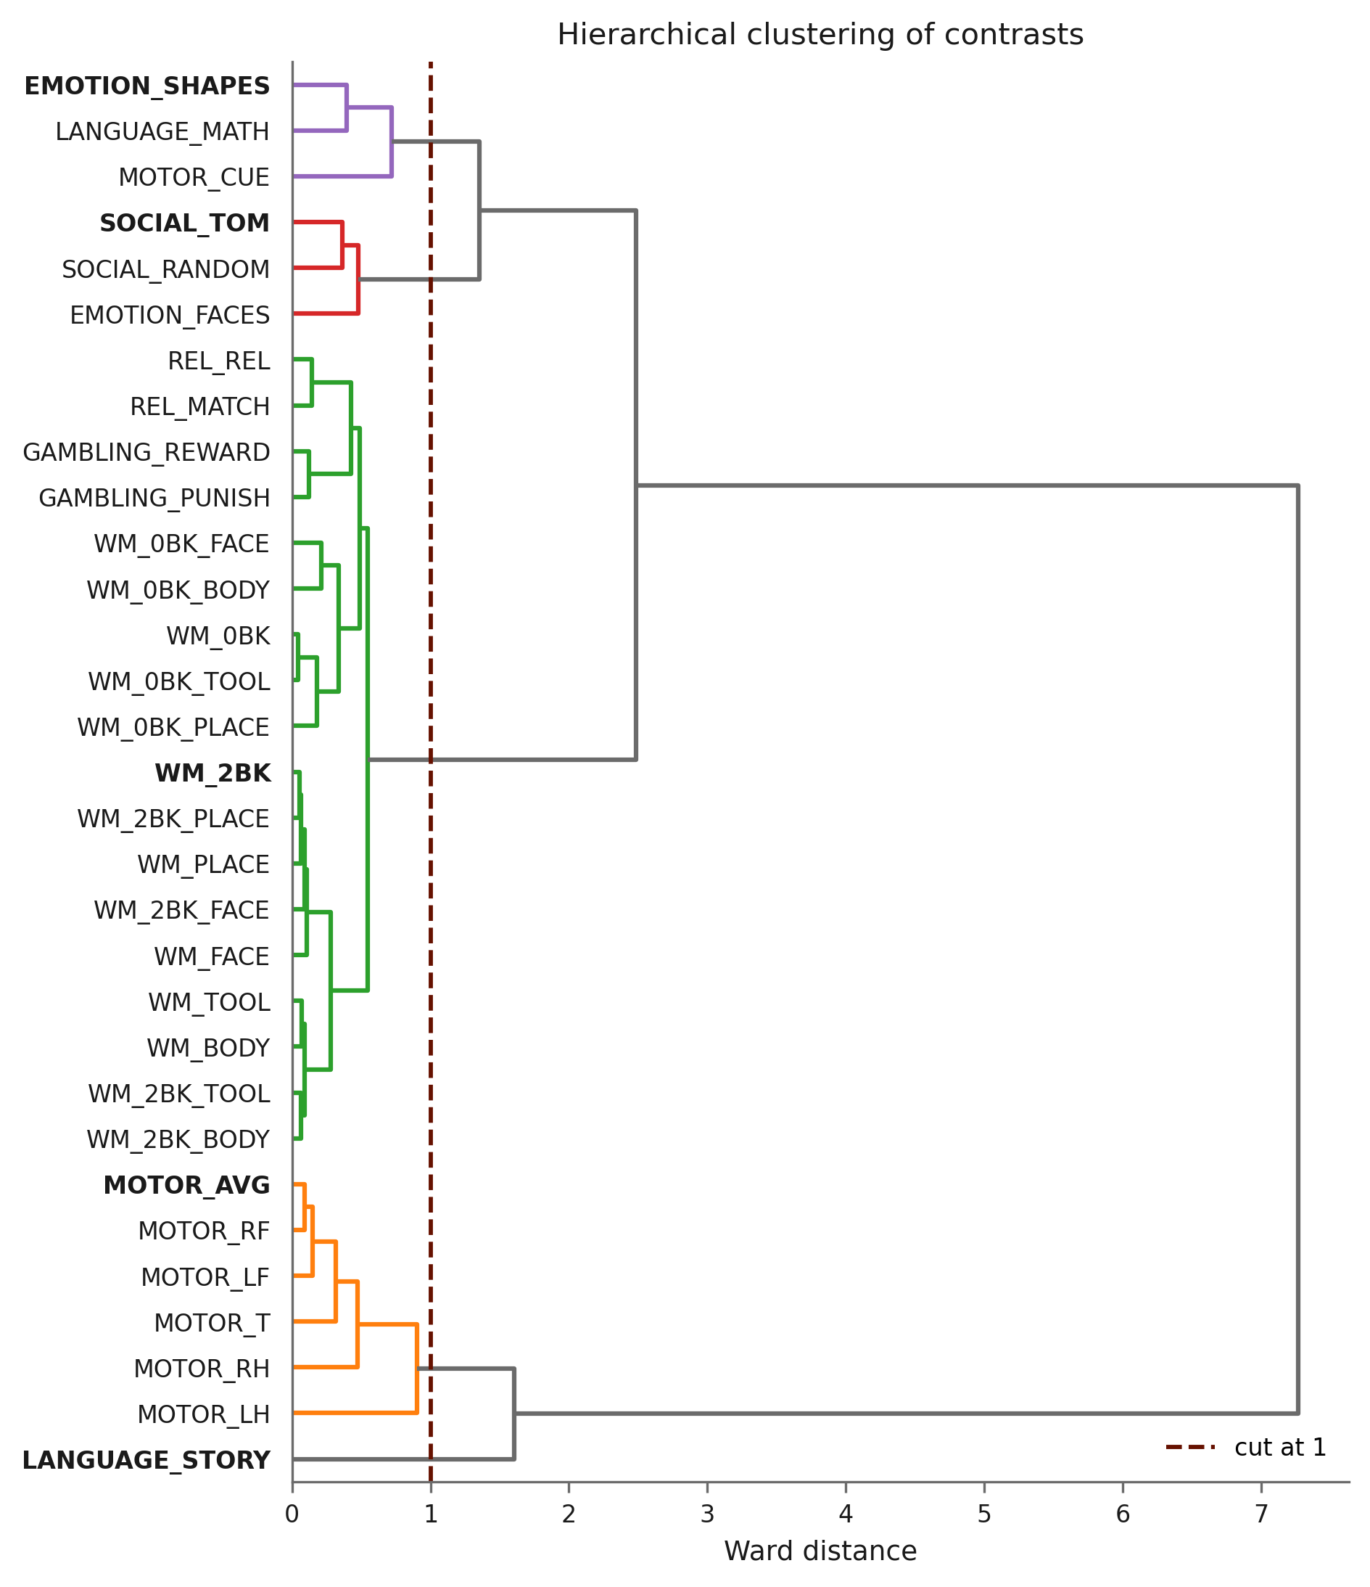
Fig. S4. Hierarchical clustering (Ward linkage) of the task contrasts by the similarity of their spatial activation patterns across the DLPFC. The cut-off at 1.0 (red line) isolated five clusters, each represented in subsequent analyses by the contrast with the shortest stem.
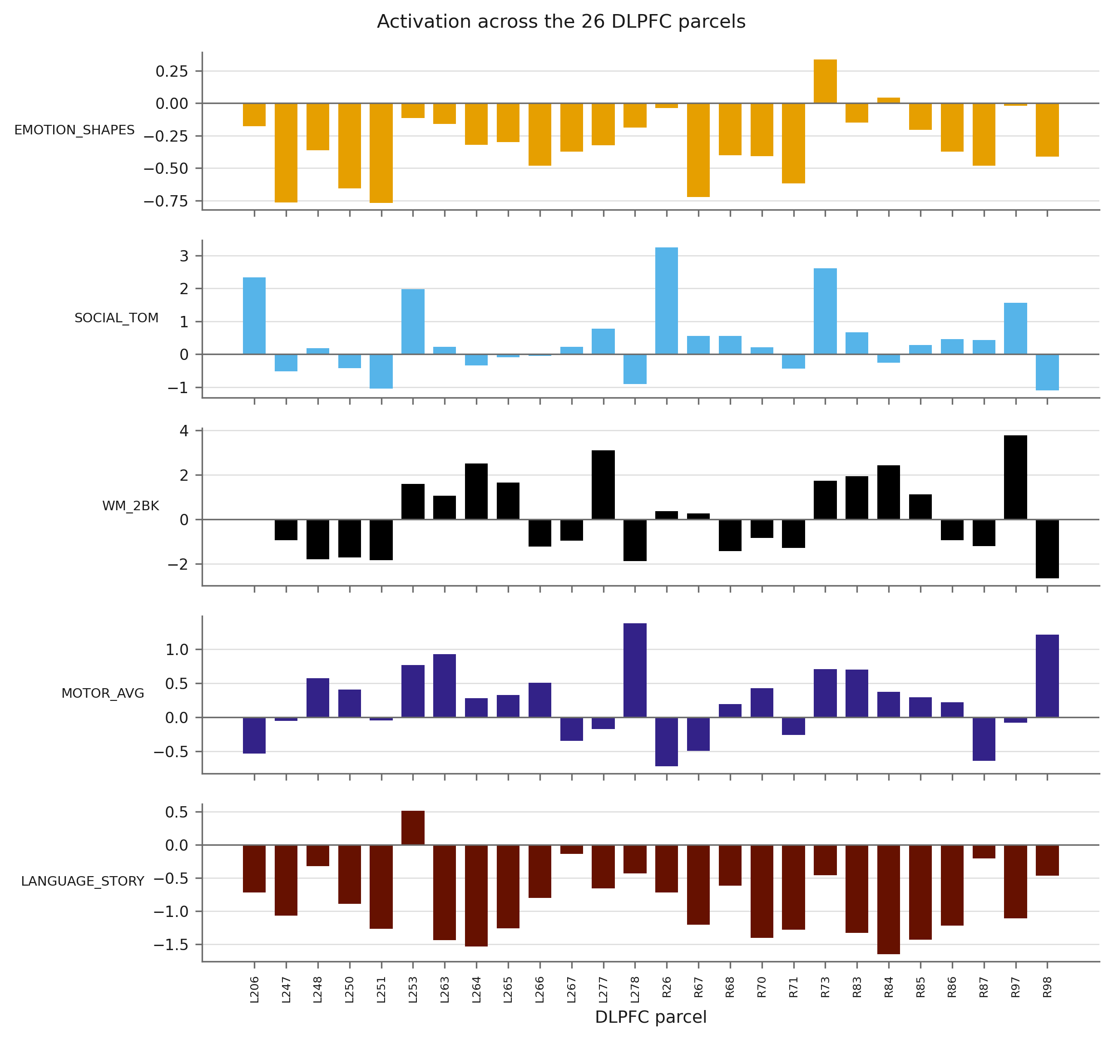
Fig. S5. The 26 DLPFC parcels show distinct profiles of activation across the five representative contrasts, in the left (A) and right (B) hemispheres. Mean beta values per parcel and participant were entered into a two-way repeated-measures ANOVA (see main text); the parcel-by-contrast interaction, F(100, 17500) = 192.5, p < 0.0001, was the largest effect (generalised η² = 0.27).
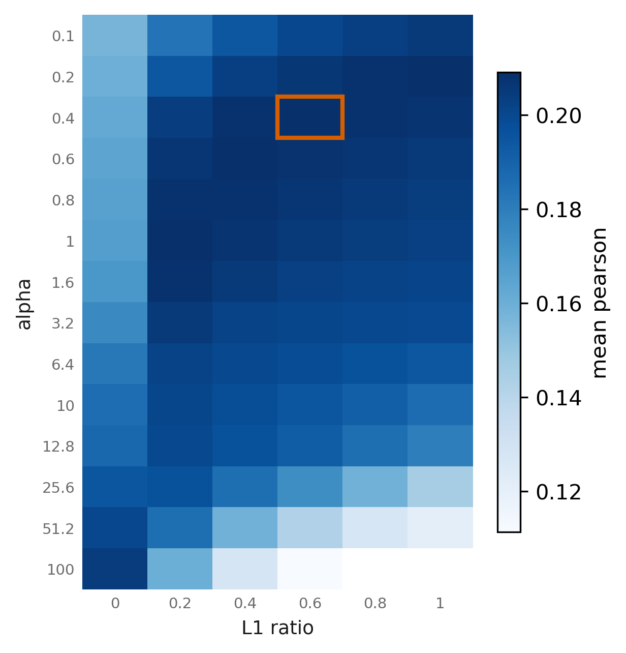
Fig. S6. Hyperparameter grid for the elastic net. Regularisation strength α (rows) and L1 ratio (columns); the combination α = 0.4, L1 ratio = 0.6 was selected.
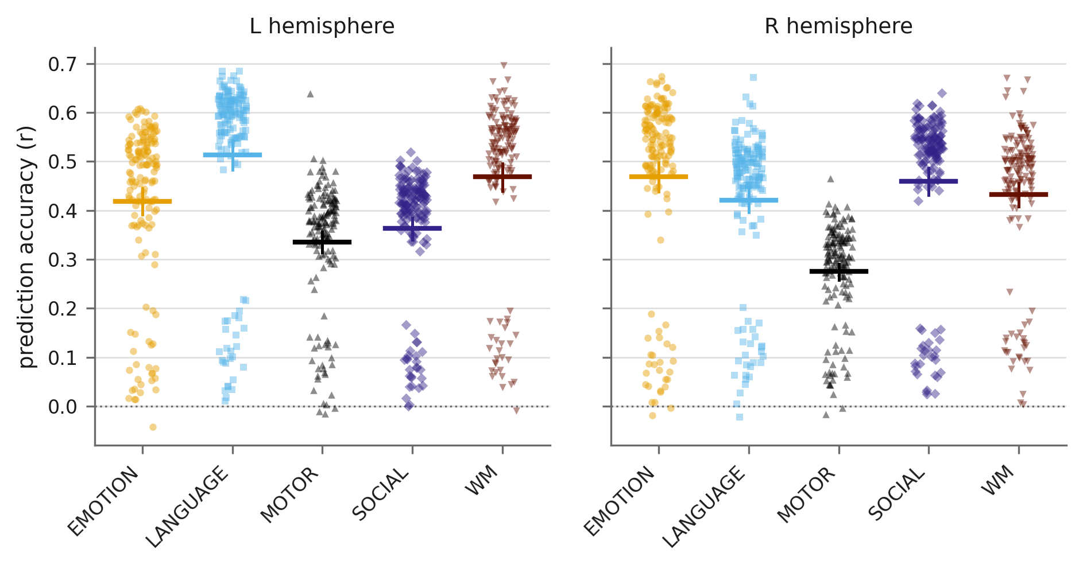
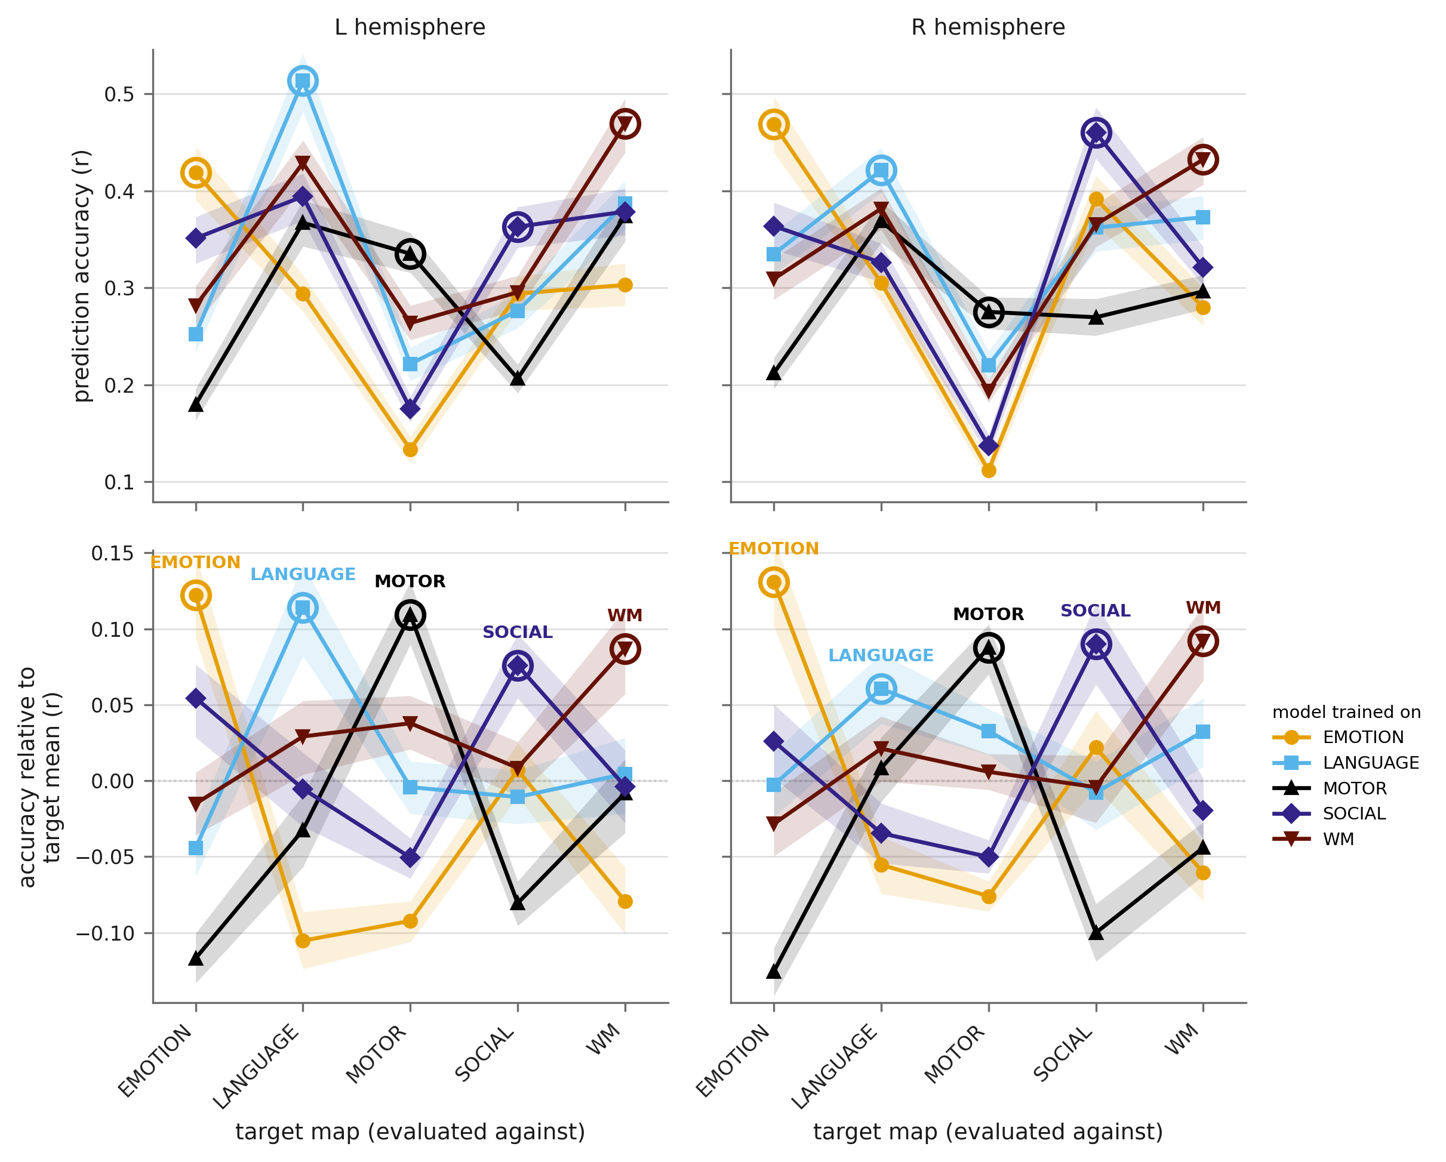
Fig. S7. Prediction of the adult group-average activation from adult connectivity, for comparison with the neonatal predictions in Fig. 3 of the main text. Elastic-net models were trained leave-one-participant-out and evaluated against the group-average activation map computed without the held-out participant. Upper panel: accuracy per contrast, each point one adult, for the left and right hemispheres. Lower panel: task specificity, conventions as in Fig. 2B.
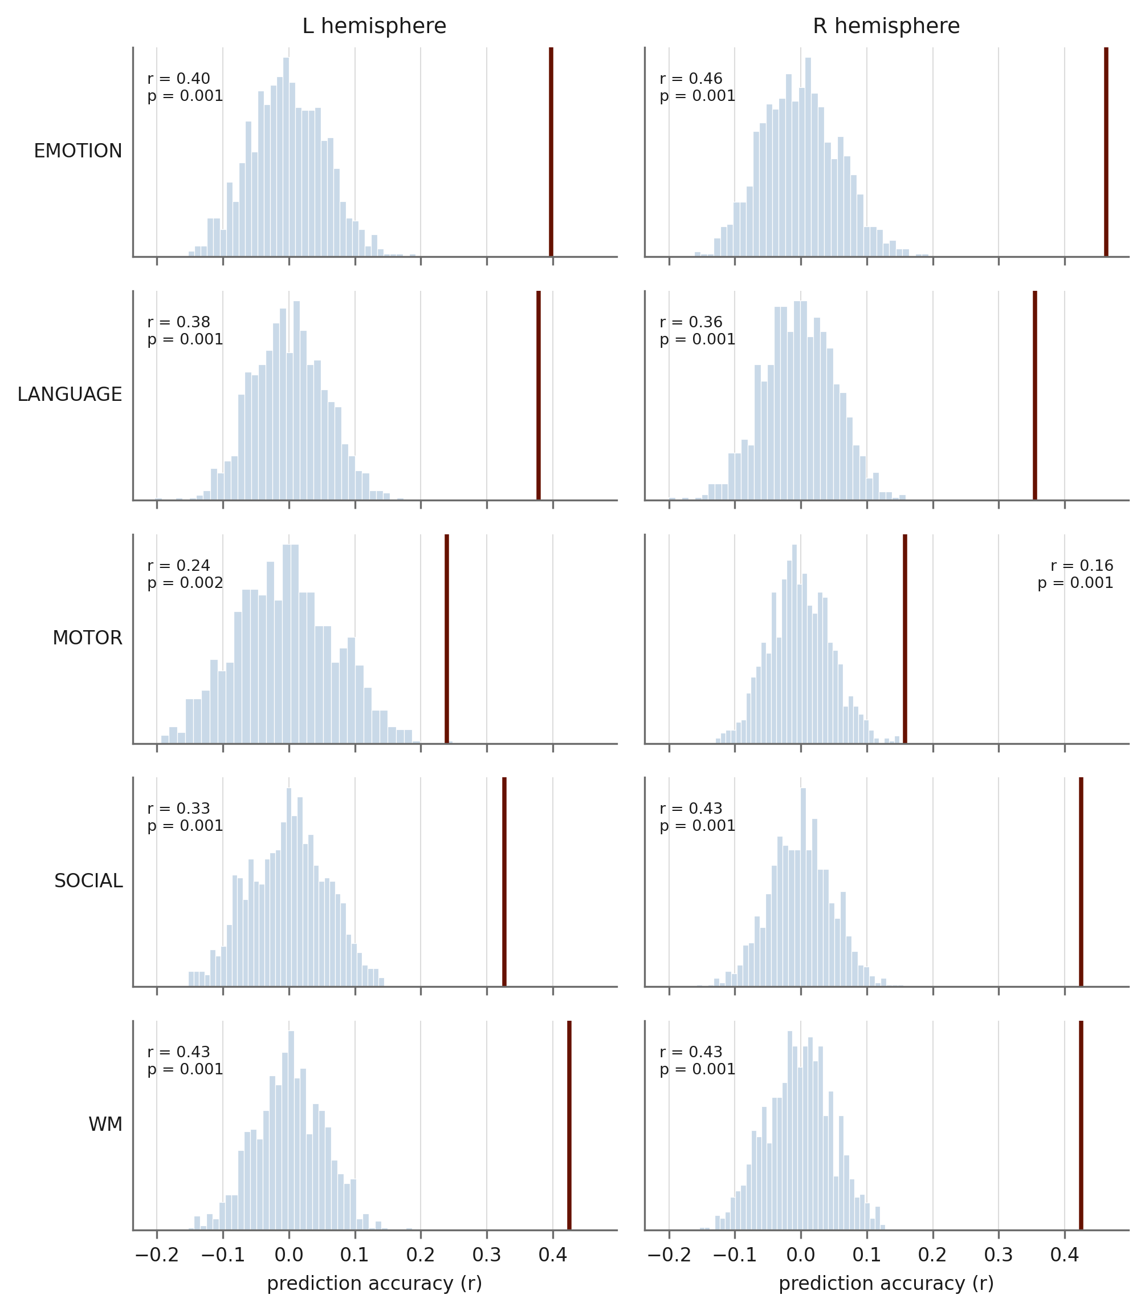
Fig. S8. Spatial null. Observed prediction accuracy from neonatal connectivity (vertical lines) against the null distribution obtained from 1,000 variogram-matched surrogates of the adult group-average activation map, for each task and hemisphere. Surrogates preserve the spatial autocorrelation and the value distribution of the observed map while destroying its correspondence with the prediction. Observed accuracy exceeded the null in all ten cases (p_spin ≤ 0.002).
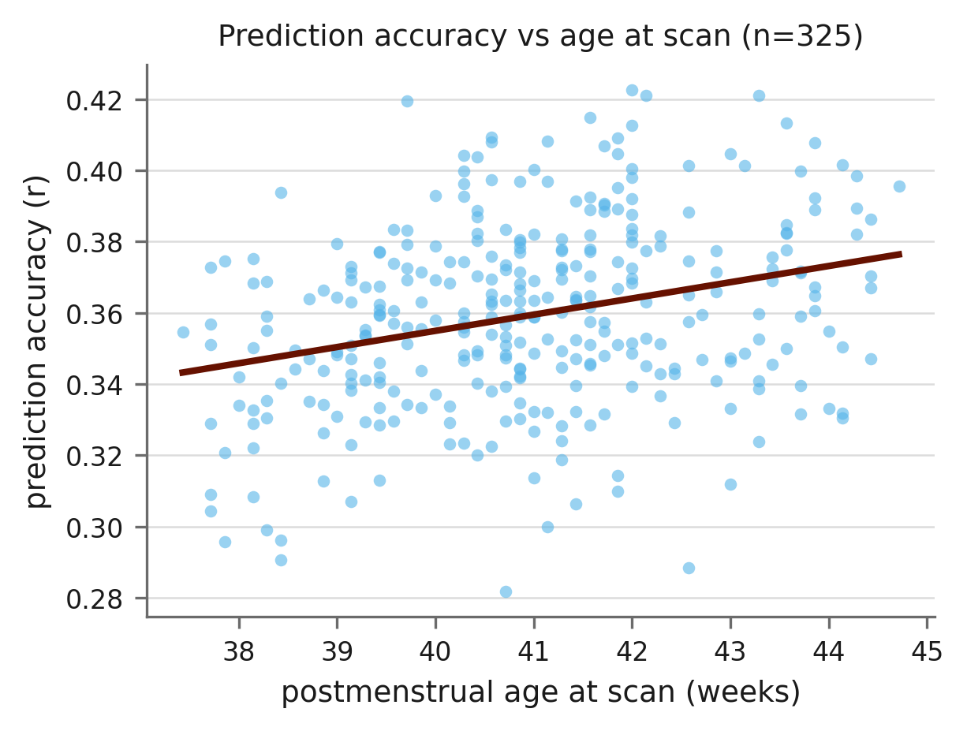
Fig. S9. Prediction accuracy from neonatal connectivity as a function of postmenstrual age at scan, averaged across the five contrasts and both hemispheres. Each point is one neonate; the line is the least-squares fit. Accuracy increased modestly with age (β = 0.0024 per week, p = 0.040, controlling for gestational age at birth and mean relative motion), an increase of 0.017 in r across the full range of scan ages.

SI Tables
Table S1. The 13 parcels per hemisphere of the HCP multimodal parcellation (Glasser et al., 2016) that together define the DLPFC in this study, with their label indices and vertex counts. The 334 target parcels are provided as a supplementary dataset.
Area | Left index | Left vertices | Right index | Right vertices
SFL | 206 | 185 | 26 | 119
8Av | 247 | 199 | 67 | 207
8Ad | 248 | 242 | 68 | 239
8BL | 250 | 151 | 70 | 190
9p | 251 | 147 | 71 | 103
8C | 253 | 257 | 73 | 243
p9-46v | 263 | 128 | 83 | 181
46 | 264 | 213 | 84 | 243
a9-46v | 265 | 126 | 85 | 95
9-46d | 266 | 267 | 86 | 249
9a | 267 | 151 | 87 | 131
i6-8 | 277 | 86 | 97 | 99
s6-8 | 278 | 55 | 98 | 86
Total |  | 2207 |  | 2185

References
Abell, F., Happé, F., & Frith, U. (2000). Do triangles play tricks? Attribution of mental states to animated shapes in normal and abnormal development. Cognitive Development, 15(1), 1–16.
Andersson, J. L. R., Skare, S., & Ashburner, J. (2003). How to correct susceptibility distortions in spin-echo echo-planar images: application to diffusion tensor imaging. NeuroImage, 20(2), 870–888.
Avants, B. B., Tustison, N. J., Wu, J., Cook, P. A., & Gee, J. C. (2011). An open source multivariate framework for n-tissue segmentation with evaluation on public data. Neuroinformatics, 9(4), 381–400.
Avants, B. B., Tustison, N. J., Stauffer, M., Song, G., Wu, B., & Gee, J. C. (2014). The
Insight ToolKit image registration framework. Frontiers in Neuroinformatics,
8. https://doi.org/10.3389/fninf.2014.00044
Barch, D. M., Burgess, G. C., Harms, M. P., Petersen, S. E., Schlaggar, B. L., Corbetta, M., Glasser, M. F., Curtiss, S., Dixit, S., Feldt, C., Nolan, D., Bryant, E., Hartley, T., Footer, O., Bjork, J. M., Poldrack, R., Smith, S., Johansen-Berg, H., Snyder, A. Z., & Van Essen, D. C. (2013). Function in the human connectome: task-fMRI and individual differences in behavior. NeuroImage, 80, 169–189.
Bastiani, M., Andersson, J. L. R., Cordero-Grande, L., Murgasova, M., Hutter, J., Price, A. N., Makropoulos, A., Fitzgibbon, S. P., Hughes, E., Rueckert, D., Victor, S., Rutherford, M., Edwards, A. D., Smith, S. M., Tournier, J.-D., Hajnal, J. V., Jbabdi, S., & Sotiropoulos, S. N. (2019). Automated processing pipeline for neonatal diffusion MRI in the developing Human Connectome Project. NeuroImage, 185, 750–763.
Behrens, T. E. J., Woolrich, M. W., Jenkinson, M., Johansen-Berg, H., Nunes, R. G., Clare, S., Matthews, P. M., Brady, J. M., & Smith, S. M. (2003). Characterization and propagation of uncertainty in diffusion-weighted MR imaging. Magnetic Resonance in Medicine, 50(5), 1077–1088.
Behrens, T. E. J., Berg, H. J., Jbabdi, S., Rushworth, M. F. S., & Woolrich, M. W. (2007). Probabilistic diffusion tractography with multiple fibre orientations: what can we gain? NeuroImage, 34(1), 144–155.
Binder, J. R., Gross, W. L., Allendorfer, J. B., Bonilha, L., Chapin, J., Edwards, J. C., Grabowski, T. J., Langfitt, J. T., Loring, D. W., Lowe, M. J., Koenig, K., Morgan, P. S., Ojemann, J. G., Rorden, C., Szaflarski, J. P., Tivarus, M. E., & Weaver, K. E. (2011). Mapping anterior temporal lobe language areas with fMRI: a multicenter normative study. NeuroImage, 54(2), 1465–1475.
Buckner, R. L., Krienen, F. M., Castellanos, A., Diaz, J. C., & Yeo, B. T. T. (2011). The organization of the human cerebellum estimated by intrinsic functional connectivity. Journal of Neurophysiology, 106(5), 2322–2345.
Burt, J. B., Helmer, M., Shinn, M., Anticevic, A., & Murray, J. D. (2020). Generative modeling of brain maps with spatial autocorrelation. NeuroImage, 220, 117038.
Cabral, L., Zubiaurre-Elorza, L., Wild, C. J., Linke, A., & Cusack, R. (2022). Anatomical correlates of category-selective visual regions have distinctive signatures of connectivity in neonates. Developmental Cognitive Neuroscience, 58, 101179.
Castelli, F., Happé, F., Frith, U., & Frith, C. (2000). Movement and mind: a functional imaging study of perception and interpretation of complex intentional movement patterns. NeuroImage, 12(3), 314–325.
Castelli, F., Frith, C., Happé, F., & Frith, U. (2002). Autism, Asperger syndrome and brain mechanisms for the attribution of mental states to animated shapes. Brain, 125(8), 1839–1849.
Delgado, M. R., Nystrom, L. E., Fissell, C., Noll, D. C., & Fiez, J. A. (2000). Tracking the hemodynamic responses to reward and punishment in the striatum. Journal of Neurophysiology, 84(6), 3072–3077.
Downing, P. E., Chan, A. W.-Y., Peelen, M. V., Dodds, C. M., & Kanwisher, N. (2006). Domain specificity in visual cortex. Cerebral Cortex, 16(10), 1453–1461.
Forbes, E. E., Hariri, A. R., Martin, S. L., Silk, J. S., Moyles, D. L., Fisher, P. M., Brown, S. M., Ryan, N. D., Birmaher, B., Axelson, D. A., & Dahl, R. E. (2009). Altered striatal activation predicting real-world positive affect in adolescent major depressive disorder. American Journal of Psychiatry, 166(1), 64–73.
Fox, C. J., Iaria, G., & Barton, J. J. S. (2009). Defining the face processing network: optimization of the functional localizer in fMRI. Human Brain Mapping, 30(5), 1637–1651.
Glasser, M. F., Sotiropoulos, S. N., Wilson, J. A., Coalson, T. S., Fischl, B., Andersson, J. L., Xu, J., Jbabdi, S., Webster, M., Polimeni, J. R., Van Essen, D. C., & Jenkinson, M. (2013). The minimal preprocessing pipelines for the Human Connectome Project. NeuroImage, 80, 105–124.
Glasser, M. F., Coalson, T. S., Robinson, E. C., Hacker, C. D., Harwell, J., Yacoub, E., Ugurbil, K., Andersson, J., Beckmann, C. F., Jenkinson, M., Smith, S. M., & Van Essen, D. C. (2016). A multi-modal parcellation of human cerebral cortex. Nature, 536(7615), 171–178.
Glover, G. H. (1999). Deconvolution of impulse response in event-related BOLD fMRI. NeuroImage, 9(4), 416–429.
Greve, D. N., & Fischl, B. (2009). Accurate and robust brain image alignment using boundary-based registration. NeuroImage, 48(1), 63–72.
Hariri, A. R., Tessitore, A., Mattay, V. S., Fera, F., & Weinberger, D. R. (2002). The amygdala response to emotional stimuli: a comparison of faces and scenes. NeuroImage, 17(1), 317–323.
Ito, T., Kulkarni, K. R., Schultz, D. H., Mill, R. D., Chen, R. H., Solomyak, L. I., & Cole, M. W. (2017). Cognitive task information is transferred between brain regions via resting-state network topology. Nature Communications, 8, 1027.
Jain, V., Duda, J., Avants, B., Giannetta, M., Xie, S. X., Roberts, T., Detre, J. A., Hurt, H., Wehrli, F. W., & Wang, D. J. J. (2012). Longitudinal Reproducibility and Accuracy of Pseudo-Continuous Arterial Spin–labeled Perfusion MR Imaging in Typically Developing Children. Radiology, 263(2), 527–536.
Jenkinson, M., & Smith, S. (2001). A global optimisation method for robust affine registration of brain images. Medical Image Analysis, 5(2), 143–156.
Jenkinson, M., Bannister, P., Brady, M., & Smith, S. (2002). Improved optimization for the robust and accurate linear registration and motion correction of brain images. NeuroImage, 17(2), 825–841.
Lawson, G. M., Duda, J. T., Avants, B. B., Wu, J., & Farah, M. J. (2013). Associations between children’s socioeconomic status and prefrontal cortical thickness. Developmental Science, 16(5), 641–652.
May, J. C., Delgado, M. R., Dahl, R. E., Stenger, V. A., Ryan, N. D., Fiez, J. A., & Carter, C. S. (2004). Event-related functional magnetic resonance imaging of reward-related brain circuitry in children and adolescents. Biological Psychiatry, 55(4), 359–366.
Pineda, R. G., Neil, J., Dierker, D., Smyser, C. D., Wallendorf, M., Kidokoro, H., Reynolds, L. C., Walker, S., Rogers, C., Mathur, A. M., Van Essen, D. C., & Inder, T. (2014). Alterations in Brain Structure and Neurodevelopmental Outcome in Preterm Infants Hospitalized in Different Neonatal Intensive Care Unit Environments. The Journal of Pediatrics, 164(1), 52-60.e2.
Smith, R., Keramatian, K., & Christoff, K. (2007). Localizing the rostrolateral prefrontal cortex at the individual level. NeuroImage, 36(4), 1387–1396.
Taylor, M. J., Batty, M., & Itier, R. J. (2007). Visual category-selectivity for faces, places and objects emerges along different developmental trajectories. Developmental Science, 10(4), F15–F30.
Tricomi, E. M., Delgado, M. R., & Fiez, J. A. (2004). Modulation of caudate activity by action contingency. Neuron, 41(2), 281–292.
Tustison, N. J., Cook, P. A., Klein, A., Song, G., Das, S. R., Duda, J. T., ... & Avants, B. B. (2014). Large-scale evaluation of ANTs and FreeSurfer cortical thickness measurements. Neuroimage, 99, 166-179.
Wang, H., Das, S. R., Suh, J. W., Altinay, M., Pluta, J., Craige, C., Avants, B., & Yushkevich, P. A. (2011). A learning-based wrapper method to correct systematic errors in automatic image segmentation: Consistently improved performance in hippocampus, cortex and brain segmentation. NeuroImage,55(3), 968–985.
Ward, J. H., Jr. (1963). Hierarchical Grouping to Optimize an Objective Function. Journal of the American Statistical Association, 58(236–244).
Wheatley, T., Milleville, S. C., & Martin, A. (2007). Understanding animate agents: distinct roles for the social network and mirror system. Psychological Science, 18(6), 469–474.
White, S. J., Coniston, D., Rogers, R., & Frith, U. (2011). Developing the Frith-Happé animations: a quick and objective test of Theory of Mind for adults with autism. Autism Research, 4(2), 149–154.
Woolrich, M. W., Ripley, B. D., Brady, M., & Smith, S. M. (2001). Temporal autocorrelation in univariate linear modeling of fMRI data. NeuroImage, 14(6), 1370–1386.

