Connectivity before function: the structural connectivity that distinguishes adult prefrontal sub-regions is present in neonates
Chiara Caldinelli and Rhodri Cusack
Trinity College Institute of Neuroscience and School of Psychology, Trinity College Dublin, Dublin, Ireland
Corresponding author: Rhodri Cusack, cusackrh@tcd.ie
Keywords: brain development; prefrontal cortex; structural connectivity; tractography; interactive specialisation; neonate
Classification: Biological Sciences — Neuroscience; Social Sciences — Psychological and Cognitive Sciences

Significance Statement
Adult brain regions have distinctive patterns of connections to the rest of the brain, and these connections shape what each region does. A long-standing question is whether connections are sculpted by the functions a region performs, or are laid down first and guide later function. We tested this in the dorsolateral prefrontal cortex, whose adult functions, such as working memory, language understanding and mentalising, are absent in newborns. Using two large public datasets, we show that the pattern of connections that distinguishes functionally different parts of the adult prefrontal cortex is already present at one month of age, before any of those functions has emerged. Connectivity therefore precedes function, providing an early scaffold that constrains how higher cognition develops.

Abstract
How does the functional specialisation of the cortex develop? Interactive specialisation proposes that regional function and connectivity emerge together, with a region’s connectivity sculpted by the functions it comes to perform. Alternatively, functionally relevant connectivity may be laid down before function, forming a proto-organisation that guides later specialisation. These accounts are hard to distinguish in sensory systems, where both are present early. We tested them in the dorsolateral prefrontal cortex (DLPFC), whose adult functions — working memory, language comprehension, mentalising and reward-guided choice — are absent in the first month of life. Using task fMRI from the Human Connectome Project, we identified five clusters of tasks with distinct activation profiles across the sub-regions of the DLPFC. In adults, an elastic-net model showed that a vertex’s profile of structural connectivity to the rest of the brain, measured with diffusion tractography, predicted its functional selectivity in a task-specific manner. We then applied these adult models to tractography from 325 term-born neonates in the Developing Human Connectome Project. Neonatal DLPFC connectivity predicted the adult activation pattern for every task, with accuracy comparable to that obtained from adult connectivity, and predictions were task-specific. Because neonates cannot perform any of these tasks, this connectivity cannot have been shaped by co-activation during them. In the DLPFC, structural connectivity precedes functional specialisation and is largely adult-like at birth, consistent with a proto-organisation that constrains, rather than emerges from, later functional development.

Introduction
A central question in developmental cognitive neuroscience is how the regional specialisation of the cortex arises. Adult cortex is a mosaic of regions with distinct functional responses, and a defining feature of each region is its pattern of structural connectivity to the rest of the brain (Passingham et al., 2002; Saygin & Kanwisher, 2014). Function and connectivity are tightly linked: differences in connectivity between locations track differences in their functional response, to the extent that a voxel’s functional selectivity can be predicted from its connectivity alone (Saygin et al., 2011; Osher et al., 2016). What is much less clear is how this relationship comes about during development. Does functionally relevant connectivity emerge alongside function, or is it present first?
Two broad accounts have been proposed. The interactive specialisation framework (Johnson, 2001, 2011) holds that specialisation is an emergent product of interactions between regions. Cortical regions begin with only weak, broadly tuned biases, and their response properties are progressively sharpened through activity-dependent competition and cooperation with the regions they are connected to. On this account, connectivity and function co-develop: the connections that characterise a mature region are strengthened and pruned in step with the functions the region comes to perform, in the spirit of “fire together, wire together”. A second account places connectivity first. Here, differences in extrinsic connectivity between cortical locations are largely established before function and act as a proto-organisation (Saygin et al., 2016; Rakic, 1988), determining where later specialisations will settle. In the visual system a coarse eccentricity-based organisation is thought to provide the scaffold on which category-selective regions later form (Levy et al., 2001; Hasson et al., 2002; Malach et al., 2002). In neonates, the connectivity of these regions already mirrors the adult pattern (Cabral et al., 2022). Newborn macaques already show a retinotopic proto-organisation spanning the whole visual hierarchy, including the regions that will later become face-selective (Arcaro & Livingstone, 2017), and face domains then form within this proto-map only if faces are seen (Arcaro et al., 2017), suggesting that an early map and later experience jointly determine where specialisation occurs. In children, connectivity at age five predicts the location of the visual word form area at age eight (Saygin et al., 2016).
These accounts are difficult to separate in sensory systems because both function and connectivity are present early. Visual cortex is responsive from birth and rapidly acquires adult-like retinotopic and category-related organisation (e.g., Deen et al., 2017; Ellis et al., 2021a; Kosakowsi et al, 2022; O’Doherty et al, 2026). Early connectivity in visual cortex is therefore compatible with both accounts: it may have been present first, or it may already have been shaped by activity in the visual pathway, which begins long before birth and arrives in three phases. Before the eyes open, spontaneous retinal waves drive patterned activity throughout the visual system (Wong, 1999; Ackman et al., 2012); once the eyes open in the third trimester, the fetus responds to light reaching it through the abdominal wall (Reid et al., 2017); and from birth there is patterned visual experience proper. To discriminate the accounts, one needs a region whose adult functions are demonstrably absent at the age of testing. If the connectivity that distinguishes its sub-regions is nevertheless present, that connectivity cannot have been sculpted by the functions it will later support.
The dorsolateral prefrontal cortex (DLPFC) offers exactly this test. It is a hub region that is richly connected (Cole et al., 2013), central to the global workspace and flexible attentional control (Dehaene et al., 1998), and engaged by effortful, goal-directed tasks of many kinds (Duncan, 2001; Barbey et al., 2013). In adults, its sub-regions show distinct profiles of activation across tasks including working memory, language comprehension, mentalising, and reward processing (Barch et al., 2013; Glasser et al., 2016). And, critically, none of these functions is available to a neonate. Even a simple working-memory task such as the A-not-B task is not passed until 9–12 months (Piaget, 1954; Wellman et al., 1987); language comprehension only begins to develop from 6–12 months (Bergelson & Swingley, 2012; Frank et al., 2017); cognitive flexibility is only apparent around 2.5 years (Perner & Lang, 2002); and inhibitory control continues to develop into adolescence (Luna, 2009). Theory of mind and gambling lie further off too. The traditional reading of this behavioural timetable is that prefrontal cortex matures last, in a hierarchical progression from sensory to association cortex (Gao et al., 2015). Although recent work has shown that the frontal lobes are not silent in neonates (Cusack et al., 2016; Dehaene-Lambertz et al., 2002, 2010; Doria et al., 2010; Ellis et al., 2021b; Linke et al., 2018; Smyser et al., 2010), what activity there is cannot reflect the adult functions, because the behaviours those functions support are far from becoming apparent. The DLPFC in the first month of life is thus a region in which the adult functions are known to be absent, making it possible to ask directly whether the connectivity that underpins those functions is present before them.
We took a two-stage approach (Fig. 1). First, in 175 low-motion adults from the Human Connectome Project (Van Essen et al, 2013), we characterised the functional organisation of the DLPFC by clustering task contrasts according to the similarity of their spatial activation patterns across its sub-regions, yielding five distinct profiles. We then used probabilistic tractography on diffusion-weighted MRI to measure, for each vertex in the DLPFC, its connectivity to 334 regions across the rest of the brain, and trained regularised regression models to predict each vertex’s task response from its connectivity. This established that variations in connectivity across the DLPFC are sufficiently rich to account for variations in function, and yielded a model of which connections matter for which function. Second, we applied these adult models, unchanged, to Diffusion MRI tractography from 325 term-born neonates in the Developing Human Connectome Project. If connectivity and function co-develop, the adult models should predict little or nothing from neonatal connectivity. If connectivity precedes function, the adult models should predict the adult activation patterns from neonatal connectivity, and should do so in a task-specific manner. We further compared the accuracy of prediction from neonatal and adult connectivity to estimate how much of the adult, functionally relevant structure is already present at birth, tested whether the neonatal prediction could be explained by spatial autocorrelation alone, and asked whether it changes across the neonatal period.
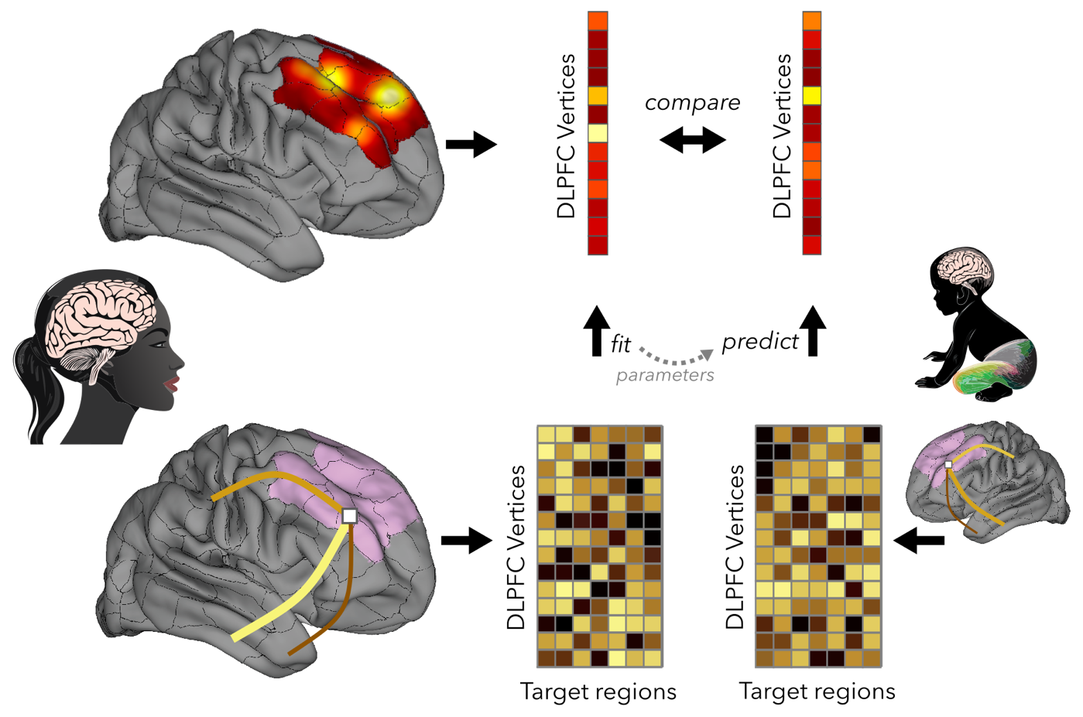
Fig. 1. Overview of the approach. In 176 adults from the Human Connectome Project, vertex-wise activation across the DLPFC was extracted from each fMRI task contrast. In these adults and 325 neonates from the Developing Human Connectome Project, probabilistic tractography on diffusion-weighted MRI was used to quantify how strongly each vertex connected to each of 334 regions across the rest of the brain. Regularised regression (elastic net) was trained in adults to predict each vertex’s activation from its connectivity profile, and the adult models were then applied to neonates.

Results

Sub-regions of the adult DLPFC have distinct profiles of task activation
We first asked whether the DLPFC, defined as 13 parcels per hemisphere (26 in total) from the Human Connectome Project multimodal parcellation (Glasser et al., 2016), contains sub-regions with distinct functional profiles. In 176 low-motion adults from the Human Connectome Project (one more than the 175 available for the prediction analyses, which required diffusion data), we extracted vertex-wise activation across the DLPFC for 31 task contrasts spanning working memory, language, social cognition, relational reasoning, emotion, incentive and motor processing (Barch et al., 2013), and computed the similarity of their spatial patterns (SI Appendix, Fig. S3). Hierarchical clustering identified five clusters of contrasts with distinct spatial patterns (SI Appendix, Fig. S4), which we represented by one contrast each: 2-back working memory, story comprehension (language), theory of mind (social), shape matching (emotion task) and the average of movement types (motor). Across the 26 DLPFC parcels, these five contrasts evoked reliably different profiles of activation (SI Appendix, Fig. S5): a repeated-measures ANOVA on mean activation per parcel showed a main effect of parcel, F(25, 4375) = 181.7, p < 0.0001, a main effect of contrast, F(4, 700) = 101.4, p < 0.0001, and, critically, a parcel-by-contrast interaction, F(100, 17500) = 192.5, p < 0.0001 , which was also the largest effect (generalised η² = 0.27). The sub-regions of the adult DLPFC therefore differ in the tasks they respond to, providing five functional profiles whose anatomical basis can be sought.

Structural connectivity predicts functional selectivity in adults
We next asked whether these functional differences are reflected in the structural connectivity of the DLPFC. For each adult, probabilistic tractography seeded from every DLPFC vertex quantified the number of streamlines reaching each of the 334 parcels outside the DLPFC across both hemispheres (167 per hemisphere), giving each vertex a connectivity profile. For each task contrast and hemisphere, an elastic-net regression was trained to predict a vertex’s activation from its connectivity profile, and prediction accuracy was quantified as the correlation across vertices between predicted and observed activation (Fig. 2A). Connectivity predicted activation for every task and in both hemispheres. Mean correlations between predicted and observed activation were 0.25 (left) and 0.22 (right) for working memory, 0.26 and 0.19 for language, 0.16 and 0.20 for social cognition, 0.12 and 0.17 for emotion, and 0.22 and 0.16 for motor.
If connectivity carries information about which function a vertex supports, rather than merely how strongly it responds to demanding tasks in general, then a model trained on one task should predict that task’s activation pattern better than another task’s. We tested this by cross-applying models between tasks (Fig. 2B). Within-task prediction (the leading diagonal) exceeded between-task prediction (off-diagonal): mean within-task r = 0.20 (SD 0.09) versus between-task r = 0.14 (SD 0.07) in the left hemisphere, and 0.19 (SD 0.08) versus 0.13 (SD 0.06) in the right; bootstrap tests confirmed the difference in both hemispheres (left: difference = 0.059, 95% CI 0.054–0.063; right: 0.052, 95% CI 0.047–0.056; both p < 0.001). Pairwise, the working-memory model was more accurate for working memory than for any other task in both hemispheres (all p < 0.0001), and language, emotion and motor models were also distinguishable from one another (Fig. 2B). The pattern of structural connectivity across the adult DLPFC is therefore sufficiently rich to distinguish, at least partly, the sub-regions supporting different high-level functions.
A
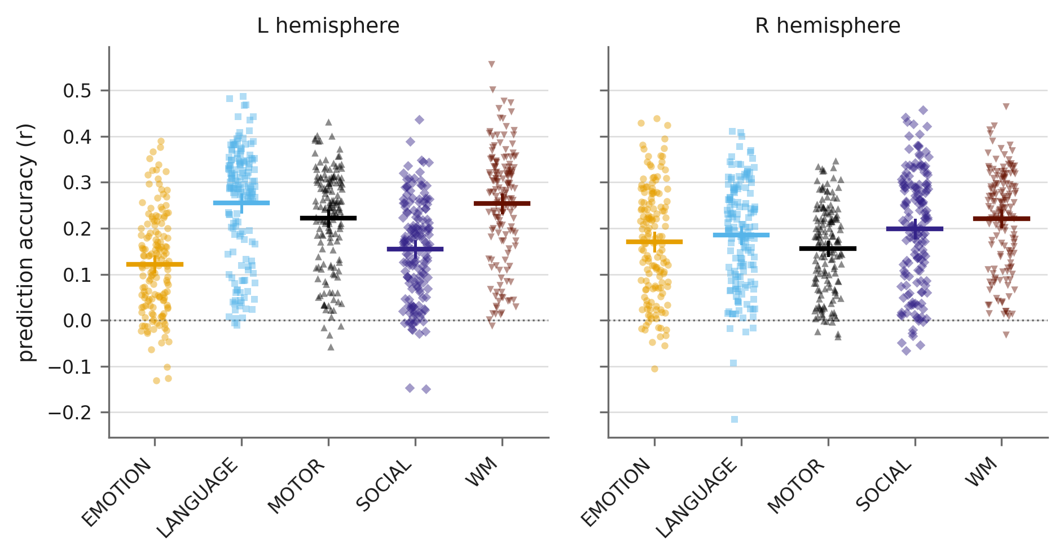
B
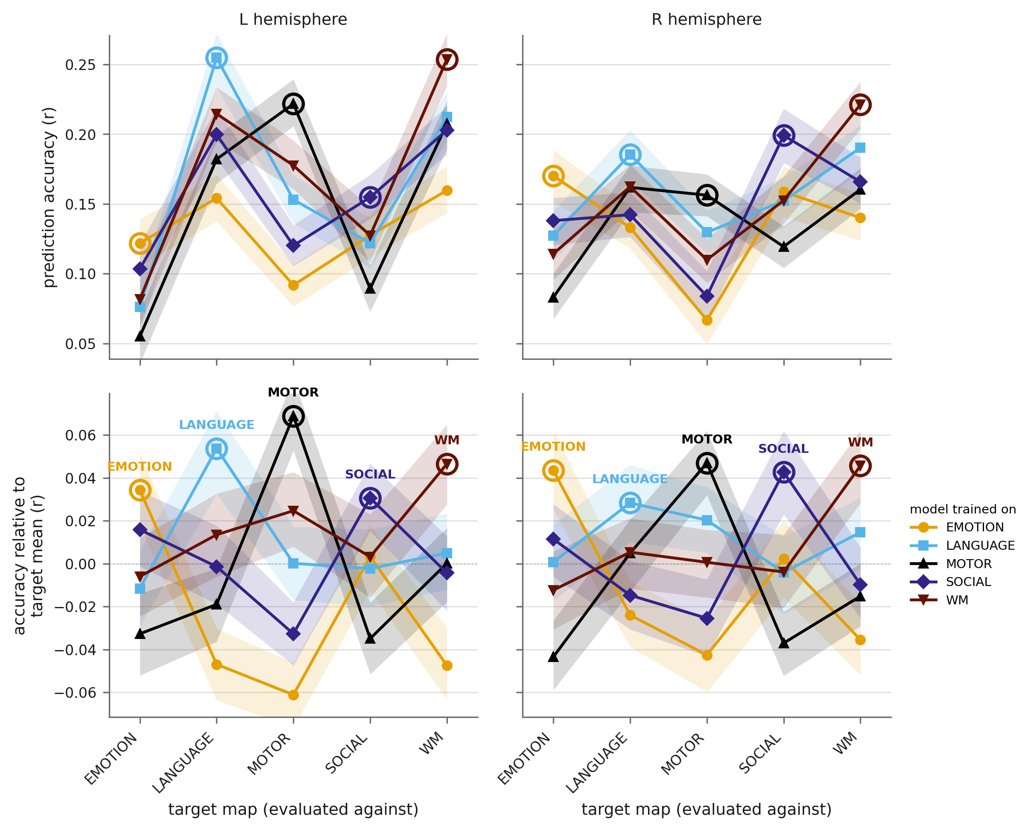
Fig. 2. In adults, the functional response of a DLPFC vertex can be predicted from its structural connectivity. (A) For each of the five task contrasts, an elastic-net model was trained to predict vertex-wise activation from tractography-derived connectivity, leave-one-participant-out; each point is one participant and the y axis is the correlation across vertices between predicted and observed activation, for the left and right hemispheres. (B) Prediction is task-specific. For each target map, the upper panels show the accuracy of every model and the lower panels the same values with each target's across-model mean removed, leaving only specificity; circled points mark each model's own target. Every target map was best predicted by its own model (40 of 40 comparisons, p_FDR ≤ 0.0002); full statistics in Table S2.

Neonatal connectivity predicts adult functional selectivity
Having established which aspects of connectivity are associated with each functional profile in adults, we asked whether those aspects are present at birth. We applied the adult models, without retraining, to tractography from 325 term-born neonates in the Developing Human Connectome Project, scanned during natural sleep at a median of 40.9 weeks postmenstrual age. The adult parcellation was transformed into each neonate’s native diffusion space, tractography was run identically to adults, and the resulting connectivity profiles were sampled back onto the adult cortical surface (SI Appendix, Figs. S1 and S2). For each neonate and task, the adult model generated a predicted activation map across DLPFC vertices, which we compared with the adult group-average activation for that task (Fig. 3A).
Neonatal connectivity predicted the adult activation pattern for every task and hemisphere. Mean correlations between predicted and observed adult activation were 0.43 (left) and 0.43 (right) for working memory, 0.38 and 0.36 for language, 0.33 and 0.43 for social cognition, 0.40 and 0.46 for emotion, and 0.24 and 0.16 for motor; all were significant by bootstrap (p < 0.001). Prediction was again task-specific (Fig. 3B): within-task prediction (mean r = 0.35, SD 0.04, left; 0.37, SD 0.03, right) exceeded between-task prediction (0.28, SD 0.04, left; 0.30, SD 0.03, right), with bootstrap differences of 0.069 (95% CI 0.067–0.070) and 0.066 (95% CI 0.065–0.067), both p < 0.001. Pairwise, the working-memory model was more accurate for working memory than for any other task in both hemispheres (all p < 0.0001), and the remaining models were largely distinguishable from one another (Fig. 3B). Thus the connectivity that distinguishes functionally different sub-regions of the adult DLPFC is present in the first weeks of life, at an age when none of the corresponding functions can be performed.
A
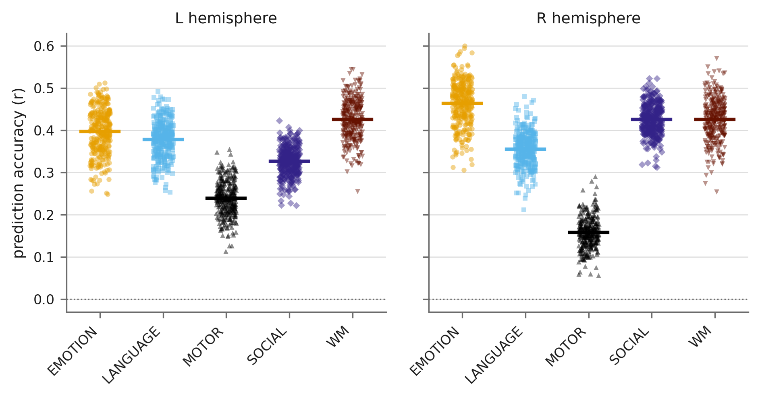
B
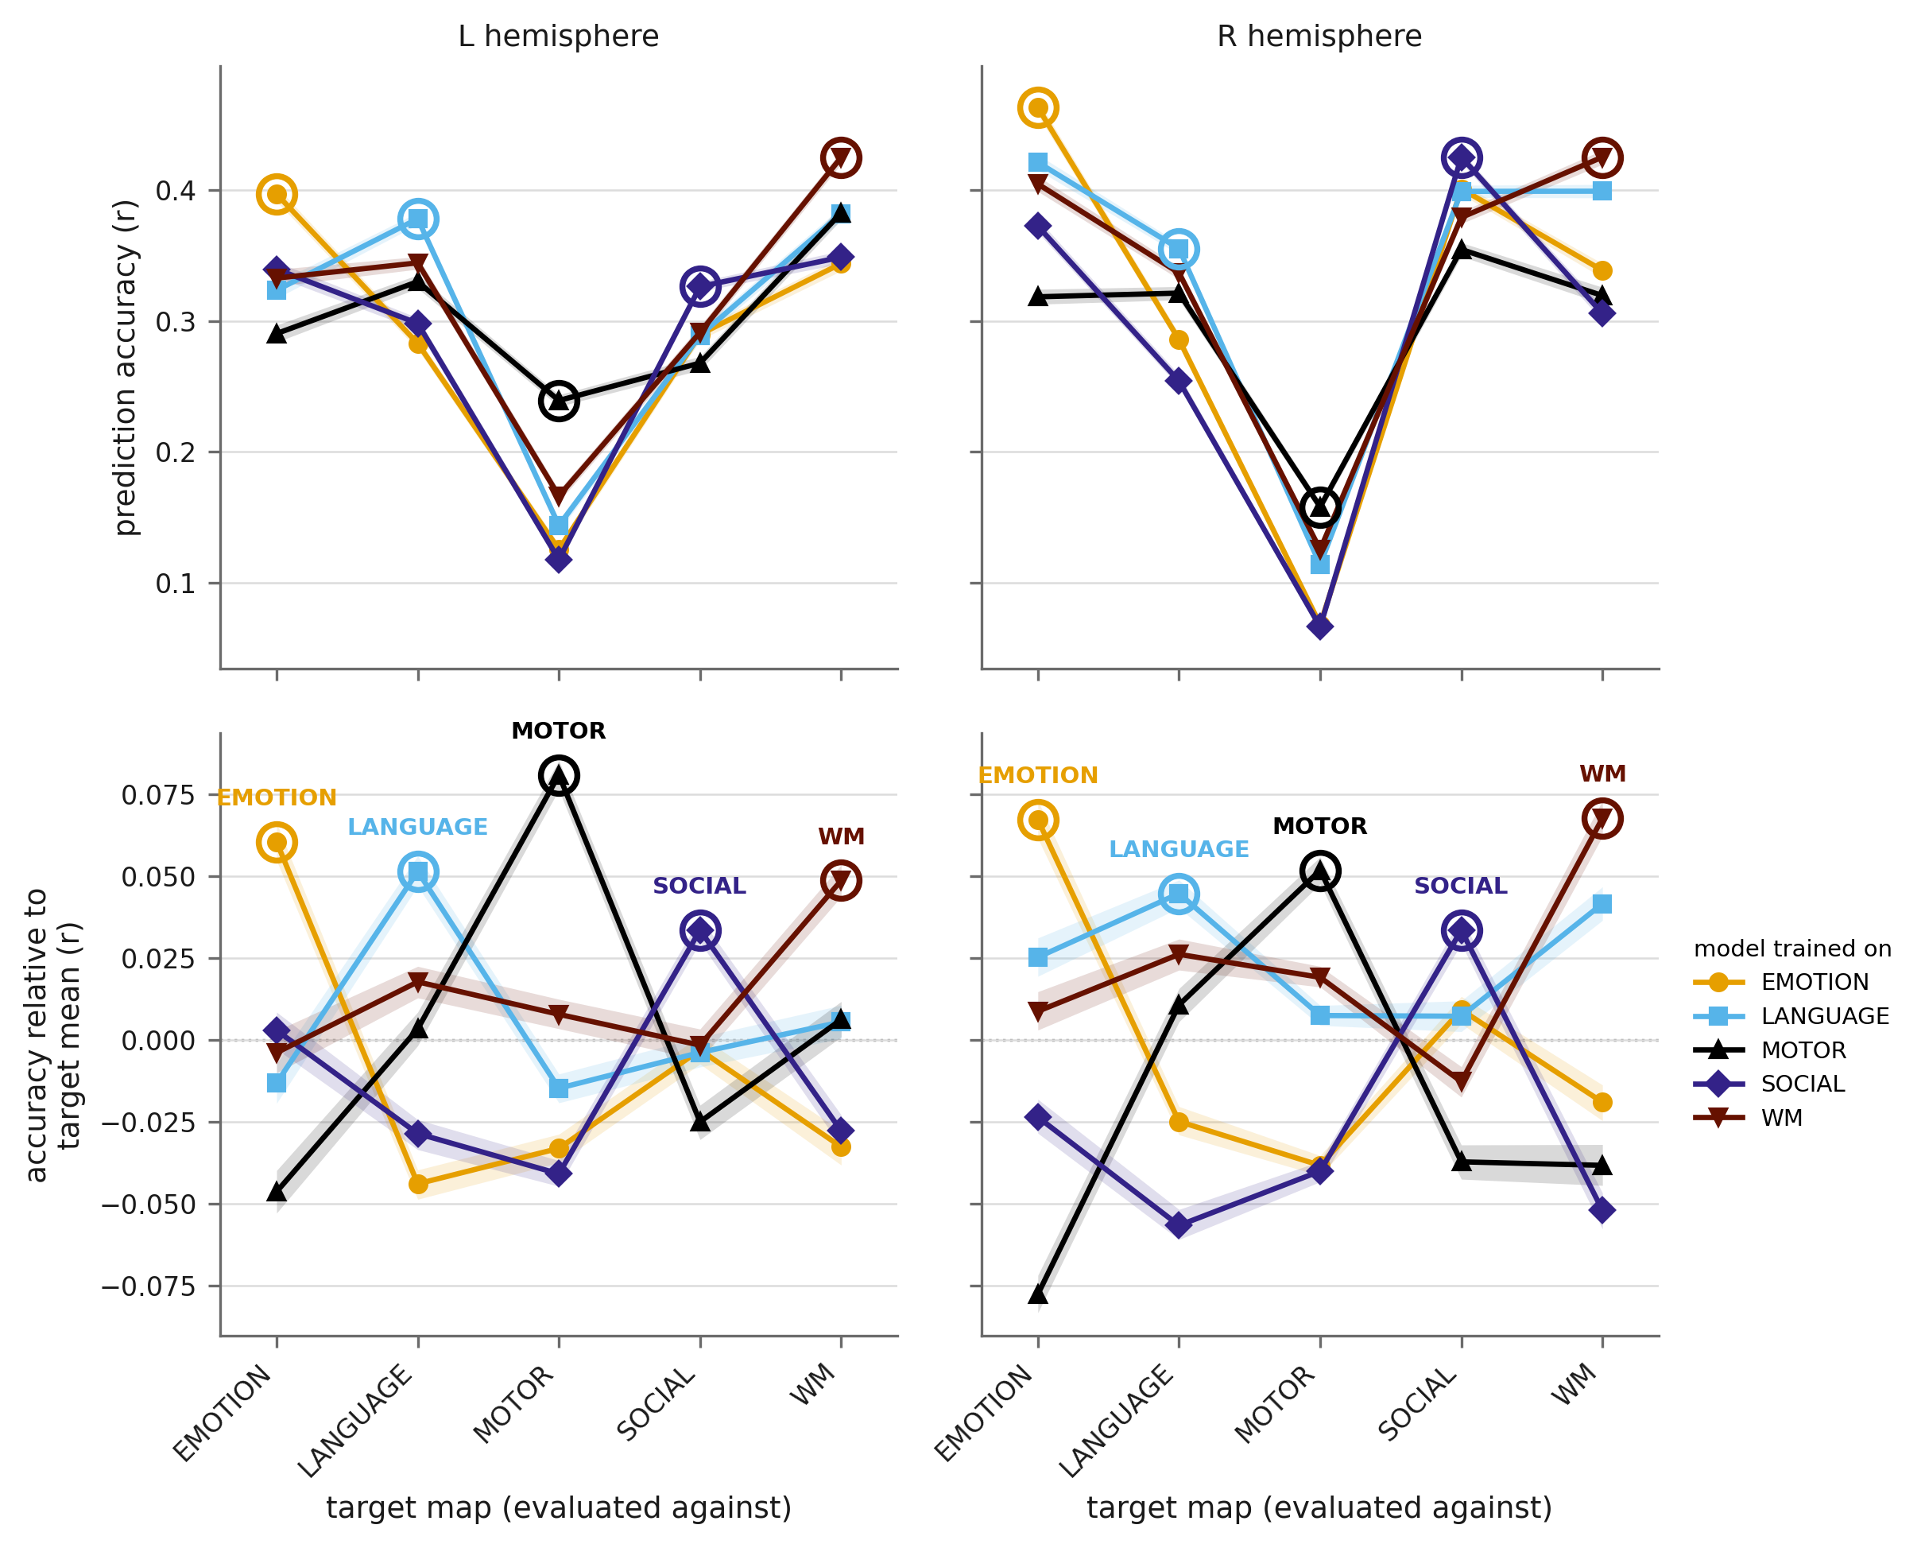
Fig. 3. Neonatal structural connectivity predicts adult functional selectivity in the DLPFC. (A) Adult elastic-net models were applied, unchanged, to tractography from 325 term-born neonates; each point is one neonate and the y axis is the correlation across vertices between the activation predicted from that neonate's connectivity and the adult group-average activation, for the left and right hemispheres. (B) Prediction from neonatal connectivity is task-specific; conventions as in Fig. 2B. Every target map was best predicted by its own model (40 of 40 comparisons, p_FDR ≤ 0.0002).

Most functionally relevant connectivity is present at birth, but not equally for every contrast
The neonatal predictions were, if anything, more accurate than the adult predictions in Fig. 2. This is because the neonatal analysis predicts the adult group-average activation map, which is far less noisy than the single-subject maps predicted in the adult analysis. To compare like with like, we repeated the adult analysis predicting the group-average map from each adult’s connectivity (SI Appendix, Fig. S7). Mean correlations were 0.47 (left) and 0.43 (right) for working memory, 0.51 and 0.42 for language, 0.36 and 0.46 for social cognition, 0.42 and 0.47 for emotion, and 0.34 and 0.28 for motor. Neonatal connectivity therefore predicted the adult functional organisation of the DLPFC about as well as adult connectivity did: averaged across tasks and hemispheres, r = 0.36 for neonates versus 0.42 for adults, a ratio of 86%. Prediction from neonatal connectivity was lower than from adult connectivity for every contrast, but the difference was not significant for emotion in either hemisphere or for working memory in the right hemisphere; it was largest for language (left hemisphere) and motor. The group-average analysis is leave-one-participant-out, with the held-out adult excluded from the average as well as from training, and the per-contrast comparison with bootstrap intervals is given in Fig. 4.
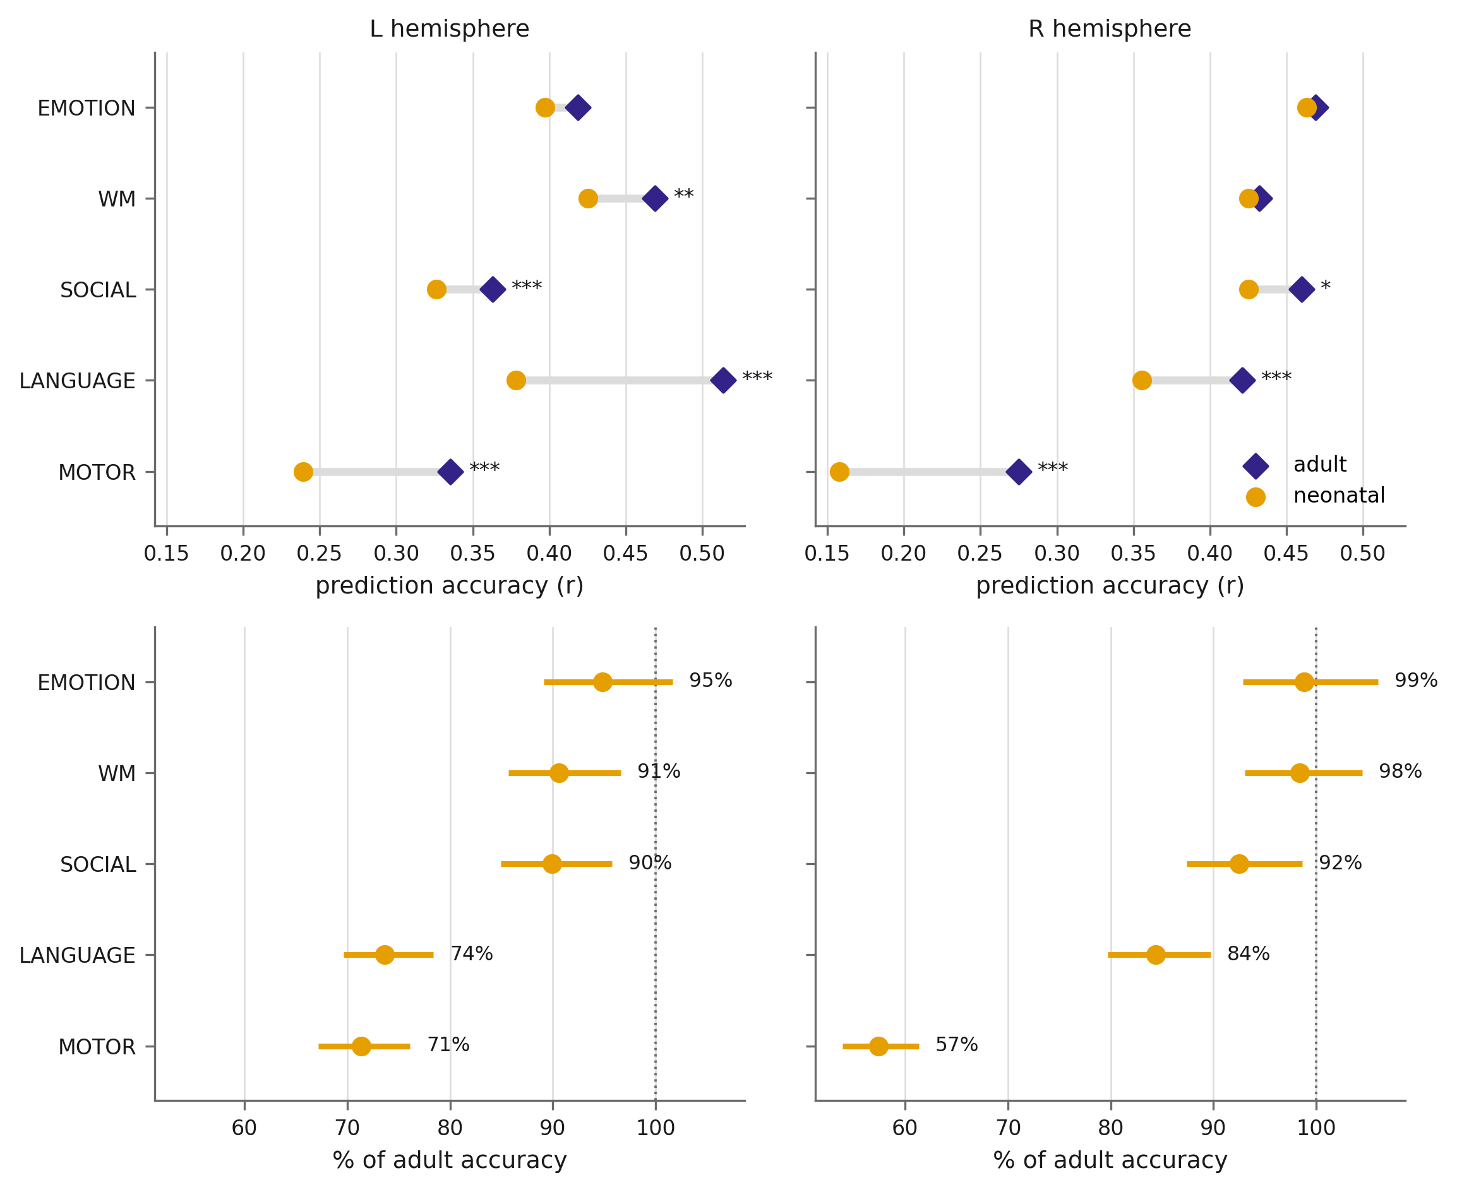
Fig. 4. Neonatal connectivity predicts adult DLPFC organisation nearly as well as adult connectivity does. Upper panels: mean prediction accuracy for each contrast from neonatal connectivity (n = 325) and from adult connectivity predicting the same group-average map (n = 155), for the left and right hemispheres; the connecting segment is the gap between them. Lower panels: the same expressed as a percentage of adult accuracy with a bootstrapped 95% interval, the dotted line marking parity. Neonatal prediction reached a median of 90% of adult accuracy (range 57–99%); for emotion in both hemispheres and working memory in the right hemisphere the difference was not significant. Asterisks mark differences significant after Benjamini–Hochberg correction (* p < 0.05, ** p < 0.01, *** p < 0.001).

Prediction from neonatal connectivity is not explained by spatial autocorrelation
Both activation and connectivity vary smoothly across the cortical sheet, so a model could in principle predict activation from connectivity simply by capturing a shared spatial gradient across the DLPFC, without any function-specific information. To test this, we compared the observed prediction accuracies against a null distribution generated by spatially rotating the adult activation maps on the sphere, which preserves their spatial autocorrelation while breaking their correspondence with connectivity (Alexander-Bloch et al., 2018; Markello & Misic, 2021). Across 1,000 variogram-matched surrogate maps, the observed neonatal prediction exceeded the null for every task and hemisphere (all p_spin ≤ 0.002; SI Appendix, Fig. S8), and the task-specificity of prediction (the diagonal-minus-off-diagonal difference) likewise exceeded its null (p_spin ≤ 0.002). Neonatal connectivity therefore carries function-specific information beyond a smooth spatial gradient.

Functionally relevant connectivity across the neonatal period
Finally, we asked whether the functionally relevant connectivity is still changing across the neonatal period. Included neonates were scanned between 37.4 and 44.7 weeks postmenstrual age, a window in which white-matter microstructure matures rapidly. For each neonate we averaged prediction accuracy across the five tasks and related it to postmenstrual age at scan, controlling for gestational age at birth and head motion. Prediction accuracy increased modestly with age at scan (β = 0.0024 per week, p = 0.040) (SI Appendix, Fig. S9); considered separately, the effect was confined to the language contrast (p_FDR = 0.0065).

Discussion
We asked whether the structural connectivity that distinguishes the sub-regions of the adult DLPFC develops alongside their functions or precedes them. In adults, the connectivity of a DLPFC vertex to the rest of the brain predicted its functional response across five distinct task profiles, and did so in a task-specific manner. When the same models were applied to the connectivity of term-born neonates, they predicted the adult activation patterns for every task, with accuracy comparable to that obtained from adult connectivity itself, and again in a task-specific manner. Because none of the functions captured by these profiles is available to a one-month-old, the connectivity cannot have been shaped by co-activation during them. In the DLPFC, then, functionally relevant connectivity is present before function. This does not exclude a role for activity-dependent refinement, which may act on this initial scaffold, but it indicates that the scaffold is largely adult-like at birth and so constrains, rather than emerges from, later specialisation. Notably, the strongest neonatal prediction was for the working-memory profile, the function for which a co-activation account would be hardest to sustain, whereas prediction of the motor profile, the one function a neonate’s brain is already engaged in something like, was among the weakest. This pattern is the opposite of what co-development would predict.
What, then, is the neonatal DLPFC doing while its connectivity is already in place? Our data are compatible with three possibilities that differ in the maturity of function rather than of anatomy. The first is that the connectivity forms a proto-organisation in the sense proposed by Saygin and colleagues (Saygin et al., 2016): functionally specific regions develop in their characteristic locations because of pre-existing differences in extrinsic connectivity. In the visual system, the connectivity of a cortical location at age five predicts whether it will become the visual word form area at age eight, and the connectivity of individual voxels predicts their selectivity for faces, objects, scenes and bodies (Saygin et al., 2016; Osher et al., 2016). Our results extend this principle to the association cortex most remote from the sensory periphery, and push its origin back to birth. The parallel with the visual system is instructive. In macaques, a retinotopic proto-organisation is present at birth throughout the visual hierarchy, yet face-selective domains form within it only with experience of faces (Arcaro & Livingstone, 2017; Arcaro et al., 2017): the map is innate, the domain is learned, and the map determines where the domain will appear. The connectivity we observe in the neonatal DLPFC may play the same role for the functions of the prefrontal cortex, specifying where working memory, language and social cognition will come to reside, without requiring that those functions are present. On this view the DLPFC may be functioning in the neonate, but its sub-regions need not yet be differentiated; the connectivity specifies where differentiation will occur.
The second possibility is that the sub-regions already have distinct functions, engaged by precursors of the adult tasks. Infants cannot do arithmetic, follow a story or gamble, but the DLPFC could be engaged by simpler operations from which these abilities are built, and those operations might already be distributed across sub-regions as in adults. Understanding what such precursors could be, and how problem solving might develop gradually from soon after birth rather than emerging abruptly as the brain matures, will likely require computational models, perhaps deep neural networks, that can be interrogated at intermediate stages of learning. The third possibility is that the DLPFC is not functioning at all in neonates and the connectivity simply lies in wait. We consider this the least likely, given the growing evidence of frontal activity in neonates (Cusack et al., 2016; Dehaene-Lambertz et al., 2002; Ellis et al., 2021; Linke et al., 2018), but our data cannot exclude it. Distinguishing these accounts will require functional measurements in infants: adaptations of developmental paradigms such as elementary working memory or language, or naturalistic stimulation such as movies, which engage a range of cognitive functions and are more tolerable to infants than cognitive paradigms.
How do these results bear on interactive specialisation? The framework does not hold that connectivity begins from nothing, and its proponents would note that by term birth the cortex has experienced months of spontaneous and sensory-driven activity in utero, which is activity-dependent in the relevant sense. Our claim is correspondingly specific. It is not that activity plays no role in shaping DLPFC connectivity, but that the connectivity relevant to distinguishing the adult functions of the DLPFC is in place before those functions, and so cannot be a product of them. This is a quantitative rather than an absolute claim, and our comparison of neonatal and adult prediction accuracy is an attempt to put a number on it: 86% of the functionally relevant structure captured by our models is present at birth, and between 57% and 99% depending on the contrast. The modest increase across the neonatal period suggests that some further change occurs after birth, though it is small relative to what is already in place, and our term-born sample cannot attribute it specifically to postnatal age rather than to gestational age at birth. Whether the remainder is filled in by activity-dependent processes, by continued programmed growth, or by both, is a question for longitudinal designs that measure connectivity and function in the same infants.
Together with the finding that visual-cortex connectivity is adult-like at birth (Cabral et al., 2022), the present results suggest that connectivity-first development is a general property of the cortex rather than a peculiarity of early-maturing sensory areas. The two studies span the cortical hierarchy from primary visual cortex to the prefrontal hub most remote from it, and in both the connectivity that will later distinguish functional sub-regions is present in the first month. This is consistent with an account in which the coarse connectional architecture is genetically specified, with activity-dependent processes acting to refine rather than to establish it, and it parallels evidence that the frontoparietal network actively shapes early development, as its disruption by perinatal brain injury impairs motor learning by four months (Linke et al., 2018).
Several limitations should be noted. Tractography in neonates is challenging because myelination is incomplete and the brain is small, and streamline counts are an indirect index of connection strength; however, these factors would be expected to weaken rather than to inflate the correspondence with adult function. The adult parcellation and activation maps were transformed into neonatal space through a chain of registrations; imperfect registration would again blur rather than create structure. The DLPFC parcels were defined in adults; whether the same boundaries are appropriate in neonates is unknown, but our vertex-wise analysis does not depend on them. Our models were linear and moderately regularised, and the modest absolute accuracies indicate that much of the variation in function across the DLPFC is not captured by the connectivity features we measured; non-linear models and finer target parcellations may capture more. Finally, the functional profiles were characterised with five representative contrasts from one task battery; a broader sampling of tasks would test whether the conclusion generalises across the full functional repertoire of the DLPFC.
In conclusion, the structural connectivity that distinguishes functionally different sub-regions of the adult DLPFC is present in neonates, before any of those functions can be performed. In the prefrontal cortex, as in the visual cortex, connectivity precedes function and provides a scaffold on which the later development of higher cognition is built.

Materials and Methods
Full details of acquisition, preprocessing, task designs and registration are given in SI Appendix, SI Methods.
Participants
Adult data were 175 participants from the Human Connectome Project 1200-subject release, selected as the low-motion exploratory cohort of Ito et al. (2017). Twenty were held out to select the elastic-net hyperparameters and excluded from all reported analyses, leaving 155 participants; the reported accuracies are therefore independent of hyperparameter selection. Preprocessed task fMRI and diffusion data were obtained from the HCP via Amazon Web Services. Neonatal data were from the second release of the Developing Human Connectome Project (dHCP). Of 445 neonates with usable diffusion data, we included those born at term (37–42 weeks gestation), one session per infant, scanned during natural sleep. Usable tractography was obtained for 325 of the 326 term-born neonates; one was excluded for failed diffusion processing. Both projects had ethical approval (Washington University IRB; UK Health Research Authority) and informed consent from participants or parents.
Functional profiles of the adult DLPFC
The DLPFC was defined as 13 parcels per hemisphere from the HCP multimodal parcellation (Glasser et al., 2016) (SI Appendix, Table S1). From the HCP task battery (Barch et al., 2013) we used 31 contrasts that were not simple task-versus-baseline comparisons (SI Appendix, SI Methods). For each contrast we extracted vertex-wise beta values across the DLPFC, correlated the spatial patterns of every pair of contrasts and clustered the resulting similarity matrix hierarchically (Ward linkage). A threshold of 1.0 on the dendrogram yielded five clusters; each was represented by the contrast with the shortest stem. We note that this selection makes the ANOVA on parcel profiles partly circular; it serves as a check that the chosen contrasts do differ across parcels, not as an unbiased estimate of effect size.
Tractography
Diffusion data were modelled with BEDPOSTX and probabilistic tractography was run with PROBTRACKX2 (FSL) with 5,000 streamlines per seed voxel, seeded from a volumetric mask of the DLPFC in each hemisphere, with the 334 non-DLPFC parcels of the same parcellation as targets and the seed-to-target option to record, for each seed voxel, the number of streamlines reaching each target. Parcels were transformed from surface to native volume space for tractography and the seed-to-target maps were sampled back to the surface. For neonates, the adult parcellation was carried into each infant’s native diffusion space via a nonlinear registration (ANTs) from the adult MNI152 template to the dHCP 40-week template, masking the cerebellum and scalp, followed by the dHCP-supplied warps to native space; the resulting maps were returned to the adult surface by the inverse path (SI Appendix, Figs. S1 and S2). Processing ran on an AWS ParallelCluster.
Predicting function from connectivity
For each participant, hemisphere and contrast, an elastic-net regression (scikit-learn 1.0.2) was trained to predict vertex-wise activation (the contrast beta) from that vertex’s connectivity profile (streamline counts to the 334 targets). Hyperparameters (regularisation strength α and L1 ratio) were selected on 20 participants held out from the reported sample and excluded from it, as the grid combination maximising mean within-task correlation, over α ∈ {0.1, …, 51.2} and L1 ratio ∈ {0, 0.2, …, 1.0}. Accuracy was the Pearson correlation across DLPFC vertices between predicted and observed activation. In adults, models predicted the participant’s own activation; for comparison with neonates, a second set of adult models predicted the adult group-average activation, leave-one-participant-out, with the held-out participant excluded from the group average as well as from training. For neonates, the adult models were applied without retraining to each infant’s connectivity profile and evaluated against the adult group-average activation. Task specificity was assessed by evaluating every model against every contrast’s activation map. For each target map we compared the accuracy of the model trained on that contrast with the accuracy of each model trained on a different contrast, using a paired bootstrap across participants (10,000 resamples) with Benjamini–Hochberg correction. Comparing within a target map rather than within a model holds constant how predictable each map is: because the motor contrast is the least predictable target, a model trained on it predicts other contrasts’ maps better than its own, and a within-model comparison would misreport that as a failure of specificity.
Spatial null and scan-age analyses
To test whether prediction could arise from spatial autocorrelation alone, we generated 1,000 variogram-matched surrogates of the adult group-average activation map within the DLPFC mask (Burt et al., 2020). Rotation-based nulls were not used because a map defined only on the DLPFC leaves most rotated vertices outside the mask with no values to replace them; surrogates are generated within the mask and so require no rotation, and prediction accuracy was recomputed for each rotation to form a null distribution. The relationship between prediction accuracy and postmenstrual age at scan was assessed by linear regression with gestational age at birth and mean framewise displacement as covariates.
Generative AI
Claude Opus 5 and Fable 5 (Anthropic, via Claude Code) were used to restructure the analysis code, implement and check the statistical analyses, generate figures from analysis outputs via plotting code, and to edit manuscript text. No figures were produced by AI image generation. The authors verified all outputs and are solely responsible for the content.
Data and code availability
HCP and dHCP data are available from their respective consortia. Analysis code and derived connectivity and prediction maps are available at https://github.com/cusacklab/smartontheinside and will be archived with a DOI on publication.

Acknowledgements
We thank the funders of this research, the European Research Council Advanced Grant ERC-2017-ADG, FOUNDCOG, 787981 (RC) and Irish Research Council Government of Ireland Scholarship GOIPG/2018/2577 (CC).

References

References
Ackman, J. B., Burbridge, T. J., & Crair, M. C. (2012). Retinal waves coordinate patterned activity throughout the developing visual system. Nature, 490(7419), 219–225.
Alexander-Bloch, A., Shou, H., Liu, S., Satterthwaite, T. D., Glahn, D. C., Shinohara, R. T., Vandekar, S. N., & Raznahan, A. (2018). On testing for spatial correspondence between maps of human brain structure and function. NeuroImage, 178, 540–551.
Arcaro, M. J., & Livingstone, M. S. (2017). A hierarchical, retinotopic proto-organization of the primate visual system at birth. eLife, 6, e26196.
Arcaro, M. J., Schade, P. F., Vincent, J. L., Ponce, C. R., & Livingstone, M. S. (2017). Seeing faces is necessary for face-patch formation. Nature Neuroscience, 20(10), 1404–1412.
Barbey, A. K., Koenigs, M., & Grafman, J. (2013). Dorsolateral prefrontal contributions to human working memory. Cortex, 49(5), 1195–1205.
Barch, D. M., Burgess, G. C., Harms, M. P., Petersen, S. E., Schlaggar, B. L., Corbetta, M., Glasser, M. F., Curtiss, S., Dixit, S., Feldt, C., et al. (2013). Function in the human connectome: Task-fMRI and individual differences in behavior. NeuroImage, 80, 169–189.
Bergelson, E., & Swingley, D. (2012). At 6–9 months, human infants know the meanings of many common nouns. Proceedings of the National Academy of Sciences, 109(9), 3253–3258.
Burt, J. B., Helmer, M., Shinn, M., Anticevic, A., & Murray, J. D. (2020). Generative modeling of brain maps with spatial autocorrelation. NeuroImage, 220, 117038.
Cabral, L., Zubiaurre-Elorza, L., Wild, C. J., Linke, A., & Cusack, R. (2022). Anatomical correlates of category-selective visual regions have distinctive signatures of connectivity in neonates. Developmental Cognitive Neuroscience, 58, 101179.
Cole, M. W., Reynolds, J. R., Power, J. D., Repovš, G., Anticevic, A., & Braver, T. S. (2013). Multi-task connectivity reveals flexible hubs for adaptive task control. Nature Neuroscience, 16(9), 1348–1355.
Cusack, R., Ball, G., Smyser, C. D., & Dehaene‐Lambertz, G. (2016). A neural window on the emergence of cognition. Annals of the New York Academy of Sciences, 1369(1), 7-23.
Deen, B., Richardson, H., Dilks, D. D., Takahashi, A., Keil, B., Wald, L. L., Kanwisher, N., & Saxe, R. (2017). Organization of high-level visual cortex in human infants. Nature Communications, 8, 13995.
Dehaene, S., Kerszberg, M., & Changeux, J.-P. (1998). A neuronal model of a global workspace in effortful cognitive tasks. Proceedings of the National Academy of Sciences, 95(24), 14529–14534.
Dehaene-Lambertz, G., Dehaene, S., & Hertz-Pannier, L. (2002). Functional neuroimaging of speech perception in infants. Science, 298(5600), 2013–2015.
Dehaene-Lambertz, G., Montavont, A., Jobert, A., Allirol, L., Dubois, J., Hertz-Pannier, L., & Dehaene, S. (2010). Language or music, mother or Mozart? Structural and environmental influences on infants' language networks. Brain and Language, 114(2), 53–65.
Doria, V., Beckmann, C. F., Arichi, T., Merchant, N., Groppo, M., Turkheimer, F. E., Counsell, S. J., Murgasova, M., Aljabar, P., Nunes, R. G., Larkman, D. J., Rees, G., & Edwards, A. D. (2010). Emergence of resting state networks in the preterm human brain. Proceedings of the National Academy of Sciences, 107(46), 20015–20020.
Duncan, J. (2001). An adaptive coding model of neural function in prefrontal cortex. Nature reviews neuroscience, 2(11), 820-829.
Ellis, C. T., Yates, T. S., Skalaban, L. J., Bejjanki, V. R., Arcaro, M. J., & Turk-Browne, N. B. (2021). Retinotopic organization of visual cortex in human infants. Neuron, 109(16), 2616-2626.
Ellis, C. T., Skalaban, L. J., Yates, T. S., & Turk-Browne, N. B. (2021). Attention recruits frontal cortex in human infants. Proceedings of the National Academy of Sciences, 118(12), e2021474118.
Frank, M. C., Braginsky, M., Yurovsky, D., & Marchman, V. A. (2017). Wordbank: An open repository for developmental vocabulary data. Journal of Child Language, 44(3), 677–694.
Gao, W., Alcauter, S., Smith, J. K., Gilmore, J. H., & Lin, W. (2015). Development of human brain cortical network architecture during infancy. Brain Structure and Function, 220(2), 1173–1186.
Glasser, M. F., Coalson, T. S., Robinson, E. C., Hacker, C. D., Harwell, J., Yacoub, E., Ugurbil, K., Andersson, J., Beckmann, C. F., Jenkinson, M., Smith, S. M., & Van Essen, D. C. (2016). A multi-modal parcellation of human cerebral cortex. Nature, 536(7615), 171–178.
Hasson, U., Levy, I., Behrmann, M., Hendler, T., & Malach, R. (2002). Eccentricity bias as an organizing principle for human high-order object areas. Neuron, 34(3), 479–490.
Ito, T., Kulkarni, K. R., Schultz, D. H., Mill, R. D., Chen, R. H., Solomyak, L. I., & Cole, M. W. (2017). Cognitive task information is transferred between brain regions via resting-state network topology. Nature Communications, 8, 1027.
Johnson, M. H. (2001). Functional brain development in humans. Nature Reviews Neuroscience, 2(7), 475–483.
Johnson, M. H. (2011). Interactive specialization: A domain-general framework for human functional brain development? Developmental Cognitive Neuroscience, 1(1), 7–21.
Kosakowski, H. L., Cohen, M. A., Takahashi, A., Keil, B., Kanwisher, N., & Saxe, R. (2022). Selective responses to faces, scenes, and bodies in the ventral visual pathway of infants. Current Biology, 32(2), 265–274.
Levy, I., Hasson, U., Avidan, G., Hendler, T., & Malach, R. (2001). Center–periphery organization of human object areas. Nature Neuroscience, 4(5), 533–539.
Linke, A. C., Wild, C., Zubiaurre-Elorza, L., Herzmann, C., Duffy, H., Han, V. K., Lee, D. S. C., & Cusack, R. (2018). Disruption to functional networks in neonates with perinatal brain injury predicts motor skills at 8 months. NeuroImage: Clinical, 18, 399–406.
Luna, B., Padmanabhan, A., & O'Hearn, K. (2009). What has fMRI told us about the development of cognitive control through adolescence? Brain and Cognition, 72(1), 101–113.
Malach, R., Levy, I., & Hasson, U. (2002). The topography of high-order human object areas. Trends in Cognitive Sciences, 6(4), 176–184.
Markello, R. D., & Misic, B. (2021). Comparing spatial null models for brain maps. NeuroImage, 236, 118052.
O'Doherty, C., Dineen, Á. T., Truzzi, A., et al. (2026). Infants have rich visual categories in ventrotemporal cortex at 2 months of age. Nature Neuroscience. Advance online publication.
Osher, D. E., Saxe, R. R., Koldewyn, K., Gabrieli, J. D. E., Kanwisher, N., & Saygin, Z. M. (2016). Structural connectivity fingerprints predict cortical selectivity for multiple visual categories across cortex. Cerebral Cortex, 26(4), 1668–1683.
Passingham, R. E., Stephan, K. E., & Kötter, R. (2002). The anatomical basis of functional localization in the cortex. Nature Reviews Neuroscience, 3(8), 606–616.
Perner, J., & Lang, B. (2002). What causes 3-year-olds’ difficulty on the dimensional
change card sorting task? Infant and Child Development, 11(2), 93–105.
https://doi.org/10.1002/icd.299
Piaget, J. (1954). The construction of reality in the child (M. Cook, Trans.). Basic Books.
Rakic, P. (1988). Specification of cerebral cortical areas. Science, 241(4862), 170–176.
Reid, V. M., Dunn, K., Young, R. J., Amu, J., Donovan, T., & Reissland, N. (2017). The human fetus preferentially engages with face-like visual stimuli. Current Biology, 27(12), 1825–1828.
Saygin, Z. M., Osher, D. E., Koldewyn, K., Reynolds, G., Gabrieli, J. D. E., & Saxe, R. (2012). Anatomical connectivity patterns predict face selectivity in the fusiform gyrus. Nature Neuroscience, 15(2), 321–327.
Saygin, Z., & Kanwisher, N. (2014). Structural and functional connectivity fingerprints for face, body, scene, and object perception. Journal of Vision, 14(10), 603-603.
Saygin, Z. M., Osher, D. E., Norton, E. S., Youssoufian, D. A., Beach, S. D., Feather, J., Gaab, N., Gabrieli, J. D., & Kanwisher, N. (2016). Connectivity precedes function in the development of the visual word form area. Nature Neuroscience, 19(9), 1250–1255.
Smyser, C. D., Inder, T. E., Shimony, J. S., Hill, J. E., Degnan, A. J., Snyder, A. Z., & Neil, J. J. (2010). Longitudinal analysis of neural network development in preterm infants. Cerebral Cortex, 20(12), 2852–2862.
Van Essen, D. C., Smith, S. M., Barch, D. M., Behrens, T. E. J., Yacoub, E., & Ugurbil, K. (2013). The WU-Minn Human Connectome Project: An overview. NeuroImage, 80, 62–79.
Wellman, H. M., Cross, D., & Bartsch, K. (1987). Infant search and object permanence: A meta-analysis of the A-not-B error. Monographs of the Society for Research in Child Development, 51(3, Serial No. 214), 1–67.
Wong, R. O. L. (1999). Retinal waves: Stirring up a storm. Neuron, 24(3), 493–495.

