**ExomeSuite**

Users' manual

**Author**

Pascual Lorente Arencibia

Unidad de investigación del Complejo Hospitalario Universitario Insular – Materno Infantil

Last updated: 5th november 2014

1. **Introduction**

ExomeSuite is an application to obtain and manipulate genetic data. It is useful to perform a standard call variants flow from read sequences, but it also let the user to compare and combine data from different formats.

1. **Main screen**

Main screen is divided in two main panels.

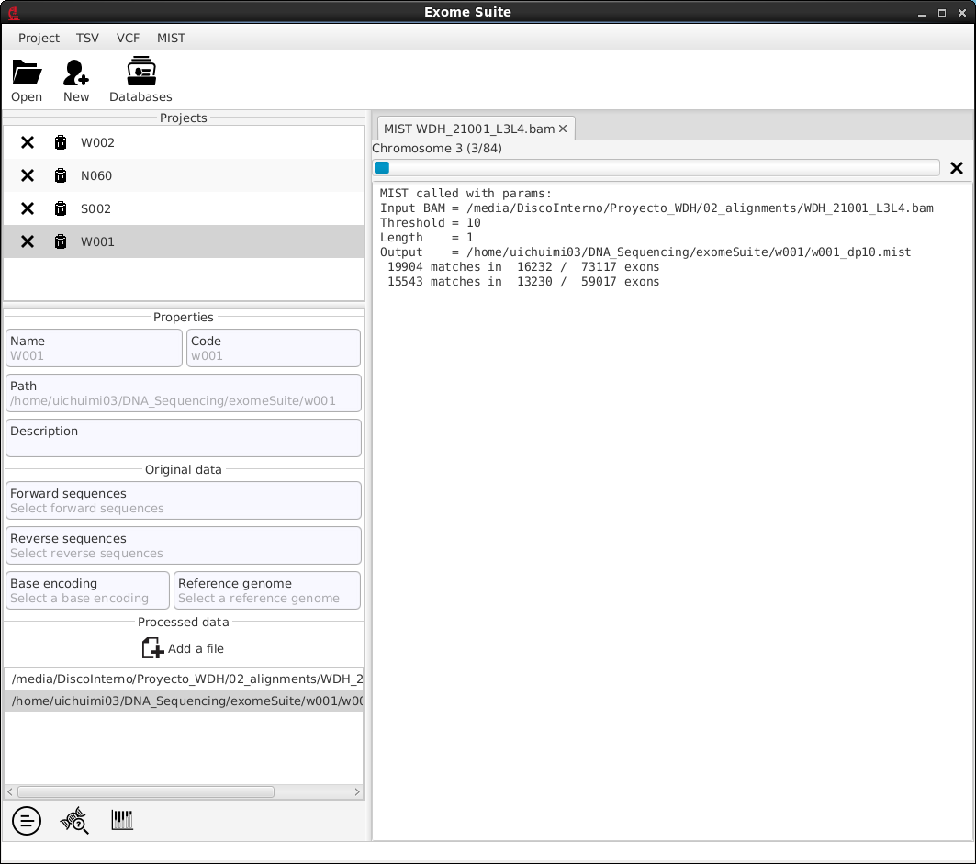

Left panel shows projects and projects information and right panel shows progress and messages. There are also more options on top of the main screen.

1. **Projects**

A project keep an individual data together, so it is easily accessible later. A project consists on a name, a code and a path. The name is just a way to give the project a significant meaning. The code must be unique, and it is used as the name for the new generated files and to sign certain fields in data such as the sample name. The folder is where properties of the project and the new generated files are stored. It may not be modified.

* 1. **Creating new project**

To create a new project, use one of the following options:

* + 1. Click on  (New)
    2. Click on Project->New Project
    3. Press Ctrl+N combination key

Next window will open:

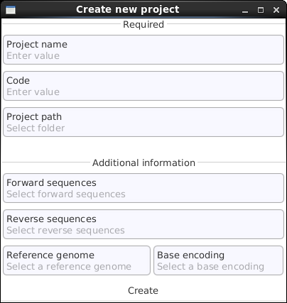

You must specify Required data. Additional information can be specified later. When you have finished setting New Project data, click on 'Create'.

New project can be seen on the left panel of the main screen.