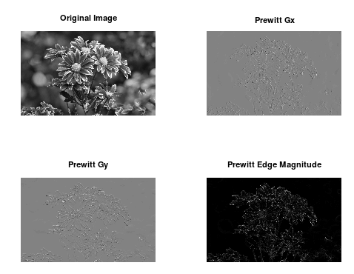
Lab 12 prewitt

clc;
clear;
close all;

% Load image package (required in Octave)
pkg load image

% Read image
img = imread('flowers33.jpg'); % put your image file here

% Convert to grayscale if RGB
if ndims(img) == 3
img = rgb2gray(img);
end

img = double(img);

% Prewitt kernels
px = [-1 0 1; -1 0 1; -1 0 1];
py = [1 1 1; 0 0 0; -1 -1 -1];

% Apply convolution
gx = conv2(img, px, 'same');
gy = conv2(img, py, 'same');

% Edge magnitude
edge = sqrt(gx.^2 + gy.^2);

% Normalize results
gx = mat2gray(gx);
gy = mat2gray(gy);
edge = mat2gray(edge);

% Display images
figure

subplot(2,2,1)
imshow(img, [])
title('Original Image')

subplot(2,2,2)
imshow(gx)
title('Prewitt Gx')

subplot(2,2,3)
imshow(gy)
title('Prewitt Gy')

subplot(2,2,4)
imshow(edge)
title('Prewitt Edge Magnitude')

% Save images
imwrite(gx,'prewitt_gx.png');
imwrite(gy,'prewitt_gy.png');
imwrite(edge,'prewitt_edge.png');

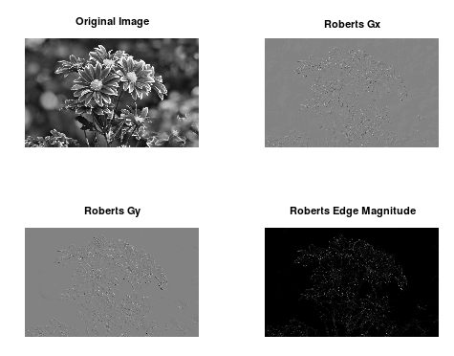

%lab13 robert
clc;
clear;
close all;

% Load image package
pkg load image

% Read image
img = imread('flowers33.jpg'); % change to your image file

% Convert to grayscale if RGB
if ndims(img) == 3
img = rgb2gray(img);
end

img = double(img);

% Roberts cross operator kernels
Rx = [1 0;
0 -1];

Ry = [0 1;
-1 0];

% Apply convolution
gx = conv2(img, Rx, 'same');
gy = conv2(img, Ry, 'same');

% Edge magnitude
edge = sqrt(gx.^2 + gy.^2);

% Normalize images for display
gx = mat2gray(gx);
gy = mat2gray(gy);
edge = mat2gray(edge);

% Display images
figure

subplot(2,2,1)
imshow(img, [])
title('Original Image')

subplot(2,2,2)
imshow(gx)
title('Roberts Gx')

subplot(2,2,3)
imshow(gy)
title('Roberts Gy')

subplot(2,2,4)
imshow(edge)
title('Roberts Edge Magnitude')

% Save outputs
imwrite(gx,'roberts_gx.png');
imwrite(gy,'roberts_gy.png');
imwrite(edge,'roberts_edge.png');

lab14 sobel
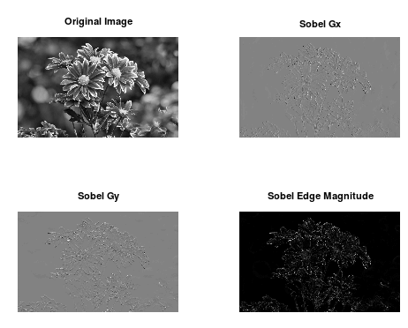
clc;
clear;
close all;

% Load image package
pkg load image

% Read image
img = imread('flowers33.jpg'); % replace with your image file

% Convert to grayscale if RGB
if ndims(img) == 3
img = rgb2gray(img);
end

img = double(img);

% Sobel kernels
Sx = [-1 0 1;
-2 0 2;
-1 0 1];

Sy = [ 1 2 1;
0 0 0;
-1 -2 -1];

% Apply convolution
gx = conv2(img, Sx, 'same');
gy = conv2(img, Sy, 'same');

% Edge magnitude
edge = sqrt(gx.^2 + gy.^2);

% Normalize for display
gx = mat2gray(gx);
gy = mat2gray(gy);
edge = mat2gray(edge);

% Display images
figure

subplot(2,2,1)
imshow(img, [])
title('Original Image')

subplot(2,2,2)
imshow(gx)
title('Sobel Gx')

subplot(2,2,3)
imshow(gy)
title('Sobel Gy')

subplot(2,2,4)
imshow(edge)
title('Sobel Edge Magnitude')

% Save output images
imwrite(gx,'sobel_gx.png');
imwrite(gy,'sobel_gy.png');
imwrite(edge,'sobel_edge.png');

Lab15 mean filter
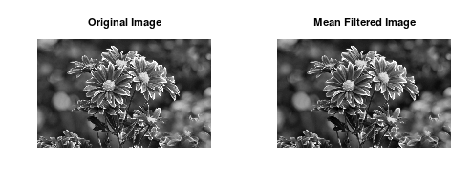

clc;
clear;
close all;

% Load image package
pkg load image

% Read image
img = imread('flowers33.jpg'); % replace with your image file

% Convert to grayscale if RGB
if ndims(img) == 3
img = rgb2gray(img);
end

img = double(img);

% Mean filter kernel (3x3 averaging mask)
mean_kernel = (1/9) * [1 1 1;
1 1 1;
1 1 1];

% Apply convolution
filtered_img = conv2(img, mean_kernel, 'same');

% Normalize for display
filtered_img = mat2gray(filtered_img);

% Display images
figure

subplot(1,2,1)
imshow(uint8(img))
title('Original Image')

subplot(1,2,2)
imshow(filtered_img)
title('Mean Filtered Image')

% Save output image
imwrite(filtered_img,'mean_filtered.png');

