Lab 1: Write a java script program to demonstrate variable like var, let and const with different datatypes.
<html>
<body>
<script>
// var example
var city = "Kathmandu";
var temp = 25;
document.write("City: " + city + "<br>Temperature: " + temp + "<br>");
var city = "Pokhara";
temp = 22;
document.write("Updated City: " + city + "<br>Updated Temp: " + temp + "<br><br>");
// let example
let student = "Aarav";
let passed = true;
document.write("Student: " + student + "<br>Passed: " + passed + "<br>");
student = "Sita";
document.write("Updated Student: " + student + "<br><br>");
// const example
const country = "Nepal";
const marks = null;
document.write("Country: " + country + "<br>Marks: " + marks);
</script>
</body>
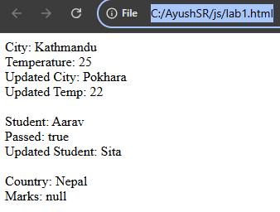
</html>

Lab 2: Write a program in JavaScript to print an even number only from 1 to 100.
<html>
<head>
<script>
document.write("Even numbers from 1-100:<br>");
for (var i = 1; i <= 100; i++)
if (i % 2 == 0)
document.write(i + " ");
</script>
</head>
</html>

Lab 3: You have sequence of number from 1 to hundred but condition is that you have to print only that number which is not divisible by 5. Write a JavaScript code for it.
<html>
<script>
document.write("Numbers not divisible by 5 from 1-100:<br>");
for (var i = 1; i <= 100; i++)
if (i % 5 != 0)
document.write(i + " ");
</script>
</html>

Lab 4: Create one paragraph and add some text on it. After this create one button, if button is clicked then the content of paragraph should be changed.
<html>
<head>
<script>
function changeText() {
document.getElementById("text").innerHTML = "Namaste";
}
</script>
<body>
<p id="text">
Hello there.
</p>
<button onclick="changeText()">Change Paragraph</button>
</body>
</html>
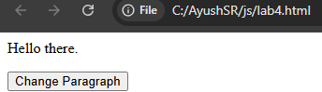
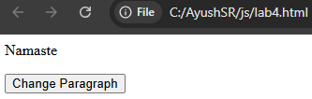

Lab 5: Create three divisions in which first division should be red, second should be blue and third should be green. After this create a button with name change. When button is clicked change the background of all division, border of division 1 should be green, border of division two should be yellow, border of 3rd division should be blue, change the radius of border for any two divisions.
<!-- Lab 5: Create three divisions in which first division should be red, second should be blue and third should be green. After this create a button with name change. When button is clicked change the background of all division, border of division 1 should be green, border of division two should be yellow, border of 3rd division should be blue, change the radius of border for any two divisions. -->
<html>
<head>
<style>
div {
height: 50px;
width: 50px;
margin: 5px;
display: inline-block;
}
#first {
background-color: red;
}
#second {
background-color: blue;
}
#third {
background-color: green;
}
</style>
<script>
function changeStyle() {
document.getElementById('first').style.backgroundColor = "orange";
document.getElementById('second').style.backgroundColor = "purple";
document.getElementById('third').style.backgroundColor = "pink";

document.getElementById('first').style.border = "1px solid green";
document.getElementById('second').style.border = "5px dotted yellow";
document.getElementById('third').style.border = "10px groove blue";
document.getElementById('first').style.borderRadius = "15px";
document.getElementById('second').style.borderRadius = "20px";
}
</script>
</head>
<body>
<div id="first"></div>
<div id="second"></div>
<div id="third"></div><br>
<button onclick="changeStyle()">Change</button>
</body>
</html>
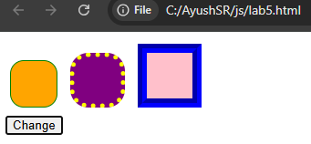
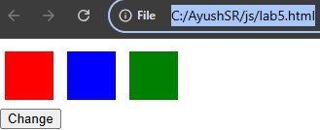

Lab 6: Write a program in JavaScript to take a two number as input from user and calculate sum, difference and multiplication.
<html>
<head>
<script>
var a = parseInt(prompt("Enter 1st number :"));
var b = parseInt(prompt("Enter 2nd number :"));
var sum = a + b;
var diff = a - b;
var mul = a * b;
document.write("Sum of " + a + " and " + b + " = " + sum + "<br>");
document.write("Difference of " + a + " and " + b + " = " + diff + "<br>");
document.write("Multiplication of " + a + " and " + b + " = " + mul + "<br>");
</script>
</head>
</html>
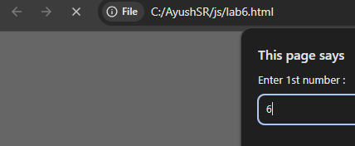

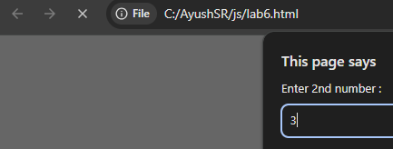

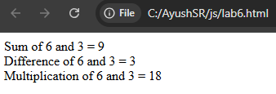

Lab 7: Write a java script program to demonstrate mouse event. You can use button, division, paragraph etc.
<html>
<head>
<style>
#box {
width: 150px;
height: 100px;
background-color: red;
border: 2px solid black;
}
</style>
</head>
<body>
<div id="box"></div>
<p id="log">Event: None</p>
<script>
const box = document.getElementById("box");
const log = document.getElementById("log");
const showEvent = (event) => {
log.textContent = "Event: " + event.type;
};
box.addEventListener("click", showEvent);
</script>
</body>
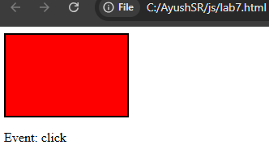
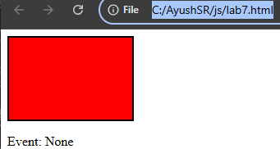
</html>

Lab 8: Write a java script program to demonstrate keyboard event.
<html>
<head>
<style>
input {
padding: 10px;
width: 300px;
font-size: 16px;
}
</style>
</head>
<body>
<input type="text" id="input" placeholder="Type here to view keyboard events">
<p id="log">Event: None</p>
<script>
const input = document.getElementById("input");
const log = document.getElementById("log");
function showEvent(event) {
log.textContent = "Event : " + event.type + " | Key : " + event.key;
}
input.addEventListener("keydown", showEvent);
input.addEventListener("keyup", showEvent);
input.addEventListener("keypress", showEvent);
</script>
</body>
</html>
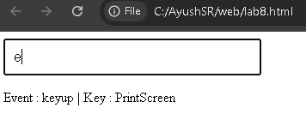

Lab 9: Write a java script program to demonstrate window event.
<html>
<head>
</head>
<body>
<h2>Window Event Demonstration</h2>
<p id="log">Event : None</p>
<script>
const log = document.getElementById("log");
function showEvent(event) {
log.textContent = "Event: " + event.type;
}
window.addEventListener("load", showEvent);
window.addEventListener("beforeunload", function (event) {
showEvent(event);
event.returnValue = "";
});
window.addEventListener("resize", showEvent);
window.addEventListener("scroll", showEvent);
window.addEventListener("focus", showEvent);
window.addEventListener("blur", showEvent);
document.addEventListener("DOMContentLoaded", showEvent);
</script>
</body>
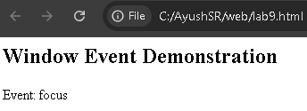
</html>
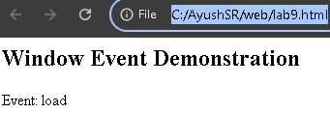

Lab 10: Write a java script program to demonstrate different string handling function.
<html>
<head>
<script>
let str = " My name is ayush. ";
document.write("<b>Original String : </b> " + str + "<br><br>");
document.write("<b>Length : </b> " + str.length + "<br>");
let trimmed = str.trim();
document.write("<b>Trimmed : </b> " + trimmed + "<br>");
document.write("<b>Uppercase : </b> " + trimmed.toUpperCase() + "<br>");
document.write("<b>Lowercase : </b> " + trimmed.toLowerCase() + "<br>");
document.write("<b>Substring (0-5) : </b> " + trimmed.substring(0, 5) + "<br>");
document.write("<b>Slice (7-17) : </b> " + trimmed.slice(7, 17) + "<br>");
document.write("<b>Replace 'name' with 'nickname' : </b> " + trimmed.replace("name", "nickname") + "<br>");
document.write("<b>Includes 'ayush' : </b> " + trimmed.includes("ayush") + "<br>");
let words = trimmed.split(" ");
document.write("<b>Split into words : </b> " + words + "<br>");
let newStr = trimmed.concat(" Welcome!");
document.write("<b>Concatenated String : </b> " + newStr + "<br>");
document.write("<b>Character at index 8 : </b> " + trimmed.charAt(8) + "<br>");
document.write("<b>Index of 'h' : </b> " + trimmed.indexOf("h") + "<br>");
</script>
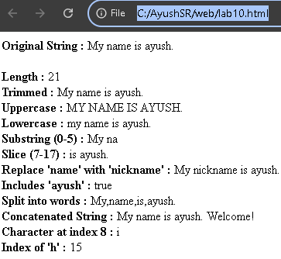
</head>
</html>

Lab 11: Write a java script code to demonstrate replace() method like below:
<html>
<body>
<input type="text" id="sentence" placeholder="Enter a sentence" size="25" />
<input type="text" id="wordToFind" placeholder="Enter word to replace" size="25" />
<input type="text" id="replacement" placeholder="Enter replacement word" size="25" />
<button onclick="doReplace()">Replace</button>
<br/>
<p id="result"></p>
<script>
function doReplace() {
var sentence = document.getElementById("sentence").value;
var wordToFind = document.getElementById("wordToFind").value;
var replacement = document.getElementById("replacement").value;
var result = sentence.replace(wordToFind, replacement);
document.getElementById("result").innerHTML = result;
}
</script>
</body>
</html>
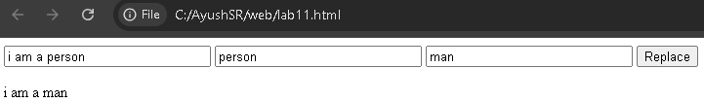

Lab 12: Write a java script code to demonstrate String methods like below:
<html>
<body>
<input type="text" id="sentence1" placeholder="Enter a sentence" size="25" />
<button onclick="getLength()">Get Length</button>
<button onclick="toUpper()">Convert to Uppercase</button>
<button onclick="toLower()">Convert to Lowercase</button>
<br/>
<p id="result1"></p>
<input type="text" id="firstName" placeholder="Enter first name" size="25" />
<input type="text" id="lastName" placeholder="Enter last name" size="25" />
<button onclick="concatNames()">Concat</button>
<br/>
<p id="result2"></p>
<input type="text" id="sentence2" placeholder="Enter a sentence" size="25" />
<input type="text" id="startIndex" placeholder="Enter start index" size="25" />
<input type="text" id="endIndex" placeholder="Enter end index" size="25" />
<button onclick="sliceStr()">Slice</button>
<br/>
<p id="result3"></p>
<script>
function getLength() {
var s = document.getElementById("sentence1").value;
document.getElementById("result1").innerHTML += "Length: " + s.length + "<br/>";
}
function toUpper() {
var s = document.getElementById("sentence1").value;
document.getElementById("result1").innerHTML += s.toUpperCase() + "<br/>";
}

function toLower() {
var s = document.getElementById("sentence1").value;
document.getElementById("result1").innerHTML += s.toLowerCase() + "<br/>";
}
function concatNames() {
var f = document.getElementById("firstName").value;
var l = document.getElementById("lastName").value;
document.getElementById("result2").innerHTML += f.concat(" ", l) + "<br/>";
}
function sliceStr() {
var s = document.getElementById("sentence2").value;
var start = parseInt(document.getElementById("startIndex").value);
var end = parseInt(document.getElementById("endIndex").value);
document.getElementById("result3").innerHTML += s.slice(start, end) + "<br/>";
}
</script>
</body>
</html>
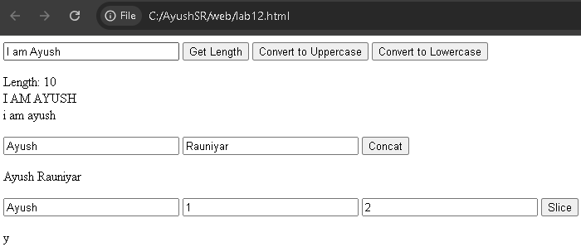

Lab 13: Write a java script program to declare variable as number and convert it into string. Check datatype using typeof operator.
<html>
<body>
<input type="text" id="numInput" placeholder="Enter a number" size="25" />
<button onclick="checkType()">Check & Convert</button>
<br/><br/>
<p id="result"></p>
<script>
function checkType() {
var num = document.getElementById("numInput").value;
var converted = Number(num);
document.getElementById("result").innerHTML +=
"Original value: " + num + "<br/>" +
"Type before conversion: " + typeof num + "<br/>" +
"After converting to Number: " + converted + "<br/>" +
"Type after conversion: " + typeof converted + "<br/><br/>";
}
</script>
</body>
</html>
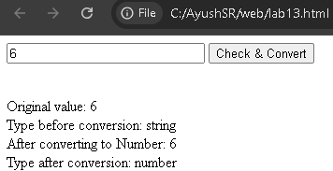

Lab 14: Write a Java script program to take one string input from user and reverse the string.
<html>
<body>
<input type="text" id="strInput" placeholder="Enter a string" size="25" />
<button onclick="reverseStr()">Reverse</button>
<p id="result"></p>
<script>
function reverseStr() {
var str = document.getElementById("strInput").value;
var reversed = str.split("").reverse().join("");
document.getElementById("result").innerHTML += "Reversed: " + reversed + "<br/>";
}
</script>
</body>
</html>
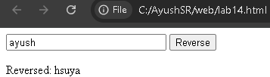

Lab 15: Write a java script code that ask user to take two string and checks them of equality. If both strings are equal then display the first string in uppercase else print two string are not equal.
<html>
<body>
<input type="text" id="str1" placeholder="Enter first string" size="25" />
<input type="text" id="str2" placeholder="Enter second string" size="25" />
<button onclick="checkEquality()">Check</button>
<br/><br/>
<p id="result"></p>
<script>
function checkEquality() {
var str1 = document.getElementById("str1").value;
var str2 = document.getElementById("str2").value;
if (str1 === str2) {
document.getElementById("result").innerHTML += str1.toUpperCase() + "<br/>";
} else {
document.getElementById("result").innerHTML += "Two strings are not equal" + "<br/>";
}
}
</script>
</body>
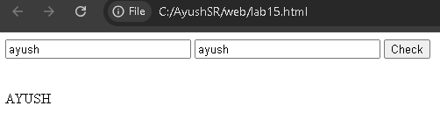
</html>

Lab 16: Provide example on all the inbuilt array handling methods
<html>
<body>
<input type="text" id="arrInput" placeholder="Enter comma separated values" size="30" />
<button onclick="initArray()">Create Array</button>
<span id="arrayDisplay"></span><br/><br/>
<button onclick="pushVal()">push()</button>
<input type="text" id="pushInput" placeholder="Value" size="10" />
<span id="r1"></span><br/>
<button onclick="popVal()">pop()</button>
<span id="r2"></span><br/>
<button onclick="shiftVal()">shift()</button>
<span id="r3"></span><br/>
<button onclick="unshiftVal()">unshift()</button>
<input type="text" id="unshiftInput" placeholder="Value" size="10" />
<span id="r4"></span><br/>
<button onclick="sliceVal()">slice()</button>
<input type="text" id="sliceStart" placeholder="Start" size="4" />
<input type="text" id="sliceEnd" placeholder="End" size="4" />
<span id="r6"></span><br/>
<button onclick="sortVal()">sort()</button>
<span id="r7"></span><br/>
<button onclick="reverseVal()">reverse()</button>
<span id="r8"></span><br/>
<button onclick="joinVal()">join()</button>
<input type="text" id="joinSep" placeholder="Separator" size="5" />
<span id="r9"></span><br/>
<button onclick="indexOfVal()">indexOf()</button>
<input type="text" id="indexInput" placeholder="Value" size="10" />
<span id="r10"></span><br/>

<button onclick="includesVal()">includes()</button>
<input type="text" id="includesInput" placeholder="Value" size="10" />
<span id="r11"></span><br/>
<button onclick="concatVal()">concat()</button>
<input type="text" id="concatInput" placeholder="Values" size="15" />
<span id="r12"></span><br/>
<script>
var arr = [];
function initArray() {
arr = document.getElementById("arrInput").value.split(",").map(v => v.trim());
document.getElementById("arrayDisplay").innerHTML = " [" + arr + "]";
}
function show(id, res) { document.getElementById(id).innerHTML = " -> " + JSON.stringify(res) + " | arr: [" + arr + "]"; }
function pushVal() { arr.push(document.getElementById("pushInput").value); show("r1", arr); }
function popVal() { show("r2", arr.pop()); }
function shiftVal() { show("r3", arr.shift()); }
function unshiftVal() { arr.unshift(document.getElementById("unshiftInput").value); show("r4", arr); }
function spliceVal() { show("r5", arr.splice(parseInt(document.getElementById("spliceIndex").value), parseInt(document.getElementById("spliceDelete").value))); }
function sliceVal() { show("r6", arr.slice(parseInt(document.getElementById("sliceStart").value), parseInt(document.getElementById("sliceEnd").value))); }
function sortVal() { arr.sort(); show("r7", arr); }
function reverseVal() { arr.reverse(); show("r8", arr); }
function joinVal() { show("r9", arr.join(document.getElementById("joinSep").value || ",")); }
function indexOfVal() { show("r10", arr.indexOf(document.getElementById("indexInput").value)); }
function includesVal() { show("r11", arr.includes(document.getElementById("includesInput").value)); }

function concatVal() { show("r12", arr.concat(document.getElementById("concatInput").value.split(",").map(v => v.trim()))); }
</script>
</body>
</html>
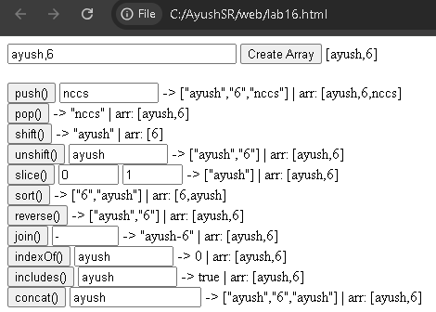

Lab 17: Write a java script program to take size of array, value from user and display the value.
<html>
<body>
Enter array size: <input type="text" id="arrSize" size="20" />
<button onclick="createArray()">Create Array</button>
<br/><br/>
<p id="result"></p>
<script>
function createArray() {
var size = parseInt(document.getElementById("arrSize").value);
var arr = [];
for (var i = 0; i < size; i++) {
var val = prompt("Enter value for element " + (i + 1) + ":");
arr.push(val);
}
document.getElementById("result").innerHTML = "Array: [" + arr.join(", ") + "]";
}
</script>
</body>
</html>
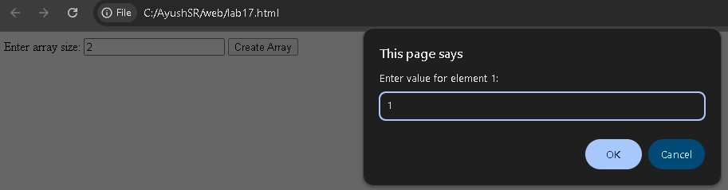

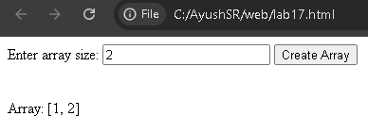

Lab 18: Write java script code to create an array that hold the name of 10 students. Convert the array into string and print that array.
<html>
<body>
<button onclick="printStudents()">Print Students</button>
<p id="result"></p>
<script>
function printStudents() {
var students = ["Ayush", "Bibek", "Suman", "Anita", "Rohan", "Priya", "Kiran", "Sita", "Ram", "Gita"];
var str = students.toString();
document.getElementById("result").innerHTML = "Array as String: " + str;
}
</script>
</body>
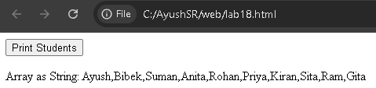
</html>

Lab 19: Write a java script code to create a string which contain name of 5 students separated with comma. Convert the string into array and display the result.
<html>
<body>
<button onclick="convertToArray()">Convert to Array</button>
<p id="result"></p>
<script>
function convertToArray() {
var str = "Ayush,Bibek,Suman,Anita,Rohan";
var arr = str.split(",");
document.getElementById("result").innerHTML = "String: " + str + "<br/>Array: [" + arr.join(", ") + "]";
}
</script>
</body>
</html>
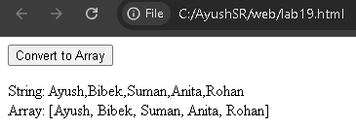

Lab 20: For the string "web programming is amazing and exciting to learn". Find out length of string, reverse a string, search a word "exciting", remove extra white space if present, convert the string into array and display, find the character present on position 8, extract the part of the string from position 2 to 10, replace the word programming with technology
<html>
<body>
<button onclick="runAll()">Run All Operations</button>
<p id="result"></p>
<script>
function runAll() {
var str = "web programming is amazing and exciting to learn";
var out = "";
out += "Original: " + str + "<br/>";
out += "Length: " + str.length + "<br/>";
out += "Reversed: " + str.split("").reverse().join("") + "<br/>";
out += "Search 'exciting' at index: " + str.indexOf("exciting") + "<br/>";
out += "After trim: " + str.trim() + "<br/>";
out += "Array: [" + str.split(" ").join(", ") + "]<br/>";
out += "Char at position 8: " + str.charAt(8) + "<br/>";
out += "Slice(2,10): " + str.slice(2, 10) + "<br/>";
out += "Replace: " + str.replace("programming", "technology") + "<br/>";
document.getElementById("result").innerHTML = out;
}
</script>
</body>
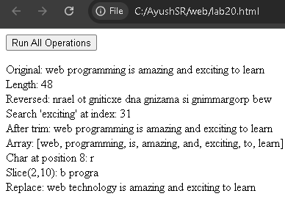
</html>

Lab 21: For the string "Web programming is fun to learn but at the same time programming is difficult too. Web programming is core course in BIM third semester". Find out no. of times a word programming is repeated.
<html>
<body>
<button onclick="countWord()">Count</button>
<p id="result"></p>
<script>
function countWord() {
var str = "Web programming is fun to learn but at the same time programming is difficult too. Web programming is core course in BIM third semester";
var count = str.match(/programming/gi).length;
document.getElementById("result").innerHTML = "String: " + str + "<br/>The word 'programming' is repeated " + count + " times.";
}
</script>
</body>
</html>
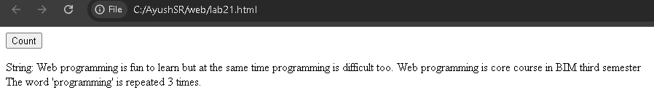

<!-- Lab 22: Create an array of size 10, add some element on it of your choice. Now add any three element at last, remove one element from last, add 3 new element from first position, add 5 new element from position 6 onward, delete any 2 elements from position 2 to 4. Convert final array into string and display the result. -->
<html>
<body>
<button onclick="runAll()">Run All Operations</button>
<p id="result"></p>
<script>
function runAll() {
var arr = ["Ayush","Bibek","Suman","Anita","Rohan","Priya","Kiran","Sita","Ram","Gita"];
var out = "";
out += "Original: [" + arr + "]<br/>";
arr.push("Alex","Bob","Clara");
out += "After push 3 at last: [" + arr + "]<br/>";
arr.pop();
out += "After pop 1 from last: [" + arr + "]<br/>";
arr.unshift("Neo","Zen","Max");
out += "After unshift 3 at first: [" + arr + "]<br/>";
arr.splice(6, 0, "E1","E2","E3","E4","E5");
out += "After splice 5 at pos 6: [" + arr + "]<br/>";
arr.splice(2, 2);
out += "After delete 2 from pos 2: [" + arr + "]<br/>";
out += "Final as String: " + arr.toString();
document.getElementById("result").innerHTML = out;
}
</script>
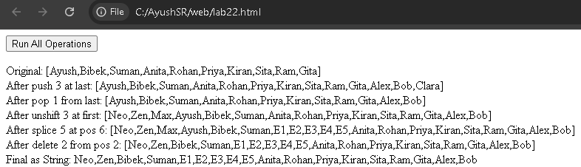
</body>
</html>

Lab 23: Create any two array of size 5 each and merge those arrays, extract element from position 4 to 8 of merged array, sort the merged array in ascending order.
<html>
<body>
<button onclick="runAll()">Run All Operations</button>
<p id="result"></p>
<script>
function runAll() {
var arr1 = [5, 3, 8, 1, 9];
var arr2 = [4, 7, 2, 6, 10];
var merged = arr1.concat(arr2);
var extracted = merged.slice(4, 8);
var sorted = merged.slice().sort(function(a, b) { return a - b; });
var out = "";
out += "Array 1: [" + arr1 + "]<br/>";
out += "Array 2: [" + arr2 + "]<br/>";
out += "Merged: [" + merged + "]<br/>";
out += "Extracted (pos 4 to 8): [" + extracted + "]<br/>";
out += "Sorted (ascending): [" + sorted + "]<br/>";
document.getElementById("result").innerHTML = out;
}
</script>
</body>
</html>
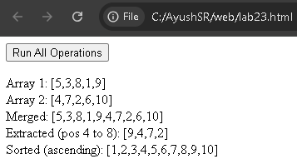

Lab 24: Write a javascript to create an array of fruits with values apple, orange, mango. Then add three more items in the form of array using javascript function and remove two items from the back of the array. Now display the items of array in string format.
<html>
<body>
<button onclick="runAll()">Run</button>
<p id="result"></p>
<script>
function runAll() {
var fruits = ["apple", "orange", "mango"];
var out = "";
out += "Original: [" + fruits + "]<br/>";
fruits.push("banana", "grapes", "watermelon");
out += "After push 3: [" + fruits + "]<br/>";
fruits.pop();
fruits.pop();
out += "After pop 2: [" + fruits + "]<br/>";
out += "As String: " + fruits.toString();
document.getElementById("result").innerHTML = out;
}
</script>
</body>
</html>
