**Customer Service Chatbot With AI**

## A PROJECT REPORT

***Submitted by***

**Ms. Sudheshna S 20211CSE0679**

**Ms. Ankitha Hudegal 20211CSE0680**

**Ms. Arpitha G 20211CSE0682**

**Ms. K Pavithra   20211CSE0690**

### *Under the guidance of*

**Mr. Md Ziaur Rahman**

***in partial fulfillment for the award of the degree of***

**BACHELOR OF TECHNOLOGY**

**IN**

**COMPUTER SCIENCE AND ENGINEERING**

**At**



**PRESIDENCY UNIVERSITY**

**BENGALURU**

**JANUARY 2025**

**PRESIDENCY UNIVERSITY**

**SCHOOL OF COMPUTER SCIENCE ENGINEERING**

**CERTIFICATE**

This is to certify that the Project report “**Customer Service Chatbot With AI**” being submitted by “SUDHESHNA, ANKITHA HUDEGAL, ARPITHA G, K PAVITHRA” bearing roll number(s) “20211CSE0679, 20211CSE0680, 20211CSE0682, 20211CSE0690” in partial fulfillment of the requirement for the award of the degree of Bachelor of Technology in Computer Science and Engineering is a bonafide work carried out under my supervision.

|  |  |
| --- | --- |
| **Mr. MD Ziaur Rahman**  Assistant Professor  School of CSE  Presidency University | **Dr. Asif Mohammed**  Associate Professor & HOD  School of CSE  Presidency University |

|  |  |  |
| --- | --- | --- |
| **Dr. L. SHAKKEERA**  Associate Dean  School of CSE  Presidency University | **Dr. MYDHILI NAIR**  Associate Dean  School of CSE  Presidency University | **Dr. SAMEERUDDIN KHAN**  Pro-VC School of Engineering  Dean -School of CSE&IS  Presidency University |

**PRESIDENCY UNIVERSITY**

**SCHOOL OF COMPUTER SCIENCE ENGINEERING**

**DECLARATION**

We hereby declare that the work, which is being presented in the project report “**CUSTOMER SERVICE CHATBOT WITH AI**” entitled in partial fulfillment for the award of Degree of **Bachelor of Technology** in **Computer Science and Engineering**, is a record of our own investigations carried under the guidance of**, MR. MD ZIAUR RAHMAN,** Assistant Professor**,** **School of Computer Science and Engineering, Presidency University, Bengaluru.**

We have not submitted the matter presented in this report anywhere for the award of any other Degree.

|  |  |
| --- | --- |
|  | **Sudheshna(20211CSE0679)**  **Ankitha Hudegal(20211CSE0680)**  **Arpitha G (20211CSE0682)**  **K Pavithra(20211CSE0690)** |

**ABSTRACT**

Our proposed work explores the role of AI chatbots in the tourism industry, focusing on customer service, operational efficiency, and business growth. As a result of artificial intelligence and Natural Language Processing (NLP), chatbots are able to perform a broad scope of tasks, from responding to inquiries to processing bookings and giving personalized recommendations. The goal of the project is to identify how AI chatbots positively impact customer experiences by responding quickly, accurately, and relevantly, thus leading to better satisfaction and engagement. AI chatbots improve operational efficiency by handling high volumes of customer interactions instantly, reducing response times, and enabling 24/7 service. This is especially valuable in the tourism industry, where travelers often require immediate assistance. Additionally, chatbots personalize the customer journey by analyzing preferences and delivering tailored suggestions, creating a more dynamic and engaging interaction.

The findings indicate that, besides improving customer satisfaction, AI chatbots can minimize operational costs and help companies to remain competitive by offering effective, scalable customer support. The project emphasizes that adoption of AI chatbots represents innovation and customer-centric operations and pushes business growth and competitiveness in the market. In a nutshell, AI chatbots are powerful tools that can revolutionize customer service in the tourism sector. They enhance engagement, reduce costs, and provide personalized experiences, which can help businesses maintain a competitive edge in the digital age.

**ACKNOWLEDGEMENTS**

First of all, we indebted to the **GOD ALMIGHTY** for giving me an opportunity to excel in our efforts to complete this project on time.

We express our sincere thanks to our respected dean **Dr. Md. Sameeruddin Khan**, Pro-VC, School of Engineering and Dean, School of Computer Science Engineering & Information Science, Presidency University for getting us permission to undergo the project.

We express our heartfelt gratitude to our beloved Associate Deans **Dr. Shakkeera L and Dr. Mydhili Nair,** School of Computer Science and Engineering, Presidency University, and Dr. “**Dr. Asif Mohammed”** Head of the Department, School of Computer Science Engineering, Presidency University, for rendering timely help in completing this project successfully.

We are greatly indebted to our guide **Mr. Md Ziaur Rahman,** Assistant Professor and Reviewer **Ms. Akkamahadevi**, School of Computer Science and Engineering, Presidency University for their inspirational guidance, and valuable suggestions and for providing us a chance to express our technical capabilities in every respect for the completion of the project work.

We would like to convey our gratitude and heartfelt thanks to the PIP2001 Capstone Project Coordinators **Dr. Sampath A K, Dr. Abdul Khadar A and Mr. Md Ziaur Rahman,** Department Project Coordinators **Mr. Amarnath & Dr. Jayanthi**

Kamalasekaran and Git hub coordinator **Mr. Muthuraj.**

We thank our family and friends for the strong support and inspiration they have provided us in bringing out this project.

Sudheshna

Ankitha Hudegal

Arpitha G

K Pavithra

**LIST OF FIGURES**

|  |  |  |  |
| --- | --- | --- | --- |
| **Sl. No.** | **Figure Name** | **Caption** | **Page No.** |
| 1  2 | Figure 6.1  Figure 7.1 | Interaction Flow Diagram  Gantt Chart | 27  33 |

|  |  |  |
| --- | --- | --- |
| **CHAPTER NO.** | **TITLE** | **PAGE NO.** |
|  | **ABSTRACT**  **ACKNOWLEDGMENT** |  |
| **1.** | **Introduction**   * 1. Overview   1.2 Features | 1    3 |
| **2.** | **Literature survey** | 6 |
| **3.** | **Research gaps of existing methods**  3.1 Traditional Systems in Travel Customer Service  3.2 Challenges of Customer Service Chatbots | 16      18 |
| **4.** | **Proposed methodology** | 22 |
| **5.** | **Objectives** | 25 |
| **6.** | **System design & implementation**  6.1 Flowchart  6.2 Algorithm | 27  29 |
| **7.** | **Timeline for execution of project** | 33 |
| **8.** | **Outcomes** | 34 |
| **9.** | **Results & Discussions** | 38 |
| **10.** | **Conclusion** | 43 |
|  | **References** | 44 |

**CONTENTS**

**Chapter 1**

**INTRODUCTION**

A customer service chatbot is an automated program designed to interact with customers through text or voice. These chatbots use artificial intelligence (AI) and natural language processing (NLP) to understand customer inquiries and provide relevant responses or assistance. It can automatically respond to different queries and use connected databases to find the answer to more complex questions. It can adapt the answers based on the customer, context, and intent. AI chatbots can simulate human conversation and understand user intent. They can learn from previous conversations and adapt their communication style to match the company's tone of voice. The tourism sector is a collaborative effort of various service providers to deliver a comprehensive travel experience. Travel agents and tour operators play a crucial role in promoting tourism by acting as intermediaries between travelers and principal suppliers such as airlines, hotels, and transport companies. As one of the largest and most dynamic industries globally, the travel and tourism sector has expanded significantly due to the increasing number of people traveling to new destinations. Travel agencies serve as the first point of contact for travelers, offering seamless travel arrangements and ensuring a hassle-free experience by providing accurate and reliable information. Their role extends beyond booking services to safeguarding tourists from potential challenges during their trips. Tourism encompasses more than just leisure; it involves the practice of touring, attracting and accommodating visitors, and managing tours for various purposes, including business and leisure. The World Tourism Organization defines it as traveling and staying in places outside one’s usual environment for no longer than a year for leisure, business, or other reasons.

* 1. **Overview**

The rapid advancement of technology, especially in artificial intelligence (AI), has brought about tremendous changes in how businesses function and interact with their customers. Among these innovations, AI-powered chatbots have emerged as one of the most impactful tools, revolutionizing customer service and operational efficiency across various industries. These intelligent conversational agents are designed to simulate human-like interactions, answering queries, solving problems, and executing tasks tailored to specific use cases. Their ability to process vast amounts of data and provide instant, accurate responses has made them indispensable in today's fast-paced, customer-driven landscape.

In industries where customer engagement is critical, such as tourism, the role of AI chatbots becomes even more pronounced. Tourism is one of the biggest drivers of economic growth in many countries, contributing significantly to their GDP and employment. Success in this industry depends largely on effective communication, personalized service, and efficient operations. AI chatbots meet all these needs by acting as virtual assistants capable of handling high volumes of customer interactions with precision and speed. They can receive, process, and then provide natural language answers due to the implementation of state-of-the-art NLP processes and therefore may provide correct contextually apt real-time supports.

These chatbots are particularly valuable in the travel and tourism sector, where customers often seek detailed information about destinations, travel packages, accommodations, and itineraries. They streamline the booking process, offer personalized recommendations based on user preferences, and ensure a seamless customer journey. Moreover, their ability to operate 24/7 ensures round-the-clock availability, enabling businesses to cater to a global audience and meet customer expectations regardless of time zones.

Apart from enhancing customer satisfaction, AI chatbots heavily reduce operational costs as repetitive tasks will be automated, leaving human agents to handle complex issues with a personal touch. For this reason, AI chatbots have become a backbone in the digital transformation plan for most businesses within and outside the tourism sector.

This paper explores the role of AI chatbots in revolutionizing customer service and business operations, especially within the tourism sector. It will go into their capabilities, benefits, and the value they add to businesses and customers. In addition, it reflects on how embracing such technologies is a way of embracing innovation and places businesses in a better position to compete in a rapidly changing, competitive, and technology-driven global market.

AI chatbots become a cornerstone of modern business strategy, offering innovative solutions that improve customer interactions and streamlined operations. Artificial intelligence in these systems allows them to understand and respond to queries in natural language with unprecedented precision and speed. They find applicability in sectors like e-commerce, healthcare, finance, and tourism, where good customer engagement is critical for success.

In the tourism industry, chatbots have emerged as transformative tools, capable of managing high volumes of customer inquiries while delivering personalized and real-time responses. These systems address a wide range of traveler needs, including providing detailed information about travel packages, recommending destinations, facilitating bookings, and assisting with itinerary planning. Their integration with natural language processing (NLP) ensures that they can comprehend and respond to customer queries in a human-like manner, making interactions seamless and engaging.

Beyond customer service, AI chatbots offer operational benefits. They automate repetitive tasks, reduce response times, and cut operational costs, allowing the business to better utilize resources. Furthermore, 24/7 availability allows customers to receive support at any time, thus enhancing the overall user experience and creating trust for the brand.

This further indicates that AI chatbots are strategically important in driving business growth and competitiveness. These tools personalize recommendations and maintain consistent communication, which creates stronger customer relationships and loyalty. Furthermore, they are an expression of innovation and adaptability in the rapidly changing technological landscape, keeping businesses ahead of the curve.

This paper will explore in-depth the role and impact of AI chatbots, focusing on their implementation in the tourism industry. It will examine how these intelligent systems are transforming customer service, improving operational efficiency, and driving sustainable growth for businesses, ultimately underlining their value as indispensable assets in today's digital economy.

* 1. **Features**
* **24/7 Availability:**

One of the main advantages of an AI-powered customer service chatbot is its availability 24/7. While human agents operate at specific hours, a chatbot can help customers anytime to ensure continuous support. Continuous availability ensures customer satisfaction as all queries are answered instantly without waiting for the working hours to pass.

* **Instant Answers:**

AI chatbots process customer queries in real-time, providing instant and accurate responses. This feature significantly reduces wait times and improves the overall customer experience. With advanced natural language processing (NLP) capabilities, these chatbots understand user intent and offer relevant solutions quickly.

* **Multilingual Support:**

The contemporary AI chatbot is fully competent with a plethora of languages and therefore is one of the most vital tools in the arsenal of global business. By overcoming language barriers, it reaches diverse customers by creating inclusivity and enabling better communication among users speaking different languages.

* **Personalization:**

AI-powered chatbots employ the usage of machine learning algorithms to analyze customer data and preferences. This allows them to offer personalized recommendations and responses to suit individual needs, thereby making interactions more engaging and effective. Personalization, apart from boosting customer satisfaction, also strengthens brand loyalty.

* **Seamless Integration:**

Customer service chatbots can be integrated with a wide range of platforms, including websites, social media, and messaging apps such as WhatsApp or Facebook Messenger. This ensures that customers have the opportunity to reach support through channels they prefer, enhancing accessibility and convenience.

* **Automated Ticketing and Escalation:**

AI chatbots process common queries and tasks efficiently, but when complex issues arise, they automatically escalate them to human agents. They pass detailed context to the human agents, including the history of the customer's query for a smooth handover and quicker resolution.

* **Cost Efficiency:**

By automating repetitive tasks and handling high volumes of customer interactions, AI chatbots reduce the need for a large customer service team. This cost-effective solution allows businesses to allocate resources more strategically while maintaining high service quality.

* **Data Collection and Analytics:**

AI chatbots collect valuable data from customer interactions, which helps in knowing their preferences, frequently asked questions, and pain points. The analytics so collected helps in the business's decision to enhance the products, services, and overall customer experiences.

* **Scalability:**

Whether it involves 10 queries or 10,000, an AI chatbot can manage an increasing volume of interactions in real time without compromising both speed and quality. This scales the delivery of excellent customer service while businesses expand.

* **Predictive Support:**

Customers AI chatbots can proactively offer service. They share updates and promos reaching a broader pool for enhancement since they're more engaging business-customer relationships.

**Chapter 2**

**LITERATURE SURVEY**

**Jagbir Kaur** et al. in the article discusses several case studies that demonstrate the effectiveness of AI chatbots in improving user interaction and satisfaction. It highlights how these chatbots can handle multiple tasks simultaneously, providing quick and accurate responses to customer inquiries, which significantly enhances the overall customer experience. The research emphasizes the importance of understanding customer perceptions and sentiments through qualitative data derived from chatbot interactions. Using such a strategy helps a firm investigate consumer opinions concerning what has been offered in its lines and where to be adjusted AI-powered chatbots using advance technology, for example natural processing and sentiment analysis.

Engaging the customers. This ability enables chatbots to make their responses more relevant and user-friendly by taking into account previous interactions. The study also indicates that although chatbots can enhance efficiency and satisfaction, they must be designed with privacy and security in mind to build trust with users. Ethical considerations in the implementation of AI are paramount for ensuring that customer data is handled responsibly. This book contains contributions from many authors, such as Jagbir Kaur, who is affiliated with Google Inc., and Ashok Choppadandi, of Hitachi Digital Services. Their different backgrounds in technology and research add credence to the findings that the article has presented.

The article would recommend further research into the ethical considerations surrounding AI in customer service, which will be about how to introduce AI responsibly in customer service without compromising the customer experience. There is also a call for further studies into the effectiveness of AI-driven customer service strategies across different industries.

**Elitza Stoilova** explores the transformative role of AI-powered chatbots in modern customer service environments, particularly during the disruptive period of the COVID-19 pandemic. The pandemic accelerated the adoption of digital and automated solutions as businesses were compelled to address rapidly shifting customer expectations and operational challenges. In this context, AI chatbots emerged as indispensable tools, offering efficient, scalable, and contactless customer interactions.

The paper highlights the functionality and benefits of AI chatbots as versatile software solutions deployed across websites, messaging platforms, and mobile apps. These chatbots are designed to perform tasks such as answering frequently asked questions, automating reservations, managing service inquiries, and collecting customer information. Beyond these basic functionalities, conversational AI enables chatbots to learn from past interactions, enhancing their accuracy and responsiveness over time. This capability not only improves customer satisfaction but also allows businesses to personalize their services, thereby fostering stronger customer relationships.

Stoilova provides concrete evidence of the effectiveness of AI chatbots through three case studies involving clients of Umni, a no-code platform for developing and managing chatbots. These case studies illustrate how businesses have successfully implemented AI chatbots to deliver instant assistance, automate routine operations, and support both customers and employees. The results demonstrated improved operational efficiency, reduced response times, and enhanced customer engagement.

In conclusion, the paper underscores the growing importance of AI chatbots in the digital transformation of customer service. They offer numerous advantages, including cost reduction, enhanced user experience, and streamlined operations. Stoilova anticipates that the ongoing evolution of conversational AI will further expand the capabilities and applications of chatbots, solidifying their role as critical tools in the business landscape.

**Li** et al. explore consumer perceptions of AI-driven customer service in e-commerce. Surveying 670 online shoppers, they found that over 92% had interacted with AI customer service, with 71.5% expressing acceptance or neutrality towards it.

The study identifies key factors contributing to AI customer service's popularity:

* Responsiveness: Over 70% of consumers appreciate AI's 24/7 availability, ensuring immediate assistance.
* Objectivity and Neutrality: Approximately 56.5% value AI's impartiality, believing it offers unbiased information without sales-driven motives.
* Perception as a Future Trend: More than 67% view AI customer service as an inevitable progression in technology, influencing their acceptance.

Despite these advantages, 28.5% of respondents remain resistant to AI chatbots, citing concerns about their relevance, effectiveness, and the seamlessness of interactions compared to human agents. Additionally, challenges persist in integrating AI systems with human customer service, affecting the overall user experience.

The research also examines consumer reactions to the transparency of AI identity. While many users are indifferent to interacting with AI, a significant portion reacts negatively if AI systems are disguised as human agents. Specifically, 60.18% would terminate the conversation upon discovering such deception, and 59.88% would feel deceived, leading to antipathy towards the merchant.

Demographic factors, including age and educational background, influence attitudes towards AI customer service. The authors recommend a gradual and transparent integration of AI in customer service, allowing consumers the choice between AI and human agents. They also emphasize the importance of media coverage and publicity to enhance public understanding and acceptance of AI technologies.

In conclusion, while AI customer service is gaining traction due to its responsiveness and perceived objectivity, challenges remain in user acceptance, particularly concerning the authenticity of interactions and the effectiveness of AI compared to human agents. A balanced approach that combines AI efficiency with human empathy, along with transparent practices, is essential for optimizing consumer satisfaction in online shopping environments.

**Nirala** et al. explains the evolution, architecture, applications, and challenges of AI-driven chatbots in both customer service and public administration domains.

The authors trace the development of chatbots from early rule-based systems, exemplified by the Turing Test, to advanced AI-integrated models that leverage natural language processing (NLP) and machine learning techniques. They categorize chatbots into two primary types: retrieval-based models, which select appropriate responses from a predefined set, and generative models, which create responses using deep learning algorithms.

The paper highlights the widespread adoption of AI chatbots in customer service, noting their effectiveness in tasks such as product recommendations, order processing, and customer support. However, it emphasizes that the application of chatbots in public administration remains underexplored. The authors argue that AI chatbots hold significant potential to enhance governance by providing efficient, accessible, and transparent services to citizens.

Despite their advantages, the implementation of AI chatbots faces several challenges. The authors discuss issues related to language understanding, contextual awareness, and the integration of chatbots with existing systems. They also address concerns about data privacy and security, which are particularly pertinent in public administration contexts.

In conclusion, the survey underscores the transformative potential of AI chatbots in both customer service and public administration. The authors advocate for further research and development to address existing challenges, aiming to fully harness the capabilities of AI chatbots in delivering efficient and effective services across various sectors.

**Chiara Valentina Misischia** et al. delves into the rising involvement of chatbots in e-commerce and e-services as it contributes to improving the quality of customer service. A literature review is conducted starting with defining the primary features and functionalities of a chatbot and how the goals can be categorized into "improvement of service performance" and "fulfilment of customer expectations." Functions of customers include interaction, entertainment, problem-solving, trendiness, and customization.

The authors discuss how these functions positively impact service quality, emphasizing the importance of chatbots in addressing customer needs effectively, offering 24/7 support, and providing personalized experiences. The findings suggest that chatbots can significantly improve service quality by aligning with customer expectations and addressing their queries efficiently, ultimately contributing to customer satisfaction and loyalty. Chatbots are becoming essential in e-commerce for improving customer service quality and meeting consumer expectations.

They can enhance service performance through effective interaction, entertainment, and problem-solving capabilities. Chatbots can provide personalized experiences by utilizing customer data for trendiness and customization.

Their ability to operate 24/7 reduces customer frustration associated with traditional support systems. Implementing chatbots can lead to increased customer satisfaction, loyalty, and favorable purchasing intentions.

**Adam** et al**.** examine how design elements of AI-driven chatbots influence user compliance in customer service settings. The researchers conducted a randomized online experiment to assess the impact of verbal anthropomorphic cues—human-like language and expressions—and the foot-in-the-door technique, which involves making a small initial request followed by a larger one, on users' willingness to comply with chatbot requests.

The findings reveal that incorporating anthropomorphic language into chatbots significantly enhances user compliance by fostering a sense of social presence, making interactions feel more personal and engaging. Additionally, employing the foot-in-the-door technique increases the likelihood of users agreeing to subsequent requests, leveraging the psychological need for consistency in behavior.

These strategies suggest that users are more inclined to follow recommendations or provide feedback when they perceive the chatbot as socially present and when their initial commitments align with subsequent requests.

The study underscores the importance of thoughtful chatbot design in customer service, highlighting that human-like language and strategic request structuring can effectively enhance user engagement and compliance. By integrating these elements, businesses can improve the efficacy of AI-based customer service interactions, leading to better user experiences and potentially increased customer satisfaction.

**Suta** et al. delve into the evolving role of machine learning (ML) in the development and enhancement of chatbot technologies. The paper presents a detailed overview of the architecture and functionality of chatbots, focusing on the integration of ML techniques to improve their ability to interact with users naturally and effectively. The authors categorize chatbots based on their underlying mechanisms, differentiating between rule-based systems and advanced AI-driven models, such as those using machine learning and deep learning frameworks.

The paper highlights the workflow of chatbots, which consists of three key steps: understanding the user's natural language input, generating contextually appropriate responses, and delivering those responses in a manner that mimics human communication. Each of these steps relies heavily on advancements in natural language processing (NLP), which is identified as a core challenge in chatbot development. Effective NLP enables chatbots to grasp the nuances of language, such as idioms, sentiment, and contextual meaning, which are critical for providing accurate and meaningful responses.

The authors also discuss various machine learning approaches used to enhance chatbot performance. Supervised learning models are employed for tasks like intent recognition and entity extraction, while unsupervised learning models assist in clustering and pattern detection in large datasets. Additionally, reinforcement learning is highlighted as a promising method for training chatbots to improve their conversational abilities through trial-and-error interactions. The use of deep learning, particularly recurrent neural networks (RNNs) and transformers like GPT, has further revolutionized chatbots by enabling them to generate human-like, coherent, and context-aware responses.

Suta et al. emphasize the importance of addressing existing challenges in chatbot development. These include improving the ability of chatbots to handle ambiguous queries, understand complex user intents, and maintain context over multi-turn conversations. They also underscore the need for robust training datasets to prevent biases and ensure chatbots are inclusive and reliable across diverse user demographics.

The paper concludes by acknowledging the transformative potential of machine learning in creating more sophisticated and autonomous chatbots. The authors advocate for continued research and innovation to address current limitations, with the ultimate goal of developing chatbots that can seamlessly integrate into various applications, including customer service, education, healthcare, and public administration. By leveraging advancements in ML and NLP, chatbots have the potential to become indispensable tools for enhancing user engagement and providing efficient, personalized support in diverse domains.

**Xin Zhou** explores how chatbots are revolutionizing customer service across various sectors. The study focuses on four key industries: retail, banking, healthcare, and telecommunications, and examines how chatbot technology is transforming the way businesses interact with customers. The paper highlights the significant role of chatbots in automating routine tasks, providing instant responses, and enhancing customer engagement.

In the retail industry, chatbots are being used to streamline customer service operations by handling product inquiries, providing personalized recommendations, and processing orders. Zhou emphasizes that chatbots not only reduce the workload of human agents but also improve customer satisfaction by offering 24/7 availability and quick responses to queries. This leads to enhanced shopping experiences, especially in e-commerce platforms where timely assistance is critical for customer retention.

In the banking sector, chatbots are deployed to assist customers with routine banking operations such as checking balances, making transfers, and answering inquiries about financial products. The paper highlights the use of chatbots in automating services like loan applications, helping customers navigate complex processes with ease. Zhou notes that chatbots in banking provide an efficient and secure way for customers to interact with financial institutions, improving accessibility and reducing human errors.

For the healthcare industry, chatbots play a crucial role in providing timely information about medical conditions, scheduling appointments, and offering basic health advice. Zhou discusses how chatbots can reduce the burden on healthcare providers by managing routine patient queries and providing health tips, thus allowing medical professionals to focus on more critical tasks. Additionally, chatbots help in increasing patient engagement by offering instant access to information, which is particularly valuable in urgent or remote situations.

In the telecommunications industry, chatbots are used to assist customers with issues related to billing, troubleshooting, and technical support. Zhou explains how chatbots in this sector can effectively handle routine queries, resolve common problems, and guide customers through troubleshooting steps, which enhances customer satisfaction and reduces call center traffic. Furthermore, chatbots in telecommunications are also used to promote new services and upgrades, delivering a more efficient and personalized customer experience.

The paper concludes by discussing the broader implications of chatbot technology in customer service. Zhou asserts that chatbots improve operational efficiency, reduce response times, and enhance customer experiences across these industries. However, the paper also acknowledges some challenges, including the need for continuous improvement in natural language processing and machine learning algorithms to handle complex queries more effectively. Despite these challenges, the author predicts that chatbots will continue to evolve and become an integral part of customer service operations in various sectors.

**Acharya** et al. explores the growing role of artificial intelligence (AI) and chatbots in enhancing customer experiences across various industries. The authors analyze how AI-driven chatbots are transforming customer interactions by providing personalized, real-time assistance and improving overall service efficiency. The paper emphasizes that the integration of AI and chatbots not only streamlines customer support but also drives business growth by increasing customer satisfaction and loyalty.

The authors begin by discussing the significance of AI in reshaping customer service. AI technologies, particularly machine learning and natural language processing, enable chatbots to understand, process, and respond to customer queries more effectively. This allows businesses to offer 24/7 support without the need for human intervention, significantly reducing response times and operational costs. Chatbots, powered by AI, are capable of handling a wide range of customer interactions, from basic inquiries to more complex issues, making them a valuable tool in various sectors, including retail, banking, and telecommunications.

The paper also highlights the critical role of chatbots in providing personalized experiences. By leveraging customer data and machine learning algorithms, AI chatbots can tailor their responses to individual customers, recommending products or services based on previous interactions and preferences. This personalized approach leads to more engaging customer experiences, fostering deeper relationships between customers and businesses. Furthermore, chatbots can proactively address customer concerns, providing instant support for common issues and guiding customers through processes such as purchases, payments, or troubleshooting.

Another key point discussed in the paper is the impact of AI and chatbots on customer satisfaction. The authors note that customers appreciate the convenience and speed of chatbot interactions, especially when they are able to receive immediate responses without waiting for a human agent. However, the paper also acknowledges some challenges in chatbot deployment, including the need for continuous improvement in natural language processing capabilities to understand more nuanced customer queries and emotions. Despite these challenges, the authors conclude that AI and chatbots represent the future of customer service, with the potential to significantly improve the customer experience while reducing costs and increasing operational efficiency.

In conclusion, Acharya, Shetty, and Sequiera (2024) argue that AI and chatbots are revolutionizing the way businesses engage with their customers. By providing faster, more personalized, and efficient service, they have become integral to improving customer experience. The paper highlights the growing importance of AI in customer service and offers insights into how businesses can leverage chatbots to stay competitive in an increasingly digital and customer-centric world.

**Angelo Ranieri** et al. examines the effects of chatbots on customer experience, focusing on both the positive and negative aspects of their usage. The study highlights how chatbots, powered by artificial intelligence, are increasingly being used by businesses to improve customer service efficiency and provide quick, accessible responses to consumer inquiries. The authors explore the dual nature of chatbots' impact, emphasizing both their benefits and potential drawbacks for customers.

On the positive side, the paper outlines how chatbots significantly enhance customer experience by providing immediate responses to queries, reducing wait times, and offering 24/7 service. This accessibility is particularly beneficial in handling routine tasks such as answering frequently asked questions, processing basic transactions, and guiding customers through troubleshooting steps. The authors also note that chatbots can help businesses scale their customer service operations without the need for a large team of human agents, thereby reducing operational costs.

However, the paper also addresses some of the negative effects chatbots may have on customer experience. Despite their efficiency, chatbots often struggle with handling more complex or nuanced customer inquiries, which can lead to frustration if the chatbot cannot provide an accurate or satisfactory response. Additionally, the authors discuss the limitations of chatbots in understanding emotional cues or offering empathetic responses, which can be a crucial aspect of customer service in certain contexts. These limitations can result in customers feeling undervalued or disconnected, especially when dealing with sensitive or intricate issues.

The paper concludes by suggesting that while chatbots can enhance customer service, their integration should be carefully managed. Businesses must ensure that chatbots complement, rather than replace, human agents for more complex or emotional interactions. The authors recommend that companies adopt a hybrid approach, combining AI-driven chatbots with human support to provide a more balanced and effective customer experience. They also emphasize the need for ongoing advancements in chatbot technology to improve their ability to handle a wider range of customer queries and interactions.

**Chapter 3**

**RESEARCH GAPS OF EXISTING METHODS**

**3.1 Traditional Systems in Travel Customer Service**

Traditionally, IS trust research has been focusing on studying relationships among human beings and organizations that are mediated by an IS such as the relationship of a customer to a service provider. Automated systems such as chatbots in customer service are not only used to mediate trust relationships between human beings but to support their users in achieving specific goals. Travel businesses often face unique demands from their customers, such as real-time assistance, itinerary changes, and multilingual support. Existing systems struggle to meet these expectations efficiently.

Travel companies are working in a fast-paced environment with customers requiring immediate, personalized, and efficient responses. The existing customer service approaches and various chatbots are usually ineffective in this regard. Below is an in-depth analysis of the problems with traditional human-operated systems and various types of chatbots when it comes to travel customer service:

**1. Human-Agent Customer Service:**

While human agents have been the core of customer service for decades, this strategy has significant drawbacks: High operational costs: Hiring multilingual agents, maintaining 24/7 coverage, and providing specialized training in intricate travel protocols, such as cancellations, rebooking, or visa assistance, significantly increases operational costs. This is particularly true for companies catering to international markets.

* **Availability:**

Human agents are limited by working hours and time zone constraints. International travelers often encounter problems outside of working hours, necessitating assistance at times when human agents are not easily accessible.

* **Slow Response Times:**

During peak travel seasons, the agents are swamped by the number of customer inquiries during holidays or festivals. Also, complex travel issues, such as last-minute changes in itineraries or missed connections, slow response times and result in unsatisfied customers.

* **Scalability Issues:**

Human-driven systems do not scale when the demand goes up during peaks. These systems can create long waits and also service degradation in critical situations.

**2. Rule-Based Chatbots:**

Rule-based chatbots, as programmed scripts-based systems were early attempts for automation in customer service, but this is accompanied with several important drawbacks:

These bots can only respond to predefined queries. When they receive an unexpected or personalized request, such as a need for special accommodation or a unique travel package, they are unable to be of much help.

* **Poor User Experience:**

Travelers often need dynamic and real-time assistance for issues such as re-bookings of flights or advice on local travel. Such situations cannot be handled by static, rule-based bots, which often frustrate and disappoint users.

**3. Retrieval-Based Models:**

Retrieval-based chatbots rely on a fixed repository of responses and try to match user queries with the most relevant answers. However, these systems are limited in their effectiveness:

* **Generic Support:** These bots use canned responses, which are too generic to handle a travel-related question, especially those that are a bit more complex or require specific action, like changing itineraries or dealing with an emergency.
* Retrieval-based bots have no memory of earlier conversation or customer booking histories. This leads to very patchy conversations where the same context has to be reproduced multiple times, thereby providing a frustrating experience. end
* In the fast-paced travel industry, real-time updates are the need of the hour. Retrieval-based bots are not updated about changes in flight schedules, travel advisories, or regulations unless manually updated, which makes their responses outdated or irrelevant.

**4. Task-Oriented Chatbots:**

Task-oriented chatbots are built to perform specific tasks efficiently, such as booking a flight or providing flight status updates. However, they suffer from several drawbacks:

* **Narrow Use Cases:**

Such bots excel for single-use conversations but fail miserably in the case of multi-intent conversations. For instance, if a tourist poses both a question regarding luggage rules and a question about a close-by hotel, the bot is sure to get stuck while processing the different intent.

* **Rigid Interaction Flow:**

Task-oriented bots are following a predefined workflow. If the user is going off the expected flow, for example, by asking about alternative destinations or travel insurance, the bot will often give irrelevant or unhelpful responses.

Traditional systems and the existing models of chatbots are not designed to address the needs and complexities of modern customer service in travel. Human-operated systems are costly, slow, and not scalable, while rule-based, retrieval-based, and task-oriented chatbots lack flexibility, personalization, and contextual understanding. These requirements make the case for advanced AI-powered solutions that can ensure seamless, real-time, and dynamic support to travelers.

**3.2 Challenges of Customer Service Chatbots**

Customer service chatbots are extremely popular in automatically engaging to improve response time and saving operational costs. The growing adaptation of these services notwithstanding, there are so many constraints that hinder them from making a complete realization in even the most complex industries. This entails travel, healthcare, and financial sectors.

* **Lack of Contextual Understanding:**

One of the significant challenges that chatbots face is their inability to understand things deeply in context. This is the reason why so many chatbots fail to maintain continuity in conversations.

For instance, if someone asks for flight details and then goes on to ask about baggage policies, it becomes tough for the chatbot to connect the dots between the two queries. This deficiency in contextual awareness makes it less intuitive for conversations, and this can be frustrating for people who expect seamless interactions.

* **Lack of Ability to deal with Multiple Questions:**

Chatbots succeed brilliantly in simple tasks, be it answering FAQs or updating the status of a booked ride; however, they do pretty miserable for sophisticated inquiries. Problems that need dynamism in solving, such as rebooking flights due to delays or advising on visa applications, are not dealt by several bots.

Their static structure does not allow flexibility within them, and therefore their users get frustrated whenever their queries are not in regular patterns.

* **Limited Personalization:**

Customers want experiences customized to their preferences, history, and specific needs. Most chatbots, however, are not sophisticated enough to provide such customized answers.

For example, an avid traveler would like destinations recommended based on travel history or preferred activities. If the chatbot does not provide such answers, then the experience becomes impersonal, thus reducing customer engagement.

* **Poor User Experience:**

Another problem that affects user experience is a rigid interaction flow. Most chatbots run within pre-defined frameworks. The moment there is deviation from expected questions or commands, they provide unhelpful responses. This makes users frustrated when trying to solve problems related to urgent or complex needs. Besides this, chatbots which are dependent on outdated interfaces and response times degrade the whole experience.

* **Dependency on Static Knowledge Bases:**

Chatbots typically draw from static or manually maintained knowledge bases, which does not work well in industries with dynamic information, such as travel or healthcare, with changing information every now and then. For example, changes in schedules of flights, travel advisory or health regulations might not be available within the bot's answers or responses, leading to potential misdirection or outdated advice.

* **Multilingual and Cultural Limitations:**

For global businesses, supporting multiple languages and understanding cultural nuances is essential. However, many chatbots struggle with accurate translations or fail to adapt their tone and responses to different cultural contexts. This limitation can alienate non-English-speaking customers or those expecting culturally relevant interactions.

* **Security and Privacy Concerns:**

Chatbots work with highly private customer data; for instance, booking information, payment method, or personal identity. Securing data security and privacy constitutes a significant challenge; vulnerabilities in any chatbot system lead to data breach. Transparency toward the method of using customers' information is lost gradually, which would affect their comfort level towards the website using the bot.

* **Scalability with Quality:**

Although chatbots are built for high volumes of interactions, their quality of response may decrease during peak demand. For instance, during holiday seasons when customers are most active for travel businesses, chatbots may provide vague or incomplete answers because the processing is limited or programming is outdated.

* **Resistance to Adoption:**

Lastly, some customers like to interact with humans more than with automated systems, especially when dealing with emotionally sensitive or complex issues. Inability to display empathy or nuanced understanding by a chatbot makes users hesitant to rely on it for critical assistance, thus leading to reduced adoption rates.

Customer service chatbots are revolutionizing the way businesses interact with their customers by automating responses, increasing efficiency, and providing round-the-clock support. However, their full potential is often undermined by challenges such as a lack of contextual understanding, limited personalization, and difficulties in handling complex or nuanced queries. These limitations indicate that while chatbots can efficiently manage routine interactions, they require significant advancements to handle more dynamic and personalized customer needs.

One area of improvement is in the integration of advanced artificial intelligence, such as machine learning and natural language processing, so that the chatbots can understand the context, learn from previous interactions, and provide tailored solutions. This will ensure a seamless and human-like experience, even for multi-intent or emotionally sensitive queries. The use of dynamic knowledge bases and real-time information retrieval for upgrading the chatbots can ensure the response is always relevant and accurate, mainly in industries like travel or healthcare where the conditions change often.

Another important aspect is the inclusion of multilingual capabilities and cultural nuances for chatbots to be effective for users across the globe. Offering accurate translations and culturally adapted responses will make chatbots more inclusive and appealing to non-English-speaking users. Security and privacy should always be a priority in order to protect customer data and maintain trust.

Finally, businesses should find a balance between automating and human support. Although the majority of questions can be answered by a chatbot, providing customers with the option to seamlessly escalate to human agents where necessary ensures that customers will feel valued and supported, especially in complex scenarios.

In conclusion, customer service chatbots have their challenges, but these can be addressed through strategic advancement in AI, personalization, scalability, and security. With a focus on these improvements, businesses will transform chatbots into tools that are not only indispensable for operational efficiency but also deepen customer loyalty and satisfaction. The future of customer service is the fusion of automation with human empathy, and when optimized, chatbots are perfectly placed to lead this change.

**Chapter 4**

**PROPOSED MOTHODOLOGY**

Our project aims to develop an AI-driven customer service chatbot specifically designed for the travel industry. Leveraging cutting-edge Natural Language Processing (NLP) techniques and deep learning models, the chatbot will transform the customer experience by providing meaningful, context-aware, and personalized responses. Integrated with a company’s Customer Relationship Management (CRM) system, the chatbot will streamline operations, enhance customer satisfaction, and increase operational efficiency

This method of building a travel booking chatbot, as in the example provided in the code, includes several major concepts, including user interaction, language localization, voice input, dynamic user flow, and booking management. The method takes into account a combination of speech recognition, dynamic conversation flows, and interactive UI elements to lead the users through the booking process.

**1. User Interaction and Dynamic Conversation Flow**

The chatbot follows a structured, step-by-step process to capture user inputs related to the travel booking. First, the bot greets the user and asks for the type of service they are looking for, such as flight, hotel, or car rental. This service selection is the first step, after which the bot continues through a series of questions: destination, number of travelers, and travel dates. The flow is governed by a currentStep variable that determines what question to ask the user based on the answers they gave previously. With each step in the flow, a prompt from the chatbot is associated; as the user responds to the input, the bot captures this information to compose the details of the booking.

**2. Language Localization**

The chatbot supports multiple languages, in this case, English and Spanish, enabling a wider audience. The language is toggled dynamically using a languageToggle button. The language affects the prompts shown to the user as well as the chatbot's responses. The use of a translation object containing both English and Spanish texts allows for easy management of multilingual conversations. When the language is toggled, the UI elements and placeholders are updated to reflect the chosen language.

**3. Voice Input and Speech Synthesis**

Another key part of the methodology is the implementation of voice input using the Web Speech API. Here, using webkitSpeechRecognition, the bot is set up to listen for voice commands, transcribe these commands into text, and process that text as user input. The function to control listening status is the toggleListening() function, where listening status is toggled, and the visual indicator for listening status is changing the color of the microphone button. Further, the chatbot employs speech synthesis (SpeechSynthesisUtterance) to voice out its answers, thus providing a more interactive experience to the users, especially for those who prefer voice-based interaction.

**4. Booking Process and Data Management**

The chatbot gathers and stores the user's information through the bookingData object. The object is filled up with information from the user at every step, including the type of service, destination, number of travelers, and travel dates. Once all the details have been obtained, the bot collates them and then proceeds to confirm whether or not they are acceptable. Upon the user confirming, the booking reference is generated with a random alphanumeric string. Thus, it is well ordered and efficient data processing for smooth transition from one phase of the booking flow to another.

**5. User Interface and Experience**

The UI is designed to be simple and intuitive. In the UI, there are fields for text input, microphone buttons for voice interaction, and service selection buttons, which can be predefined in advance. The chatbot provides visual feedback by adding chat messages to the UI and updating the UI elements dynamically based on the current language and step in the booking process. The chat window scrolls automatically to present new messages. Besides, the chatbot is responsive to user inputs; confirmation or error messages are sent where applicable.

**6. Error Handling and Edge Cases**

While the provided methodology focuses primarily on the ideal user flow, handling errors and edge cases such as invalid inputs or interrupted speech recognition should be considered. For instance, the chatbot could prompt the user again in case of invalid responses (e.g., non-numeric values when asking for the number of travelers). Furthermore, if the microphone input fails, the bot should either retry or alert the user with a message indicating the issue.

The proposed methodology is an integration of some modern web technologies, including speech recognition, dynamic conversation management, and language localization, into a travel booking assistant. The design is modular so that it can easily expand, such as adding more languages or services. It ensures clarity through the step-by-step conversation flow that leads the user smoothly through the booking process, while voice interaction enhances

**Chapter 5**

**OBJECTIVES**

The proposed AI-powered travel chatbot is designed to address key challenges in customer service for the travel industry. By leveraging advanced AI and integration capabilities, the chatbot will meet the following objectives:

**1. Effectively Resolve Customer Queries**

The chatbot will:

* Handle a diverse range of travel-related queries, including flight and hotel bookings, itinerary changes, cancellations, and baggage inquiries.
* Provide accurate, real-time information about flight schedules, delays, and local travel advisories.
* Address complex queries, such as visa requirements, connecting flights, or group bookings, with context-aware, step-by-step guidance.
* Seamlessly escalate issues to human agents for highly specialized or unresolved cases, ensuring continuity in customer support.

**2. Reduce Average Response Time**

To improve operational efficiency, the chatbot will:

* Use real-time processing to respond to customer inquiries instantly, significantly reducing wait times.
* Handle thousands of simultaneous interactions, ensuring quick responses even during peak travel periods.
* Automate routine tasks, such as confirming bookings, providing check-in links, or answering FAQs, freeing up human agents to focus on complex cases.

**3. Enhance Customer Satisfaction with Personalization**

By integrating with the company’s CRM system, the chatbot will:

* Deliver personalized responses tailored to individual customer preferences, travel history, and loyalty status.
* Recommend relevant travel services, such as seat upgrades, baggage options, or exclusive offers, based on user profiles.
* Maintain conversational continuity by remembering context across interactions, creating a seamless and user-friendly experience.
* Proactively send reminders for upcoming trips, gate information, or required documents, adding convenience for travellers.

**4. Analyse Customer Feedback for Continuous Improvement**

The chatbot will include mechanisms to collect and process feedback:

* Implement sentiment analysis to gauge customer satisfaction after interactions.
* Use customer feedback to identify areas for improvement in the chatbot's responses, services, and travel options.
* Apply machine learning algorithms to refine the chatbot’s capabilities over time, ensuring it adapts to changing customer needs and travel trends.
* Generate detailed reports on interaction patterns, frequently asked questions, and recurring issues to help the company optimize its services.

**Additional Benefits for Travel Businesses and Customers**

**For Businesses:**

* Cost Reduction: Automate repetitive tasks, minimizing operational costs associated with human agents.
* Scalability: Easily manage increased volumes of inquiries during peak travel seasons or unforeseen events (e.g., weather disruptions).
* Brand Loyalty: Improve customer trust and retention through consistent, reliable, and helpful support.

**For Customers:**

* Convenience: Access travel assistance 24/7 through preferred platforms like websites, mobile apps, or social media.
* Confidence: Receive accurate and up-to-date travel information without waiting in queues.
* Enhanced Experience: Benefit from proactive, personalized recommendations and solutions tailored to individual travel needs.

**Chapter 6**

**SYSTEM DESIGN & IMPLEMENTATION**

**6.1 Flowchart**

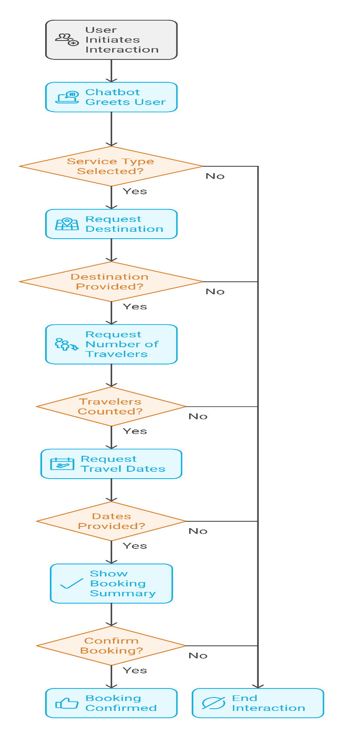

**Fig.6.1 Interaction Flow Diagram**

**Step 1: Accepting Users Query:**

The Chatbot will accept any user’s Query.

**Step 2: Analyzing the Query:**

The Chatbot will analyze the user’s asked query and check for the most appropriate solution for it in the Database.

**Step 3: Reply to Query:**

The Chatbot will provide solution to the user’s query if it finds a solution in the Database.

**Step 4: If Solution Not Found:**

If no solution is available to the query the chatbot will redirect the user to the customer support admin and the admin will provide the solution to the user and also will add the new query and solution into the chatbot for future use.

The flowchart describes a structured interaction process for a travel booking chatbot, focusing on the convenience and efficiency of experience by users. The journey starts as soon as the user initiates an interaction, indicating their intention to converse with the chatbot. This prompts the chatbot to greet the user in a friendly and engaging manner that will set the tone of the interaction.

It advances to the next stage of ensuring the service type is selected by the chatbot. It prompts the user to state what kind of service he needs, such as flight booking, hotel reservations, or even some other travel-related services. If the user does not select a service, then the chatbot might re-prompt or even end the interaction. After the selection of a service, the chatbot continues by asking for crucial booking information. It begins with the destination, and users are required to state where they wish to travel to. This forms a basis for further personalization of the booking process.

Once it confirms that the destination is covered, the chatbot then continues with another step: how many people will be traveling. This way, it ensures the number of participants involved in the reservation is reflected by the booking system. Henceforth, the chatbot asks about dates of travel so that a reservation can be checked for feasibility and availability and then get the best options or fare. The chatbot assures a valid user input at each point before it proceeds to move to the next stage if any input required is found missing; otherwise, either it prompts the user about the missing input or will abruptly cut down interaction.

The chatbot thus showcases booking details of all information collected. This summary puts together all such information like destination, number of travelers, and dates of travels, thus enabling users with an overview of their chosen options. The chat then waits for confirmation from the user to confirm the booking. Having received the confirmation, if so, the chat finalized the booking process and might offer a confirmation of this booking that includes a reference number, receipt, or other further instructions, if needed. If the user does not want to continue, the chatbot will end the conversation nicely and will provide help in case further questions arise.

This flow is step-by-step, user-friendly, and uses decision checkpoints to validate user input and streamline the process. It is designed for scalability and can integrate additional features or services while ensuring an efficient and personalized booking experience for us.

**6.2 Algorithm**

* **User Initiates Interaction:**

This is the point when the user initiates interaction with the chatbot, and it may be either a website, mobile app, or even a messaging platform.

The chatbot greets the user with a welcoming message that sets a positive tone for the interaction and introduces itself as a travel booking assistant.

* **Type of Service:**

The chatbot asks the user to choose the type of service he or she is looking for, such as flights, hotels, car rentals, or packages.

Decision Point:

If the user selects a valid service type, then it moves on to the next step.

If the user does not select a type of service (for example, by not answering or giving ambiguous input), the chatbot will end the conversation while also providing future help when asking questions.

* **Travel Destination Request**

When the chatbot has successfully identified a service type, it then asks the user to request their travel destination.

Decision Node:

If the user supplies a valid destination, the chatbot saves the input and then continues to the next node.

Unless specified the number of travelers, the chatbot should send further confirmation for clarification or end a session without closure in case the query gets undetermined.

* **Number of Travelers:**

The booking is asked about the quantity of travelers. This step is necessary to get real-time pricing and availability generation.

Decision Point:

Providing the number of travelers information, the chatbot gathers information and proceeds.

In case the user does not respond, the chatbot can then send a question again or simply end the session.

* **Travel Dates Request:**

The chatbot prompts the user to provide the travel dates, including start date and end date for the trip.

Decision

If the user gives their dates in a format the chatbot recognizes, the system moves on.

If the user did not input valid information or becomes inactive, the chatbot shall provide examples of correct entries or end the session.

* **Provide Booking Summary:**

After gathering the details required, including services to be availed of, destination, number of passengers, and travel date, the chatbot summarizes the booking.

Summarized information shall be provided about the booking details that the customer should review to confirm the entries are correct.

The chatbot might provide other options, like booking upgrades or add-on services such as insurance.

* **Confirm Booking:**

The chatbot asks the user to confirm the details of the booking.

Decision Point:

If the user confirms, the chatbot finalizes the booking and shows a confirmation message along with a booking reference number. It can also send a confirmation email or text for the user's records.

If the user refuses to book (for example, because of mistakes in the summary), the bot provides the user with an opportunity to make changes or terminate the conversation without booking.

* **Close Session:**

Depending on the choice of the user:

In case the booking is done, the bot closes the session with a message like "Thanks" and can add additional help, such as "Is there anything else you need?".

If the booking isn't concluded, the chatbot politely exits the conversation, leaving the chance for the user to revisit in case they need more support sometime in the future.

**Key Features:**

Error Handling and Clarifications :

The chatbot validates responses at each decision point, offering clarification or examples, in case of ambiguous input from the user.

User-Friendly Design:

The process is linear and straightforward, with clear questions and checkpoints for validation.

Efficiency:

The chatbot collects all the necessary information in an organized manner, thus eliminating delays and ensuring a smooth booking process.

Flexibility:

The chatbot allows users to correct mistakes at the booking summary step, giving them control and flexibility in their decisions.

Scalability:

This workflow can handle multiple user queries at the same time, making it suitable for businesses of any size.

Personalized Experience:

The chatbot addresses the user directly, confirms input at every step, and offers tailored services to ensure a personalized and satisfactory experience.

**Chapter 7**

**TIMELINE FOR EXECUTION OF PROJECT**

**(GANTT CHART)**

**Fig.7.1 Gantt Chart**

**Chapter 8**

**OUTCOMES**

**Fully Functional AI-Based Chatbot:**

* A fully functional AI-powered chatbot revolutionizes customer engagement by providing dynamic, interactive, and efficient communication. It is capable of managing multi-turn conversations, ensuring it comprehends and addresses complex customer queries effectively. For users in mobile environments, the inclusion of voice recognition enhances accessibility and convenience, especially when typing isn’t feasible.
* Furthermore, the chatbot supports multilingual interaction, making it suitable for a global audience by breaking down language barriers. To ensure continuous improvement, the bot leverages machine learning to learn from past interactions, enhancing its accuracy and personalization capabilities over time.
* In practice, this chatbot can handle various tasks: booking flights, hotels, and car rentals; recommending personalized travel itineraries based on preferences and budget; and providing real-time travel updates, such as flight status or weather changes. These features streamline the user experience, making travel planning effortless and highly efficient.

**Reduction in Customer Service Response Time:**

* The chatbot significantly reduces response times for customer service inquiries. It can instantly handle FAQs, addressing common questions about baggage policies, cancellations, or visa requirements without human intervention.
* This automation extends to repetitive tasks, such as confirming reservations or sending reminders for payments. Additionally, its AI-powered triaging system ensures that only complex or unresolved queries are forwarded to human agents, optimizing resource allocation.
* By minimizing wait times and addressing routine queries instantaneously, the chatbot creates a faster and more efficient customer service process, enhancing user satisfaction while freeing human agents to focus on more nuanced issues.

**Improved Customer Satisfaction Through Personalized Responses:**

* Personalization lies at the core of modern customer experiences, and this chatbot excels at delivering tailored interactions. Using natural language processing (NLP), it analyses a user’s tone and intent to craft appropriate and empathetic responses.
* For instance, it can suggest travel destinations, activities, or deals that align with a user’s interests, booking history, or location.
* By integrating with CRM systems, the chatbot can access customer profiles to offer seamless support. For example, a frequent traveler to tropical locations might receive proactive recommendations for vacation packages or seasonal discounts in similar regions. This level of personalization fosters loyalty and builds stronger customer relationships by showing a deep understanding of individual preferences and needs.

**Cost Reduction in Customer Service Operations:**

* AI chatbots significantly reduce operational costs while maintaining high service quality. Their scalability allows them to manage thousands of interactions simultaneously, eliminating the need for additional staff during peak hours or seasonal surges.
* With 24/7 availability, businesses no longer require night shifts or extended hours, reducing labor costs while ensuring consistent service.
* Moreover, integrating the chatbot with back-end systems reduces manual errors, such as overbooking or incorrect invoices. This efficiency saves time and resources, allowing businesses to focus on strategic priorities while maintaining operational excellence.

**Provide Real-Time Assistance 24/7**

* The chatbot’s ability to provide real-time assistance around the clock ensures that customers are supported whenever they need help. It can guide travelers through self-check-in or boarding procedures, simplifying their airport experience.
* Additionally, it sends instant notifications for updates such as gate changes, delays, or cancellations, helping users stay informed and stress-free.
* In emergencies, the chatbot proves invaluable by assisting with locating nearby medical facilities or reporting lost luggage. This comprehensive support enhances customer trust and ensures that travelers feel supported.

**Minimize Human Intervention While Maintaining High Service Quality:**

* The chatbot employs advanced AI technologies to minimize the need for human involvement without compromising service quality. Context retention allows it to understand follow-up questions and maintain conversational flow, avoiding the frustration of customers repeating themselves.
* Through sentiment analysis, the bot can detect dissatisfaction or negative experiences and escalate these cases to human agents immediately, ensuring critical issues are addressed with care.
* Regular updates to its AI knowledge base ensure that the chatbot stays aligned with the latest policies, procedures, and offerings. This adaptability ensures it remains relevant and capable of providing accurate information, keeping customers informed and confident in their interactions.

**Key Benefits for Travel Businesses:**

With a travel booking chatbot, travel businesses enjoy important advantages mainly in terms of improved revenues, operational efficiency, and customer loyalty. A huge benefit is increased revenue as upselling premium services on actual real-time conversations with the customers will be possible for these bots. For instance, at the time of booking, a chatbot can propose seat upgrades, exclusive tours, priority boarding, and so on, depending upon the user's preferences and their travel itinerary. Businesses, thus, can increase revenue per customer without having to manually intervene and promote higher-tier options based on the opportunities identified. Additionally, chatbots can cross-sell related services, such as recommending hotels after booking a flight or offering discounted car rentals, ensuring a holistic travel package that aligns with customer needs.

Another critical benefit is the enhancement of brand loyalty. In the travel industry, customer trust and satisfaction are paramount. By providing a consistent, user-friendly, and reliable service experience, chatbots can foster stronger relationships with customers. Travelers appreciate timely responses, correct booking processes, and customized recommendations-all of which make for a positive experience about the brand. Additionally, the chatbots ensure it is available 24/7, and customers do not have to wait when they need assistance, which cements trust and makes it appear reliable. This ensures seamless experiences that will entice repeat business and inspire long-term loyalty, with a resultant effect of persistent growth.

The final one is the use of chatbots, which helps travel businesses to have efficient operations and manage resources better. The chatbot can take routine customer inquiries, such as flight schedule checks, ticket bookings, or answering the most common FAQs, allowing human agents to focus on complex, high-value tasks. For example, human agents may focus their skills on high-level issue resolution, managing corporate accounts, or handcrafting bespoke travel experiences for high-end clients. With this division of labor comes not only operational efficiency but also reduced labor costs for businesses, allowing them to grow their operations without directly and proportionally increasing their number of employees. In the end, the chatbot is a digital assistant helping to streamline repetitive tasks that ensure smooth customer service delivery.

With these benefits-revenue growth, enhanced customer loyalty, and operational efficiency-a travel business can remain competitive in a fast-evolving industry while meeting and exceeding customer expectations.

**Chapter 9**

**RESULTS AND DISCUSSIONS**

The Travel Chatbot class provides an excellently designed framework for a more interactive travel booking assistant by the help of modern web technologies. TTS, speech recognition, and multi-linguistic support are incorporated within this feature to make it as user-friendly and accessible to a vast audience. Interacting with the chatbot can be done via either text input or voice commands. The bot responds contextually in relation to the stage in the booking process. The chatbot will gather information such as service type, destination, travel dates, and other preferences and summarize the inputs for confirmation before creating a random booking reference. Dynamic language switching between English and Spanish also increases its accessibility to non-English speakers.

The booking process is logically structured, prompting users with sequential questions to gather all necessary information. It also offers a responsive and visually clear user interface, with mobile-friendly design adjustments for smaller screens. Speech recognition enables real-time voice input, while TTS reads responses aloud for an inclusive experience, especially for users with visual impairments. Error handling ensures that the chatbot gracefully manages unsupported browsers or invalid inputs, maintaining a smooth user experience.

However, there are areas for improvement. Input validation could be enhanced to ensure proper formatting for dates and numeric values. Edge cases, such as partial or ambiguous responses, need better handling to make interactions more robust. The functionality of the chatbot could be significantly expanded by integrating it with a backend API or database to store and manage booking details. Adding personalization features, such as budget or travel class preferences, could make the chatbot more user-centric.

The modular design of the chatbot allows for scalability, and it can easily extend features like real-time suggestions or integrate additional services such as flight bookings. Aesthetic improvements to the interface and a more intuitive service selection mechanism could further enhance usability. Currently, the chatbot simulates delays for processing responses, but real-time processing can be implemented once backend integration is achieved.

In the future, Travel Chatbot can add AI capabilities to suggest smarter based on user behavior or external factors such as weather. The ability to support more languages and package it as a mobile or progressive web app could expand its reach. Overall, the chatbot is a very promising prototype that well merges conversational AI with modern web technologies, offering a solid base for building highly advanced travel assistants.

**Results:**

1. **Core Functionalities:**
   * **Text Input and Responses:**
     + Users can type or speak commands.
     + Bot responds with context-based questions or confirmations.
   * **Speech Recognition:**
     + Uses web-kit Speech Recognition for real-time voice input.
     + Captures user responses and processes them as text.
   * **Text-to-Speech:**
     + Bot reads messages aloud for accessibility and user engagement.
2. **Booking Process:**
   * Sequential prompts for service type, destination, travellers, dates, and other specifics like hotel amenities or car rental preferences.
   * A summary of inputs is displayed for confirmation.
   * Generates a random reference number upon confirmation.
3. **Multilingual Support:**
   * Translations for both English and Spanish, toggled dynamically.
   * Interface elements, prompts, and messages adapt based on the selected language.
4. **User Interface:**
   * Dynamic chat UI with user and bot messages clearly distinguished.
   * Mobile-friendly layout with responsive design adjustments.
5. **Error Handling:**
   * Alerts users if speech recognition is unsupported.
   * Ensures valid input by rejecting empty responses.
6. **Extensibility:**
   * Easily extendable to include new services or features (e.g., integrating a real booking API).

**Discussions:**

**Strengths:**

* **User Experience:**
  + The chatbot provides a conversational and interactive interface, making it engaging for users.
  + Multilingual capabilities increase accessibility for non-English speakers.
* **Scalability:**
  + Modular design supports adding additional services, such as flight booking or real-time suggestions.
* **Tech Utilization:**
  + The integration of speech recognition and TTS enhances interaction, especially for mobile or visually impaired users.

**Areas for Improvement:**

1. **Error and Edge Case Handling:**
   * Improve handling of invalid or ambiguous inputs (e.g., users providing partial answers).
   * Add retry options for unrecognized voice commands.
2. **Data Validation:**
   * Validate user inputs for proper format (e.g., dates should match a specific pattern).
   * Validate numeric inputs like the number of travelers or rental days.
3. **Enhancements in Personalization:**
   * Add fields for user preferences like budget or travel class.
   * Provide default suggestions or popular destinations.
4. **Backend Integration:**
   * Currently, booking details are only stored locally. Integrating with an API or database would make it more practical for real-world applications.
5. **UI/UX Adjustments:**
   * Enhance chatbot visual design for more modern aesthetics.
   * Improve service selection interface for intuitive navigation.
6. **Performance Optimization:**
   * Simulated delays in responses (setTimeout) can be replaced with real-time processing once backend integration is implemented.

**Future Scope of the Customer Service Chatbot:**

**1. AI Integration for Smart Recommendations:**

Integration with highly sophisticated AI technologies will also strengthen the capabilities of this type of chatbot. Applying advanced machine learning and natural language processing, the chatbot can provide users with insightful and personalized recommendations based on their past travel experiences or search patterns.

Using AI, for instance, may allow the chatbot to recommend a specific destination based on the user's interests from previously documented travel history or searched for sites. Moreover, AI can assess external factors such as weather conditions, travel trends, or upcoming events in certain places to recommend the best travel options. This intelligent support not only enhances user engagement but also makes the chatbot a go-to travel guide, offering value beyond answering simple queries.

**2. Multilingual Support:**

Multilingual support is crucial in reaching a global audience. This would help the chatbot to communicate better with a wider range of languages to users from diverse cultural and linguistic backgrounds, breaking the barriers of exclusivity.

For example, the chatbot could change languages dynamically based on the user's preference or region-specific questions. This is particularly useful for businesses looking to tap into global markets. Furthermore, correct translations and culturally appropriate answers ensure that the chatbot provides a smooth, localized experience to the users, hence increasing customer satisfaction and trust.

**3. Cross-Platform Compatibility:**

In the modern digital space, the user interacts with businesses across different devices and platforms. To ensure wide accessibility, the chatbot can be developed as a mobile app or a progressive web app (PWA). PWAs combine the best of web and mobile applications, providing features such as offline functionality, push notifications, and a responsive interface. Given that it is cross-platform compatible, the chatbot ensures that users can use its services on any type of device, whether that is a desktop, smartphone, or tablet.

In this regard, the versatility enhances user convenience but broadens the reach of its audience. Integration with popular messaging platforms like WhatsApp, Facebook Messenger, and Slack can broaden its usage even further; hence, it would be of utmost utility for users not only in personal but professional settings too.

**Long-Term Vision:**

The combination of AI-driven personalization, multi-language support, and cross-platform availability will position the chatbot as a cutting-edge solution in the customer service space. These enhancements will enable businesses to stay ahead of technological trends while delivering unparalleled user experiences. As the chatbot evolves, it will become more than just a tool for transactions—it will be a comprehensive platform for engagement, fostering deeper connections with users and driving sustainable growth for businesses.

Overall, the chatbot effectively demonstrates a framework for building conversational travel assistants, with a focus on user interactivity and scalability.

**Chapter 10**

**CONCLUSION**

The integration of a travel booking chatbot into a business offers significant revenue-driving benefits, especially through the upselling and cross-selling of products. It can analyze customers' preferences and suggest upgraded flights, lounge access, travel insurance, or exclusive tours. It can also bundle services, offering discounted hotel stays or car rentals with the flight, increasing transaction value and promoting comprehensive packages tailored to customers' needs.

Chatbots also contribute to building brand loyalty through 24/7 support for bookings, itinerary queries, or travel restrictions. Personalized interaction, including remembering preferences, making tailored recommendations, and communicating in a preferred language, ensures that customers have a smooth and attentive experience. This creates trust and encourages repeat bookings, giving businesses an edge in the competitive market.

Apart from customer engagement, operational efficiency is enhanced through automated repetitive tasks such as inquiring about flight availability or answering frequently asked questions, thus allowing human agents to deal with complex issues without reducing the quality of the service. Scalable, with the ability to handle thousands of interactions at a time, chatbots ensure resource allocation is streamlined, an indispensable tool for sustainable growth in the travel industry.

**REFERENCES**

[1] Acharya, P. V., Shetty, P., & Sequiera, P. (2024). A study on AI and chatbots in customer experience. 5th International Conference on New Age Marketing, ISBN: 978-93-83302-66-6, 1-10. <https://www.sdmimd.ac.in/marketingconference2024/papers/IMC2466.pdf>.

[2] Adam, M., Wessel, M., & Benlian, A. (2020). AI-based chatbots in customer service and their effects on user compliance. Electronic Markets, 31, 427–445. <https://doi.org/10.1007/s12525-020-00414-7>

[3] Kaur, J., Choppadandi, A., Chenchala, P. K., Nakra, V., & Pandian, P. K. G. (2019). Case studies on improving user interaction and satisfaction using AI-enabled chatbots for customer service. International Journal of Transcontinental Discoveries, 6(1), 29-34. <https://internationaljournals.org/index.php/ijtd/article/view/98>

[4] Li, C., Pan, R., Xin, H., & Deng, Z. (2020). Research on artificial intelligence customer service on consumer attitude and its impact during online shopping. Journal of Physics: Conference Series, 1575(1), 012192. <https://doi.org/10.1088/1742-6596/1575/1/012192>

[5] Misischia, C. V., Poecz, F., & Strauss, C. (2022). Chatbots in customer service: Their relevance and impact on service quality. *Procedia Computer Science, 201*, 421–428. <https://doi.org/10.1016/j.procs.2022.03.055>

[6] Nirala, K. K., Singh, N. K., & Purani, V. S. (2022). A survey on providing customer and public administration based services using AI: Chatbot. Multimedia Tools and Applications, 81(5), 6315-6330. <https://doi.org/10.1007/s11042-021-11458-y>

[7] Ranieri, A., Di Bernardo, I., & Mele, C. (n.d.). Serving customers through chatbots: Positive and negative effects on customer experience. *Journal of Service Theory and Practice*. Retrieved from <https://www.emerald.com/insight/content/doi/10.1108/jstp-01-2023-0015/full/html>.

[8] Stoilova, E. (2021). AI chatbots as a customer service and support tool. ROBONOMICS: The Journal of the Automated Economy, 2, 21. <https://journal.robonomics.science/index.php/rj/article/view/21>

[9] S uta, P., Lan, X., Wu, B., Mongkolnam, P., & Chan, J. H. (2020). An Overview of Machine Learning in Chatbots. *International Journal of Mechanical Engineering and Robotics Research*, 9, 502-510. <https://doi.org/10.18178/ijmerr.9.4.502-510>

[10] Zhou, X. (2023). Chatbot improves customer service in four important industries. Highlights in Science, Engineering and Technology CMLAI, 39, 339-346. <https://doi.org/10.5281/zenodo.1234567>

**APPENDIX-A**

**PSUEDOCODE**

CLASS TravelChatbot:

PROPERTIES:

currentStep = "greeting"

language = "en"

isListening = false

bookingData = {

serviceType: "",

destination: "",

travelers: "",

dates: "",

preferences: "",

hotelDetails: {

roomType: "",

nights: "",

hotelAmenities: ""

},

carRentalDetails: {

carType: "",

rentalDays: "",

pickupLocation: "",

dropOffLocation: ""

}

}

translations = {

"en": {dictionary of English translations},

"es": {dictionary of Spanish translations}

}

CONSTRUCTOR:

Initialize speech recognition if supported

Initialize UI elements

Bind event listeners

Start chat with greeting

FUNCTION initialize():

Display greeting message

Display service selection prompt

Adjust layout for current device

FUNCTION handleInput(userInput):

IF userInput is empty THEN

Show error message

RETURN

Add user message to chat

Show processing message

SWITCH currentStep:

CASE "destination":

Save destination

Ask for number of travelers

Set currentStep to "travelers"

CASE "travelers":

Save travelers count

Ask for travel dates

Set currentStep to "dates"

CASE "dates":

Save dates

Show booking summary

Set currentStep to "confirmation"

CASE "confirmation":

IF user confirms THEN

Generate booking reference

Show confirmation

Reset booking

ELSE

Cancel booking

Reset state

END IF

FUNCTION handleServiceSelection(service):

Save selected service type

Ask for destination

Set currentStep to "destination"

Hide service selector

FUNCTION toggleLanguage():

Switch between "en" and "es"

Update UI text elements

Update speech recognition language

FUNCTION handleSpeechInput():

IF speech recognition supported THEN

IF currently listening THEN

Stop listening

ELSE

Start listening

Set recognition language

Show listening prompt

END IF

ELSE

Show error message

END IF

FUNCTION showBookingSummary():

Format booking details

Display summary

Ask for confirmation

FUNCTION confirmBooking():

Generate random reference number

Show confirmation message

Reset booking data

Set currentStep to "complete"

FUNCTION resetBooking():

Clear all booking data

Reset to initial state

Show service selector

HELPER FUNCTIONS:

addMessage(text, isBot) - Add message to chat

scrollToBottom() - Scroll chat to latest message

speak(text) - Convert text to speech

adjustLayoutForMobile() - Handle responsive design

updateUILanguage() - Update UI text based on language

**APPENDIX-B**

**SCREENSHOTS**

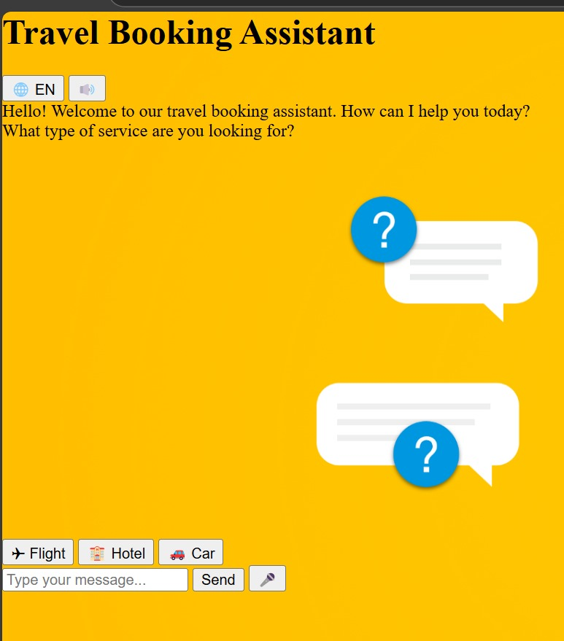

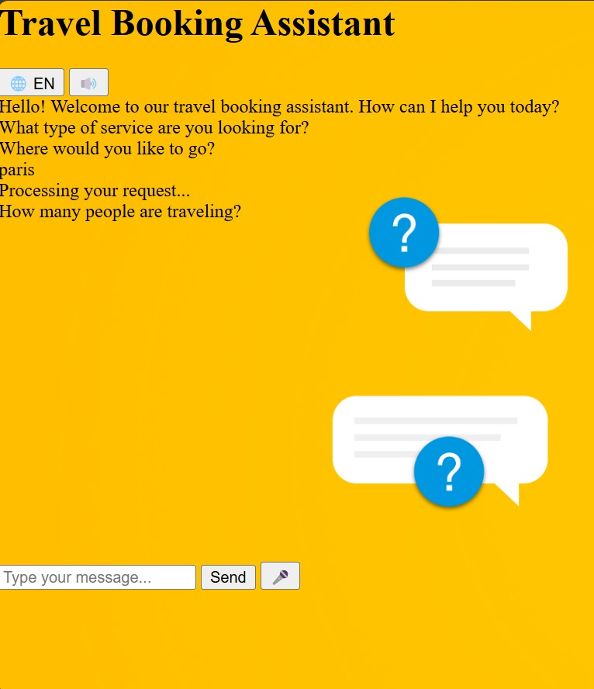

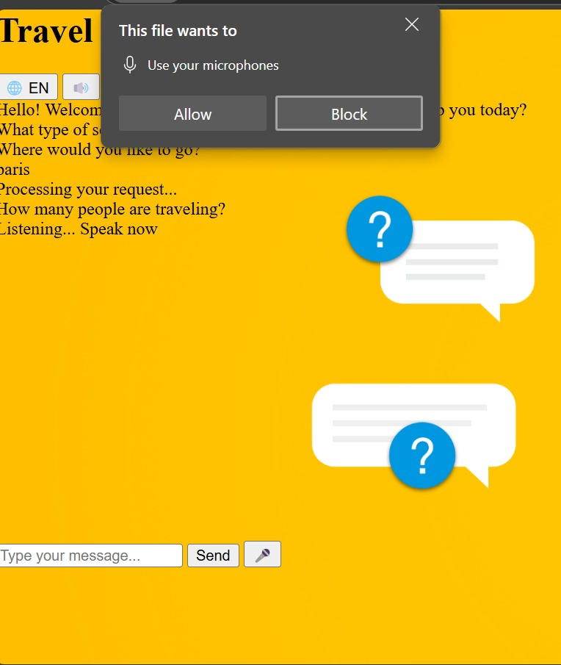

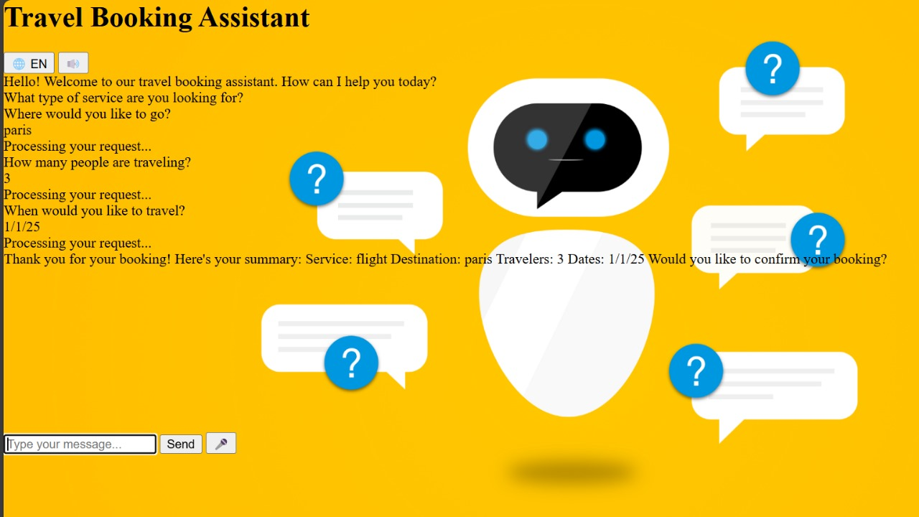

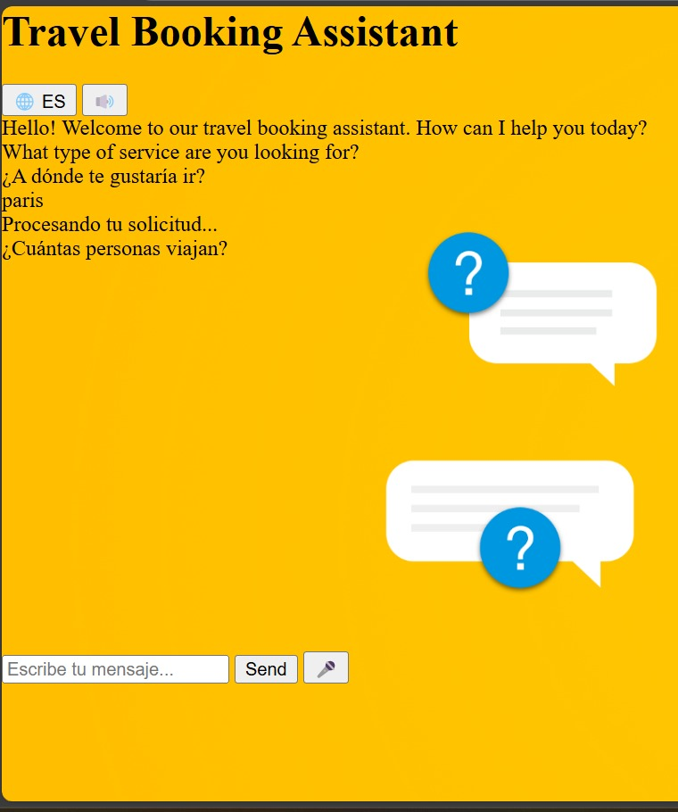

**APPENDIX-C**

**ENCLOSURES**

**Sustainable Development Goals**



**The Project work carried out here is mapped to SDG-9 Industry, Innovation and Infrastructure.**

A Customer Service Chatbot with AI fits into SDG 9 as it harnesses technological advancements for communication infrastructure and service delivery improvement. It fosters innovation through the automation of processes for customer service, with increased efficiency and reduced response times. In addition, AI-powered chatbots enhance accessibility and inclusivity by allowing businesses to reach diverse customers effectively even in remote areas, contributing to sustainable and scalable industrial growth.

**Plagiarism Report**

